SUPPLEMENTARY INFORMATION

Multi-Analytical Investigation of Frescoes in Santa Maria della Grotta, Marsala: Materials, Techniques and Conservation Study
Chiara Tuccio ^{a,b}, Francesco Armetta ^{a,c}, Rosina Celeste Ponterio ^{c},
Dario Giuffrida ^{c}, Maria Luisa Saladino ^{a,c,*}

ª Department of Biological, Chemical and Pharmaceutical Sciences and Technologies (STEBICEF)-University of Palermo, Viale delle Scienze, Bld.17, Palermo I-90128, Italy.
^{b} Department of Cultures and Societies, University of Palermo, Viale delle Scienze, Bld.15, Palermo I-90128, Italy
^{c} National Research Council, Institute for Chemical and Physical Processes (CNR-IPCF), Viale Ferdinando Stagno d’Alcontres 37, I-98158 Messina, Italy

Corresponding author: marialuisa.saladino@unipa.it

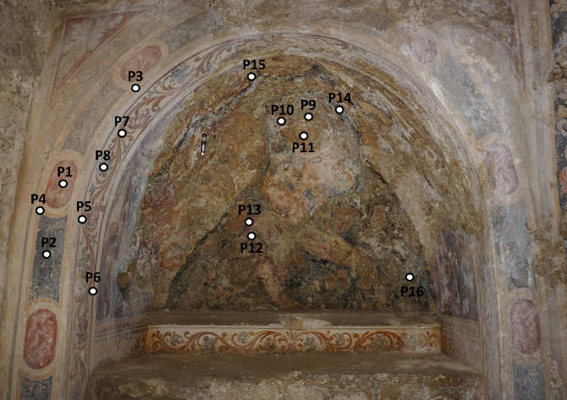  La Madonna Odigitra | 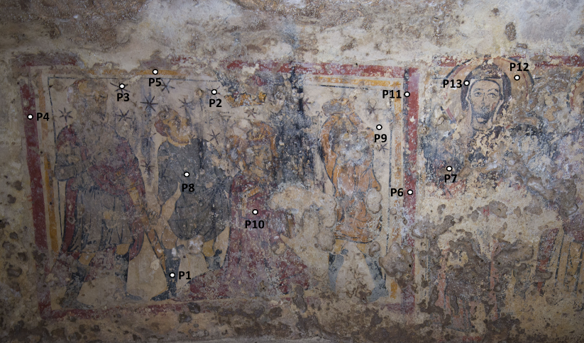  Il Martirio di Santo Stefano
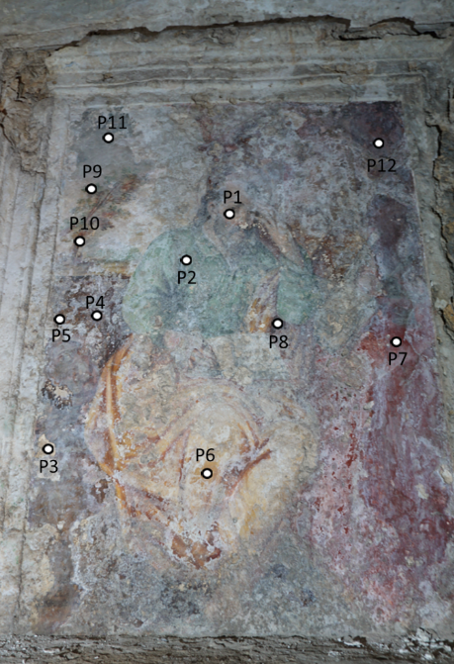  San Marco Evangelista | 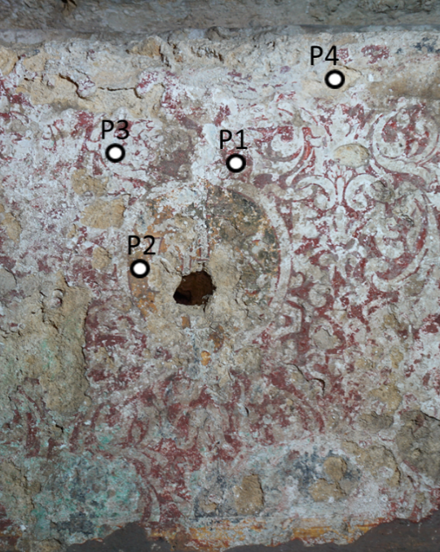  San Marco evangelista-Altar
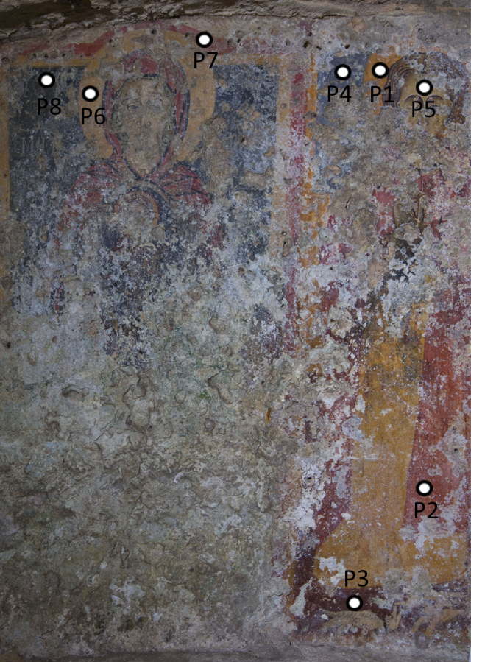  Vergine e San Vito | 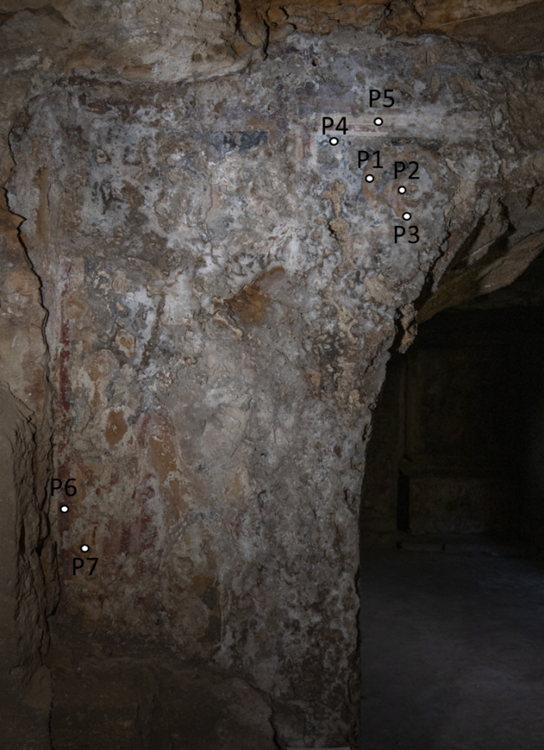  Odigitria e San Gabriele Arcangelo
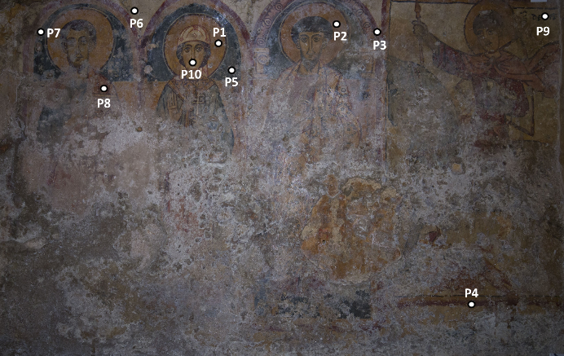  La Teoria dei Santi | 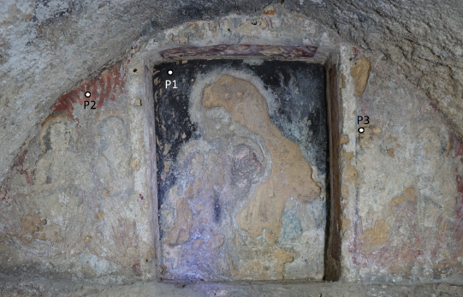  Madonna Odigitria tra anime purganti
Supplementary Figure 1. Area investigated by XRF and/or Raman spectroscopy.

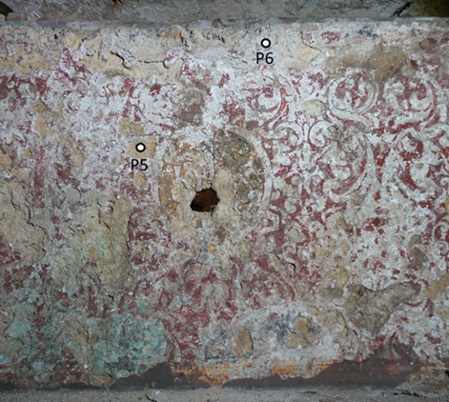  Altar – San Marco Evangelista | 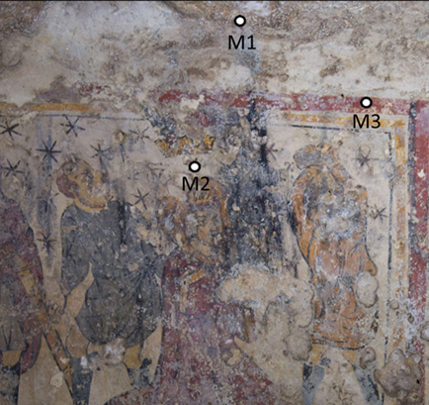  Il Martirio di Santo Stefano
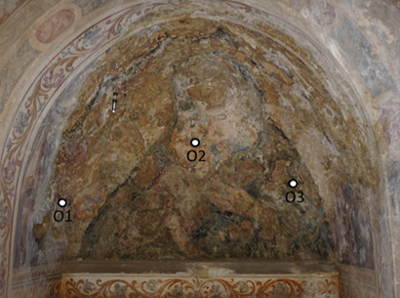  La Madonna Odigitra | 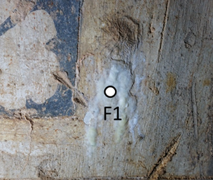  Cornice- La Madonna Odigitria

Supplementary Figure 2. Sampling Area- Salts .
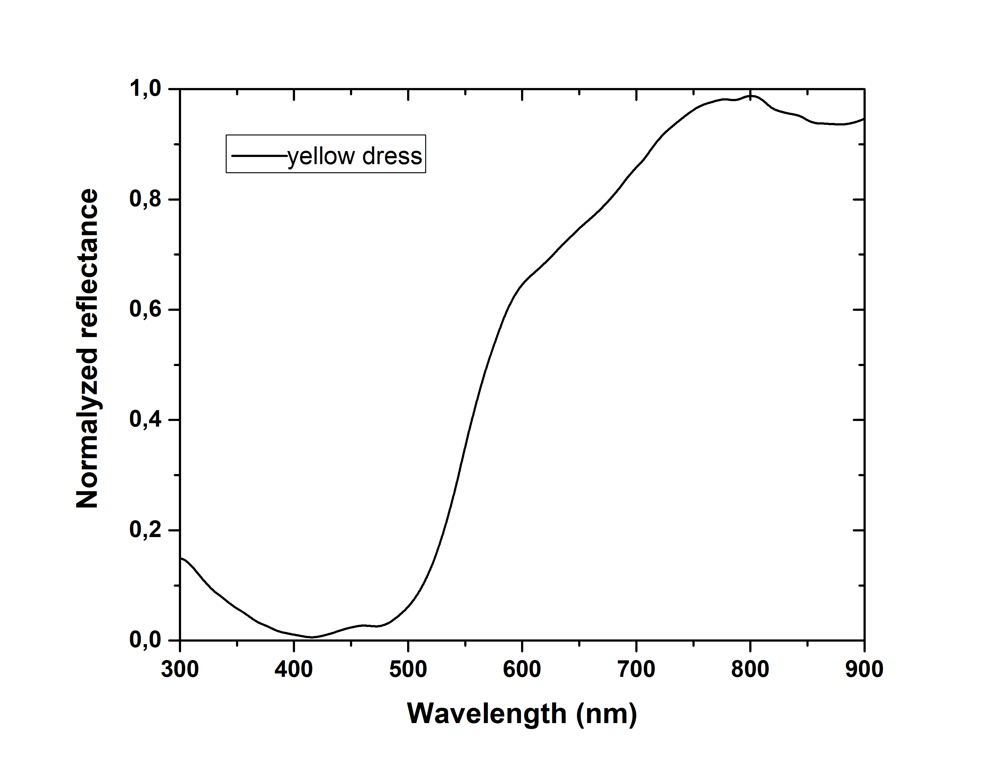
Supplementary Figure 3. FORS reflectance spectrum acquired on the yellow-painted area (“yellow dress”) of the Teoria dei Santi fresco, showing the characteristic spectral behavior attributable to yellow ochre pigments.

