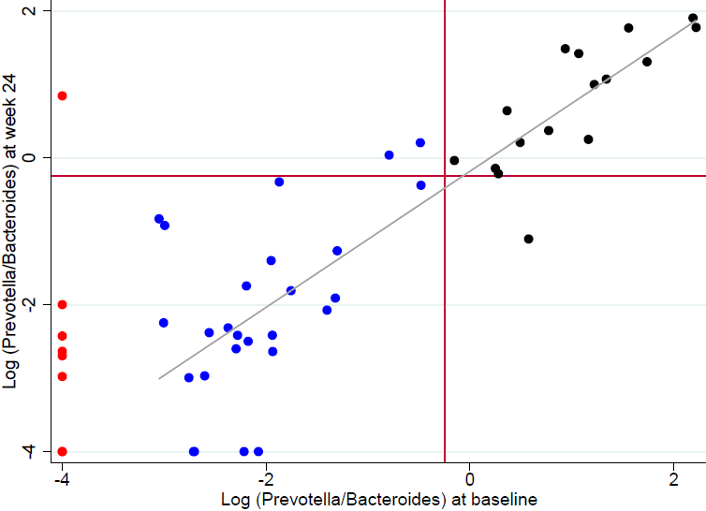
Figure S2: Scatterplot between baseline and 24-week post-intervention log (Prevotella/Bacteriodes)

