Supplementary Material

Inhibition of food craving is a metabolically active process in obese men

Gene-Jack Wang¹, Ehsan Shokri Kojori¹, Kai Yuan^{1,2}, Corinde E. Wiers¹, Peter Manza¹, Christopher T. Wong¹, Joanna S. Fowler³, Nora D Volkow^{1,4}.

¹ Laboratory of Neuroimaging, National Institute on Alcohol Abuse and Alcoholism, Bethesda, MD, 20892-1013
² School of Life Science and Technology, Xidian University, Xi'an Shaanxi 710071, Peoples R China
³ Brookhaven National Laboratory, Upton, NY, 11973
⁴ National Institute on Drug Abuse, National Institutes of Health, Bethesda, MD, 20892

Correspondence: Gene-Jack Wang MD, National Institute on Alcohol Abuse and Alcoholism, Laboratory of Neuroimaging, National Institutes of Health, 10 Center Drive, Room B2L124, Bethesda, MD, 20892, USA. E-mail: gene-jack.wang@nih.gov, Phone: +1 301-496-5012

Supplementary Figure 1. Dynamic changes in the behavioral measures during food stimulation in no inhibition (NI) and attempted inhibition (AI) in normal and obese participants. Self-reported measurements were collected every 5 min.

Supplementary Figure 2. In the no- stimulation baseline (BL), CMRglu was lower within the left medial and superior frontal gyri in obese than non-obese men (p < 0.002, k > 200, cluster size = 246).

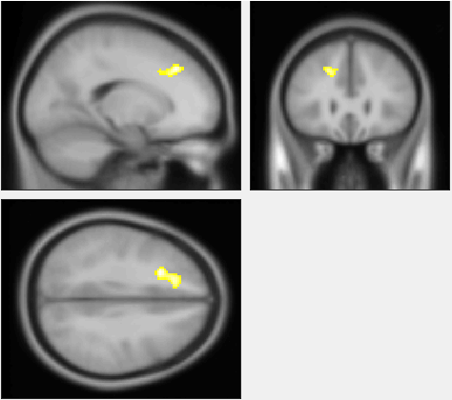

Supplementary Figure 3. Outlier detection results for the correlation between changes in CMRglu and changes in subjective ratings of food desire (left) and hunger (right), from no inhibition (NI) to attempted inhibition (AI) conditions.

