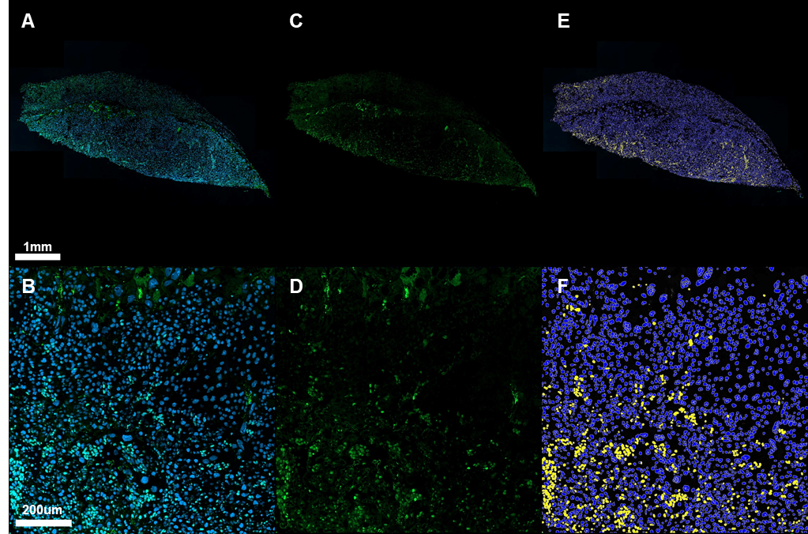

Supplementary Figure S2. Immunofluorescent staining of Ki67 and analysis of cell proliferation. (A, B) Placental section stained for Ki67 (green) and DAPI (blue), or (C, D) Ki67 only; (E, F) HALO analysis output showing Ki67-negative (purple) and positive (yellow) nuclei.

