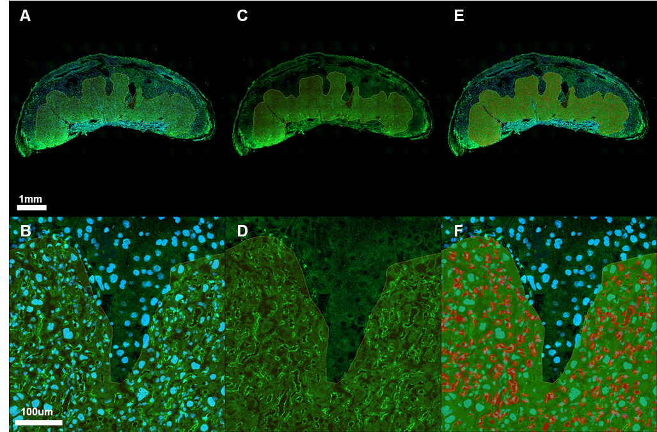

Supplementary Figure S3. Immunofluorescent staining of CD31 and analysis of labyrinth fetal vasculature. (A, B) Placental section stained for CD31 (green) and DAPI (blue), or (C, D) CD31 only; (E, F) HALO analysis output showing regions of the labyrinth zone classified as fetal blood vessels (red) or other tissue (green).

