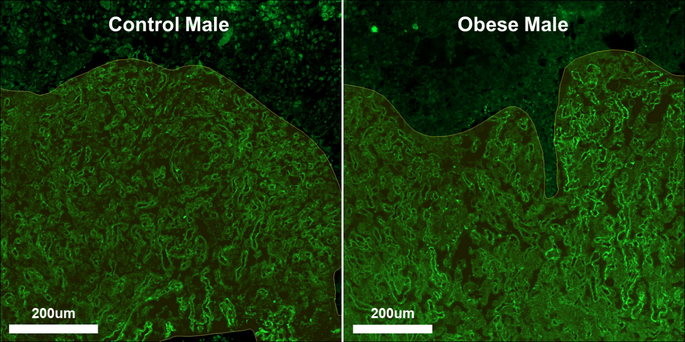

Supplementary Figure S4. Immunofluorescent staining of CD31 in male placentae. The proportion of fetal capillaries within the labyrinth zone of male placentae was not affected by maternal obesity or gestational age, determined by two-way ANOVA analysis.

