Supplementary Figure 1. 1993 Birth Cohort recruitment and follow-up.
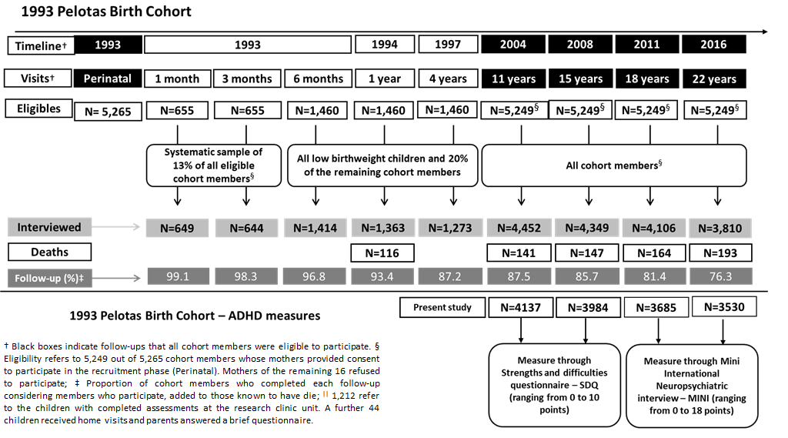

Supplementary Table 1. Linear regression results for crude models testing the association between confounders factors, ADHD symptoms, and BMI at 11 and 15-years of age among participants in the 1993 Pelotas (Brazil) birth cohort.
 | ADHD |  | BMI
 | β (95% CI) | p-value | β (95% CI) | p-value
11-years
Maternal characteristics at birth
Family income (MMW)
1.1 to 3.0 | -0.28 (-0.55;-0.02) | 0.037 | 0.12 (0.02;0.23) | 0.016
3.1 to 6.0 | -0.74 (-1.03;-0.45) | <0.001 | 0.34 (0.23;0.46) | <0.001
6.1 to 10.0 | -1.13 (-1.53;-0.72) | <0.001 | 0.46 (0.31;0.62) | <0.001
≥10 | -1.52 (-1.94;-1.11) | <0.001 | 0.47 (0.31;0.63) | <0.001
Pre-gestacional BMI (Kg/m²) | -0.04 (-0.06;-0.01) | 0.003 | 0.09 (0.08;0.10) | <0.001
Smoking in pregnancy (yes) | 0.69 (0.50;0.89) | <0.001 | -0.004 (-0.08;0.07) | 0.923
Alcohol consumption in pregnancy (yes) | 0.45 (0.03;0.88) | 0.038 | 0.002 (-0.15;0.18) | 0.828
Participants
Type of delivery (cesarean) | -0.36 (-0.57;-0.16) | 0.001 | 0.25 (0.17;033) | <0.001
Birth weight (g) | -0.0002 (-0.0004;-0.0001) | 0.014 | 0.0005 (0.0003;0.0005) | <0.001
Sex (female) | -0.98 (1.17;-0.80) | <0.001 | -0.20 (-0.27;-0.12) | <0.001
Race£
Black Brazilians | 0.64 (0.36;0.92) | <0.001 | -0.06 (-0.17;0.05) | 0.276
Others¥ | 0.61 (0.37;0.84) | <0.001 | -0.17 (-0.26;-0.08) | <0.001
15-years
Maternal characteristics at birth
Family income
1.1 to 3.0 | -0.02 (-0.29;0.25) | 0.879 | 0.12 (0.02;0.22) | 0.018
3.1 to 6.0 | -0.48 (-0.78;-0.19) | 0.001 | 0.23 (0.12;0.34) | <0.001
6.1 to 10.0 | -0.58 (-0.98;-0.17) | 0.005 | 0.27 (0.12;0.42) | <0.001
≥10 | -0.99 (-1.41;-0.58) | <0.001 | 0.30 (0.15;0.46) | <0.001
Pre-gestacional BMI (Kg/m²) | -0.03 (-0.06;-0.01) | 0.015 | 0.09 (0.08;0.10) | <0.001
Smoking in pregnancy (yes) | 0.72 (0.52;0.92) | <0.001 | 0.05 (-0.03;0.12) | 0.205
Alcohol consumption in pregnancy (yes) | 0.76 (0.34;1.18) | <0.001 | -0.06 (-0.22;0.09) | 0.431
Participants
Type of delivery (cesarean) | -0.25 (-0.45;-0.05) | 0.016 | 0.21 (0.14;0.29) | <0.001
Birth weight (g) | -0.0002 (-0.0004;-2.15e6) | 0.047 | 0.0003 (0.0003;0.0004) | <0.001
Sex (female) | -0.83 (-1.02;-0.64) | <0.001 | -0.10 (-0.17;-0.03) | 0.004
Race£
Black Brazilians | 0.39 (0.11;0.66) | 0.006 | -0.004 (-0.11;0.10) | 0.945
Others¥ | 0.64 (0.40;0.87) | <0.001 | -0.09 (-0.18;-0.004) | 0.040
Notes: ADHD, Attention-Deficit/Hyperactivity Disorder; BMI, Body Mass Index; MMW, monthly minimum wages.
¥Others including mixed-race Brazilians and Asian Brazilians; £ White Brazilians was used as a reference group.
Supplementary Table 2. Linear regression results for crude models testing the association between covariables, ADHD symptoms, BMI, and body composition at 18 and 22-years of age among participants in the 1993 Pelotas (Brazil) birth cohort.
 | ADHD |  | BMI |  | Fat-free mass |  | Fat mass
 | β (95% CI) | p-value | Β (95% CI) | p-value | β (95% CI) | p-value | β (95% CI) | p-value
18-years
Maternal characteristics at birth
Family income (MMW)
1.1 to 3.0 | -0.13 (-0.51;0.26) | 0.510 | 0.10 (-0.01;0.20) | 0.076 | -1.28 (-2.34;-0.22) | 0.018 | 1.34 (0.21;2.47) | 0.020
3.1 to 6.0 | -0.40 (-0.82;0.03) | 0.068 | 0.21 (0.09;0.33) | <0.001 | -3.04 (-4.22;-1.87) | <0.001 | 3.22 (1.98;4.47) | <0.001
6.1 to 10.0 | -0.65 (-1.23;-0.08) | 0.027 | 0.18 (0.02;0.33) | 0.030 | -3.11 (-4.69;-1.53) | <0.001 | 3.29 (1.61;4.97) | <0.001
≥10 | -0.74 (-1.34;-0.14) | 0.016 | 0.17 (0.01;0.34) | 0.041 | -3.18 (-4.87;-1.50) | <0.001 | 3.36 (1.57;5.15) | <0.001
Pre-gestacional BMI (Kg/m²) | -0.03 (-0.06;0.01) | 0.151 | 0.09 (0.08;0.10) | <0.001 | -0.52 (-0.62;-0.42) | <0.001 | 0.54 (0.43;0.65) | <0.001
Smoking in pregnancy (yes) | 0.43 (0.14;0.72) | 0.004 | 0.07 (-0.01;0.14) | 0.107 | 0.26 (-0.55;1.06) | 0.528 | -0.28 (-1.14;0.57) | 0.516
Alcohol consumption in pregnancy (yes) | 0.39 (-0.22;1.01) | 0.212 | -0.05 (-0.22;0.12) | 0.535 | -0.28 (-1.99;1.43) | 0.747 | 0.37 (-1.45;2.18) | 0.693
Participants
Type of delivery (cesarean) | -0.29 (-0.58;0.001) | 0.051 | 0.16 (0.08;0.24) | <0.001 | -1.38 (-2.20;-0.57) | 0.001 | 1.44 (0.57;2.30) | 0.001
Birth weight (g) | -0.0001  (-0.0003;0001) | 0.504 | 0.0003  (0.0002;0.0004) | <0.001 | 0.00002  (-0.001;0.001) | 0.961 | -0.0001  (-0.001;0.001) | 0.726
Sex (female) | 0.58 (0.31;0.86) | <0.001 | 0.16 (0.08;0.23) | <0.001 | -16.74  (-17.28;-16.20) | <0.001 | 18.09 (17.52;18.65) | <0.001
Race£
Black Brazilians | 1.15 (0.75;1.55) | <0.001 | 0.09 (-0.03;0.20) | 0.133 | 1.91 (0.80;3.03) | 0.001 | -2.14 (-3.32;-0.95) | <0.001
Others¥ | 0.91 (0.57;1.26) | <0.001 | -0.02 (-0.12;0.07) | 0.613 | 1.50 (0.54;2.45) | 0.002 | -1.59 (-2.60;-0.57) | 0.002

Continuation. Supplementary Table 2. Linear regression results for crude models testing the association between covariables, ADHD symptoms, BMI, and body composition at 18 and 22-years of age among participants in the 1993 Pelotas (Brazil) birth cohort.
 | ADHD |  | BMI |  | Fat-free mass |  | Fat mass
 | β (95% CI) | p-value | Β (95% CI) | p-value | β (95% CI) | p-value | β (95% CI) | p-value
22-years
Maternal characteristics at birth
Family income (MMW)
1.1 to 3.0 | -0.01 (-0.37;0.35) | 0.951 | 0.11 (-0.39;0.61) | 0.670 | -0.95 (-2.11;0.21) | 0.108 | 1.05 (-0.18;2.29) | 0.094
3.1 to 6.0 | -0.26 (-0.65;0.13) | 0.197 | 0.35 (-0.19;0.90) | 0.203 | -1.97 (-3.24;-0.69) | 0.002 | 2.17 (0.028;3.53) | 0.002
6.1 to 10.0 | -0.20 (-0.72;0.33) | 0.462 | -0.28 (-1.02;0.46) | 0.457 | -1.25 (-2.98;0.48) | 0.156 | 1.43 (-0.40;3.27) | 0.126
≥10 | -0.43 (-0.97;0.11) | 0.120 | -0.69 (-1.46;0.08) | 0.079 | -1.32 (-3.10;0.46) | 0.146 | 1.50 (-0.39;3.40) | 0.119
Pre-gestacional BMI (Kg/m²) | -0.03 (-0.07;0.001) | 0.064 | 0.35 (0.30;0.40) | <0.001 | -0.51 (-0.61;-0.40) | <0.001 | 0.53 (0.42;0.65) | <0.001
Smoking in pregnancy (yes) | 0.48 (0.22;0.75) | <0.001 | 0.62 (0.24;0.99) | 0.001 | -0.24 (-1.11;0.63) | 0.585 | 0.17 (-0.75;1.10) | 0.716
Consumption of alcohol during pregnancy (yes) | 0.49 (-0.06;1.05) | 0.083 | -0.13 (-0.91;0.66) | 0.749 | -0.71 (-2.54;1.12) | 0.445 | 0.93 (-1.01;2.88) | 0.346
Participants
Type of delivery (cesarean) | -0.19 (-0.46;0.08) | 0.161 | 0.24 (-0.13;0.62) | 0.205 | -0.95 (-1.82;-0.07) | 0.034 | 1.03 (0.09;1.96) | 0.031
Birth weight (g) | -0.0001  (-0.0004;0001) | 0.300| | 0.0009  (0.0005;0.001) | <0.001 | 0.0003  (-0.001;0.001) | 0.484 | -0.0003  (-0.001;0.001) | 0.471
Sex (female) | 0.14 (-0.11;0.39) | 0.274 | 0.47 (0.12;0.82) | 0.008 | -15.92  (-16.53;-15.31) | <0.001 | 17.17 (16.52;17.81) | <0.001
Race£
Black Brazilians | 0.69 (0.32;1.05) | <0.001 | 0.66 (0.15;1.18) | 0.011 | 1.27 (0.08;2.46) | 0.037 | -1.41 (-2.68;-0.15) | 0.028
Others¥ | 0.61 (0.29;0.93) | <0.001 | 0.07 (-0.38;0.51) | 0.773 | 1.40 (0.37;2.44) | 0.008 | -1.57 (-2.67;-0.46) | 0.005
Notes: ADHD, Attention-Deficit/Hyperactivity Disorder; BMI, Body Mass Index; MMW, monthly minimum wages
¥Others including mixed-race Brazilians and Asian Brazilians; £ White Brazilians was used as a reference group.

