Deoxyguanosine kinase mutation F180S is associated with a lean phenotype in mice.
Supplemental Figure 1 Significantly lower 11-deoxycorticosterone and corticosterone levels in Dguok ^{F180S/F180S} mice.
Progesterone (A and F), 11-Deoxycorticosterone (B and G), Corticosterone (C and H), 18-OH Corticosterone (D and I) and Aldosterone (E and J) levels of male (upper panel) and female (lower panel) Dguok^{F180S/F180S} mice and their unaffected littermates. WT: Wild type animals, MUT: Dguok^{F180S/F180S}. *p<0.05 (Student’s t test). Values are expressed as mean ± SEM.

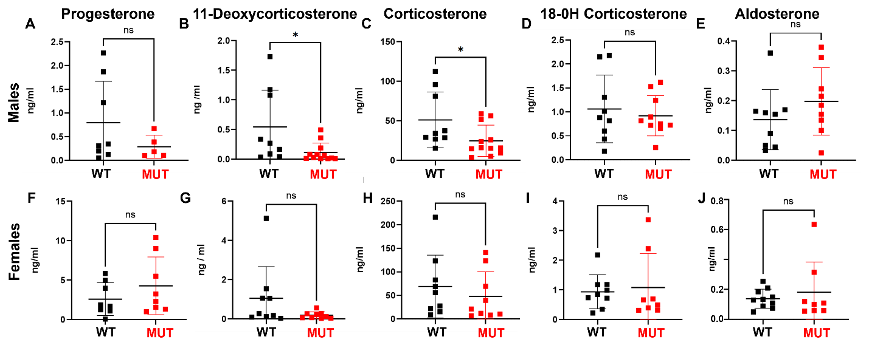

Supplemental Figure 2 Similar UCP1 protein levels in Dguok^{F180S/F180S} mutant and control littermate mice in subscapular brown adipose tissue.
Representative western blot of UCP1 protein levels in BAT (A). H/E staining of the BAT of control littermate (B) and mutant animals (C). WT: Wild type animals, MUT: Dguok^{F180S/F180S}, Ucp1: Uncoupling protein 1.
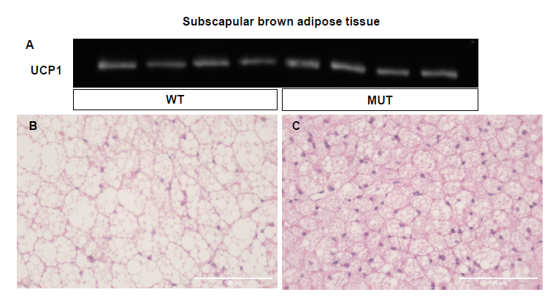

Supplemental Figure 3 Conservation of the missense mutation F180S among species.
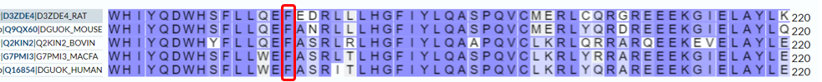
Supplemental Figure 4: Top 5 predicted 3-dimensional models for the wild type (WT) and F180S mutant DGUOK protein (Source https://zhanggroup.org/I-TASSER/).
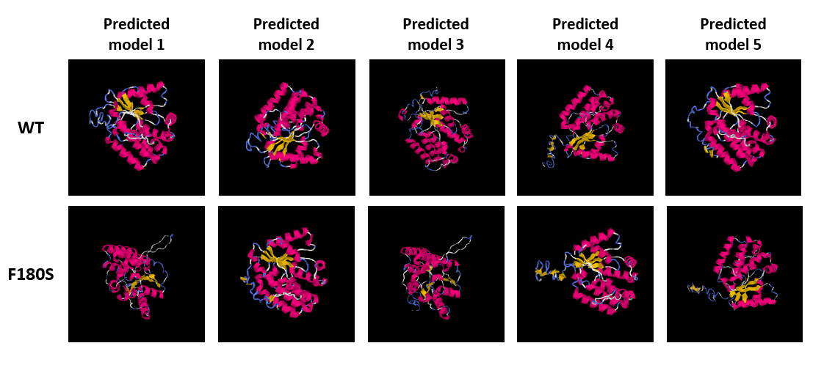
Supplemental Table 1: Primer pairs for sequencing or qPCR analysis of the respective genes.
Atp5b F | 5’-GGTTCATCCTGCCAGAGACTA-3’
Atp5b R | 5’- AATCCCTCATCGAACTGGACG-3’
Citrate Synthase F | 5'-CGG TTT GTC TAC CCT TCC CC-3'
Citrate Synthase R | 5'-GGC AGG ATG AGT TCT TGG CT-3'
Dck F | 5'-CAG CTA GCC TCT CTC AAT GGC A-3'
Dck R | 5'-GCT GTT CAT CCA GTC GTG CCA-3'
Dguok Seq F | 5'-GCT AAC TCT CCT GCT CTC ATG AC-3'
Dguok Seq R | 5'-GCT CAG AGT TAC CTG GGG TGA-3'
Dguok c (Mut) | TEX-gTTTgCg+gACTC+CTg--BBQ | “+” = LNA base
Dguok c (WT) | Cy5-ggTTTgCg+AAC+TC+CTg--BBQ | “+” = LNA base
Dguok F Geno | 5'-CAG TGA CAT CGA GTG GCA CA-3' | RT-qPCR genotyping
Dguok R Geno | 5'-GCT CAG AGT TAC CTG GGG TG-3' | RT-qPCR genotyping
Gadph F | 5'-GCA TTG TGG AAG GGC TCA TGA CC-3'
Gadph R | 5'-TTC TCC AGG CGG CAC GTC AGA T-3'
Idh1 F | 5'-ATG CAA GGA GAT GAA ATG ACA CG-3'
Idh1 R | 5'-GCA TCA CGA TTC TCT ATG CCT AA-3'
Idh2 F | 5’-GGAGAAGCCGGTAGTGGAGAT-3’
Idh2 R | 5’-GGTCTGGTCACGGTTTGGAA-3’
Lep F | 5'-ACA TTT CAC ACA CGC AGT CGG TAT-3'
Lep R | 5'-TGA GGA CCT GTT GAT AGA CTG CCA G-3'
Nampt F | 5'-GCA GAA GCC GAG TTC AAC ATC-3'
Nampt R | 5'-TTT TCA CGG CAT TCA AAG TAG GA-3'
Mt-Nd1 S | 5’-TCG ACC TGA CAG AAG GAG AAT CA-3’ | Mt-DNA quantification
Mt-Nd1 AS | 5’-GGG CCG GCT GCG TAT T-3’ | Mt-DNA quantification
Nmnat1 F | 5'-TCT TGT ACG CAT CAC CGA CC-3'
Nmnat1 R | 5'-GCT GGG ATG AGC CCT TTC TT-3'
Nadsyn1 F | 5’-ACGGCTGCTCACTACTTGTTA-3’
Nadsyn1 R | 5’-CTGAGAACCGAGGCAACTTC-3’
Rpph F | 5’-GGA GAG TAG TCT GAA TTG GGT TAT GAG | Genomic DNA quantification
Rpph R | 5’-CAG CAG TGC GAG TTC AAT GG-3’ | Genomic DNA quantification
Sdha F | 5'-ACT GTT ATT GCT ACT GGG GGC-3'
Sdha R | 5'-TAC CTG TGG GGT GGA ACT GA-3'
Ucp1 F | 5'-TCA GGG AGA GAA ACA CCT GCC TC-3'
Ucp1 R | 5'-CTT GCA TTC TGA CCT TCA CGA CCT-3'
Tbp F | 5'-GAA GAA CAA TCC AGA CTA GCA-3'
Tbp R | 5'-CCT TAT AGG GAA CTT CAC AG-3'

