Supplementary Figure 1.
Flowchart showing the strategy used to identify new BMI loci in American Indians that also have some effect in the GIANT consortium dataset.

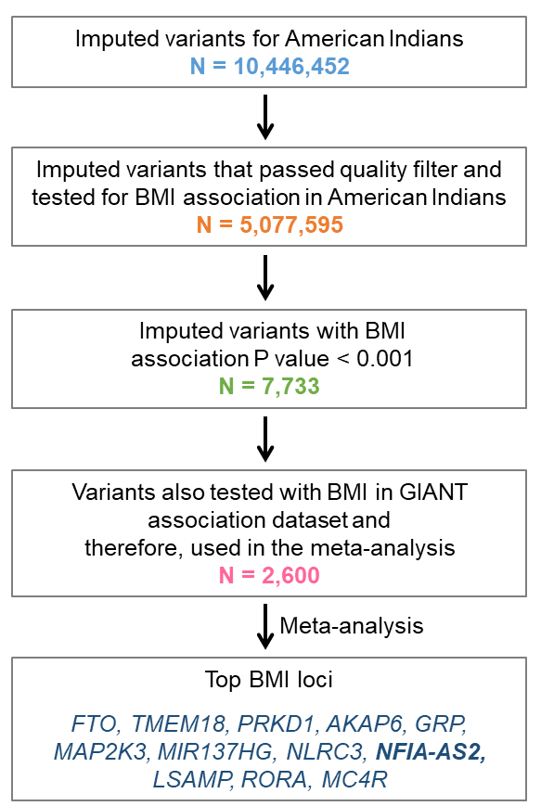

Supplementary Figure 2.
Figure showing the variants in the NFIA-AS2 region significantly associated with BMI in the combined American Indian + GIANT analysis. NFIA-AS2 transcript isoforms V1, V2 and V3 are indicated. The element harboring rs1777538 shows histone marks characteristic of gene enhancers and features chromatin interaction with the promoters of NFIA-AS2 and long isoform of NFIA (ENST00000371191.5).
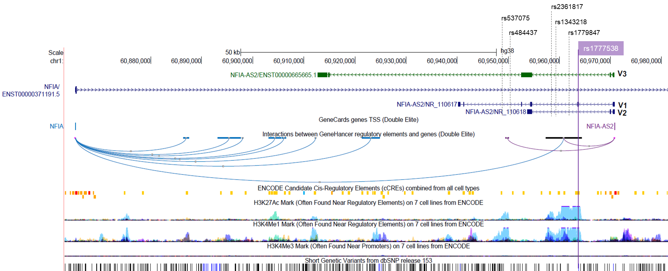

Supplementary Figure 3.
Poly(A) RNA sequencing data in brown and white adipose tissue of mouse was deduced from ENCODE v97 and was visualized in UCSC genome browser. NFIA-AS2 does not exist in mouse.
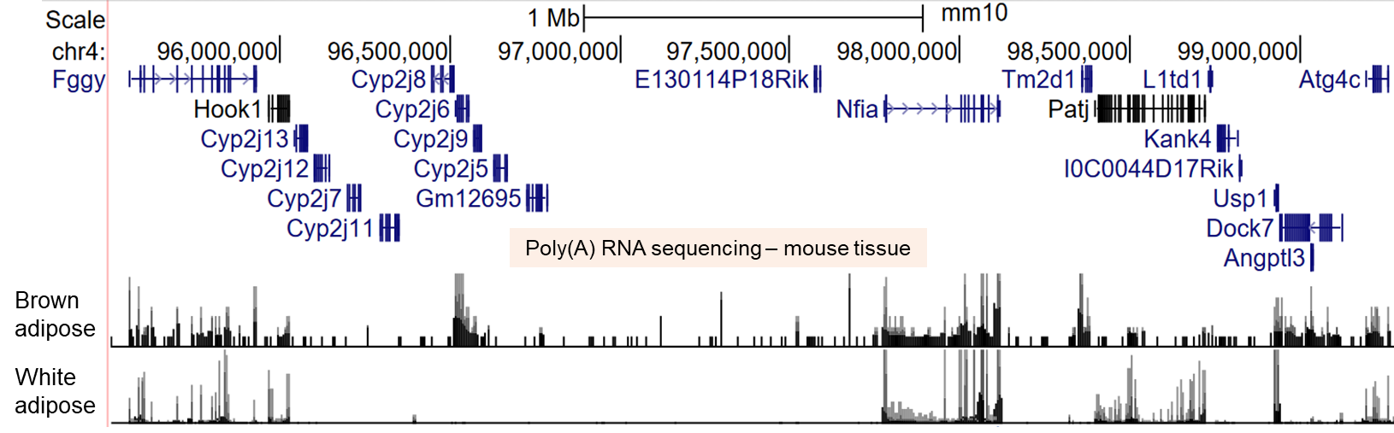

Supplementary Figure 4.
Secondary structures for the NFIA-AS2 transcripts containing either the rs1777538 T or C allele. The rs1777538 T>C variant does not significantly alter RNA secondary structure. Black arrows indicate the rs1777538 T and C nucleotides. The T to C substitution produces only a small change in the H-bonding of the flanking bases. The secondary structures were predicted using SNPfold.
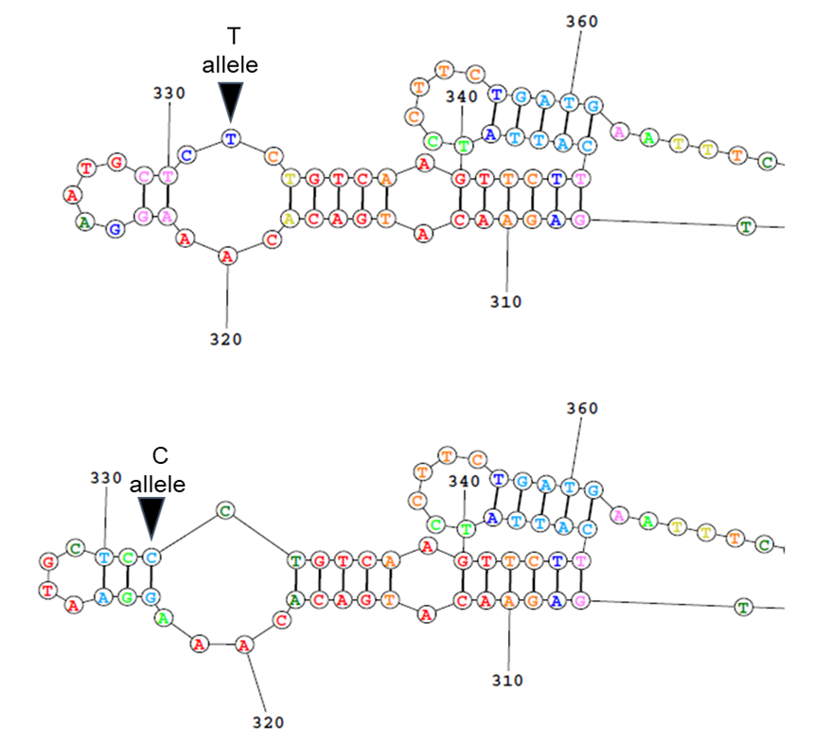

Supplementary Figure 5.
Expression of neighboring genes of NFIA-AS2 after treatment with miR6754-5p and miR4270 in HEK293 cells. Expression levels for each gene were normalized with TBP and are shown relative to the no miRNA control. Data is presented as mean + SE. The experiments were repeated on three separate days and done in triplicate per experiment.
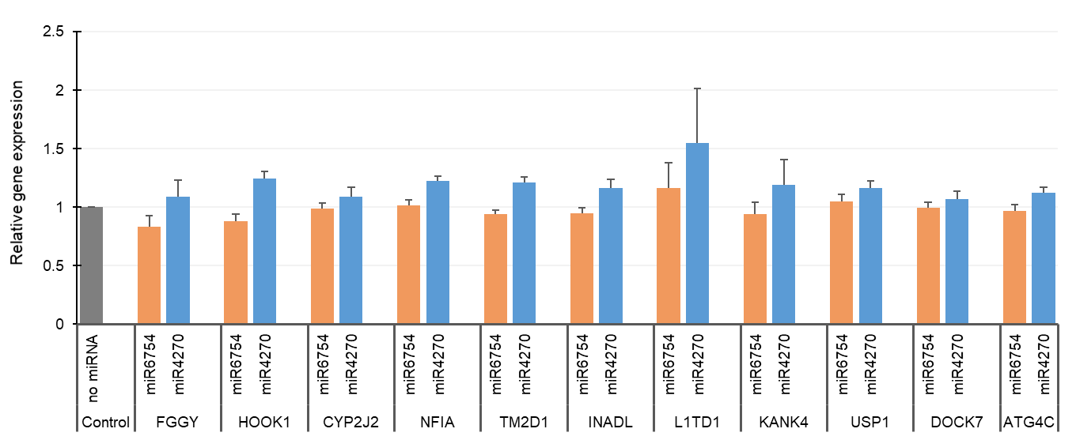
Supplementary Figure 6.
Expression of different marker genes during differentiation of brown preadipocytes. Expression levels for each gene were normalized with TBP and are shown relative to preadipocytes. Data is presented as mean + SE. The experiments were repeated on three separate days and done in triplicate per experiment. Preadipo, preadipocytes.
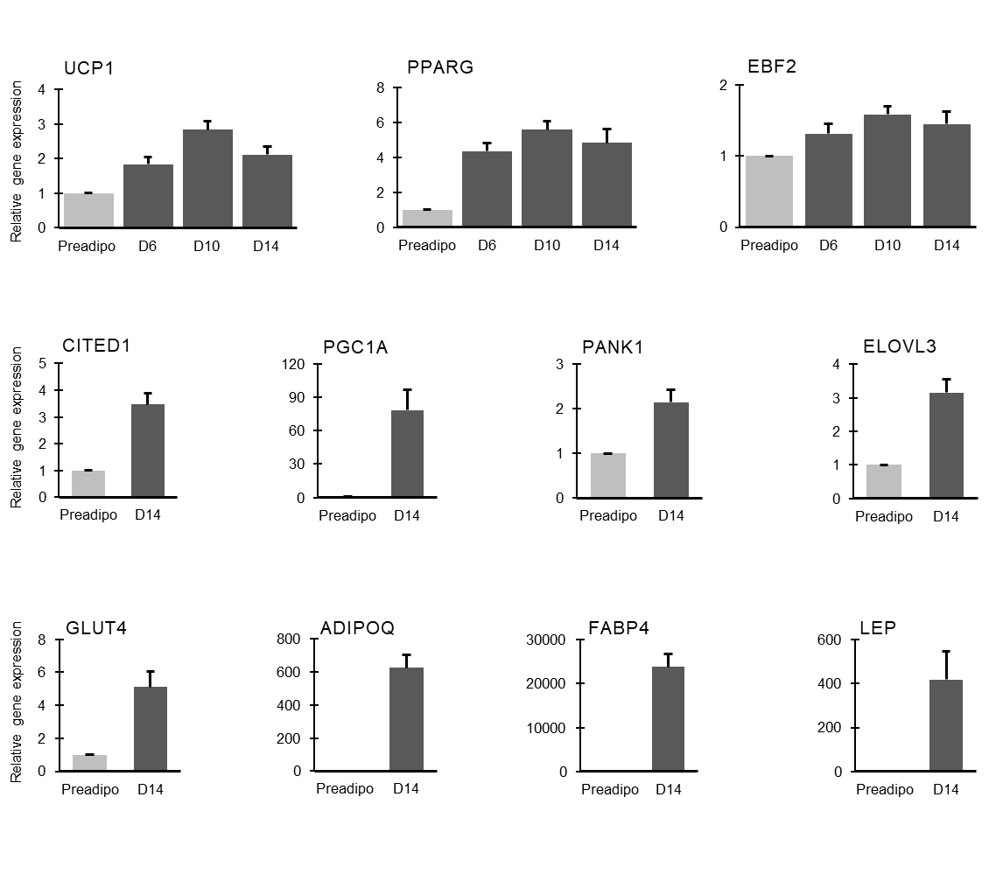
Supplementary Figure 7.
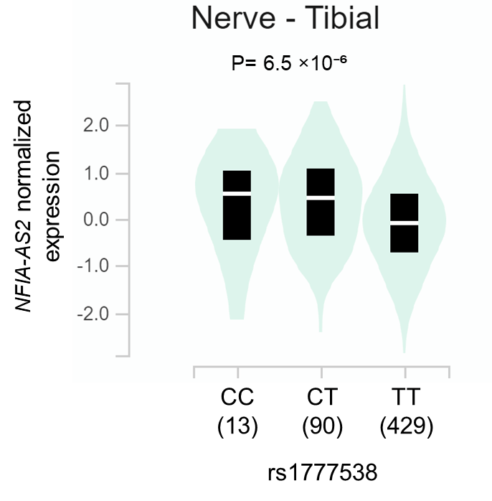
EQTL association data from GTEx database (version 8) showing that TT genotype of rs1777538 is associated with lower NFIA-AS2 expression in tibial nerve tissue. The violin plot depicts the density of gene expression levels in each genotype and the bar denotes the median values. P = Nominal p value generated for variant-gene pair by testing whether that the slope of a linear regression model between genotype and expression deviates from 0.

