Supplementary Information
Supplementary Table 1 – Classifications of children in cultural and ethnic groups based on language spoken at home and country of birth
Cultural and ethnic group | Country list | Language list
English | Australia, United Kingdom, England, Scotland, Wales, Northern Ireland, Ireland, New Zealand, Canada, USA, South Africa | English, Auslan
Middle East & North Africa | Algeria, Egypt, Libya, Morocco, Sudan, Bahrain, Gaza Strip and West Bank, Iran, Iraq, Israel, Jordan, Kuwait, Lebanon, Qatar, Saudi Arabia, Syria, Turkey, United Arab Emirates | Kurdish, Dari, Iranic not elsewhere classified, Arabic, Assyrian including Aramaic, Hebrew, Middle Eastern Semitic Languages not elsewhere classified, Turkish
East Asia | Myanmar, Cambodia, Laos, Thailand, Vietnam, Brunei Darussalam, Indonesia, Malaysia, Philippines, Singapore, Timor-Leste, China (excludes SARs and Taiwan), Hong Kong (SAR of China), Macau (SAR of China), Taiwan, Japan, South Korea | Burmese, Burmese and related languages not elsewhere classified, Hmong-Miean, Khmer, Vietnamese, Mon-Khmer, Lao, Thai, Cebuano, Ilokano, Indonesian, Malay, Tetum, Tagalog, Other Southeast Asian languages, Cantonese, Hakka, Hokkien, Teochew, Mandarin, Chinese not elsewhere classified, Japanese, Korean,
South and Central Asia | Bangladesh, India, Maldives, Nepal, Pakistan, Sri Lanka, Afghanistan, Armenia, Azerbaijan, Georgia, Kazakhstan, Kyrgyzstan, Tajikistan, Turkmenistan, Uzbekistan | Kannada, Malayalam, Tamil, Telegu, Bengali, Gujurati, Hindi, Konkani, Marathi, Nepali, Punjabi, Sindhi, Sinhalese, Urdu, Indo-Aryan not elsewhere classified, Other Southern Asian langauges
Europe | Austria, Belgium, France, Germany, Luxembourg, Netherlands, Switzerland, Denmark, Finland, Norway, Sweden, Gibraltar, Italy, Malta, Portugal, Spain, Albania, Bosnia and Herzegovina, Croatia, Cyprus, North Macedonia, Greece, Moldova, Romania, Slovenia, Serbia, Czechia, Estonia, Hungary, Lithuania, Poland, Russia Federation, Slovakia, Ukraine | Danish, Norwegian, Swedish, Finnish, French, Greek, Portuguese, Spanish, Italian, Maltese, Latvian, Hungarian, Lithuanian, Russian, Ukrainian, Bosnian, Croatian, Slovene, Serbian, Polish, Slovak, Romanian, Albanian, Other Eastern European languages not elsewhere classified
Africa | Ghana, Liberia, Nigeria, Sierra Leone, Angola, Eritrea, Ethiopia, Kenya, Malawi, Mauritius, Namibia, Seychelles, Somalia, Eswatini, Tanzania, Uganda, Zambia, Zimbabwe, Southern and Eastern Africa, not elsewhere classified | Acholi, Mauritian Creole, Oromo, Somali, Swahili, Amharic, Tigre, African languages not elsewhere classified, French
Americas | South America, no further description, Argentina, Bolivia, Brazil, Chile, Colombia, Ecuador, Guyana, Peru, Uruguay, Venezuela, Costa Rica, El Salvador, Honduras, Mexico, Nicaragua, Bahamas, Caribbean, no further description, Jamaica, Trinidad and Tobago | Spanish, Portuguese, English
Oceania | New Caledonia, Papua New Guinea, Solomon Islands, Melanesia/Polynesia not further described, Cook Islands, Fiji, Niue, Samoa, Samoa, American, Tonga | Fijian, Maori Cook Island, Maori New Zealand, Motu, Niue, Samoan, Tongan, Pacific Austronesian languages not elsewhere classified, Oceanian Pidgins and Creoles not elsewhere classified Kiwai
Aboriginal and Torres Strait Islander | Variable specified in LSAC | Variable specified in LSAC
*Lack of languages listed by participants in the study
Supplementary Figure 1 – Cultural and ethnic groups specified by countries (Aboriginal and Torres Strait Islander excluded)
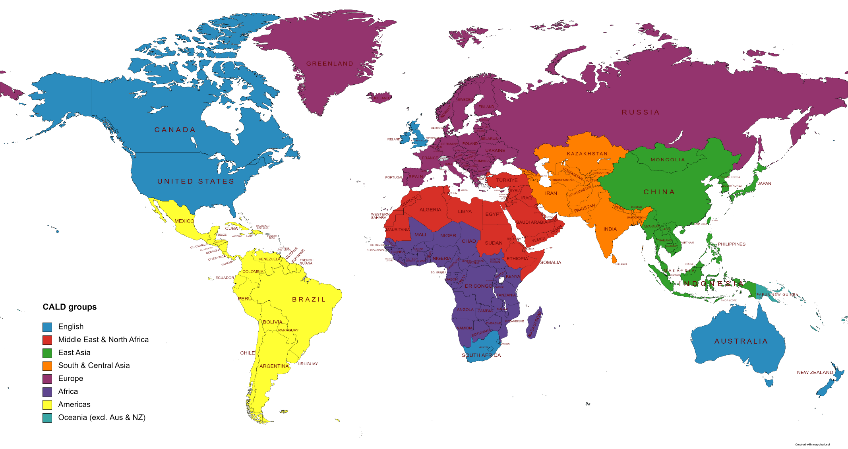
*Aboriginal and Torres Strait Islander not included
Supplementary Table 2 - How children were classified into cultural and ethnic groups
At baseline, children were classified using a combination of 6 variables collected in the Longitudinal Study of Australian Children (LSAC), with the exception of Aboriginal and Torres Strait Islanders as they were defined using a separate variable in LSAC on their Aboriginal and Torres Strait Islander status. For each variable, they were assigned to a priority population group based on their country of birth and language spoken at home using the table above.
Country of birth | Main language spoken at home
1. In which country was the Study Child born? | 4. Does Study Child speak a language other than English at home?
2. In which country was Parent 1 born? | 5. Does Parent 1 speak a language other than English at home?
3. In which country was Parent 2 born? | 6. Does Parent 2 speak a language other than English at home?

A series of distinct decision rules were made to classify children to different priority populations based on family’s responses to the six variables. These were conducted sequentially to account for the different combinations of responses from participants.

Supplementary Figure 2 - How children were assigned to different cultural and ethnic groups using the variables ‘country of birth’ and ‘main language spoken at home’ collected in the Longitudinal Study of Australian Children for study child, parent 1 and parent 2
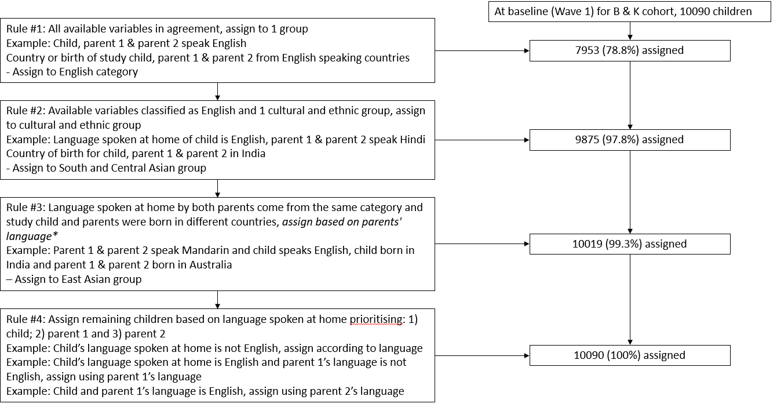
*Exceptions – to account for European colonization of the Americas and Africa, those who spoke a European language (Spanish/Portuguese) and were born in countries from the Americas were assigned to the Americas category, and those who spoke French and were born in African countries were assigned to the African category
Supplementary Table 3 - Sample size of priority populations by wave, cohort and sex
B cohort
Age | 2-3 years |  | 4-5 years |  | 6-7 years |  | 8-9 years |  | 10-11 years |  | 12-13 years |  | 14-15 years
Wave | 2 |  | 3 |  | 4 |  | 5 |  | 6 |  | 7 |  | 8
Sex | Male | Female | Male | Female | Male | Female | Male | Female | Male | Female | Male | Female | Male | Female
English | 1747 (76.0%) | 1712 (77.5%) | 1706 (77.4%) | 1658 (78.7%) | 1658 (77.3%) | 1594 (78.8%) | 1610 (78.8%) | 1556 (79.9%) | 1430 (78.4%) | 1391 (80.0%) | 1286 (78.4%) | 1238 (81.0%) | 1194 (78.4%) | 1129 (80.5%)
Middle East & North Africa | 54 (2.4%) | 71 (3.2%) | 52 (2.4%) | 66 (3.1%) | 52 (2.4%) | 67 (3.3%) | 27 (1.3%) | 29 (1.5%) | 36 (2.0%) | 52 (3.0%) | 34 (2.1%) | 37 (2.4%) | 34 (2.2%) | 37 (2.6%)
East Asian | 125 5.4%) | 112 5.1%) | 109 4.9%) | 97 (4.6%) | 109 5.1%) | 94 (4.7%) | 95 (4.7%) | 87 (4.5%) | 93 (5.1%) | 83 (4.8%) | 81 (4.9%) | 73 (4.8%) | 78 (5.1%) | 69 (4.9%)
South & Central Asia | 62 (2.7%) | 26 (1.2%) | 56 (2.5%) | 25 (1.2%) | 54 (2.5%) | 20 (1.0%) | 41 (2.0%) | 21 (1.1%) | 49 (2.7%) | 20 (1.2%) | 44 (2.7%) | 13 (0.9%) | 43 (2.8%) | 16 (1.1%)
Europe | 140 (6.1%) | 138 (6.3%) | 135 (6.1%) | 132 (6.3%) | 131 (6.1%) | 129 (6.4%) | 97 (4.8%) | 101 (5.2%) | 116 (6.4%) | 102 (5.9%) | 104 (6.3%) | 94 (6.2%) | 93 (6.1%) | 86 (6.1%)
Africa | 12 (0.5%) | 19 (0.9%) | 10 (0.5%) | 17 (0.8%) | 8 (0.4%) | 16 (0.8%) | 26 (1.3%) | 31 (1.6%) | 6 (0.3%) | 14 (0.8%) | 4  (0.2%) | 11 (0.7%) | 4 (0.3%) | 10 (0.7%)
Americas | 21 (0.9%) | 20 (0.9%) | 21 (1.0%) | 18 (0.9%) | 18 (0.8%) | 18 (0.9%) | 45 (2.2%) | 34 (1.8%) | 16 (0.9%) | 14 (0.8%) | 16 (1.0%) | 13 (0.9%) | 17 (1.1%) | 11 (0.8%)
Oceania | 45 (2.0%) | 27 (1.2%) | 41 (1.9%) | 23 (1.1%) | 39 (1.8%) | 19 (0.9%) | 32 (1.6%) | 24 (1.2%) | 27 (1.5%) | 19 (1.1%) | 28 (1.7%) | 14 (0.9%) | 24 (1.6%) | 13 (0.9%)
Aboriginal & Torres Strait Islander | 92 (4.0%) | 83 (3.8%) | 75 (3.4%) | 70 (3.3%) | 76 (3.5%) | 66 (3.3%) | 69 (3.4%) | 64 (3.3%) | 50 (2.7%) | 44 (2.5%) | 43 (2.6%) | 36 (2.4%) | 36 (2.4%) | 32 (2.3%)
K cohort
Age | 6-7 years |  | 8-9 years |  | 10-11 years |  | 12-13 years |  | 14-15 years |  | 16-17 years |  | 18 years
Wave | 2 |  | 3 |  | 4 |  | 5 |  | 6 |  | 7 |  | 8
Sex | Male | Female | Male | Female | Male | Female | Male | Female | Male | Female | Male | Female | Male | Female
English | 1687 (75.0%) | 1613 (74.4%) | 1666 (76.0%) | 1586 (75.7%) | 1575 (76.5%) | 1478 (76.0%) | 1499 (77.0%) | 1413 (76.2%) | 1315 (77.8%) | 1220 (77.3%) | 1153 (78.0%) | 1062 (76.9%) | 583 (76.6%) | 551 (74.1%)
Middle East & North Africa | 58 (2.6%) | 40 (1.9%) | 52 (2.4%) | 30 (1.4%) | 48 (2.3%) | 24 (1.2%) | 39 (2.0%) | 21 (1.1%) | 32 (1.9%) | 14 (0.9%) | 26 (1.8%) | 15 (1.1%) | 13 (1.7%) | 10 (1.3%)
East Asian | 130 (5.8%) | 137 (6.3%) | 128 (5.8%) | 131 (6.3%) | 115 (5.6%) | 120 (6.2%) | 114 (5.9%) | 117 (6.3%) | 98 (5.8%) | 102 (6.5%) | 86 (5.8%) | 91 (6.6%) | 53 (7.0%) | 59 (7.9%)
South & Central Asia | 51 (2.3%) | 57 (2.6%) | 49 (2.2%) | 58 (2.8%) | 46 (2.2%) | 51 (2.6%) | 42 (2.2%) | 54 (2.9%) | 44 (2.6%) | 48 (3.0%) | 37 (2.5%) | 36 (2.6%) | 25 (3.3%) | 21 (2.8%)
Europe | 173 (7.7%) | 156 (7.2%) | 164 (7.5%) | 148 (7.1%) | 155 (7.5%) | 144 (7.4%) | 144 (7.4%) | 129 (7.0%) | 122 (7.2%) | 104 (6.6%) | 101 (6.8%) | 96 (7.0%) | 57 (7.5%) | 65 (8.7%)
Africa | 14 (0.6%) | 33 (1.5%) | 16 (0.7%) | 30 (1.4%) | 14 (0.7%) | 29 (1.5%) | 12 (0.6%) | 27 (1.5%) | 10 (0.6%) | 21 (1.3%) | 8  (0.5%) | 23 (1.7%) | 4 (0.5%) | 12 (1.6%)
Americas | 27 (1.2%) | 26 (1.2%) | 25 (1.1%) | 24 (21.2%) | 22 (1.1%) | 23 (1.2%) | 19 (1.0%) | 24 (1.3%) | 14 (0.8%) | 18 (1.1%) | 17 (1.2%) | 17 (1.2%) | 8 (1.1%) | 13 (1.8%)
Oceania | 36 (1.6%) | 27 (1.3%) | 35 (1.6%) | 25 (1.2%) | 31 (1.5%) | 24 (1.2%) | 28 (1.4%) | 18 (1.0%) | 22 (1.3%) | 14 (0.9%) | 19 (1.3%) | 12 (0.9%) | 9 (1.2%) | 1 (0.1%)
Aboriginal & Torres Strait Islander | 72 (3.2%) | 78 (3.6%) | 58 (2.6%) | 63 (3.0%) | 52 (2.5%) | 52 (2.7%) | 51 (2.6%) | 51 (2.8%) | 34 (2.0%) | 38 (2.4%) | 31 (2.1%) | 30 (2.2%) | 9 (1.2%) | 12 (1.6%)

Supplementary Table 4 - Mean BMI z-score values by cultural and ethnic groups by age
Age | 2-3 yrs | 4-5 yrs | 6-7 yrs | 8-9 yrs | 10-11 yrs | 12-13 yrs | 14-15 yrs | 16-17 yrs | 18-19 yrs
English | 0.89 (1.04) | 0.65 (1.04) | 0.51 (1.05) | 0.56 (1.13) | 0.52 (1.17) | 0.46 (1.16) | 0.46 (1.13) | 0.46 (1.17) | 0.49 (1.25)
Middle East & North Africa | 1.11 (1.11) | 1.08 (1.25) | 0.86 (1.26) | 0.97 (1.30) | 1.02 (1.24) | 0.84 (1.21) | 0.79 (1.35) | 0.94 (1.23) | 0.92 (1.39)
East Asia | 0.83 (1.15) | 0.56 (1.17) | 0.36 (1.09) | 0.40 (1.20) | 0.47 (1.21) | 0.36 (1.14) | 0.33 (1.09) | 0.27 (1.10) | 0.18 (1.18)
South & Central Asian | 0.24 (1.23) | 0.15 (1.22) | 0.15 (1.27) | 0.36 (1.32) | 0.31 (1.32) | 0.19 (1.35) | 0.09 (1.22) | -0.03 (1.21) | 0.06 (1.15)
Europe | 0.86 (0.96) | 0.67 (1.04) | 0.58 (1.08) | 0.61 (1.19) | 0.62 (1.22) | 0.55 (1.20) | 0.47 (1.12) | 0.49 (1.18) | 0.56 (1.21)
Africa | 0.61 (1.11) | 0.56 (1.21) | 0.22 (1.00) | 0.44 (1.12) | 0.34 (1.24) | 0.19 (1.28) | 0.41 (1.15) | 0.31 (1.01) | 0.06 (1.30)
Americas | 1.14 (1.02) | 0.98 (1.00) | 0.85 (1.10) | 1.12 (1.40) | 0.97 (1.25) | 0.88 (1.13) | 0.77 (0.98) | 0.78 (0.99) | 0.85 (1.02)
Oceania | 1.03 (1.21) | 0.93 (1.30) | 1.03 (1.38) | 1.14 (1.48) | 1.00 (1.34) | 0.99 (1.47) | 0.89 (1.44) | 1.27 (1.26) | 1.26 (1.00)
Aboriginal & Torres Strait Islander | 0.86 (1.15) | 0.46 (1.12) | 0.58 (1.28) | 0.77 (1.36) | 0.72 (1.42) | 0.79 (1.44) | 0.80 (1.38) | 0.98 (1.46) | 0.58 (1.37)

Supplementary Table 5 - Number of children interviewed at each wave by cohort, attrition rate and those with complete information on body-mass index and priority population
B Cohort
Wave | Age of children | Children interviewed | Complete information on BMI
2 | 2-3 | 4606 | 4506 (97.83%)
3 | 4-5 | 4386 | 4311 (98.29%)
4 | 6-7 | 4242 | 4168 (98.26%)
5 | 8-9 | 4085 | 3989 (97.65%)
6 | 10-11 | 3764 | 3562 (94.63%)
7 | 12-13 | 3381 | 3169 (93.73%)
8 | 14-15 | 3127 | 2926 (93.57%)
K Cohort
2 | 6-7 | 4464 | 4415 (98.90%)
3 | 8-9 | 4331 | 4288 (99.01%)
4 | 10-11 | 4169 | 4003 (96.02%)
5 | 12-13 | 3956 | 3802 (96.11%)
6 | 14-15 | 3537 | 3270 (92.45%)
7 | 16-17 | 3089 | 2860 (92.59%)
8 | 18-19 | 3037 | 1601 (52.72%)

Supplementary Table 6 -Missing data for variables used to classify priority populations at baseline
Variable | B | K
Country of birth – Study Child | 0 | 0
Country of birth – Parent 1 | 0 | 1
Country of birth – Parent 2 | 478 | 697
Main language spoken at home – Study Child | 3 | 0
Main language spoken at home – Parent 1 | 0 | 0
Main language spoken at home – Parent 2 | 477 | 697
Aboriginal and Torres Strait Islander status | 175 | 150

Supplementary Table 7 – Multilevel linear regression models examining cultural and ethnic groups and the association with BMI z-score across three periods of childhood
Period | Early childhood | Middle childhood | Adolescence
Sample | n=4715 | n=8992 | n=7348
Age | (2-5 years) | (6-11 years) | (12-18 years)
Variables | β (95% CI) | β (95% CI) | β (95% CI)
Cultural and ethnic groups (referent: English speaking)
Middle East & North African | 0.33 (0.16, 0.49)** | 0.42 (0.28, 0.56)** | 0.34 (0.16, 0.53)**
East Asian | -0.08 (-0.21, 0.04) | -0.11 (-0.21, -0.02)* | -0.15 (-0.26, -0.03)*
South & Central Asian | -0.58 (-0.78, -0.37)** | -0.28 (-0.43, -0.12)** | -0.32 (-0.50, -0.15)**
European | 0.00 (-0.11, 0.12) | 0.08 (-0.01, 0.17) | 0.06 (-0.04, 0.16)
African | -0.13 (-0.47, 0.21) | -0.23 (-0.47, 0.01) | -0.20 (-0.49, 0.09)
Americas | 0.30 (0.01, 0.59)** | 0.41 (0.18, 0.63) ** | 0.40 (0.15, 0.66)**
Oceania | 0.21 (-0.02, 0.43) | 0.59 (0.40, 0.78)** | 0.62 (0.39, 0.85)**
Aboriginal & Torres Strait Islander | -0.07 (-0.21, 0.07) | 0.13 (0.01, 0.26)* | 0.30 (0.14, 0.46)**
Between-children variance | 0.69 (0.65, 0.73) | 1.08 (1.05, 1.11) | 1.13 (1.09, 1.17)
Intraclass correlation coefficient | 0.61 | 0.81 | 0.83
*p<0.05, **p<0.01.
Supplementary Table 8 – Multilevel linear regression models examining socioeconomic position and the association with BMI z-score across three periods of childhood, adjusting for the confounder of cultural and ethnic group
Period | Early childhood | Middle childhood | Adolescence
Sample | n=4704 | n=8968 | n=7304
Age | (2-5 years) | (6-11 years) | (12-18 years)
Variables | β (95% CI) | β (95% CI) | β (95% CI)
Socioeconomic position (referent Quintile 5, most advantaged)
SEP Quintile 1 | 0.10 (0.02, 0.18)* | 0.22 (0.17, 0.27)** | 0.23 (0.18, 0.29)**
SEP Quintile 2 | 0.09 (0.01, 0.16)* | 0.17 (0.13, 0.22)** | 0.19 (0.13, 0.24)**
SEP Quintile 3 | 0.04 (-0.03, 0.12) | 0.10 (0.06, 0.14)** | 0.09 (0.04, 0.14)**
SEP Quintile 4 | 0.03 (-0.04, 0.10) | 0.04 (0.01, 0.08)* | 0.05 (0.01, 0.09)*
Cultural and ethnic groups (referent: English speaking)
Middle East & North African | 0.33 (0.15, 0.50)** | 0.39 (0.25, 0.53)** | 0.30 (0.11, 0.49)**
East Asian | -0.07 (-0.19, 0.06) | -0.11 (-0.21, -0.01)* | -0.15 (-0.27, -0.04)**
South & Central Asian | -0.56 (-0.76, -0.36)** | -0.24 (-0.39, -0.09)** | -0.29 (-0.46, -0.12)**
European | 0.01 (-0.10, 0.13) | 0.10 (0.01, 0.19)* | 0.08 (-0.02, 0.18)
African | -0.13 (-0.47, 0.21) | -0.21 (-0.45, 0.03) | -0.17 (-0.46, 0.12)
Americas | 0.30 (0.01, 0.59)* | 0.42 (0.20, 0.65) ** | 0.42 (0.17, 0.67)**
Oceania | 0.21 (-0.01, 0.44) | 0.57 (0.39, 0.76)** | 0.58 (0.36, 0.81)**
Aboriginal & Torres Strait Islander | -0.08 (-0.23, 0.06) | 0.08 (-0.05, 0.20)* | 0.27 (0.10, 0.43)**
Between-children variance | 0.69 (0.65, 0.73) | 1.06 (1.03, 1.10) | 1.12 (1.08, 1.16)
Intraclass correlation coefficient | 0.61 | 0.81 | 0.83
*p<0.05, **p<0.01.
SEP – Socioeconomic position

