Supplementary Information

Accurate Prediction of Three-Dimensional Humanoid Avatars for Anthropometric Modeling

Cassidy McCarthy¹, Michael C. Wong², Jasmin Brown¹, Sophia Ramirez¹, Shengping Yang¹, Jonathan P. Bennett², John A. Shepherd², Steven B. Heymsfield¹

¹Pennington Biomedical Research Center, Louisiana State University System, Baton Rouge, LA, USA; ²University of Hawaii Cancer Center, Honolulu, HI, USA
Address Correspondence to:
Steven B. Heymsfield, MD
Pennington Biomedical Research Center
6400 Perkins Road
Baton Rouge, LA, USA 70808
Tel: 225-763-2541
Fax: 225-763-3030
E-mail: steven.heymsfield@pbrc.edu

Contents:
SI. Circumference measurements sites.
Figure S1. Body landmarks.
Table S1. Manifold regression model sample characteristics.
Table S2. Prospective sample characteristics.
Figure S2. Ground-truth and predicted avatars for a representative male and female.

SI. Circumference measurement sites¹.
- Waist Circumference was measured at the lateral border of the right ilium of the pelvis.
- Hip Circumference was measured at the maximum circumference point within the trochanteric area.
- Upper Arm Circumference was measured at the midpoint between the acromion process and tip of the elbow. This point was landmarked standing behind the subject as he or she held their arms at a 90° angle with palms facing up and then measured with arms relaxed at his or her sides. Both arms were evaluated.
- Thigh Circumference was measured at the midpoint between the inguinal crease and the proximal boarder of the patella. This point was landmarked with the subject in a seated position with the legs positioned at a 90° angle and then measured in a standing position with a slight bend at the knee. Both legs were evaluated.

Figure S1. Circumference landmarks generated by the Universal Software. Colors represent body regions demarcated by the software that also provides related volumes and surface areas^{2, 3}.
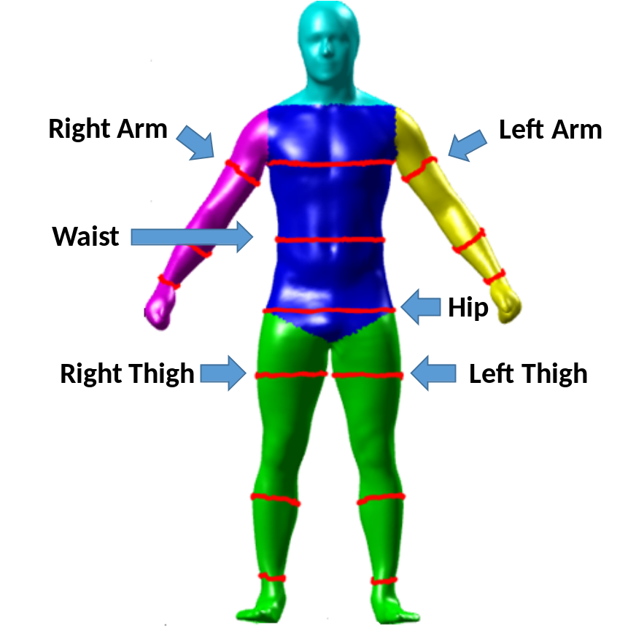

- Centers for Disease Control and Prevention (CDC), National Center for Health Statistics (NCHS). National Health and Nutrition Examination Survey (NHANES): Anthropometry Procedures Manual. Hyattsville, MD: Centers for Disease Control and Prevention; 2007
https://www.cdc.gov/nchs/data/nhanes/nhanes_07_08/manual_an.pdf.
- Sobhiyeh S, Dunkel A, Dechenaud M, Mehrnezhad A, Kennedy S, Shepherd J, Wolenski P, Heymsfield SB. Digital anthropometric volumes: Toward the development and validation of a universal software. Med Phys. 2021 Jul;48(7):3654-3664. doi: 10.1002/mp.14829. Epub 2021 Jul 9. PMID: 33694162.
- Sobhiyeh S, Kennedy S, Dunkel A, et al. Digital anthropometry for body circumference measurements: Toward the development of universal three‐dimensional optical system analysis software. Obes Sci Pract. 2021;7:35–44. https://doi.org/10.1002/osp4.467

Table S1. Characteristics of the adult sample used in developing the manifold regression equations. Modified from (1).
 | Males | Females
 | (n=258) | (n=312)
Age (yrs)
Mean (SD) | 43.8 (16.0) | 45.8 (15.8)
Median [Min, Max] | 42.5 [18.0, 79.0] | 47.0 [18.0, 75.0]
Height (cm)
Mean (SD) | 176 (7.59) | 162 (6.95)
Median [Min, Max] | 176 [151, 202] | 162 [144, 181]
Weight (kg)
Mean (SD) | 87.2 (20.4) | 71.9 (20.4)
Median [Min, Max] | 83.8 [40.6, 174] | 68.6 [35.4, 153]
BMI (kg/m²)
Mean (SD) | 28.1 (5.86) | 27.2 (7.43)
Median [Min, Max] | 27.4 [17.0, 52.6] | 26.4 [14.2, 53.1]
BMI, body mass index; SD, standard deviation.
- Wong MC, McCarthy C, Fearnbach N, Yang S, Shepherd J, Heymsfield SB. Emergence of the obesity epidemic: 6-decade visualization with humanoid avatars. Am J Clin Nutr. 2022;115:1189-1193.

Table S2. Prospective sample characteristics.

 | Males  (n=35) | Females  (n=49)
Age (y) | 43.0 ± 13.9 | 46.5 ± 16.9
Height (cm) | 178 ± 6.2 | 163.2 ± 6.5
Weight (kg) | 95.0 ± 22.0 | 65.6 ± 14.0
BMI (kg/m²) | 30.1 ± 6.6 | 24.6 ± 5.0
Fat (%) | 28.4 ± 8.2 | 35.2 ± 7.7
Results are mean±SD. Abbreviation: BMI, body mass index.

Figure S2. Ground-truth 3D digital avatar (left) and corresponding predicted avatar (right) for a representative man (upper panel) and woman (lower panel). BMI, body mass index; HC, hip circumference; WC, waist circumference. Predicted and ground-truth circumference measurements are in good agreement in the man but deviations are larger in the woman, notably for the waist circumference measurement.

