Supplementary material summary – file content
Supplementary Figure 1. Directed Acyclic Graphs to predict key confounders.
Supplementary Figure 2. Parallel analysis indicating the number of factors to be retained in the exploratory factor analysis.
Supplementary Table 1. Description of food groups and included food items in HELIX cohorts.
Supplementary Table 2. Sociodemographic characteristics by HELIX cohort (n=1597).
Supplementary Table 3. Description of child weekly dietary intake of food groups.
Supplementary Table 4. Description of sociodemographic characteristics of the a posteriori dietary patterns adherence (high adherence to each pattern) by cohort.
Supplementary Table 5. Associations between child KIDMED index and data-driven dietary patterns with child weight-related outcomes, within all six cohorts, restricting to the same population as prospective analyses.

Supplementary Figure 1. Directed Acyclic Graphs to predict confounders in the association between child dietary patterns and childhood and adolescence weight outcomes.
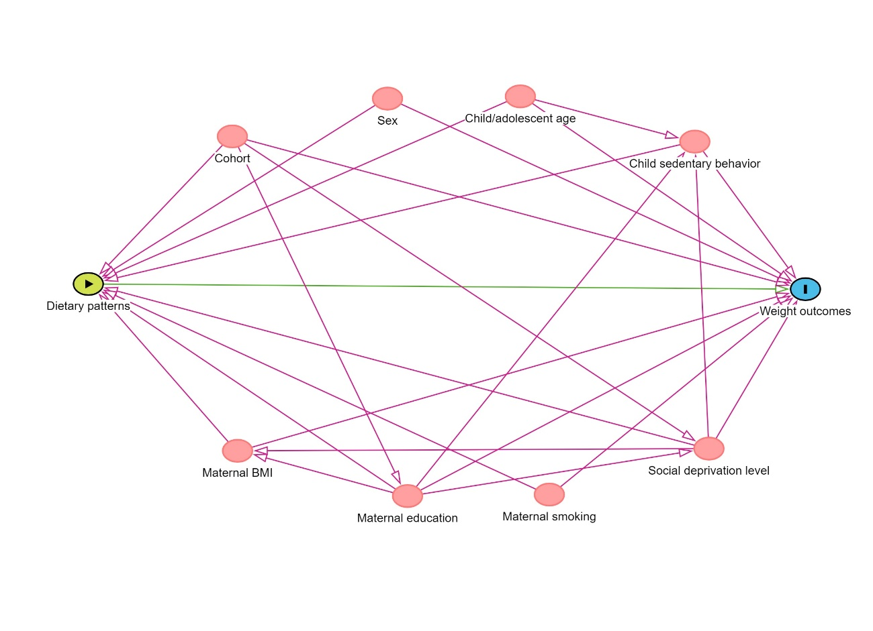

Supplementary Figure 2. Parallel analysis indicating the number of factors to be retained in the exploratory factor analysis.

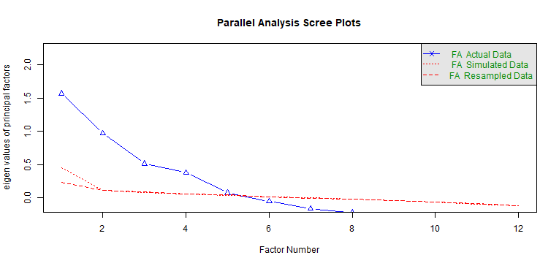

Supplementary Table 1. Description of the food items included in each of the main food groups in HELIX.
Food groups | Food items
Meat | Cold meat cuts + Ham + Poultry + Red meat
Processed meat | Cold meat cuts + Ham
Fish | Canned fish + Oily fish + White fish + Seafood
Sweets | Chocolate + Sweets + Sugar
Beverages | Diet SSB + SSB
Potatoes | French fries + Potatoes
Vegetables | Cooked vegetables + Raw vegetables
Dairy | Cheese + Milk + Yogurt + Probiotic yogurt + Desert
Yogurt | Yogurt + Probiotic yogurt
Fruits | Canned fruit + Dry fruits + Fresh juice + Fruits
Bread | Dark bread + White bread
Breakfast cereal | Sugar-sweetened breakfast cereals + Other breakfast cereals
Bakery products | Cookies + Pastries
Oil and fats | Butter + Margarine + Vegetable oil
Cereals | Dark bread + White bread + Rice & pasta + Sugar-sweetened breakfast cereals + Other breakfast cereals + Rusks
SSB: Sugar-sweetened beverages

Supplementary Table 2. Sociodemographic characteristics by HELIX cohort (n=1597).
 | BiB  (n=229) | EDEN  (n=205) | KANC (n=205) | MoBa  (n=290) | RHEA  (n=199) | INMA  (n=469)
Mother age (pre-pregnancy) (years)
Median [Min, Max] | 28.0  [16.0, 43.0] | 29.9  [20.0, 43.3] | 28.6  [19.2, 43.5] | 32.5  [23.0, 43.0] | 31.0  [17.0, 42.3] | 31.7  [18.2, 43.0]
Missing | 1 (0.4) | 0 (0.0) | 5 (2.4) | 8 (2.8) | 2 (1.0) | 49 (10.4)
Maternal pre-pregnancy BMI (Kg/m²) – n(%)
Underweight/ Healthy weight (BMI < 24.9 Kg/m²) | 65 (28.4) | 145 (70.7) | 60 (29.3) | 235 (81.0) | 141 (70.9) | 303 (64.6)
Overweight (BMI ≥ 24.9 & < 30 Kg/m²) | 84 (36.7) | 41 (20.0) | 82 (40.0) | 39 (13.4) | 37 (18.6) | 79 (16.8)
Obesity (BMI ≥ 30 Kg/m²) | 74 (32.3) | 17 (8.3) | 58 (28.3) | 8 (2.8) | 18 (9.0) | 38 (8.1)
Missing | 6 (2.6) | 2 (1.0) | 5 (2.4) | 8 (2.8) | 3 (1.5) | 49 (10.4)
Maternal educational level (pre-pregnancy) – n(%)
Low (primary school) | 98 (42.8) | 13 (6.3) | 13 (6.3) | 0 (0) | 9 (4.5) | 100 (21.3)
Middle (secondary school) | 35 (15.3) | 75 (36.6) | 71 (34.6) | 55 (19.0) | 110 (55.3) | 178 (38.0)
High (University or higher) | 70 (30.6) | 114 (55.6) | 116 (56.6) | 225 (77.6) | 78 (39.2) | 140 (29.9)
Missing | 26 (11.4) | 3 (1.5) | 5 (2.4) | 10 (3.4) | 2 (1.0) | 51 (10.9)
Maternal smoking during pregnancy – n(%)
Yes | 24 (10.5) | 45 (22.0) | 12 (5.9) | 0 (0.0) | 41 (20.6) | 54 (11.5)
No | 156 (68.1) | 151 (73.7) | 185 (90.2) | 251 (86.6) | 156 (78.4) | 163 (34.8)
Missing | 49 (21.4) | 9 (4.4) | 8 (3.9) | 39 (13.4) | 2 (1.0) | 252 (53.7)
Family affluence score (pre-pregnancy) – n(%)
Low | 65 (28.4) | 2 (1.0) | 31 (15.1) | 4 (1.4) | 30 (15.1) | 37 (7.9)
Medium | 98 (42.8) | 43 (21.0) | 107 (52.2) | 77 (26.6) | 102 (51.3) | 171 (36.5)
High | 66 (28.8) | 160 (78.0) | 67 (32.7) | 209 (72.1) | 67 (33.7) | 258 (55.0)
Missing | 0 (0.0) | 0 (0.0) | 0 (0.0) | 0 (0.0) | 0 (0.0) | 3 (0.6)
Child ethnicity – n(%)
African | 7 (3.1) | 0 (0.0) | 0 (0.0) | 0 (0.0) | 0 (0.0) | 5 (1.1)
Asian | 13 (5.7) | 1 (0.5) | 0 (0.0) | 7 (2.4) | 0 (0) | 2 (0.4)
Caucasian | 90 (39.3) | 200 (97.6) | 200 (97.6) | 258 (89.0) | 199 (100) | 381 (81.2)
Native American | 0 (0.0) | 0 (0.0) | 0 (0.0) | 2 (0.7) | 0 (0.0) | 9 (1.9)
Other | 17 (7.4) | 0 (0.0) | 0 (0.0) | 2 (0.7) | 0 (0.0) | 3 (0.6)
Pakistani | 81 (35.4) | 0 (0.0) | 0 (0.0) | 0 (0.0) | 0 (0.0) | 0 (0.0)
White non-European | 0 (0.0) | 0 (0.0) | 0 (0.0) | 0 (0.0) | 0 (0.0) | 25 (5.3)
Missing | 21 (9.2) | 4 (2.0) | 5 (2.4) | 21 (7.2) | 0 (0.0) | 44 (9.4)
BiB: Born in Bradford cohort; EDEN: The Étude des Déterminants pré et postnatals du développement et de la santé de l’Enfant study; INMA: INfancia y Medio Ambiente cohort; KANC: Kaunas cohort; MoBa: Norwegian Mother, Father and Child Cohort study; RHEA: Rhea Mother Child Cohort study.
Supplementary Table 3. Description of child weekly dietary intake of food groups overall and specifically in each HELIX cohort.
Food group weekly consumption - Median  [Min, Max] | Overall (n=1597) | Cohort (n)
Food group weekly consumption - Median  [Min, Max] | Overall (n=1597) | BiB (n=229) | EDEN (n=205) | KANC (n=205) | MoBa (n=290) | RHEA (n=199) | INMA (n=469)
Meat | 7.50  [0, 51.0] | 6.0  [0, 22.0] | 7.50  [2.0, 26.5] | 7.13  [0.89, 51.0] | 7.50  [0.50, 39.0] | 6.50  [2.0, 20.0] | 8.0  [1.76, 42.0]
Processed meat | 3.13  [0, 35.0] | 0.63  [0, 18.0] | 2.00  [0, 18.5] | 2.00  [0, 24.5] | 4.00  [0, 35.0] | 3.13  [0, 14.0] | 4.0  [0, 33.5]
Fish | 2.13  [0, 21.6] | 2.0  [0, 14.5] | 2.13  [0, 9.50] | 1.0  [0, 7.0] | 2.63  [0, 21.6] | 1.50  [0, 7.0] | 3.50  [0, 14.5]
Sweets | 6.50  [0, 57.0] | 7.0  [0, 31.5] | 8.50  [0.13, 42.0] | 9.50  [0.76, 57.0] | 5.00  [0.26, 27.5] | 6.0  [0, 29.0] | 4.50  [0, 34.0]
Beverages | 0.50  [0, 56.0] | 0.50  [0, 24.5] | 1.0  [0, 35.0] | 0.50  [0, 29.0] | 0.63  [0, 6.0] | 0.13  [0, 7.0] | 0.500  [0, 56.0]
Potatoes | 3.50  [0, 35.0] | 4.0  [0, 20.5] | 3.13  [0.63, 20.5] | 3.13  [0.50, 35.0] | 3.13  [0, 7.50] | 3.50  [0.50, 12.5] | 3.50  [0, 14.0]
Vegetables | 6.0  [0, 56.0] | 6.0  [0, 35.0] | 8.50  [0, 35.0] | 6.0  [0, 56.0] | 8.50  [0, 35.0] | 6.50  [0, 31.0] | 6.0  [0, 56.0]
Dairy | 19.5  [0, 71.0] | 24.0  [0, 64.0] | 25.5  [3.0, 71.0] | 11.0  [0, 65.5] | 20.8  [0, 59.5] | 22.5  [4.50, 54.0] | 18.0  [0, 63.0]
Fruits | 8.63  [0, 46.1] | 15.5  [0, 46.1] | 6.63  [0, 40.6] | 7.26  [0.13, 41.0] | 14.1  [0.50, 45.5] | 8.50  [0.13, 29.0] | 7.13  [0, 37.0]
Bakery products | 4.0  [0, 56.0] | 6.0  [0, 24.5] | 6.0  [0.26, 35.0] | 4.0  [0, 35.0] | 1.50  [0.13, 6.5] | 6.0  [0.63, 35.0] | 4.0  [0, 56.0]
Oil and fats | 4.0  [0, 38.0] | 7.0  [0, 31.5] | 5.63  [0, 38.0] | 7.0  [0, 38.0] | 7.50  [0.13, 38.0] | 1.0  [0, 10.0] | 1.0  [0, 21.0]
Yogurt | 3.50  [0, 35.0] | 7.0  [0, 35.0] | 7.0  [0, 35.0] | 3.0  [0, 35.0] | 3.13  [0, 24.5] | 3.0  [0, 17.5] | 5.63  [0, 35.0]
Data represent median values and minimum-maximum of weekly portions consumed. BiB: Born in Bradford cohort; EDEN: The Étude des Déterminants pré et postnatals du développement et de la santé de l’Enfant study; INMA: INfancia y Medio Ambiente cohort; KANC: Kaunas cohort; MoBa: Norwegian Mother, Father and Child cohort study; RHEA: Rhea Mother Child cohort study.
Supplementary Table 4. Description of sociodemographic characteristics of the a posteriori dietary patterns adherence (high adherence to each pattern) by cohort.
Cohort | Dietary pattern  (High adherence) | N  (% high adherence) |  |  | Sociodemographic characteristics
Cohort | Dietary pattern  (High adherence) | N  (% high adherence) | Child age (years - Median [Percentiles 25,75] or Mean (SD)) | Child sex (Male - n (%)) |  | Child sedentary behavior (min/day - Median [Percentiles 25,75]) | Maternal weight status  (Ov/Ob - n (%))ª | Maternal education  (High - n (%))ª | Maternal smoking during pregnancy (Yes – n(%)) | Family affluence score  (High - n (%))ª
MoBa | “Meat pattern” | 128 (44.1) | 8.5 [8.2;8.8] | 72 (56.2) |  | 184.6 [137.7;251.8] | 19 (15.2) | 101 (81.5) | 0 (0.0) | 96 (75.0)
MoBa | “Dairy pattern” | 99 (34.1) | 8.3 [8.2;8.6] | 56 (56.6) |  | 175.7 [141.8;223.9] | 15 (15.6) | 78 (81.2) | 0 (0.0) | 70 (70.7)
MoBa | “Western pattern” | 25 (8.6) | 8.4 [8.2;8.7] | 17 (68.0) |  | 194.3 [156.4;244.3] | 3 (12.0) | 20 (80.0) | 0 (0.0) | 19 (76.0)
MoBa | “Healthy pattern” | 168 (57.9) | 8.4 [8.2;8.7] | 93 (55.4) |  | 178.6 [137.8;244.6] | 24 (14.5) | 133 (80.6) | 0 (0.0) | 120 (71.4)
MoBa | “Sweets and fats pattern” | 131 (45.2) | 8.3 [8.2;8.7] | 76 (58.0) |  | 191.4 [141.1;239.5] | 24 (18.9) | 99 (78.6) | 0 (0.0) | 95 (72.5)
KANC | “Meat pattern” | 56 (27.3) | 6.3 [6.1;6.8] | 31 (55.4) |  | 372.9 [260.4;467.1] | 38 (70.4) | 26 (48.1) | 2 (3.6) | 19 (33.9)
KANC | “Dairy pattern” | 25 (12.2) | 6.3 [6.1;7.0] | 14 (56.0) |  | 377.1 [314.3;462.9] | 15 (62.5) | 12 (50.0) | 3 (12.0) | 9 (36.0)
KANC | “Western pattern” | 117 (57.1) | 6.3 [6.1;6.8] | 67 (57.3) |  | 368.6 [248.6;462.9] | 77 (67.0) | 65 (56.5) | 1 (3.2) | 34 (29.1)
KANC | “Healthy pattern” | 44 (21.5) | 6.3 [6.1;6.8] | 24 (54.5) |  | 385.7 [254.6;462.9] | 28 (63.6) | 23 (52.3) | 4 (9.1) | 15 (34.1)
KANC | “Sweets and fats pattern” | 130 (63.4) | 6.3 [6.1;6.9] | 68 (52.3) |  | 357.9 [253.0;462.9] | 88 (68.2) | 73 (56.6) | 0 (0.0) | 35 (26.9)
RHEA | “Meat pattern” | 42 (21.1) | 6.4 [6.4;6.5] | 29 (69.0) |  | 257.1 [173.6;303.2] | 14 (33.3) | 9 (21.4) | 14 (33.3) | 14 (33.3)
RHEA | “Dairy pattern” | 70 (35.2) | 6.5 [6.4;6.6] | 42 (60.0) |  | 210.0 [170.4;277.5] | 17 (24.3) | 24 (34.3) | 12 (17.1) | 23 (32.9)
RHEA | “Western pattern” | 73 (36.7) | 6.4 [6.4;6.6] | 41 (56.2) |  | 222.9 [180.0;288.6] | 27 (37.5) | 23 (31.9) | 7 (14.3) | 21 (28.8)
RHEA | “Healthy pattern” | 42 (21.1) | 6.4 [6.3;6.5] | 25 (59.5) |  | 203.2 [156.4;264.1] | 9 (22.0) | 18 (42.9) | 7 (16.7) | 15 (35.7)
RHEA | “Sweets and fats pattern” | 16 (8.0) | 6.4 [6.4;6.5] | 6 (37.5) |  | 225.0 [196.1;283.9] | 6 (37.5) | 5 (31.2) | 16 (14.2) | 4 (25.0)
INMA | “Meat pattern” | 208 (44.4) | 9.0 [8.5;9.6] | 119 (57.2) |  | 196.1 [155.2;252.9] | 51 (27.4) | 66 (35.9) | 28 (13.5) | 113 (54.6)
INMA | “Dairy pattern” | 120 (25.6) | 9.0 [8.5;9.5] | 78 (65.0) |  | 205.7 [154.3;259.3] | 36 (32.7) | 31 (28.4) | 16 (13.3) | 57 (47.5)
INMA | “Western pattern” | 126 (26.9) | 8.9 [8.4;9.5] | 64 (50.8) |  | 210.0 [175.7;272.1] | 28 (24.3) | 30 (26.3) | 19 (11.1) | 60 (47.6)
INMA | “Healthy pattern” | 104 (22.2) | 9.1 [8.6;9.6] | 57 (54.8) |  | 185.4 [152.1;245.0] | 30 (30.9) | 38 (39.2) | 9 (8.7) | 56 (54.4)
INMA | “Sweets and fats pattern” | 67 (14.3) | 8.8 [8.5;9.5] | 35 (52.2) |  | 212.1 [180.0;270.0] | 16 (26.2) | 16 (26.7) | 36 (14.1) | 32 (47.8)
BiB | “Meat pattern” | 50 (21.8) | 6.7 [6.4;6.8] | 29 (58.0) |  | 252.9 [180.0;334.3] | 38 (77.6) | 22 (52.4) | 6 (12.0) | 22 (44.0)
BiB | “Dairy pattern” | 115 (50.2) | 6.6 [6.4;6.8] | 60 (52.2) |  | 234.6 [157.5;299.6] | 77 (69.4) | 39 (36.4) | 9 (7.8) | 36 (31.3)
BiB | “Western pattern” | 105 (45.9) | 6.7 [6.4;6.8] | 60 (57.1) |  | 240.0 [147.9;287.1] | 69 (67.0) | 28 (30.8) | 5 (10.2) | 28 (26.7)
BiB | “Healthy pattern” | 121 (52.8) | 6.6 [6.4;6.8] | 74 (61.2) |  | 231.4 [151.4;285.7] | 84 (71.2) | 42 (40.8) | 9 (7.4) | 45 (37.2)
BiB | “Sweets and fats pattern” | 103 (45.0) | 6.7 [6.4;6.8] | 54 (52.4) |  | 227.1 [157.9;280.7] | 70 (70.0) | 28 (31.1) | 3 (7.5) | 29 (28.2)
EDEN | “Meat pattern” | 58 (28.3) | 10.8 (0.5) | 33 (56.9) |  | 188.6 [137.1;248.6] | 20 (34.5) | 31 (55.4) | 13 (22.4) | 46 (79.3)
EDEN | “Dairy pattern” | 114 (55.6) | 10.8 (0.6) | 67 (58.8) |  | 184.3 [134.5;226.1] | 37 (33.0) | 58 (51.3) | 25 (21.9) | 84 (73.7)
EDEN | “Western pattern” | 97 (47.3) | 10.8 (0.6) | 58 (59.8) |  | 186.4 [143.6;247.1] | 31 (32.0) | 56 (58.9) | 11 (27.5) | 80 (82.5)
EDEN | “Healthy pattern” | 64 (31.2) | 10.9 (0.6) | 31 (48.4) |  | 162.9 [115.7;205.7] | 16 (25.4) | 43 (69.4) | 11 (17.2) | 57 (89.1)
EDEN | “Sweets and fats pattern” | 96 (46.8) | 10.8 (0.6) | 53 (55.2) |  | 188.6 [154.3;237.5] | 34 (35.8) | 50 (53.2) | 11 (26.2) | 70 (72.9)
BiB: Born in Bradford cohort; EDEN: The Étude des Déterminants pré et postnatals du développement et de la santé de l’Enfant study; INMA: INfancia y Medio Ambiente cohort, Sabadell; KANC: Kaunas Cohort; KIDMED: Mediterranean Diet Quality Index for children and adolescents; MoBa: Norwegian Mother, Father and Child Cohort Study; RHEA: Rhea Mother Child Cohort study; SD: Standard deviation; Ov/Ob: Overweight/Obesity (BMI ≥24.9 Kg/m²). ª Maternal weight status and educational level, and family affluence score are all referred to the pre-pregnancy period, and only categories of high education (University degree or higher) and high family affluence score are described. Percentages are described by row (within the high level of adherence), in each cohort.

Supplementary Table 5. Associations between child KIDMED index and data-driven dietary patterns with child weight-related outcomes, within all six cohorts, restricting to the same population as prospective analyses.
 | zBMI (n=562) |  |  | Fat mass proportion (n=556) |  |  | Waist-to-height ratio (n=562)
 | High | Average | Low | High | Average | Low | High | Average | Low
KIDMED dietary pattern | Ref. | 0.04  (-0.21; 0.30) | -0.12  (-0.55; 0.31) | Ref. | 0.46  (-1.03; 1.95) | 1.05  (-1.95; 4.04) | Ref. | 0.00  (-0.01; 0.01) | -0.00  (-0.02; 0.00)
“Meat pattern” | Ref. | -0.04  (-0.31; 0.22) | -0.02  (-0.29; 0.24) | Ref. | 0.23  (-1.41; 1.87) | 0.14  (-1.54; 1.81) | Ref. | -0.00  (-0.01; 0.01) | -0.00  (-0.01; 0.01)
“Dairy pattern” | Ref. | -0.18  (-0.43; -0.07) | -0.37  (-0.64; -0.09) | Ref. | -1.01  (-2.59; 0.57) | -2.49  (-4.33; -0.65) | Ref. | -0.00  (-0.01; 0.00) | -0.02  (-0.03; -0.00)
“Western pattern” | -0.19  (-0.44; 0.06) | -0.15  (-0.41; 0.10) | Ref. | -0.54  (-2.06; 0.99) | -0.68  (-2.34; 0.97) | Ref. | -0.01  (-0.02; -0.00) | -0.00  (-0.01; 0.01) | Ref.
“Healthy pattern” | Ref. | 0.10  (-0.14; 0.34) | 0.17  (-0.08; 0.42) | Ref. | 1.63  (0.18; 3.08) | 1.66  (0.00; 3.33) | Ref. | 0.00  (-0.00; 0.01) | 0.01  (0.00; 0.02)
“Sweets and fats pattern” | 0.04  (-0.23; 0.30) | 0.01  (-0.24; 0.27) | Ref. | 0.56  (-1.24; 2.36) | 0.31  (-1.37; 1.98) | Ref. | 0.00  (-0.01; 0.01) | 0.00  (-0.01; 0.01) | Ref.
All models were adjusted for cohort, child age, sex, child sedentary behavior, FAS score, maternal age, smoking during pregnancy and education. Statistically significant values are highlighted in bold type (p<0.05). CI: Confidence intervals; zBMI: Body mass index z-score; Ref.: Reference category.

