Supplementary Information

The association of overweight, obesity, and long-term obesity with SARS-CoV-2 infection: a meta-analysis of 9 population-based cohorts in the Netherlands

Bette Loef¹, Jolanda M.A. Boer¹, Marian Beekman², Sophie L. Campman^{3,4,5}, Emiel O. Hoogendijk⁶, Floris Huider⁷, Demi M.E. Pagen^{8,9}, Marije J. Splinter¹⁰, Jeroen H.P.M. van der Velde¹¹, Dorret I. Boomsma⁷, Pieter C. Dagnelie¹², Jenny van Dongen⁷, Eco J.C. de Geus^{7,13}, Martijn Huisman^{6,14}, M. Arfan Ikram¹⁰, Annemarie Koster⁸, Silvan Licher¹⁰, Jochen O. Mierau^{15,16,17}, Renée de Mutsert¹¹, H. Susan J. Picavet¹, Frits R. Rosendaal¹¹, Miranda T. Schram^{10,12}, P. Eline Slagboom², Evie van der Spoel², Karien Stronks¹⁸, W.M. Monique Verschuren^{1,19}, Saskia W. van den Berg¹, Lifelines Corona Research initiative*

1 Center for Prevention, Lifestyle and Health, National Institute for Public Health and the Environment, Bilthoven, the Netherlands
2 Department of Biomedical Data Sciences, Section of Molecular Epidemiology, Leiden University Medical Center, the Netherlands
3 Department of Infectious Diseases, Public Health Service of Amsterdam, Amsterdam, the Netherlands
4 Amsterdam UMC location University of Amsterdam, Infectious Diseases, Amsterdam, the Netherlands
5 Amsterdam Institute for Immunology & Infectious Diseases, Amsterdam, the Netherlands
6 Department of Epidemiology and Data Science, Amsterdam Public Health Research Institute, Amsterdam UMC—Vrije Universiteit Amsterdam, Amsterdam, the Netherlands
7 Netherlands Twin Register, Vrije Universiteit Amsterdam; Amsterdam Reproduction and Development (AR&D) and Amsterdam Public Health (APH) Research Institutes, the Netherlands
8 Department of Social Medicine, CAPHRI Care and Public Health Research Institute, Maastricht University, Maastricht, the Netherlands
9 Department of Sexual Health, Infectious Diseases, and Environmental Health, Living Lab Public Health, South Limburg Public Health Service, Heerlen, the Netherlands
10 Department of Epidemiology, Erasmus University Medical Center, Rotterdam, the Netherlands
11 Department of Clinical Epidemiology, Leiden University Medical Center, Leiden, the Netherlands
12 Department of Internal Medicine and Heart and Vascular Center, Maastricht University Medical Centre+ (MUMC+), Cardiovascular Research Institute Maastricht (CARIM), Maastricht University, Maastricht, the Netherlands
13 Department of Biological Psychology, Vrije Universiteit Amsterdam, Amsterdam, the Netherlands
14 Department of Sociology, Vrije Universiteit, Amsterdam, the Netherlands
15 Department of Economics, Econometrics and Finance, Faculty of Economics and Business, University of Groningen, Groningen, the Netherlands
16 Lifelines Cohort Study and Biobank, Groningen, the Netherlands
17 Team Strategy and External Relations, University Medical Center Groningen, Groningen, the Netherlands
18 Amsterdam UMC location University of Amsterdam, Department of Public and Occupational Health, Amsterdam, the Netherlands
19 Julius Center for Health Sciences and Primary Care, University Medical Center Utrecht, Utrecht University, Utrecht, the Netherlands

*Lifelines Corona Research Initiative:
H. Marike Boezen†²⁰, Jochen O. Mierau^{15,16,17}, H. Lude Franke²¹, Jackie Dekens^{21,23}, Patrick Deelen²¹, Pauline Lanting²¹, Judith M. Vonk²⁰, Ilja Nolte²⁰, Anil P.S. Ori^{21,22}, Annique Claringbould²¹, Floranne Boulogne²¹, Marjolein X.L. Dijkema²¹, Henry H. Wiersma²¹, Robert Warmerdam²¹, Soesma A. Jankipersadsing²¹, Irene van Blokland^{21,24}, Geertruida H. de Bock²⁰, Judith GM Rosmalen^{22,25}, Cisca Wijmenga²¹.
20 Department of Epidemiology, University of Groningen, University Medical Center Groningen, Groningen, The Netherlands
21 Department of Genetics, University of Groningen, University Medical Center Groningen, Groningen, The Netherlands
22 Department of Psychiatry, University of Groningen, University Medical Center Groningen, Groningen, The Netherlands
23 Center of Development and Innovation, University of Groningen, University Medical Center Groningen, Groningen, The Netherlands
24 Department of Cardiology, University of Groningen, University Medical Center Groningen, Groningen, The Netherlands
25 Department of Internal Medicine, University of Groningen, University Medical Center Groningen, Groningen, The Netherlands

Address for correspondence:
Bette Loef, Center for Prevention, Lifestyle and Health, National Institute for Public Health and the Environment, Bilthoven, the Netherlands, PO Box 1, 3720 BA Bilthoven, the Netherlands. E-mail: bette.loef@rivm.nl.
Text S1. Description of cohorts
Doetinchem Cohort Study (1-3)
The Doetinchem Cohort Study is a prospective longitudinal study on lifestyle and other determinants of health and disease as they develop over the life course and during ageing. It started in 1987 as a monitoring study on cardiovascular disease risk factors, with 12,404 participants aged 20-59 years from Doetinchem, a provincial town in The Netherlands. Two-third of those assessed at baseline (n=7768) were invited for a first follow-up measurement in 1993-1997 (round 2: n=6117), and every five years since. A broad range of lifestyle, biological, health (physical and psycho-social), well-being, disease and care factors are measured. For the COVID-19 sub-study, all remaining participants of the Doetinchem Cohort Study were invited. Participants were included in the study if they planned to receive COVID-19 vaccination or had completed the primary vaccination series within the last 28 days. Approval was obtained through the Medical Ethical Committee of Utrecht and the Netherlands Organization for Applied Scientific Research.

Healthy Life in an Urban Setting study (HELIUS) (4)
The HELIUS study is designed as a population-based multi-ethnic prospective cohort study, including individuals of Dutch, Surinamese (further classified into African, South-Asian, Javanese or ‘other’), Ghanaian, Turkish, and Moroccan origin living in Amsterdam, the Netherlands. The general objective of the HELIUS study is to study the causes of (the unequal burden of) diseases across these ethnic groups, with emphasis on three disease categories: cardiovascular diseases, mental health and infectious diseases. Between 2011 and 2015, 24,788 participants aged 18-70 years were included in the baseline assessment. In 2019-2022, a follow-up measurement was completed. Data on physical, behavioral, psychosocial and biological risk factors, ethnicity-specific characteristics (e.g., culture, migration history, ethnic identity, socioeconomic factors and discrimination), and health outcomes (cardiovascular, mental health and infections) were collected. For the COVID-19 sub-study, a random subsample of all active participants was invited to participate. The HELIUS study has been approved by the Medical Ethical Committee of the Academic Medical Center Amsterdam.

Longitudinal Aging Study Amsterdam (LASA) (5, 6)
LASA is a prospective cohort study among older adults in the Netherlands. The primary objective of LASA is to study the determinants, trajectories and consequences of (changes in) functioning in four domains: physical, cognitive, emotional and social functioning. The study started in 1992 with a representative sample of 3107 older adults aged 55–84 years, which are interviewed approximately every 3 years. Exactly 10 and 20 years after baseline measurement, refresher cohorts of respectively 1002 and 1023 adults aged 55–64 years were added to the study. The data collection includes both questionnaires and clinical tests on physical, cognitive, emotional and social functioning. For the COVID-19 sub-study, participants who were participating in the last measurement cycle before the pandemic and who were still alive and for whom it was expected that the additional questionnaire would not be too much of a burden, were invited. In 2021-2022, LASA conducted a regular measurement wave in which also COVID-19 data were collected (Wave K). For the current study, COVID-19 data from the COVID-19 sub-study and wave K were combined. LASA has been approved by the Medical Ethical Committee of the VU University Medical Center.

Leiden Longevity Study (7)
The Leiden Longevity Study (LLS) is a prospective family-based cohort study of nonagenarian siblings, their offspring and partners there off. The LLS is aimed at the identification of heritable determinants of healthy longevity and factors promoting healthy ageing. For the Leiden Longevity Study (https://leidenlangleven.nl/), long-lived siblings of European descent were recruited together with their offspring and the partners of this offspring between 2002 and 2006. Families were recruited if at least two long-lived siblings were alive and fulfilled the age criterion of 89 years or older for males and 91 years or older for females, representing less than 0.5% of the Dutch population in 2001. In total 944 long-lived siblings were included with a mean age of 94 years (range 89-104), 1671 offspring (61 years, 34-81) and 744 partners (60 years, 30-79). The Leiden Longevity Study protocol was approved by the Medical Ethical Committee of the Leiden University Medical Center before the start of the study (P01.113) in August 2002. The first participant was enrolled in September 2002. For the COVID-19 sub-study, all active participants of the Leiden Longevity Study were invited to fill out a questionnaire (N=1296 offspring/partners) between 1st of October 2020 and 1st of May 2021. The Medical Ethical Committee of the Leiden University Medical Center recognized that the LLS COVID-19 questionnaire was not covered by the law on medical-scientific research involving human subjects (CoCo 2020-065).

Lifelines (8-10)
Lifelines is a large population-based cohort study and biobank that was established as a resource for research on complex interactions between environmental, phenotypic and genomic factors in the development of chronic diseases and healthy ageing. Between 2006-2013, 167,729 inhabitants from the north of the Netherlands, aged between 6 months and 93 years old, were recruited to participate in Lifelines through their general practitioner, their family members, or self-registration. Since the baseline assessment, two other general assessments have taken place in 2014-2017 and 2019-2023, and in between these assessments additional questionnaires have been send. Lifelines employs a broad range of investigative procedures in assessing the biomedical, sociodemographic, behavioral, physical and psychological factors which contribute to the health and disease of the general population, with a special focus on multimorbidity and complex genetics. For the COVID-19 sub-study, all active adult participants were invited to participate. Lifelines was approved by the Medical Ethical Committee of the University Medical Center Groningen (2007/152).

The Netherlands Twin Register (NTR) (11, 12)
The Netherlands Twin Register is a national register in which twins, multiples and their parents, siblings, spouses and other family members participate. Starting around 1986, NTR systematically started to approach parents to register their newborn twins in the Young NTR (YNTR). Once they become adults, the YNTR twins can opt to join the Adult NTR (ANTR). Apart from the YNTR influx, (young) adult twins and their relatives have been recruited through city councils starting in 1985 for cardiovascular and other studies. Longitudinal surveys have been sent to adult NTR participants about every 2–3 years since 1991. Since the early 1980s, the NTR has enrolled around 120,000 twins and higher-order multiples and a roughly equal number of their relatives. The majority of twin families have participated in survey studies, and subsamples took part in biomaterial collection (e.g. blood, urine, buccal cells) and dedicated projects, for example, for neuropsychological, biomarker and behavioral traits. For the COVID-19 sub-study, participants aged 16 years and older for whom an email address was available were invited. NTR has been approved by the Medical Ethical Committee of the VU University Medical Center.

The Maastricht Study (13)
The Maastricht Study is an observational prospective population-based cohort study enriched with individuals with type 2 diabetes (T2DM). The study focuses on the etiology, pathophysiology, complications and comorbidities of T2DM and is characterized by an extensive phenotyping approach. Eligible for participation were all individuals aged between 40 and 75 years and living in the southern part of the Netherlands. Participants were recruited through mass media campaigns and from the municipal registries and the regional Diabetes Patient Registry via mailings. Recruitment was stratified according to known T2DM status, with an oversampling of individuals with T2DM, for reasons of efficiency. Baseline data were collection between November 2010 and October 2020 in 9187 participants. Information was collected on demographics, anthropometrics, biomarkers, health behaviors, medication, and health. For the COVID-19 sub-study, 7936 participants of the Maastricht Study were invited. The study has been approved by the institutional medical ethical committee (NL31329.068.10) and the Minister of Health, Welfare and Sport of the Netherlands (Permit 131088-105234-PG). All participants gave written informed consent.

The Netherlands Epidemiology of Obesity (NEO) study (14)
The NEO study is a population-based, prospective cohort study that is designed for extensive phenotyping to investigate pathways that lead to obesity-related diseases. It includes 6671 individuals aged 45–65 years living in the greater area of Leiden in the west of the Netherlands, with an oversampling of individuals with overweight or obesity. Participants were recruited to participate through their general practitioner, through advertisements and posters, and through registries of municipalities. Baseline data were collected between 2008 and 2012. Data on among others demography, lifestyle, medical history, anthropometry, and health were collected. Participants are followed for the incidence of obesity-related diseases and mortality. For the COVID-19 sub-study, all active participants (in 2020) of the NEO study were invited. The NEO study was approved by the Medical Ethical Committee of the Leiden University Medical Center.

The Rotterdam Study (15, 16)
The Rotterdam Study is an ongoing prospective cohort study that aims to unravel etiology, preclinical course, natural history and potential targets for intervention for chronic diseases in mid-life and late-life. The study focuses on cardiovascular, endocrine, hepatic, neurological, ophthalmic, psychiatric, dermatological, otolaryngological, locomotor, and respiratory diseases. It started in 1990 in the district of Ommoord in the city of Rotterdam, The Netherlands. In total, 17,931 persons aged 40 years and over enrolled in the study. The participants were all extensively examined at baseline and at subsequent follow-up visits that took place every three to six years. They are followed for a variety of diseases that are frequent in the elderly, which include coronary heart disease, heart failure and stroke, Parkinson disease, Alzheimer disease and other dementias, depression and anxiety disorders, macular degeneration and glaucoma, COPD, emphysema, liver diseases, diabetes mellitus, osteoporosis, dermatological diseases and cancer. For the COVID-19 sub-study, all living non-institutionalized participants of the Rotterdam Study were invited to participate. The Rotterdam Study was approved by the Medical Ethics Committee of the Erasmus MC (registration number MEC 02.1015) and by the Dutch Ministry of Health, Welfare, and Sport (Population Screening Act WBO, license number 1071272-159521-PG).

References
1. Verschuren WM, Blokstra A, Picavet HS, Smit HA. Cohort profile: the Doetinchem Cohort Study. Int J Epidemiol. 2008 Dec;37(6):1236-41. Doi: 10.1093/ije/dym292. Epub 2008 Jan 31.
2. Picavet HSJ, Blokstra A, Spijkerman AMW, Verschuren WMM. Cohort Profile Update: The Doetinchem Cohort Study 1987-2017: lifestyle, health and chronic diseases in a life course and ageing perspective. Int J Epidemiol. 2017 Dec 1;46(6):1751-1751g. doi: 10.1093/ije/dyx103.
3. Kuijpers Y, Picavet HSJ, de Rond L, de Zeeuw-Brouwer ML, Rutkens R, Gijsbers E et al. Potential determinants of antibody responses after vaccination against SARS-CoV-2 in older persons: the Doetinchem Cohort Study. Immun Ageing. 2023 Oct 25;20(1):57. Doi: 10.1186/s12979-023-00382-4.
4. Snijder MB, Galenkamp H, Prins M, Derks EM, Peters RJG, Zwinderman AH et al. Cohort profile: the Healthy Life in an Urban Setting (HELIUS) study in Amsterdam, The Netherlands. BMJ Open. 2017 Dec 14;7(12):e017873. Doi: 10.1136/bmjopen-2017-017873.
5. Hoogendijk EO, van der Horst MHL, Poppelaars J, van Vliet M, Huisman M. Multiple domains of functioning in older adults during the pandemic: design and basic characteristics of the Longitudinal Aging Study Amsterdam COVID-19 questionnaire. Aging Clin Exp Res. 2021 May;33(5):1423-1428. Doi: 10.1007/s40520-021-01829-8.
6. Hoogendijk EO, Deeg DJH, de Breij S, Klokgieters SS, Kok AAL, Stringa N et al. The Longitudinal Aging Study Amsterdam: cohort update 2019 and additional data collections. Eur J Epidemiol. 2020 Jan;35(1):61-74. Doi: 10.1007/s10654-019-00541-2.
7. Westendorp RG, van Heemst D, Rozing MP, Frölich M, Mooijaart SP, Blauw GJ et al. Nonagenarian siblings and their offspring display lower risk of mortality and morbidity than sporadic nonagenarians: The Leiden Longevity Study. J Am Geriatr Soc. 2009 Sep;57(9):1634-7. Doi: 10.1111/j.1532-5415.2009.02381.x.
8. Scholtens S, Smidt N, Swertz MA, Bakker SJ, Dotinga A, Vonk JM et al. Cohort Profile: LifeLines, a three-generation cohort study and biobank. Int J Epidemiol 2015;44(4):1172–80. Doi: 10.1093/ije/dyu229.
9. Sijtsma A, Rienks J, van der Harst P, Navis G, Rosmalen JGM, Dotinga A. Cohort Profile Update: Lifelines, a three-generation cohort study and biobank. Int J Epidemiol. 2022 Oct 13;51(5):e295-e302. Doi: 10.1093/ije/dyab257.
10. Mc Intyre K, Lanting P, Deelen P, Wiersma HH, Vonk JM, Ori AP et al. Lifelines COVID-19 cohort: investigating COVID-19 infection and its health and societal impacts in a Dutch population-based cohort. BMJ Open 2021;11(3):e044474. Doi: 10.1136/bmjopen-2020-044474.
11. Ligthart L, van Beijsterveldt CEM, Kevenaar ST, de Zeeuw E, van Bergen E, Bruins S et al. The Netherlands Twin Register: Longitudinal Research Based on Twin and Twin-Family Designs. Twin Res Hum Genet. 2019 Dec;22(6):623-636. Doi: 10.1017/thg.2019.93.
12. van Dongen J, Willemsen G, Heijmans BT, Neuteboom J, Kluft C, Jansen R et al. Longitudinal weight differences, gene expression and blood biomarkers in BMI-discordant identical twins. Int J Obes (Lond). 2015 Jun;39(6):899-909. Doi: 10.1038/ijo.2015.24.
13. Schram MT, Sep SJ, van der Kallen CJ, Dagnelie PC, Koster A, Schaper N et al. The Maastricht Study: an extensive phenotyping study on determinants of type 2 diabetes, its complications and its comorbidities. Eur J Epidemiol. 2014 Jun;29(6):439-51. Doi: 10.1007/s10654-014-9889-0.
14. de Mutsert R, den Heijer M, Rabelink TJ, Smit JW, Romijn JA, Jukema JW et al. The Netherlands Epidemiology of Obesity (NEO) study: study design and data collection. Eur J Epidemiol. 2013 Jun;28(6):513-23. Doi: 10.1007/s10654-013-9801-3.
15. Ikram MA, Brusselle G, Ghanbari M, Goedegebure A, Ikram MK, Kavousi M,et al. Objectives, design and main findings until 2020 from the Rotterdam Study. Eur J Epidemiol. 2020 May;35(5):483-517. Doi: 10.1007/s10654-020-00640-5.
16. Licher S, Terzikhan N, Splinter MJ, Velek P, van Rooij FJA, Heemst JV et al. Design, implementation and initial findings of COVID-19 research in the Rotterdam Study: leveraging existing infrastructure for population-based investigations on an emerging disease. Eur J Epidemiol. 2021 Jun;36(6):649-654. Doi: 10.1007/s10654-021-00789-7.
Text S2. Results of risk of bias assessment
Using the ROBINS-E tool, which is a tool to assess risk of bias in non-randomized follow-up studies of exposure effects, the potential for bias in each cohort analysis was assessed (1, 2). Bias for most domains was considered to be low in all nine cohort studies. However, bias due to missing data was deemed to be high, because between 13-86% of the invited study populations participated in the COVID-19 sub-studies (Table 1). Furthermore, complete case analysis was conducted where participants with missing data were excluded. Bias arising from measurement of the outcome was graded as "some concerns", because participants with overweight/obesity may have been more likely to test for SARS-CoV-2 infection. For cohorts that objectively measured the exposure by research staff, this bias was considered low, while for cohorts where the exposure was self-reported was rated as having "some concerns". Bias due to confounding, bias in selection of participants into the study, bias due to post-exposure interventions, and bias in selection of the reported result was all considered to be low, mostly because a standardized protocol was used for conducting and reporting the analyses across all cohorts.
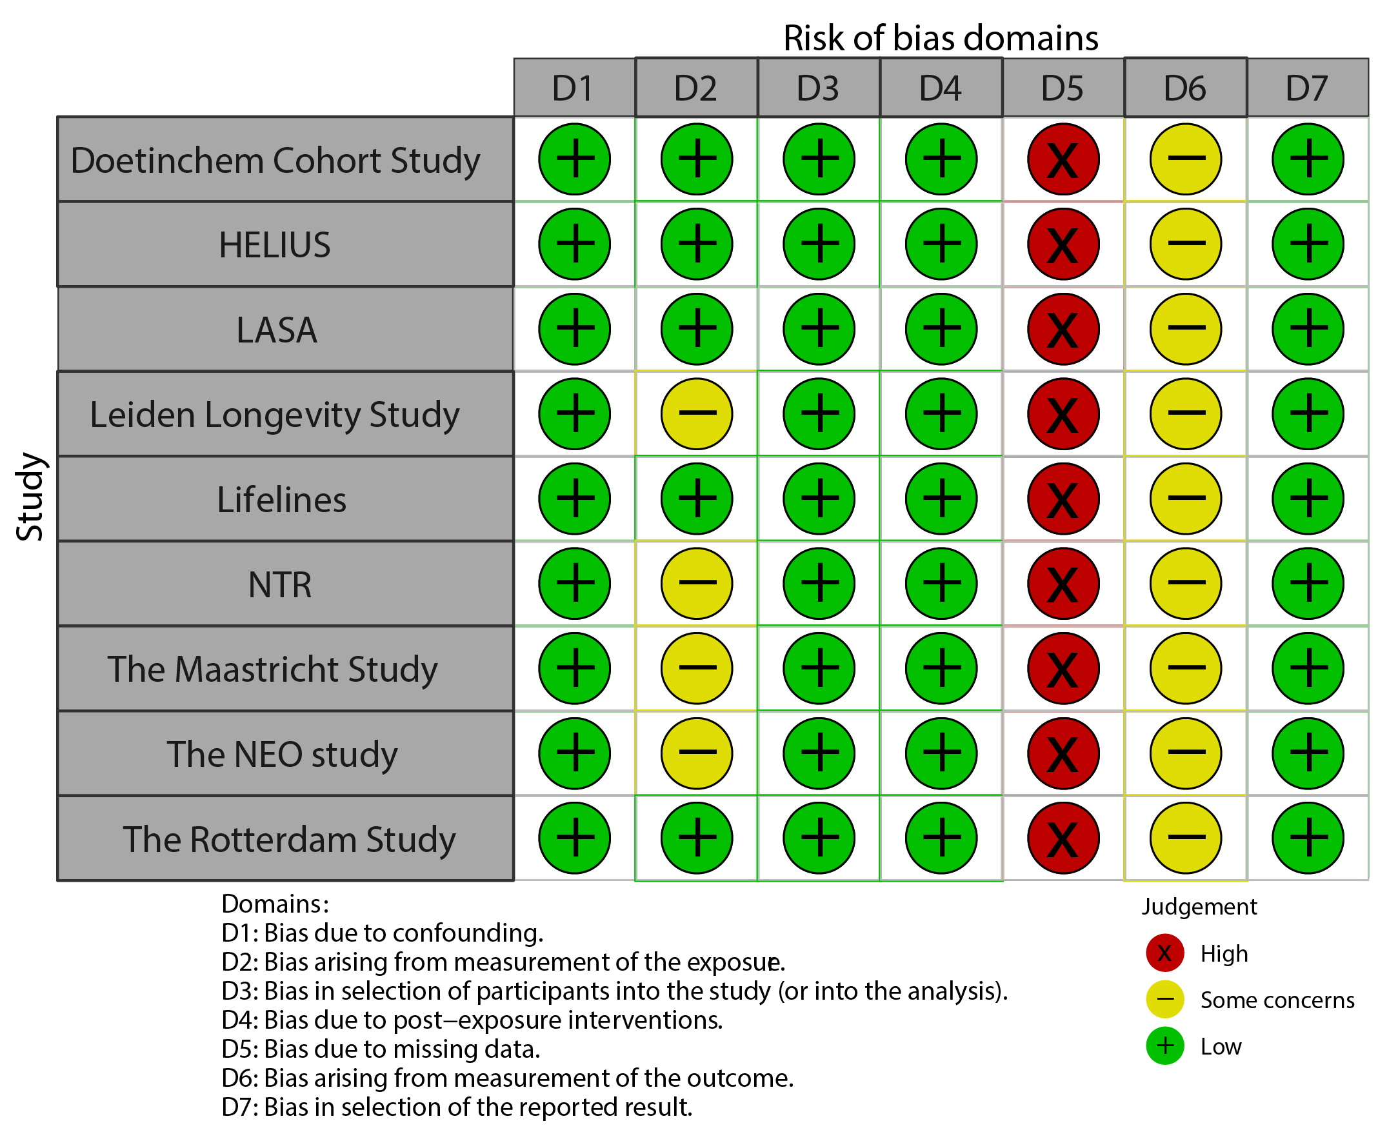
Figure of Text S2. Risk of bias assessment

References
1. Higgins JPT, Morgan RL, Rooney AA, Taylor KW, Thayer KA, Silva RA, et al. A tool to assess risk of bias in non-randomized follow-up studies of exposure effects (ROBINS-E). Environ Int. 2024 Apr;186:108602. Doi: 10.1016/j.envint.2024.108602.
2. McGuinness, LA, Higgins, JPT. Risk-of-bias VISualization (robvis): An R package and Shiny web app for visualizing risk-of-bias assessments. Res Syn Meth. 2020; 1- 7. Doi: 10.1002/jrsm.1411

Table S1. Participant characteristics per cohort
Cohortª | Sex (% women) | Age (years) | Overweight/obesity^{b} | Abdominal overweight/obesity^{c} | SARS-Cov-2 by self-report | SARS-Cov-2 by serology
 | % (n) | Mean ± SD | % (n) | % (n) | % (n) | % (n)
Doetinchem Cohort Study (n=1238) | 53.6 (664) | 64.8 ± 7.8 | 44.7 (554)/  16.4 (203) | 30.5 (378)/  49.8 (616) | 5.3 (65) | 12.1 (150)
HELIUS (n=2401) | 56.8 (1363) | 52.6 ± 12.1 | 40.1 (962)/  23.1 (555) | 25.0 (599)/  39.8 (956) | 8.7 (208) | 22.2 (530)
LASA (n=1280) | 52.8 (676) | 73.4 ± 7.4 | 45.2 (578)/  22.6 (289) | 21.7 (277)/  67.6 (864) | 13.1 (168) | NA
Leiden Longevity Study (n=913) | 56.0 (511) | 74.0 ± 6.2 | 39.0 (356)/  10.8 (99) | NA | 2.3 (21) | NA
Lifelines (n=74049) | 60.6 (44905) | 54.3 ± 12.2 | 39.6 (29296)/  15.7 (11631) | 27.5 (20388)/  36.0 (26693) | 24.7 (18295) | NA
NTR (n=7647) | 71.7 (5486) | 48.1 ± 15.4 | 29.5 (2258)/  9.8 (749) | 23.3 (362)/  21.4 (333) | 4.5 (343) | NA
The Maastricht Study (n=4591) | 49.8 (2288) | 64.0 ± 9.0 | 43.0 (1975)/  17.1 (783) | 28.1 (1290)/  41.7 (1915) | 8.7 (399) | NA
The NEO study (n=3846) | 49.6 (1908) | 64.9 ± 6.0 | 45.6 (1755)/  37.0 (1424) | 17.9 (590)/  75.5 (2485) | 0.9 (35) | NA
The Rotterdam Study (n=3605) | 57.3 (2064) | 74.2 ± 8.4 | 46.9 (1691)/  23.7 (854) | 27.2 (981)/  46.9 (1689) | 1.2 (44) | 9.8 (355)
HELIUS, Healthy Life in an Urban Setting study; LASA, Longitudinal Aging Study Amsterdam; n, number of participants; NA, Not available; NEO, Netherlands Epidemiology of Obesity; NTR, The Netherlands Twin Register; SD, standard deviation.
ª Numbers in specific analyses can be lower than the total number of participants, due to missing values on a particular exposure or outcome.
^{b} Overweight: body mass index (BMI) ≥25 and <30 kg/m²; obesity: BMI ≥30 kg/m².
^{c} Abdominal overweight: waist circumference (WC) ≥94 cm and <102 cm among men and ≥80 cm and 88 cm among women; abdominal obesity: WC ≥102 cm among men and ≥88 cm among women.

Table S2. Results of random-effects meta-analysis of the association between overweight/obesity and SARS-CoV-2 infection measured by self-report with and without the Lifelines cohort
 | With Lifelines |  |  | Without Lifelines
Exposures | OR (95% CI)^{a,b} | n^{c} | I² (%)^{d} | OR (95% CI)^{a,b} | n | I² (%)^{d}
Most recent BMI status^{e}
Healthy weight | 1 (ref) |  |  | 1 (ref)
Overweight | 1.08 (1.04-1.13) | 9 | 0 | 1.14 (0.99-1.30) | 8 | 0
Obesity | 1.43 (1.18-1.75) | 9 | 56 | 1.52 (1.29-1.79) | 8 | 0
Long-term obesity^{f}
No obesity | 1 (ref) |  |  | 1 (ref)
Only former obesity | 1.08 (0.94-1.25) | 8 | 1 | 1.41 (0.93-2.15) | 7 | 0
Only recent obesity | 1.51 (1.01-2.26) | 9 | 57 | 1.69 (1.06-2.69) | 8 | 41
Long-term obesity | 1.48 (1.15-1.91) | 9 | 65 | 1.60 (1.27-2.01) | 8 | 22
Most recent WC status^{g}
Healthy waist | 1 (ref) |  |  | 1 (ref)
Abdominal overweight | 1.09 (1.04-1.14) | 8 | 0 | 1.03 (0.81-1.32) | 7 | 21
Abdominal obesity | 1.24 (1.00-1.55) | 8 | 57 | 1.35 (1.06-1.71) | 7 | 28
Long-term abdominal obesity^{f}
No abdominal obesity | 1 (ref) |  |  | 1 (ref)
Only former abdominal obesity | 1.04 (0.96-1.12) | 5 | 0 | 0.81 (0.47-1.40) | 4 | 0
Only recent abdominal obesity | 1.17 (0.90-1.52) | 6 | 22 | 1.46 (0.99-2.15) | 5 | 0
Long-term abdominal obesity | 1.31 (1.01-1.70) | 6 | 50 | 1.50 (1.15-1.95) | 5 | 0
BMI, body mass index; CI, confidence interval; n, number of studies; OR, odds ratio; ref, reference; WC, waist circumference.
ª Bold indicates statistical significance according to 95% CI.
^{b} Odds ratios are adjusted for age, sex, educational level, and number of SARS-CoV-2 infection measurements (and ethnicity for one cohort).
^{c} Some results are based on less than nine studies, because waist circumference was not measured (twice) and/or because no cases were available in a particular exposure category.
^{d} Heterogeneity can be considered low when I²=0%-40%, moderate when I²=30%-60%, substantial when I²=50%-90%, and high when I²=75%-100%.
^{e} Healthy weight: BMI <25 kg/m²; overweight: BMI ≥25 and <30 kg/m²; obesity: BMI ≥30 kg/m².
^{f} No obesity: no obesity at both measurements; only former obesity: obesity at the least recent measurement, but not the most recent measurement; only recent obesity: obesity at the most recent measurement, but not the least recent measurement; long-term obesity: obesity at both measurements.
^{g} Healthy waist: WC <94 cm among men and <80 cm among women; abdominal overweight: WC ≥94 cm and <102 cm among men and ≥80 cm and 88 cm among women; abdominal obesity: WC ≥102cm among men and ≥88 cm among women.

Table S3. Results of random-effects meta-analysis of the association between overweight/obesity and SARS-CoV-2 infection measured by self-report before 2021 and from 2021 onwards
 | Before 2021 |  |  | From 2021 onwards
Exposures | OR (95% CI)^{a,b} | n | I² (%)^{c} | OR (95% CI)^{a,b} | n | I² (%)^{c}
Most recent BMI status^{d}
Healthy weight | 1 (ref) |  |  | 1 (ref)
Overweight | 1.10 (1.01-1.20) | 7 | 0 | 1.06 (1.01-1.11) | 6 | 0
Obesity | 1.59 (1.24-2.04) | 7 | 44 | 1.17 (0.96-1.43) | 6 | 39
Most recent WC status^{e}
Healthy waist | 1 (ref) |  |  | 1 (ref)
Abdominal overweight | 1.10 (0.99-1.23) | 6 | 0 | 1.07 (1.02-1.13) | 5 | 0
Abdominal obesity | 1.36 (0.97-1.90) | 6 | 49 | 1.15 (0.92-1.43) | 5 | 54
BMI, body mass index; CI, confidence interval; n, number of studies; OR, odds ratio; ref, reference; WC, waist circumference.
ª Bold indicates statistical significance according to 95% CI.
^{b} Odds ratios are adjusted for age, sex, educational level, and number of SARS-CoV-2 infection measurements (and ethnicity for one cohort).
^{c} An I² of 25%, 50%, and 75% corresponds with low, medium, and high heterogeneity, respectively.
^{d} Healthy weight: BMI <25 kg/m²; overweight: BMI ≥25 and <30 kg/m²; obesity: BMI ≥30 kg/m².
^{e} Healthy waist: WC <94 cm among men and <80 cm among women; abdominal overweight: WC ≥94 cm and <102 cm among men and ≥80 cm and 88 cm among women; abdominal obesity: WC ≥102cm among men and ≥88 cm among women.

Table S4. Results of random-effects meta-analysis of the association between overweight/obesity and SARS-CoV-2 infection measured by serology before 2021 and from 2021 onwards
 | Before 2021 |  |  | From 2021 onwards
Exposures | OR (95% CI)^{a,b} | n | I² (%)^{c} | OR (95% CI)^{a,b} | n | I² (%)^{c}
Most recent BMI status^{d}
Healthy weight | 1 (ref) |  |  | 1 (ref)
Overweight | 1.16 (0.95-1.42) | 2 | 0 | 0.87 (0.63-1.21) | 2 | 35
Obesity | 1.42 (1.13-1.78) | 2 | 0 | 0.79 (0.48-1.32) | 2 | 60
Most recent WC status^{e}
Healthy waist | 1 (ref) |  |  | 1 (ref)
Abdominal overweight | 0.98 (0.71-1.34) | 2 | 49 | 1.18 (0.88-1.57) | 3 | 0
Abdominal obesity | 1.26 (0.89-1.79) | 2 | 65 | 1.09 (0.83-1.44) | 3 | 1
BMI, body mass index; CI, confidence interval; n, number of studies; OR, odds ratio; ref, reference; WC, waist circumference.
ª Bold indicates statistical significance according to 95% CI.
^{b} Odds ratios are adjusted for age, sex, educational level, and number of SARS-CoV-2 infection measurements (and ethnicity for one cohort).
^{c} An I² of 25%, 50%, and 75% corresponds with low, medium, and high heterogeneity, respectively.
^{d} Healthy weight: BMI <25 kg/m²; overweight: BMI ≥25 and <30 kg/m²; obesity: BMI ≥30 kg/m².
^{e} Healthy waist: WC <94 cm among men and <80 cm among women; abdominal overweight: WC ≥94 cm and <102 cm among men and ≥80 cm and 88 cm among women; abdominal obesity: WC ≥102cm among men and ≥88 cm among women.

Table S5. Results of random-effects meta-analysis of the association between overweight/obesity and SARS-CoV-2 infection measured by self-report stratified by sex
 | Men |  |  | Women
Exposures | OR (95% CI)^{a,b} | n | I² (%)^{c} | OR (95% CI)^{a,b} | n | I² (%)^{c}
Most recent BMI status^{d}
Healthy weight | 1 (ref) |  |  | 1 (ref)
Overweight | 1.02 (0.69-1.50) | 7 | 42 | 1.13 (0.90-1.40) | 7 | 0
Obesity | 1.82 (1.33-2.47) | 7 | 8 | 1.42 (1.10-1.84) | 7 | 0
Most recent WC status^{e}
Healthy waist | 1 (ref) |  |  | 1 (ref)
Abdominal overweight | 0.88 (0.60-1.28) | 6 | 26 | 1.16 (0.76-1.78) | 5 | 31
Abdominal obesity | 1.42 (1.10-1.84) | 6 | 0 | 1.50 (1.06-2.11) | 5 | 23
BMI, body mass index; CI, confidence interval; n, number of studies; OR, odds ratio; ref, reference; WC, waist circumference.
ª Bold indicates statistical significance according to 95% CI.
^{b} Odds ratios are adjusted for age, sex, educational level, and number of SARS-CoV-2 infection measurements (and ethnicity for one cohort).
^{c} Heterogeneity can be considered low when I²=0%-40%, moderate when I²=30%-60%, substantial when I²=50%-90%, and high when I²=75%-100%.
^{d} Healthy weight: BMI <25 kg/m²; overweight: BMI ≥25 and <30 kg/m²; obesity: BMI ≥30 kg/m².
^{e} Healthy waist: WC <94 cm among men and <80 cm among women; abdominal overweight: WC ≥94 cm and <102 cm among men and ≥80 cm and 88 cm among women; abdominal obesity: WC ≥102cm among men and ≥88 cm among women.

Table S6. Results of random-effects meta-analysis of the association between overweight/obesity and SARS-CoV-2 infection measured by self-report stratified by age
 | <70 years |  |  | ≥70 years
Exposures | OR (95% CI)^{a,b} | n | I² (%)^{c} | OR (95% CI)^{a,b} | n | I² (%)^{c}
Most recent BMI status^{d}
Healthy weight | 1 (ref) |  |  | 1 (ref)
Overweight | 0.94 (0.62-1.45) | 6 | 71 | 1.20 (0.84-1.70) | 5 | 0
Obesity | 1.35 (1.09-1.68) | 6 | 0 | 2.15 (1.30-3.55) | 5 | 28
Most recent WC status^{e}
Healthy waist | 1 (ref) |  |  | 1 (ref)
Abdominal overweight | 1.04 (0.83-1.31) | 6 | 0 | 1.16 (0.52-2.57) | 4 | 49
Abdominal obesity | 1.42 (0.96-2.09) | 6 | 56 | 1.64 (0.83-3.27) | 4 | 47
BMI, body mass index; CI, confidence interval; n, number of studies; OR, odds ratio; ref, reference; WC, waist circumference.
ª Bold indicates statistical significance according to 95% CI.
^{b} Odds ratios are adjusted for age, sex, educational level, and number of SARS-CoV-2 infection measurements (and ethnicity for one cohort).
^{c} Heterogeneity can be considered low when I²=0%-40%, moderate when I²=30%-60%, substantial when I²=50%-90%, and high when I²=75%-100%.
^{d} Healthy weight: BMI <25 kg/m²; overweight: BMI ≥25 and <30 kg/m²; obesity: BMI ≥30 kg/m².
^{e} Healthy waist: WC <94 cm among men and <80 cm among women; abdominal overweight: WC ≥94 cm and <102 cm among men and ≥80 cm and 88 cm among women; abdominal obesity: WC ≥102cm among men and ≥88 cm among women.

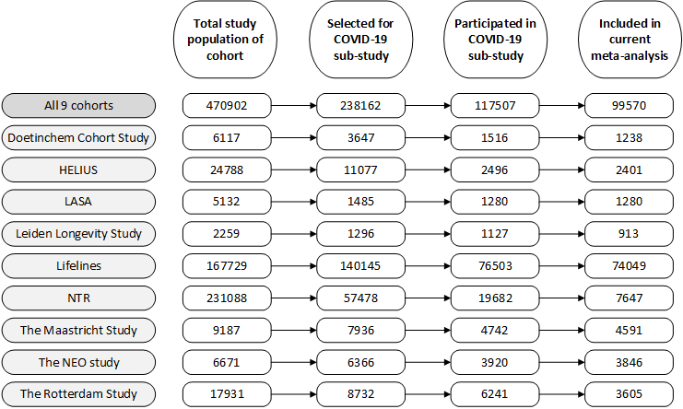
Figure S1. Flowchart of study participants. HELIUS, Healthy Life in an Urban Setting study; LASA, Longitudinal Aging Study Amsterdam; NEO, Netherlands Epidemiology of Obesity; NTR, The Netherlands Twin Register. Note: For LASA, COVID-19 data were obtained from both the COVID-19 sub-study (2020-2021) and the regular 2021-2022 measurement wave (Wave K).

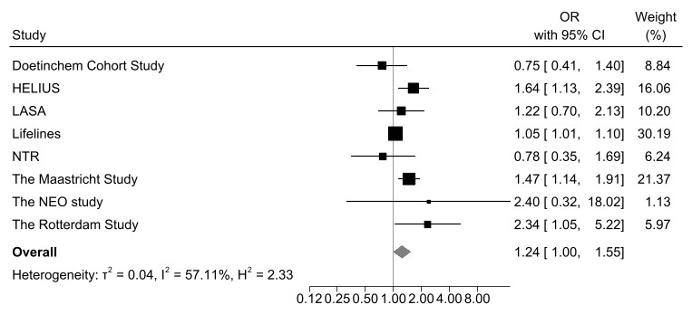
a. Abdominal overweight vs. healthy waist b. Abdominal obesity vs. healthy waist
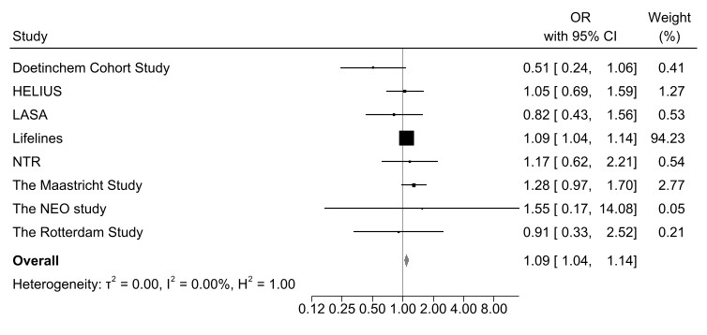
Figure S2. Forest plot of the association between abdominal overweight (a) and abdominal obesity (b) (vs. healthy waist) and SARS-CoV-2 infection measured by self-report. CI, confidence interval; HELIUS, Healthy Life in an Urban Setting study; LASA, Longitudinal Aging Study Amsterdam; NEO, Netherlands Epidemiology of Obesity; NTR, The Netherlands Twin Register; OR, odds ratio. Odds ratios are adjusted for age, sex, educational level, and number of SARS-CoV-2 infection measurements (and ethnicity for one cohort).
a. Only former abdominal obesity vs. no abdominal obesity b. Only recent abdominal obesity vs. no abdominal obesity
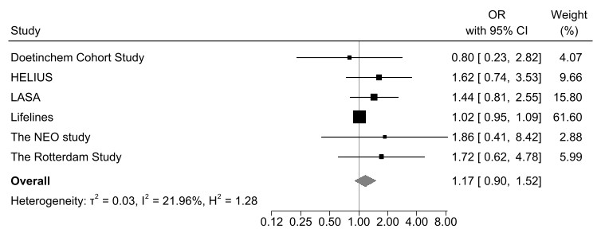
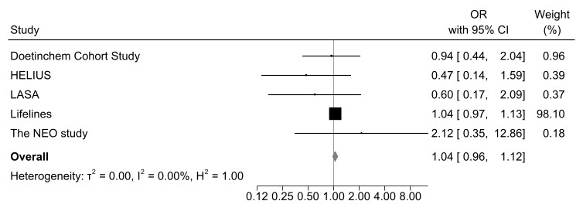
c. Long-term abdominal obesity vs. no abdominal obesity
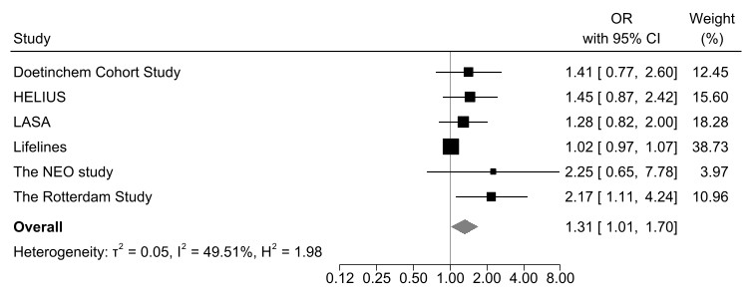
Figure S3. Forest plot of the association between duration of abdominal obesity and SARS-CoV-2 infection measured by self-report. CI, confidence interval; HELIUS, Healthy Life in an Urban Setting study; LASA, Longitudinal Aging Study Amsterdam; NEO, Netherlands Epidemiology of Obesity; OR, odds ratio. Odds ratios are adjusted for age, sex, educational level, and number of SARS-CoV-2 infection measurements (and ethnicity for one cohort).

a. Overweight vs. healthy weight b. Obesity vs. healthy weight
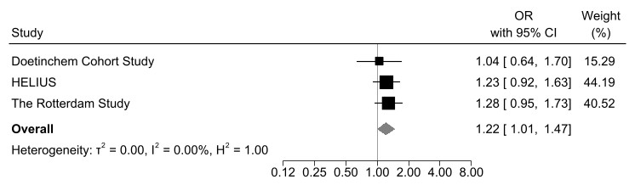
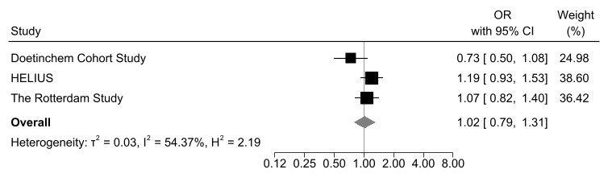
Figure S4. Forest plot of the association between overweight (a) and obesity (b) (vs. healthy weight) and SARS-CoV-2 infection measured by serology. CI, confidence interval; HELIUS, Healthy Life in an Urban Setting study; OR, odds ratio. Odds ratios are adjusted for age, sex, educational level, and number of SARS-CoV-2 infection measurements (and ethnicity for one cohort).

a. Abdominal overweight vs. healthy waist b. Abdominal obesity vs. healthy waist
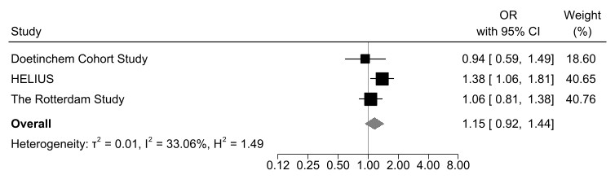
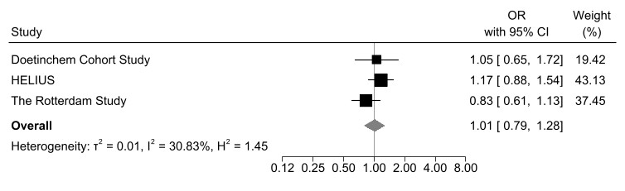
Figure S5. Forest plot of the association between abdominal overweight (a) and abdominal obesity (b) (vs. healthy waist) and SARS-CoV-2 infection measured by serology. CI, confidence interval; HELIUS, Healthy Life in an Urban Setting study; OR, odds ratio. Odds ratios are adjusted for age, sex, educational level, and number of SARS-CoV-2 infection measurements (and ethnicity for one cohort).

a. Only former obesity vs. no obesity b. Only recent obesity vs. no obesity
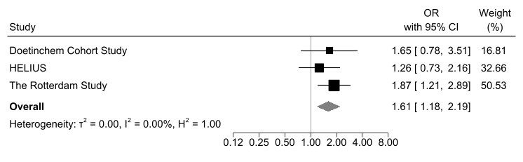
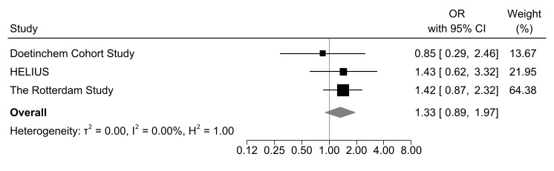
c. Long-term obesity vs. no obesity
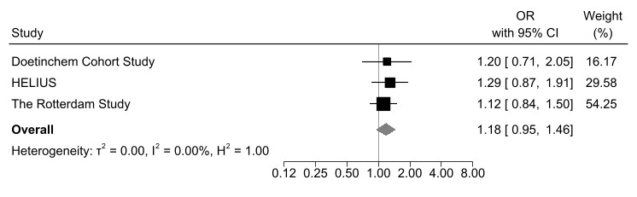
Figure S6. Forest plot of the association between duration of obesity and SARS-CoV-2 infection measured by serology. CI, confidence interval; HELIUS, Healthy Life in an Urban Setting study; OR, odds ratio. Odds ratios are adjusted for age, sex, educational level, and number of SARS-CoV-2 infection measurements (and ethnicity for one cohort).

a. Only former abdominal obesity vs. no abdominal obesity b. Only recent abdominal obesity vs. no abdominal obesity
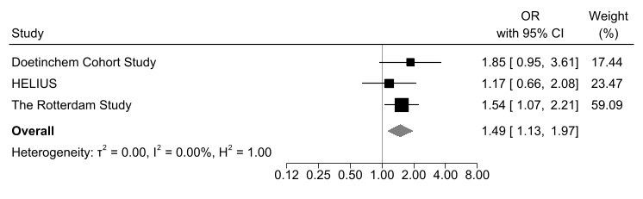
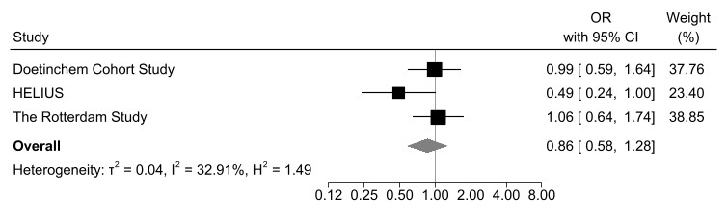
c. Long-term abdominal obesity vs. no abdominal obesity
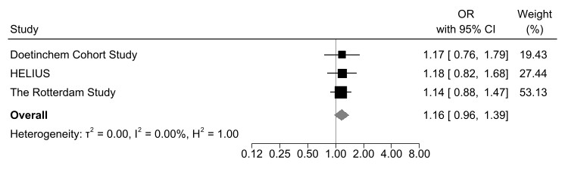
Figure S7. Forest plot of the association between duration of abdominal obesity and SARS-CoV-2 infection measured by serology. CI, confidence interval; HELIUS, Healthy Life in an Urban Setting study; OR, odds ratio. Odds ratios are adjusted for age, sex, educational level, and number of SARS-CoV-2 infection measurements (and ethnicity for one cohort).

a. Overweight vs. healthy weight before 2021 b. Overweight vs. healthy weight from 2021 onwards
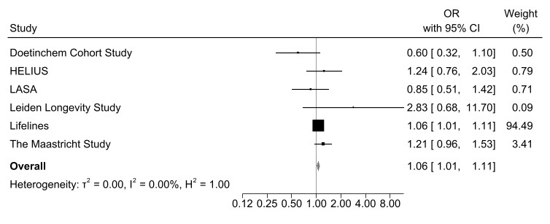
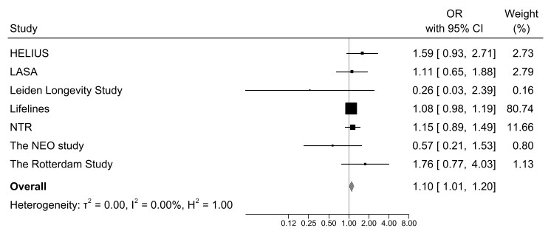
c. Obesity vs. healthy weight before 2021 d. Obesity vs. healthy weight from 2021 onwards
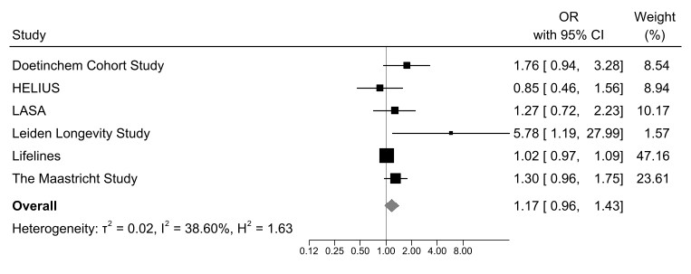
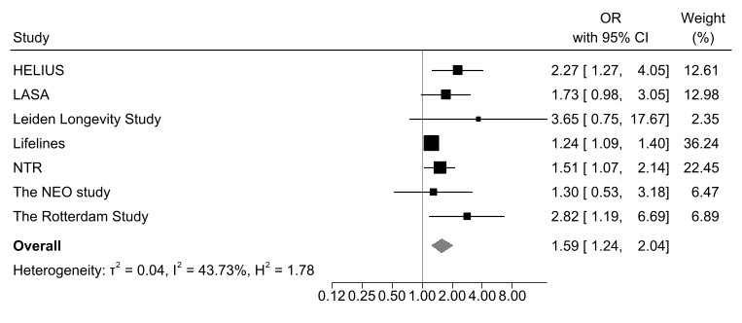
Figure S8. Forest plot of the association between overweight and obesity (vs. healthy weight) and SARS-CoV-2 infection measured by self-report before 2021 and from 2021 onwards. CI, confidence interval; HELIUS, Healthy Life in an Urban Setting study; LASA, Longitudinal Aging Study Amsterdam; NEO, Netherlands Epidemiology of Obesity; NTR, The Netherlands Twin Register; OR, odds ratio. Odds ratios are adjusted for age, sex, educational level, and number of SARS-CoV-2 infection measurements (and ethnicity for one cohort).

a. Abdominal overweight vs. healthy waist before 2021 b. Abdominal overweight vs. healthy waist from 2021 onwards
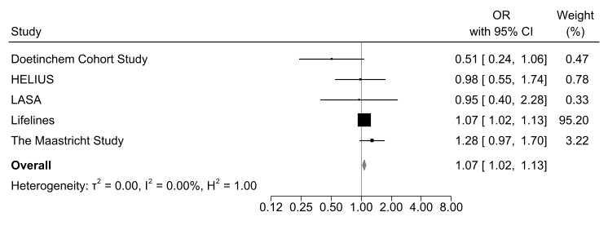
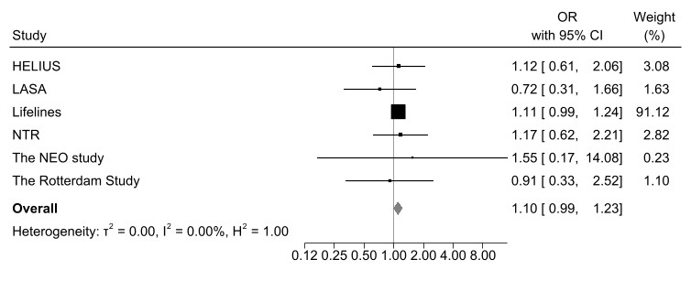
c. Abdominal obesity vs. healthy waist before 2021 d. Abdominal obesity vs. healthy waist from 2021 onwards
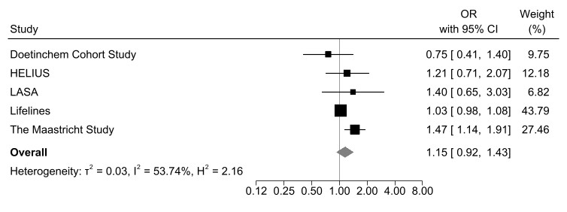
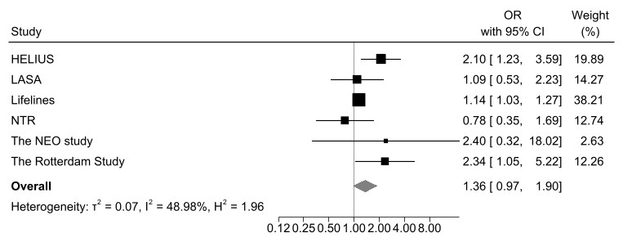
Figure S9. Forest plot of the association between abdominal overweight and abdominal obesity (vs. healthy waist) and SARS-CoV-2 infection measured by self-report before 2021 and from 2021 onwards. CI, confidence interval; HELIUS, Healthy Life in an Urban Setting study; LASA, Longitudinal Aging Study Amsterdam; NEO, Netherlands Epidemiology of Obesity; NTR, The Netherlands Twin Register; OR, odds ratio. Odds ratios are adjusted for age, sex, educational level, and number of SARS-CoV-2 infection measurements (and ethnicity for one cohort).

