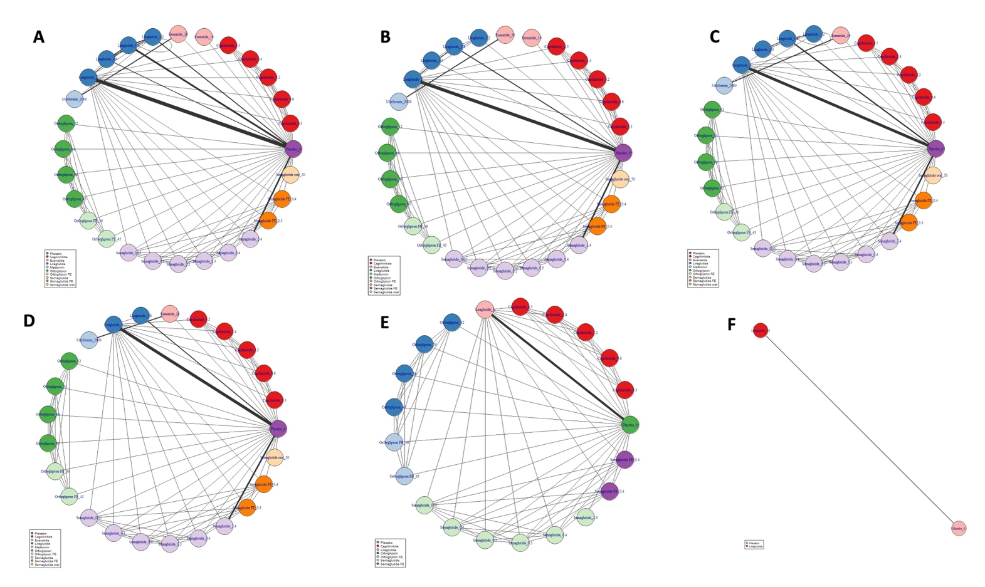
Supplementary figure 1. Network dose-response meta-analysis for (A) nausea, (B) vomiting, (C) diarrhea, (D) constipation, (E) decreased appetite, and (F) gallstone-related.

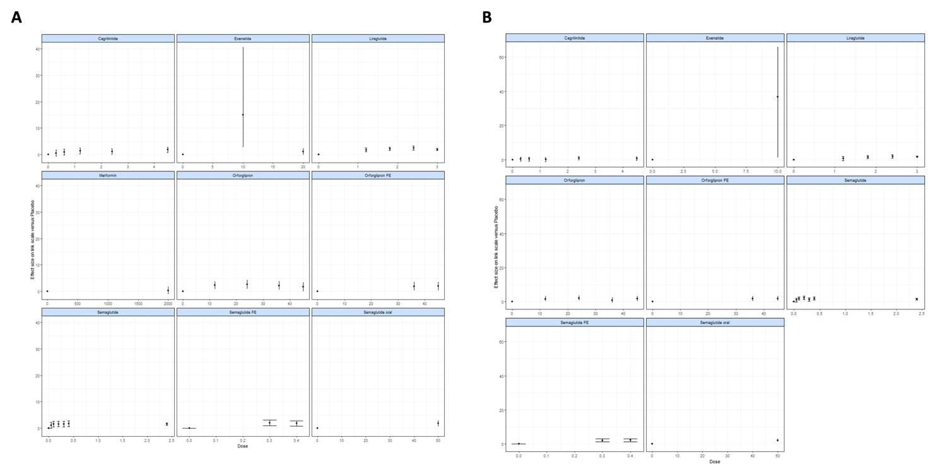
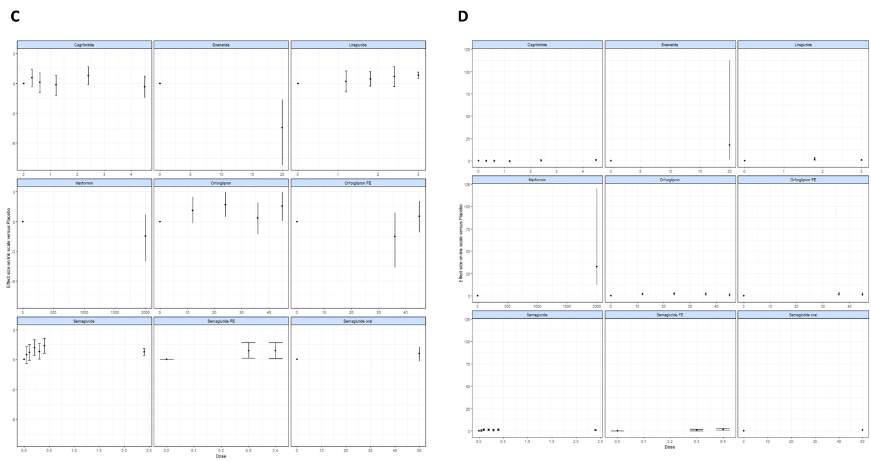

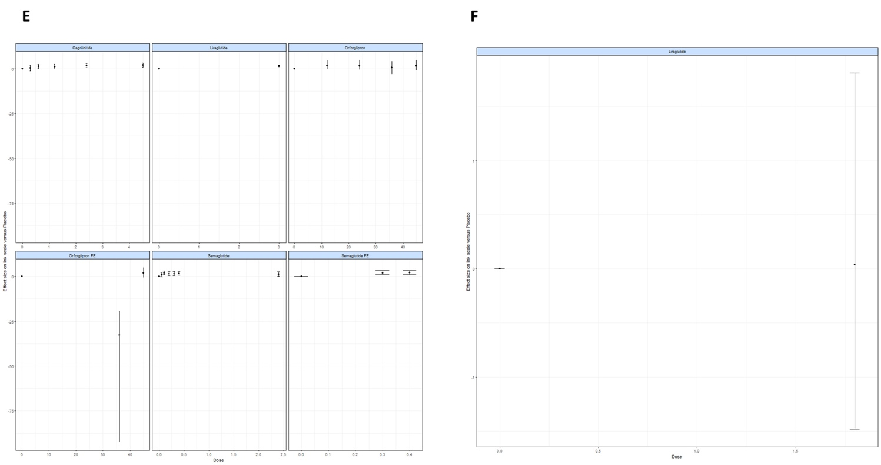
Supplementary figure 2. Network dose-response meta-analysis estimates by dose for (A) nausea, (B) vomiting, (C) diarrhea, (D) constipation, (E) decreased appetite, and (F) gallstone-related.

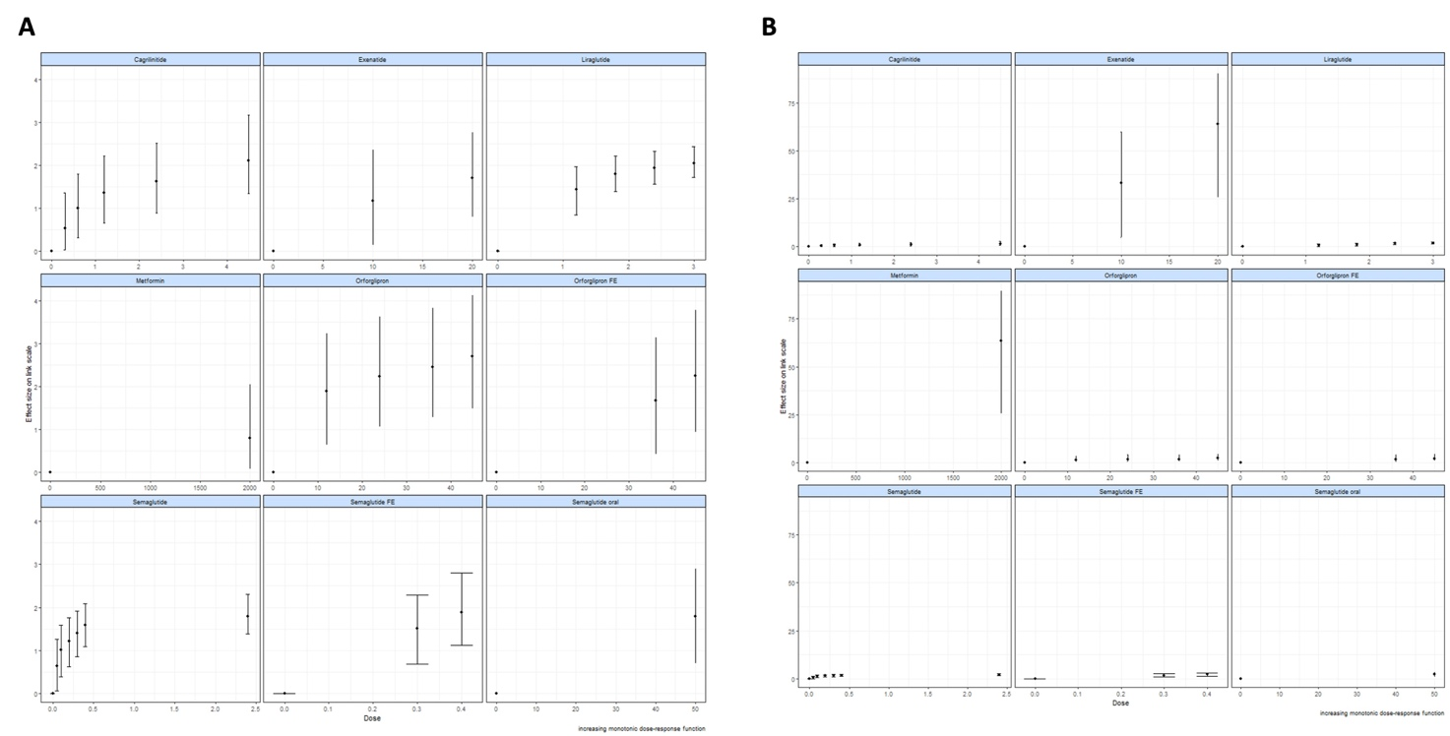

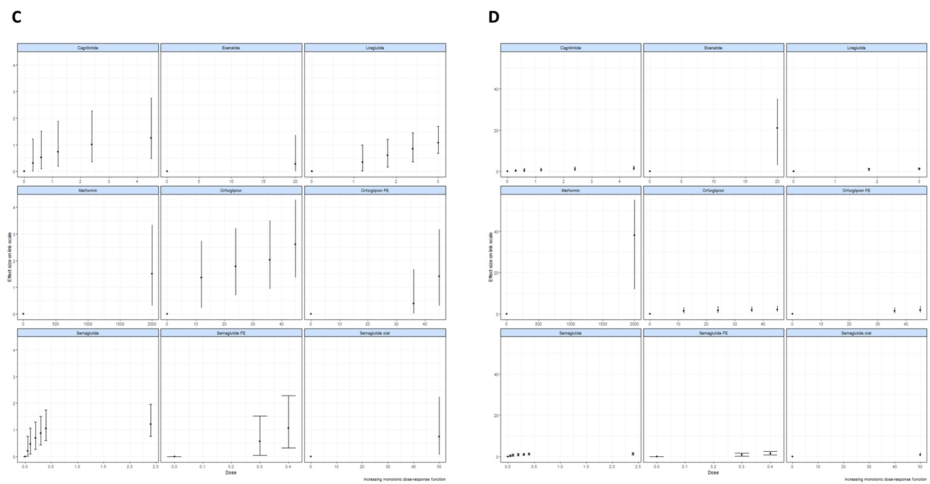
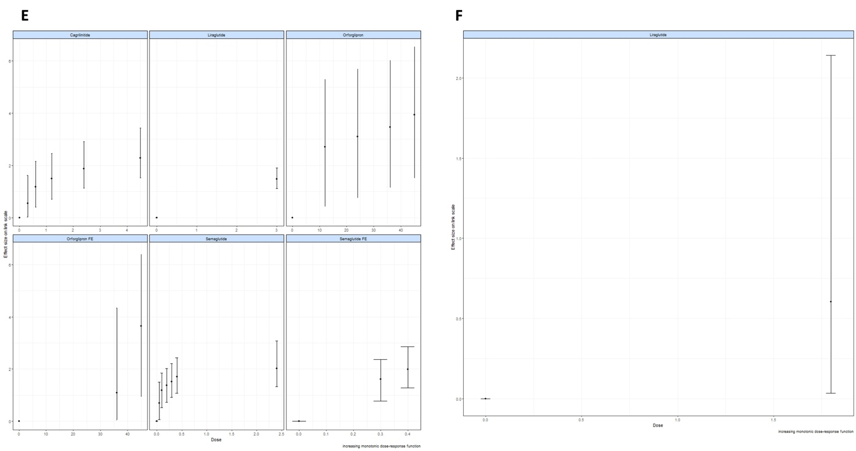
Supplementary figure 3. Nonparametric monotonic increasing model for (A) nausea, (B) vomiting, (C) diarrhea, (D) constipation, (E) decreased appetite, and (F) gallstone-related.

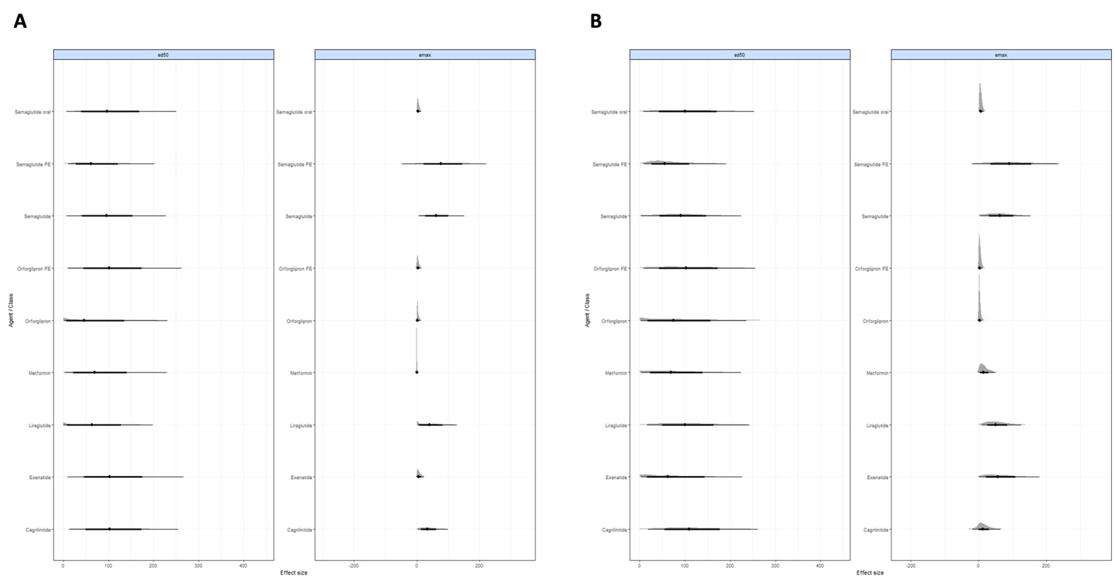
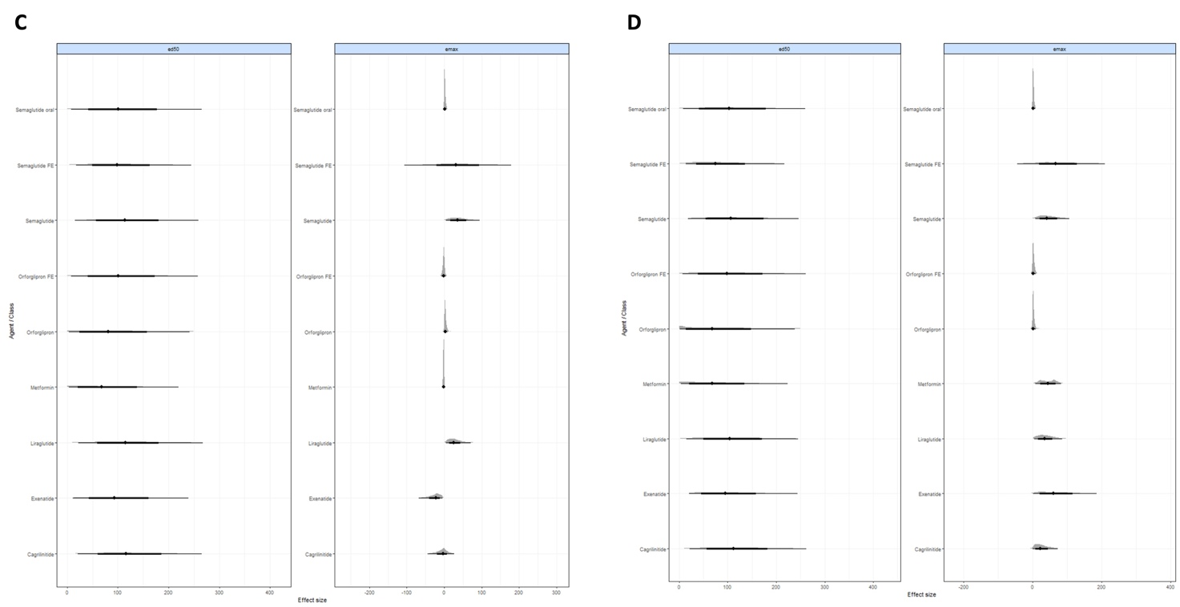
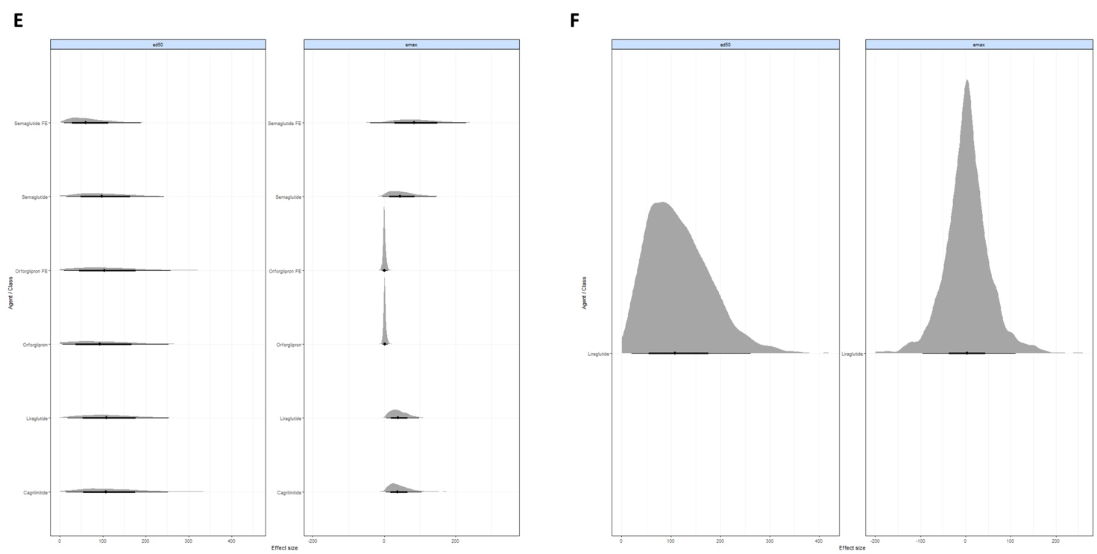
Supplementary figure 4. Network meta-analysis forest plot for (A) nausea, (B) vomiting, (C) diarrhea, (D) constipation, (E) decreased appetite, and (F) gallstone-related.
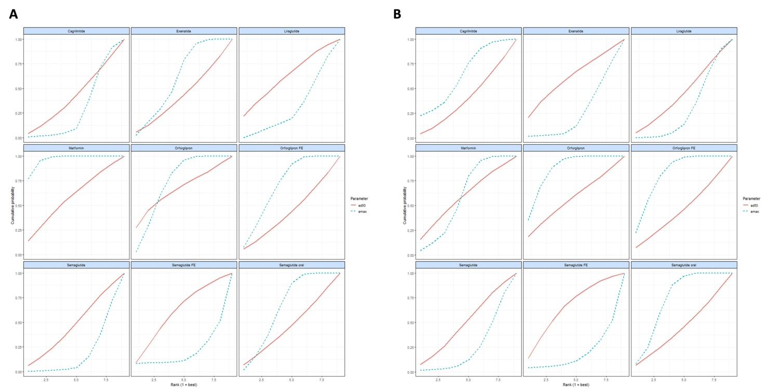
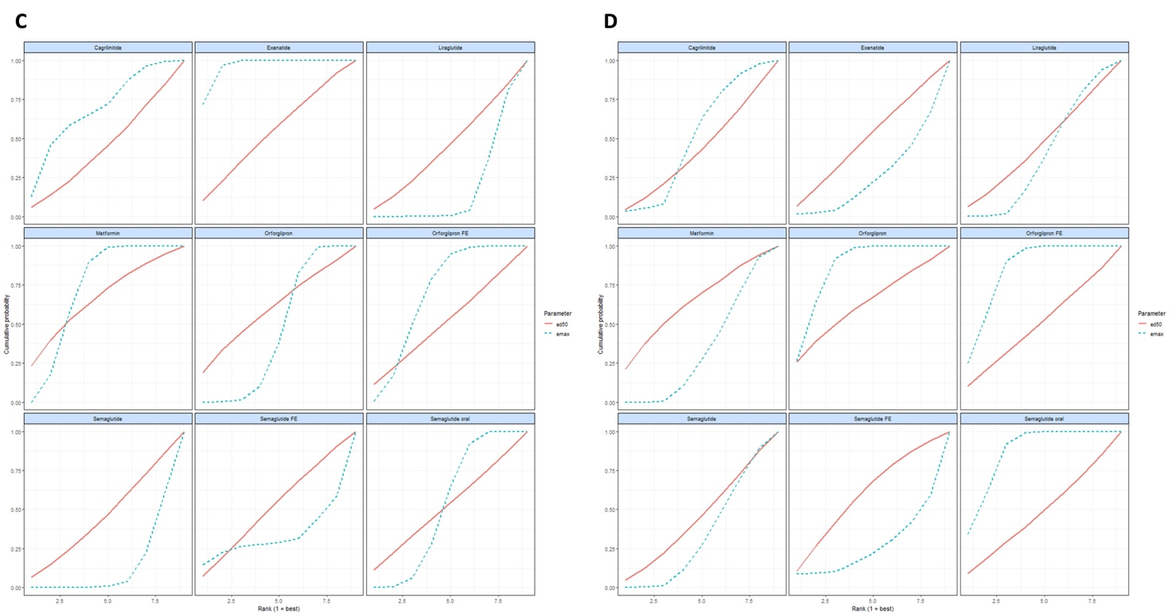
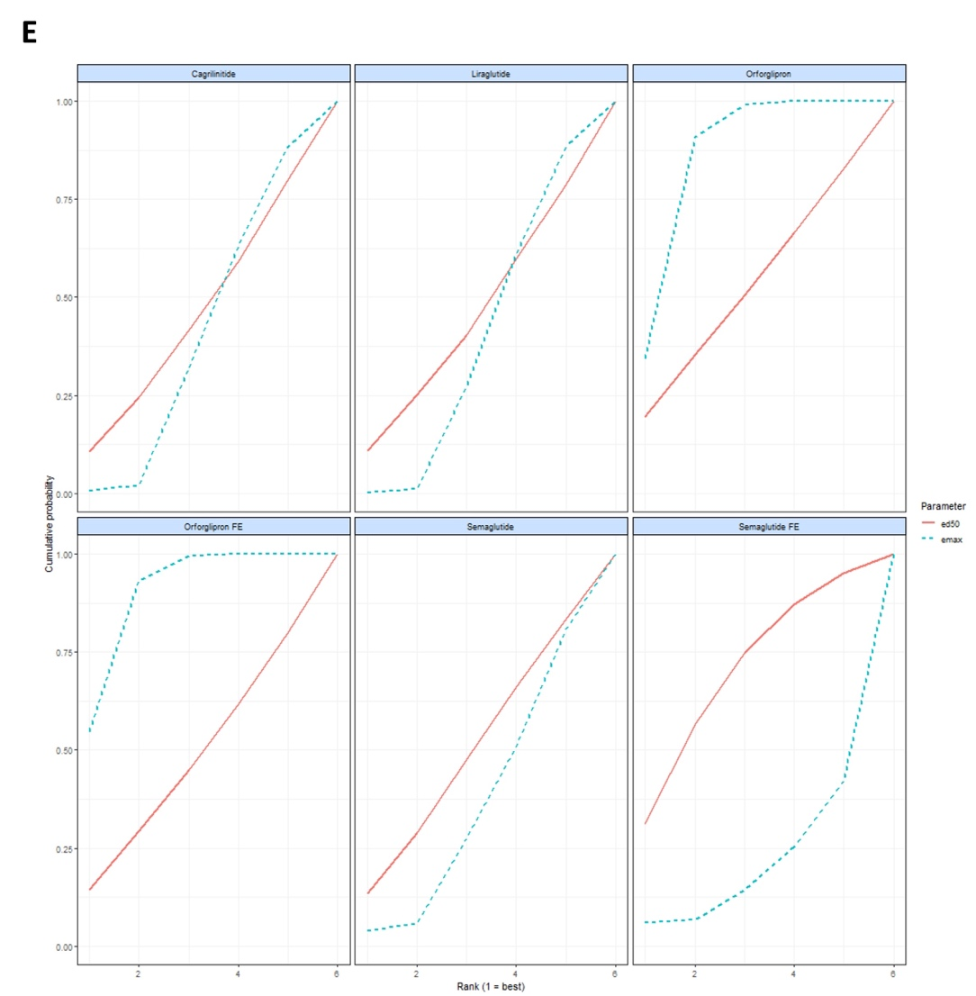
Supplementary figure 5. Network meta-analysis cumulative ranking for (A) nausea, (B) vomiting, (C) diarrhea, (D) constipation, and (E) decreased appetite.

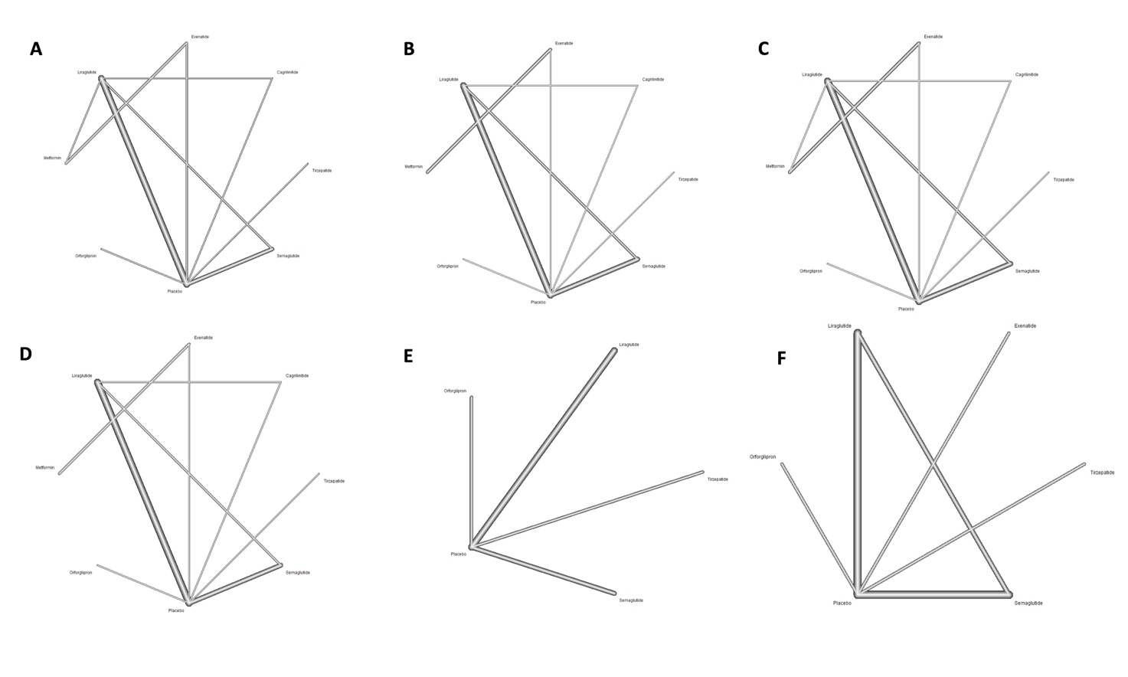
Supplementary figure 6. Network plot for (A) nausea, (B) vomiting, (C) diarrhea, (D) constipation, (E) GERD, and (F) eructation.

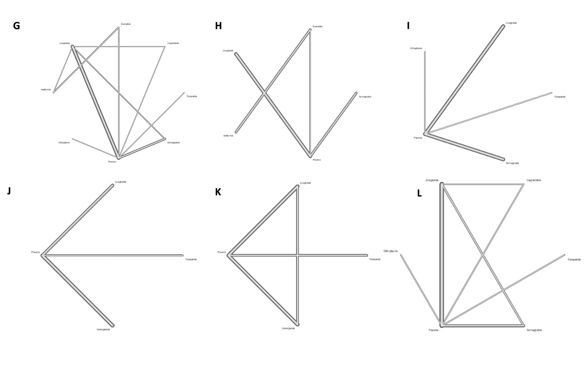
Supplementary figure 6. Network plot for (G) abdominal distention, (H) abdominal pain upper, (I) abdominal pain, (J) flatulence, (K) cholelithiasis, and (L) decreased appetite.
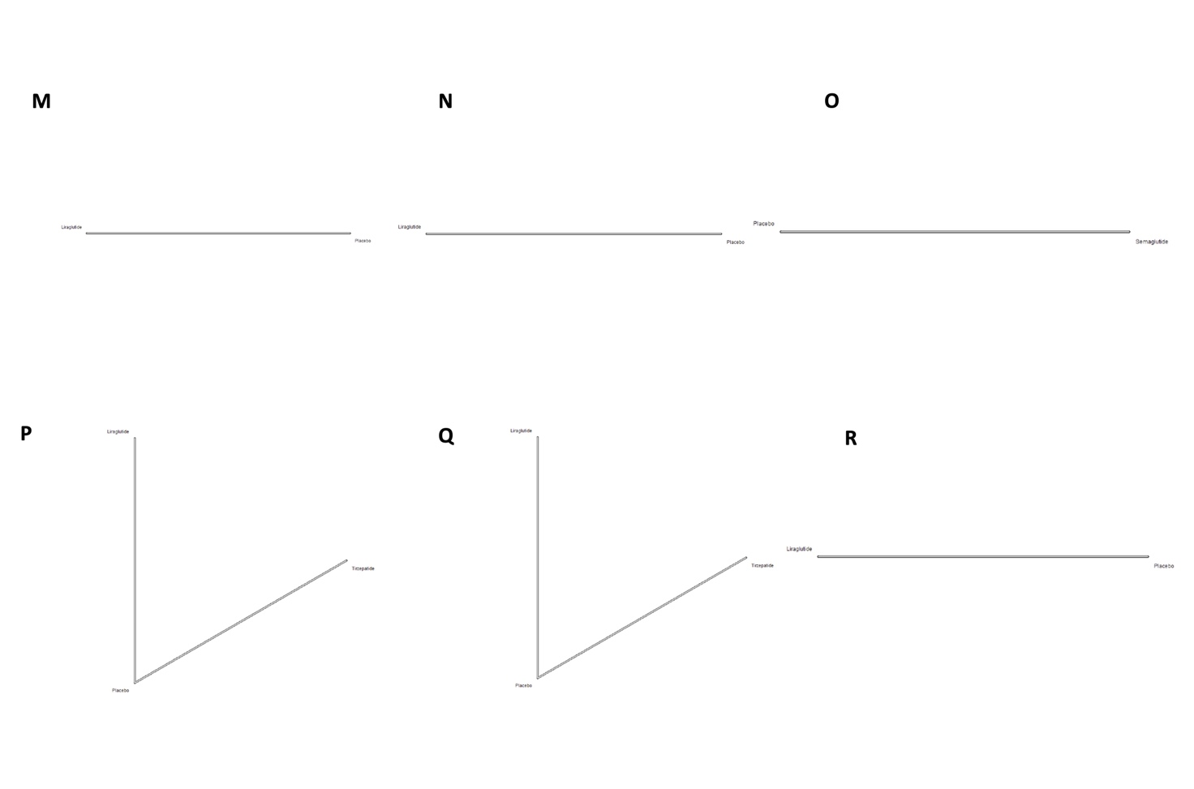
Supplementary figure 7. Network plot for (M) abdominal discomfort, (N) gallstone-related, (O) viral gastroenteritis, (P) cholecystitis, (Q) acute cholecystitis, and (R) acute pancreatitis.



Supplementary figure 8. Network plot for (S) hard feces, and (T) infrequent bowel movements.

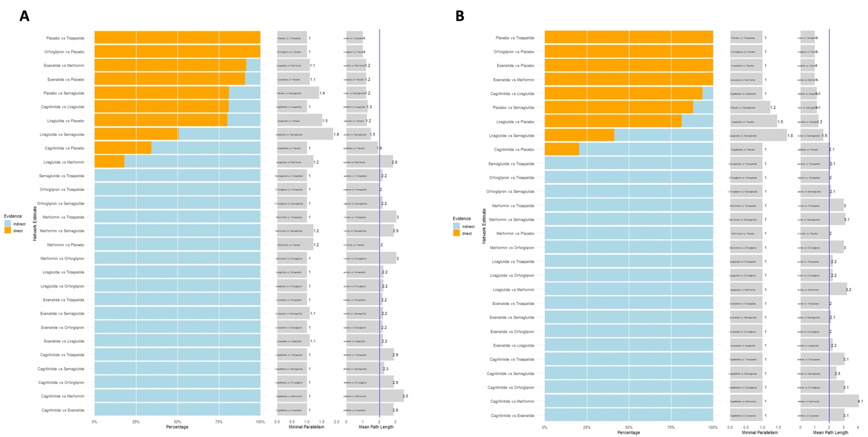
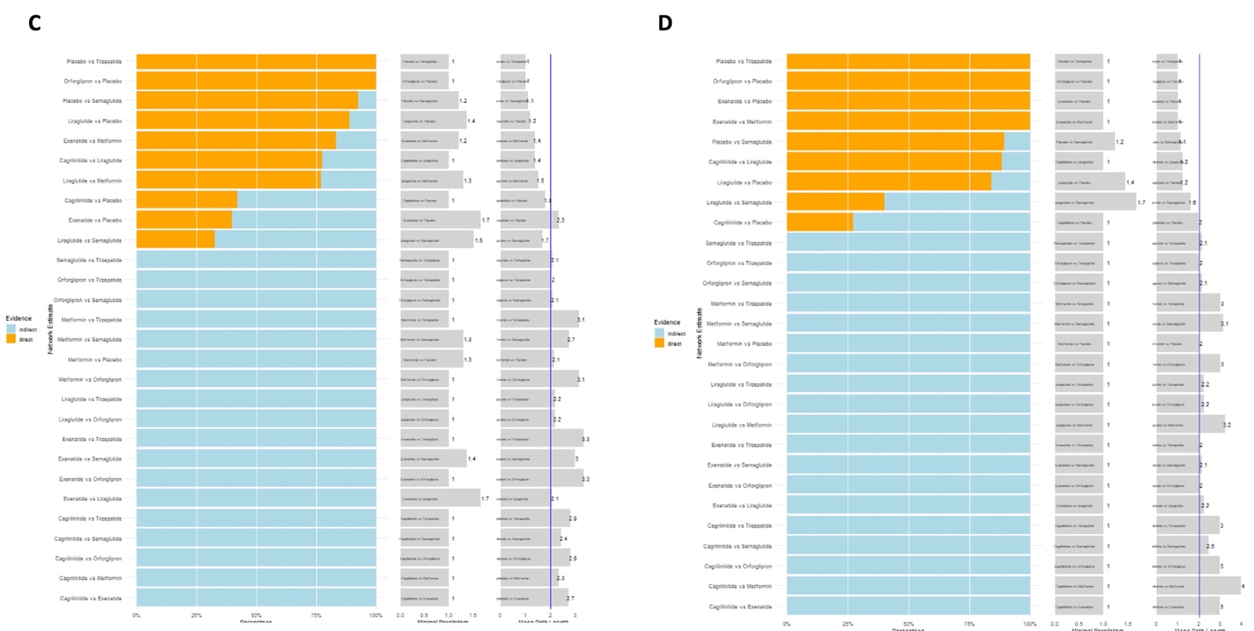
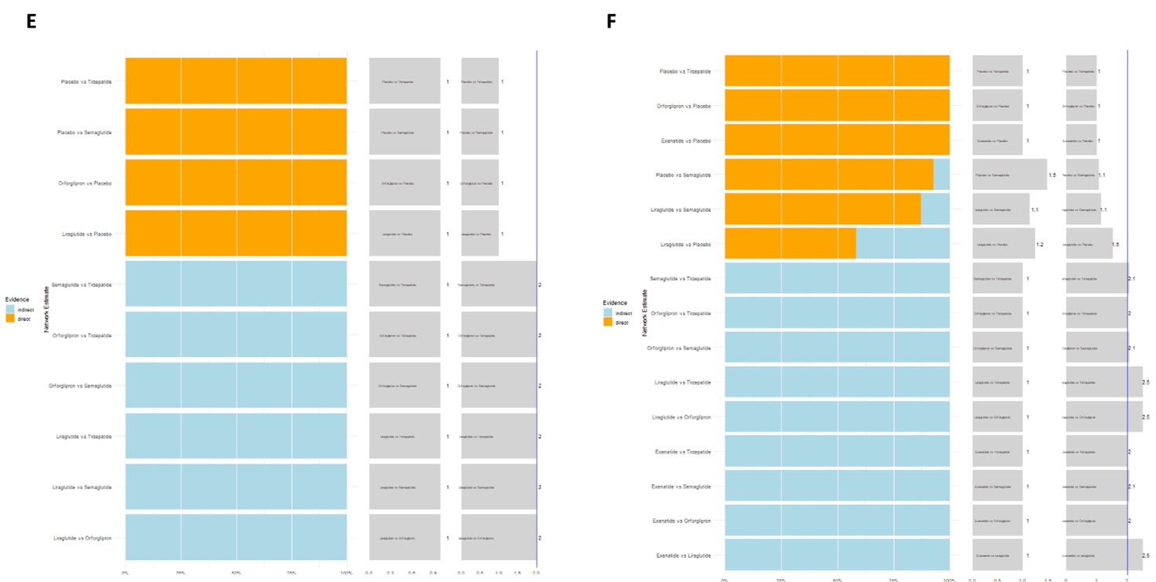
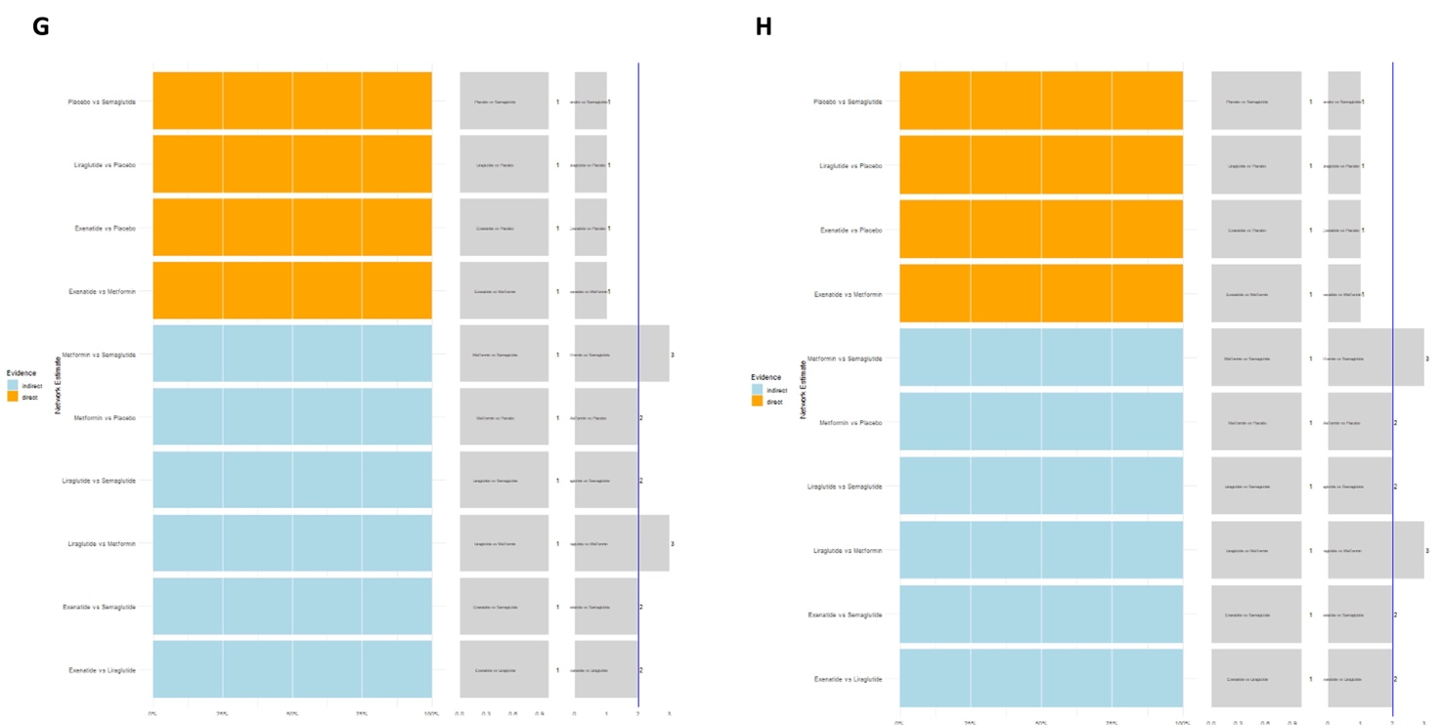
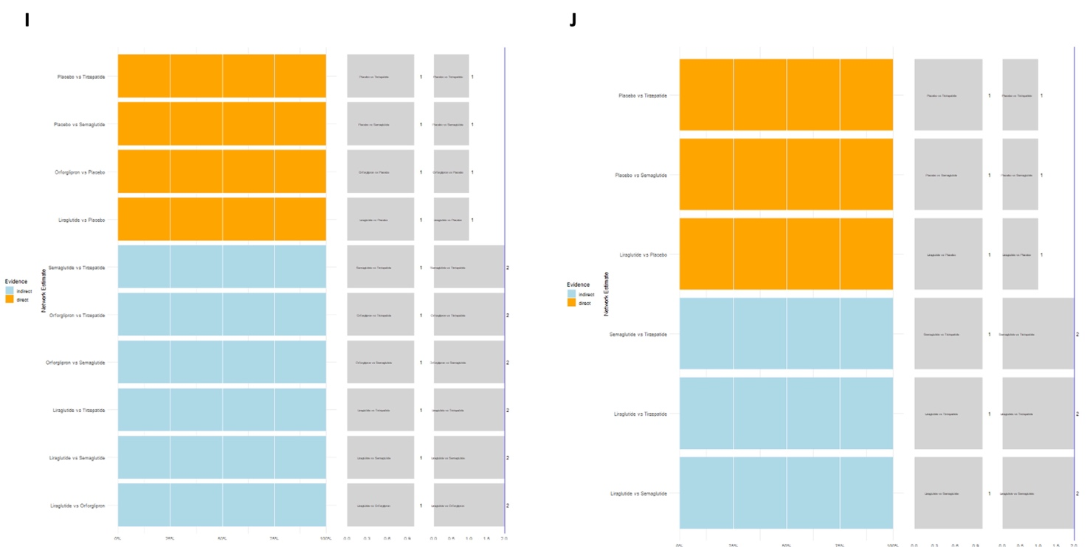
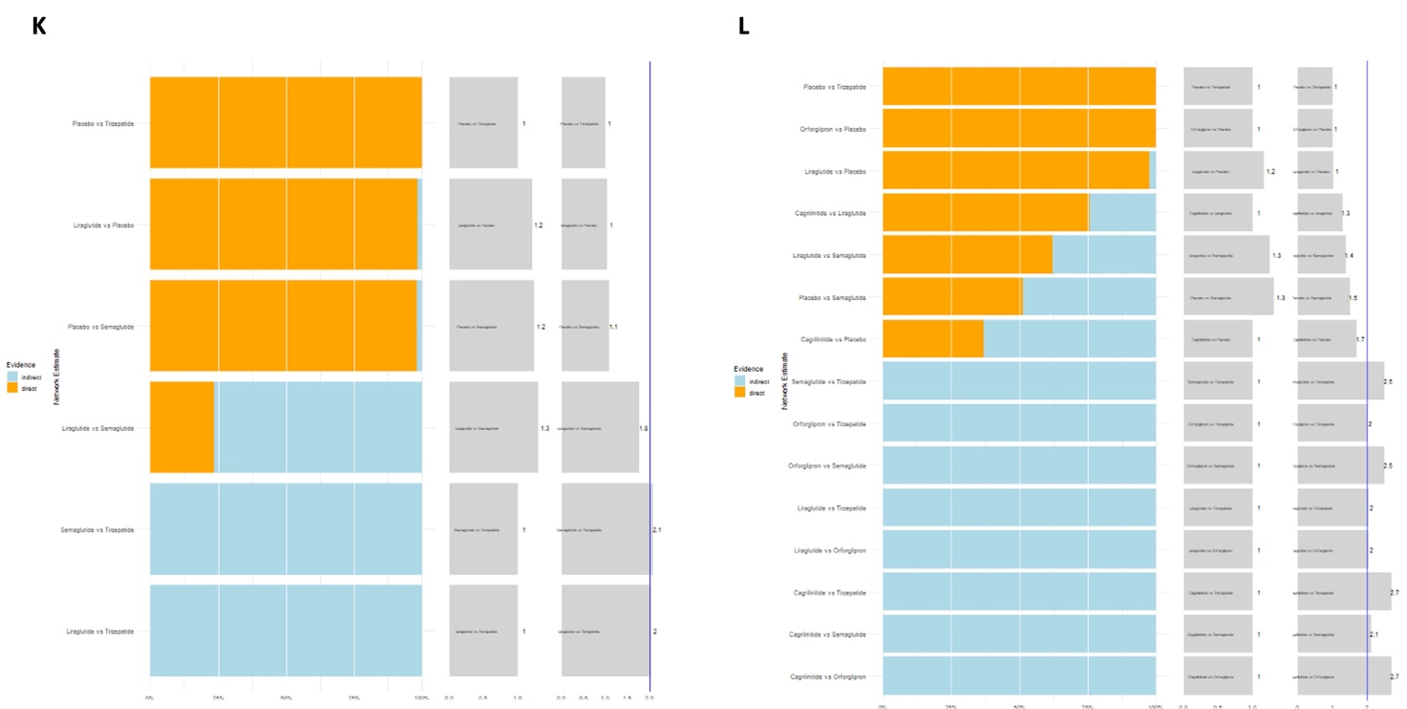
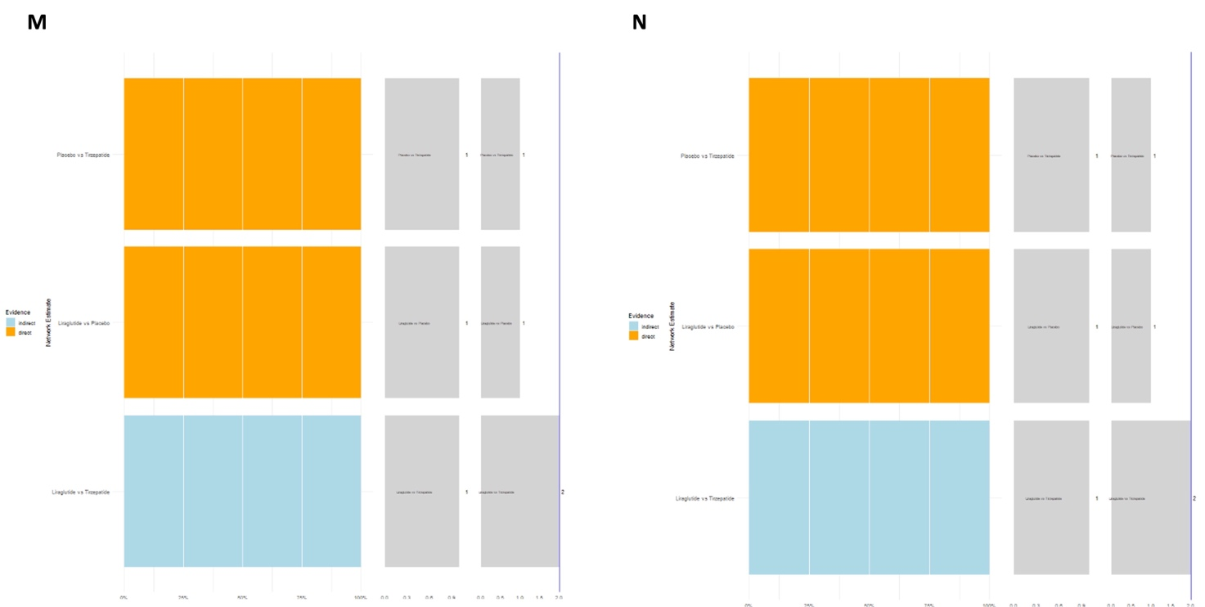
Supplementary figure 9. Fixed-effect model for (A) nausea, (B) vomiting, (C) diarrhea, (D) constipation, (E) GERD, (F) eructation, (G) abdominal distention, (H) abdominal pain, (I) abdominal pain, (J) flatulence, (K) cholelithiasis, (L) decreased appetite, (M) cholecystitis, and (N) acute cholecystitis.
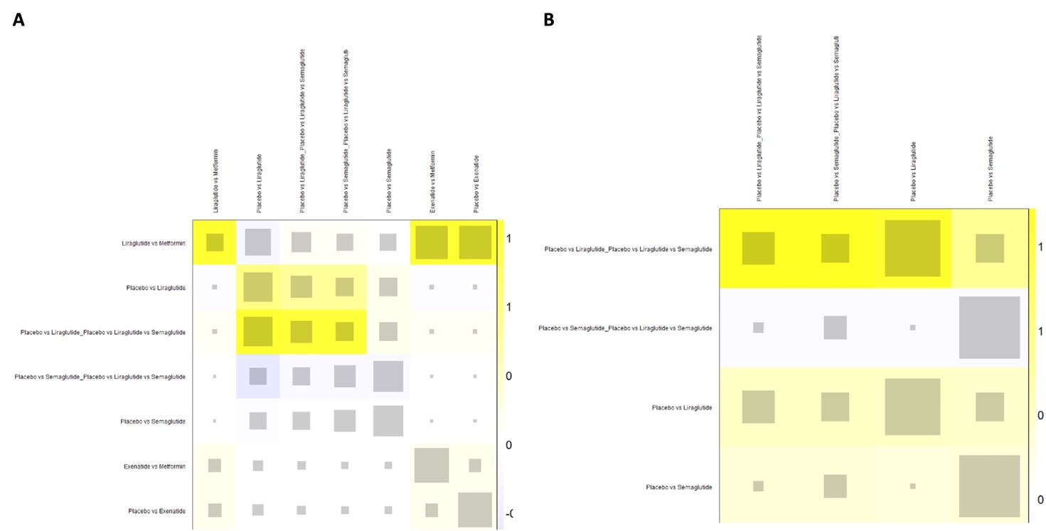
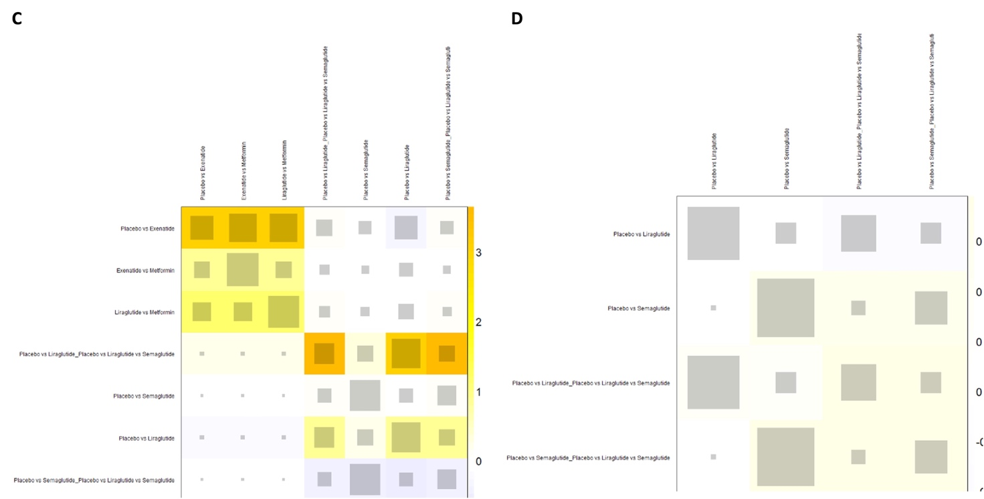
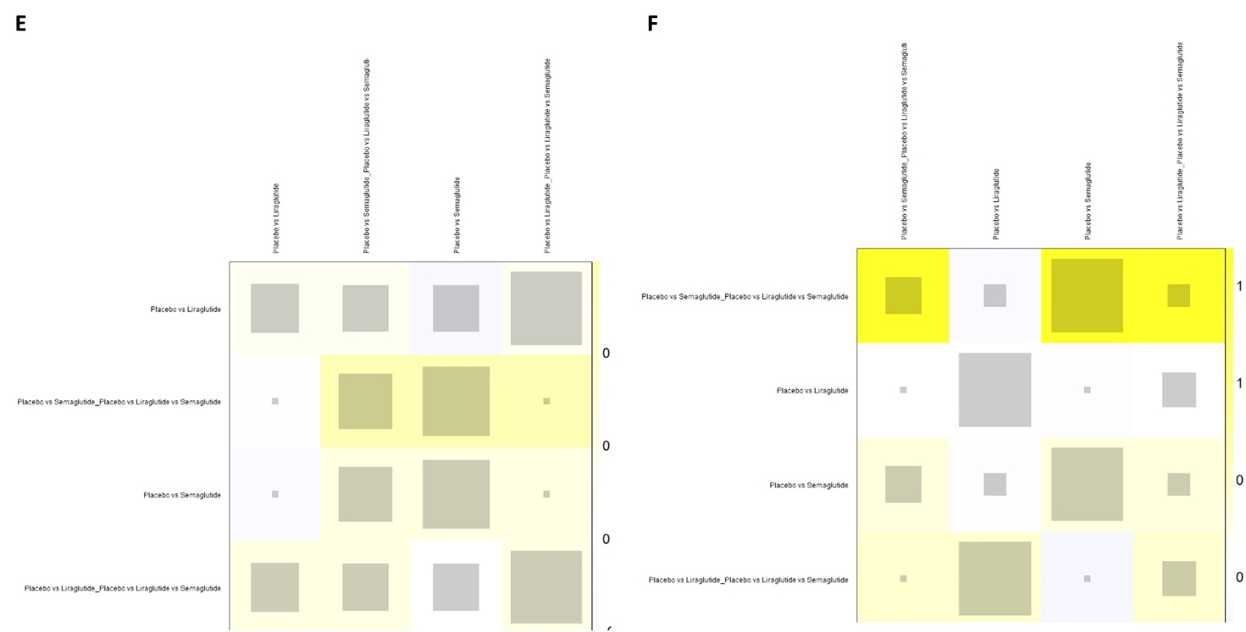
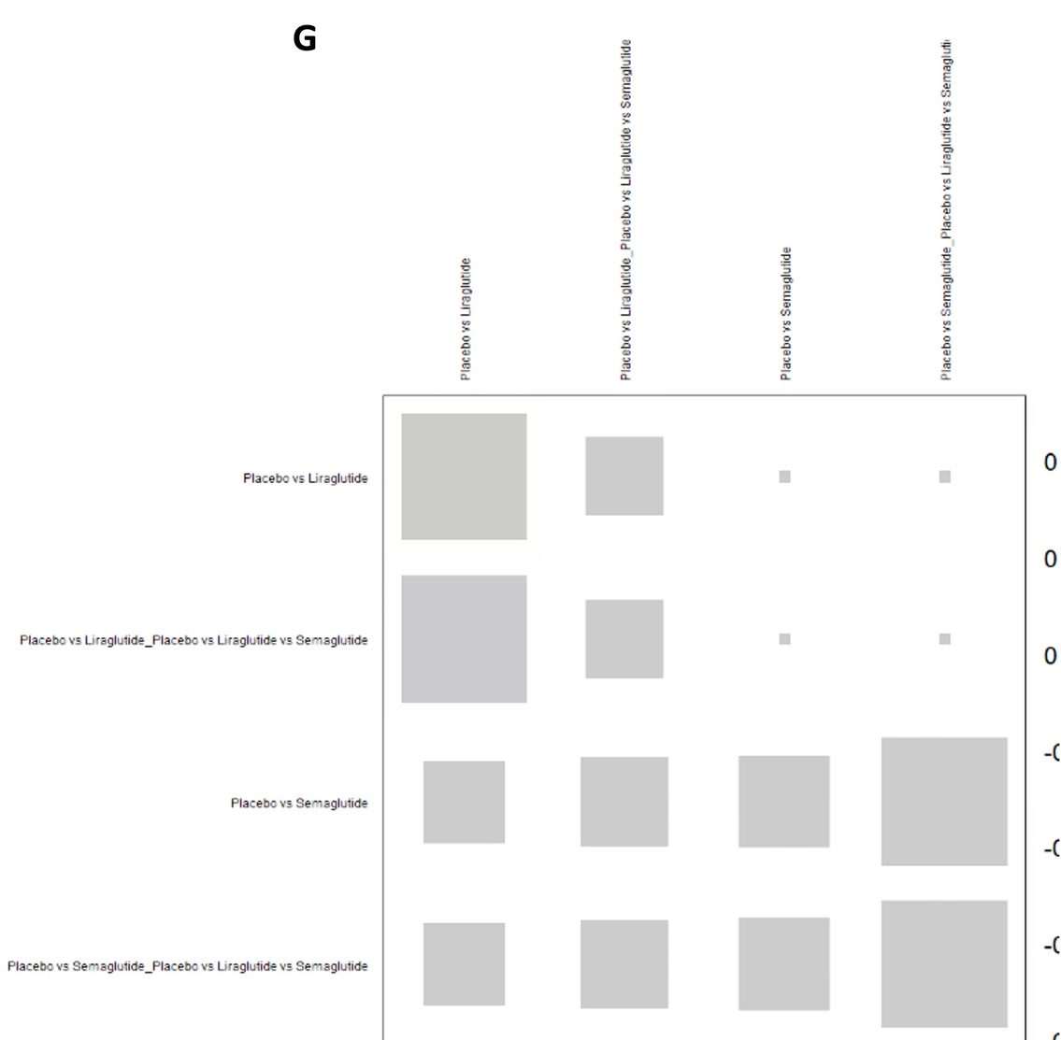
Supplementary figure 10. Heat plot for (A) nausea, (B) vomiting, (C) diarrhea, (D) constipation, (E) eructation, (F) cholelithiasis, and (G) decreased appetite.

