Supplemental materials
Supplementary Note S1. Exploratory machine learning regression analyses.
As exploratory analyses complementing the primary partial correlation and normative modeling approaches (Sections 2.5–2.6, 3.5–3.6), we evaluated three machine learning methods for individual-level prediction of AUC-DD from neuroanatomical features. All models showed limited predictive performance (Table S1), suggesting that individual differences in delay discounting cannot be reliably predicted from structural brain features alone.
Random forest regression (randomForest and ranger implementations in R) using the 15 SVM-selected features yielded test-set correlations of r = 0.04–0.05 and negative R² values after strict cross-validation. XGBoost regression using the same 15 features yielded r = 0.02 (R² < 0). Expanding the feature set to all 152 available neuroanatomical features in XGBoost marginally improved the correlation to r = 0.16 but R² remained negative, indicating performance no better than the sample mean.
Generalized additive models (GAMs, mgcv package in R) were fitted with penalized thin-plate regression splines (k = 5) for each of the 15 SVM-selected features, separately for obesity and healthy-weight groups, adjusting for age and sex. Seven of the 15 smooth terms reached FDR-corrected significance in the healthy-weight group, with six showing effective degrees of freedom (EDF) > 1.5 indicative of nonlinear associations (Table S2). The right entorhinal cortex exhibited the strongest nonlinearity (EDF = 2.80, pFDR = 0.003). However, a multi-feature GAM incorporating the seven FDR-significant features achieved only marginally higher explained variance (adjusted R² = 0.075) compared to a purely linear model (adjusted R² = 0.068), and a model comparison F-test indicated statistically significant but practically modest improvement (p = 0.018).
These negative results suggest that the neuroanatomical features that successfully discriminate obesity at the group level (SVM AUC = 0.648) and show robust population-level associations with delay discounting (partial correlations, 10/15 FDR significant) are insufficient for precise individual-level behavioral phenotyping. This dissociation — between group-level discrimination and individual-level prediction — is consistent with broader observations in population neuroimaging and provides indirect support for the normative modeling finding (Section 3.6): the obesity group's elevated delay discounting may reflect factors beyond what is captured by regional brain structural measures.
Table S1 : Exploratory machine learning models for individual-level prediction of AUC-DD from neuroanatomical features.
Model | Features | R | R² | RMSE | MAE
RF (randomForest) | 15 SVM | 0.052 | −0.088 | 0.200 | 0.170
RF (ranger) | 15 SVM | 0.041 | −0.100 | 0.201 | 0.170
XGBoost | 15 SVM | 0.023 | −0.366 | 0.224 | 0.182
XGBoost | 152 FS | 0.157 | −0.034 | 0.195 | 0.163
Note：All models trained on the obesity training set (N = 169) with hyperparameter tuning via 5-fold CV or OOB error, evaluated on the held-out test set (N = 72). Negative R² indicates performance worse than the mean baseline. FS = FreeSurfer-derived neuroanatomical features.

Table S2: Results of Generalized Additive Models (GAM) Predicting Delay Discounting (AUC-DD) from Neuroanatomical Features
Brain Region | edf | Ref. df | F | p | Dev. Expl. (%) | Adj. R² | p_{FDR}
R ITG (CSA) | 1.00 | 1.00 | 19.87 | < .001 | 6.15 | .054 | < .001
L MTG (CSA) | 1.00 | 1.00 | 17.23 | < .001 | 6.08 | .054 | < .001
R MTG (CSA) | 1.00 | 1.00 | 16.65 | < .001 | 6.08 | .054 | < .001
R EC (CSA) | 2.80 | 3.35 | 6.11 | < .001 | 6.96 | .060 | .002
L Amy (Vol) | 1.09 | 1.18 | 7.42 | .006 | 4.56 | .038 | .025
R PCC (CT) | 1.69 | 2.09 | 4.27 | .012 | 4.50 | .037 | .042
L rMFG (CSA) | 1.56 | 1.94 | 4.78 | .015 | 5.04 | .041 | .046
L Thal (Vol) | 1.90 | 2.37 | 3.59 | .022 | 4.47 | .036 | .060
L EC (CSA) | 1.88 | 2.36 | 3.66 | .026 | 5.18 | .043 | .066
L VDC (Vol) | 2.10 | 2.61 | 3.22 | .040 | 4.43 | .036 | .081
L SMG (CSA) | 1.00 | 1.00 | 3.15 | .076 | 3.95 | .032 | .127
R SPL (CT) | 1.00 | 1.00 | 1.15 | .282 | 3.33 | .026 | .392
R IPL (CT) | 1.00 | 1.00 | 1.08 | .298 | 4.73 | .038 | .392
R Ling (CT) | 1.07 | 1.15 | 1.09 | .330 | 3.46 | .027 | .397
R PCC (CSA) | 1.00 | 1.00 | 0.09 | .753 | 3.31 | .026 | .753
Note. N = 713. All smooth terms represent the thin-plate regression splines for the respective brain regions within the Healthy Weight group, predicting the area under the receiver operating characteristic curve for delay discounting (AUC-DD). edf, estimated degrees of freedom (an edf of 1.0 indicates a strictly linear relationship, while edf > 1.0 indicates a non-linear relationship); Ref. df, reference degrees of freedom used for hypothesis testing; F, F-statistic; Dev. Expl. (%), percentage of deviance explained by the model; Adj. R², adjusted R-squared; p_{FDR}, p-value adjusted using the Benjamini-Hochberg False Discovery Rate (FDR) correction.Abbreviations: L, left hemisphere; R, right hemisphere; CSA, cortical surface area; CT, cortical thickness; Vol, subcortical gray matter volume; MTG, middle temporal gyrus; ITG, inferior temporal gyrus; EC, entorhinal cortex; rMFG, rostral middle frontal gyrus; SMG, supramarginal gyrus; PCC, posterior cingulate cortex; IPL, inferior parietal lobule; SPL, superior parietal lobule; Ventral DC, ventral diencephalon.* p_{FDR}< .05, ** p_{FDR} < .01, *** p_{FDR} < .001.

Figure S1. Flowchart of participant selection and study design.
Out of the initial 1,206 participants from the HCP S1200 release, 113 were excluded based on established exclusion criteria. The remaining eligible participants were categorized by Body Mass Index (BMI). After excluding 375 overweight individuals (25≤BMI<30), a final sample of 718 young adults was identified, comprising 243 individuals with obesity (BMI≥30) and 475 healthy weight controls (18.5≤BMI<25). For analyses involving delay discounting, 5 participants (2 with obesity and 3 with healthy weight) were excluded due to missing AUC-DD data, resulting in a final analytical sample of N=713.
Abbreviations: HCP, Human Connectome Project; BMI, Body Mass Index; AUC-DD, area under the curve for delay discounting.

Figure S2. Radar charts demonstrating the performance of (A) the neuroanatomical model and (B) the combined model in the test cohort. AUC, area under the receiver operating characteristic curve; ACC, accuracy; SEN, sensitivity; SPE, specificity; PPV, positive predictive value; NPV, negative predictive value.
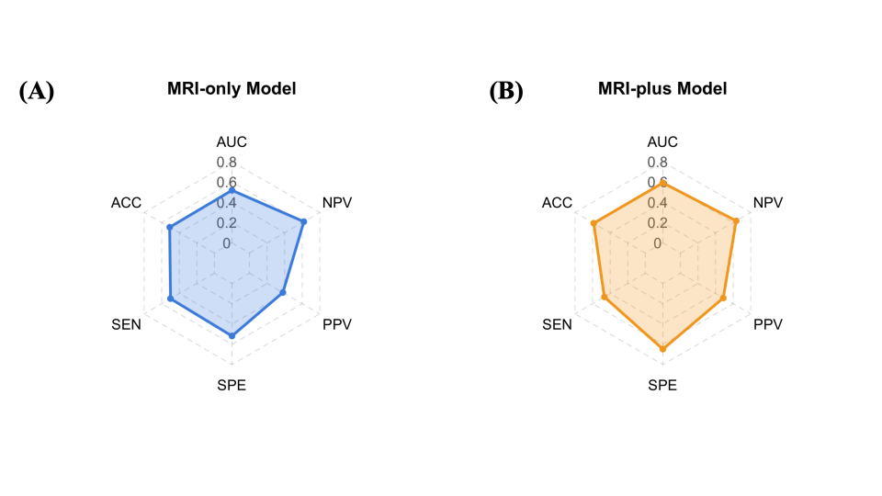

Supplementary Note S2. TIV-adjusted sensitivity analysis
Background. Cortical surface area (CSA) and subcortical gray matter volume scale with total intracranial volume (TIV), which is correlated with body size and sex. To evaluate whether the neuroanatomical signature identified by the main SVM classifier was confounded by global scaling, we performed a sensitivity analysis with TIV adjustment.
Methods. Within the training partition (70% of the sample), each CSA and subcortical volume feature was residualized against TIV using linear regression. The TIV regression coefficients learned from the training set were then applied to the held-out test set to prevent data leakage. Cortical thickness (CT) features were not adjusted as they are theoretically independent of TIV. The SVM classifier was retrained on the residualized features using identical preprocessing and hyperparameter tuning procedures as the main analysis (5-fold cross-validation, grid search over C ∈ {0.01, 0.1, 1, 10}).
Results. The optimal cost parameter selected via cross-validation was C = 0.01. On the held-out test set, the TIV-adjusted classifier achieved AUC = 0.615, accuracy = 0.589, sensitivity (obesity as positive class) = 0.583, and specificity = 0.592. The confusion matrix is shown in.
Of the top 15 features in the TIV-adjusted model, 7 were CT-based, 6 were TIV-adjusted CSA-based, and 2 were TIV-adjusted subcortical volume features. Three features overlapped with the original top 15: right superior parietal lobule CT, left entorhinal cortex CSA, and left amygdala volume .
Interpretation. The TIV-adjusted analysis indicates that the neuroanatomical signature is not solely driven by global scaling effects, with CT-based features showing particular robustness. However, the limited overlap among CSA features (3 out of 13 non-CT features) suggests that some CSA-based associations identified in the main analysis may partly reflect TIV-related variation, consistent with the well-documented coupling between CSA and TIV. The bilateral entorhinal cortex and right superior parietal lobule, which are central to our theoretical interpretations, remained robust to TIV adjustment.

