Supplement Table S1. Obesity-related conditions used to diagnose clinical obesity and the definition/ascertainment in AoU
Condition Category | Conditions | Definition / Ascertainment
Neurologic | Idiopathic intracranial hypertension | SNOMED-CT diagnosis
Respiratory | Obstructive sleep apnea; Pulmonary arterial hypertension | SNOMED-CT diagnosis
Cardiovascular | Heart failure; Myocardial infarction; Stroke; Recurrent atrial fibrillation; Recurrent deep vein thrombosis; Recurrent pulmonary embolism | SNOMED-CT diagnosis
Genitourinary | Urinary incontinence | SNOMED-CT diagnosis
Musculoskeletal | Decreased range of hip/knee movement | SNOMED-CT diagnosis
Hepatic | Non-alcoholic fatty liver disease | SNOMED-CT diagnosis
Lymphatic | Lower limb lymphedema | SNOMED-CT diagnosis
Reproductive (Female) | Anovulation; Polycystic ovary syndrome; Oligomenorrhea | SNOMED-CT diagnosis
Reproductive (Male) | Hypogonadism | SNOMED-CT diagnosis
Renal | Chronic kidney disease | SNOMED-CT diagnosis
Metabolic | Type 2 diabetes; Metabolic Disorder Composite | SNOMED-CT diagnosis, laboratory, or physical examination data.  Metabolic disorder composite defined as ≥2 of the following within 3 years prior to baseline: 1. Elevated blood glucose: Fasting >100 mg/dL or non-fasting >140 mg/dL without T2DM, or SNOMED-CT diagnosis of hyperglycemia.  2. Elevated blood pressure: SBP >140 mmHg or DBP >90 mmHg at baseline exam, or SNOMED-CT diagnosis of primary hypertension.  3. Elevated triglycerides: >150 mg/dL, or SNOMED-CT diagnosis of hypertriglyceridemia (non-familial).  4. Low HDL cholesterol: <40 mg/dL (male) or <50 mg/dL (female).  Most recent laboratory values within 3 years were used if multiple available.

Supplement Table S2. Source and definition of covariates
Variable | Source | Definition/Categories
Sex at birth | Self-reported | Female; Male
Age | Self-reported
Race/Ethnicity | Self-reported | White; Black; Hispanic; Asian; Other (participants not in the above categories)
Annual household income level | Self-reported | Low (<$25k); Middle ($25k–$200k); High (>$200k)
Education level | Self-reported | Less than high school; Completed high school; Some college; Graduate/advanced degree
Smoking status | Self-reported (Lifestyle Survey) | Current; Former; Never
Alcohol use in the past year | Self-reported (Lifestyle Survey) | Never; Light; Moderate; Frequent
Overall health status | Self-reported (Overall Health Survey) | Excellent; Very good; Good; Fair; Poor
Quality of life status | Self-reported (Overall Health Survey) | Excellent; Very good; Good; Fair; Poor
HbA1c level | EHR
CRP level | EHR

Supplement Figure S1. Cumulative incidence of transition from preclinical to clinical obesity across time, stratified by BMI category
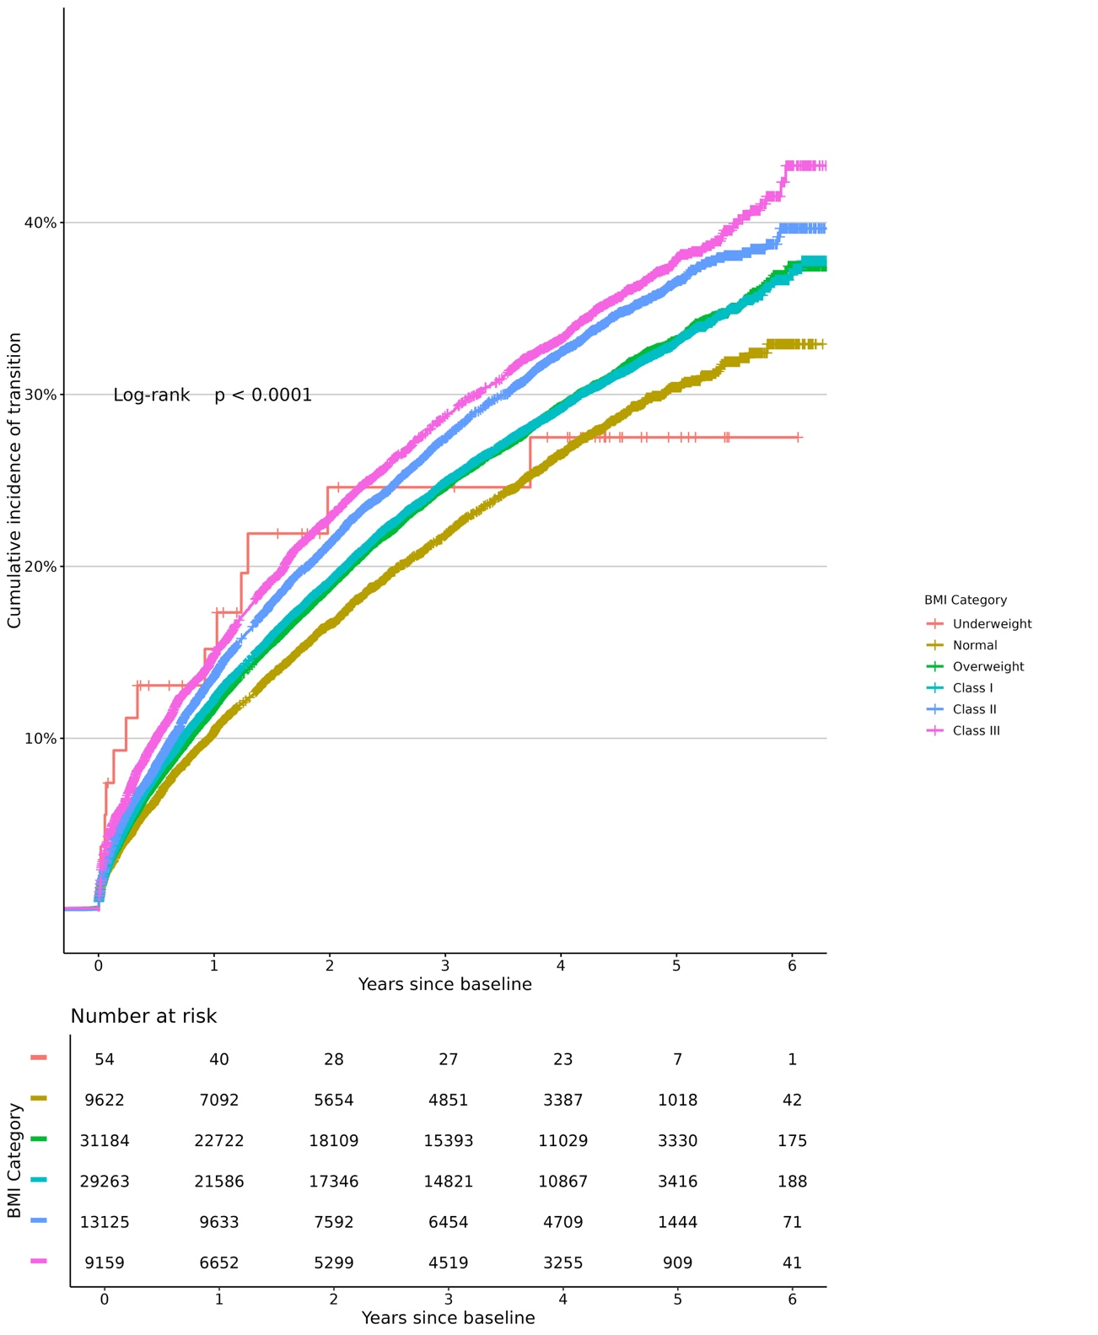

Supplement Figure S2. Cumulative incidence of transition from preclinical to clinical obesity across time, stratified by age group
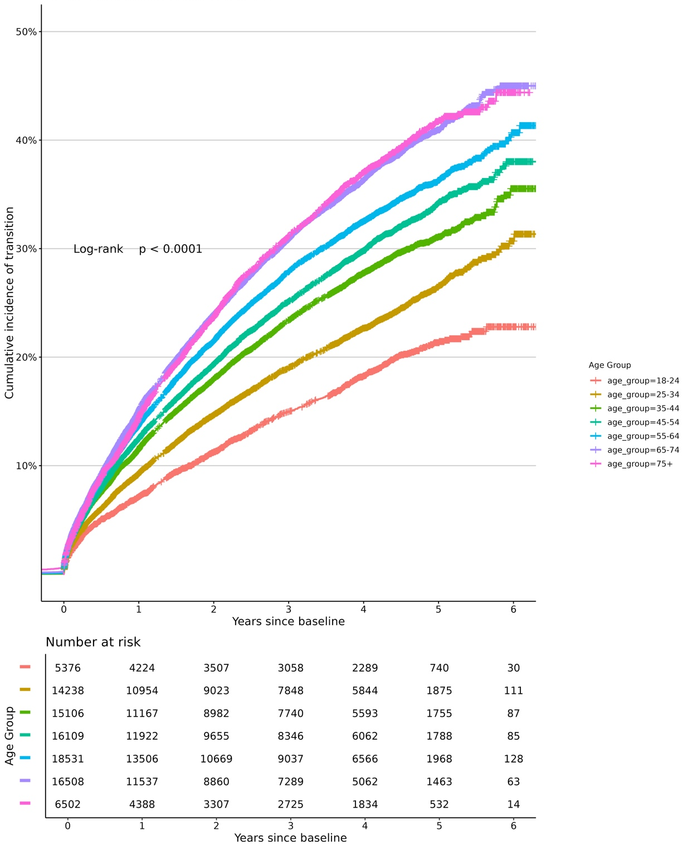
Supplement Figure S3. Cumulative incidence of transition from preclinical to clinical obesity across time, stratified by sex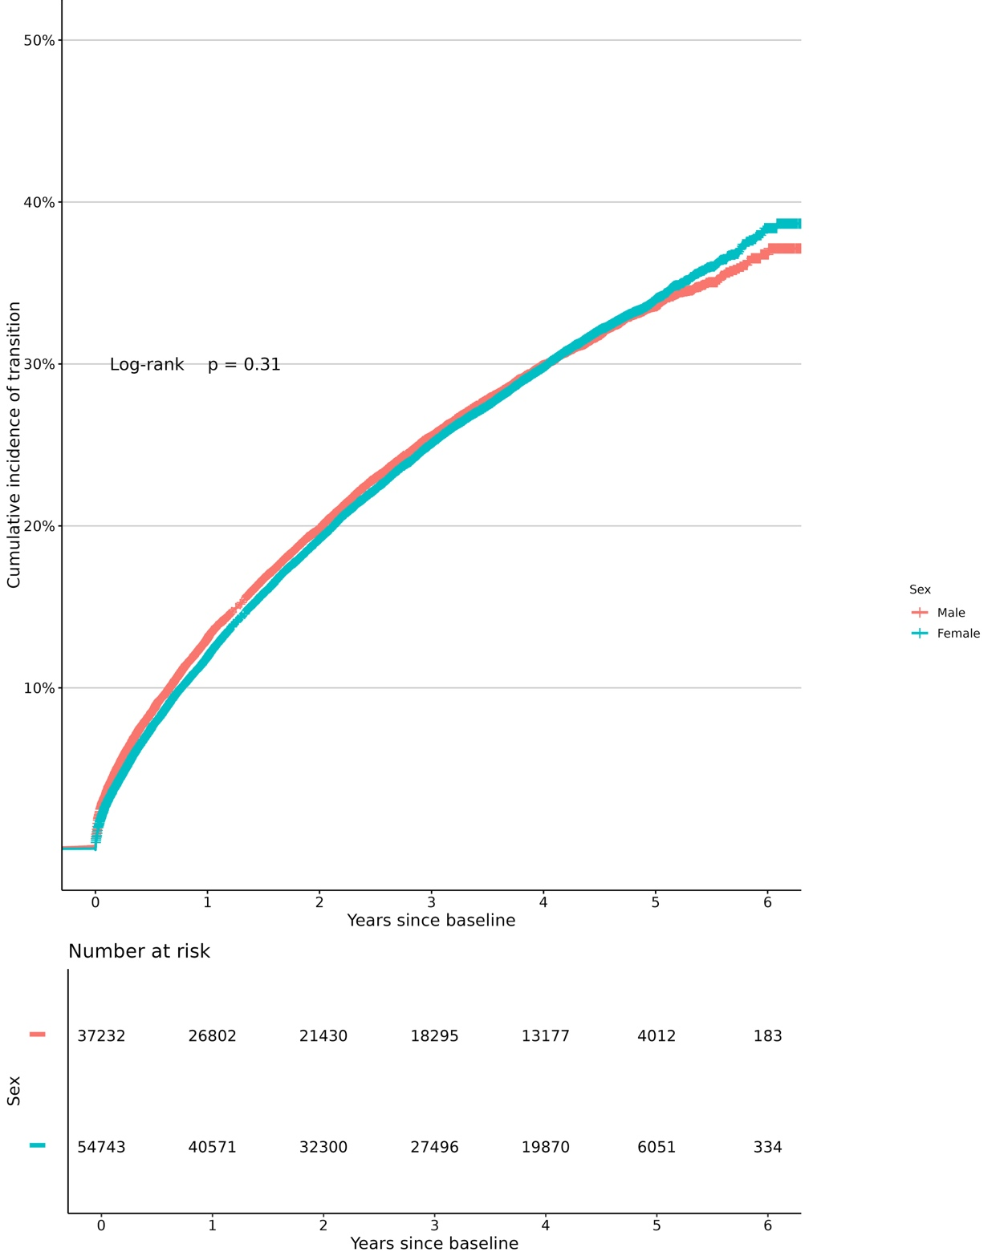

Supplement Figure S4. Cumulative incidence of transition from preclinical to clinical obesity across time, stratified by race/ethnicity
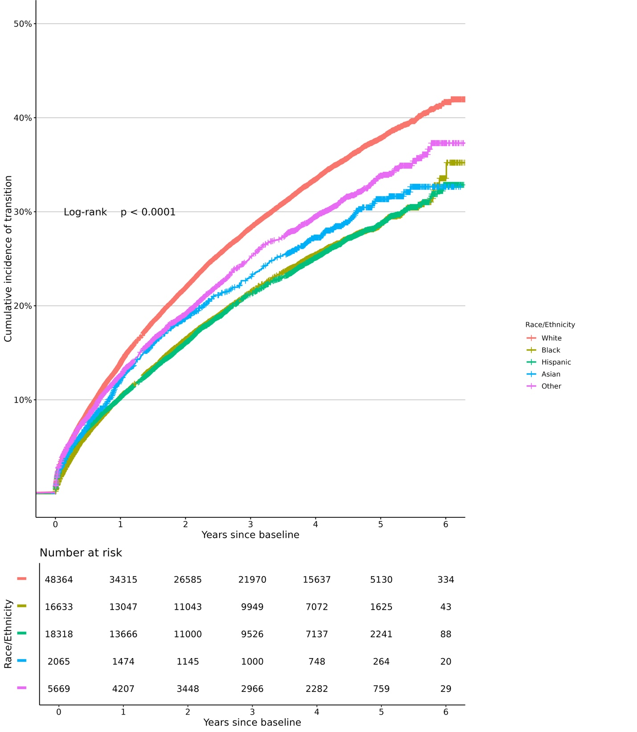

Supplement Figure S5. Cumulative incidence of transition from preclinical to clinical obesity across time, stratified by sex and race/ethnicity
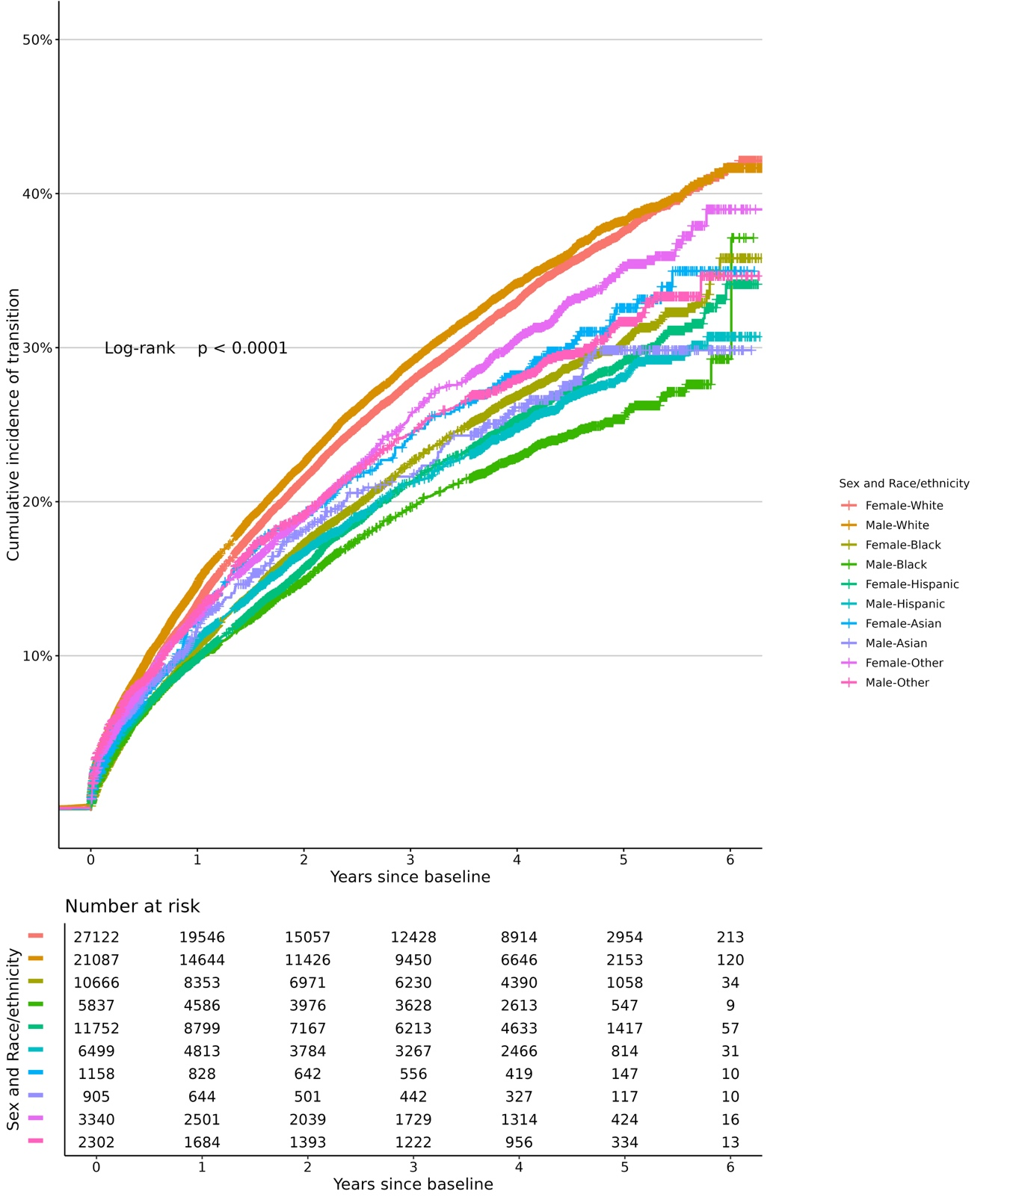
Supplement Figure S6. Cumulative incidence of transition from preclinical to clinical obesity across time, stratified by income level
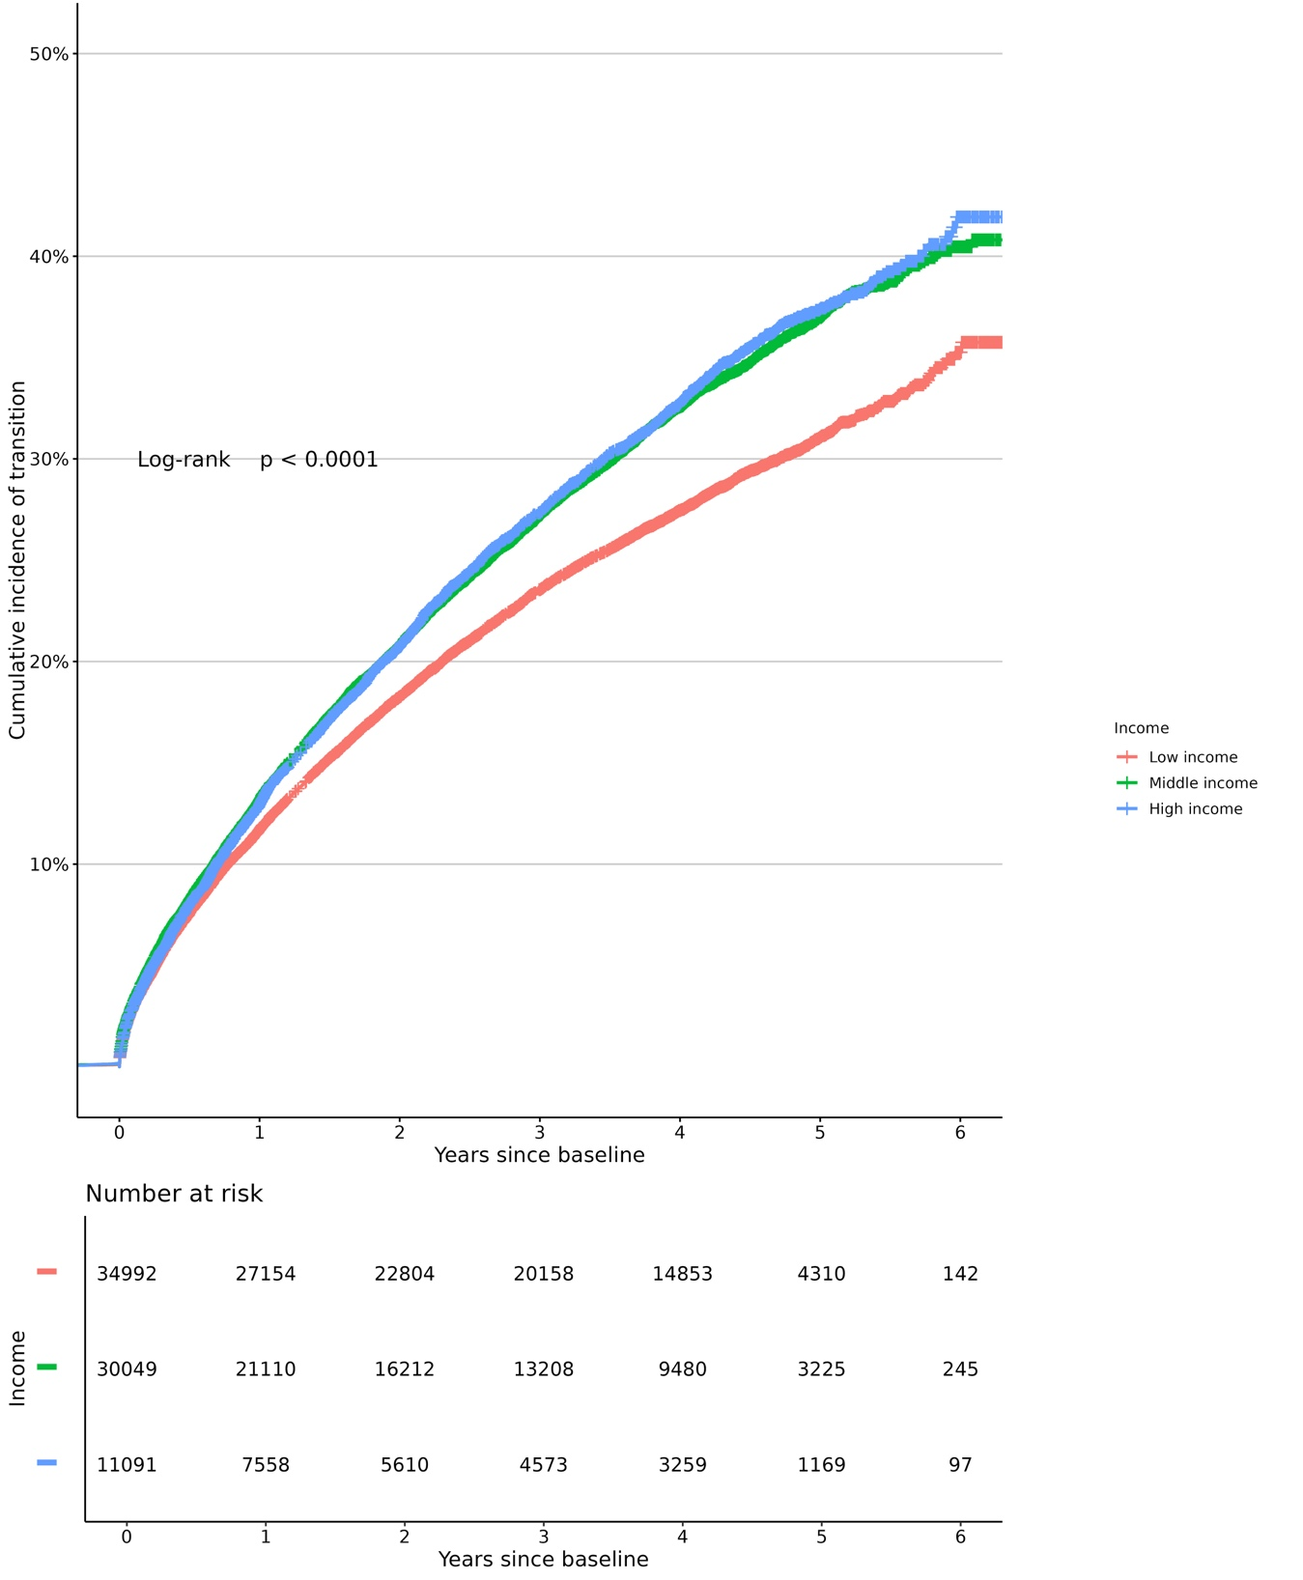

Supplement Figure S7. Cumulative incidence of transition from preclinical to clinical obesity across time, stratified by education level
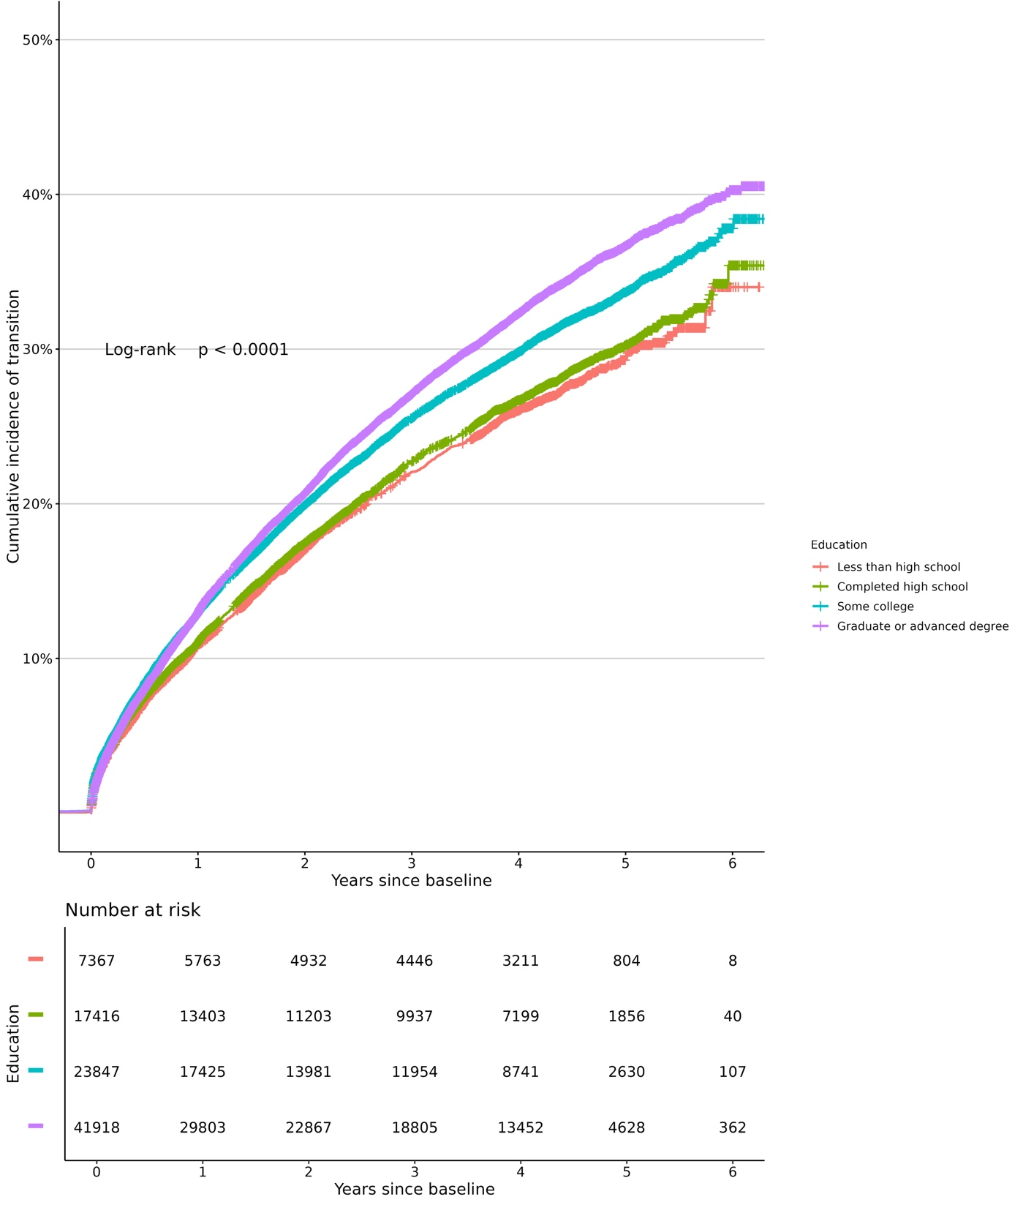

Supplement Figure S8. Cumulative incidence of transition from preclinical to clinical obesity across time, stratified by insurance status
