Supplementary materials
A comprehensive profile of TCF1⁺ progenitor and TCF1⁻ terminally exhausted PD-1⁺CD8⁺ T cells in head and neck squamous cell carcinoma: implications for prognosis and immunotherapy

Dikan Wang¹, Juan Fang¹, Shuqiong Wen¹, Qunxing Li¹, Jinming Wang¹, Lisa Yang¹, Wenxiao Dai¹, Huanzi Lu¹, Junyi Guo¹, Zhongyan Shan¹, Wenqiang Xie¹, Xiangqi Liu¹, Liling Wen¹, Jie Shen³, Anxun Wang², Qianming Chen³, Zhi Wang¹

¹Hospital of Stomatology, Guanghua School of Stomatology, Guangdong Provincial Key Laboratory of Stomatology, Sun Yat-Sen University, Guangzhou, Guangdong, China.
²Department of Oral and Maxillofacial Surgery, First Affiliated Hospital, Sun Yat-Sen University, Guangzhou, Guangdong, China.
³Hospital of Stomatology, Key Laboratory of Oral Biomedical Research of Zhejiang Province, School of Stomatology, Zhejiang University School of Medicine, Hangzhou, Zhejiang, China.

Correspondence: Zhi Wang (wangzh75@mail.sysu.edu.cn)
These author contributed equally: Dikan Wang, Juan Fang, Shuqiong Wen

Fig. S1
Fig. S1. a Representative mIHC image to show intratumoral and stromal region recognition. b and c mIHC quantitative analysis revealed that both intratumoral and stromal TCF1⁻Tex^{term} were more than TCF1⁺Tex^{prog}, particularly in the stromal region (n=102). d Gating strategy to detect and classify CD8⁺PD-1⁺TCF1⁺Tex^{prog} and CD8⁺PD-1⁺TCF1⁻Tex^{term} by flow cytometry. Data were shown as Mean ± SEM. Paired t test for b and c. **: P < 0.01, ns: P >0.05. Scale bars: 200 μm for a.

Fig. S2
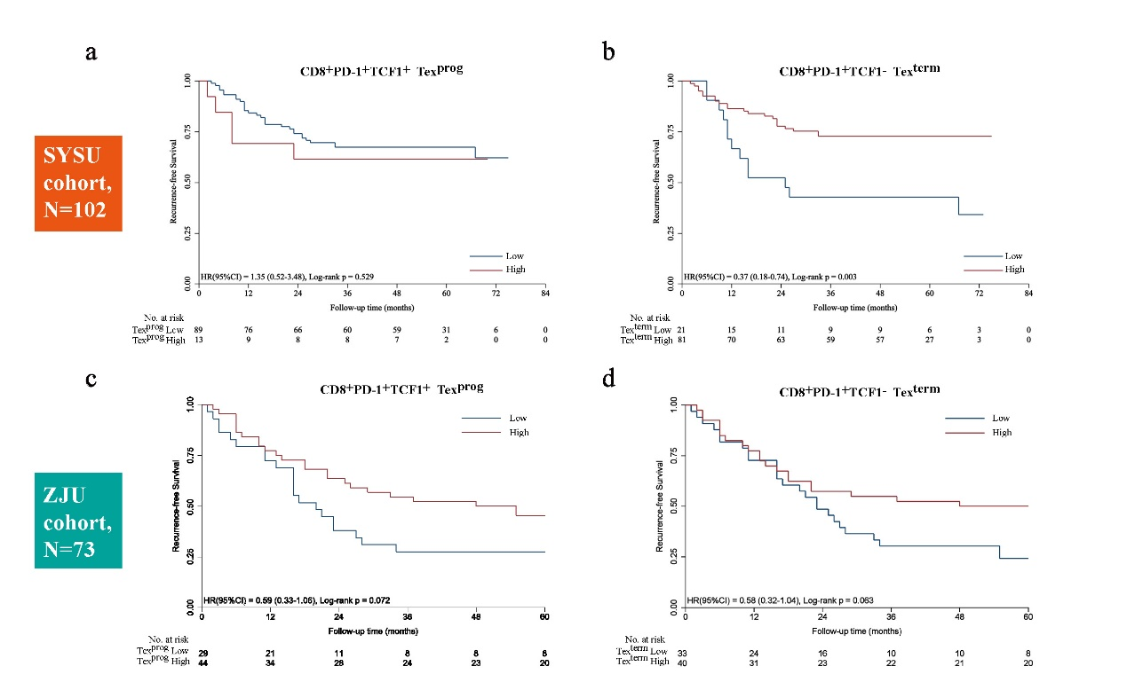
Fig. S2. CD8⁺PD-1⁺TCF1⁻ terminally exhausted T cells (TCF1⁻Tex^{term}) indicated a favorable recurrence-free survival (RFS) in head and neck squamous cell carcinoma (HNSCC). a Kaplan-Meier curves for RFS according to high and low density of CD8⁺PD-1⁺TCF1⁺ progenitor exhausted T cells (TCF1⁺Tex^{prog}) in the SYSU cohort. b Kaplan-Meier curves for RFS according to high and low density of TCF1⁻Tex^{term} in the SYSU cohort. c RFS analysis of high/low density of TCF1⁺Tex^{prog} in the ZJU cohort. d RFS analysis of high/low density of TCF1⁻Tex^{term} in the ZJU cohort. The log-rank test was used for a-d.

Table S1. Clinicopathologic characteristics of the HNSCC patients in the flow cytometry cohort

Patient# | Gender | Age | Cigarette smoking | Alcohol drinking | Primary site | HPV status | TNM classification | Clinical stage | Differentiation | Neoadjuvant therapy
1 | Male | 80 | No | No | Base of tongue | Negative | T2N0M0 | Ⅱ | Moderate | None
2 | Female | 32 | No | No | Tongue | Negative | T2N1M0 | Ⅲ | Moderate | None
3 | Female | 63 | No | No | Tongue | Negative | T1N0M0 | Ⅰ | Moderate | None
4 | Male | 58 | Yes | No | Tongue | Negative | T2N0M0 | Ⅱ | Moderate | None
5 | Female | 57 | No | No | Gingiva | Negative | T2N0M0 | Ⅱ | Well | None
6 | Male | 69 | Yes | Yes | Tongue | Negative | T1N0M0 | Ⅰ | Moderate | None
7 | Female | 75 | No | No | Tongue | Negative | T1N0M0 | Ⅰ | Well | None
8 | Female | 56 | No | No | Buccal | Negative | T3N2bM0 | Ⅳ | Moderate | None
9 | Female | 73 | No | No | Tongue | Negative | T2N1M0 | Ⅲ | Moderate | None
10 | Male | 43 | No | No | Buccal | Negative | T2N2bM0 | Ⅳ | Moderate | None
11 | Male | 38 | Yes | No | Base of tongue | Negative | T2N1M0 | Ⅲ | Well | Radiotherapy
12 | Female | 71 | No | No | Gingiva | Negative | T4aN2bM0 | Ⅳ | Moderate | None
13 | Male | 86 | No | No | Buccal | Negative | T2N0M0 | Ⅱ | Moderate | None
14 | Male | 48 | No | No | Oropharynx | Negative | T4aN2bM0 | Ⅳ | Moderate | None
15 | Male | 46 | Yes | Yes | Base of tongue | Negative | T2N1M0 | Ⅲ | Well | None
16 | Male | 42 | Yes | No | Tongue | Negative | T2N2bM0 | Ⅳ | Poor | None
17 | Male | 48 | No | No | Tongue | Negative | T3N2bM0 | Ⅳ | Well | None
18 | Female | 83 | No | No | Tongue | Negative | T4aN1M0 | Ⅳ | Moderate | Chemotherapy
19 | Male | 49 | Yes | No | Tongue | Negative | T1N0M0 | Ⅰ | Poor | None
20 | Female | 68 | No | No | Tongue | Negative | T2N1M0 | Ⅲ | Well | None
21 | Male | 64 | Yes | Yes | Gingiva | Negative | T4N0M0 | Ⅳ | Moderate | None
22 | Male | 56 | Yes | No | Tongue | Negative | T4aN1M0 | Ⅳ | Moderate | None
23 | Male | 63 | Yes | Yes | Tongue | Negative | T2N0M0 | Ⅱ | Moderate | None
24 | Male | 56 | Yes | No | Tongue | Negative | T2N0M0 | Ⅱ | Poor | None
25 | Male | 65 | No | No | Gingiva | Negative | T4N0M0 | IV | Poor | None
26 | Female | 50 | No | No | Buccal | Negative | T4aN0M0 | IV | Moderate | None
27 | Male | 67 | Yes | No | Tongue | Negative | T2N1M0 | III | Well | None
28 | Female | 62 | No | No | Buccal | Negative | T2N2bM0 | IV | Poor | None
29 | Female | 71 | No | No | Gingiva | Negative | T4aN2bM0 | IV | Moderate | None
30 | Female | 74 | No | No | Floor of mouth | Negative | T3N0M0 | III | Well | None
31 | Male | 66 | Yes | No | Tongue | Negative | T1N1M0 | III | Moderate | None
32 | Male | 59 | Yes | No | Tongue | Negative | T3N0M0 | III | Moderate | None
33 | Male | 50 | Yes | No | Tongue | Negative | T3N2bM0 | IV | Well | None
34 | Male | 63 | No | No | Floor of mouth | Negative | T3N0M0 | III | Well | None

Variables | SYSU cohort (N=102) |  |  | ZJU cohort (N=73)
Variables | No. | % |  | No. | %
Age (years) | 59 (32-85) |  |  | 60 (24-85)
Gender
Male | 70 | 68.6 |  | 51 | 69.9
Female | 32 | 31.4 |  | 22 | 30.1
Cigarette smoking | 44 | 43.9 |  | 40 | 54.8
Alcohol drinking | 37 | 36.3 |  | 36 | 49.3
Primary site
Tongue | 45 | 44.1 |  | 30 | 41.1
Buccal mucosa | 20 | 19.6 |  | 12 | 16.5
Gingiva | 17 | 16.7 |  | 11 | 15.1
Floor of mouth | 10 | 9.8 |  | 5 | 6.8
Palate | 6 | 5.9 |  | 5 | 6.8
Others | 4 | 3.9 |  | 10 | 13.7
Differentiation
Well | 77 | 75.5 |  | 51 | 69.9
Moderate | 20 | 19.6 |  | 18 | 24.7
Poor | 5 | 4.9 |  | 4 | 5.4
Tumor size
T1 | 24 | 23.5 |  | 20 | 27.4
T2 | 44 | 43.1 |  | 34 | 46.6
T3 | 11 | 10.8 |  | 9 | 12.3
T4 | 23 | 22.5 |  | 10 | 13.7
N stage
N0 | 77 | 75.5 |  | 49 | 67.1
N1-N3 | 25 | 24.5 |  | 24 | 32.9
Clinical stage
Early stage (I +II) | 57 | 55.9 |  | 36 | 49.3
Late stage (III + IV) | 45 | 44.1 |  | 37 | 50.7
Table S2. Demographic and clinical information of the patients from two clinical cohorts in the survival analysis cohort

Table S3. Univariate overall survival analysis of clinicopathological parameters in two clinical cohorts
Variables |  | SYSU cohort |  | ZJU cohort
Variables |  | HR (95% CI) | P Value | HR (95% CI) | P Value
Gender | Male | 0.551(0.240-1.266) | 0.160 | 0.766(0.374-1.568) | 0.466
 | Female
Age (years) | ≥60 | 1.807(0.918-3.559) | 0.087 | 0.640(0.343-1.192) | 0.159
 | <60
Smoking | Yes | 1.937(0.984-3.813) | 0.056 | 1.036(0.553-1.940) | 0.911
 | No
Alcohol | Yes | 1.339(0.676-2.652) | 0.402 | 1.544(0.824-2.894) | 0.175
 | No
Primary site | Tongue | 0.801(0.611-1.050) | 0.109 | 1.269(0.778-2.070) | 0.340
 | Buccal
 | Gingiva
 | Mouth Floor
 | Palate
 | Others
Differentiation | High | 1.050(0.584-1.888) | 0.871 | 1.015(0.849-1.213) | 0.871
 | Moderate
 | Poor
T stage | T1/T2 | 1.230(0.616-2.458) | 0.557 | 1.198(0.598-2.401) | 0.610
 | T3/T4
Nodal invasion | Positive | 2.755(1.389-5.463) | 0.004* | 2.102(1.116-3.962) | 0.022*
 | Negative
Clinical stage | Stage I/II | 2.131(1.075-4.222) | 0.030* | 1.971(1.043-3.725) | 0.037*
 | Stage III/IV
Radiotherapy | Yes | 2.314(1.175-4.558) | 0.015* | 0.628(0.151-2.607) | 0.522
 | No
Chemotherapy | Yes | 1.208(0.526-2.774) | 0.656 | 0.988(0.530-1.842) | 0.969
 | No
Tex^{prog} density | High | 1.356(0.525-3.504) | 0.530 | 1.004(0.995-1.013) | 0.358
(cells/mm²) | Low
Tex^{term} density | High | 0.378(0.186-0.767) | 0.007* | 0.391(0.205-0.744) | 0.004*
(cells/mm²) | Low
Tex^{prog}: CD8⁺PD1⁺TCF1⁺progenitor exhausted T cells; Tex^{term}: CD8⁺PD1⁺TCF1⁻terminally exhausted T cells; SYSU cohort: patients with HNSCC who were treated with surgery at Sun Yat-Sen University; ZJU cohort: patients with HNSCC who were treated with surgery at Zhejiang University; HR: hazard ratio; 95% CI: 95% confidence interval; * P<0.05.

