Supporting Information

Cai Qi¹, Qiang Sun^{1,2}, Dexuan Xiao¹, Mei Zhang¹, Shaojingya Gao¹, Bin Guo^{3*}, Yunfeng Lin^{1,2*}
1 State Key Laboratory of Oral Diseases, National Center for Stomatology, National Clinical Research Center for Oral Diseases, West China Hospital of Stomatology, Sichuan University, Chengdu, Sichuan 610041, China
2 Sichuan Provincial Engineering Research Center of Oral Biomaterials, Chengdu, Sichuan 610041, China
3 Department of Stomatology, the First Medical Centre, Chinese PLA General Hospital, Beijing 100853, China
Cai Qi and Qiang Sun contributed equally to this work.
*Correspondence: Bin Guo (guobin0408@126.com) & Yunfeng Lin (yunfenglin@scu.edu.cn)

Appendix Figure

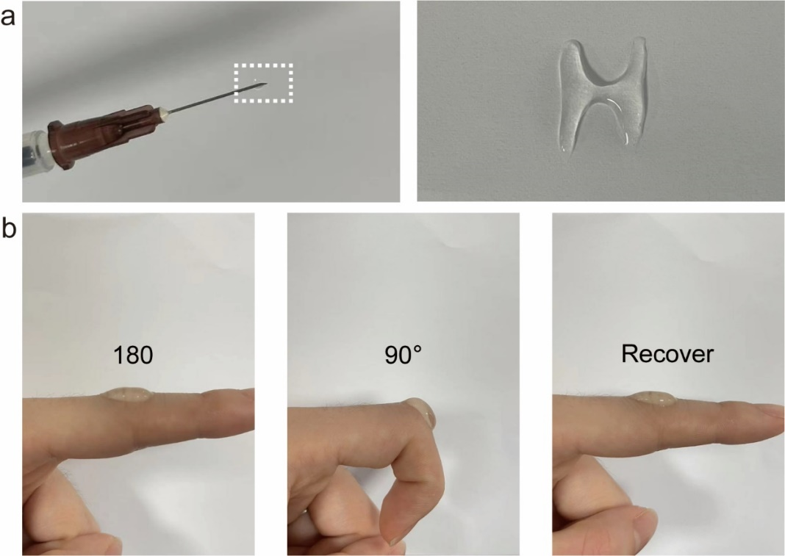
Fig. 1 Supplemental characterization of HAMA/tFNA-GL13K hydrogel. a Injectability and light curing capacity of HAMA/tFNA-GL13K hydrogel. b Elasticity and viscosity of HAMA/tFNA-GL13K hydrogel.

Fig. 2 Supplemental characterization of tFNA-GL13K. a Absorbance−concentration standard curve of GL13K. b The adsorption efficiency of GL13K on tFNA. c Ultraviolet (UV) absorbance spectra of tFNA-G13K with different GL13K/tFNA ratios.

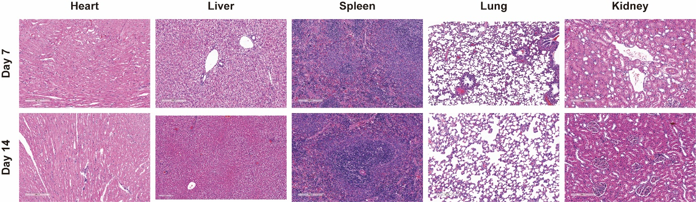
Fig. 3 HE staining of internal organs sections on 7th and 14th.

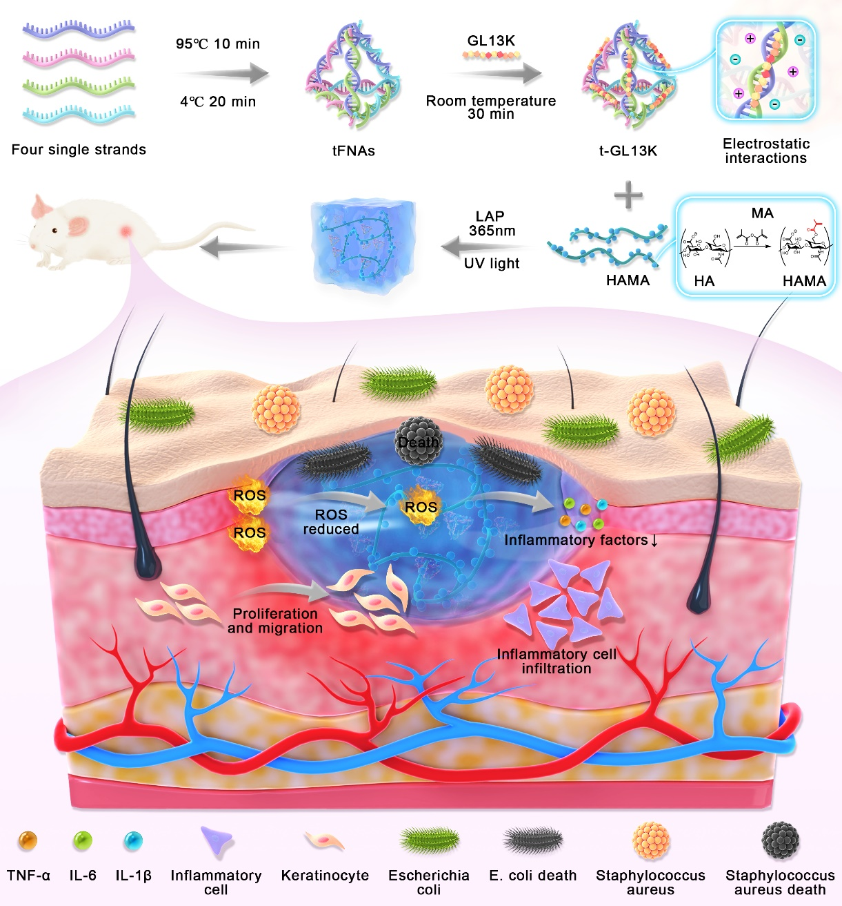
Fig 4. Illustration of the synthesis, and the antibacterial and anti-inflammatory processes of HAMA/tFNA-GL13K.

Appendix Table

NAME OF GENE | FORWARD | REVERSE
TNF-α | 5′-CCTGCCCCAATCCCTTTATT-3′ | 5′-CCCTAAGCCCCCAATTCTCT-3′
IL-1β | 5′-ACAACAGGAAAGTCCAGGCTA-3′ | 5′-TGGCAGAAAGGGAACAGAA-3′
IL-6 | 5′-AGTTGCCTTCTTGGGACTGA-3′ | 5′-ACAGTGCATCATCGCTGTTC-3′
p65 | 5'-CGCGGATCCGCCACCATGGACGAACTG-3' | 5'-CCGCTCGAGTTAGGAGCTGATCTG-3'
GADPH | 5′-TCATGACCACAGTCCATGCCATCA-3′ | 5′-CCCTGTTGCTGTAGCCAAATTCGT-3′
Table 1 The primer sequences

