Supplementary Information
Supplemental Tables
Supplementary Table 1. Primary antibodies for Western blotting and Immunofluorescence staining
Name | Application
OMD | WB, IF | Invitrogen, PA5-14382
TNFα | WB, IF | Servicebio, GB11188-100
IL-1β | WB, IF | ZEN BIO, 516288
β-actin | WB | ZEN BIO, 380624
NLRP3 | WB | Proteintech, 19771-1-AP
Caspase-1 | WB | Cell Signaling Technology, Human Reactive Inflammasome Antibody Sampler Kit II, #25620
Cleaved-Caspase-1 | WB | Cell Signaling Technology, Human Reactive Inflammasome Antibody Sampler Kit II, #25620
Pro-IL-1β | WB | Cell Signaling Technology, Human Reactive Inflammasome Antibody Sampler Kit II, #25620
Cleaved-IL-1β | WB | Cell Signaling Technology, Human Reactive Inflammasome Antibody Sampler Kit II, #25620
IL1R1 | WB | Abclonal, A5727
Phospho-p65 | WB | Cell Signaling Technology, #3033
p65  FLAG-tag rabbit  HA-tag rabbit  FLAG-tag mouse  HA-tag mouse | WB  Co-IP  Co-IP  Co-IP  Co-IP | ZEN BIO, 380172  Proteintech, 20543-1-AP  Sino Biological Inc, 100028-T36  Sigma-Aldrich, F3165  Santa Cruz, SC-7392

Supplementary Table 2. Primer sequences for RT-qPCR
Primers | Sequences
OMD-F  OMD-R | GGTGAACAACGAAGCACTAATGG  TGCTCCTTCTTGTTCTGGGC
Omd-F  Omd-R | GCACATTCAGCAACTCAACCTTCAG  CACATTCACCAGCCCGTCCATG
β-actin-F  β-actin-R | CCACGAAACTACCTTCAACTCCATC  AGTGATCTCCTTCTGCATCCTGTC
IL-1β-F  IL-1β-R | ATGGCTTATTACAGTGGCAATGAGG  AGTGGTGGTCGGAGATTCGTAG
TNFα-F  TNFα-R | CTCATCTACTCCCAGGTCCTCTTC  CGATGCGGCTGATGGTGTG
NLRP3-F  NLRP3-R | CTGTTCTATATCCACTGTCGG  CGGTCCTATGTGCTCGTCAA
Caspase-1-F  Caspase-1-R | CCTTAATATGCAAGACTCTCAAGGA  TAAGCTGGGTTGTCCTGCACT
IL1R1-F  IL1R1-R | AGTCCAGCGACGGTCACCTTC  ACGTGAGCCTCTCTTTGCAGTTTC
GAPDH-F  GAPDH-R | ACACCCACTCCTCCACCTTTG  TCCACCACCCTGTTGCTGTAG

Supplementary Table 3. Sequences of siRNA
Name | positive-sense strand | antisense strand
NC | UUCUCCGAACGUGUCACGUTT | ACGUGACACGUUCGGAGAATT
hs-OMD-si | GGUCAAACAAUACAACUAATT | UUAGUUGUAUUGUUUGACCTT
hs-GAPDH | GUGGAUAUUGUUGCCAUCATT | UGAUGGCAACAAUAUCCACTT

Supplemental Figures

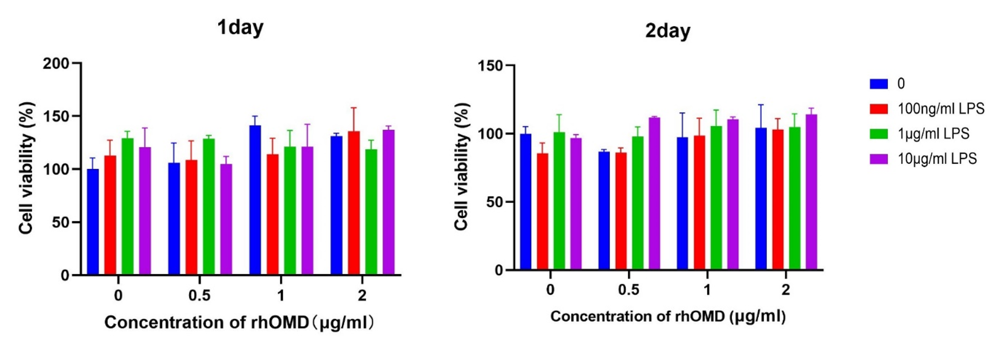
Supplementary Figure 1. The CCK8 results of the combined application of LPS (0, 0.1, 1, and 10µg/mL) and rhOMD (0, 0.5, 1, and 2 µg/ml) to hDPSCs within 2 days.

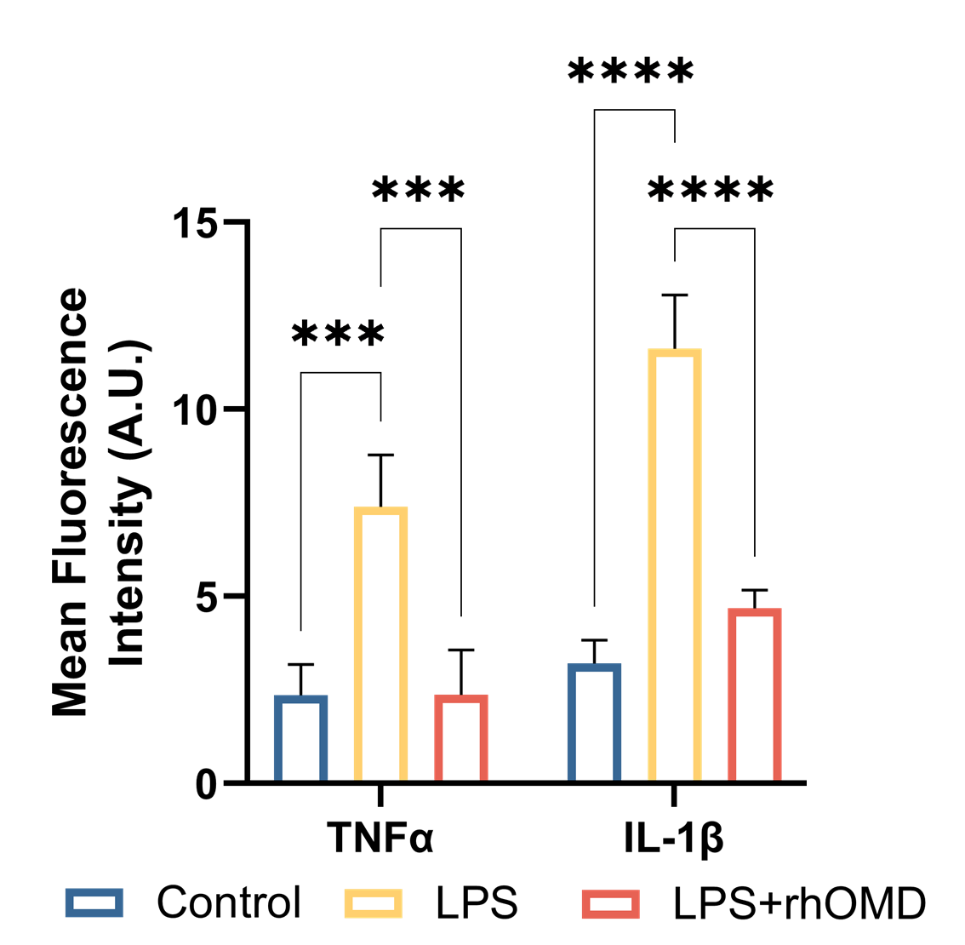
Supplementary Figure 2. Quantitative analysis of the red fluorescence intensity in (Fig 2e and 2f) using ImageJ. The results are expressed as mean ± SD (***P < 0.001 and ****P < 0.0001).
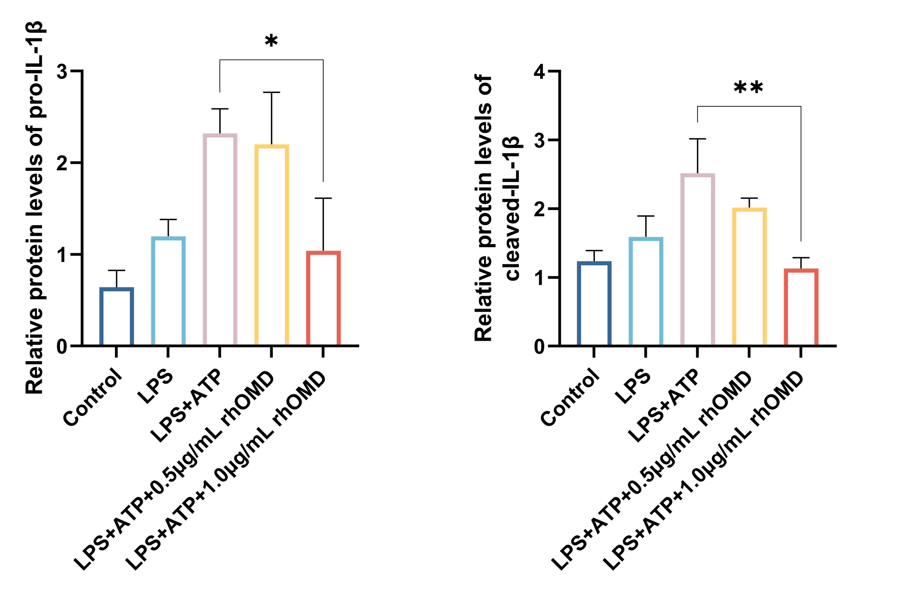
Supplementary Figure 3. Quantitative analysis of the relative protein levels of pro-IL-1β and cleaved-IL-1β in Figure 3d. The results are expressed as mean ± SD (*P < 0.05 and **P < 0.01).
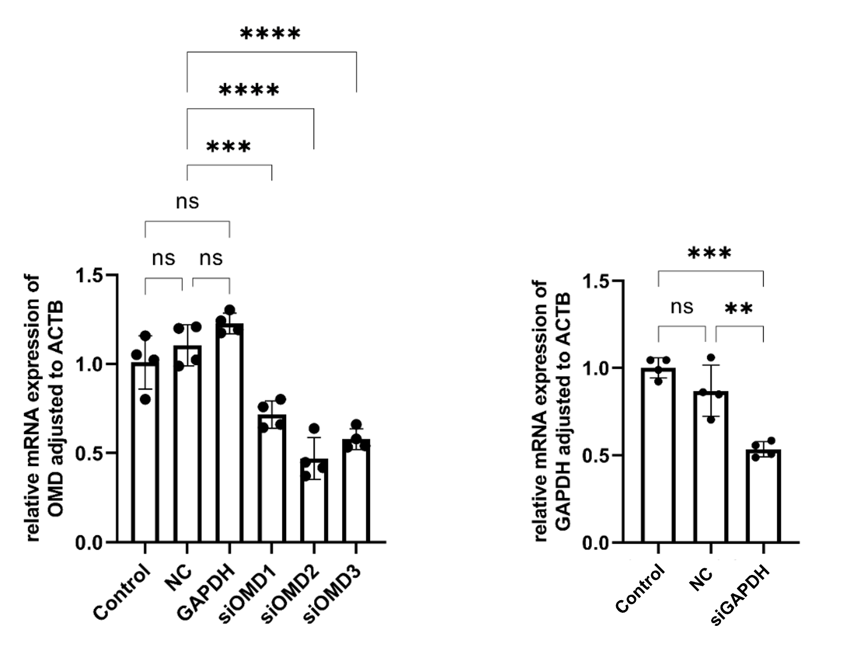
Supplementary Figure 4. RT-qPCR results showing the knockdown efficiency of siOMD for selecting the optimized siRNA. siGAPDH was used as a positive control. Results are expressed as mean ± SD (**P < 0.01, ***P < 0.001, and ****P < 0.0001; ns means no significance).
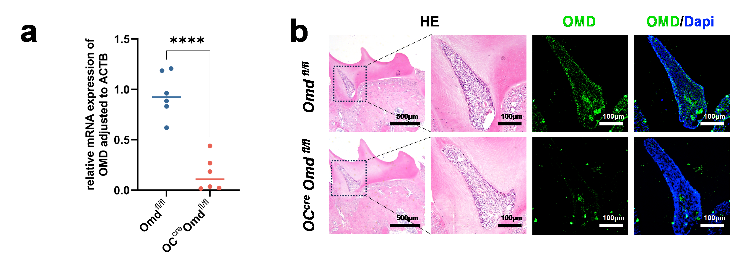
Supplementary Figure 5. (a) mRNA expression of Omd in the maxillary bone tissues of Omd^{fl/fl} mice and OC-Cre; Omd^{fl/fl} mice (n = 6). (b) HE and immunofluorescence staining of OMD, with 5× magnification (scale bar: 500 μm) and 20× magnification (scale bar: 100 μm). Results are expressed as mean ± SD (****P < 0.0001).

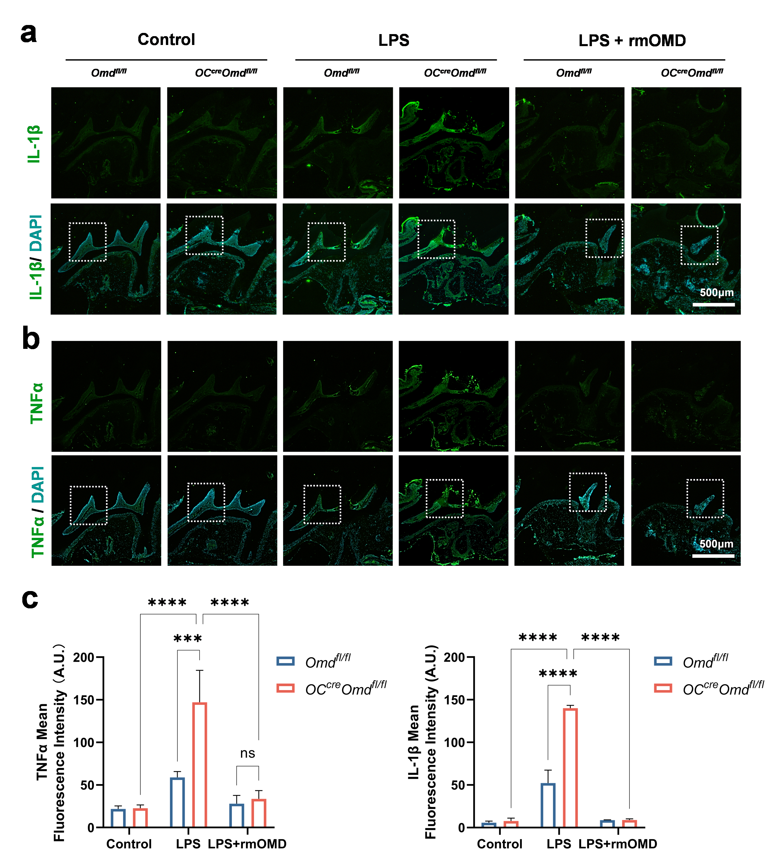
Supplementary Figure 6. (a, b) Immunofluorescence staining of TNFα and IL-1β, with 5× magnification (scale bar: 500 μm) (c) Mean immunofluorescence intensity of TNFα and IL-1β expression in (a). Results are expressed as mean ± SD (***P < 0.001 and ****P < 0.0001).

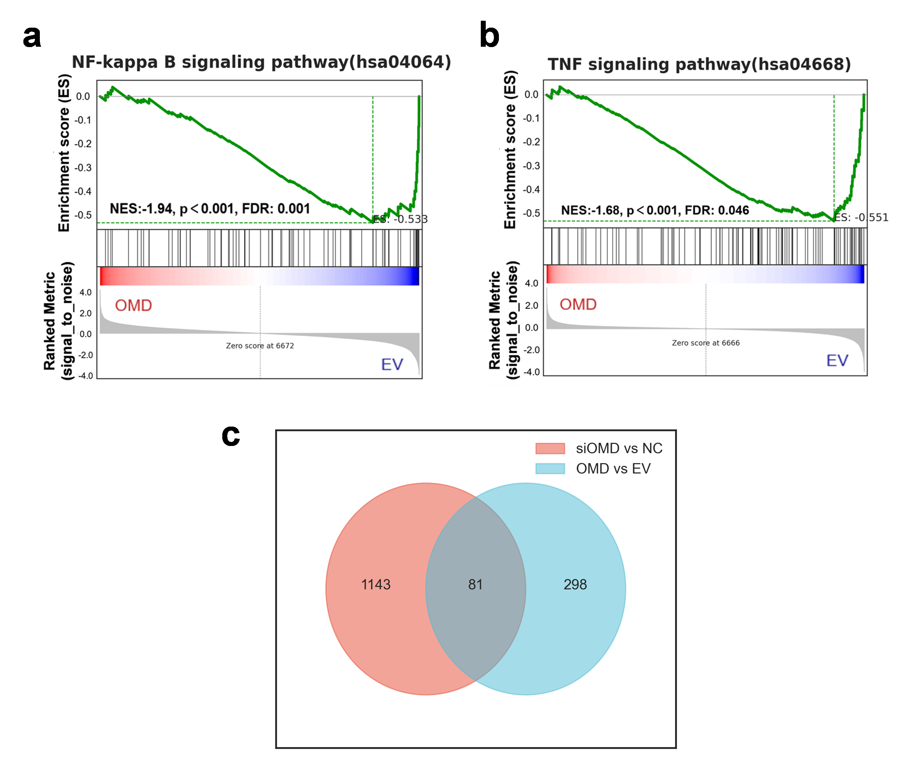
Supplementary Figure 7. (a, b) GSEA of NF-κB and TNF signaling pathways. (c) Venn diagram visualizing the number of co-occurring differentially expressed genes in the OMD-overexpressing hDPSCs and OMD-knockdown hDPSCs.

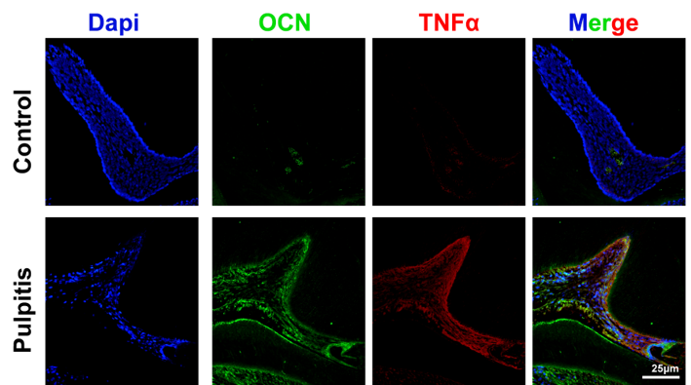
Supplementary Figure 8. Immunofluorescence staining of OCN and TNFα in normal pulp tissue and inflamed pulp tissue in mice.

