Supplementary Information
Model development
a. Data Exploration
From correlation plots together with our prior knowledge, our variables of interest are shown below,
1. Confirmed cases (C_{t})
2. Virus (V_{t})
3. Acetaminophen (A_{t})
4. Desethylhydroxychloroquine (DH_{t})

b. Cross Correlations
We also look at cross-correlations between the confirmed cases and (1) virus, (2) acetaminophen, and (3) desethylhydroxychloroquine (see figures below). That is, if there is any lead time between the peaks of any of the three variables and the confirmed cases. From those results specifically, desethylhydroxychloroquine seems to be a good indicator for early warning of cases outbreak.
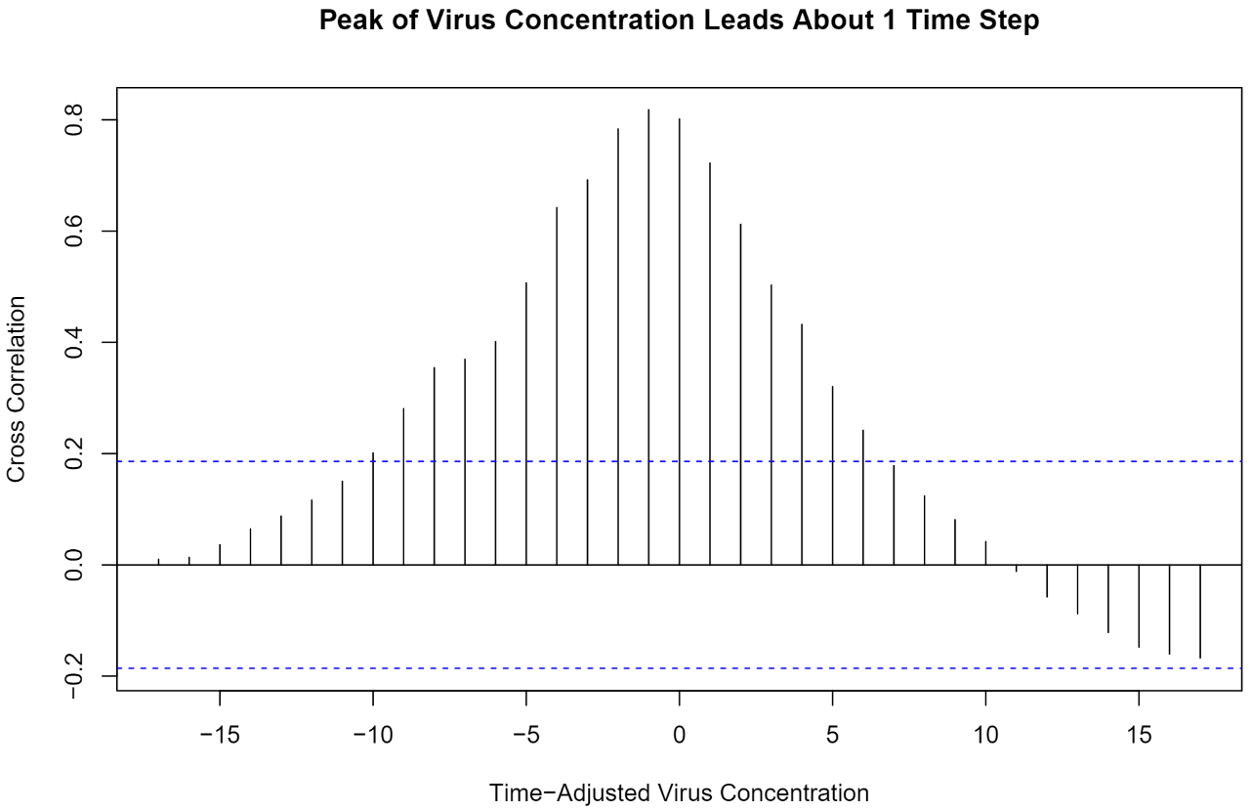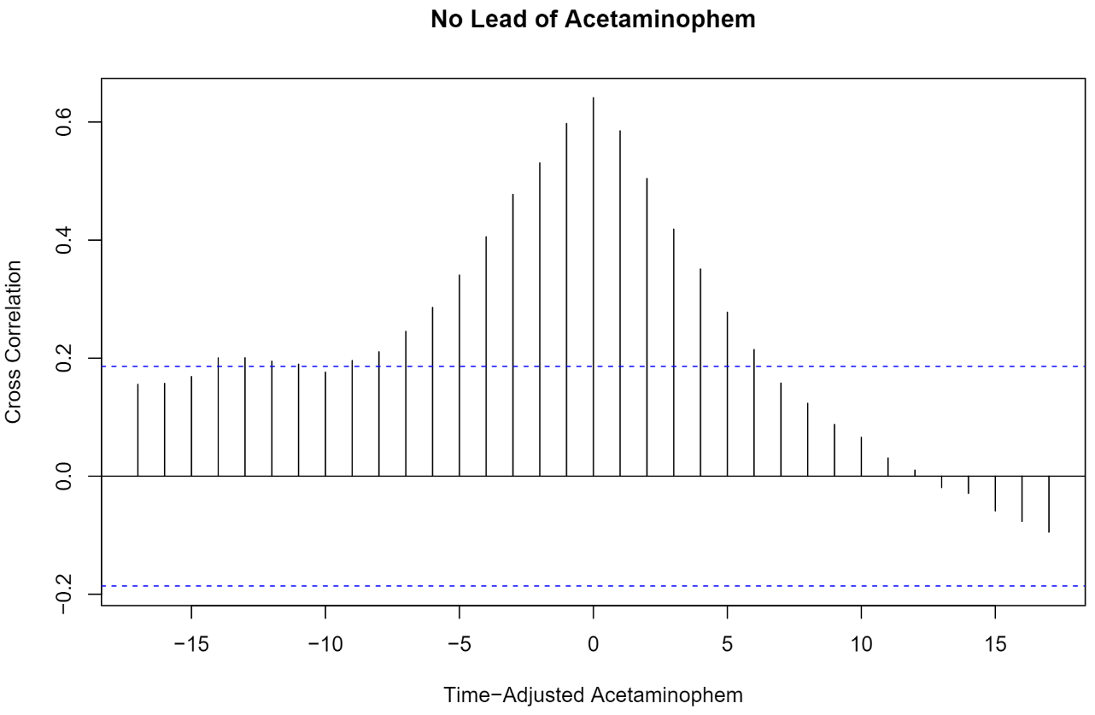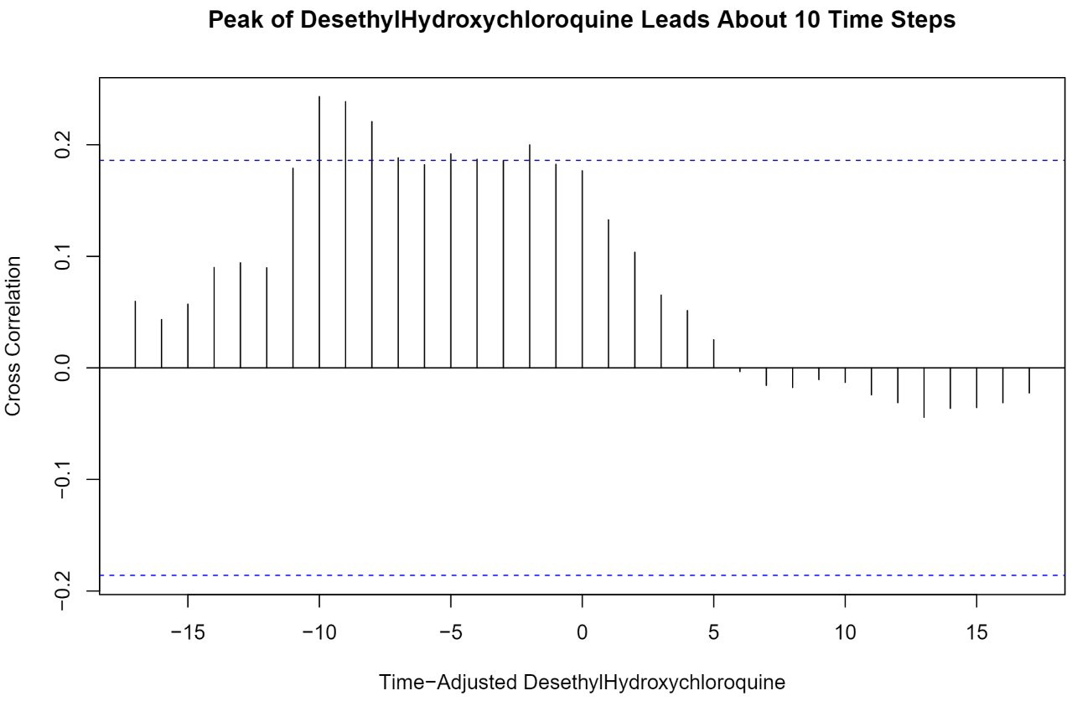

c. Temporal Trends
For time series plots of these variables, virus, acetaminophen, and desethylhydroxychloroquine show a similar trend to our outcome variable, confirmed case, and are chosen as predictors in our models

d. Models
Three specific sets of models are considered:
1. M-110s: models with one substance and ten lags (m = 1, n = 10).
2. M-205s: models with two substances and five lags (m = 2, n = 5).
3. M-303s: models with three substances and three lags (m = 3, n = 3).
For each set of models, we test possible combinations of variables according to Data Exploration and Cross Correlation. We retain the model with the best predictive performance based on the Watanabe–Akaike Information Criterion (WAIC).

M-110s:
M-110s regress the current confirmed cases on ten lags of a single predictor variable (1 x 10). Candidate substances considered for this model: (1) virus, (2) acetaminophen, and (3) desethylhydroxychloroquine. The virus model has the lowest WAIC score and has the following form:
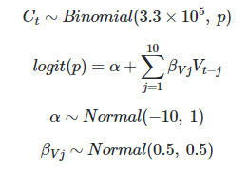
M-205s:
M-205s regress the current confirmed cases on five lags of two predictor substances (2 x 5). The model with the virus concentration and desethylhydroxychloroquine has the best performance and has the following form:
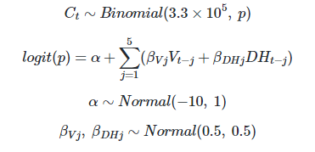
M-303s:
M-303s regress the current confirmed cases on three substances, each with three lags (3 x 3). The best model uses (1) virus, (2) desethylhydroxychloroquine, and (3) acetaminophen as predictors and has the following form:
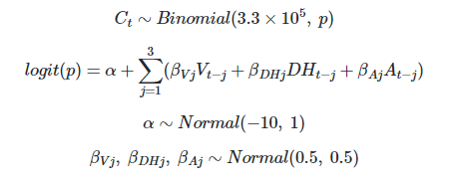

e. Prior Predictive Simulations
Common priors are applied to all parameters to regularize our estimate. The choice of priors is based on their resulted confirmed case distributions. For a specific set of priors, we calculate its infection probabilities (by taking the inverse logit of the linear combination of parameters) and the simulated confirmed cases (via a binomial process) under different distributions of virus concentration. As a result, the following set of priors is chosen:
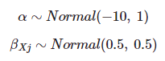
Here, we show how infection probability and confirmed cases are distributed under three cases of virus distributions.
Case 1: virus concentration distributed uniformly
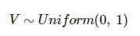
Distribution of Infection Probability
Min. | 1st. Qu. | Median | Mean | 3rd Qu. | Max.
0.0000016 | 0.0001322 | 0.0004810 | 0.0048370 | 0.0021727 | 0.4947711
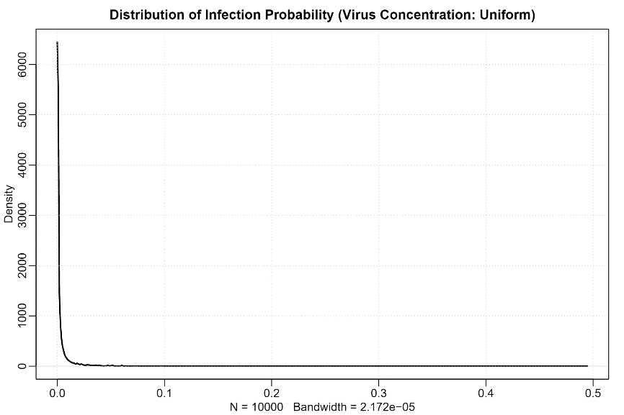

Distribution of Confirmed Case
Min. | 1st. Qu. | Median | Mean | 3rd Qu. | Max.
0 | 44 | 158 | 1596 | 715 | 163123
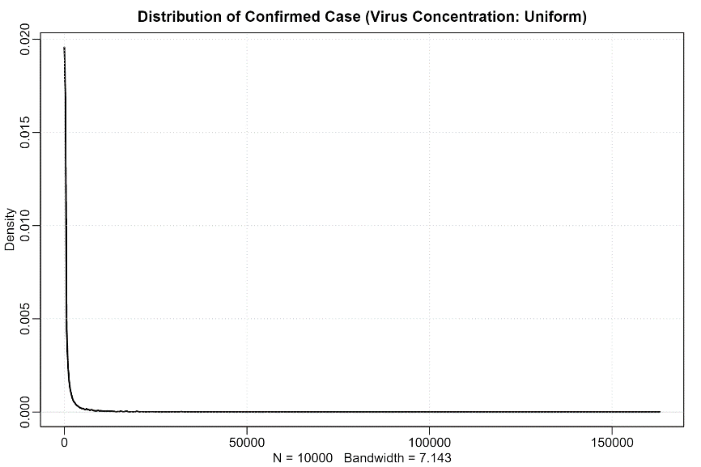

Case 2: virus concentration at the maximum
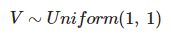
Distribution of Infection Probability
Min. | 1st. Qu. | Median | Mean | 3rd Qu. | Max.
0.0000094 | 0.0019102 | 0.0067741 | 0.0264734 | 0.0227059 | 0.8991982
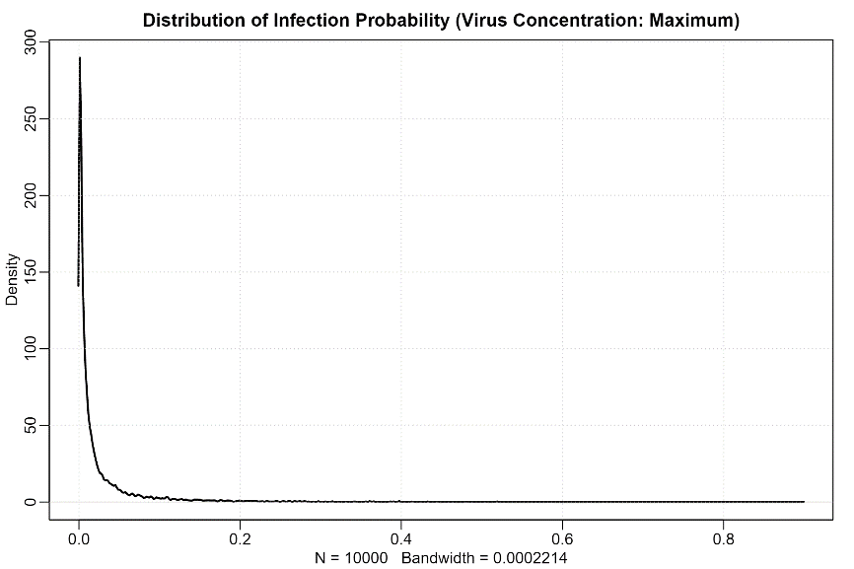

Distribution of Confirmed Case
Min. | 1st. Qu. | Median | Mean | 3rd Qu. | Max.
2 | 627 | 2240 | 8736 | 7501 | 296497
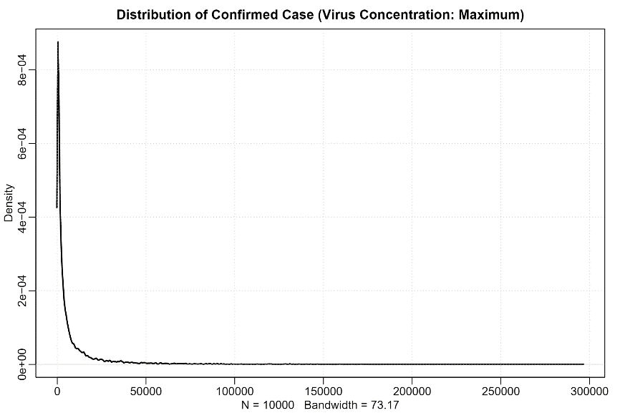

Case 3: virus concentration at the minimum
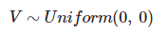
Distribution of Infection Probability
Min. | 1st. Qu. | Median | Mean | 3rd Qu. | Max.
9.011e-07 | 2.306e-05 | 4.538e-05 | 7.407e-05 | 8.776e-05 | 1.576e-03
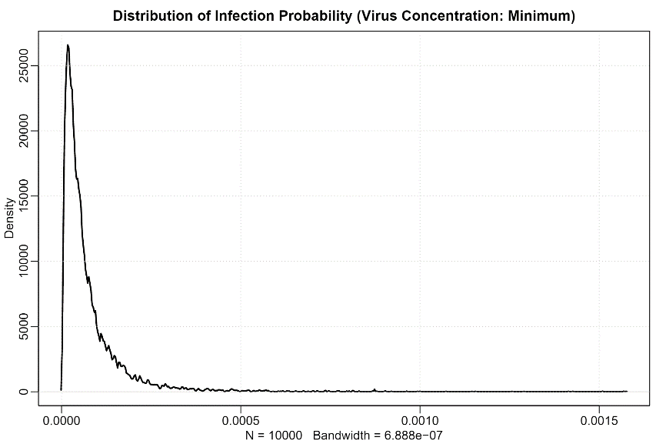

Distribution of Confirmed Case
Min. | 1st. Qu. | Median | Mean | 3rd Qu. | Max.
0 | 7 | 15 | 25 | 30 | 542
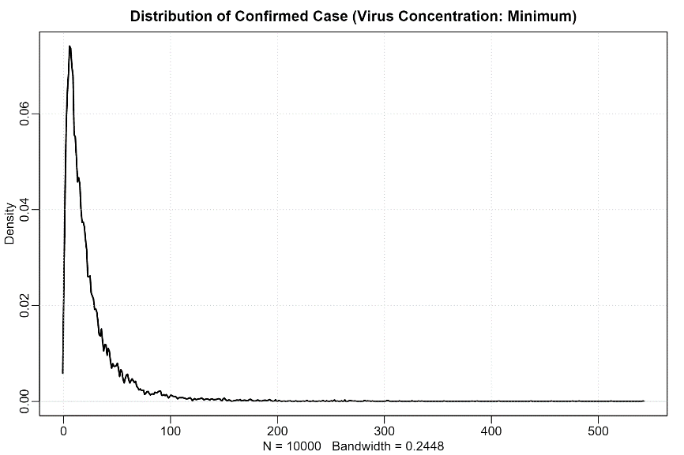

f. MCMC Diagnostics
Several criteria are used to gauge the sampling quality of the MCMC algorithm. Generally, for accurate inference, we look for three qualities of our Markov chain: (1) convergence, (2) stationary, and (3) good mixing. The trace and rank plots (Vehtari et al 2019) below show these features. The R-hats are close to one, and hence confirm the convergence (Brook and Gelman 2012). The ESSs (the effective MCMC length without autocorrelation) seem reasonable given the non-skewed posterior distributions shown in the Posterior Distributions and Coefficient Intervals section below. The means, standard deviations, and 95% percentile intervals of the posterior distributions for parameters are also provided.

M-110s: Virus
R-hat and ESS table:
 | mean | sd | 2.5% | 97.5% | n_eff | Rhat4
a | -20.2427857 | 0.11476878989114 | -20.4620425 | -20.013475 | 2214.4863524851 | 1.00116317885218
bV1 | 2.976528885 | 0.171112402199256 | 2.643832 | 3.31255975 | 1643.73214728439 | 1.00042066324287
bV2 | 2.479392245 | 0.196401317925699 | 2.1000095 | 2.865888 | 1370.17549874953 | 1.0029853747985
bV3 | 3.209276455 | 0.210821438767752 | 2.78020025 | 3.6148165 | 1490.86948641381 | 0.999423506131243
bV4 | 2.75133813 | 0.199930503449593 | 2.362772 | 3.1503055 | 1654.00425493691 | 1.00076036118224
bV5 | 1.1288664655 | 0.203925305643139 | 0.73637725 | 1.50726375 | 1429.28423218 | 1.00061958324148
bV6 | 0.50851240765 | 0.191145413027201 | 0.15102115 | 0.888727625 | 1329.22964981724 | 0.999989500610677
bV7 | 0.7954933373 | 0.203546563920791 | 0.379082925 | 1.195953 | 1504.67971532945 | 1.00041903592141
bV8 | 1.168763591 | 0.209639824620233 | 0.752779125 | 1.59919675 | 1542.02061138882 | 1.00078714463858
bV9 | 0.1405384286705 | 0.185773004216639 | -0.229559775 | 0.4951723 | 1288.99129650425 | 1.00108498177418
bV10 | -0.473194798 | 0.175532874113711 | -0.79649015 | -0.11700585 | 1574.32602177099 | 0.999769590091101
Trace plot:
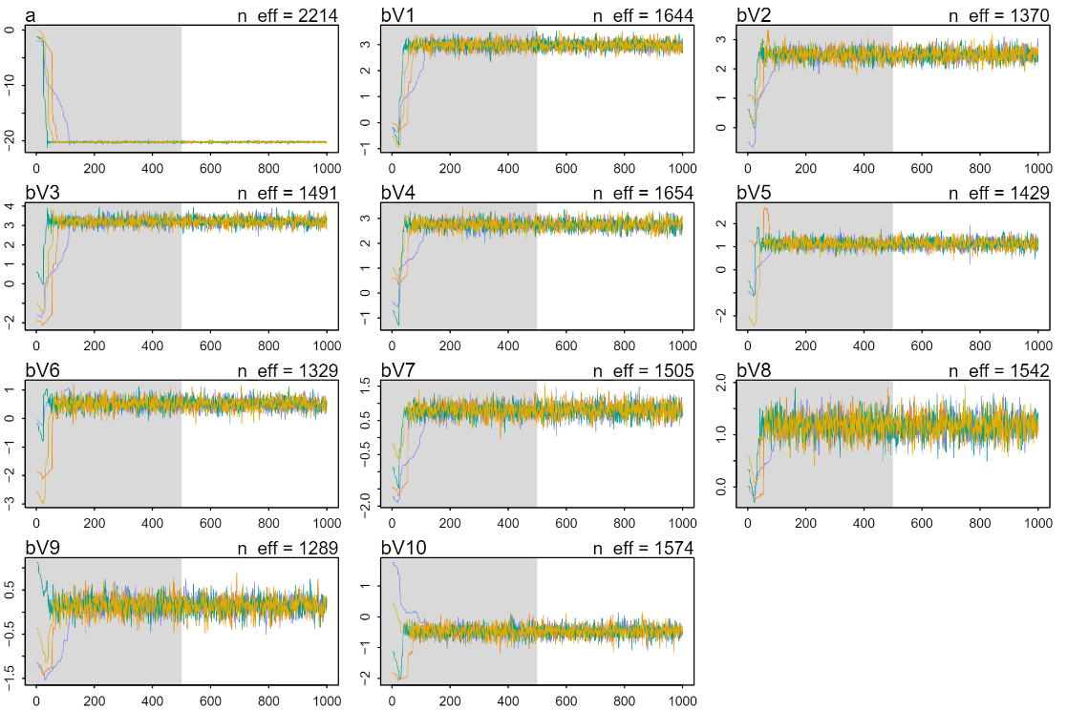
Rank plot:
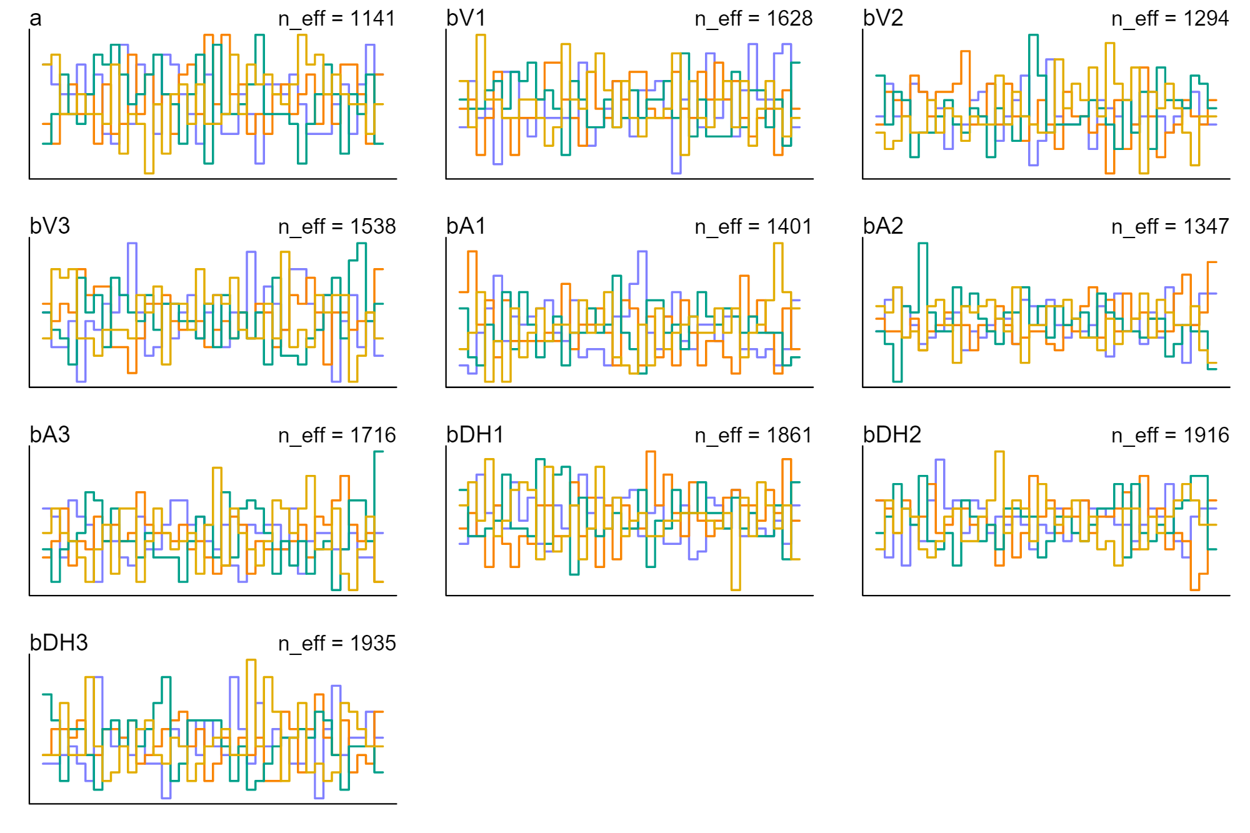
M-205s: Virus, DHCQ
R-hat and ESS table:
 | mean | sd | 2.5% | 97.5% | n_eff | Rhat4
a | -20.45360485 | 0.113687392674404 | -20.6705225 | -20.23459 | 2311.38544786293 | 0.998826853006411
bV1 | 3.05481166 | 0.184079955961636 | 2.68427175 | 3.41571275 | 1868.81050851382 | 0.999051632575679
bV2 | 2.94109687 | 0.190333897299808 | 2.56817725 | 3.31896925 | 1800.32641132757 | 1.00098269638083
bV3 | 3.606532705 | 0.197466960487001 | 3.23139575 | 3.98984925 | 1953.69907238804 | 0.999849399505337
bV4 | 3.452917565 | 0.19594375253475 | 3.06231875 | 3.838581 | 1708.78515431058 | 1.00092232182518
bV5 | 1.91873244 | 0.183183758141845 | 1.56771475 | 2.26638775 | 1484.89782391102 | 1.00061573922292
bDH1 | -0.076415091929 | 0.0614733536293056 | -0.200453525 | 0.0433177524999999 | 2746.80363408721 | 0.99885262344014
bDH2 | 0.1092584038235 | 0.054669528693183 | 0.00272403975000003 | 0.213536225 | 2014.83751424707 | 0.999782270906632
bDH3 | -0.3860911695 | 0.0547408185972599 | -0.490672975 | -0.28253515 | 1993.42221739312 | 1.000146310914
bDH4 | -0.30162288 | 0.0492771349498328 | -0.39849395 | -0.20997505 | 2272.54692022841 | 0.998717756238328
bDH5 | 0.25627089765 | 0.0501226627452254 | 0.157081075 | 0.355773675 | 2801.84521842147 | 0.999839724174783
Trace plot:
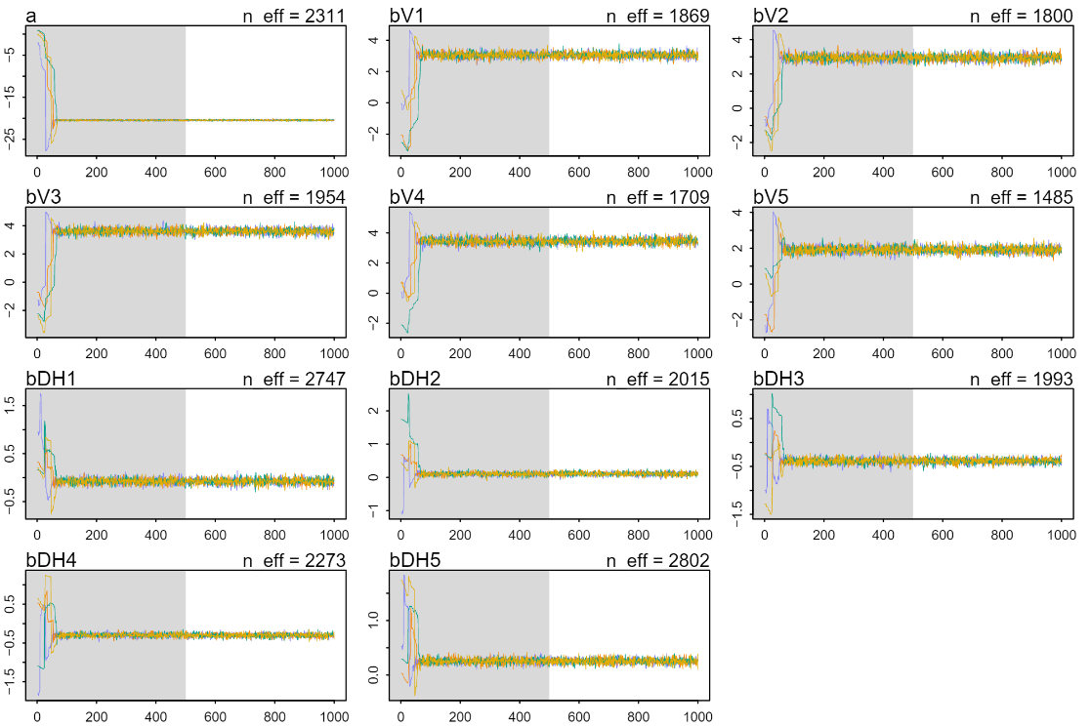
Rank plot:
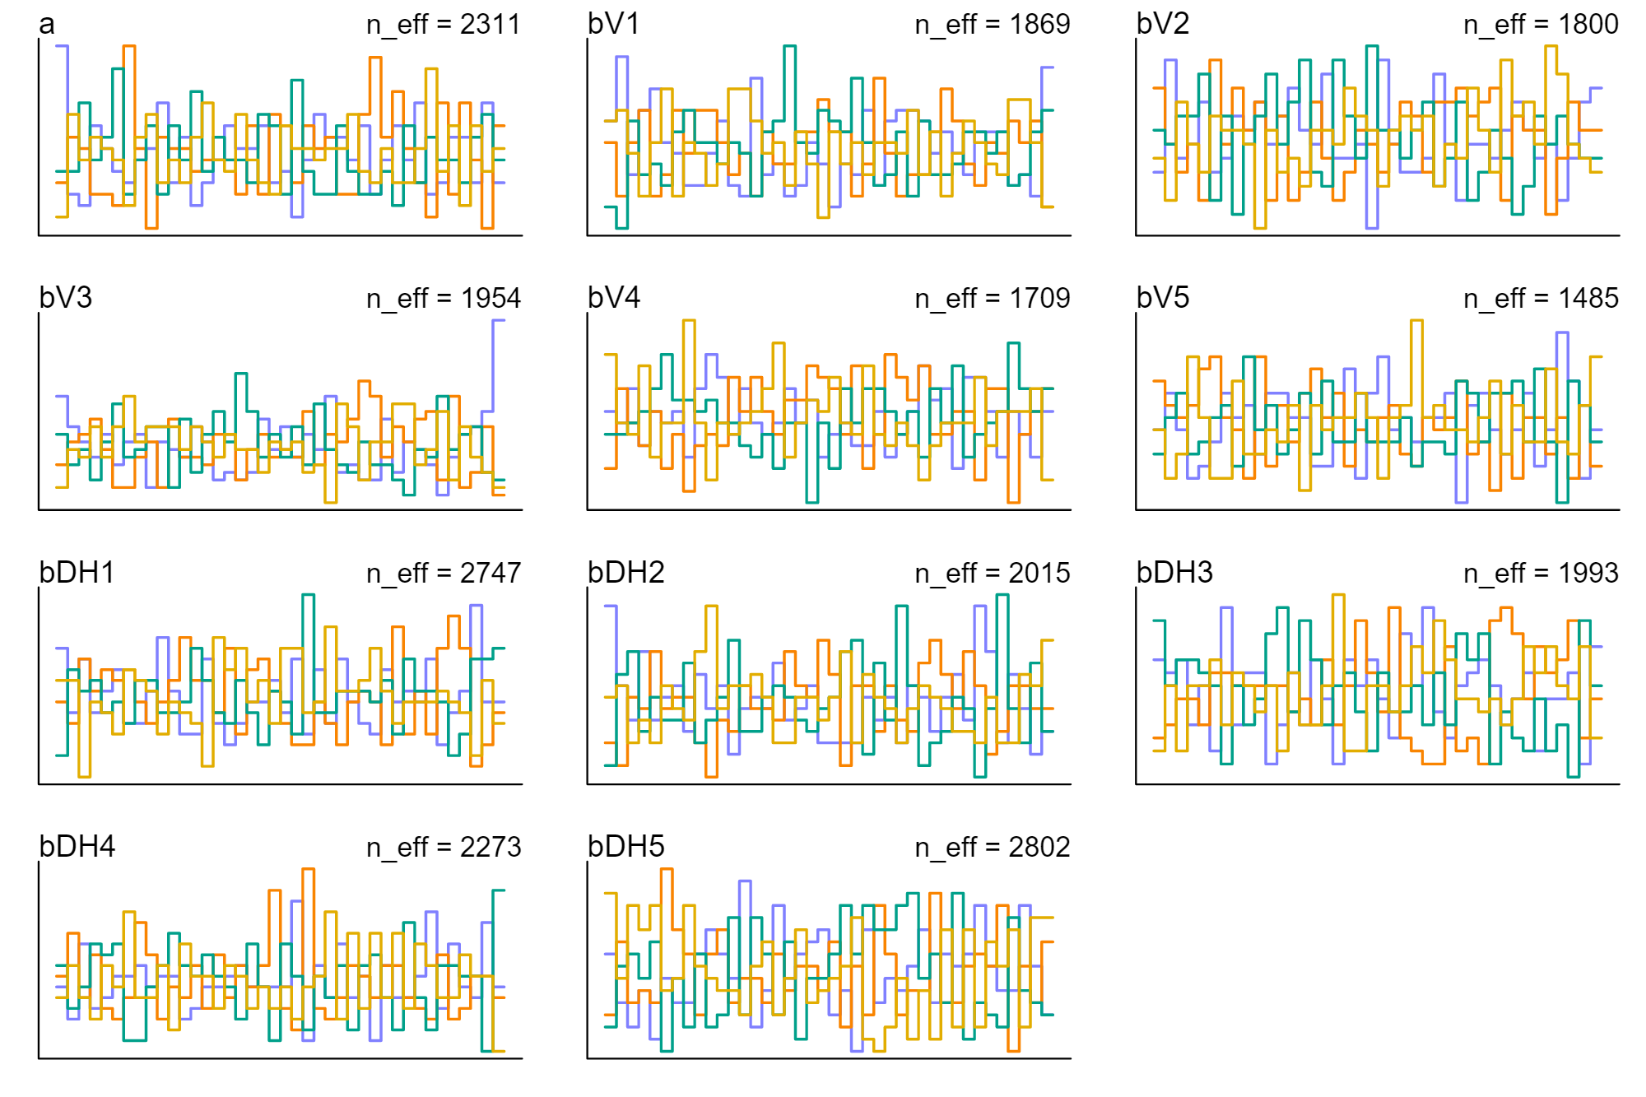

M-303s: Virus, Acetaminophen, DHCQ
R-hat and ESS table:
 | mean | sd | 2.5% | 97.5% | n_eff | Rhat4
a | -18.91869605 | 0.173812719471627 | -19.25225 | -18.580265 | 1140.60054647012 | 0.999667279050107
bV1 | 3.555158465 | 0.174897765423601 | 3.2312505 | 3.901155 | 1628.39388147896 | 0.999430556485637
bV2 | 4.18278649 | 0.190557405516496 | 3.807111 | 4.56528 | 1293.77095374366 | 1.00169140368818
bV3 | 5.091493575 | 0.186956001008328 | 4.7366525 | 5.45865125 | 1538.02841990903 | 1.00117099851413
bA1 | -0.0454128706412 | 0.0692575847326355 | -0.1803886 | 0.0869741625 | 1401.33249140676 | 1.00183336390553
bA2 | 0.17687891344 | 0.0715849341741194 | 0.0367496225 | 0.319598775 | 1346.94086469418 | 1.00263185466211
bA3 | 0.671696725 | 0.0646138993655002 | 0.542563975 | 0.792891525 | 1715.88595300365 | 0.99974900042454
bDH1 | -0.3279348945 | 0.0608648413996099 | -0.44648045 | -0.2092736 | 1861.25212269855 | 1.00282111811401
bDH2 | -0.16147877917 | 0.0555688817119925 | -0.271931225 | -0.055911375 | 1916.20468056737 | 1.00025738625242
bDH3 | -0.295262143 | 0.0550883493838168 | -0.4022526 | -0.18791735 | 1934.80854984805 | 0.999810933974121
Trace plot:
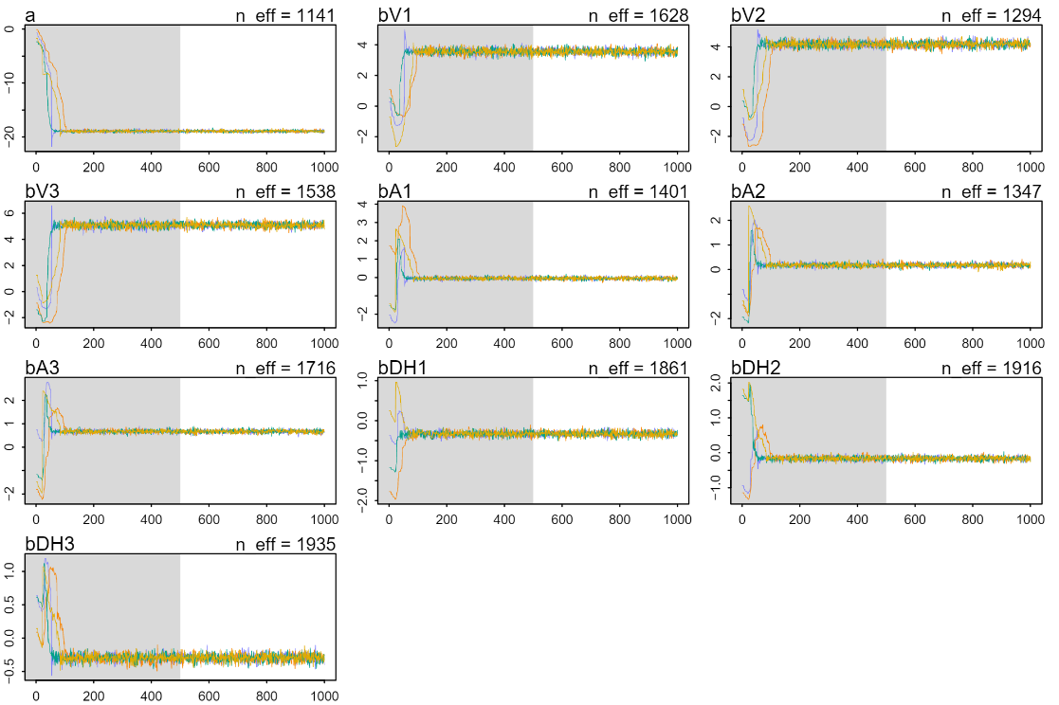
Rank plot:

g. Posterior Distributions and Coefficient Intervals
The posterior distributions of parameters and their 95% intervals are shown below.
M-110s: Virus
Distributions:
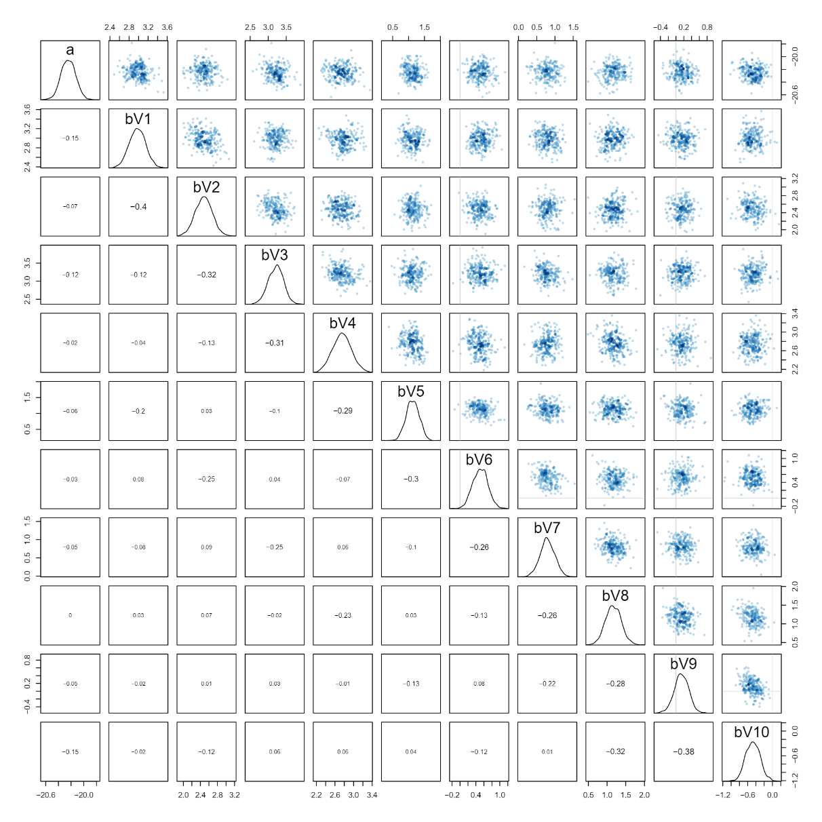
Coefficient Intervals:
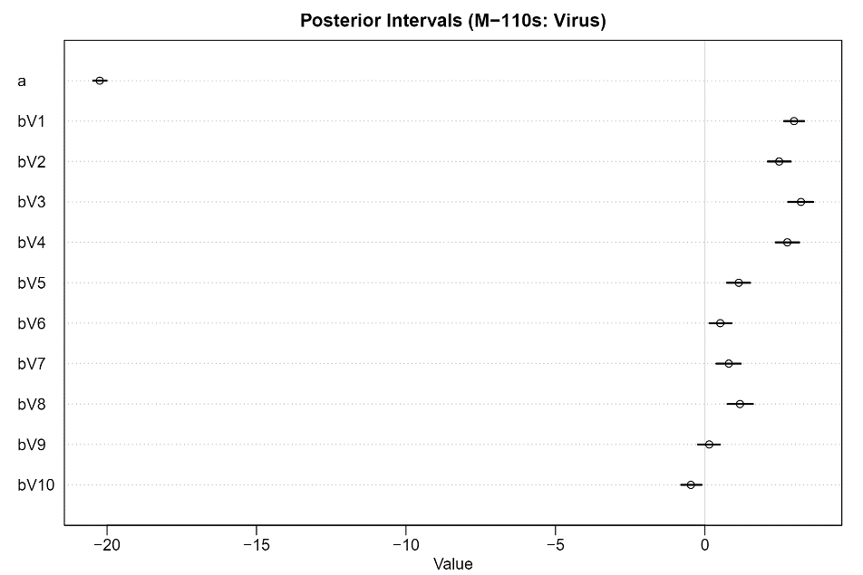

M-205s: Virus, DHCQ
Distributions:
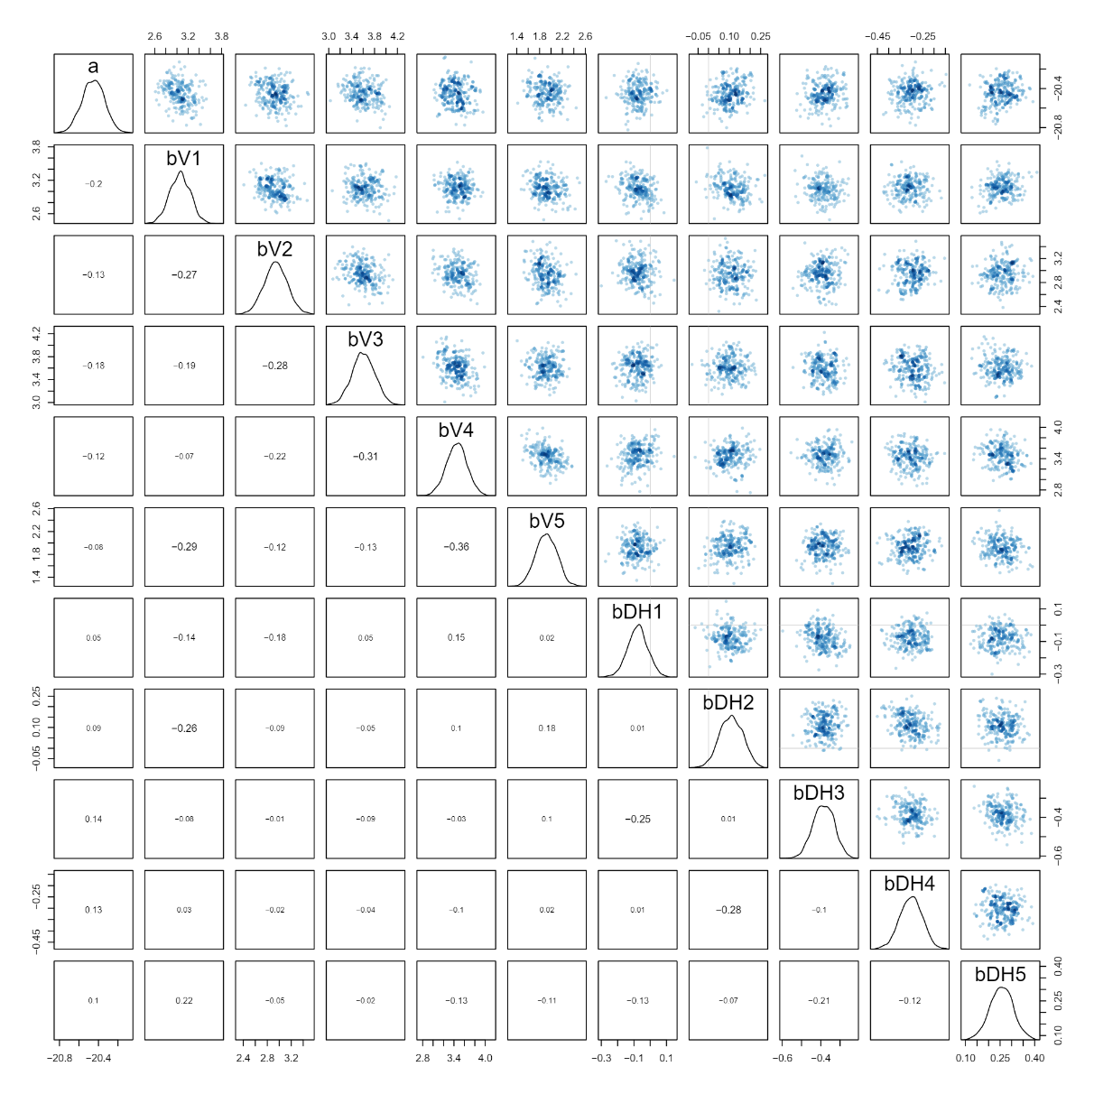
Coefficient Intervals:
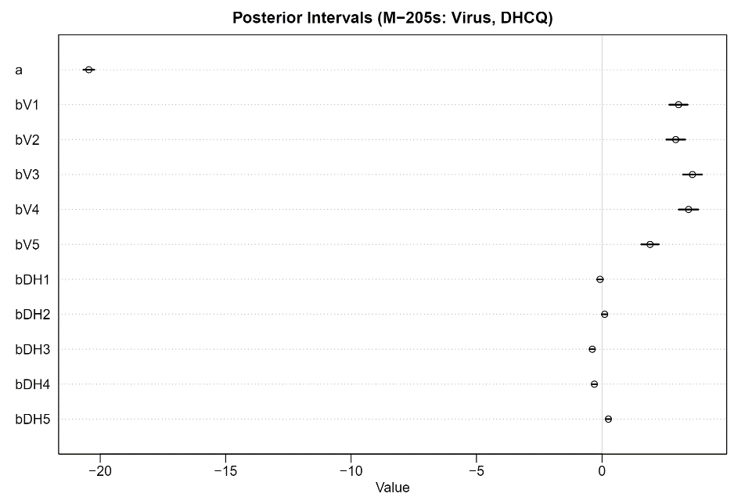

M-303s: Virus, Acetaminophen, DHCQ
Distributions:
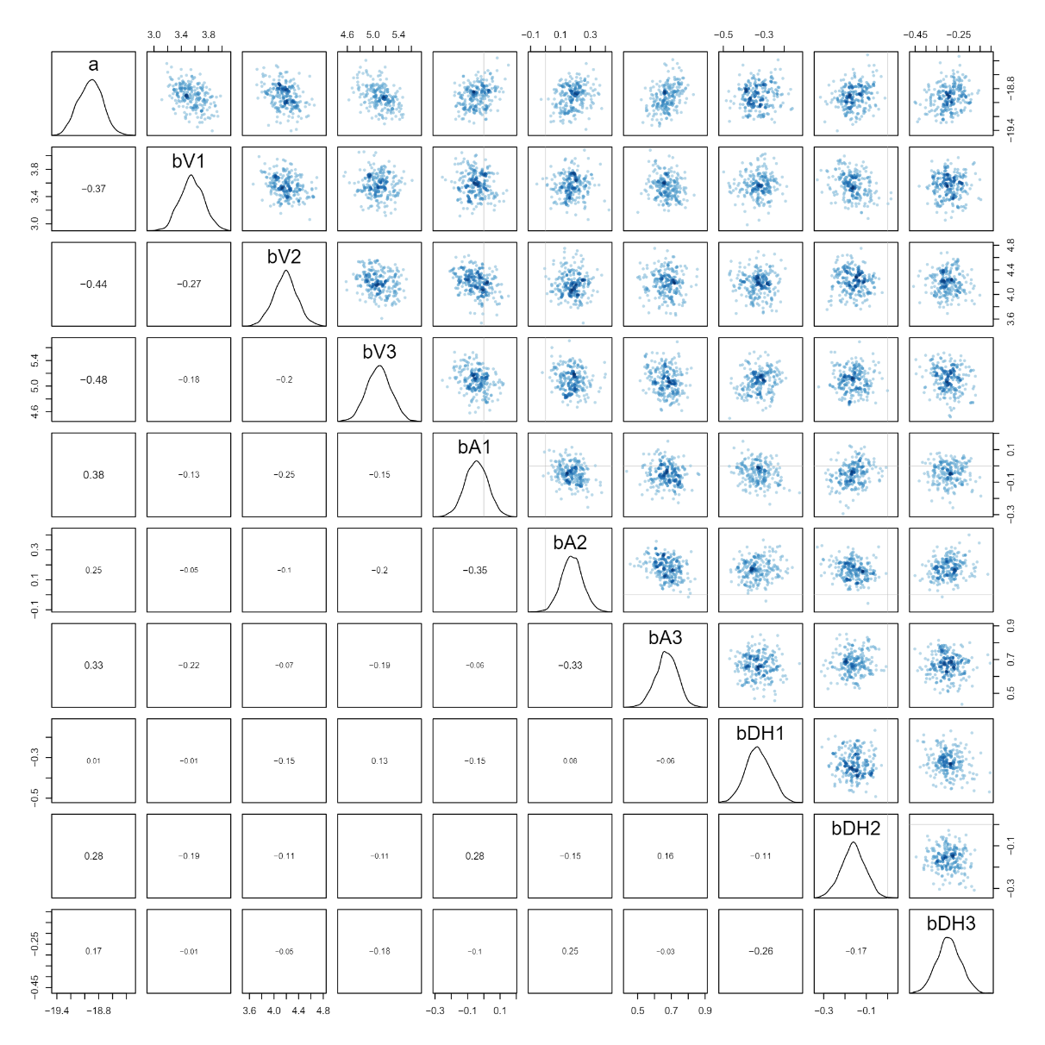
Coefficient Intervals:
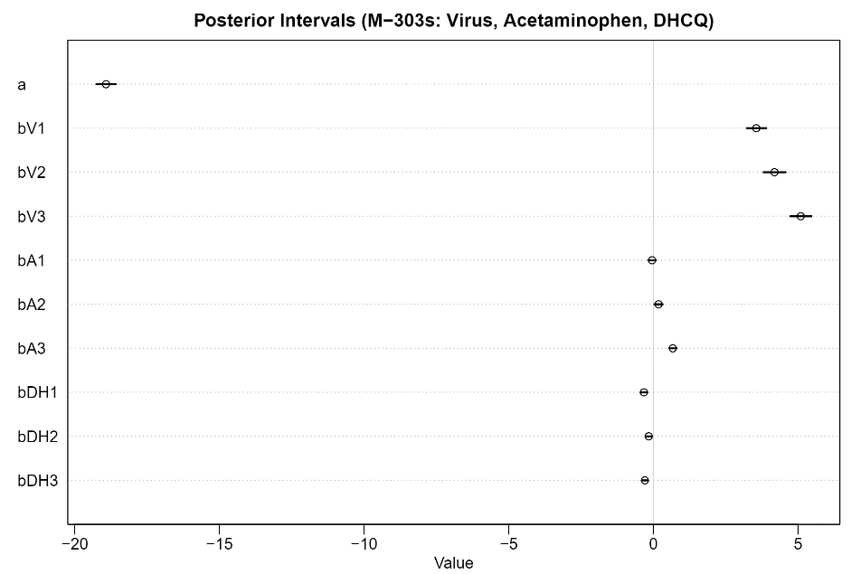

Reference
Vehtari, A., Gelman, A., Simpson, D., Carpenter, B., & Bürkner, P. C. (2021). Rank-normalization, folding, and localization: An improved R ̂ for assessing convergence of MCMC (with discussion). Bayesian analysis, 16(2), 667-718.
Brooks, S. P., & Gelman, A. (1998). General methods for monitoring convergence of iterative simulations. Journal of computational and graphical statistics, 7(4), 434-455.

