Table S1 – Launch times of metropolitan 4th of July Fireworks displays sampled by air monitors and respective show lengths with locations of the shows with an estimated centralized point.
Metropolitan Area | Launch Time | Display Length (min) | Launch Location
New York City, NY | 21:25 EST | 25 | 40° 44' 26.2" N 73° 58' 00.4" W
Philadelphia, PA | 21:45 EST | 13 | 39° 57' 55.7" N 75° 10' 50.9" W
Boston, MA | 22:30 EST | 30 | 42° 21' 31.8" N 71° 04' 40.9" W
Washington D.C. | 21:09 EST | 17 | 38° 53' 21.7" N 77° 02' 41.3" W
San Francisco, CA | 21:30 PST | 30 | 37° 48' 41.2" N 122° 25' 03.9" W
Seattle, WA | 22:20 PST | 18 | 47° 38' 35.9" N 122° 20' 05.7" W

Table S2 – Operating conditions for the ICP-MS
Condition | Value (Unit)
Nebulizer gas flow Meinhard | 1.02 ml/min
Spray Chamber | Glass Cyclonic
RF power | 1600 Watts
Analog Stage Voltage | -1693 Volts
Pulse Stage Voltage | 1100 Volts
Discriminator Threshold | 12
Deflector Voltage | -11.5 Volts

Table S3 – Metropolitan cities with the number of air monitors data was extracted.
Metropolitan Area | EPA Monitors | Purple Air Monitors
New York City, NY | 8 | 5
Philadelphia, PA | 5 | 5
Boston, MA | 4 | 5
Washington D.C. | 4 | 0
San Francisco, CA | 4 | 5
Seattle, WA | 4 | 5

Figure S1. Animated time course of PM_{2.5} concentrations obtained from sampling alongside of New York City’s East River relative to the Macy’s Fourth of July Fireworks show.

Figure S2. Animated time course of PM_{2.5} concentrations obtained from EPA’s AirNow API relative to the Macy’s Fourth of July Fireworks show.

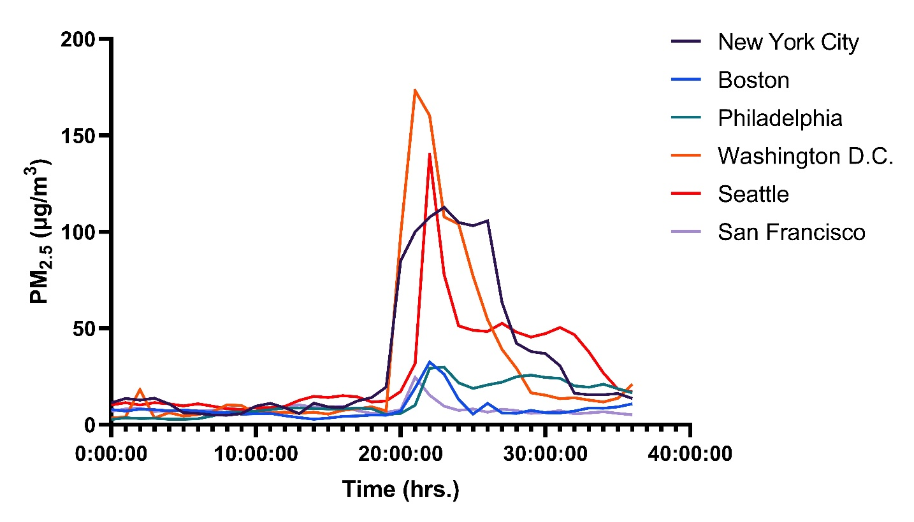
Figure S3. 36-hour synchronized time course of the average concentrations measured on EPA equivalent monitors across 6 major metropolitan areas with fireworks displays beginning on 7/4/2023 at approximately 20:00:00 (hh:mm:ss).
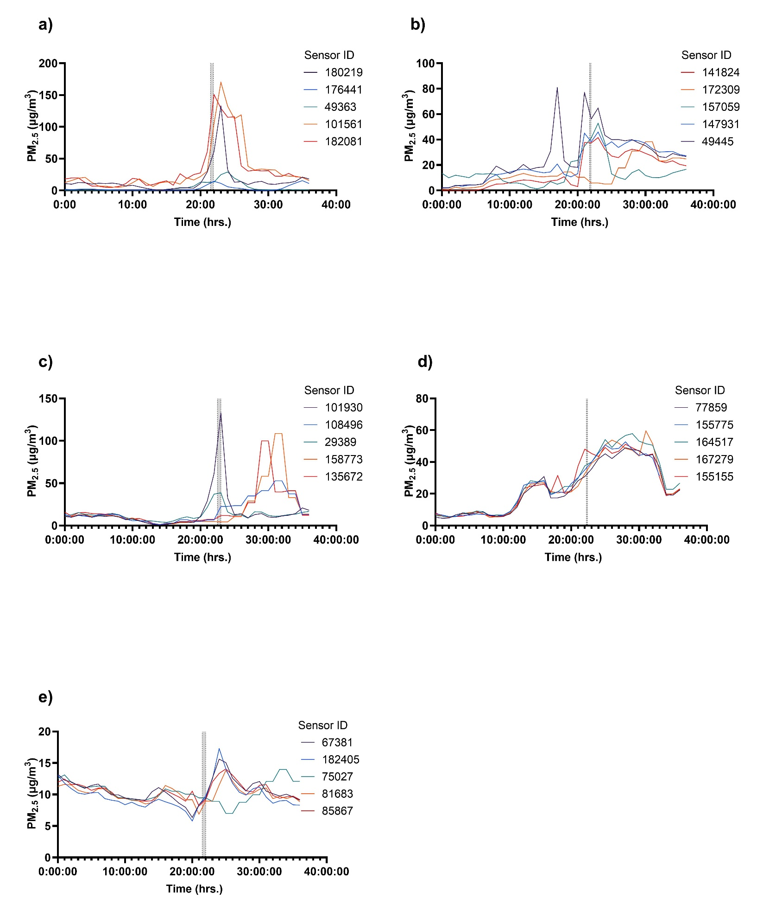
Figure S4 (a-e). Hourly concentration data from Purple Air monitors across cities a) New York City, b) Philadelphia, c) Boston, d) Seattle, e) San Francisco, within a 1.5-kilometer radius and the fireworks show highlighted in grey.

