Supplementary Information for

Longitudinal and cross-sectional analysis of perfluoroalkyl substances and kidney function

Eklund, A¹., Taj, T²., Dunder L²³., Lind, PM ³., Lind, L³⁴. Salihovic, S*¹.

¹School of Medical Sciences, Faculty of Medicine and Health, Örebro University, Örebro, Sweden; ²Clinical Epidemiology and Biostatistics, School of Medical Sciences, Faculty of Medicine and Health, Örebro University, Örebro, Sweden; ³ Department of Medical Sciences, Occupational and Environmental Medicine, Uppsala University, Uppsala, Sweden;⁴ Department of Medical Sciences, Uppsala University, Uppsala, Sweden

*Corresponding author:
Samira Salihovic, PhD
School of Medical Sciences, Faculty of Medicine and Health, Örebro University, Örebro, Sweden., 701 82 Örebro, Sweden.
Telephone: +46 19303226.
E-mail: samira.salihovic@oru.se

Table of Contents

Supplementary Table 1. Linear vs. spline models for the longitudinal association of plasma PFAS concentration with eGFR
Supplementary Figure 1. Diacyclic graph (DAG) of the hypothesized causal relationships between PFAS exposure and eGFR. Abbreviations: BMI, body mass index; estimated glomerular filtration rate, eGFR, high-density lipoprotein cholesterol, HDL; low-density lipoprotein cholesterol, LDL; perfluoroalkyl substances (PFAS).
Supplementary Table 2. Associations between baseline PFAS concentrations and eGFR over time without covariate adjustment for BMI, HDL- and LDL-cholesterol from the models. All other covariates (age, triglycerides, smoking, glucose, and statin use) were retained.
Supplementary Table 3. Associations between baseline eGFR and PFAS concentrations over time to assess potential for reverse causation.
Supplementary Table 4. Associations between the baseline PFAS concentrations and the change in eGFR over time including only individuals who participated in all three investigations (complete case analysis).
Supplementary Table 1. Linear vs. spline models for the longitudinal association of plasma PFAS concentration with eGFR
PFAS | Linear AIC | Spline AIC
PFHpA | 24502,99 | 24467,92
PFHxS | 24509,03 | 24456,69
PFOA | 24508,45 | 24450,5
PFNA | 24491,98 | 24422,94
PFDA | 24507,29 | 24444,59
PFOSA | 24489,42 | 24449,7
PFUnDA | 24505,61 | 24435,32
L-PFOS | 24498,27 | 24443,56

Note: AIC (Akaike Information Criterion) values are presented for both linear and spline models. All models were adjusted for age (time), BMI, smoking, HDL- and LDL-cholesterol, triglycerides, glucose, and statin use.

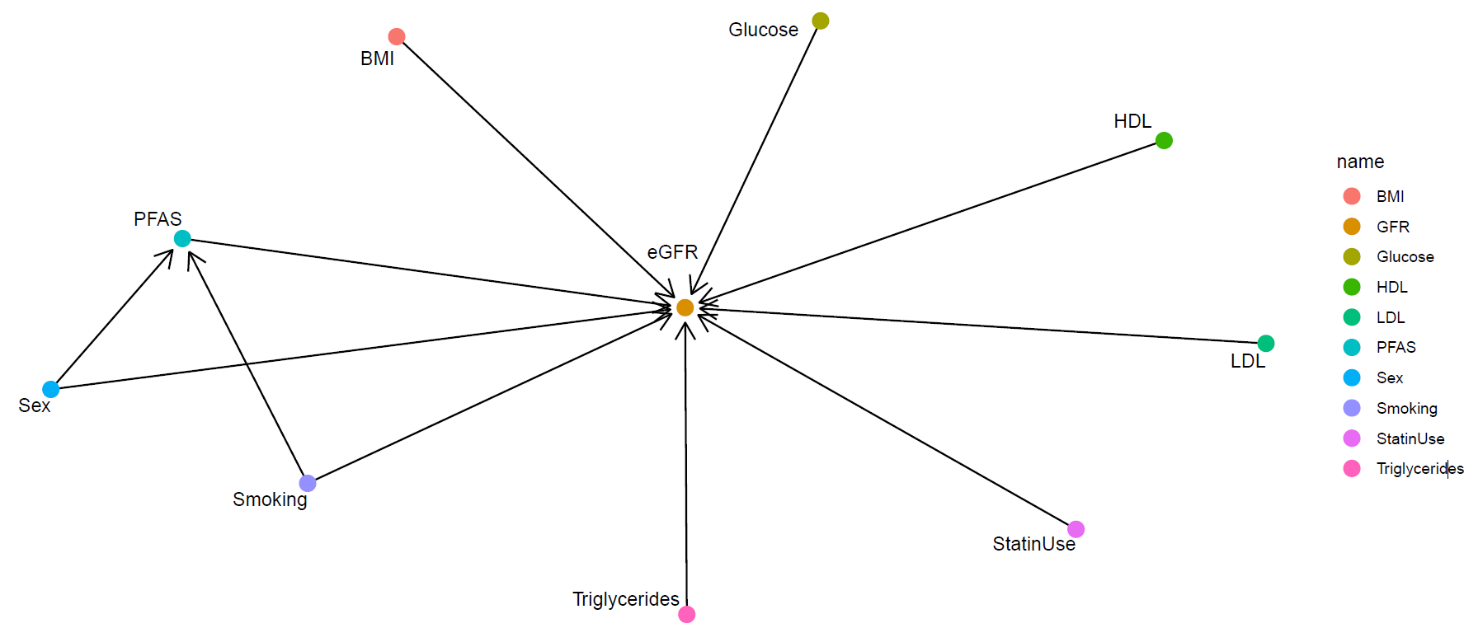

Supplementary Figure 1. Diacyclic graph (DAG) of the hypothesized causal relationships between PFAS exposure and eGFR. Abbreviations: BMI, body mass index; estimated glomerular filtration rate, eGFR, high-density lipoprotein cholesterol, HDL; low-density lipoprotein cholesterol, LDL; perfluoroalkyl substances (PFAS).
Supplementary Table 2. Associations between baseline PFAS concentrations and eGFR over time without covariate adjustment for BMI, HDL- and LDL-cholesterol from the models. All other covariates (age, triglycerides, smoking, glucose, and statin use) were retained.
PFAS | Main effect (β), 95% CI | Interaction effect (β), 95% CI
PFHpA | -0.657 (-1.690, 0.375) | 0.165 (-2.191, 2.521)
PFHxS | 1.287 (0.313, 2.261) | -0.025 (-2.046, 1.997)
PFOA | 2.036 (0.654, 3.417) | 0.159 (-2.933, 3.252)
PFNA | 3.915 (2.592, 5.237) | -2.103 (-5.045, 0.841)
PFDA | 4.286 (2.360, 6.213) | -2.664 (-6.657, 1.329)
PFOSA | -3.552 (-4.642, -2.462) | 5.630 (3.145, 8.116)
PFUnDA | 5.081 (3.300, 6.864) | -3.376 (-7.215, 0.463)
L-PFOS | 1.310 (0.441, 2.180) | 0.542 (-1.472, 2.557)

Supplementary Table 3. Associations between baseline eGFR and PFAS concentrations over time to assess potential for reverse causation.
PFAS | Main effect (β), 95% CI | Interaction effect (β), 95% CI
PFHpA | -0.002 (-0.005, 0.000) | 0.001 (-0.001, 0.002)
PFHxS | 0.003 (0.000, 0.006) | 0.000 (-0.002, 0.001)
PFOA | 0.002 (0.000, 0.003) | 0.000 (-0.001, 0.001)
PFNA | 0.003 (0.002, 0.005) | -0.001 (-0.002, 0.000)
PFDA | 0.002 (0.000, 0.003) | -0.001 (-0.002, 0.000)
PFOSA | -0.005 (-0.006, -0.003) | 0.003 (0.002, 0.004)
PFUnDA | 0.002 (0.001, 0.004) | -0.001 (-0.002, 0.000)
L-PFOS | 0.004 (0.001, 0.006) | 0.000 (-0.002, 0.002)
Note: All models were adjusted for age (time), BMI, smoking, HDL- and LDL-cholesterol, triglycerides, glucose, and statin use.
Supplementary Table 4. Associations between the baseline PFAS concentrations and the change in eGFR over time including only individuals who participated in all three investigations (complete case analysis).
PFAS | Main effect (β), 95% CI | Interaction effect (β), 95% CI
PFHpA | -0.050 (-1.907, 1.810) | -1.639 (-5.428, 2.138)
PFHxS | 1.047 (-1.091, 3.183) | 0.234 (-3.841, 4.319)
PFOA | 3.464 (0.233, 6.697) | -2.121 (-8.384, 4.131)
PFNA | 2.233 (-0.577, 5.047) | -0.498 (-5.943, 4.939)
PFDA | 2.120 (-1.462, 5.703) | -0.759 (-7.609, 6.089)
PFOSA | -2.684 (-4.598, -0.766) | 3.516 (-0.414, 7.433)
PFUnDA | 0.456 (-2.748, 3.660) | 3.227 (-3.049, 9.506)
L-PFOS | 1.547 (-1.028, 4.124) | 1.251 (-3.614, 6.109)
Note: All models were adjusted for age (time), BMI, smoking, HDL- and LDL-cholesterol, triglycerides, glucose, and statin use.

