Supplementary Material for:
Urine glyphosate levels and kidney function outcomes in a cohort study of workers in El Salvador and Nicaragua

Contents:

Analytical methods for glyphosate and AMPA analyses in urine

Glyphosate and AMPA Quality Assurance and Quality Control

Analytical methods for universal pesticide panel analyses in urine

Universal pesticide panel Quality assurance and quality control

Table S1. Target analytes and their MRM parameters; precursor ion (Q1), product ion (Q3), declustering potential (DP), entrance potential (EP), collision energy (CE), and collision exit potential (CXP).

Table S2. Instrumental analysis and compound specific parameters

Table S3. Summary statistics of pesticide concentrations in MANOS participants

Table S4. Number of participants in highest quartile for glyphosate and at least one other pesticide

Figure S1. Kendall’s tau correlations for log transformed creatinine-standardized pesticide concentrations (ng/g) at study visit 1

Figure S2. Proportional odds for being in higher glyphosate level (group 3 vs. group 2 and group 2 vs. referent) and higher AMPA level predicted by reported use of glyphosate outside of of work and at work

Figure S3. Exposure patterns for highest quartile of exposures for at least one pesticide grouped by industry

Figure S4. Difference in mean eGFR (ml/min/1.73m²) estimated by linear regression for pesticide exposure among MANOS participants with urine creatinine between 30-300 mg/dL

Figure S5. Odds of percent decline (10%, 20%) in eGFR from study visit 1 to last study visit associated with glyphosate and AMPA detection at study visits 1 and 3 and having an agrochemical job among participants with urine creatinine between 30-300 mg/dL

Figure S6. Odds of trajectory clusters associated with glyphosate and AMPA detection at both study visits 1 and 3 and having an agrochemical job among participants with urine creatinine between 30-300 mg/dL

Analytical methods for glyphosate and AMPA analyses in urine
Glyphosate and its metabolite, AMPA (aminomethyl phosphonic acid), were analyzed as follows: 500 µL of urine were transferred into 15 mL polypropylene (PP) tubes and spiked with 10 ng each of isotopic labeled internal standards (IS). Samples were then vortexed, diluted with addition of 0.5 mL of water, and then extracted in a two-step process. First, samples were passed through an ENVI-Carb™ cartridge (250 mg, 3 mL, Supelclean™; St. Louis, MO, USA) for purification and removal of interferences. The cartridge was washed with 0.5 mL of water, and the combined elute was basified by the addition of 2 mL of 2% NH₄OH in water. In the next step, the basified eluent was loaded on an Oasis MAX (3 cc, 60 mg, 30 µm; Waters, Milford, MA, USA) for the enrichment of glyphosate and AMPA. Prior to loading, the Oasis MAX cartridge was pre-conditioned with 1.5 mL of methanol, 0.5 mL of water, and 1.5 mL of 1% NH₄OH in water, in that sequence. The cartridge was washed with 0.5 mL 1% NH₄OH in water and allowed to dry under vacuum. The target analytes were eluted using 1% formic acid in methanol (3 × 1 mL), and the eluent was evaporated to near-dryness under a gentle stream of nitrogen. The residue was reconstituted with 100 µL of methanol:water mixture (6:4, v/v) and transferred into a vial with 150-µL glass insert for LC-MS/MS analysis.

A Shimadzu LC-30 AD series HPLC coupled to a Sciex Quadruple 5500 mass spectrometry (Applied Biosystems, Foster City, CA, USA) was used in the identification and quantification of target analytes. The glyphosate and AMPA were chromatographically separated on Raptor Polar X (30 mm × 2.1 mm; 2.7 µm; Restek, Bellefonte, PA, USA) with 0.5% formic acid in water (A) and 0.1% formic acid in acetonitrile (B) as mobile phases. The gradient program was as follows: 35% A (minute 0), 35%–95% A and hold for 1.5 min (minutes 0.01–6.5), 95%–35% A (minutes 6.50–6.51), and a hold for 3.50 min, for a total run time of 10.0 min. The mobile-phase flow rate, sample injection volume, and autosampler temperature were set at 0.5 mL/min, 10 µL, and 15 °C, respectively. The mass spectrometer (MS) was operated in electrospray ionization in negative mode multiple reaction monitoring mode (ESI⁻-MS/MS) and quantification was performed through isotopic dilution method. The details of analyte specific MS parameters are presented in Table S1.

Glyphosate and AMPA Quality Assurance and Quality Control
A ten-point calibration standard, at concentrations of analytes ranging from 0.1 to 100 ng/mL (with 10 ng/mL IS mixture) with regression coefficients >0.9995, was used for analyte quantification. A synthetic blank urine was used for procedural and matrix blank samples. Target analytes were not found in both procedural and matrix blanks. A pair of matrix spike samples were analyzed with every batch of 20 samples. Accuracy (mean relative recoveries ±SD) of the method was determined at two concentrations, 1 and 5 ng/mL, was 93.7 ± 0.46 and 101 ± 2.63% for AMPA, and 107 ± 0.47 and 106 ± 1.44% for glyphosate, respectively. The limits of detection (LOD) at signal-to-noise ratio (S/N) ≥3 were 0.1 ng/mL for both AMPA and glyphosate and the method limits of quantification (LOQ) at S/N≥10 were 0.5 ng/mL for both analytes. A sample diluent (methanol: water, 6:4) and a mid-point calibration standard were injected to check for carry-over of analytes and drift in instrumental sensitivity. The method also was successfully validated by analyzing proficiency test samples provided in the round 2021-01 of External Quality Assessment Scheme for organic substances in urine (OSEQAS), Quebec, Canada and our values were between 75-101% of the assigned values for both glyphosate and AMPA.

Table S1. Target analytes and their MRM parameters; precursor ion (Q1), product ion (Q3), declustering potential (DP), entrance potential (EP), collision energy (CE), and collision exit potential (CXP).

S.No | Analyte Name | Abbreviation | Q1 | Q3 | DP(V) | EP(V) | CE(V) | CXP(V)
1 | Aminomethylphosphonic acid | AMPA | 110 | 79 | -40 | -10 | -35 | -10
2 | Glyphosate | GLYP | 168 | 63 | -40 | -8 | -25 | -10
3 | Aminomethylphosphonic acid-¹³C, ¹⁵N, methylene-D2 | AMPA-¹³C, ¹⁵N, D2 | 114 | 63 | -20 | -10 | -35 | -10
4 | Glyphosate-¹³C, ¹⁵N | GLYP-¹³C₂,¹⁵N | 170 | 63 | -20 | -10 | -30 | -10

Universal pesticide method
The target pesticides were analyzed in urine samples after enzymatic deconjugation, followed by solid phase extraction. Briefly, 0.5 mL of urine was transferred into a 15-mL PP tube, and 1 ng each of labeled internal standard mixture (corresponding labeled internal standards were available for nine target compounds, except for cis-DCCA and cis-DBCA) was added. The urine samples were mixed with 400 μL of 0.2M sodium acetate buffer, containing 745 units/mL of β-glucuronidase and 56 units/mL of sulfatase, and were incubated at 37 °C for at least 6 h. The samples were then passed through Oasis® HLB 3 mL solid phase extraction cartridges that were conditioned with acetone (2 mL) and 1% acetic acid in water (2 mL). After loading samples, cartridges were washed with acetic acid/methanol/water (1:5:94, v/v/v) and vacuum dried for 5 min. Analytes were recovered by elution with 3 mL of acetone and 3 mL of hexane. Combined eluates were evaporated to dryness under nitrogen and redissolved in 100 μL of acetonitrile:water (1:1, v/v) and transferred into glass vial inserts for instrumental analysis.
Chromatographic separation was performed with a Waters ACQUITY Class I HPLC system (Waters, Milford, MA, USA) using a Betasil C18 column (100×2.1 mm, 5 μm; Thermo Electron Corp., Waltham, MA, USA), serially connected to a Javelin Betasil C18 guard column (20×2.1 mm, 5 μm; Thermo Electron Corp.). The injection volume was 3 μL, and the mobile phase flow rate was 350 μL/min. The mobile phase comprised HPLC-grade water with 0.2% (v/v) acetic acid (A) and acetonitrile (B). The gradient started with 95% A, held for 1 min, and linearly decreased to 50% within 1 min, and then to 5% in 1 min and held for 3 min. The mobile phase composition was reverted to initial conditions in 2 min, followed by an equilibration time of 2 min, for a total run time of 10 min.

Mass spectrometric analysis was performed on an Applied Biosystems API 5500 electrospray triple quadrupole mass spectrometer (ESI-MS/MS; Applied Biosystems, Foster City, CA, USA). The turbo ion spray source settings in the positive ionization mode were: curtain gas (CUR) 45 psi; collision gas (CAD) 6 psi; source temperature 450 °C; ion source gas 1 (GS1) 60 psi; ion source gas 2 (GS2) 65 psi; and ion spray voltage 4500 V. For the negative ionization mode, the mass spectrometric parameters were similar except that the ion spray voltage was −4500 V. Nitrogen was used as CUR and CAD.

Table S2. Instrumental analysis and compound specific parameters
Ion Source Parameters
Name | DP | EP | CE | EX | CXP | Mode
IMPY | 190 | 10 | 25 | 100 | 13 | +
MDA | -70 | -10 | -12 | 100 | -10 | -
PNP | -180 | -10 | -24 | 100 | -10 | -
TCPY | -70 | -10 | -40 | 100 | -16 | -
2,4-D | -70 | -10 | -20 | 100 | -8 | -
2,4,5-T | -70 | -10 | -20 | 100 | -10 | -
3-PBA | -70 | -10 | -30 | 100 | -7 | -
4F-3PBA | -70 | -10 | -35 | 100 | -10 | -
Trans-DCCA | -70 | -10 | -40 | 100 | -16 | -
Cis-DCCA | -70 | -10 | -40 | 100 | -16 | -
Cis-DBCA | -70 | -10 | -40 | 100 | -9 | -
13C4-IMPY | 190 | 10 | 25 | 100 | 13 | +
13C4-MDA | -70 | -10 | -12 | 100 | -10 | -
D4-PNP | -180 | -10 | -24 | 100 | -10 | -
13C3-TCPY | -70 | -10 | -40 | 100 | -16 | -
13C6-2,4-D | -70 | -10 | -20 | 100 | -8 | -
13C6-2,4,5-T | -70 | -10 | -20 | 100 | -10 | -
13C6-3-PBA | -70 | -10 | -30 | 100 | -7 | -
13C6-4F-3PBA | -70 | -10 | -35 | 100 | -10 | -
13C2-trans-DCCA | -70 | -10 | -40 | 100 | -16 | -
13C2-cis-DCCA | -70 | -10 | -40 | 100 | -16 | -
13C2-cis-DBCA | -70 | -10 | -40 | 100 | -9 | -

Quality assurance
Analytes were quantified using an internal standard method. The most abundant precursor/product ion transition was used for quantification. An 11- to 16-point standard calibration curve, with concentrations ranging from 0.01 to 200 ng/mL, was used for the quantification of the target analytes. The regression coefficients (r) were≥0.99 for all calibration curves. The method limits of quantitation (MLOQs) were determined based on the lowest point of the calibration standard with a signal-to-noise ratio of ≥10, volume of urine taken for analysis, and the sample concentration factor. As a check for instrumental drift in response factors, a midpoint calibration standard was injected after every 20 samples. Sample-to-sample carryover of target analytes was monitored by the injection of a pure solvent (acetonitrile) after every 10 samples. For each batch of 20 samples analyzed (within one day), one procedural blank was analyzed simultaneously to determine contamination arising from the laboratory materials and solvents. For every 20 samples, three pre-extraction matrix spikes (in urine) at 1, 5, and 25 ng/mL and one water spike at 10 ng/mL were prepared and passed through the entire analytical procedure. The MLOQs for the 11 target analytes ranged from 0.002 to 0.019 ng/mL. Trace concentrations of target compounds (0.016–0.607 ng/mL) were found in procedural blanks, which were subtracted from concentrations measured in urine samples.

Table S3. Summary statistics of pesticide concentrations in MANOS participants
visit |  | parent pesticide | metabolite | n | LOD | LOQ | %>LOD | units | Mean | median | SD | max
1 |  | AMPA | AMPA | 285 | 0.1 | 0.5 | 49.82 | μg/g | 0.16 | 0.074 ª | 0.32 | 1.4
 |  |  |  |  |  |  |  | μg/L | 0.24 | 0.10 ª | 0.53 | 3.1
 |  | Glyphosate | Glyphosate | 285 | 0.1 | 0.5 | 37.89 | μg/g | 0.46 | 0.033 ª | 6.5 | 19
 |  |  |  |  |  |  |  | μg/L | 0.53 | 0.052 ª | 5.3 | 17
 |  | 2,4-D | 2,4-D | 50 | 0.01 | 0.03 | 100 | μg/g | 26 | 0.61 | 78 | 440
 |  |  |  |  |  |  |  | μg/L | 23 | 0.60 | 62 | 290
 |  | 2,4,5-T | 2,4,5-T | 50 | 0.02 | 0.06 | 98 | μg/g | 0.42 | 0.25 | 0.47 | 1.9
 |  |  |  |  |  |  |  | μg/L | 0.33 | 0.25 | 0.28 | 1.3
 |  | Cyfluthrin, | 3-PBA | 50 | 0.01 | 0.03 | 100 | μg/g | 0.91 | 0.66 | 0.85 | 4.7
 |  | Cypermethrin, Permethrin |  |  |  |  |  | μg/L | 1.3 | 0.68 | 1.9 | 9.8
 |  | Cyfluthrin, | 4F-3PBA | 50 | 0.01 | 0.03 | 50 | μg/g | 0.015 | 0.012 | 0.012 | 0.06
 |  | Flumethrin |  |  |  |  |  | μg/L | 0.025 | 0.011 | 0.051 | 0.16
 |  | Cyfluthrin, | cis-DCCA | 50 | 0.02 | 0.07 | 96 | μg/g | 0.60 | 0.40 | 0.73 | 4.3
 |  | Cypermethrin, Permethrin | cis-DCCA |  |  |  |  | μg/L | 0.84 | 0.37 | 1.6 | 9.0
 |  | Cyfluthrin, | trans-DCCA | 50 | 0.02 | 0.07 | 96 | μg/g | 0.84 | 0.56 | 1.1 | 6.8
 |  | Cypermethrin, Permethrin |  |  |  |  |  | μg/L | 1.3 | 0.55 | 2.5 | 14
 |  | Deltamethrin | cis-DBCA | 50 | 0.1 | 0.31 | 34 | μg/g | 0.26 | 0.13 ª | 0.43 | 1.10
 |  |  |  |  |  |  |  | μg/L | 0.56 | 0.12 ª | 2.7 | 2.3
 |  | Diazinon | IMPY | 50 | 0.02 | 0.05 | 100 | μg/g | 1.2 | 0.75 | 1.1 | 5.3
 |  |  |  |  |  |  |  | μg/L | 1.7 | 0.96 | 2.0 | 8.6
 |  | Malathion | MDA | 50 | 0.05 | 0.15 | 78 | μg/g | 0.29 | 0.25 | 0.19 | 1.1
 |  |  |  |  |  |  |  | μg/L | 0.41 | 0.25 | 0.46 | 2.7
 |  | Parathion | PNP | 50 | 0.1 | 0.31 | 96 | μg/g | 3.5 | 2.5 | 3.3 | 17
 |  |  |  |  |  |  |  | μg/L | 5.6 | 2.9 | 6.4 | 28
 |  | Chlorpyrifos | TCPY | 50 | 0.01 | 0.03 | 100 | μg/g | 4.1 | 1.1 | 12 | 74
 |  |  |  |  |  |  |  | μg/L | 4.3 | 1.3 | 9.0 | 57
3 |  | AMPA | AMPA | 275 | 0.1 | 0.5 | 57.45 | μg/g | 0.10 | 0.067 | 0.13 | 1.14
 |  |  |  |  |  |  |  | μg/L | 0.22 | 0.12 | 0.32 | 2.5
 |  | Glyphosate | Glyphosate | 275 | 0.1 | 0.5 | 44.36 | μg/g | 0.10 | 0.042 ª | 0.21 | 0.91
 |  |  |  |  |  |  |  | μg/L | 0.20 | 0.084 ª | 0.43 | 4.1
ª indicates calculation is made when more than 50% of measurements were < LOD
Mean, median, and standard deviation were calculated from maximum likelihood estimation when more than 75% of measurements were < LOD (glyphosate, AMPA, 4F-3PBA, and cis-DBCA)
Mean, median, and standard deviation reported in ng/g are normalized for urine creatinine
Mean, median, and standard deviation reported in μg/L are not corrected for urine creatinine
Table S4. Participants in top quartile for at least one OP, PYR, or PA; for glyphosate; and for both at least one OP, PA, or PYR, and glyphosate
Industry | > 75th percentile for at least one OP, PYR, PA (n/industry n, %) | > 75th percentile for glyphosate (n/industry n, %) | > 75th percentile for at least one UP and glyphosate (n/industry n, %)
sugarcane | 19/20 (95%) | 12/128 (9.4%) | 1/20 (5%)
corn | 10/10 (100%) | 0/57 | 0/10
plantain | 7/10 (70%) | 10/33 (30%) | 1/10 (10%)
brick | 5/5 (100%) | 0/44 | 0/5
construction | 5/5 (100%) | 5/23 (22%) | 1/5 (20%)
total | 46/50 (92%) | 27/285 (9.5%) | 3/50 (6%)

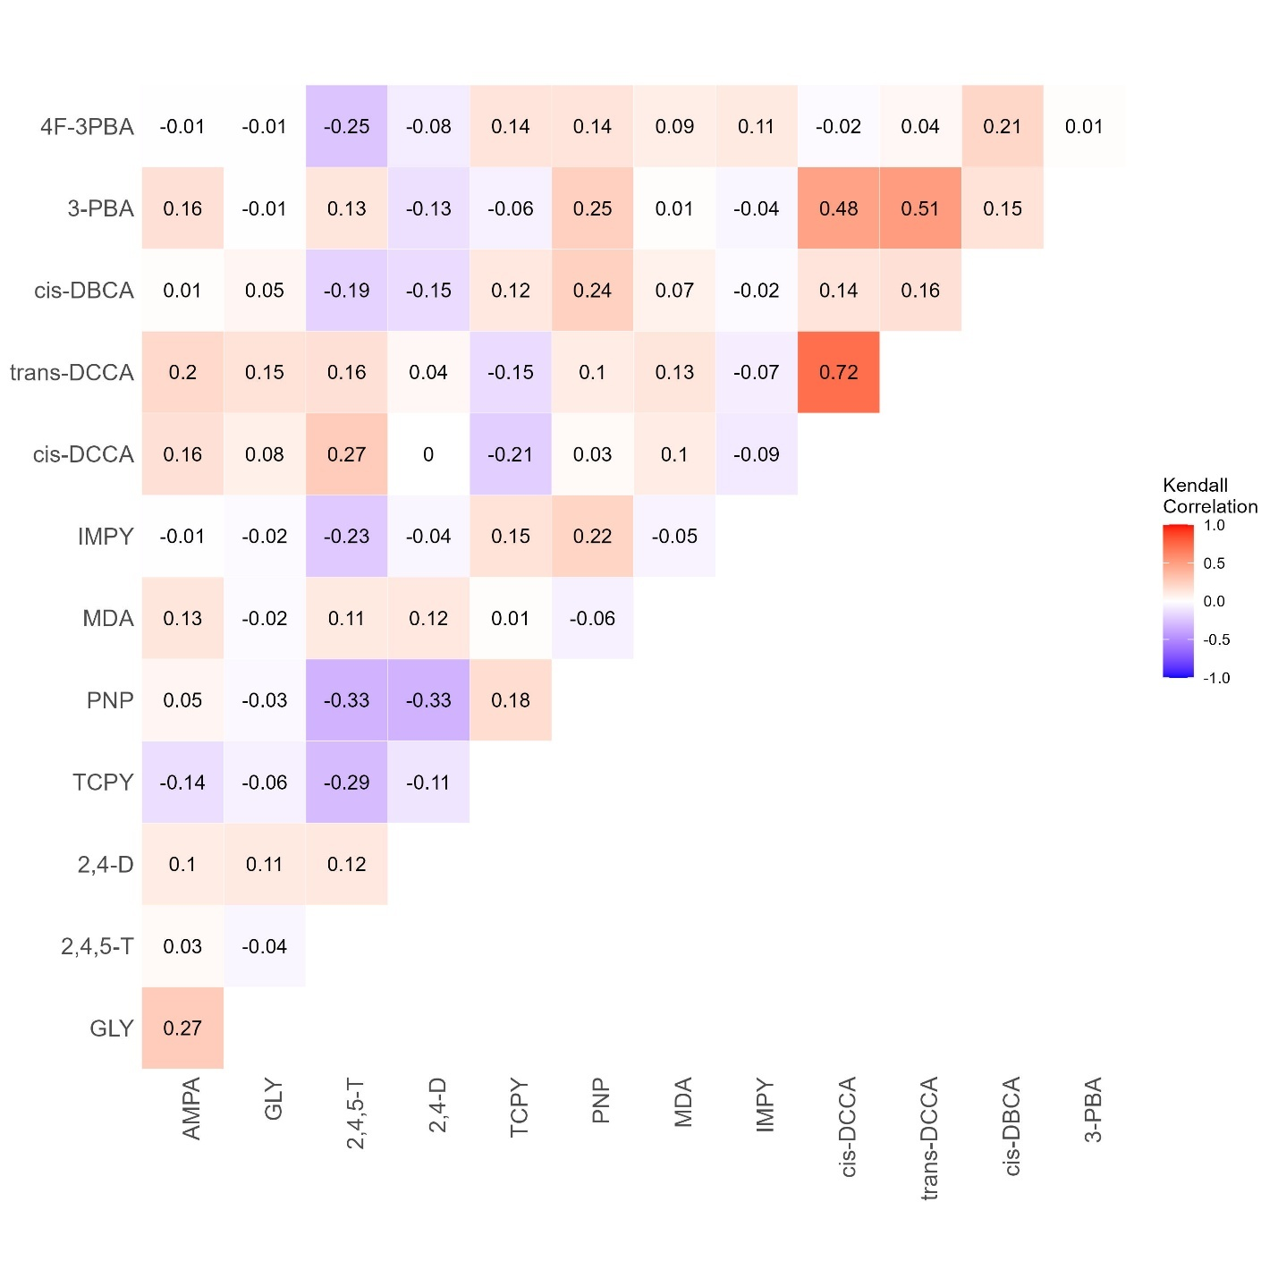
Figure S1. Kendall’s tau correlation coefficients for log transformed creatinine-standardized pesticide concentrations (μg/g) at study visit 1 (n=50)

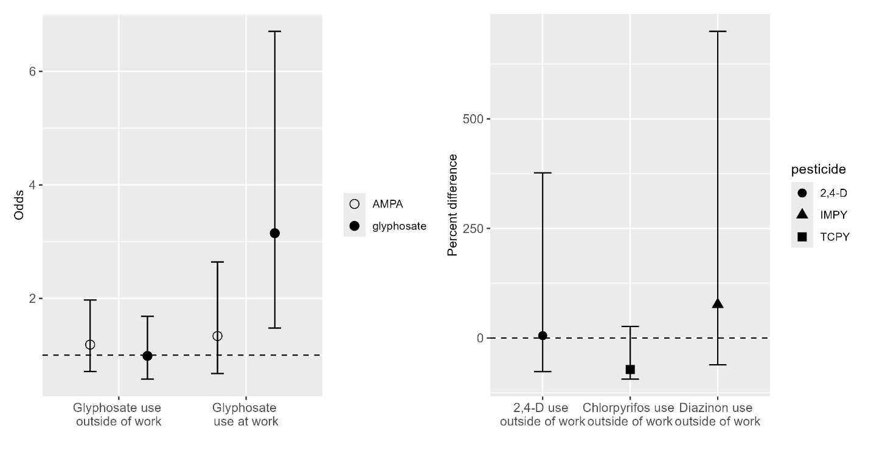
Figure S2. Proportional odds for being in higher glyphosate or AMPA level (group 2 vs. group 1 and group 1 vs. group 0) predicted by reported use of glyphosate at work or at home, and percent difference in urine concentration (ng/g) of 2,4-D, TCPY, and IMPY associated with reported use of 2,4-D, chlorpyrifos, and diazinon outside of work.

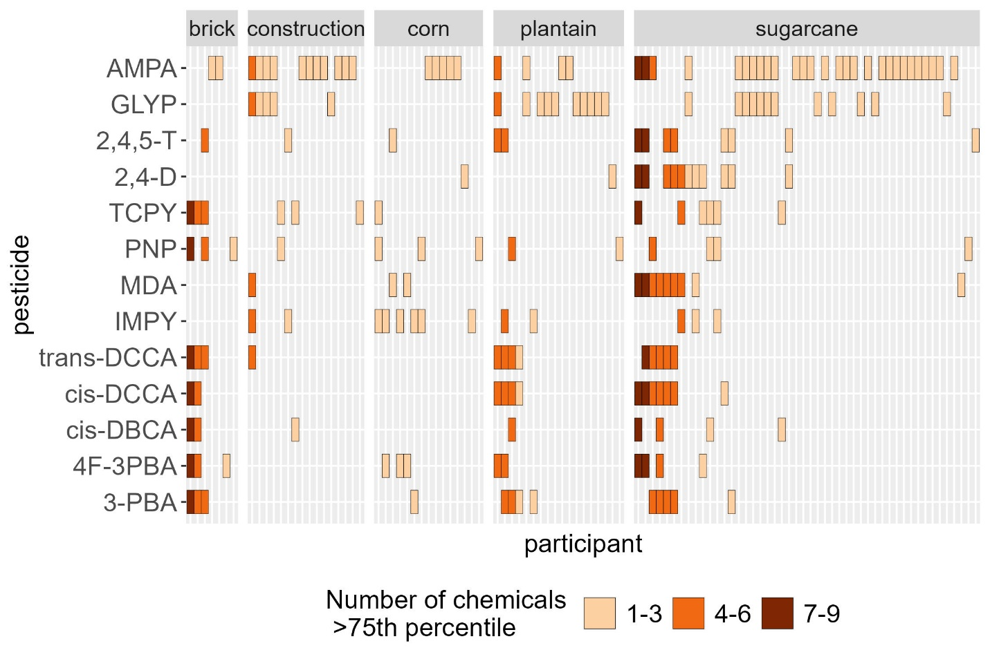
Figure S3. Exposure patterns for participants in highest quartile of exposures for eat least one pesticide, grouped by industry
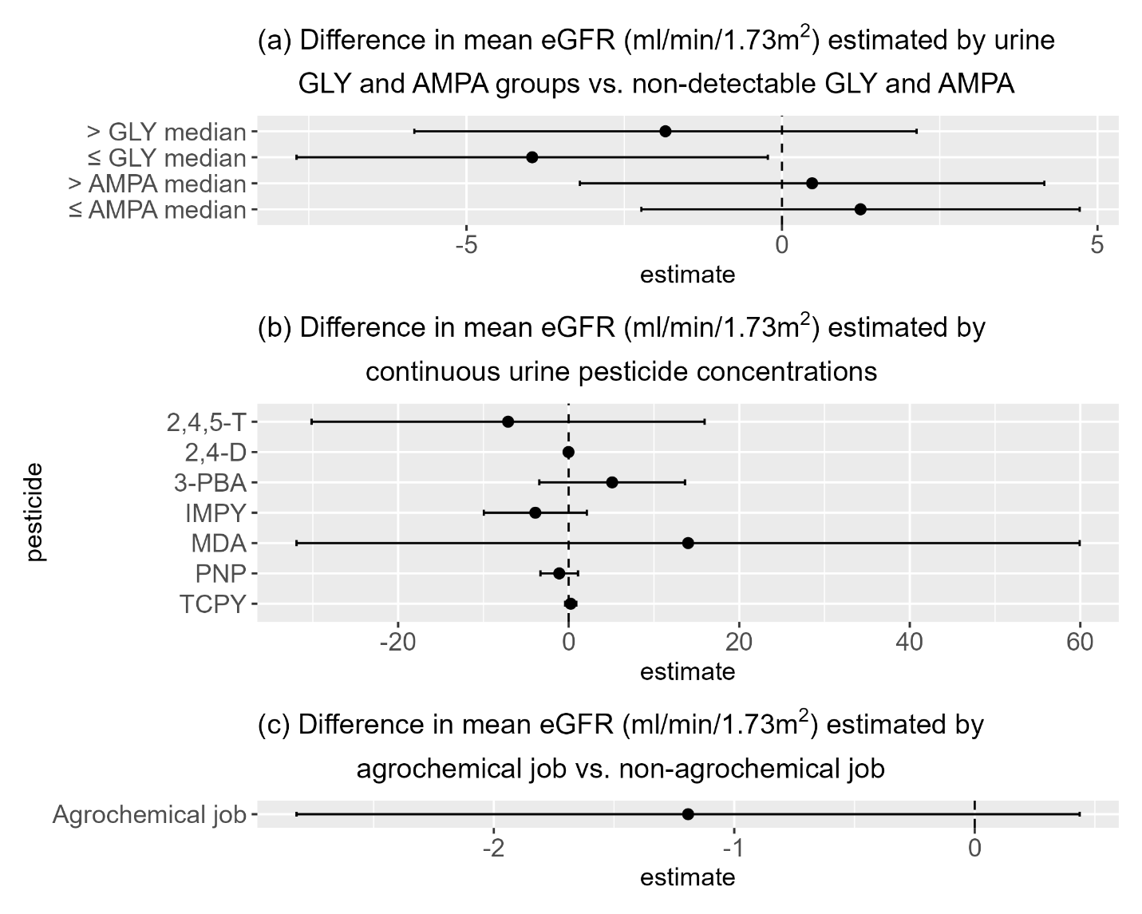
Figure S4. Difference in mean eGFR (ml/min/1.73m²) estimated by linear regression for pesticide exposure among MANOS participants with urine creatinine between 30-300 mg/dL. All models were adjusted for age.
(a) Glyphosate and AMPA models mutually adjusted and adjusted for age, agrochemical job, residential source of drinking water, study visit, and a random intercept for participant.
(b) 2,4,5-T model adjusted for current alcohol consumption, agrochemical job, total volume of water consumed at work, total volume of other beverages consumed at work, residential source of drinking water, and industry. 2,4-D model adjusted for current alcohol consumption, agrochemical job, total volume of water consumed at work, total volume of other beverages consumed at work, and industry. 3-PBA model adjusted for agrochemical job, total volume of water consumed at work, total volume of other beverages consumed at work, residential source of drinking water, and industry. IMPY and TCPY models adjusted for agrochemical job, total water consumed at work, residential source of drinking water, and industry. MDA model adjusted for current alcohol consumption, total volume of water consumed at work, residential source of drinking water, PPE use at work, and industry. PNP model adjusted for agrochemical job, total water consumed at work, and industry.
(c) Agrochemical job model adjusted for age, study visit, and a random intercept for participant.
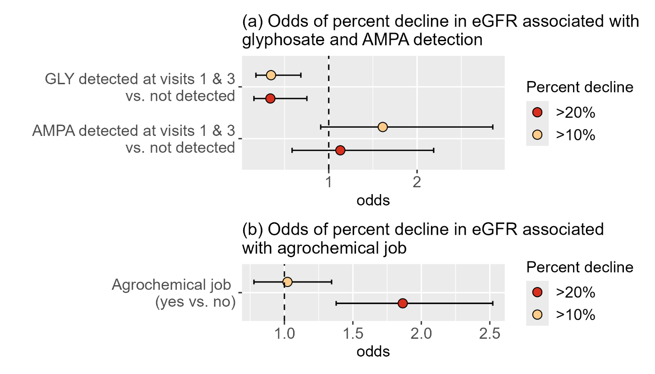

Figure S5. Odds of percent decline (10%, 20%) in eGFR from study visit 1 to last study visit associated with glyphosate and AMPA detection at study visits 1 and 3 among participants with urine creatinine between 30-300 mg/dL. Glyphosate and AMPA models mutually adjusted and adjusted for age, agrochemical job, industry, PPE use, and residential source of drinking water. Agrochemical job model adjusted for age.
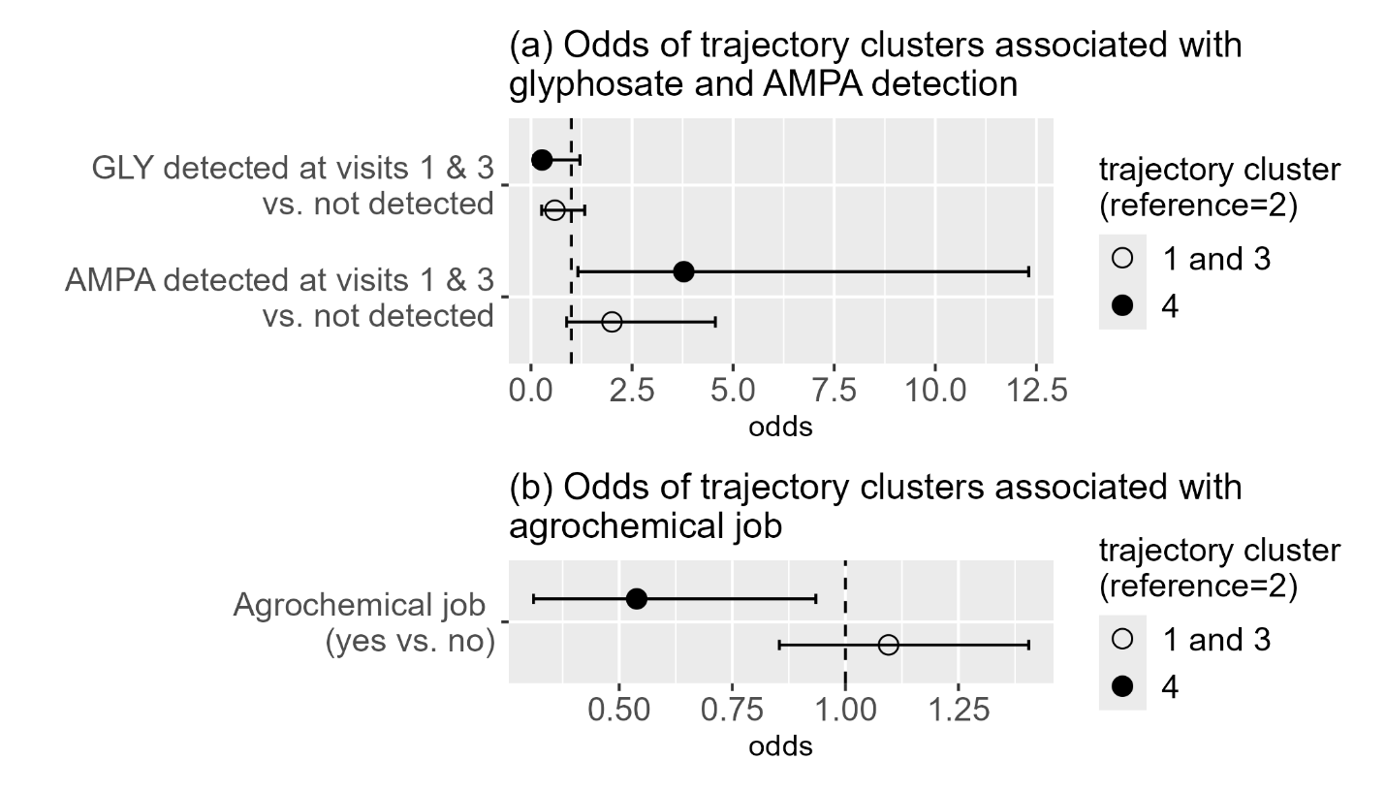

Figure S6. Odds of trajectory clusters associated with glyphosate and AMPA detection at both study visits 1 and 3 among participants with urine creatinine between 30-300 mg/dL. Glyphosate and AMPA models mutually adjusted and adjusted for agrochemical job, and residential source of drinking water. Agrochemical job model unadjusted.

