Evaluation of integrated, multimedia biomarkers of prenatal metals exposure in association with child neurodevelopment in Puerto Rico

Supplementary Figures

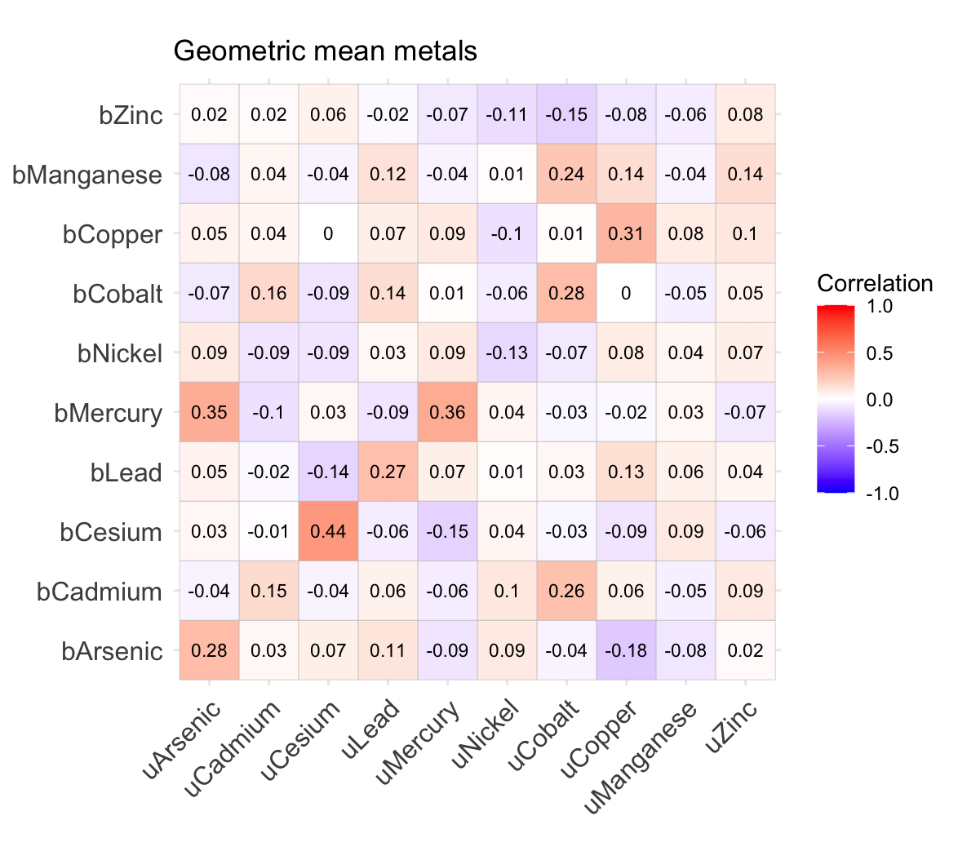
Supplementary Figure 1. Spearman correlations between geometric mean urinary and blood metal measures.

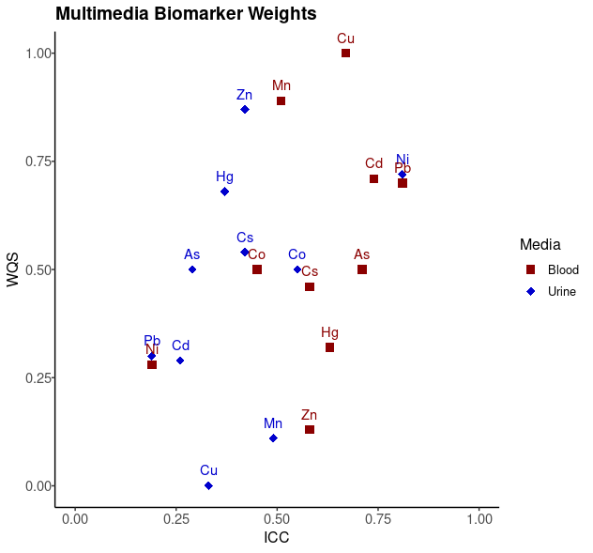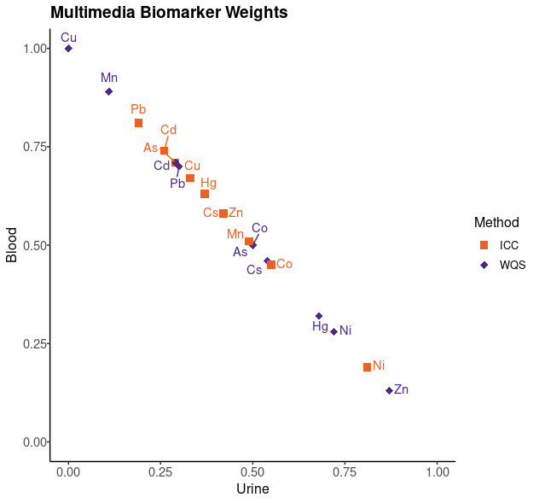

Supplementary Figure 2. Plot of multimedia biomarker weights derived using intraclass correlation coefficients (ICC) or weight quantile sum regression (WQS), labeled by metal, in blood and urine. Weights using the total score domain are shown for WQS.

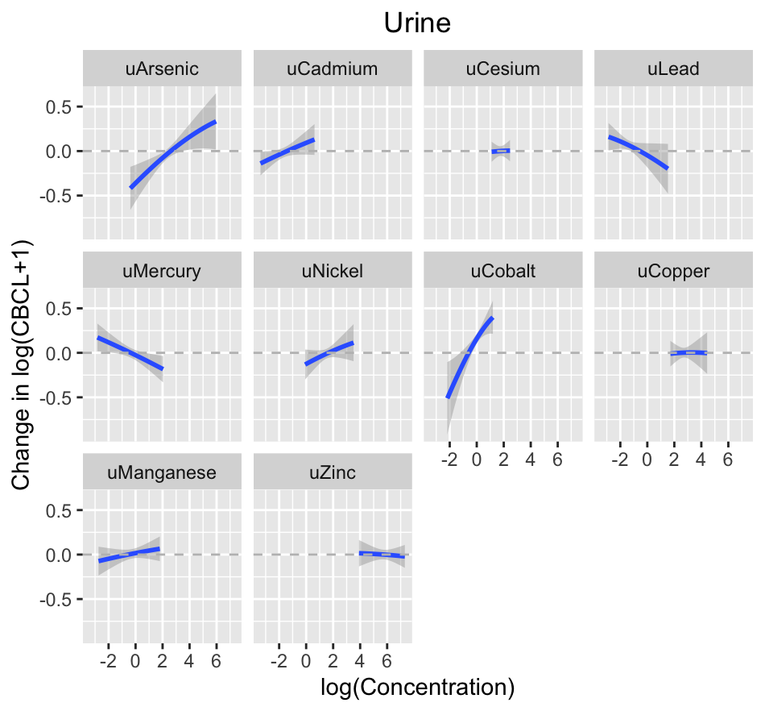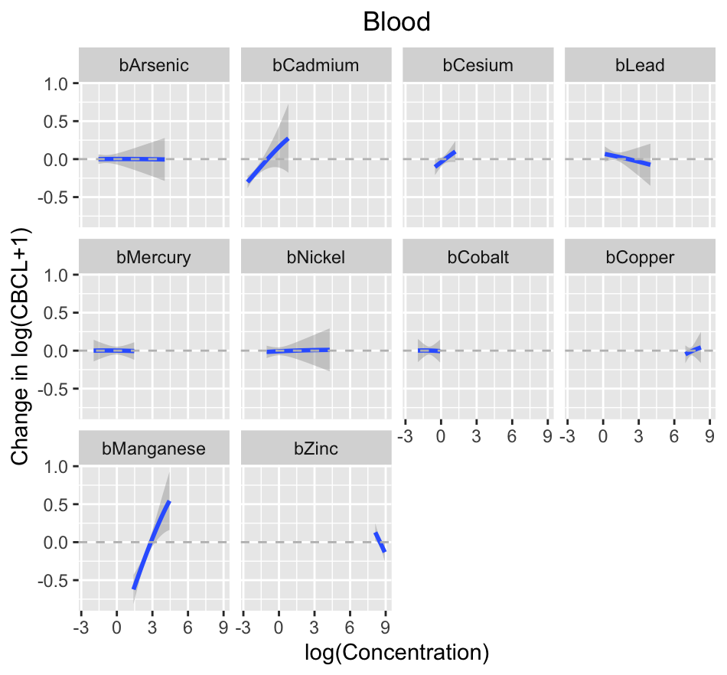
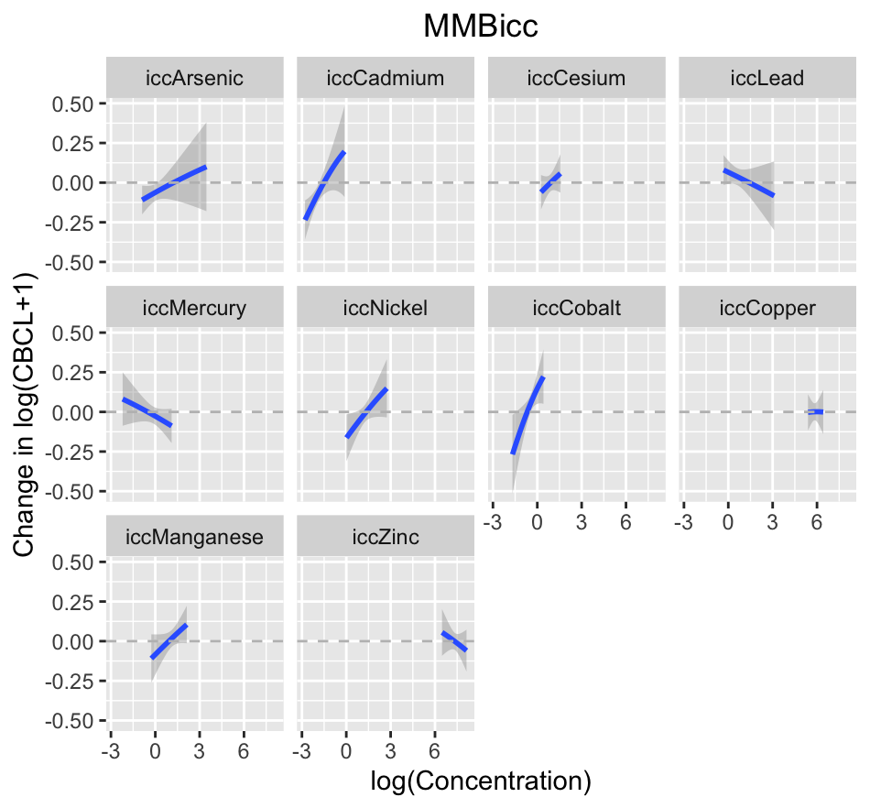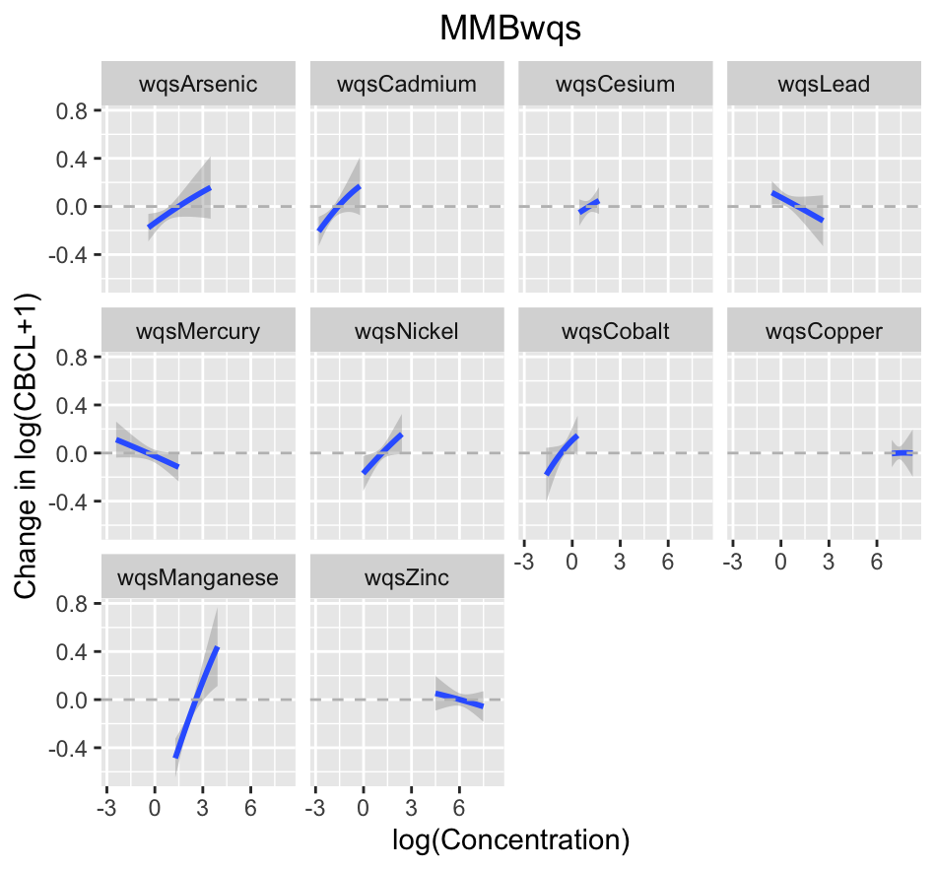

Supplementary Figure 3. Univariate response plots, showing the shape of the association between each exposure and total score for each media, while holding other exposures at their median values, from a Bayesian Kernel Machine Regression (BKMR) with metals and repeated log(CBCL score + 1), adjusted for sex, age at assessment, maternal educational level, and maternal age (N = 284 individuals and 464 observations).

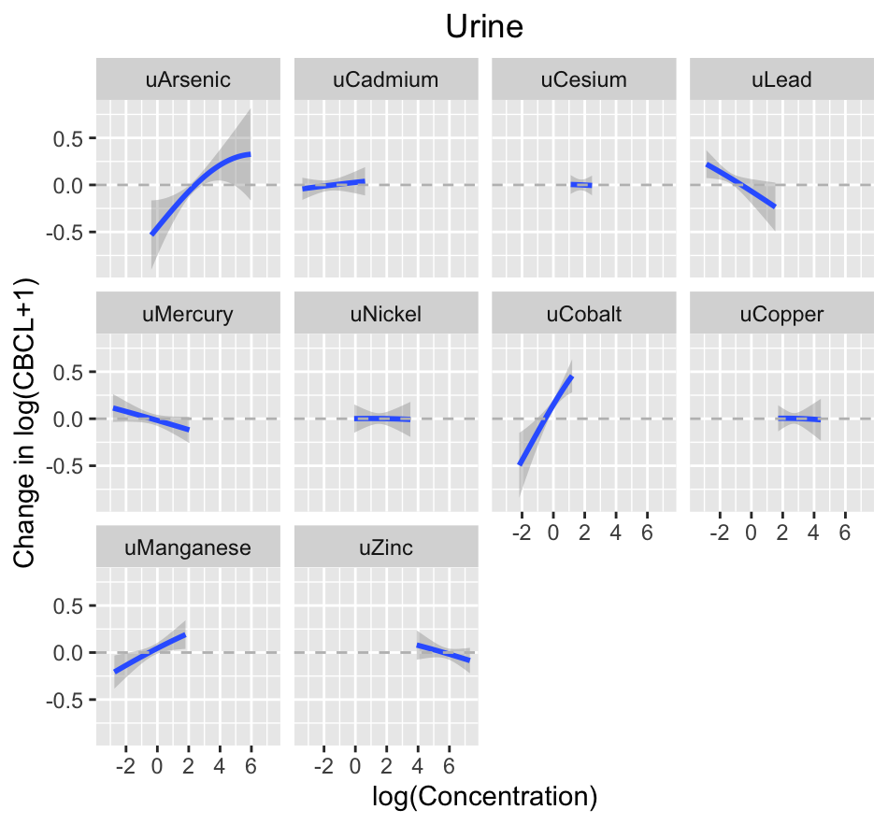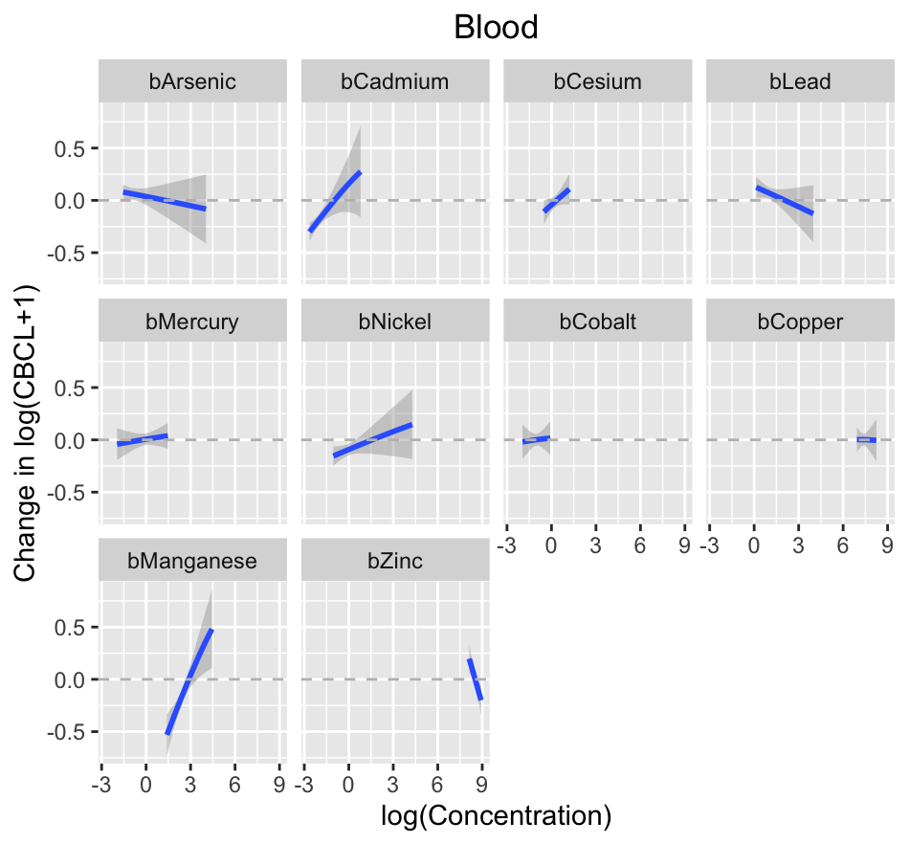
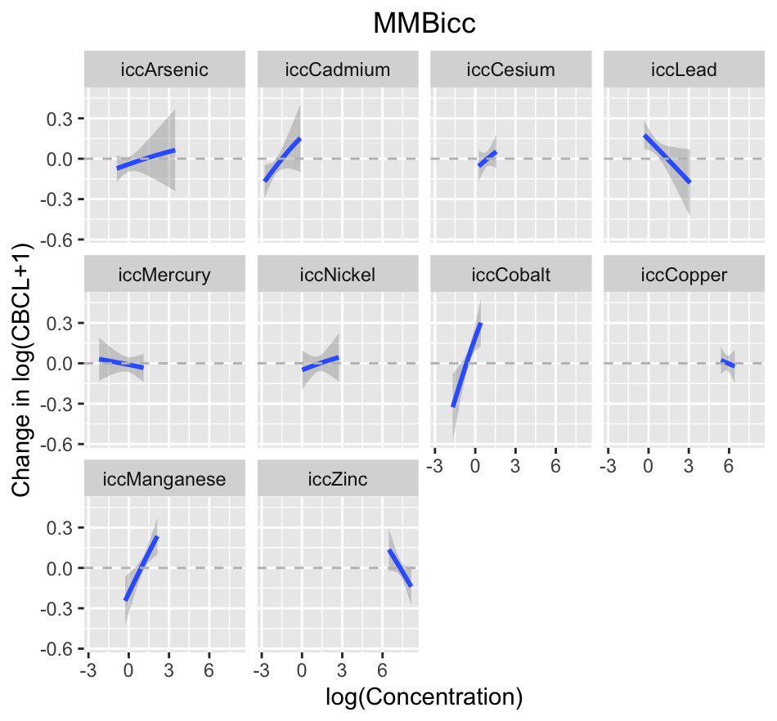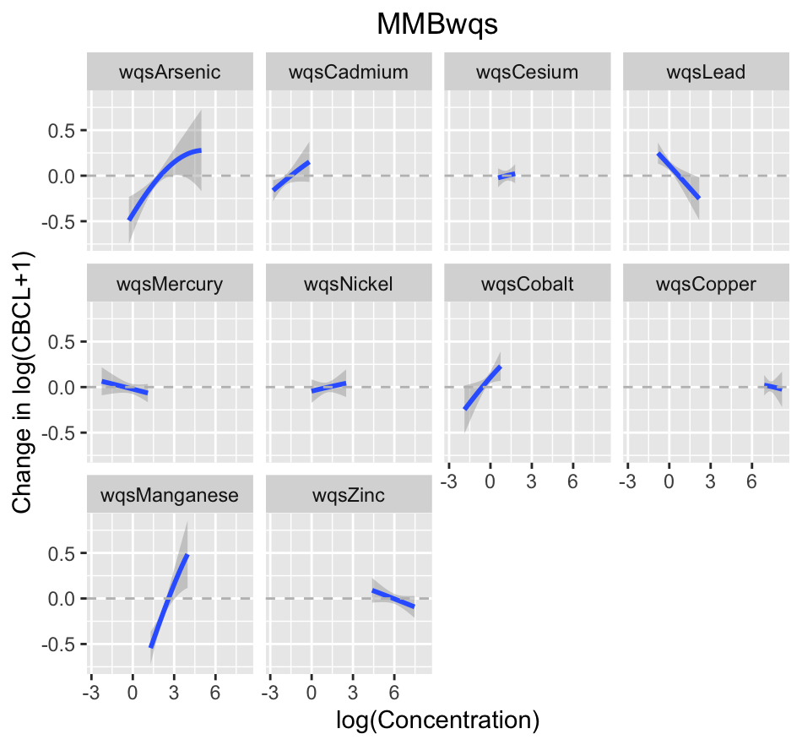

Supplementary Figure 4. Univariate response plots, showing the shape of the association between each exposure and internalizing score for each media, while holding other exposures at their median values, from a Bayesian Kernel Machine Regression (BKMR) with metals and repeated log(CBCL score + 1), adjusted for sex, age at assessment, maternal educational level, and maternal age (N = 284 individuals and 464 observations).

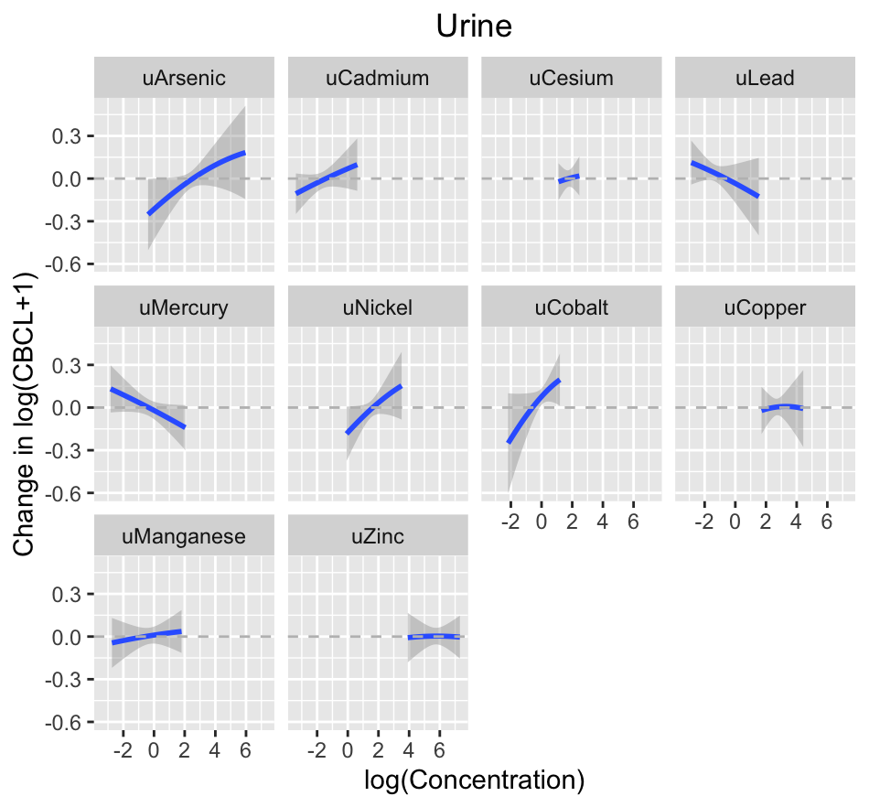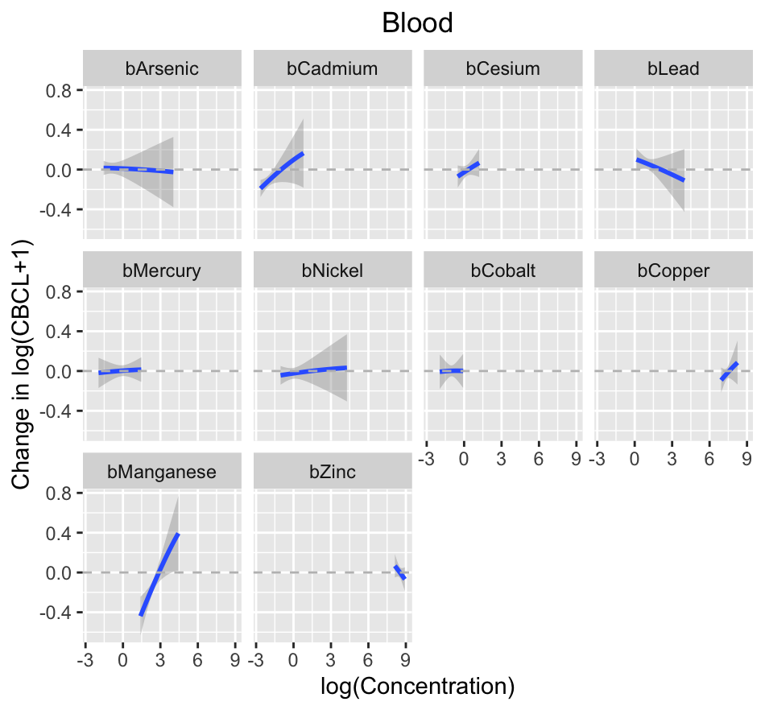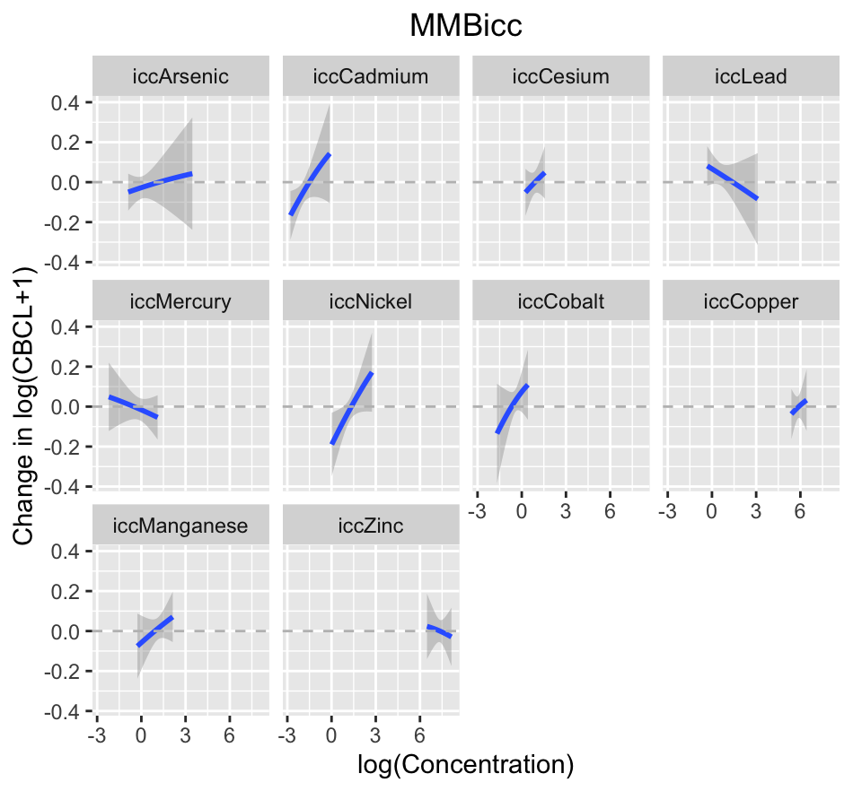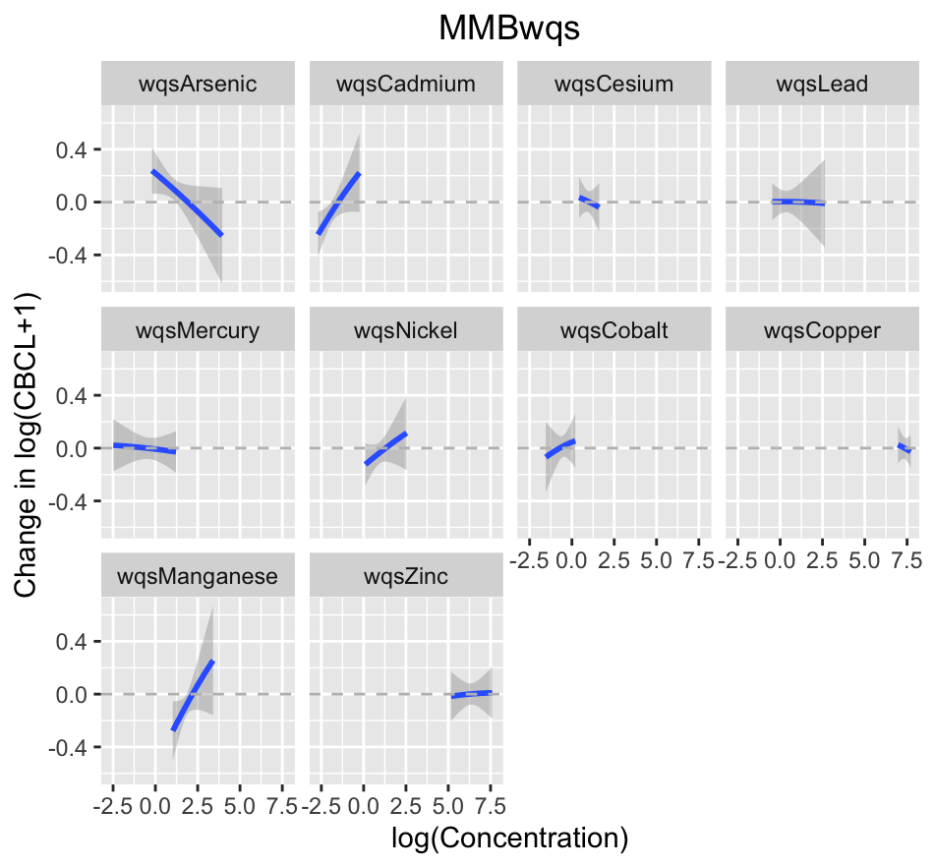

Supplementary Figure 5. Univariate response plots, showing the shape of the association between each exposure and externalizing score for each media, while holding other exposures at their median values, from a Bayesian Kernel Machine Regression (BKMR) with metals and repeated log(CBCL score + 1), adjusted for sex, age at assessment, maternal educational level, and maternal age (N = 284 individuals and 464 observations).

