Supplementary materials
Short-Term Effects and Attributable Burden of Ambient VOC Mixtures on Pediatric Atopic Dermatitis and Asthma in Seoul

List of contents
Table S1. Trends of yearly outpatient visits and hospital admissions for AD and asthma in Seoul, 2015-2019 A3
Table S2. Pariwise correlations of daily VOC concentrations across three monitoring stations in Seoul A4
Figure S1. Time-series concordance of representative VOC concentrations across the three monitoring stations in Seoul: (a) Toluene, (b) Hexane, and (c) Cyclohexane. Daily concentrations were standardized as z-scores within each VOC–station combination A5
Table S3. Grouping of VOCs by chemical structure and group composition A6
Table S4. Missingness, below-LOQ values, and imputation proportions by monitoring statons A7
Table S5. Daily concentrations of individual VOC compounds by VOC groups A9
Figure S2. Concentration distributions of each VOC group A10
Table S6. Relative risks (95% CIs) in outpatient visits and hospital admissions for AD and asthma per quartile increase of WQS index by different lags. The 95% CIs were derived from 100 bootstrap samples with 100 repeated holdouts, reflecting the stability of the WQSR estimates A11

Table S7. Relative risks (95% CIs) in outpatient visits and hospital admissions for AD and asthma per quartile increase of WQS index by different moving average lags. The 95% CIs were derived from 100 bootstrap samples with 100 repeated holdouts, reflecting the stability of the WQSR estimates A12
Table S8. Association between exposure to VOC mixtures and outpatient visits and hospital admissions for AD and asthma by gender and age groups at lag 4 A13
Table S9. Association between exposure to VOC mixtures and outpatient visits and hospital admissions for AD and asthma by sites at lag 4 A14
Table S10. Association between exposure to VOC mixtures and outpatient visits and hospital admissions for AD and asthma after adjustment for air pollutants at lag 4 A15
Figure S3. Bivariate exposure–response relationship between each VOC concentration in Group 4 (aromatics) and AD estimates at lag 4. Each VOC is presented on the upper coordinate axis, with estimates calculated when the corresponding VOCs on the right longitudinal axis are fixed at the 25th, 50th, and 75th percentiles, and the remaining VOCs in each group are held at the 50th percentile A16
Figure S4. Bivariate exposure–response relationship between each VOC concentration in Group 1 (n-alkanes) and asthma estimates at lag 4. Each VOC is presented on the upper coordinate axis, with estimates calculated when the corresponding VOCs on the right longitudinal axis are fixed at the 25th, 50th, and 75th percentiles, and the remaining VOCs in each group are held at the 50th percentile A17
Figure S5. Bivariate exposure–response relationship between each VOC concentration in Group 2 (branched/cyclo-alkanes) and asthma estimates at lag 4. Each VOC is presented on the upper coordinate axis, with estimates calculated when the corresponding VOCs on the right longitudinal axis are fixed at the 25th, 50th, and 75th percentiles, and the remaining VOCs in each group are held at the 50th percentile A18
Figure S6. Bivariate exposure–response relationship between each VOC concentration in Group 4 (aromatics) and asthma estimates at lag 4. Each VOC is presented on the upper coordinate axis, with estimates calculated when the corresponding VOCs on the right longitudinal axis are fixed at the 25th, 50th, and 75th percentiles, and the remaining VOCs in the group are held at the 50th percentile A19

Table S1. Trends of yearly outpatient visits and hospital admissions for AD and asthma in Seoul, 2015-2019
Groups | Atopic dermatitis (AD) | Asthma
2015 | 15,099 | 76,301
2016 | 14,875 | 90,045
2017 | 15,347 | 80,889
2018 | 14,292 | 79,809
2019 | 13,643 | 69,246

Table S2. Pairwise correlations of daily VOC concentrations across three monitoring stations in Seoul
VOC Substance | Station1 vs. Station2 | Station1 vs. Station3 | Station2 vs. Station3
Group1 (ppb)
Ethane | 0.45*** | 0.51*** | 0.37***
Propane | 0.25*** | 0.39*** | 0.34***
n-Butane | 0.15*** | 0.27*** | 0.30***
n-Pentane | 0.25*** | 0.31*** | 0.19***
Hexane | 0.06** | 0.28*** | 0.18***
n-Heptane | 0.05* | 0.12*** | 0.11***
n-Octane | 0.13*** | 0.03 | 0.23***
n-Nonane | 0.06* | 0.03 | 0.05*
n-Decane | 0.06** | 0.04 | 0.05
n-Undecane | 0.06** | -0.05* | -0.01
n-Dodecane | -0.03 | -0.04 | 0.26***
Group2 (ppb)
Isobutane | 0.17*** | 0.23*** | 0.30***
Isopentane | 0.16*** | 0.26*** | 0.04
2-Methylpentane | 0.04 | 0.18*** | 0.04
3-Methylpentane | -0.02 | 0.10*** | -0.01
3-Methylhexane | 0.06* | 0.13*** | 0.07**
Cyclopentane | 0.12*** | 0.12*** | 0.08***
Cyclohexane | 0.11*** | 0.22*** | 0.18***
Methylcyclopentane | 0.06* | 0.19*** | 0.19***
Methylcyclohexane | 0.15*** | 0.02 | 0.08***
Group3 (ppb)
Acetylene | 0.01 | 0.32*** | 0.04
Ethylene | 0.49*** | 0.48*** | 0.39***
Propylene | 0.06* | 0.40*** | 0.17***
1-Butene | -0.10*** | 0.09*** | -0.05
Group4 (ppb)
Benzene | 0.52*** | 0.46*** | 0.49***
Ethylbenzene | 0.20*** | 0.21*** | 0.28***
Toluene | 0.24*** | 0.29*** | 0.28***
m/p-Xylene | 0.16*** | 0.18*** | 0.19***
o-Xylene | 0.05 | 0.12*** | 0.15***
1,2,4-Trimethylbenzene | 0.05* | -0.01 | 0.09***
Station1: Gangseo-gu, Station2: Gwangjin-gu, Station3: Jongno-gu
* p < 0.05; ** p < 0.01; *** p < 0.001

Figure S1. Time-series concordance of representative VOC concentrations across the three monitoring stations in Seoul: (a) Toluene, (b) Hexane, and (c) Cyclohexane. Daily concentrations were standardized as z-scores within each VOC–station combination
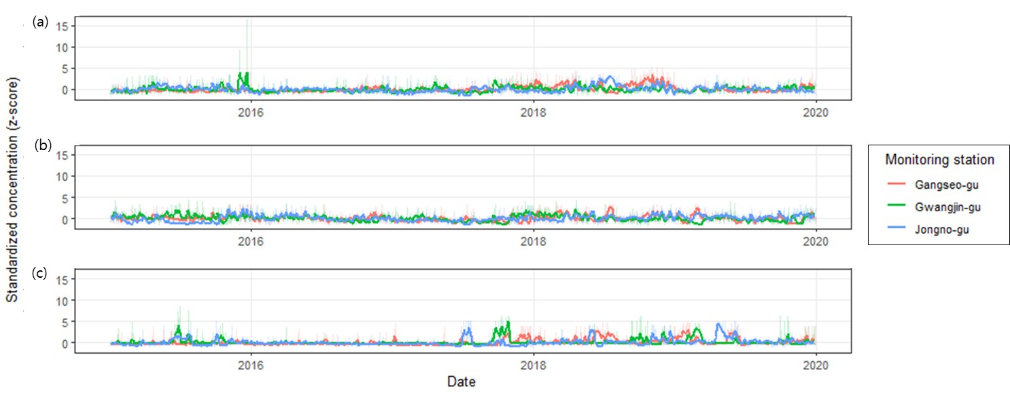
Table S3. Grouping of VOCs by chemical structure and group composition
Groups | VOCs | Kinds | Substance
Group1 | n-alkanes | 11 | Ethane, Propane, n-Butane, n-Pentane,  Hexane, n-Heptane, n-Octane, n-Nonane,  n-Decane, n-Undecane, n-Dodecane
Group2 | branched- or  cyclo-alkanes | 9 | Isobutane, Isopentane,  2-Methylpentane, 3-Methylpentane, 3-Methylhexane,  Cyclopentane, Cyclohexane,  Methylcyclopentane, Methylcyclohexane,
Group3 | Alkenes/Alkynes | 4 | Acetylene, Ethylene, Propylene, 1-Butene
Group4 | Aromatics | 6 | Benzene, Ethylbenzene, Toluene,  m/p-Xylene, o-Xylene, 1,2,4-Trimethylbenzene

Table S4. Missingness, below-LOQ values, and imputation proportions by monitoring statons
VOCs | Total days | Station1 |  |  |  | Station2 |  |  |  | Station3
VOCs | Total days | Missing  (n) | % Missing | %  <LOQ | % Imputed | Missing  (n) | % Missing | %  <LOQ | % Imputed | Missing  (n) | % Missing | %  <LOQ | % Imputed
Group1 (ppb)
Ethane | 1826 | 412 | 22.6 | 0 | 22.6 | 368 | 20.2 | 0.2 | 20.3 | 407 | 22.3 | 1.8 | 24.1
Propane | 1826 | 417 | 22.8 | 0 | 22.8 | 383 | 21.0 | 1.4 | 22.4 | 408 | 22.3 | 0.1 | 22.4
n-Butane | 1826 | 416 | 22.8 | 0.2 | 22.9 | 383 | 21.0 | 0.5 | 21.5 | 401 | 22.0 | 0.8 | 22.7
n-Pentane | 1826 | 412 | 22.6 | 0.7 | 23.3 | 382 | 20.9 | 4.1 | 25.0 | 403 | 22.1 | 2.2 | 24.3
Hexane | 1826 | 411 | 22.5 | 3.5 | 26.0 | 371 | 20.3 | 3.1 | 23.4 | 406 | 22.2 | 1.9 | 24.1
n-Heptane | 1826 | 414 | 22.7 | 12.8 | 35.5 | 373 | 20.4 | 10.6 | 31.1 | 407 | 22.3 | 10.8 | 33.1
n-Octane | 1826 | 410 | 22.5 | 10.1 | 32.6 | 376 | 20.6 | 15.4 | 36.0 | 409 | 22.4 | 25.5 | 47.9
n-Nonane | 1826 | 415 | 22.7 | 9.7 | 32.5 | 376 | 20.6 | 12.3 | 32.9 | 408 | 22.3 | 12.3 | 34.7
n-Decane | 1826 | 414 | 22.7 | 2.7 | 25.4 | 375 | 20.5 | 2.2 | 22.8 | 410 | 22.5 | 8.7 | 31.1
n-Undecane | 1826 | 411 | 22.5 | 18.8 | 41.3 | 377 | 20.6 | 21.8 | 42.4 | 409 | 22.4 | 13.3 | 35.7
n-Dodecane | 1826 | 414 | 22.7 | 21.9 | 44.6 | 377 | 20.6 | 26.2 | 46.8 | 405 | 22.2 | 23.8 | 45.9
Group2 (ppb)
Isobutane | 1826 | 414 | 22.7 | 1.8 | 24.5 | 382 | 20.9 | 0.2 | 21.1 | 406 | 22.2 | 0.3 | 22.5
Isopentane | 1826 | 409 | 22.4 | 0.8 | 23.2 | 378 | 20.7 | 3.5 | 24.2 | 409 | 22.4 | 1.9 | 24.3
2-Methylpentane | 1826 | 414 | 22.7 | 10.7 | 33.4 | 376 | 20.6 | 8.4 | 29.0 | 404 | 22.1 | 21.0 | 43.1
3-Methylpentane | 1826 | 415 | 22.7 | 28.4 | 51.2 | 381 | 20.9 | 19.6 | 40.4 | 408 | 22.3 | 23.2 | 45.6
3-Methylhexane | 1826 | 411 | 22.5 | 27.1 | 49.6 | 377 | 20.6 | 16.5 | 37.2 | 408 | 22.3 | 17.7 | 40.1
Cyclopentane | 1826 | 404 | 22.1 | 17.5 | 39.6 | 382 | 20.9 | 19.6 | 40.5 | 408 | 22.3 | 12.4 | 34.8
Cyclohexane | 1826 | 412 | 22.6 | 27.9 | 50.5 | 379 | 20.8 | 18.0 | 38.8 | 408 | 22.3 | 23.1 | 45.4
Methylcyclopentane | 1826 | 409 | 22.4 | 13.5 | 35.9 | 378 | 20.7 | 5.9 | 26.6 | 407 | 22.3 | 6.6 | 28.9
Methylcyclohexane | 1826 | 410 | 22.5 | 17.9 | 40.3 | 380 | 20.8 | 18.5 | 39.3 | 404 | 22.1 | 16.0 | 38.2
Group3 (ppb)
Acetylene | 1826 | 409 | 22.4 | 19.7 | 42.1 | 383 | 21.0 | 24.9 | 45.9 | 411 | 22.5 | 9.2 | 31.7
Ethylene | 1826 | 413 | 22.6 | 0.1 | 22.7 | 378 | 20.7 | 0.8 | 21.5 | 408 | 22.3 | 2.1 | 24.4
Propylene | 1826 | 416 | 22.8 | 1.5 | 24.3 | 357 | 19.6 | 10.4 | 29.9 | 410 | 22.5 | 5.3 | 27.7
1-Butene | 1826 | 413 | 22.6 | 13.2 | 35.8 | 376 | 20.6 | 28.5 | 49.1 | 402 | 22.0 | 12.8 | 34.8
Group4 (ppb)
Benzene | 1826 | 413 | 22.6 | 6.8 | 29.5 | 378 | 20.7 | 1.7 | 22.4 | 406 | 22.2 | 3.8 | 26.1
Ethylbenzene | 1826 | 413 | 22.6 | 0 | 22.6 | 370 | 20.3 | 0.1 | 20.4 | 408 | 22.3 | 1.8 | 24.2
Toluene | 1826 | 408 | 22.3 | 0.2 | 22.6 | 369 | 20.2 | 0.1 | 20.3 | 408 | 22.3 | 1.5 | 23.9
m/p-Xylene | 1826 | 411 | 22.5 | 0.1 | 22.6 | 363 | 19.9 | 0.1 | 20.0 | 408 | 22.3 | 0.5 | 22.9
o-Xylene | 1826 | 412 | 22.6 | 2.4 | 24.9 | 360 | 19.7 | 1.0 | 20.8 | 408 | 22.3 | 1.8 | 24.2
1,2,4-Trimethylbenzene | 1826 | 414 | 22.7 | 2.9 | 25.6 | 376 | 20.6 | 15.1 | 35.7 | 407 | 22.3 | 8.7 | 30.9
Station1: Gangseo-gu, Station2: Gwangjin-gu, Station3: Jongno-gu

Table S5. Daily concentrations of individual VOC compounds by VOC group
VOCs |  | Mean ± SD |  |  | Min |  | Q₁ |  | Median | Q₃ | IQR
Group1 (ppb)
Ethane |  | 6.0 ± 2.8 |  |  | 0.8 |  | 3.8 |  | 5.5 | 7.8 | 4.0
Propane |  | 5.0 ± 2.4 |  |  | 1.0 |  | 3.2 |  | 4.6 | 6.3 | 3.1
n-Butane |  | 3.9 ± 2.1 |  |  | 0.4 |  | 2.3 |  | 3.3 | 5.2 | 2.9
n-Pentane |  | 0.9 ± 0.4 |  |  | 0.2 |  | 0.6 |  | 0.8 | 1.1 | 0.5
Hexane |  | 0.8 ± 0.4 |  |  | 0.1 |  | 0.4 |  | 0.7 | 1.0 | 0.6
n-Heptane |  | 0.2 ± 0.1 |  |  | 0.07 |  | 0.1 |  | 0.2 | 0.3 | 0.1
n-Octane |  | 0.2 ± 0.08 |  |  | 0.06 |  | 0.1 |  | 0.2 | 0.2 | 0.08
n-Nonane |  | 0.2 ± 0.08 |  |  | 0.06 |  | 0.1 |  | 0.1 | 0.2 | 0.07
n-Decane |  | 0.2 ± 0.1 |  |  | 0.05 |  | 0.1 |  | 0.2 | 0.2 | 0.1
n-Undecane |  | 0.1 ± 0.07 |  |  | 0.05 |  | 0.08 |  | 0.09 | 0.1 | 0.06
n-Dodecane |  | 0.1 ± 0.05 |  |  | 0.04 |  | 0.07 |  | 0.08 | 0.1 | 0.04
Group2 (ppb)
Isobutane |  | 2.0 ± 0.9 |  |  | 0.4 |  | 1.3 |  | 1.8 | 2.5 | 1.2
Isopentane |  | 1.4 ± 0.6 |  |  | 0.1 |  | 0.9 |  | 1.3 | 1.7 | 0.7
2-Methylpentane |  | 0.3 ± 0.2 |  |  | 0.08 |  | 0.2 |  | 0.3 | 0.4 | 0.2
3-Methylpentane |  | 0.3 ± 0.1 |  |  | 0.08 |  | 0.2 |  | 0.2 | 0.3 | 0.1
3-Methylhexane |  | 0.2 ± 0.07 |  |  | 0.07 |  | 0.1 |  | 0.1 | 0.2 | 0.07
Cyclopentane |  | 0.3 ± 0.3 |  |  | 0.1 |  | 0.2 |  | 0.2 | 0.4 | 0.2
Cyclohexane |  | 0.2 ± 0.09 |  |  | 0.08 |  | 0.1 |  | 0.2 | 0.3 | 0.1
Methylcyclopentane |  | 0.3 ± 0.2 |  |  | 0.08 |  | 0.2 |  | 0.3 | 0.4 | 0.2
Methylcyclohexane |  | 0.2 ± 0.08 |  |  | 0.07 |  | 0.1 |  | 0.2 | 0.2 | 0.1
Acetylene |  | 0.9 ± 0.5 |  |  | 0.3 |  | 0.6 |  | 0.8 | 1.2 | 0.6
Ethylene |  | 2.1 ± 1.0 |  |  | 0.4 |  | 1.3 |  | 1.8 | 2.7 | 1.3
Propylene |  | 0.7 ± 0.3 |  |  | 0.2 |  | 0.4 |  | 0.7 | 0.9 | 0.4
1-Butene |  | 0.3 ± 0.1 |  |  | 0.1 |  | 0.2 |  | 0.3 | 0.3 | 0.1
Group4 (ppb)
Benzene |  | 0.5 ± 0.2 |  |  | 0.1 |  | 0.3 |  | 0.4 | 0.6 | 0.3
Ethylbenzene |  | 0.9 ± 0.5 |  |  | 0.1 |  | 0.5 |  | 0.8 | 1.1 | 0.5
Toluene |  | 4.2 ± 2.0 |  |  | 0.5 |  | 2.7 |  | 4.0 | 5.4 | 2.7
m/p-Xylene |  | 1.1 ± 0.6 |  |  | 0.1 |  | 0.7 |  | 1.0 | 1.4 | 0.7
o-Xylene |  | 0.5 ± 0.3 |  |  | 0.08 |  | 0.3 |  | 0.4 | 0.6 | 0.3
1,2,4-Trimethylbenzene |  | 0.2 ± 0.1 |  |  | 0.06 |  | 0.1 |  | 0.2 | 0.2 | 0.1
LOQ: Limit of quantification, SD: Standard deviation, Q₁: 25 percentiles, Q₃: 75 percentiles, IQR: Inter-quartile range

Figure S2. Concentration distributions of each VOC group
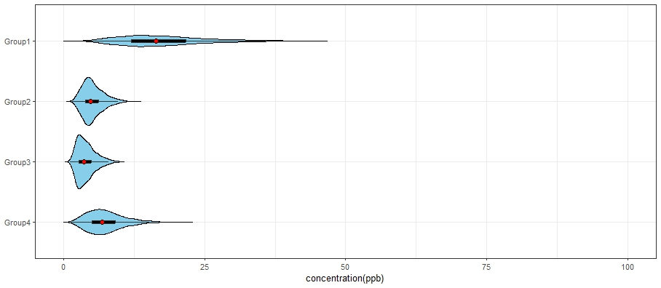

Table S6. Relative risks (95% CIs) in outpatient visits and hospital admissions for AD and asthma per quartile increase of WQS index by different lags. The 95% CIs were derived from 100 bootstrap samples with 100 repeated holdouts, reflecting the stability of the WQSR estimates
VOC groups | Lag0 | Lag1 | Lag2 | Lag3 | Lag4 | Lag5 | Lag6 | Lag7
Atopic dermatitis (AD)
n-Alkanes | 1.036  (0.976, 1.100) | 0.968  (0.942, 0.994) | 0.996  (0.972, 1.020) | 1.010  (0.992, 1.028) | 1.057  (1.038, 1.077) | 1.015  (0.992, 1.040) | 0.992  (0.968, 1.016) | 1.015  (0.996, 1.035)
branched- or cyclo-alkanes | 1.046  (1.026, 1.067) | 0.986  (0.967, 1.005) | 1.002  (0.980, 1.025) | 1.010  (0.992, 1.027) | 1.051  (1.031, 1.071) | 1.039  (1.018, 1.061) | 0.984  (0.957, 1.010) | 1.017  (0.998, 1.037)
Alkenes/Alkynes | 1.021  (0.995, 1.047) | 0.977  (0.951, 1.003) | 0.969  (0.946, 0.993) | 0.992  (0.968, 1.017) | 1.010  (0.985, 1.036) | 1.018  (0.995, 1.042) | 1.004  (0.979, 1.029) | 1.015  (0.992, 1.038)
Aromatics | 0.993  (0.928, 1.062) | 0.962  (0.934, 0.992) | 0.986  (0.967, 1.006) | 1.014  (0.993, 1.036) | 1.072  (1.057, 1.088) | 1.037  (1.017, 1.057) | 0.984  (0.962, 1.007) | 0.996  (0.977, 1.015)
Asthma
n-Alkanes | 1.051  (0.989, 1.116) | 0.983  (0.964, 1.003) | 1.026  (1.003, 1.049) | 1.031  (1.014, 1.049) | 1.055  (1.037, 1.074) | 1.020  (0.999, 1.041) | 1.006  (0.988, 1.024) | 1.042  (0.989, 1.099)
branched- or cyclo-alkanes | 1.034  (1.014, 1.054) | 0.992  (0.973, 1.011) | 1.014  (0.995, 1.035) | 1.036  (1.017, 1.055) | 1.050  (1.032, 1.069) | 1.041  (1.021, 1.061) | 1.001  (0.979, 1.023) | 1.042  (0.986, 1.101)
Alkenes/Alkynes | 0.999  (0.977, 1.021) | 0.977  (0.955, 0.999) | 0.978  (0.958, 0.998) | 1.000  (0.980, 1.021) | 1.000  (0.975, 1.026) | 1.022  (1.000, 1.045) | 0.999  (0.975, 1.023) | 1.006  (0.985, 1.028)
Aromatics | 1.018  (0.996, 1.040) | 0.974  (0.951, 0.997) | 1.010  (0.989, 1.031) | 1.039  (1.020, 1.059) | 1.065  (1.049, 1.081) | 1.034  (1.012, 1.055) | 1.004  (0.982, 1.026) | 1.016  (0.994, 1.038)
CI: Confidence Intervals

Table S7. Relative risks (95% CIs) in outpatient visits and hospital admissions for AD and asthma per quartile increase of WQS index by different moving average lags. The 95% CIs were derived from 100 bootstrap samples with 100 repeated holdouts, reflecting the stability of the WQSR estimates
VOC groups | Lag01 | Lag02 | Lag03 | Lag04 | Lag05 | Lag06 | Lag07
Atopic dermatitis (AD)
n-Alkanes | 0.997  (0.972, 1.023) | 0.989  (0.963, 1.016) | 0.996  (0.962, 1.031) | 0.993  (0.958, 1.028) | 0.995  (0.970, 1.020) | 0.989  (0.957, 1.022) | 0.989  (0.955, 1.024)
branched- or cyclo-alkanes | 1.009  (0.988, 1.029) | 0.995  (0.971, 1.020) | 0.986  (0.958, 1.015) | 1.003  (0.976, 1.031) | 1.008  (0.986, 1.030) | 1.002  (0.980, 1.024) | 1.004  (0.978, 1.031)
Alkenes/Alkynes | 1.003  (0.974, 1.033) | 0.967  (0.939, 0.997) | 0.973  (0.943, 1.004) | 0.980  (0.949, 1.013) | 0.973  (0.947, 1.000) | 0.987  (0.956, 1.019) | 0.991  (0.959, 1.024)
Aromatics | 0.980  (0.960, 1.001) | 0.986  (0.955, 1.017) | 0.980  (0.957, 1.007) | 0.998  (0.973, 1.023) | 0.995  (0.974, 1.018) | 0.995  (0.966, 1.025) | 0.989  (0.960, 1.020)
Asthma
n-Alkanes | 1.005  (0.980, 1.029) | 1.005  (0.978, 1.033) | 1.020  (0.992, 1.049) | 1.021  (0.989, 1.054) | 1.038  (1.007, 1.071) | 1.043  (1.010, 1.078) | 1.053  (1.014, 1.093)
branched- or cyclo-alkanes | 1.008  (0.987, 1.030) | 0.990  (0.967, 1.014) | 1.005  (0.979, 1.030) | 1.028  (1.007, 1.050) | 1.043  (1.021, 1.066) | 1.040  (1.018, 1.061) | 1.056  (1.029, 1.083)
Alkenes/Alkynes | 0.987  (0.958, 1.016) | 0.970  (0.942, 0.998) | 0.974  (0.944, 1.004) | 0.993  (0.961, 1.025) | 0.996  (0.968, 1.026) | 1.006  (0.975, 1.038) | 1.013  (0.971, 1.057)
Aromatics | 0.990  (0.967, 1.014) | 0.988  (0.964, 1.013) | 0.993  (0.967, 1.020) | 1.013  (0.985, 1.041) | 1.025  (0.997, 1.054) | 1.032  (1.000, 1.066) | 1.041  (1.007, 1.076)
CI: Confidence Intervals

Table S8. Association between exposure to VOC mixtures and outpatient visits and hospital admissions for AD and asthma by gender and age groups at lag 4

Outcomes | VOC group | Gender |  | Age groups
Outcomes | VOC group | Male | Female | ≤ 2 yrs old | 3-6 yrs old | 7-12 yrs old | 13-18 yrs old
Atopic  dermatitis  (AD) | Group1 | 1.055 (1.035, 1.075) | 1.051 (1.032, 1.070) | 1.051 (1.030, 1.072) | 1.064 (1.043, 1.085) | 1.052 (1.025, 1.080) | 1.049 (1.022, 1.077)
Atopic  dermatitis  (AD) | Group2 | 1.048 (1.033, 1.063) | 1.053 (1.029, 1.077) | 1.047 (1.023, 1.071) | 1.055 (1.036, 1.075) | 1.052 (1.025, 1.080) | 1.040 (1.010, 1.071)
Atopic  dermatitis  (AD) | Group4 | 1.046 (1.025, 1.067) | 1.055 (1.032, 1.078) | 1.060 (1.038, 1.082) | 1.079 (1.059, 1.099) | 1.081 (1.053, 1.109) | 1.080 (1.053, 1.107)
Asthma | Group1 | 1.054 (1.037, 1.071) | 1.056 (1.035, 1.077) | 1.058 (1.033, 1.083) | 1.056 (1.038, 1.073) | 1.046 (1.023, 1.069) | 1.055 (1.024, 1.086)
Asthma | Group2 | 1.052 (1.034, 1.069) | 1.050 (1.034, 1.066) | 1.058 (1.036, 1.079) | 1.052 (1.034, 1.069) | 1.044 (1.021, 1.067) | 1.039 (1.011, 1.067)
Asthma | Group4 | 1.065 (1.046, 1.083) | 1.064 (1.045, 1.083) | 1.068 (1.048, 1.089) | 1.071 (1.055, 1.086) | 1.054 (1.033, 1.075) | 1.053 (1.023, 1.084)

Table S9. Association between exposure to VOC mixtures and outpatient visits and hospital admissions for AD and asthma by sites at lag 4
Outcomes | VOC  groups | Station1 | Station2 | Station3
Atopic  dermatitis  (AD) | Group1 | 1.047 (1.020, 1.074) | 1.053 (1.005, 1.102) | 1.110 (1.060, 1.162)
Atopic  dermatitis  (AD) | Group2 | 1.028 (0.990, 1.066) | 1.067 (1.019, 1.116) | 1.105 (1.062, 1.150)
Atopic  dermatitis  (AD) | Group4 | 1.057 (1.041, 1.073) | 1.067 (1.044, 1.091) | 1.070 (1.043, 1.097)
Asthma | Group1 | 1.050 (1.025, 1.077) | 1.060 (1.016, 1.106) | 1.136 (1.077, 1.200)
Asthma | Group2 | 1.030 (1.001, 1.060) | 1.067 (1.022, 1.115) | 1.108 (1.066, 1.153)
Asthma | Group4 | 1.036 (1.018, 1.054) | 1.065 (1.036, 1.095) | 1.067 (1.042, 1.093)

Station1: Gangseo-gu, Station2: Gwangjin-gu, Station3: Jongno-gu

Table S10. Association between exposure to VOC mixtures and outpatient visits and hospital admissions for AD and asthma after adjustment for air pollutants at lag 4
Diseases | VOC group | Adjust for  O₃ | Adjust for  NO₂ | Adjust for  SO₂ | Adjust for  CO | Adjust for  PM₁₀ | Adjust for  PM_{2.5} | All adjust
Atopic  dermatitis  (AD) | Group1 | 1.057  (1.041, 1.073) | 1.067  (1.044, 1.091) | 1.058  (1.040, 1.077) | 1.053  (1.025, 1.081) | 1.059  (1.043, 1.076) | 1.063  (1.045, 1.081) | 1.023  (0.994, 1.054)
Atopic  dermatitis  (AD) | Group2 | 1.051  (1.031, 1.072) | 1.058  (1.032, 1.084) | 1.051  (1.028, 1.073) | 1.063  (1.038, 1.088) | 1.052  (1.032, 1.072) | 1.055  (1.034, 1.076) | 1.051  (1.022, 1.079)
Atopic  dermatitis  (AD) | Group4 | 1.075  (1.059, 1.091) | 1.099  (1.078, 1.121) | 1.078  (1.062, 1.094) | 1.085  (1.062, 1.109) | 1.075  (1.059, 1.091) | 1.081  (1.064, 1.097) | 1.060  (1.036, 1.085)
Asthma | Group1 | 1.053  (1.034, 1.071) | 1.059  (1.033, 1.087) | 1.049  (1.027, 1.070) | 1.061  (1.034, 1.089) | 1.060  (1.040, 1.080) | 1.062  (1.043, 1.082) | 1.036  (1.006, 1.067)
Asthma | Group2 | 1.048  (1.030, 1.066) | 1.052  (1.029, 1.076) | 1.043  (1.022, 1.063) | 1.068  (1.044, 1.093) | 1.055  (1.036, 1.074) | 1.055  (1.036, 1.074) | 1.055  (1.026, 1.083)
Asthma | Group4 | 1.065  (1.050, 1.080) | 1.081  (1.060, 1.102) | 1.062  (1.045, 1.079) | 1.077  (1.054, 1.100) | 1.071  (1.053, 1.089) | 1.081  (1.064, 1.097) | 1.057  (1.033, 1.082)
Each column represents models adjusted for individual co-pollutants (one-at-a-time), and the “All adjust” column represents the model adjusted for six co-pollutants simultaneously.

Figure S3. Bivariate exposure–response relationship between each VOC concentration in Group 4 (aromatics) and AD estimates at lag 4. Each VOC is presented on the upper coordinate axis, with estimates calculated when the corresponding VOCs on the right longitudinal axis are fixed at the 25th, 50th, and 75th percentiles, and the remaining VOCs in the group are held at the 50th percentile. Numbers 1–6 denote: 1 = Benzene, 2 = Ethylbenzene, 3 = Toluene, 4 = m/p-Xylene, 5 = o-Xylene, 6 = 1,2,4-Trimethylbenzene

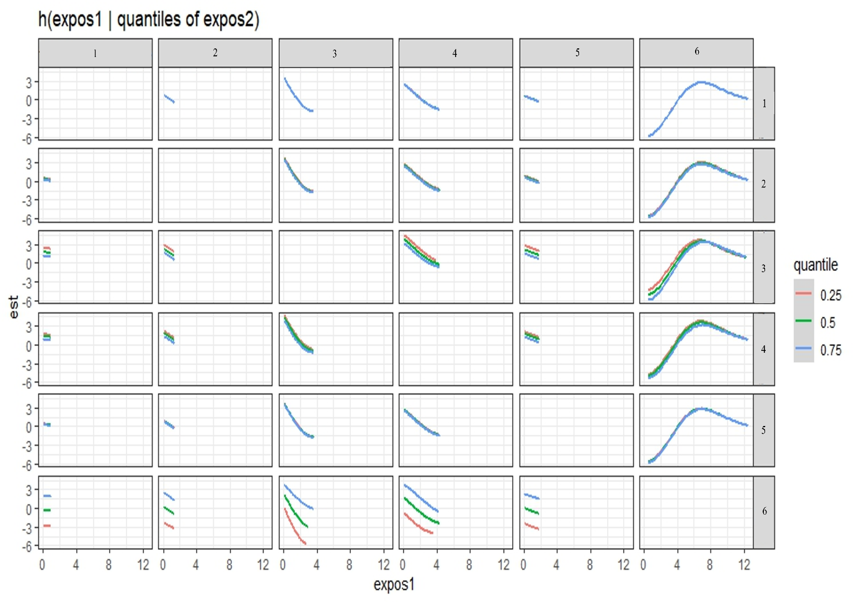

Figure S4. Bivariate exposure–response relationship between each VOC concentration in Group 1 (n-alkanes) and asthma estimates at lag 4. Each VOC is presented on the upper coordinate axis, with estimates calculated when the corresponding VOCs on the right longitudinal axis are fixed at the 25th, 50th, and 75th percentiles, and the remaining VOCs in the group are held at the 50th percentile. Numbers 1–11 denote: 1 = Ethane, 2 = Propane, 3 = n-Butane, 4 = n-Pentane, 5 = Hexane, 6 = n-Heptane, 7 = n-Octane, 8 = n-Nonane, 9 = n-Decane, 10 = n-Undecane, 11 = n-Dodecane

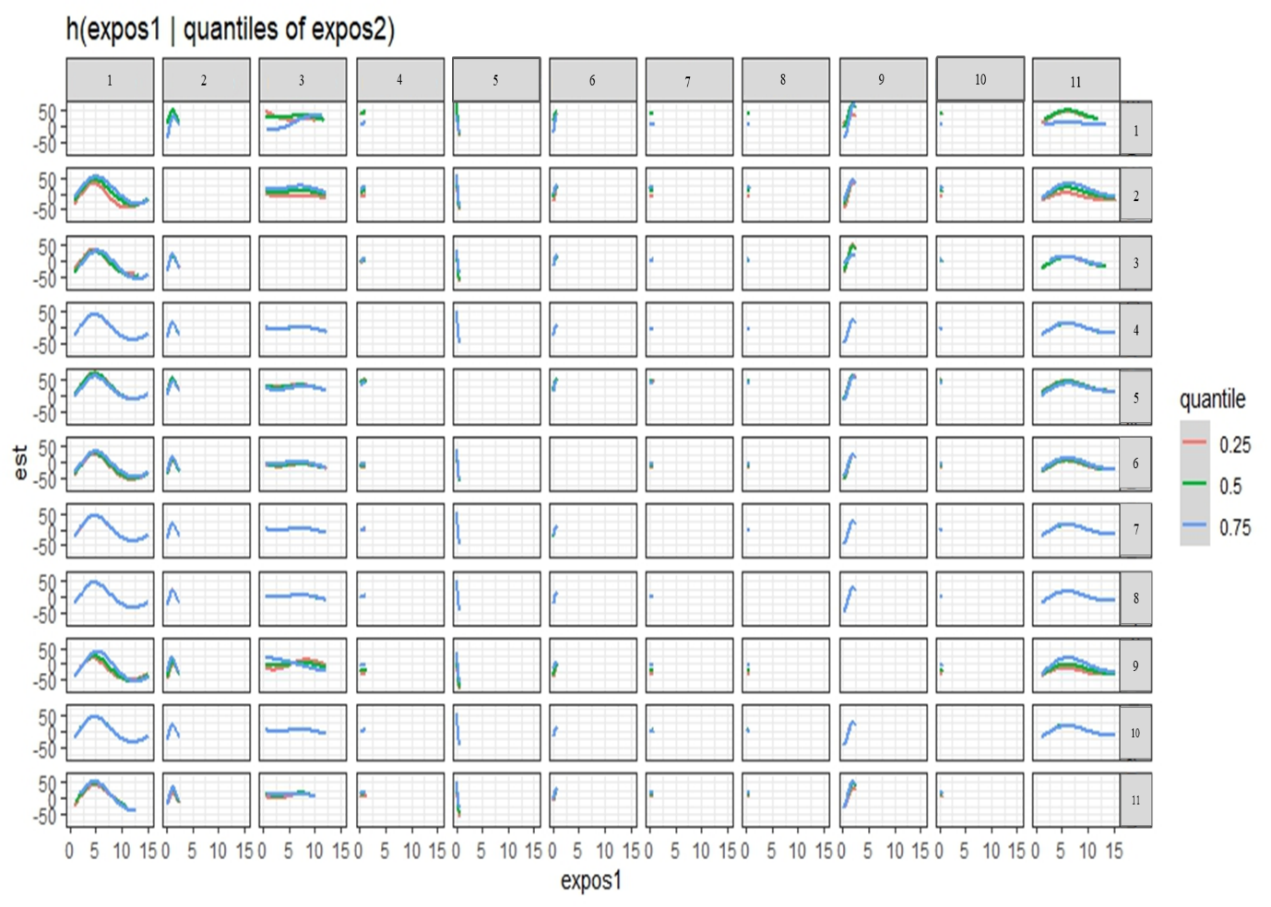

Figure S5. Bivariate exposure–response relationship between each VOC concentration in Group 2 (branched/cyclo-alkanes) and asthma estimates at lag 4. Each VOC is presented on the upper coordinate axis, with estimates calculated when the corresponding VOCs on the right longitudinal axis are fixed at the 25th, 50th, and 75th percentiles, and the remaining VOCs in the group are held at the 50th percentile. Numbers 1–9 denote: 1 = Isobutane, 2 = Isopentane, 3 = 2-Methylpentane, 4 = 3-Methylpentane, 5 = 3-Methylhexane, 6 = Cyclopentane, 7 = Cyclohexane, 8 = Methylcyclopentane, 9 = Methylcyclohexane

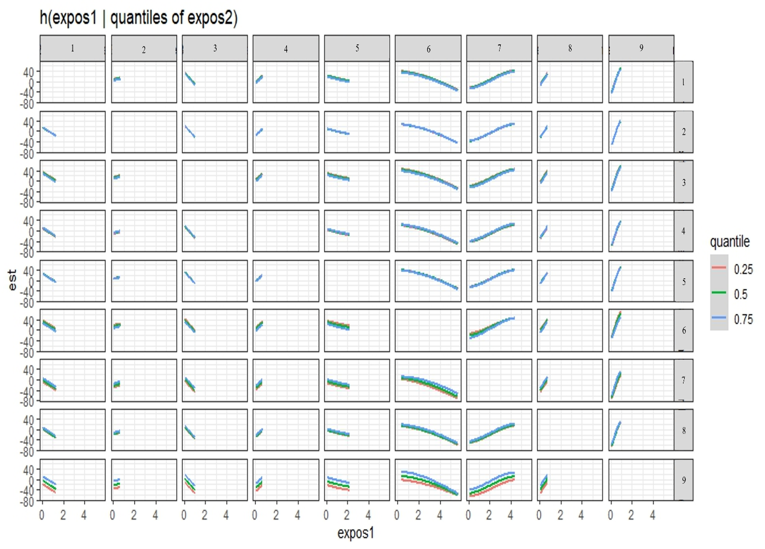

Figure S6. Bivariate exposure–response relationship between each VOC concentration in Group 4 (aromatics) and asthma estimates at lag 4. Each VOC is presented on the upper coordinate axis, with estimates calculated when the corresponding VOCs on the right longitudinal axis are fixed at the 25th, 50th, and 75th percentiles, and the remaining VOCs in the group are held at the 50th percentile. Numbers 1–6 denote: 1 = Benzene, 2 = Ethylbenzene, 3 = Toluene, 4 = m/p-Xylene, 5 = o-Xylene, 6 = 1,2,4-Trimethylbenzene

