Supporting information
Association between ambient temperature and thrombosis-related signaling lipids: Implications for early cardiovascular risk
Table of Contents
Supplemental Methods
Thromboxane (Tx) B2 Profiling
Lyso-Platelet Activating Factor (LysoPAF) and Lysophosphatidic Acid (LPA) Profiling
Sphingosine 1-Phosphate (S1P) Profiling
Supplemental Figures
Figure S1 Flowchart of participant inclusion
Figure S2 Directed acyclic graph (DAG) for covariate selection
Figure S3 The associations between thrombosis-related bioactive lipids and thrombosis biomarkers
Figure S4 Lag patterns of associations between thrombosis-related signaling lipids and thrombosis biomarkers with cold exposure over cumulative 1–30 days
Figure S5 Thirty-day cumulative ambient temperature exposure-response curves for thrombosis-related signaling lipids and thrombosis biomarkers (complete case analysis)
Figure S6 Lag patterns of associations between thrombosis-related signaling lipids and thrombosis biomarkers with heat exposure over cumulative 1–30 days (complete case analysis)
Figure S7 Lag patterns of associations between thrombosis-related signaling lipids and thrombosis biomarkers with cold exposure over cumulative 1–30 days (complete case analysis)
Figure S8 Thirty-day cumulative ambient temperature exposure-response curves for thrombosis-related signaling lipids and thrombosis biomarkers (further adjusted for additional covariates)
Figure S9 Lag patterns of associations between thrombosis-related signaling lipids and thrombosis biomarkers with heat exposure over cumulative 1–30 days (further adjusted for additional covariates)
Figure S10 Lag patterns of associations between thrombosis-related signaling lipids and thrombosis biomarkers with cold exposure over cumulative 1–30 days (further adjusted for additional covariates)
Figure S11 Thirty-day cumulative ambient temperature exposure-response curves for thrombosis-related signaling lipids and thrombosis biomarkers (increased spline complexity)
Figure S12 Lag patterns of associations between thrombosis-related signaling lipids and thrombosis biomarkers with heat exposure over cumulative 1–30 days (increased spline complexity)
Figure S13 Lag patterns of associations between thrombosis-related signaling lipids and thrombosis biomarkers with cold exposure over cumulative 1–30 days (increased spline complexity)
Figure S14 Thirty-day cumulative ambient temperature exposure-response curves for thrombosis-related signaling lipids and thrombosis biomarkers (further adjusted for ozone)
Figure S15 Lag patterns of associations between thrombosis-related signaling lipids and thrombosis biomarkers with heat exposure over cumulative 1–30 days (further adjusted for ozone)
Figure S16 Lag patterns of associations between thrombosis-related signaling lipids and thrombosis biomarkers with cold exposure over cumulative 1–30 days (further adjusted for ozone)
Figure S17 Thirty-day cumulative ambient temperature exposure-response curves for thrombosis-related signaling lipids and thrombosis biomarkers, estimated using distributed lag non-linear models (DLNMs)
Figure S18 Lag patterns of associations between thrombosis-related signaling lipids and thrombosis biomarkers with cold and heat exposure (cold and heat effects) over cumulative 1–30 days, estimated using distributed lag non-linear models (DLNMs)
Figure S19 The correlation of outdoor and personal temperature exposure 1 day before the visits in another panel study in Beijing conducted in the similar period of the study
Figure S20 Sensitivity analysis comparing primary and <LOQ-excluded analyses for LPA 18:0 and LPA 18:1
Figure S21 Distribution of ln-transformed TxB2 concentrations (modelling scale)
Supplemental Tables
Table S1 Baseline characteristics of participants included in and excluded from the analysis
Table S2 Calibration curves, recoveries, precisions, and detection rates of thrombosis-related signaling lipids
Table S3 Model comparison across PM_{2.5} moving-average windows based on AIC values for the associations between cumulative ambient temperature exposure and health outcomes
Table S4 Supplementary summary of participant characteristics
Table S5 Levels of ambient meteorological parameters and fine particulate matter during 1, 7, 14, and 30 days prior to visits
Table S6 Absolute changes in thrombosis-related signaling lipid and thrombosis biomarkers associated with cold/heat exposure
Table S7 Individual and total mediation effects of thrombosis-related bioactive lipids on the heat exposure–soluble CD40 ligand association
Table S8 The mediation effects of thrombosis-related bioactive lipids on the associations between heat exposure and soluble CD40 ligand (complete case analysis)
Table S9 The mediation effects of thrombosis-related bioactive lipids on the associations between heat exposure and soluble CD40 ligand (further adjusted for additional covariates)
Table S10 Sensitivity of heat-associated TxB2 estimates to alternative temperature specifications
Table S11 Influence of high-temperature observations on the temperature–TxB2 association
Table S12 Heat and cold effects on thrombosis-related signaling lipid and thrombosis biomarkers using 99% confidence intervals

Supplemental Methods

Thromboxane (Tx) B2 Profiling
A 50 μL of serum aliquot was first added to a volume of 200 μL extraction mix containing 165 μL of extraction solvent (MeOH/ACN/HAC: 50/50/0.1, v/v/v), 10 μL of antioxidant solution (0.2 mg/mL BHT, 0.2 mg/mL Na₂EDTA, and 100 μM trans-AUCB in MeOH), and 25 μL of deuterated internal standard (ISTD) mix solution (containing 10 ng/mL prostaglandin E2-d4 in MeOH) on ice. The mixed solution was then vortexed, incubated for 15 min at -20 ℃ and centrifuged at 20,000 g for 15 min at 4 ℃. 150 μL of the supernatant was removed to a new tube and evaporate to dryness at 45℃. The dry residue was reconstituted with 150 μL MeOH/water (40/60, v/v). All supernatant was transferred to a new LC-vial for the following analysis. Online solid Phase Extraction - liquid chromatography - tandem mass spectrometry (online SPE-LC-MS/MS) was performed using an Agilent 1290 Infinity Flexible Cube equipped with two TurboFlow Cyclone cartridges (0.5 × 50 mm; Thermo Scientific, Waltham, MA), an Agilent 1290 Infinity ultrahigh-performance LC equipped with an Acquity UPLC CSH C18 column (100 × 2.1 mm, 1.7 μm; Waters, MA, USA) and an Agilent 6470 triple quadrupole (QqQ) mass spectrometer with an electrospray ionization (ESI) source. The mobile phases consisted of (A) water, ACN and HAc (60/40/0.02, v/v/v) and (B) ACN/IPA (50/50, v/v). 100 μL of each sample was first loaded on a cartridge of online SPE, washed with Water/MeOH (90/10, v/v) and then backflushed into the LC column. Separation was performed as the following gradient conditions: 4-5 min, 0-5% B; 5-5.5 min, 5-30% B; 5.5-9 min, 30-55% B; 9-11 min, 55-70% B; 11-11.5 min, 70% B. The LC column temperature was 60°C.The flow rate was 0.4 mL/min. The separated analytes were ionized in negative ESI mode and scanned using dynamic multiple reaction monitoring (dMRM) mode.

Lyso-Platelet Activating Factor (LysoPAF) and Lysophosphatidic Acid (LPA) Profiling
LysoPAFs and LPAs were extracted from a 50-μL plasma aliquot using 200 μL of extraction solvent containing 175 μL of MeOH with 0.01% BHT and 25 μL of the ISTD stock solution [containing 1,000 ng/mL LysoPAF C16-d4, 2,000 ng/mL LysoPAF C18-d4, and 200 ng/mL LPA 17:0 in MeOH/CHCl₃ (2/1, v/v)] on ice. The mixture was vortexed for 10 s, incubated on ice for 15 min, and then centrifuged at 21,000 g for 15 min at 4°C after another vortex. 150 μL supernatant was transferred to a new tube and evaporated to dryness using a vacuum evaporator at 35°C. The dry residue was reconstituted with 150 μL of MeOH/CHCl₃ (2/1, v/v), followed by vortexing for 30 s and ultrasonicating for 10 min. All the resulting supernatant was vortexed for another 10 s, filtered through a 0.22-μm hydrophobic PTFE syringe filter (ANPEL Laboratory Technologies, Shanghai, China), and transferred to a new vial for LC-MS/MS analysis. The profiling of LysoPAFs and LPAs was performed using a 1290 Infinity ultrahigh performance LC (Agilent, Santa Clara, CA, USA) with an Atlantis® HILIC column (2.1 × 150 mm, 3 μm; Waters Corporation, Milford, MA, USA). Mobile phases were water with 0.2% formic acid and 50 mM ammonium formate (A), and acetonitrile with 0.2% formic acid (B). For each injection, 10 μL of sample was loaded and the analytes were separated under the following gradient: 0–1.5 min, 95% B; 1.5–2.5 min, 95–85% B; 2.5–5.5 min, 85–84% B; 5.5–9.5 min, 84% B; 9.5–9.6 min, 84–50% B; 9.6–11.5 min, 50% B; 11.5–11.6 min, 50–95% B; and 11.6–18 min, 95% B. The flow rate was 0.6 mL/min, and the column was kept at 40°C. Quantification was achieved by a 6470 QqQ mass spectrometer (Agilent, Santa Clara, CA, USA) with a ESI source under negative mode. The dMRM mode was applied for MS/MS data acquisition.

Sphingosine 1-Phosphate (S1P) Profiling
A 10-μL aliquot of plasma was added to 80 μL of MeOH with 0.01% BHT and 10 μL of the ISTD mix solution [containing S1P (d17:1) in MeOH] on ice. The mixture was vortexed for 10 s, incubated on ice for 30 min, and centrifuged at 20,000 g for 8 min. The resulting supernatant was transferred to a new vial for LC-MS/MS analysis. LC-MS/MS analysis was conducted using an Agilent 1290 Infinity ultrahigh performance LC coupled with an Agilent 6470 QqQ mass spectrometer equipped with an ESI source. Analytes were separated on an Acquity UPLC BEH C18 column (100 × 2.1 mm; 1.7 μm; Waters, Milford, MA, USA). The mobile phases consisted of A (H₂O:MeOH = 8:2) and B (IPA:MeOH = 9:1), both containing 0.1% formic acid and 10 mM ammonium formate. For each run, 5 μL of sample was injected onto the LC column using the following gradient: 0–1.5 min, 20–40% B; 1.5–2.25 min, 40–45% B; 2.25–7.5 min, 45–52% B; 7.5–8.25 min, 52–67% B; 8.25–12.75 min, 67–73% B; 12.75–15 min, 73–99% B; and 15–16 min, 99–20% B. The flow rate was 0.4 mL/min, and the column was operated at 80℃. The separated analytes were ionized in positive ESI mode. The dMRM method was used to acquire MS data.

Supplemental Figures
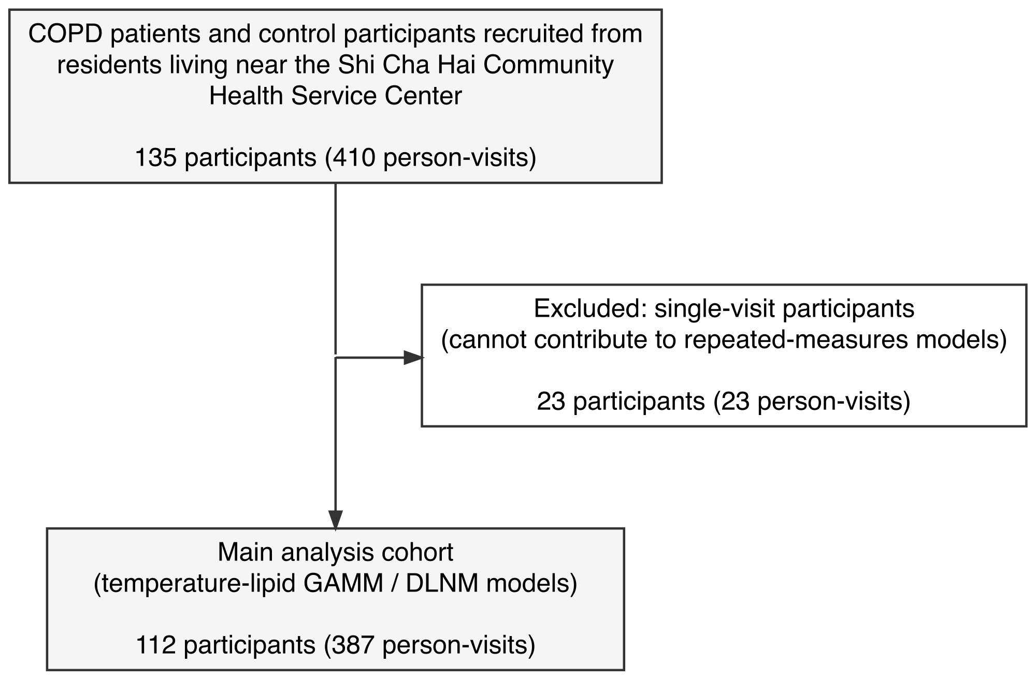
Figure S1 Flowchart of participant inclusion. Abbreviations: COPD, chronic obstructive pulmonary disease; GAMM, generalized additive mixed model; DLMM, distributed lag nonlinear model.
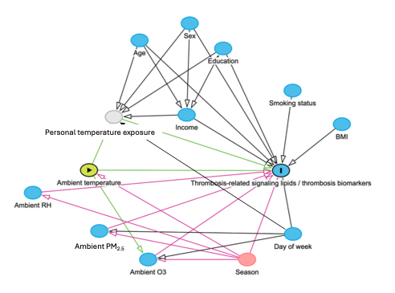
Figure S2 Directed acyclic graph (DAG) for covariate selection. Abbreviations: BMI, body mass index; RH, relative humidity; PM_{2.5}, fine particulate matter.
Figure S3 Between-individual (A) and within-individual (B) correlations of thrombosis-related bioactive lipids and thrombosis biomarkers. (A) Spearman correlations of concentrations between individuals, calculated using data from the first follow-up visit. (B) Within-individual correlations determined using the repeated measures correlation method. Abbreviations: Tx, thromboxane; LysoPAF, lysoalkylphosphatidylcholine; LPA, lysophosphatidic acid; S1P, sphingosine-1-phosphate; MPV, mean platelet volume; PDW, Platelet distribution width; P-LCR, platelet larger cell ratio; sCD40L, soluble CD40 ligand.
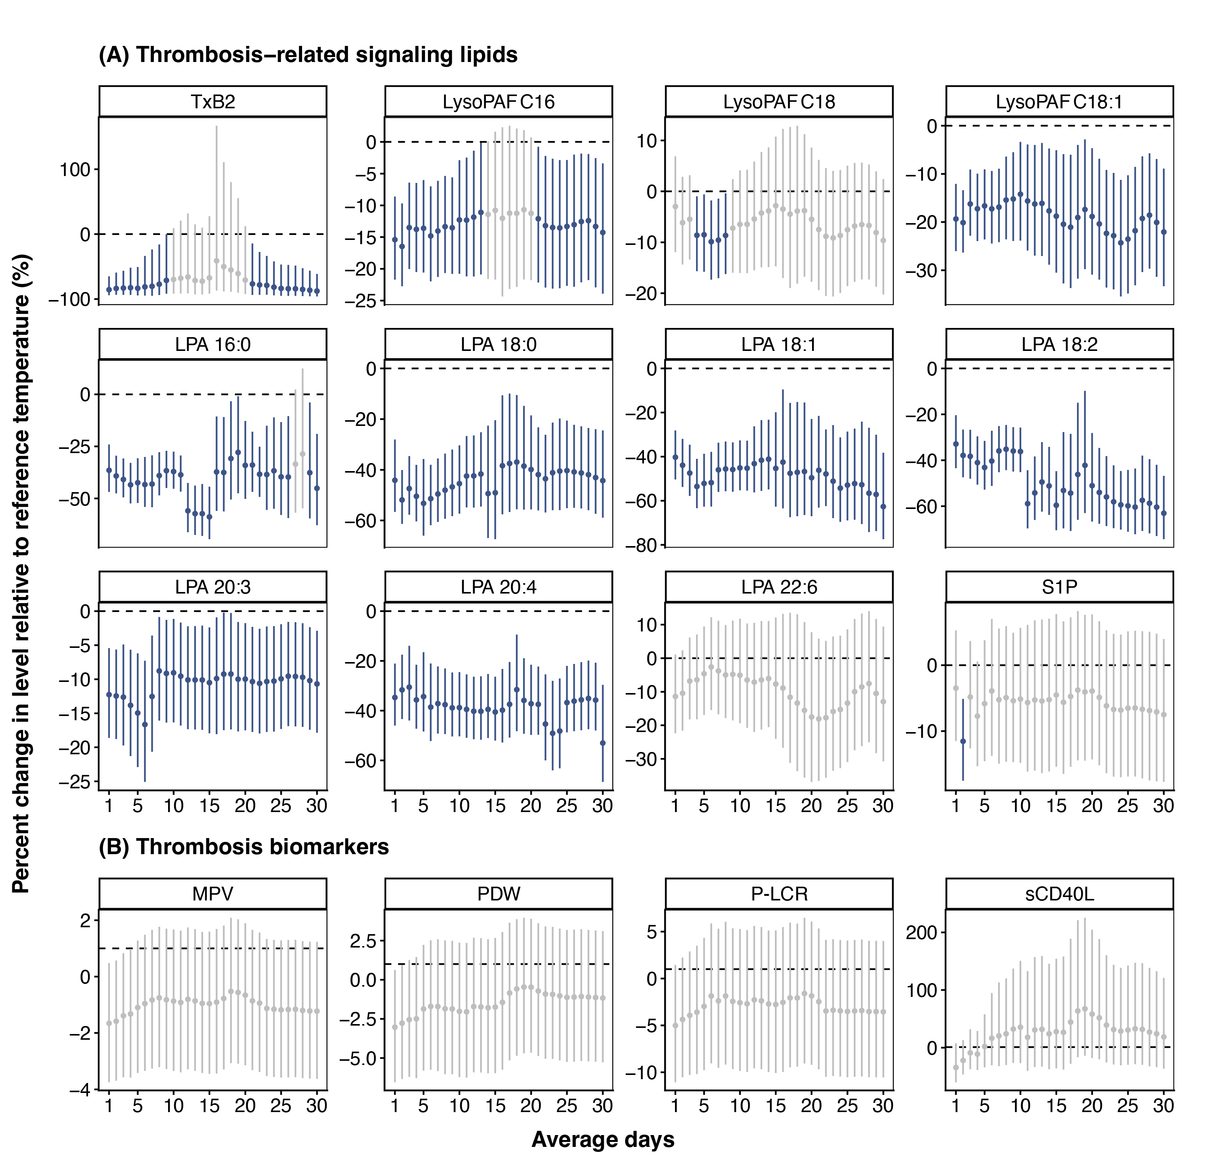
Figure S4 Lag patterns of associations between thrombosis-related signaling lipids and thrombosis biomarkers with cold exposure over cumulative 1–30 days. The estimates were from generalized additive mixed models adjusting for season, day of week, age, sex, body mass index, education, income, smoke, ambient relative humidity, cumulative exposure to ambient fine particulate matter (moving-average windows chosen by AIC), and random intercepts at participant levels. 18.7°C, the median of 30-day cumulative ambient temperature exposure levels among visits, was used as a reference for predictions. Cold was defined as -0.8°C, corresponding to the 5th percentile. Abbreviations: TxB2, thromboxane B2; LysoPAF, lyso-platelet-activating factor; LPA, lysophosphatidic acid; S1P, sphingosine-1-phosphate; MPV, mean platelet volume; P-LCR, platelet larger cell ratio; PDW, Platelet distribution width; sCD40L, soluble CD40 ligand.

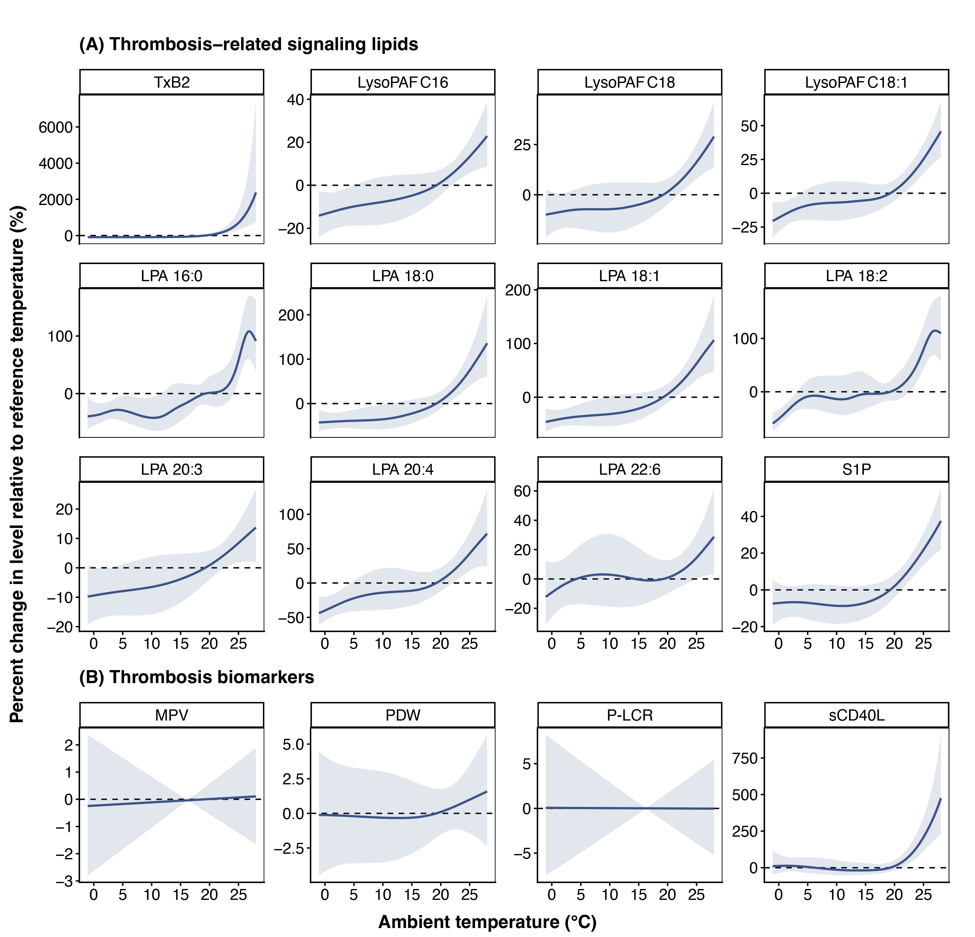
Figure S5 Thirty-day cumulative ambient temperature exposure-response curves for thrombosis-related signaling lipids and thrombosis biomarkers (complete case analysis). The estimates were from generalized additive mixed models adjusting for season, day of week, age, sex, body mass index, education, income, smoke, 30-day cumulative exposure to ambient relative humidity, cumulative exposure to ambient fine particulate matter (moving-average windows chosen by AIC), and random intercepts at participant levels. A complete case analysis was performed. 19.3°C, the median of 30-day cumulative ambient temperature exposure levels among visits, was used as a reference for predictions. Abbreviations: TxB2, thromboxane B2; LysoPAF, lyso-platelet-activating factor; LPA, lysophosphatidic acid; S1P, sphingosine-1-phosphate; MPV, mean platelet volume; PDW, Platelet distribution width; P-LCR, platelet larger cell ratio; sCD40L, soluble CD40 ligand.
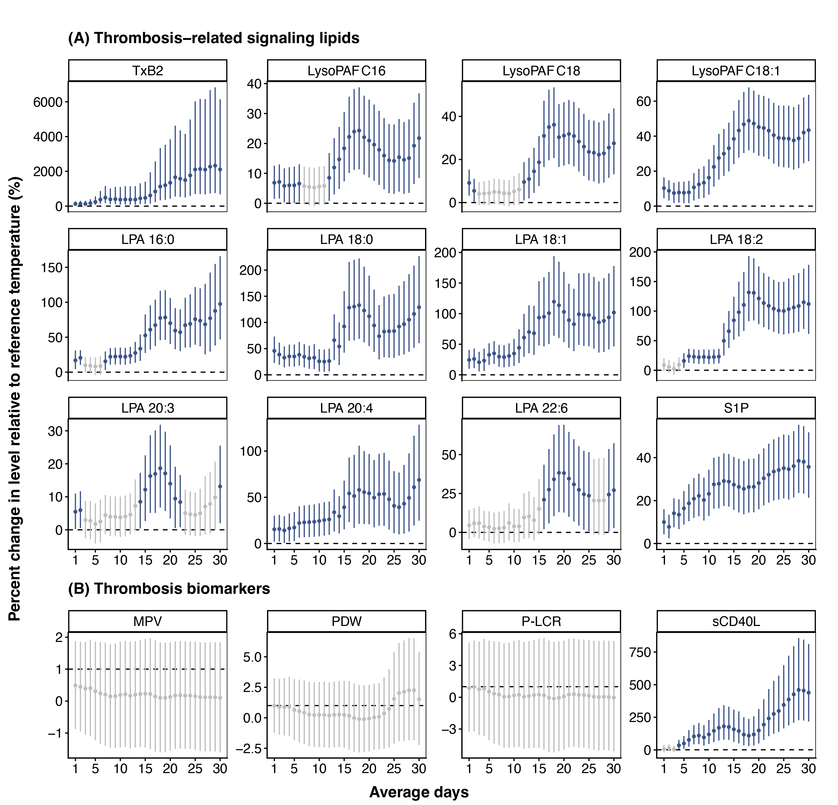
Figure S6 Lag patterns of associations between thrombosis-related signaling lipids and thrombosis biomarkers with heat exposure over cumulative 1–30 days (complete case analysis). The estimates were from generalized additive mixed models adjusting for season, day of week, age, sex, body mass index, education, income, smoke, ambient relative humidity, cumulative exposure to ambient fine particulate matter (moving-average windows chosen by AIC), and random intercepts at participant levels. A complete case analysis was performed. 19.3°C, the median of 30-day cumulative ambient temperature exposure levels among visits, was used as a reference for predictions. Heat was defined as 27.7°C, corresponding to the 95th percentile. Abbreviations: TxB2, thromboxane B2; LysoPAF, lyso-platelet-activating factor; LPA, lysophosphatidic acid; S1P, sphingosine-1-phosphate; MPV, mean platelet volume; P-LCR, platelet larger cell ratio; PDW, Platelet distribution width; sCD40L, soluble CD40 ligand.

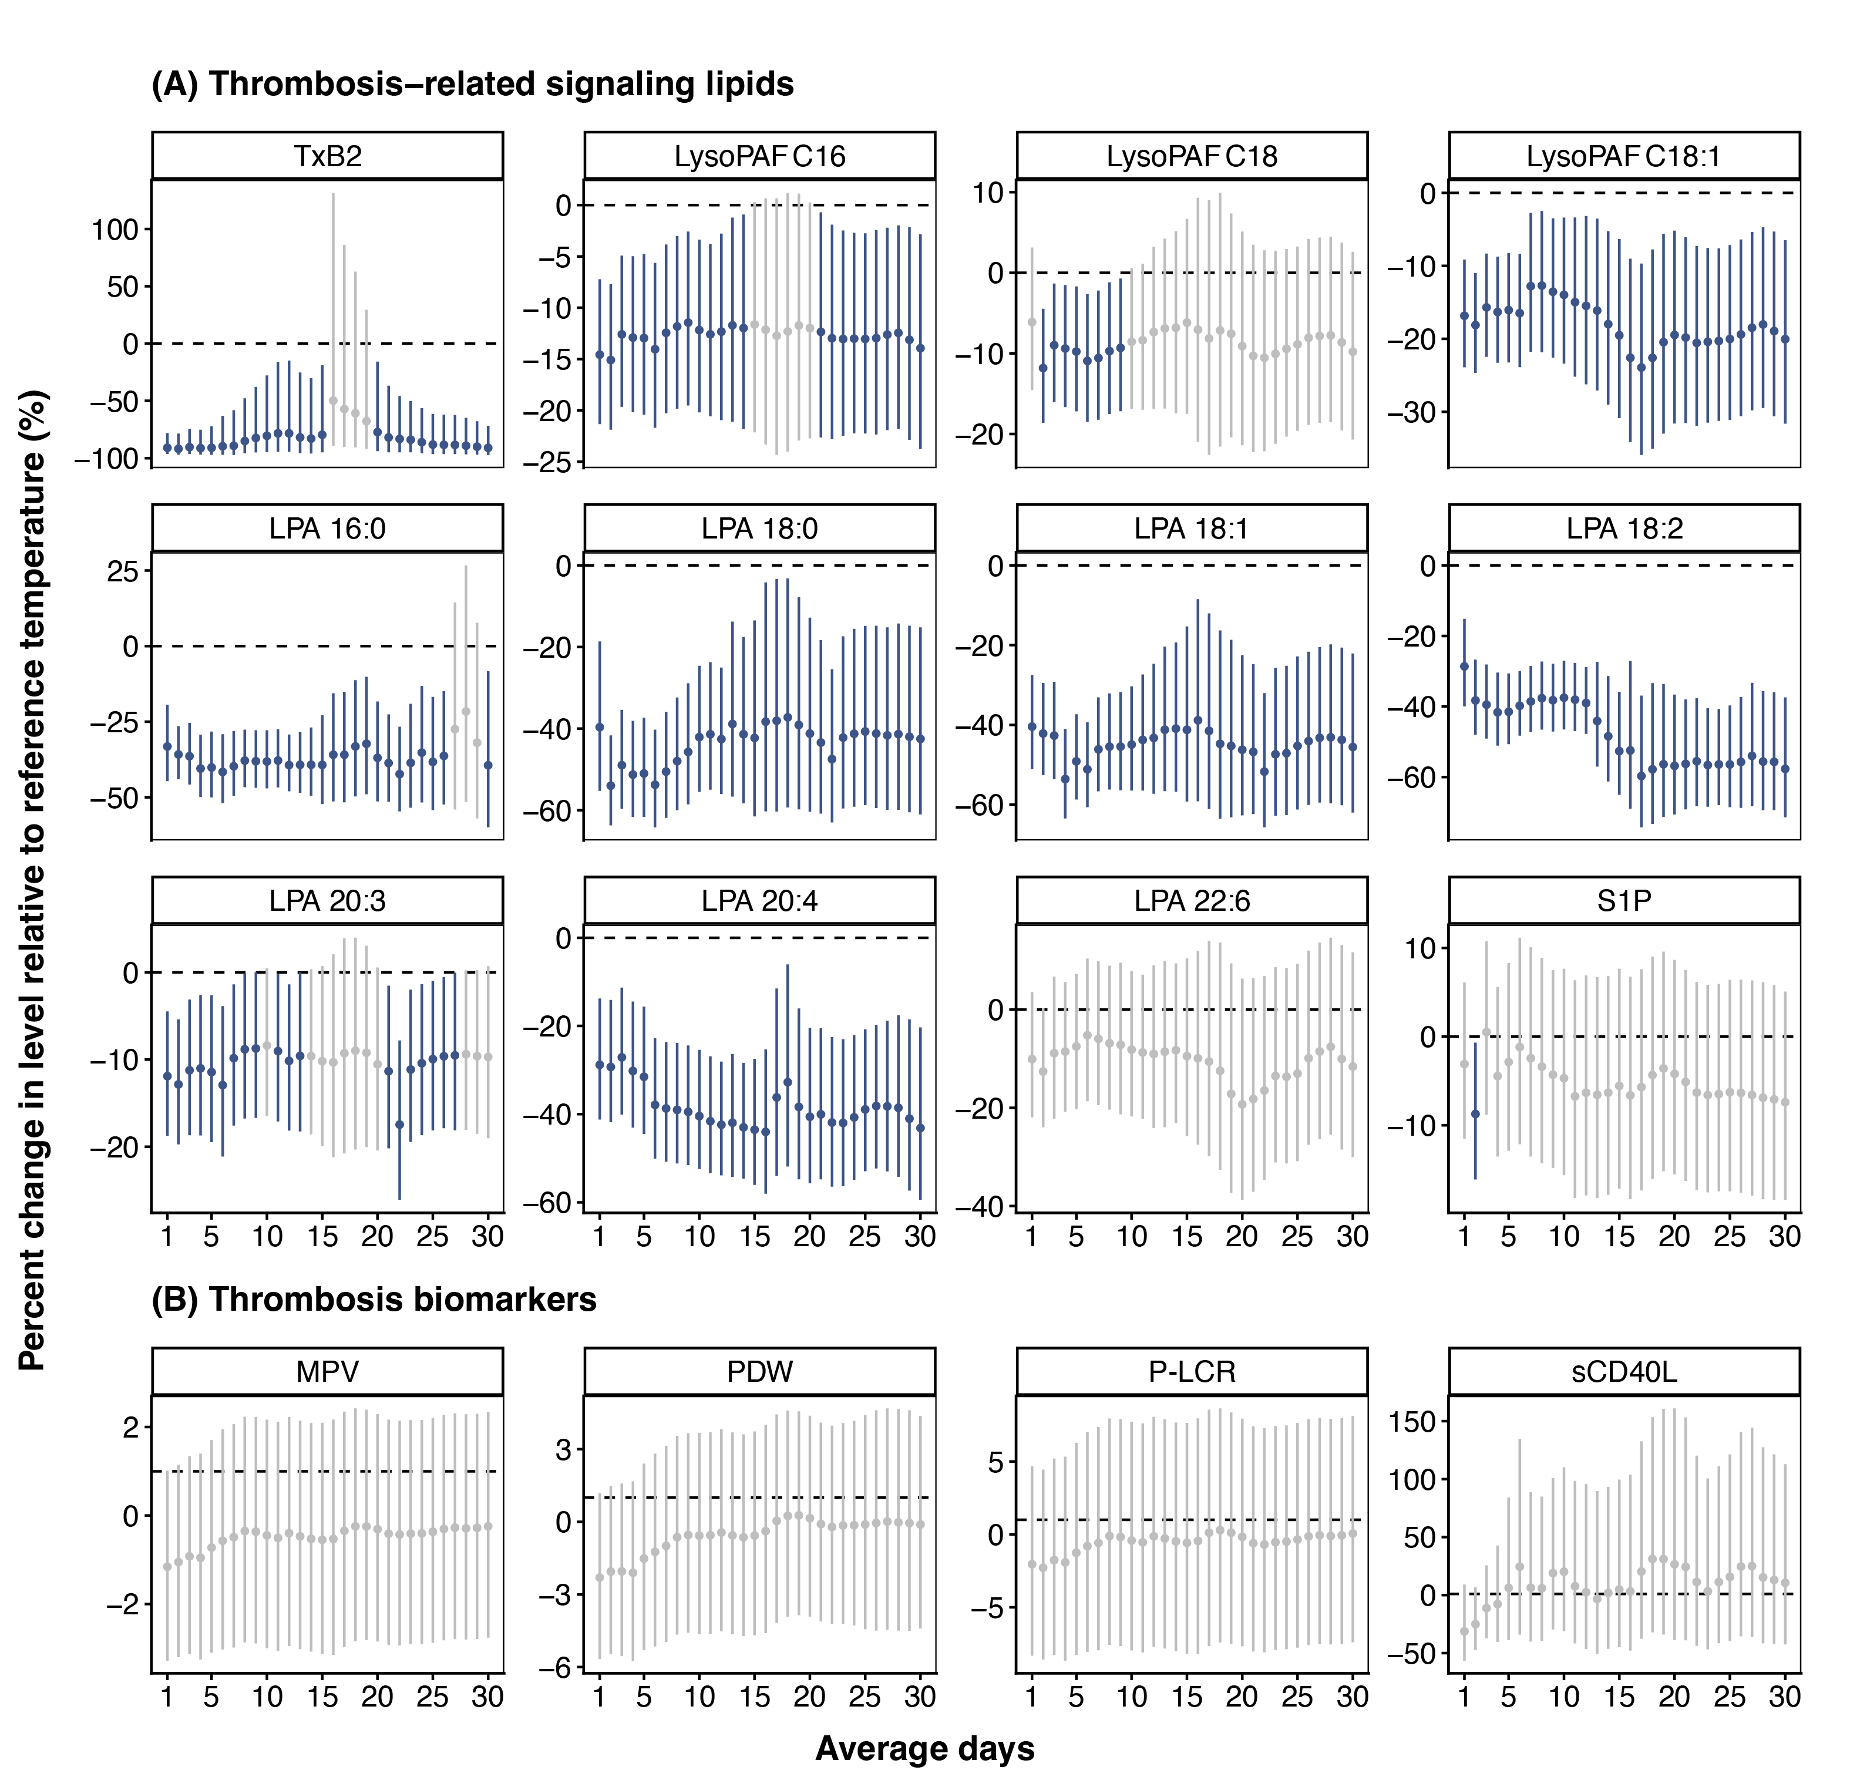
Figure S7 Lag patterns of associations between thrombosis-related signaling lipids and thrombosis biomarkers with cold exposure over cumulative 1–30 days (complete case analysis). The estimates were from generalized additive mixed models adjusting for season, day of week, age, sex, body mass index, education, income, smoke, ambient relative humidity, cumulative exposure to ambient fine particulate matter (moving-average windows chosen by AIC), and random intercepts at participant levels. A complete case analysis was performed. 19.3°C, the median of 30-day cumulative ambient temperature exposure levels among visits, was used as a reference for predictions. Cold was defined as -0.8°C, corresponding to the 5th percentile. Abbreviations: TxB2, thromboxane B2; LysoPAF, lyso-platelet-activating factor; LPA, lysophosphatidic acid; S1P, sphingosine-1-phosphate; MPV, mean platelet volume; P-LCR, platelet larger cell ratio; PDW, Platelet distribution width; sCD40L, soluble CD40 ligand.
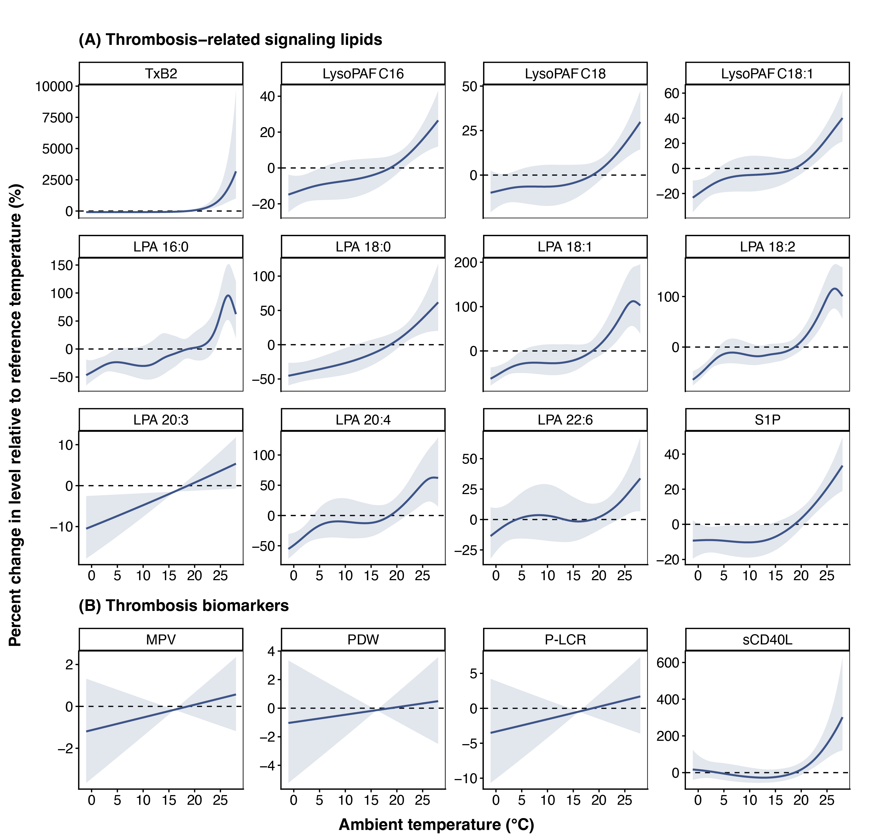
Figure S8 Thirty-day cumulative ambient temperature exposure-response curves for thrombosis-related signaling lipids and thrombosis biomarkers (further adjusted for additional covariates). The estimates were from generalized additive mixed models adjusting for season, day of week, age, sex, body mass index, education, income, smoke, 30-day cumulative exposure to ambient relative humidity, cumulative exposure to ambient fine particulate matter (moving-average windows chosen by AIC), chronic obstructive pulmonary disease (COPD) status, lipid-lowering medication intake, and anticoagulant medication intake within the two weeks prior to the visit, alcohol consumption within 24 hours prior to the visit, and random intercepts at participant levels. 18.7°C, the median of 30-day cumulative ambient temperature exposure levels among visits, was used as a reference for predictions. Abbreviations: TxB2, thromboxane B2; LysoPAF, lyso-platelet-activating factor; LPA, lysophosphatidic acid; S1P, sphingosine-1-phosphate; MPV, mean platelet volume; PDW, Platelet distribution width; P-LCR, platelet larger cell ratio; sCD40L, soluble CD40 ligand.
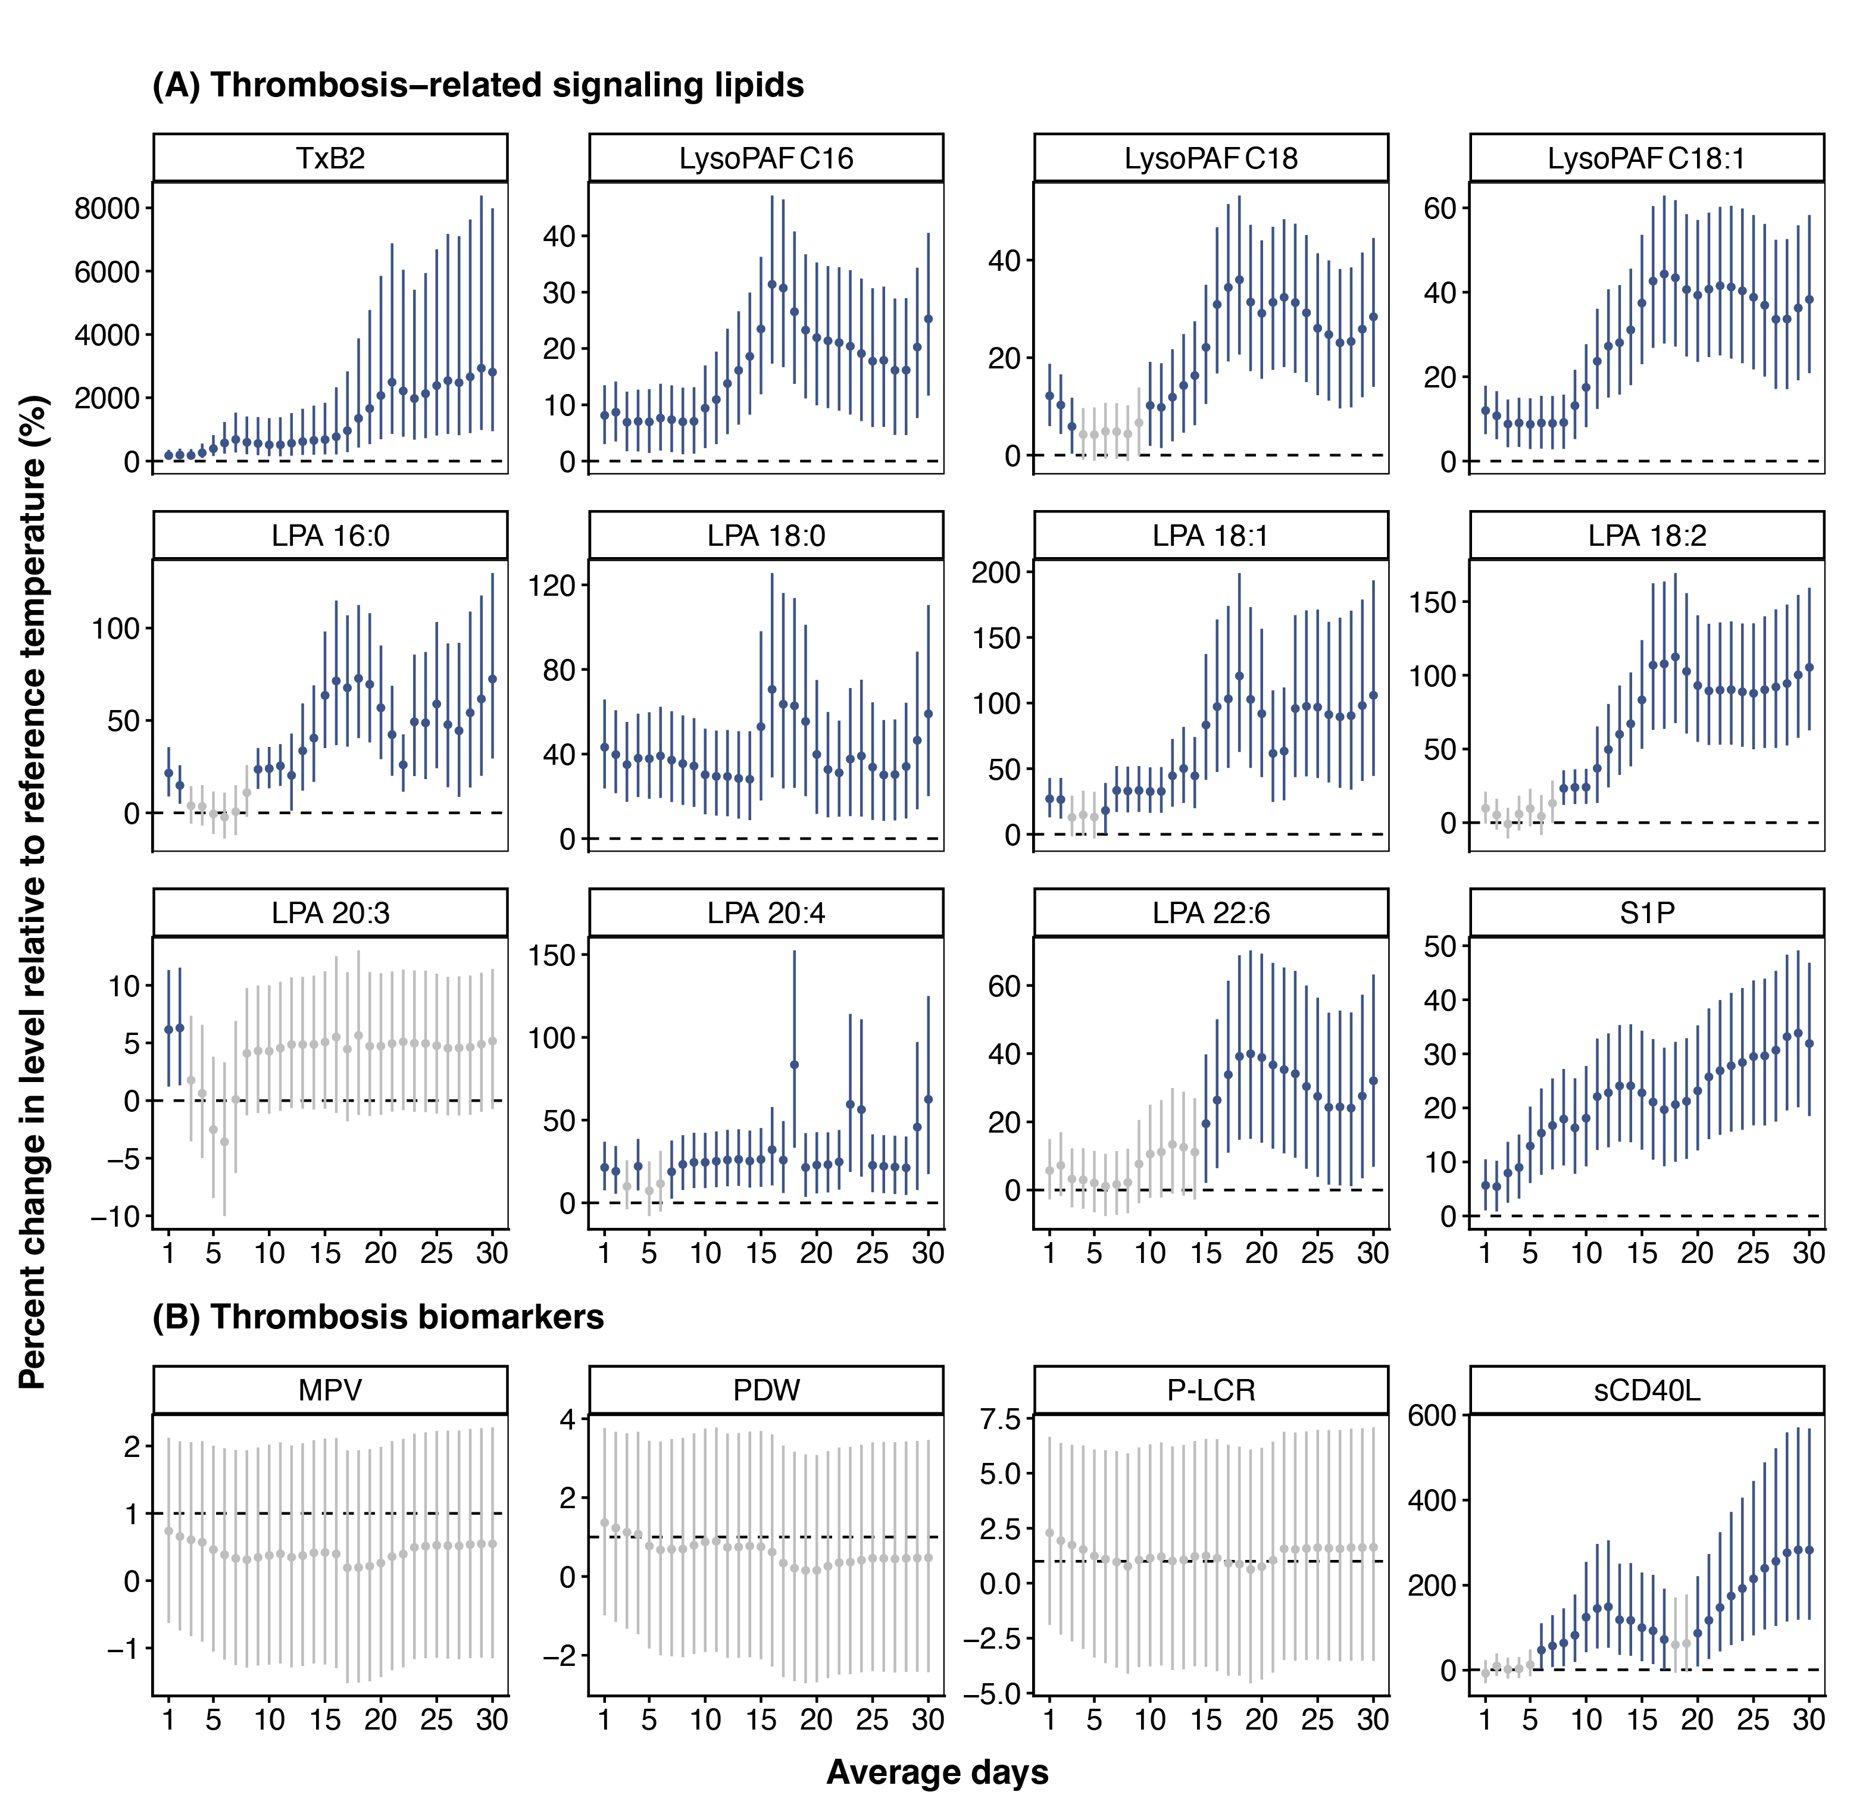
Figure S9 Lag patterns of associations between thrombosis-related signaling lipids and thrombosis biomarkers with heat exposure over cumulative 1–30 days (further adjusted for additional covariates). The estimates were from generalized additive mixed models adjusting for season, day of week, age, sex, body mass index, education, income, smoke, ambient relative humidity, cumulative exposure to ambient fine particulate matter (moving-average windows chosen by AIC), chronic obstructive pulmonary disease (COPD) status, lipid-lowering medication intake, and anticoagulant medication intake within the two weeks prior to the visit, alcohol consumption within 24 hours prior to the visit, and random intercepts at participant levels. 18.7°C, the median of 30-day cumulative ambient temperature exposure levels among visits, was used as a reference for predictions. Heat was defined as 27.7℃, corresponding to the 95th percentile. Abbreviations: TxB2, thromboxane B2; LysoPAF, lyso-platelet-activating factor; LPA, lysophosphatidic acid; S1P, sphingosine-1-phosphate; MPV, mean platelet volume; P-LCR, platelet larger cell ratio; PDW, Platelet distribution width; sCD40L, soluble CD40 ligand.

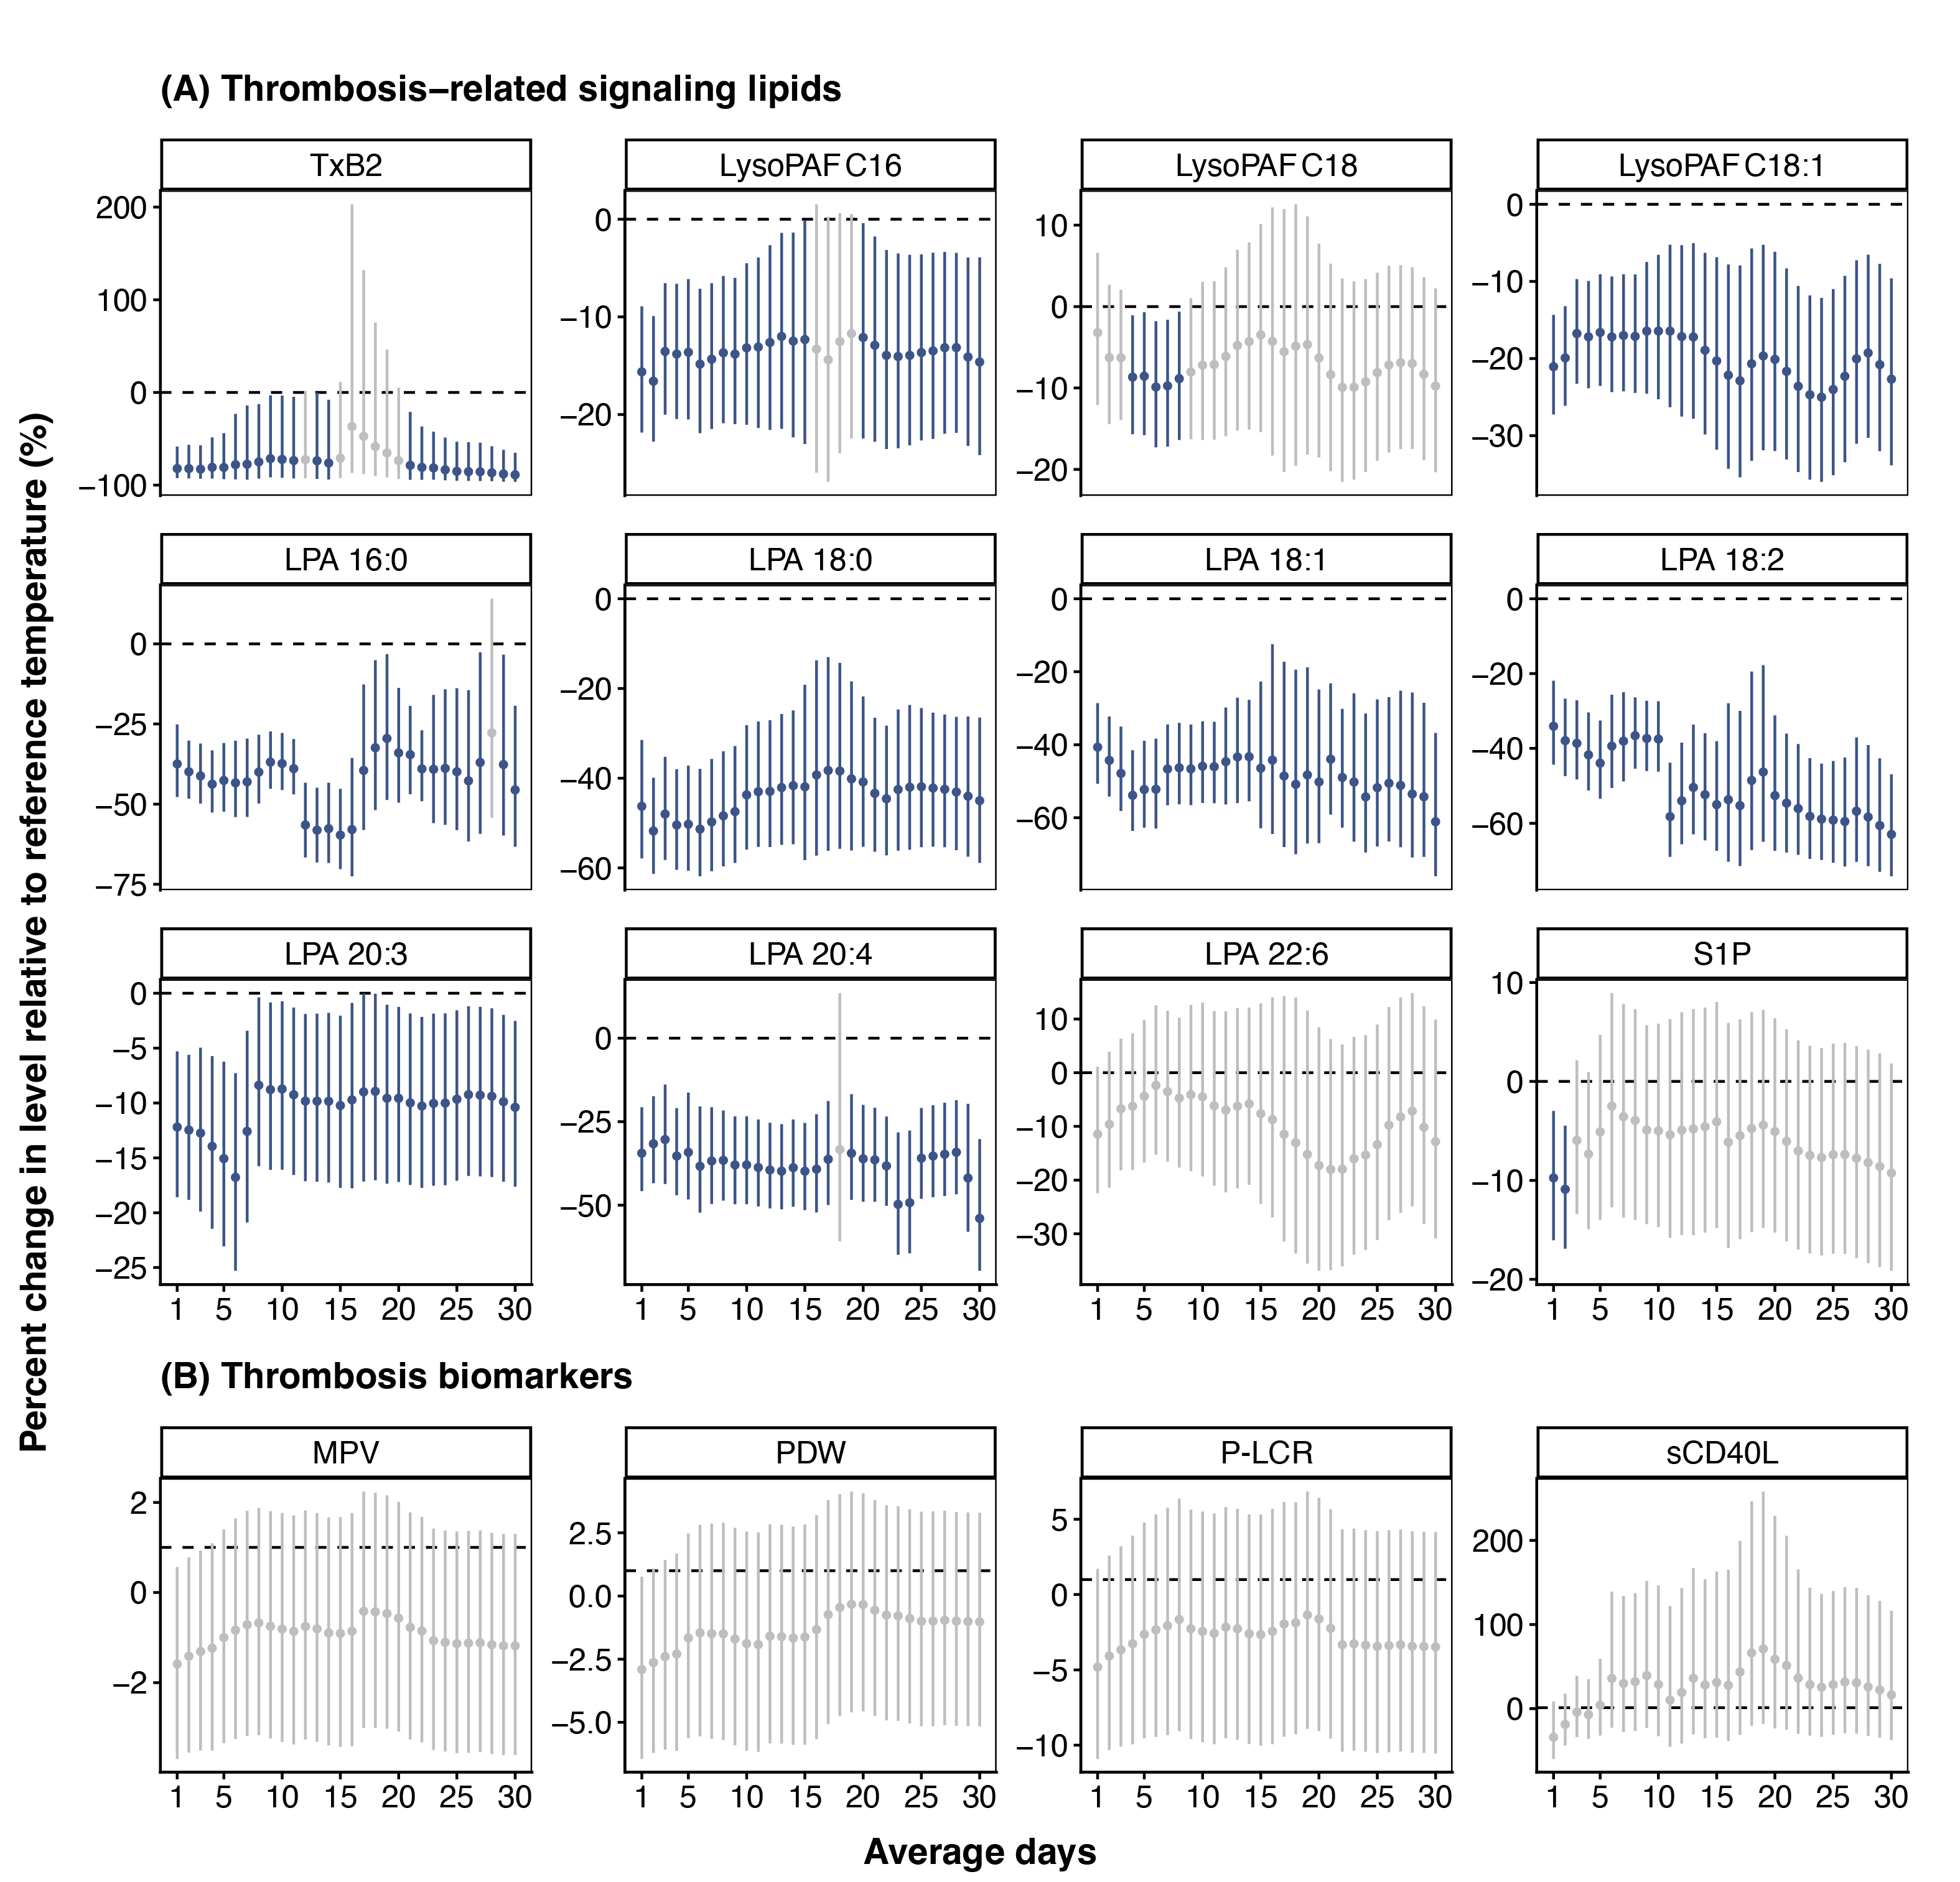
Figure S10 Lag patterns of associations between thrombosis-related signaling lipids and thrombosis biomarkers with cold exposure over cumulative 1–30 days (further adjusted for additional covariates). The estimates were from generalized additive mixed models adjusting for season, day of week, age, sex, body mass index, education, income, smoke, ambient relative humidity, cumulative exposure to ambient fine particulate matter (moving-average windows chosen by AIC), chronic obstructive pulmonary disease (COPD) status, lipid-lowering medication intake, and anticoagulant medication intake within the two weeks prior to the visit, alcohol consumption within 24 hours prior to the visit, and random intercepts at participant levels. 18.7°C, the median of 30-day cumulative ambient temperature exposure levels among visits, was used as a reference for predictions. Cold was defined as -0.8°C, corresponding to the 5th percentile. Abbreviations: TxB2, thromboxane B2; LysoPAF, lyso-platelet-activating factor; LPA, lysophosphatidic acid; S1P, sphingosine-1-phosphate; MPV, mean platelet volume; P-LCR, platelet larger cell ratio; PDW, Platelet distribution width; sCD40L, soluble CD40 ligand.
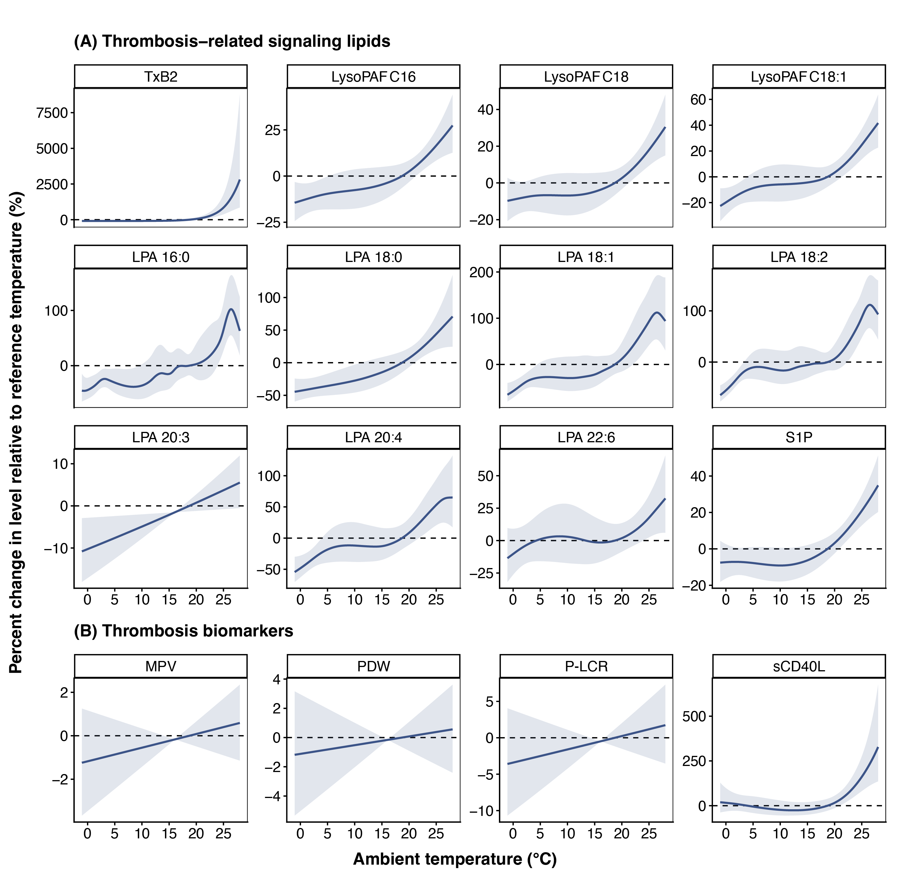
Figure S11 Thirty-day cumulative ambient temperature exposure-response curves for thrombosis-related signaling lipids and thrombosis biomarkers (increased spline complexity). The estimates were from generalized additive mixed models adjusting for season, day of week, age, sex, body mass index, education, income, smoke, 30-day cumulative exposure to ambient relative humidity, cumulative exposure to ambient fine particulate matter (moving-average windows chosen by AIC), and random intercepts at participant levels. The thin-plate splines were specified with an increased basis dimension of 20, allowing greater flexibility in modeling the smooth curve. 18.7°C, the median of 30-day cumulative ambient temperature exposure levels among visits, was used as a reference for predictions. Abbreviations: TxB2, thromboxane B2; LysoPAF, lyso-platelet-activating factor; LPA, lysophosphatidic acid; S1P, sphingosine-1-phosphate; MPV, mean platelet volume; PDW, Platelet distribution width; P-LCR, platelet larger cell ratio; sCD40L, soluble CD40 ligand.
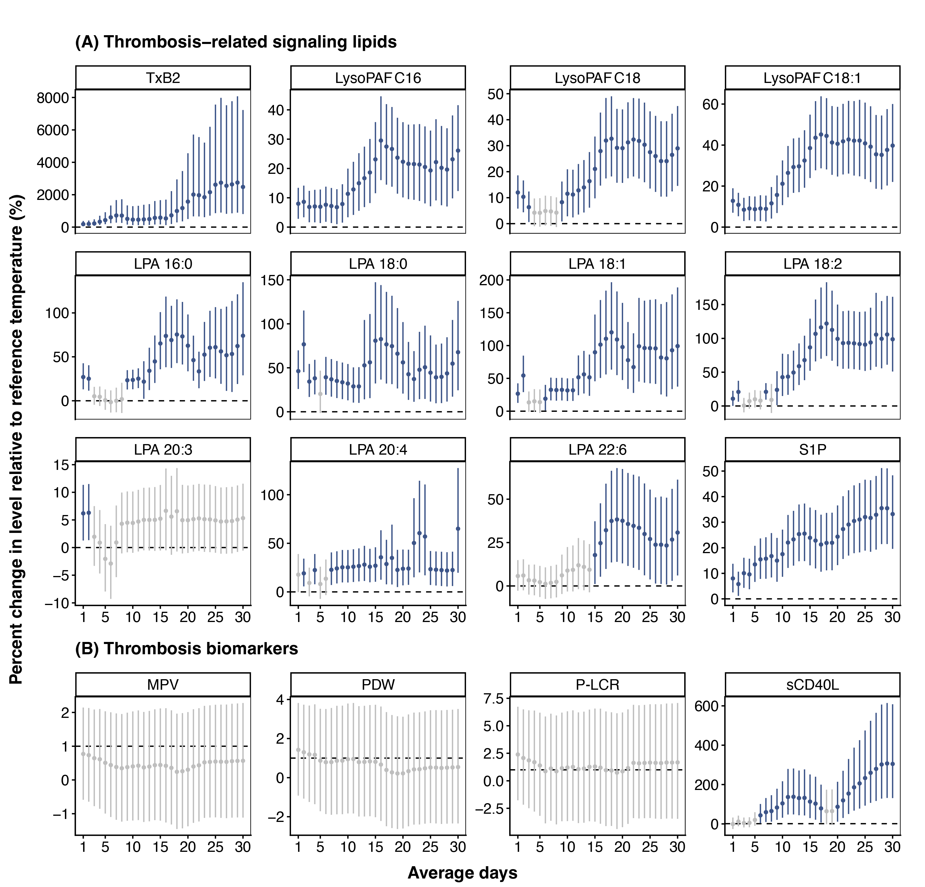
Figure S12 Lag patterns of associations between thrombosis-related signaling lipids and thrombosis biomarkers with heat exposure over cumulative 1–30 days (increased spline complexity). The estimates were from generalized additive mixed models adjusting for season, day of week, age, sex, body mass index, education, income, smoke, ambient relative humidity, cumulative exposure to ambient fine particulate matter (moving-average windows chosen by AIC), and random intercepts at participant levels. The thin-plate splines were specified with an increased basis dimension of 20, allowing greater flexibility in modeling the smooth curve. 18.7°C, the median of 30-day cumulative ambient temperature exposure levels among visits, was used as a reference for predictions. Heat was defined as 27.7℃, corresponding to the 95th percentile. Abbreviations: TxB2, thromboxane B2; LysoPAF, lyso-platelet-activating factor; LPA, lysophosphatidic acid; S1P, sphingosine-1-phosphate; MPV, mean platelet volume; P-LCR, platelet larger cell ratio; PDW, Platelet distribution width; sCD40L, soluble CD40 ligand.

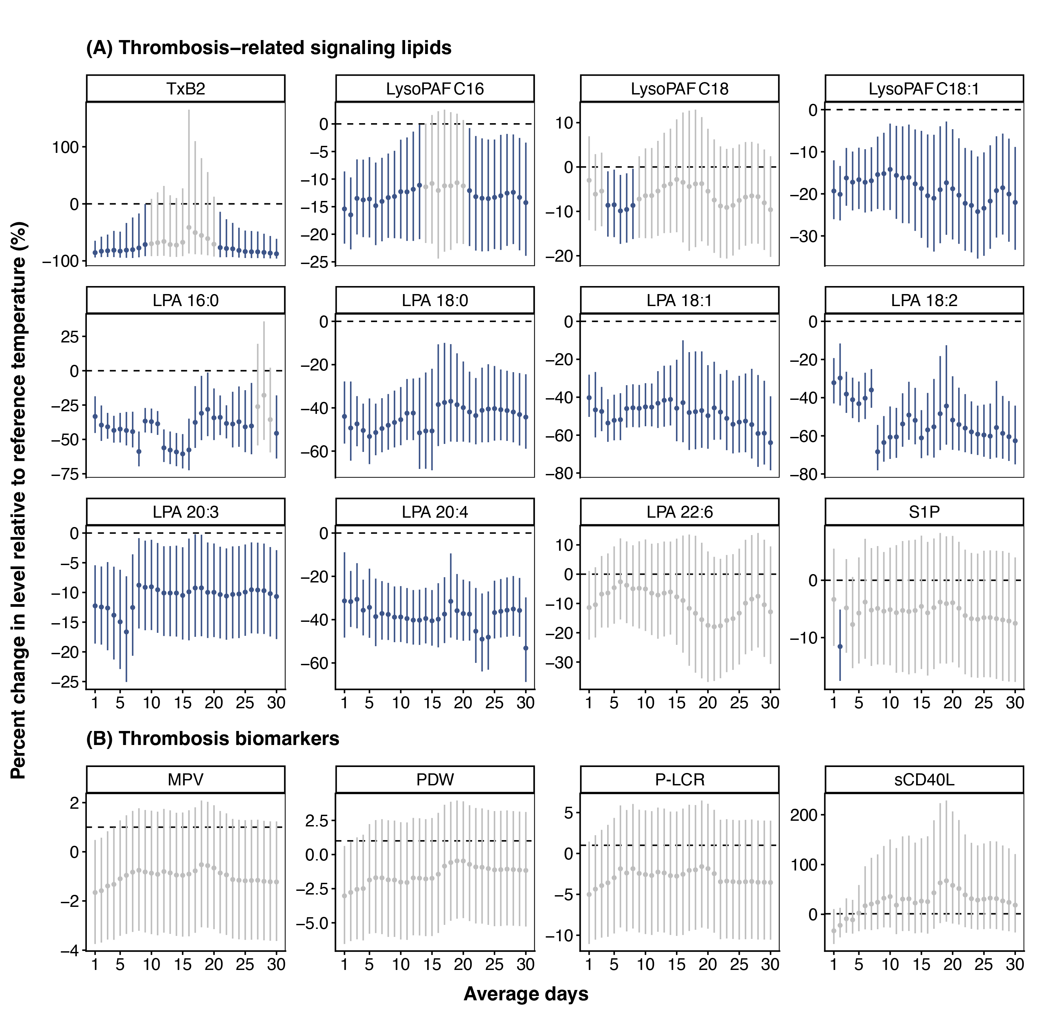
Figure S13 Lag patterns of associations between thrombosis-related signaling lipids and thrombosis biomarkers with cold exposure over cumulative 1–30 days (increased spline complexity). The estimates were from generalized additive mixed models adjusting for season, day of week, age, sex, body mass index, education, income, smoke, ambient relative humidity, cumulative exposure to ambient fine particulate matter (moving-average windows chosen by AIC), and random intercepts at participant levels. The thin-plate splines were specified with an increased basis dimension of 20, allowing greater flexibility in modeling the smooth curve. 18.7°C, the median of 30-day cumulative ambient temperature exposure levels among visits, was used as a reference for predictions. Cold was defined as -0.8°C, corresponding to the 5th percentile. Abbreviations: TxB2, thromboxane B2; LysoPAF, lyso-platelet-activating factor; LPA, lysophosphatidic acid; S1P, sphingosine-1-phosphate; MPV, mean platelet volume; P-LCR, platelet larger cell ratio; PDW, Platelet distribution width; sCD40L, soluble CD40 ligand.
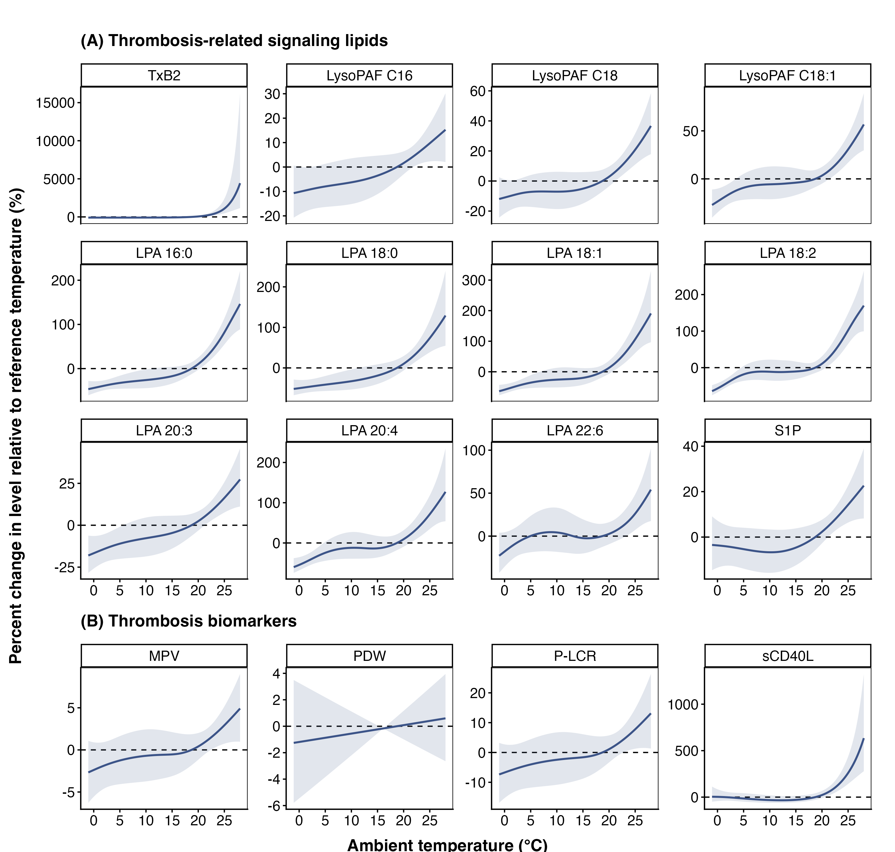
Figure S14 Thirty-day cumulative ambient temperature exposure-response curves for thrombosis-related signaling lipids and thrombosis biomarkers (further adjusted for ozone). The estimates were from generalized additive mixed models adjusting for season, day of week, age, sex, body mass index, education, income, smoke, 30-day cumulative exposure to ambient relative humidity, cumulative exposure to ambient fine particulate matter and ozone (moving-average windows chosen independently by AIC using a two-step procedure), and random intercepts at participant levels. 18.7°C, the median of 30-day cumulative ambient temperature exposure levels among visits, was used as a reference for predictions. Abbreviations: TxB2, thromboxane B2; LysoPAF, lyso-platelet-activating factor; LPA, lysophosphatidic acid; S1P, sphingosine-1-phosphate; MPV, mean platelet volume; PDW, Platelet distribution width; P-LCR, platelet larger cell ratio; sCD40L, soluble CD40 ligand.
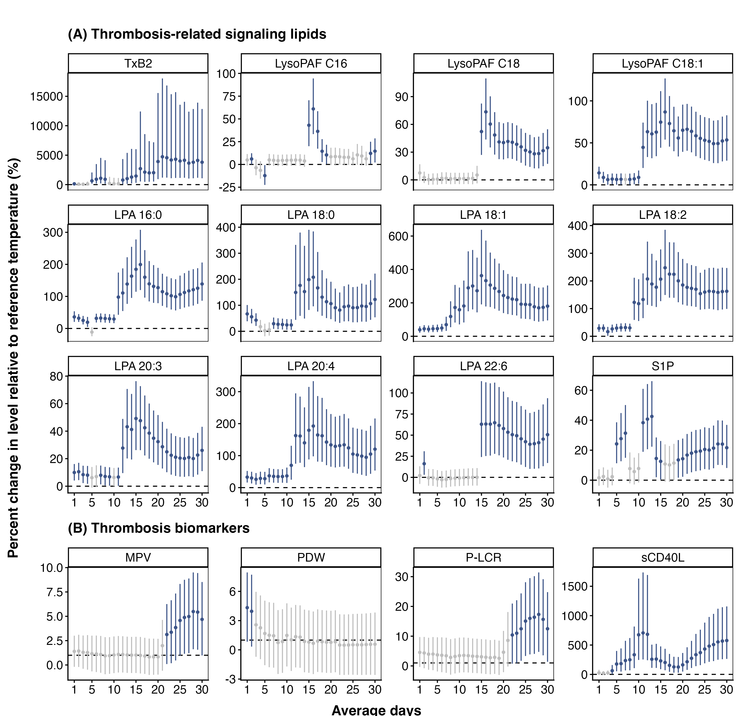
Figure S15 Lag patterns of associations between thrombosis-related signaling lipids and thrombosis biomarkers with heat exposure over cumulative 1–30 days (further adjusted for ozone). The estimates were from generalized additive mixed models adjusting for season, day of week, age, sex, body mass index, education, income, smoke, 30-day cumulative exposure to ambient relative humidity, cumulative exposure to ambient fine particulate matter and ozone (moving-average windows chosen independently by AIC using a two-step procedure), and random intercepts at participant levels. 18.7°C, the median of 30-day cumulative ambient temperature exposure levels among visits, was used as a reference for predictions. Heat was defined as 27.7℃, corresponding to the 95th percentile. Abbreviations: TxB2, thromboxane B2; LysoPAF, lyso-platelet-activating factor; LPA, lysophosphatidic acid; S1P, sphingosine-1-phosphate; MPV, mean platelet volume; P-LCR, platelet larger cell ratio; PDW, Platelet distribution width; sCD40L, soluble CD40 ligand.
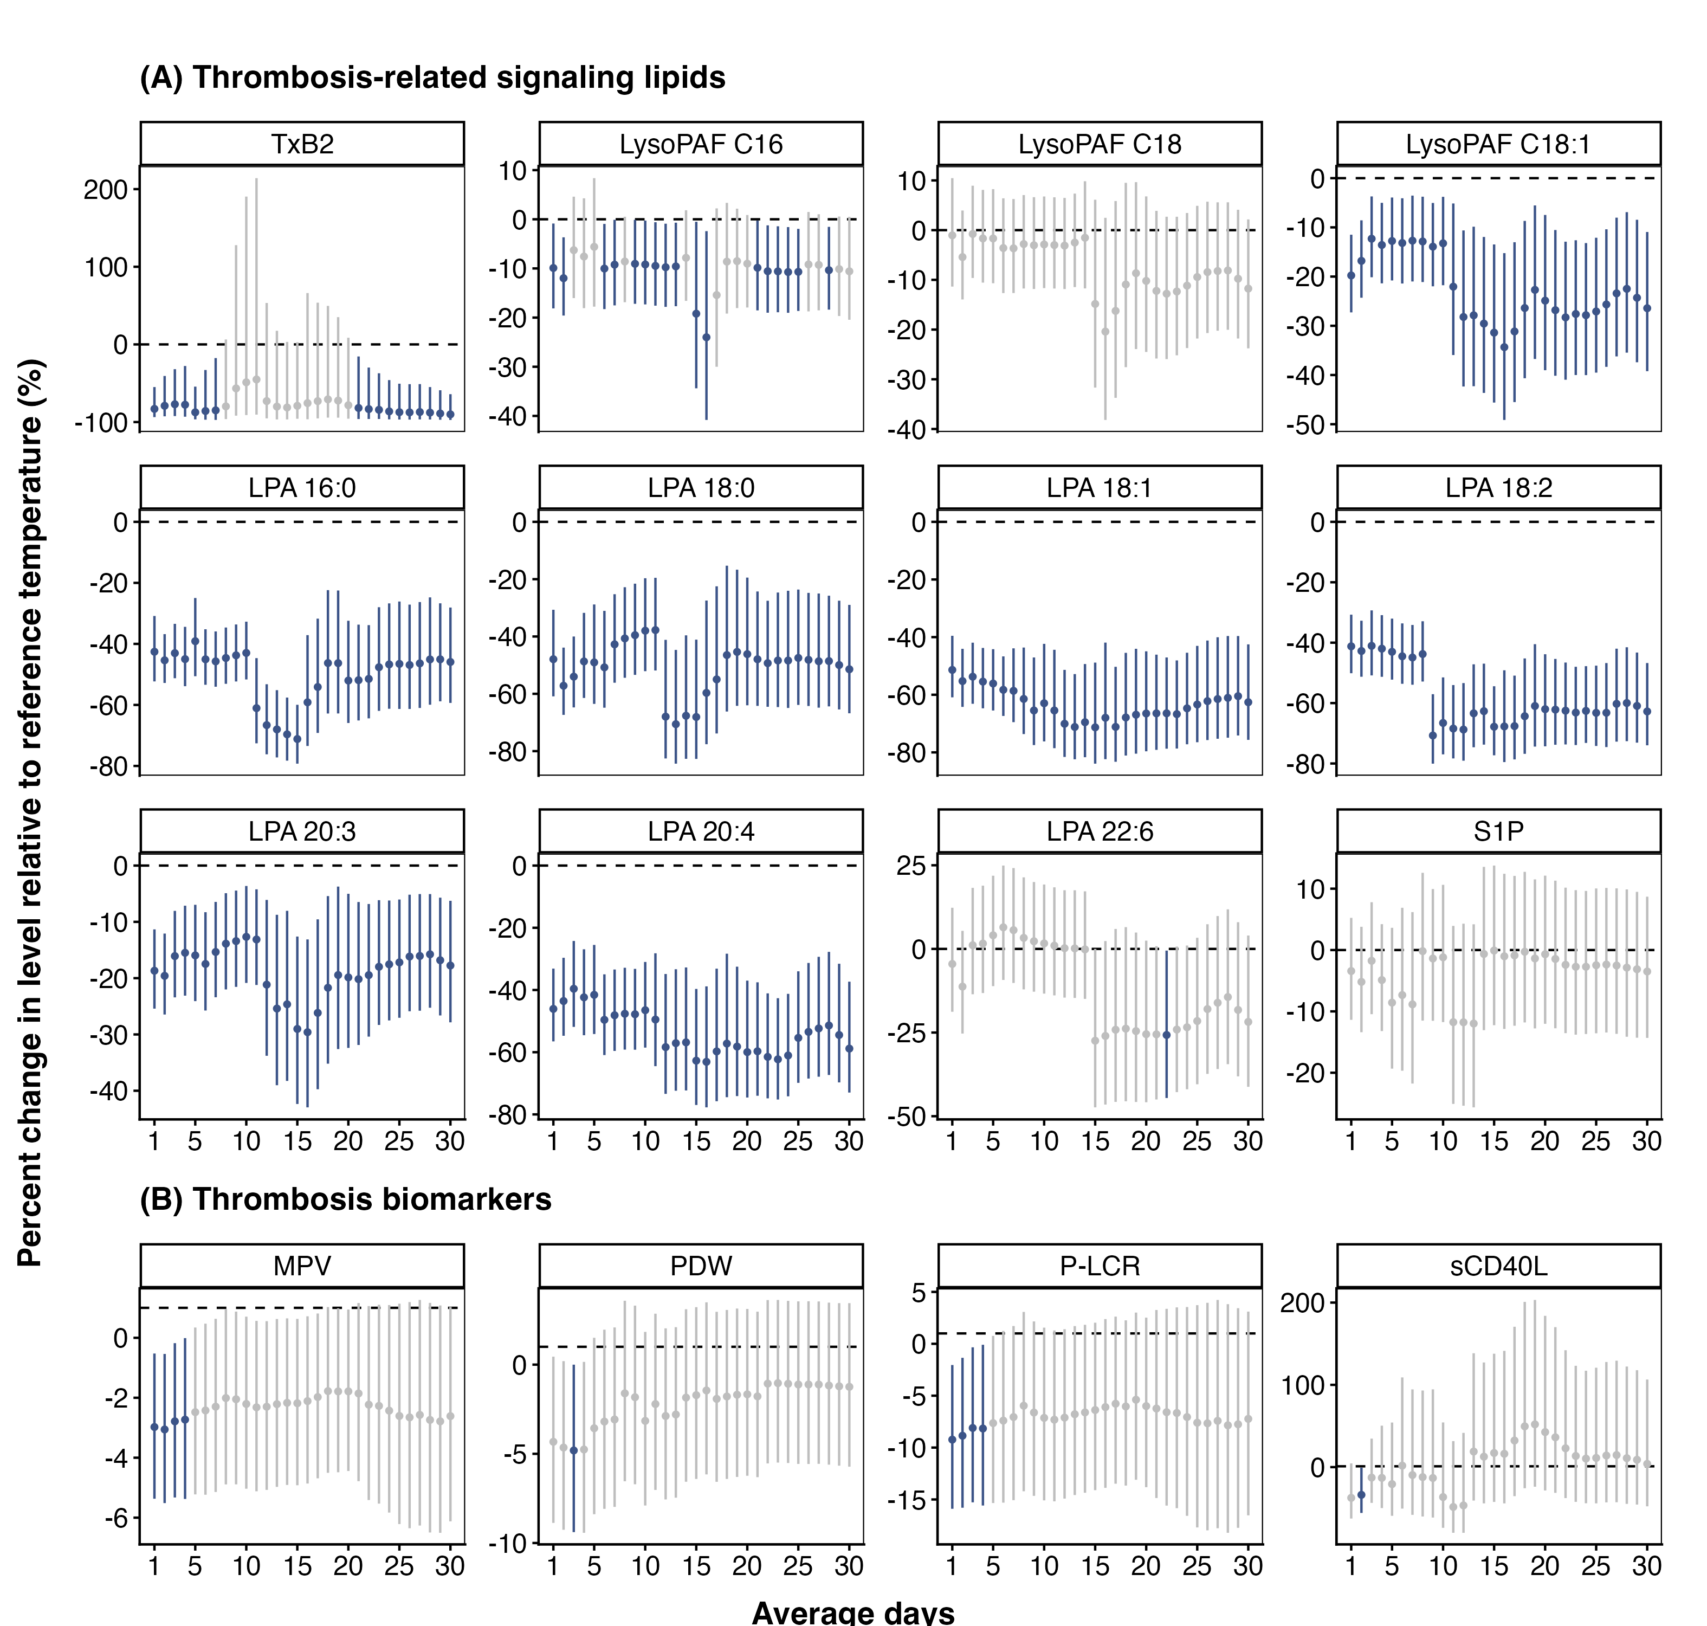
Figure S16 Lag patterns of associations between thrombosis-related signaling lipids and thrombosis biomarkers with cold exposure over cumulative 1–30 days (further adjusted for ozone). The estimates were from generalized additive mixed models adjusting for season, day of week, age, sex, body mass index, education, income, smoke, 30-day cumulative exposure to ambient relative humidity, cumulative exposure to ambient fine particulate matter and ozone (moving-average windows chosen independently by AIC using a two-step procedure), and random intercepts at participant levels. 18.7°C, the median of 30-day cumulative ambient temperature exposure levels among visits, was used as a reference for predictions. Cold was defined as -0.8°C, corresponding to the 5th percentile. Abbreviations: TxB2, thromboxane B2; LysoPAF, lyso-platelet-activating factor; LPA, lysophosphatidic acid; S1P, sphingosine-1-phosphate; MPV, mean platelet volume; P-LCR, platelet larger cell ratio; PDW, Platelet distribution width; sCD40L, soluble CD40 ligand.
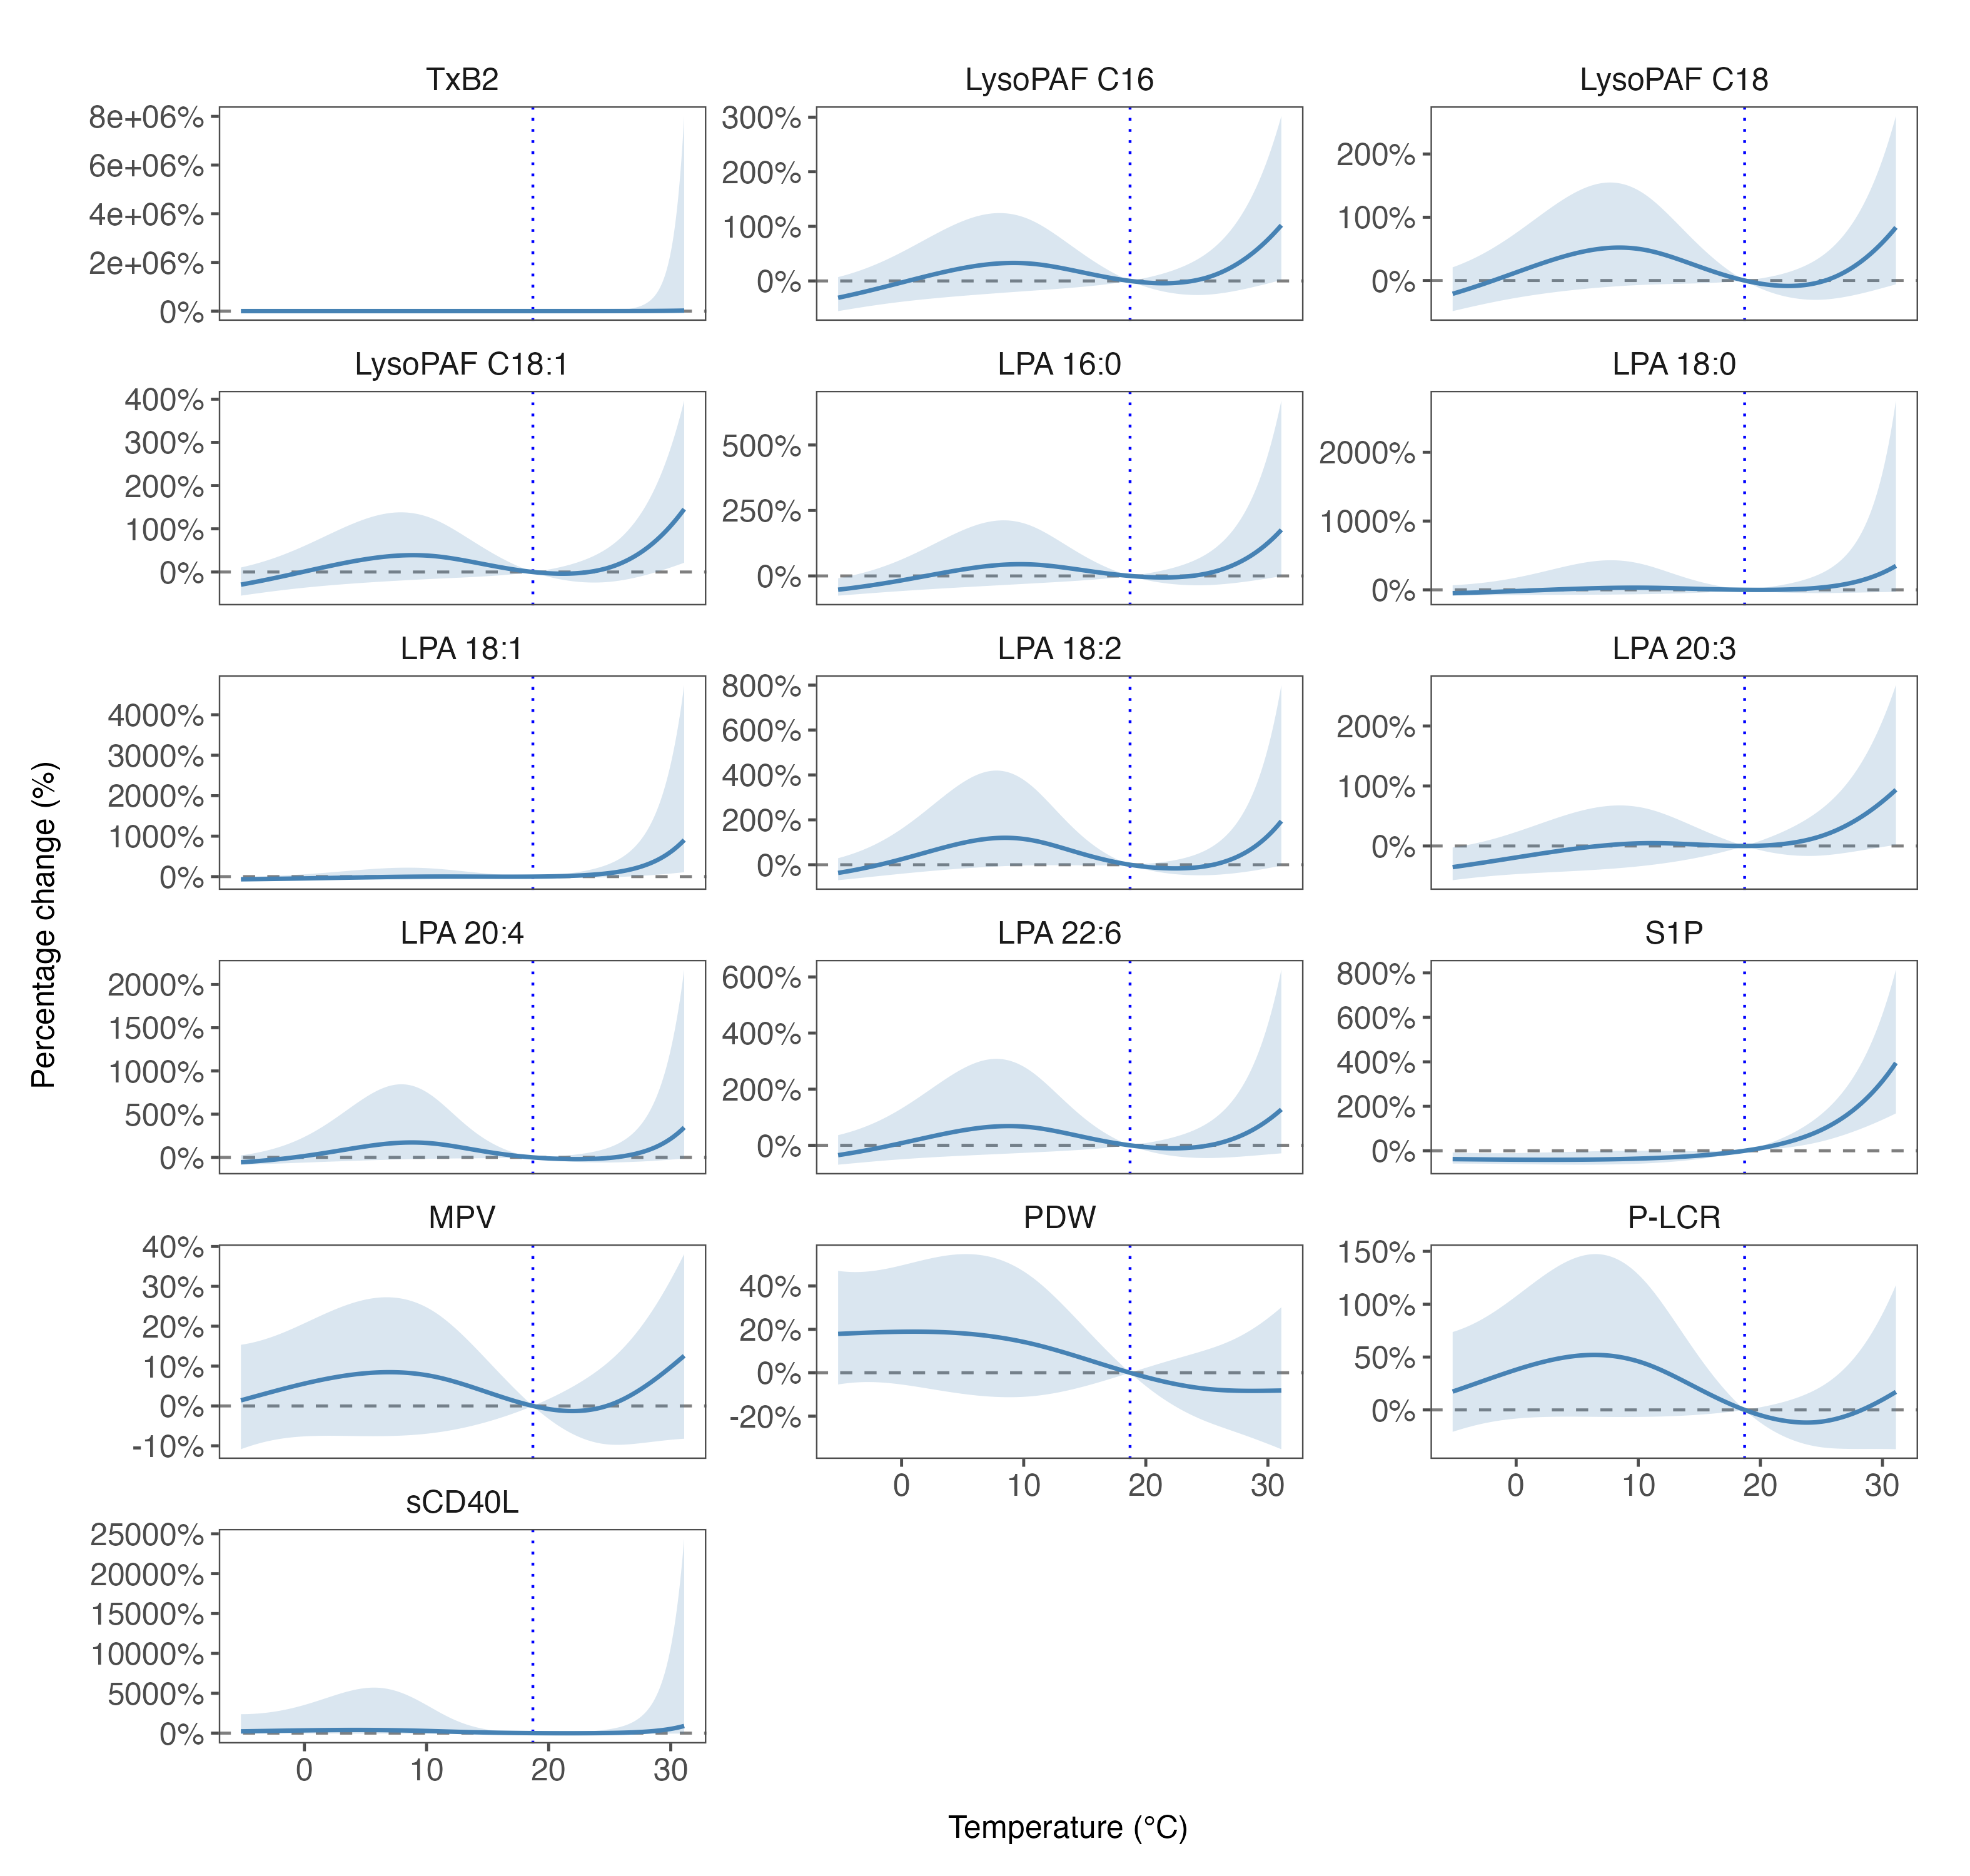
Figure S17 Thirty-day cumulative ambient temperature exposure-response curves for thrombosis-related signaling lipids and thrombosis biomarkers, estimated using distributed lag non-linear models (DLNMs). 18.7°C, the median of 30-day cumulative ambient temperature exposure levels among visits, was used as a reference for predictions. Abbreviations: AIC, Akaike Information Criterion; TxB2, thromboxane B2; LysoPAF, lyso-platelet-activating factor; LPA, lysophosphatidic acid; S1P, sphingosine-1-phosphate; MPV, mean platelet volume; PDW, Platelet distribution width; P-LCR, platelet larger cell ratio; sCD40L, soluble CD40 ligand.
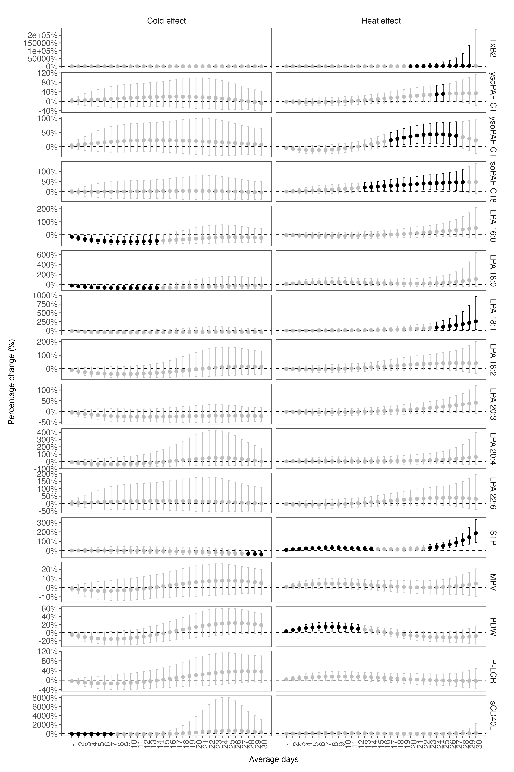
Figure S18 Lag patterns of associations between thrombosis-related signaling lipids and thrombosis biomarkers with cold and heat exposure (cold and heat effects) over cumulative 1–30 days, estimated using distributed lag non-linear models (DLNMs). 18.7°C, the median of 30-day cumulative ambient temperature exposure levels among visits, was used as a reference for predictions. Cold was defined as -0.8°C, corresponding to the 5th percentile. Heat was defined as 27.7℃, corresponding to the 95th percentile. Abbreviations: TxB2, thromboxane B2; LysoPAF, lyso-platelet-activating factor; LPA, lysophosphatidic acid; S1P, sphingosine-1-phosphate; MPV, mean platelet volume; P-LCR, platelet larger cell ratio; PDW, Platelet distribution width; sCD40L, soluble CD40 ligand.
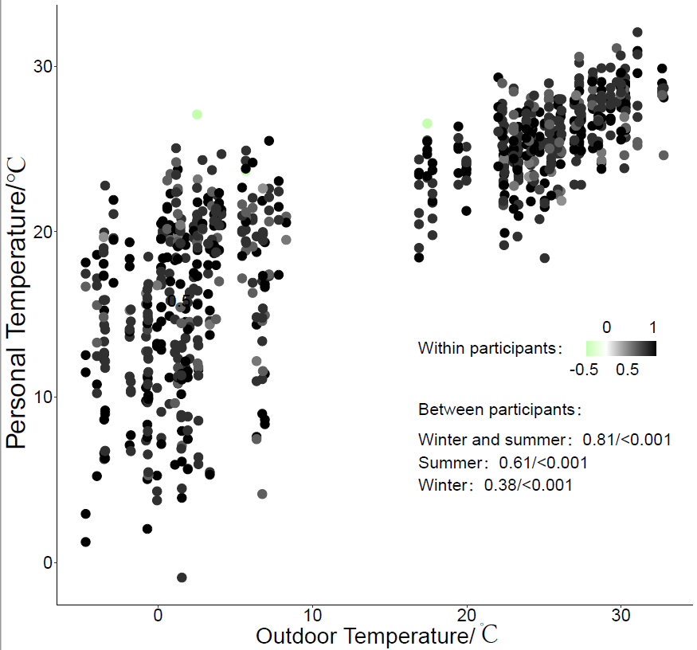

Figure S19 The correlation of outdoor and personal temperature exposure 1 day before the visits in another panel study in Beijing conducted in the similar period of the study. The data was from the AIRLESS study in Beijing launched in November and December of 2016 and May and June of 2017. Only the 780 temperature exposure data of the participants who attended more than 2 visits were included in the analysis. Pearson correlation analysis of outdoor and personal temperature in all visits of all participants was conducted in summer, winter, and both seasons, and the correlation coefficients and p-values were presented in the Figure. The color of the points denoted the spearman correlation coefficients of the outdoor and personal temperature exposure in different visits of each participant.
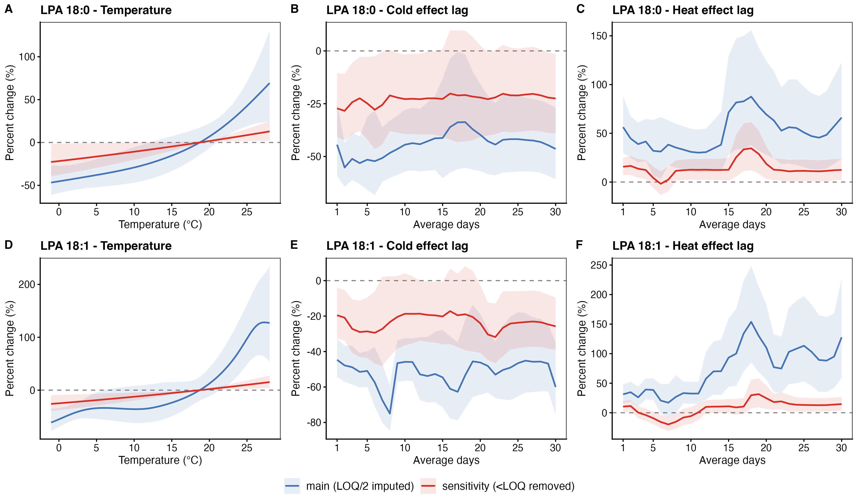
Figure S20 Sensitivity analysis comparing primary and <LOQ-excluded analyses for LPA 18:0 and LPA 18:1. Abbreviations: LOQ, limit of quantification; LPA, lysophosphatidic acid.
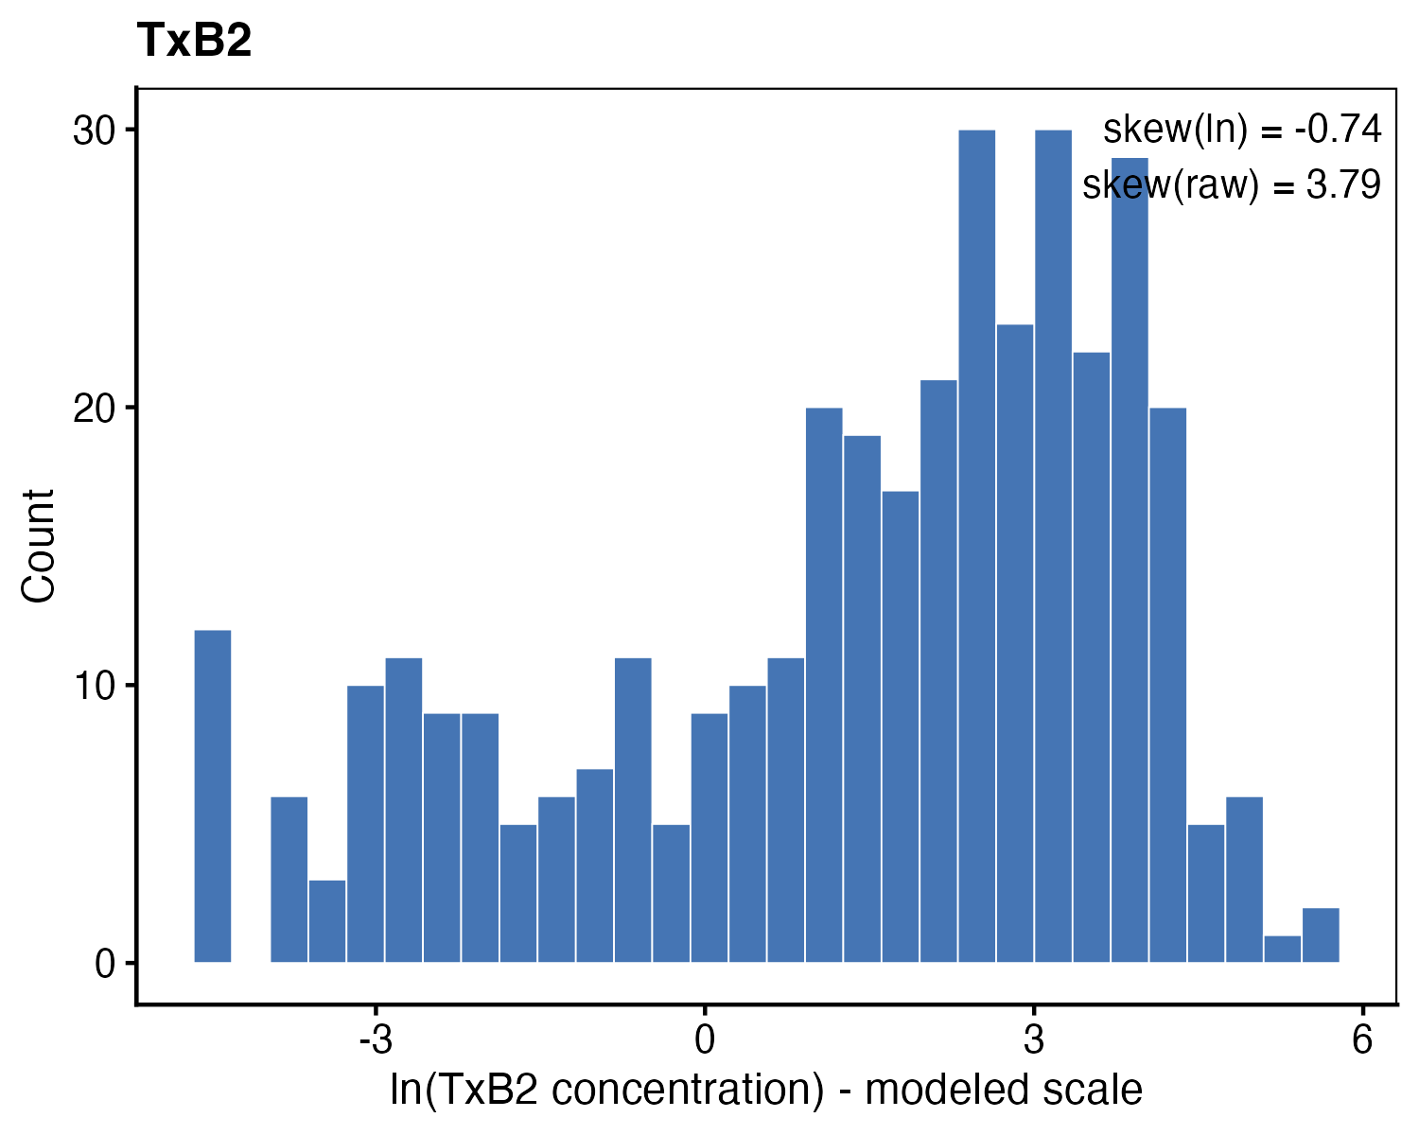
Figure S21 Distribution of natural log-transformed TxB2 concentrations (modelling scale). Histogram of ln(TxB2) with the corresponding skewness statistic (−0.74). Abbreviations: TxB2, thromboxane B2; ln, natural log-transformed.

Supplemental Tables
Table S1 Baseline characteristics of participants included in and excluded from the analysis ª
Characteristic, Unit ^{b} |  | Included (>=2 visits) | Excluded (1 visit) | P-value ^{c}
Total number of participants |  | 112 | 23
Age, year |  | 61 ± 8 | 59 ± 9 | 0.393
Sex | Male | 48 (43) | 8 (35) | 0.629
Sex | Female | 64 (57) | 15 (65)
BMI, kg/m² |  | 24.6 ± 3.3 | 25.5 ± 3.5 | 0.261
Education level | Illiteracy | 1 (1) | 0 (0) | 0.996
Education level | Primary school | 5 (4) | 1 (4)
Education level | Junior high school | 40 (36) | 9 (39)
Education level | High school or technical school | 37 (33) | 8 (35)
Education level | College | 15 (13) | 3 (13)
Education level | University | 13 (12) | 2 (9)
Education level | NA | 1 (1) | 0 (0)
Monthly salary | <2,000 CNY | 9 (8) | 3 (13) | 0.891
Monthly salary | 2,000 – 5,000 CNY | 84 (75) | 16 (70)
Monthly salary | 5,000 – 8,000 CNY | 12 (11) | 3 (13)
Monthly salary | ≥8,000 CNY | 5 (4) | 1 (4)
Monthly salary | NA | 2 (2) | 0 (0)
Smoking | Nonsmoker | 74 (66) | 13 (57) | 0.618
Smoking | Former smoker | 18 (16) | 4 (17)
Smoking | Current smoker | 20 (18) | 6 (26)
ª Categorical variables are reported as count (percentage), and continuous variables are presented as mean ± standard deviation.
^{b} BMI was missing for 2 included and 1 excluded participant.
^{c} P-values for categorical variables were calculated using the chi-square test (or Fisher’s exact test when cell counts were small). P-values for continuous variables were calculated using one-way Analysis of Variance (ANOVA).
Abbreviations: BMI, body mass index; NA, not available; CNY, Chinese Yuan.
Table S2 Calibration curves, recoveries, precisions, and detection rates of thrombosis-related signaling lipids
Subclass | Analyte ª | ISTD | LLOQ (pg) | ULOQ (pg) | R² | Accuracy (%) ^{b} | Precision (%) ^{c} | Detection rate (%)
Tx | TxB2 | PGE2-d4 | 0.45 | 900 | 0.998 | 87–94 | 7–8 | 97
LysoPAF | LysoPAF C16 | LysoPAF C16-d4 | 42.19 | 54000 | 0.999 | 93–95 | 3–15 | 100
 | LysoPAF C18 | LysoPAF C18-d4 | 33.75 | 10800 | 0.999 | 73–88 | 3–12 | 100
 | LysoPAF C18:1 | LysoPAF C18-d4 | 14.06 | 18000 | 0.999 | 77–90 | 3–14 | 100
LPA | LPA 16:0 | LPA 17:0 | 14.06 | 9000 | 0.998 | 109–113 | 6–12 | 99
 | LPA 18:0 | LPA 17:0 | 2.81 | 1800 | 0.997 | 107–109 | 5–24 | 59
 | LPA 18:1 | LPA 17:0 | 11.25 | 3600 | 0.996 | 100–117 | 4–21 | 82
 | LPA 18:2 | LPA 17:0 | 140.63 | 18000 | 0.998 | 99–102 | 7–18 | 97
 | LPA 20:3 | LPA 17:0
 | LPA 20:4 | LPA 17:0 | 56.25 | 18000 | 0.998 | 94–97 | 3–10 | 93
 | LPA 22:6 | LPA 17:0
S1P | S1P | S1P (d17:1) | 13.5 | 2700 | 0.999 | 87–108 | 4–6 | 100
ª For analytes without external standards (i.e., LPA 20:3, and LPA 22:6), only the corresponding ISTDs were shown.
^{b} Determined in quality controls spiked with low, middle, and high concentrations of external standards, and shown as ranges across the three levels.
^{c} denoted the coefficient of variation of the calculated concentrations across multiple quality controls.
Abbreviations: ISTD, internal standard; LLOQ, lower limit of quantification; ULOQ, upper limit of quantification; R², goodness of fit; Tx, thromboxane; LysoPAF, lysoalkylphosphatidylcholine; LPA, lysophosphatidic acid; S1P, sphingosine-1-phosphate; PG, prostaglandin.
Table S3 Model comparison across PM_{2.5} moving-average windows based on AIC values for the associations between 30-day cumulative ambient temperature exposure and health outcomes
Health outcome | PM_{2.5} MA window with minimum AIC value | △AIC ª
TxB2 | 14 | 5.0
LysoPAF C16 | 1 | 1.6
LysoPAF C18 | 12 | 2.4
LysoPAF C18:1 | 14 | 1.6
LPA 16:0 | 1 | 6.1
LPA 18:0 | 2 | 2.8
LPA 18:1 | 14 | 7.9
LPA 18:2 | 10 | 3.3
LPA 20:3 | 14 | 2.5
LPA 20:4 | 14 | 8.2
LPA 22:6 | 14 | 1.7
S1P | 1 | 3.7
MPV | 14 | 1.1
PDW | 14 | 1.2
P-LCR | 14 | 1.2
sCD40L | 6 | 5.9
ª △AIC represents the difference between the maximum and minimum AIC values across all PM_{2.5} moving-average windows.
Abbreviations: PM_{2.5}, fine particulate matter; AIC, Akaike Information Criterion; MA, moving average; TxB2, thromboxane B2; LysoPAF, lyso-platelet-activating factor; LPA, lysophosphatidic acid; S1P, sphingosine-1-phosphate; MPV, mean platelet volume; PDW, Platelet distribution width; P-LCR, platelet larger cell ratio; sCD40L, soluble CD40 ligand.
Table S4 Supplementary summary of participant characteristics
Characteristic |  | N (%) ª
COPD status | Non-COPD | 66 (59)
 | COPD | 46 (41)
Lipid-lowering medication intake | No | 227 (59)
 | Yes | 160 (41)
Anticoagulant medication intake | No | 272 (70)
 | Yes | 115 (29.7)
Alcohol consumption | No | 330 (85)
 | Yes | 57 (15)
ª Values are reported as counts (percentages) based on 112 participants for COPD status and on 387 visits for all other characteristics.
Abbreviations: COPD, chronic obstructive pulmonary disease.
Table S5 Levels of ambient meteorological parameters and fine particulate matter during 1, 7, 14, and 30 days prior to visits ª
Exposure, Unit | Time window | All visits | Visit 1 | Visit 2 | Visit 3 | Visit 4
Temperature, ℃ | 1-day average | 16.7 ± 10.1 | 25.1 ± 4.6 | 2.8 ± 4.0 | 17.9 ± 3.0 | 24.4 ± 2.7
 | 7-day average | 16.5 ± 10.3 | 25.9 ± 3.1 | 1.7 ± 2.7 | 17.4 ± 2.3 | 24.9 ± 1.1
 | 14-day average | 16.1 ± 11.0 | 26.5 ± 2.2 | 0.8 ± 1.7 | 15.0 ± 2.6 | 26.0 ± 0.9
 | 30-day average | 16.6 ± 10.1 | 25.5 ± 3.6 | 2.3 ± 3.3 | 17.9 ± 2.4 | 24.6 ± 1.4
RH, % | 1-day average | 50.4 ± 20.7 | 62.1 ± 12.7 | 41.4 ± 21.0 | 32.7 ± 12.0 | 67.0 ± 11.5
 | 7-day average | 54.4 ± 16.2 | 64.1 ± 9.4 | 47 ± 13.2 | 37.3 ± 7.6 | 70.5 ± 5.1
 | 14-day average | 56.1 ± 14.7 | 66.9 ± 6.1 | 46.7 ± 12.1 | 41.6 ± 6.0 | 71.0 ± 1.3
 | 30-day average | 53.2 ± 17.0 | 63.0 ± 11.1 | 45.2 ± 15.5 | 37.3 ± 9.3 | 68.8 ± 6.8
PM_{2.5}, µg/m³ | 7-day average | 65.9 ± 48.1 | 53.5 ± 16.9 | 92.1 ± 78.8 | 53.2 ± 17.4 | 57.7 ± 17.2
ª shown as “mean ± standard deviation”.
Abbreviations: RH, relative humidity; PM_{2.5}, fine particulate matter.
Table S6 Absolute changes in thrombosis-related signaling lipid and thrombosis biomarkers associated with cold/heat exposure ª
Health outcome, Unit | Absolute concentration change (ng/mL)
Health outcome, Unit | Heat effect | Cold effect
TxB2, ng/mL | 256.6 (83.6, 748.3) | -9.1 (-9.9, -6.3)
LysoPAF C16, ng/mL | 73.1 (34.5, 116.4) | -39.9 (-66.9, -9.5)
LysoPAF C18, ng/mL | 19 (9.5, 29.6) | -6.3 (-13.3, 1.6)
LysoPAF C18:1, ng/mL | 35.5 (19.7, 53.6) | -19.7 (-29.8, -8)
LPA 16:0, ng/mL | 19.3 (8.4, 33.7) | -11.3 (-15.7, -4.7)
LPA 18:0, ng/mL | 1.1 (0.4, 2.1) | -0.7 (-1, -0.4)
LPA 18:1, ng/mL | 12.7 (4.9, 24) | -8 (-9.9, -4.9)
LPA 18:2, ng/mL | 112.2 (67.4, 168.9) | -63.6 (-75, -47.2)
LPA 20:3, ng/mL | 0.5 (-0.1, 1.2) | -1.1 (-1.8, -0.3)
LPA 20:4, ng/mL | 29.2 (8.9, 57.1) | -23.9 (-30.9, -13.3)
LPA 22:6, ng/mL | 4.5 (0.9, 8.9) | -1.9 (-4.5, 1.4)
S1P, ng/mL | 120.6 (71.2, 175.6) | -27.3 (-64.3, 14.4)
MPV, fL | 0.1 (-0.1, 0.2) | -0.1 (-0.4, 0.1)
PDW, fL | 0.1 (-0.3, 0.4) | -0.1 (-0.7, 0.4)
P-LCR, % | 0.4 (-0.8, 1.7) | -0.9 (-2.6, 1)
sCD40L, ng/mL | 18.6 (8, 37.1) | 1.1 (-2.2, 7.4)
ª Reference concentrations were the model-predicted geometric means at the median temperature (18.7 °C). Absolute changes and corresponding 95% confidence intervals at the heat (27.7 °C; 95th percentile) and cold (−0.8 °C; 5th percentile) temperatures were derived from the estimated percent changes.
Abbreviations: TxB2, thromboxane B2; LysoPAF, lyso-platelet-activating factor; LPA, lysophosphatidic acid; S1P, sphingosine-1-phosphate; MPV, mean platelet volume; PDW, Platelet distribution width; P-LCR, platelet larger cell ratio; sCD40L, soluble CD40 ligand.
Table S7 Individual and total mediation effects of thrombosis-related bioactive lipids on the heat exposure–soluble CD40 ligand association.
Mediator | Proportion mediated (95% CI)
LPA 18:0 | 12% (-60%, 121%)
LPA 18:1 | -5% (-90%, 71%)
LPA 20:4 | 7% (-50%, 73%)
LPA 22:6 | 16% (-38%, 58%)
S1P | 35% (-94%, 199%)
Total | 65% (-121%, 277%)
Abbreviations: LPA, lysophosphatidic acid; S1P, sphingosine-1-phosphate.

Table S8 The mediation effects of thrombosis-related bioactive lipids on the associations between heat exposure and soluble CD40 ligand (complete case analysis) ª
Mediator | Proportion mediated (95% CI) | P-value ^{b}
TxB2 | 6% (-2%, 21%) | 0.131
LysoPAF C16 | -5% (-25%, 4%) | 0.265
LysoPAF C18 | -9% (-36%, 1%) | 0.092
LysoPAF C18:1 | -5% (-28%, 10%) | 0.467
LPA 16:0 | 5% (-19%, 34%) | 0.607
LPA 18:0 | 12% (-4%, 37%) | 0.135
LPA 18:1 | 16% (-3%, 50%) | 0.102
LPA 18:2 | 9% (-12%, 38%) | 0.394
LPA 20:3 | 8% (-2%, 29%) | 0.118
LPA 20:4 | 13% (-4%, 44%) | 0.126
LPA 22:6 | 9% (-1%, 30%) | 0.087
S1P | 26% (9%, 54%) | 0.004
ª The results were estimated using mediation analysis based on linear mixed effect models in 184 visits with 30-day cumulative ambient temperatures exposure level above the median of 18.7°C.
^{b} P-values < 0.05 are highlighted in bold.
Abbreviations: TxB2, thromboxane B2; LysoPAF, lyso-platelet-activating factor; LPA, lysophosphatidic acid; S1P, sphingosine-1-phosphate.
Table S9 The mediation effects of thrombosis-related bioactive lipids on the associations between heat exposure and soluble CD40 ligand (further adjusted for additional covariates) ª
Mediator | Proportion mediated (95% CI) | P-value ^{b}
TxB2 | 27% (8%, 83%) | 0.004
LysoPAF C16 | -3% (-28%, 9%) | 0.507
LysoPAF C18 | -2% (-24%, 13%) | 0.692
LysoPAF C18:1 | 0% (-20%, 19%) | 0.968
LPA 16:0 | 13% (-5%, 49%) | 0.150
LPA 18:0 | 17% (2%, 57%) | 0.026
LPA 18:1 | 23% (4%, 83%) | 0.017
LPA 18:2 | 22% (2%, 84%) | 0.034
LPA 20:3 | 7% (-3%, 33%) | 0.154
LPA 20:4 | 21% (3%, 80%) | 0.014
LPA 22:6 | 13% (0%, 52%) | 0.057
S1P | 29% (2%, 79%) | 0.038
ª The results were estimated using mediation analysis based on linear mixed effect models in 184 visits with 30-day cumulative ambient temperatures exposure level above the median of 18.7°C. Models were adjusted for season, day of week, age, sex, body mass index, education, income, smoke, ambient relative humidity, 7-day cumulative exposure to ambient fine particulate matter, chronic obstructive pulmonary disease (COPD) status, lipid-lowering medication intake, and anticoagulant medication intake within the two weeks prior to the visit, alcohol consumption within 24 hours prior to the visit, and random intercepts at participant levels.
^{b} P-values < 0.05 are highlighted in bold.
Abbreviations: TxB2, thromboxane B2; LysoPAF, lyso-platelet-activating factor; LPA, lysophosphatidic acid; S1P, sphingosine-1-phosphate.
Table S10 Sensitivity of heat-associated TxB2 estimates to alternative temperature specifications ª
Model | Heat effect
Default spline | 2484% (809%, 7246%)
Natural spline, df = 3 | 3199% (576%, 16004%)
Linear | 230% (120%, 393%)
ª Values represent the percent change in TxB2 at the heat reference temperature (27.7 °C; 95th percentile) relative to the median temperature (18.7 °C), with 95% confidence intervals. All models included the same covariates and participant-level random intercept; only the temperature term differed, being modeled as a penalized spline (default), a natural spline (3 degrees of freedom), or a linear term.
Abbreviations: TxB2, thromboxane B2.
Table S11 Influence of high-temperature observations on the temperature–TxB2 association ª
Dataset | N | Temperature slope, % per °C (95% CI)
Full cohort | 387 | 14.2 (9.2, 19.5)
Excluding >=27 °C | 332 | 14.6 (9.9, 19.5)
Excluding 20 hottest | 367 | 14.5 (9.7, 19.4)
Excluding 10 hottest | 377 | 14 (9, 19.1)
ª Slopes were estimated from log-linear generalized additive mixed models.
Table S12 Heat and cold effects on thrombosis-related signaling lipid and thrombosis biomarkers with 99% confidence intervals.
Health outcome | Heat effect (99% CI) | Cold effect (99% CI)
TxB2 | 2484% (555%, 10100%) | -88% (-97%, -45%)
LysoPAF C16 | 26% (8%, 47%) | -14% (-27%, 0%)
LysoPAF C18 | 29% (10%, 51%) | -10% (-23%, 7%)
LysoPAF C18:1 | 40% (17%, 67%) | -22% (-37%, -4%)
LPA 16:0 | 77% (22%, 157%) | -45% (-67%, -8%)
LPA 18:0 | 68% (13%, 148%) | -44% (-63%, -17%)
LPA 18:1 | 99% (23%, 222%) | -63% (-81%, -28%)
LPA 18:2 | 111% (55%, 188%) | -63% (-77%, -40%)
LPA 20:3 | 5% (-2%, 14%) | -11% (-20%, 0%)
LPA 20:4 | 65% (8%, 151%) | -53% (-72%, -20%)
LPA 22:6 | 31% (-1%, 72%) | -13% (-36%, 18%)
S1P | 33% (16%, 53%) | -8% (-21%, 8%)
MPV | 1% (-2%, 3%) | -1% (-4%, 2%)
PDW | 1% (-3%, 4%) | -1% (-7%, 4%)
P-LCR | 2% (-5%, 9%) | -4% (-13%, 6%)
sCD40L | 304% (94%, 742%) | 19% (-48%, 169%)
Abbreviations: CI, confidence interval; TxB2, thromboxane B2; LysoPAF, lyso-platelet-activating factor; LPA, lysophosphatidic acid; S1P, sphingosine-1-phosphate; MPV, mean platelet volume; PDW, Platelet distribution width; P-LCR, platelet larger cell ratio; sCD40L, soluble CD40 ligand.

