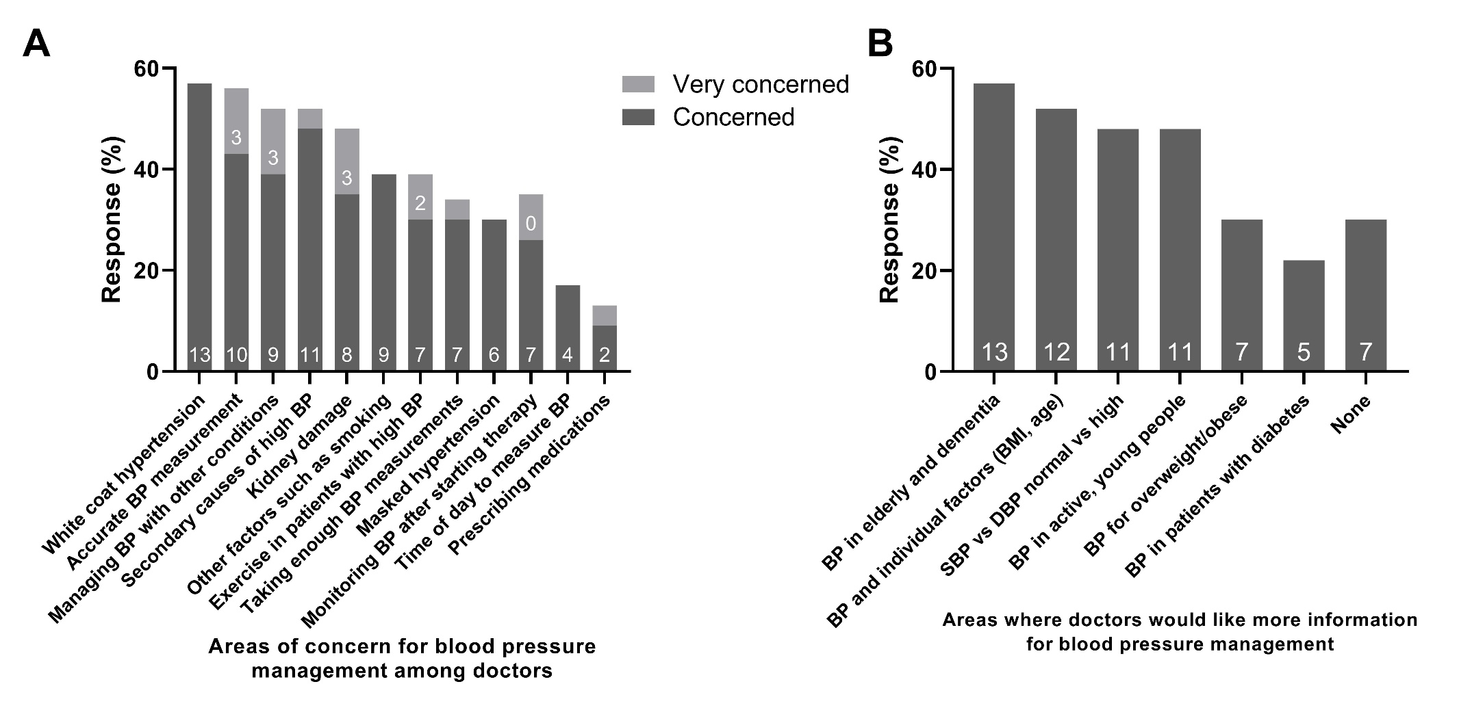
Supplementary Figure 1. The key concerns (1A) and areas where general practitioners would like more information (1B) relating to blood pressure management (n=23) in Australia.

