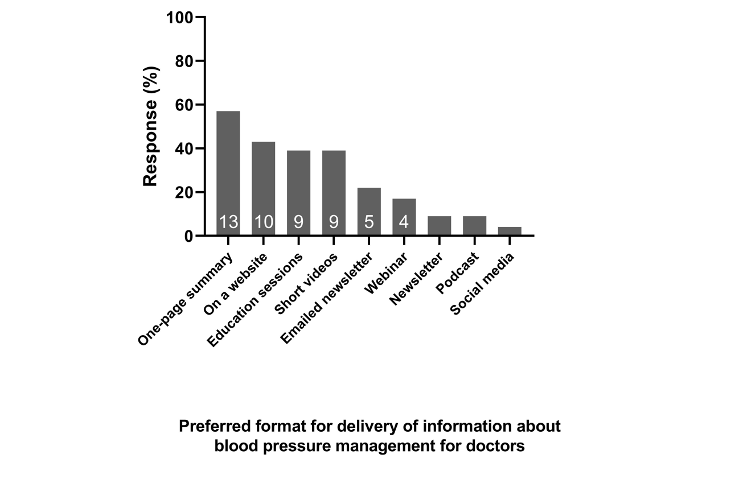
Supplementary Figure 2. Sources general practitioners (n=23) would prefer to access information for blood pressure management.

