Supplementary material

Supplementary Figure 1: Map showing provider engagement in lean and intensive ward
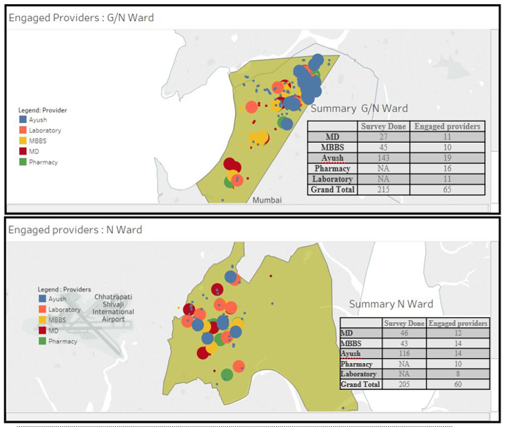

Supplementary Figure 2: Distribution by type of providers in lean and intensive ward

Supplementary Figure 3: Follow-up activities with empanelled private providers in the Mumbai hypertension project
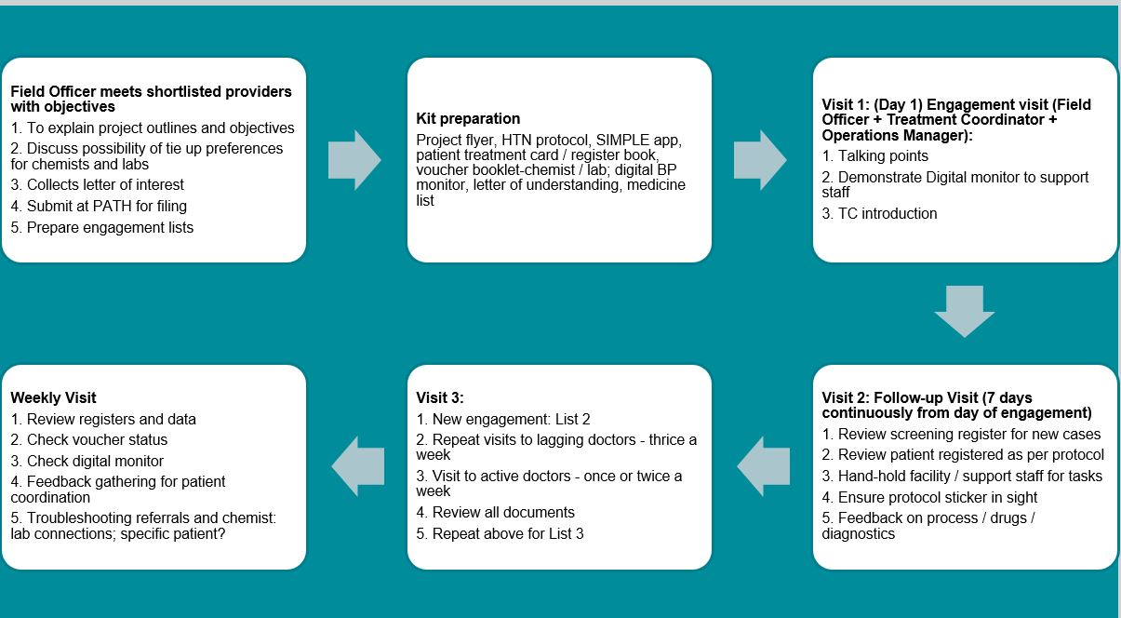

Supplementary Figure 4: Mid-course correction strategies and operational changes
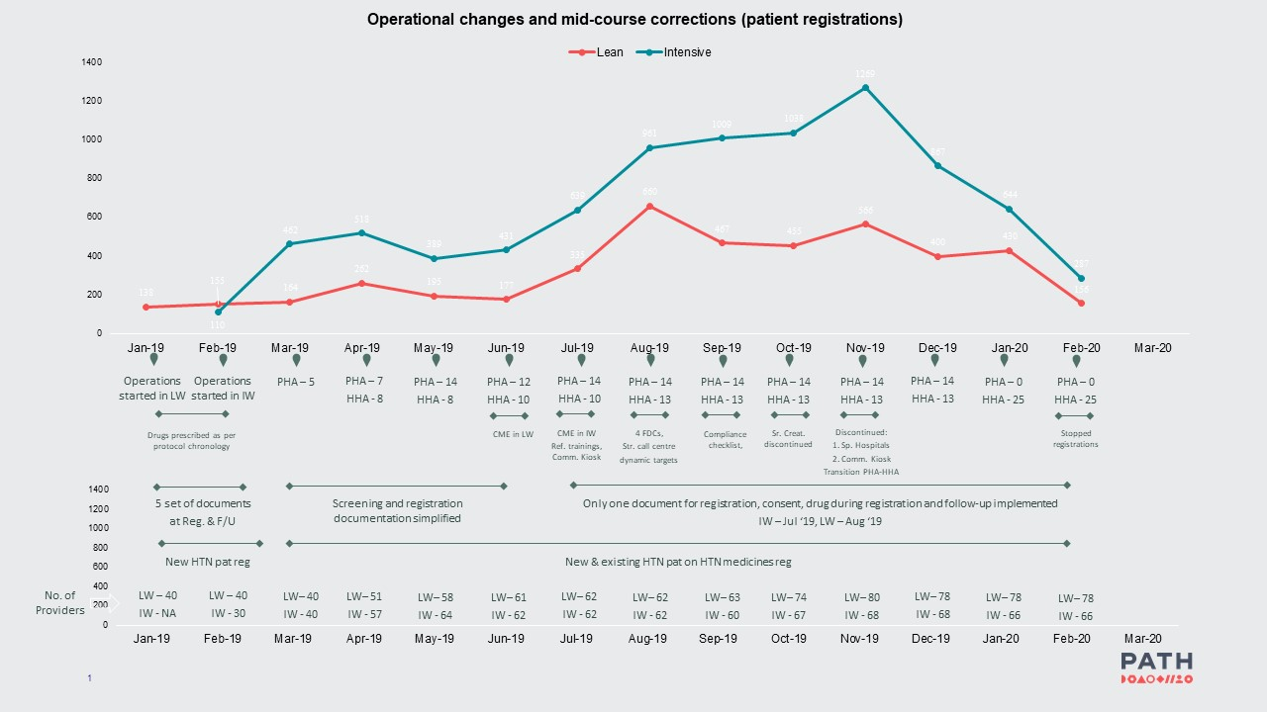

Supplementary Figure 5: Follow up details of 13,184 registered patients in MHP

