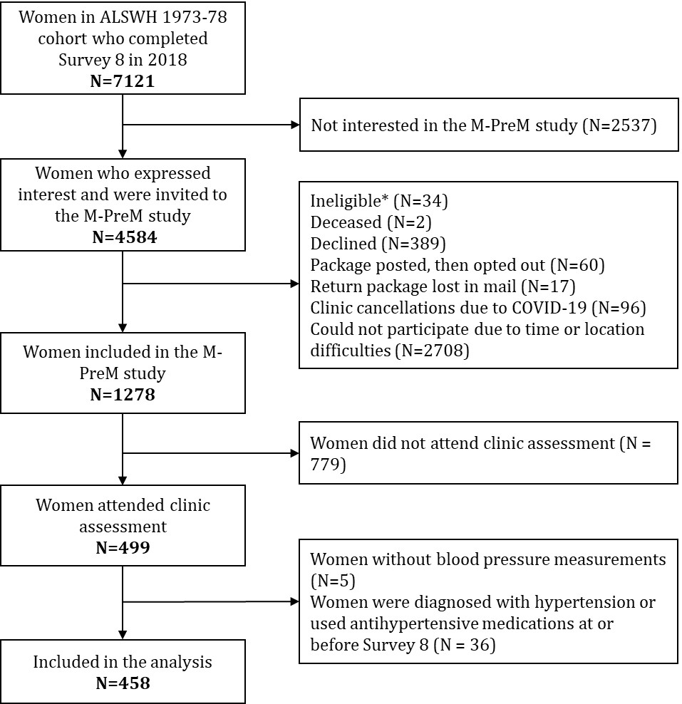
Supplemental Figure 1. Flow chart of the selection of participants
* Women who were pregnant or were being treated for a reproductive cancer at the time of invitation were excluded.

Supplemental Table 1. Comparison of characteristics in Survey 8 (2018) between women included in the analysis and women not included
 | Women included in the analysis (n=458) | Women not included in the analysis (n=6663) | P-value
Age, mean±SD | 42.3 ± 1.5 | 42.4 ± 1.5 | <0.01
Area of residence, N (%) |  |  | <0.01
Major cities | 425 (93.2) | 3599 (55.6)
Reginal and remote areas | 31 (6.8) | 2875 (44.4)
Education, N (%) |  |  | <0.01
University degree or higher | 348 (76.0) | 3546 (56.1)
Trade/certificate/diploma | 82 (17.9) | 1825 (28.9)
≤12 years of schooling | 28 (6.1) | 947 (15.0)
Physical activity, N (%) |  |  | <0.01
Nil/sedentary | 49 (11.0) | 773 (13.3)
Low | 109 (24.4) | 1797 (30.8)
Moderate | 107 (24.0) | 1305 (22.4)
High | 181 (40.6) | 1956 (33.5)
Smoking status, N (%) |  |  | <0.01
Never | 320 (69.9) | 3934 (61.1)
Ex-smoker | 111 (24.2) | 1836 (28.5)
Current smoker | 27 (5.9) | 669 (10.4)
Current use of oral contraceptive pills, N (%) | 63 (13.8) | 840 (13.2) | 0.7
Ever diagnosis of gynaecological conditions by Survey 8^{α}
Endometriosis, N (%) | 41 (9.0) | 842 (12.6) | 0.02
Uterine polyps or fibroids, N (%) | 27 (5.9) | 321 (4.8) | 0.3
Polycystic ovary syndrome, N (%) | 43 (9.4) | 626 (9.4) | 1.0
Family history of hypertension, N (%) |  |  | 0.4
Yes | 215 (49.2) | 2884 (52.6)
No | 194 (44.4) | 2252 (41.1)
Not sure | 28 (6.4) | 344 (6.3)
History of gestational hypertension, N (%) | 27 (5.9) | 756 (11.4) | <0.01
History of gestational diabetes, N (%) | 31 (6.8) | 562 (8.4) | 0.2
Menstrual symptoms
Heavy menstrual bleeding, N (%) | 69 (15.1) | 799 (12.4) | 0.09
Irregular periods, N (%) | 40 (8.7) | 436 (6.8) | 0.1
Dysmenorrhea, N (%) | 29 (6.4) | 484 (7.5) | 0.4
^{α}The questions regarding endometriosis, uterine polyps or fibroids, and polycystic ovary syndrome were asked between Surveys 2-8, Surveys 7-8, and Surveys 4-8, respectively. Women reported having diagnosis in any survey were classified as having that condition by Survey 8.

Supplemental Table 2. The brand and model of the blood pressure monitors used in the Menarche-to-PreMenopause (M-PreM) study
Study location | Brand | Model
Brisbane, Australia | Welch Allyn | Connex® Vital Signs Machine 6000 Series
Melbourne, Australia | Welch Allyn | Connex® ProBP™ 3400 Digital Blood Pressure Device
Adelaide, Australia | Phillips | Intellivue MP30 Patient Monitor
Perth, Australia | Omron | Automatic Blood Pressure Monitor HEM-907
Sydney, Australia | Omron | Automatic Blood Pressure Monitor HEM-7121

Supplemental Table 3. Comparison of characteristics in Survey 8 (2018) between women in different trajectories of heavy menstrual bleeding

 | Trajectory of heavy menstrual bleeding |  |  | P-value
 | Reference  (N = 381, 83.2%) | Increasing  (N = 48, 10.5%) | Chronic  (N = 29, 6.3%) | P-value
Age, mean±SD | 42.2 ± 1.5 | 42.4 ± 1.5 | 42.2 ± 1.8 | 0.8
Area of residence, N (%) |  |  |  | 0.7
Major cities | 351 (92.6) | 46 (95.8) | 28 (96.6)
Reginal and remote areas | 28 (7.4) | 2 (4.2) | 1 (3.5)
Education, N (%) |  |  |  | 0.1
University degree or higher | 290 (76.1) | 38 (79.2) | 20 (69.0)
Trade/certificate/diploma | 68 (17.9) | 5 (10.4) | 9 (31.0)
≤12 years of schooling | 23 (6.0) | 5 (10.4) | 0 (0.0)
Physical activity, N (%) |  |  |  | 0.5
Nil/sedentary | 39 (10.5) | 5 (10.6) | 5 (17.9)
Low | 91 (24.5) | 12 (25.5) | 6 (21.4)
Moderate | 87 (23.5) | 10 (21.3) | 10 (35.7)
High | 154 (41.5) | 20 (42.6) | 7 (25.0)
Smoking status, N (%) |  |  |  | 0.01
Never | 275 (72.2) | 31 (64.6) | 14 (48.3)
Ex-smoker | 89 (23.4) | 11 (22.9) | 11 (37.9)
Current smoker | 17 (4.5) | 6 (12.5) | 4 (13.8)
Current use of oral contraceptive pills, N (%) | 54 (14.2) | 6 (12.8) | 3 (10.7) | 0.9
Ever diagnosis of gynaecological conditions by Survey 8^{α}
Endometriosis, N (%) | 25 (6.6) | 7 (14.6) | 9 (31.0) | <0.01
Uterine polyps or fibroids, N (%) | 15 (3.9) | 3 (6.3) | 9 (31.0) | <0.01
Polycystic ovary syndrome, N (%) | 33 (8.7) | 4 (8.3) | 6 (20.7) | 0.1
Family history of hypertension, N (%) |  |  |  | 0.04
Yes | 174 (47.5) | 22 (46.8) | 19 (79.2)
No | 169 (46.2) | 21 (44.7) | 4 (16.7)
Not sure | 23 (6.3) | 4 (8.5) | 1 (4.2)
History of gestational hypertension, N (%) | 20 (5.3) | 4 (8.3) | 3 (10.3) | 0.3
History of gestational diabetes, N (%) | 26 (6.8) | 3 (6.3) | 2 (6.9) | 1.0
Body mass index, N (%)^{β} |  |  |  | 0.1
Underweight/normal weight (<25kg/m²) | 170 (44.7) | 19 (39.6) | 6 (20.7)
Overweight (25 to <30kg/m²) | 109 (28.7) | 18 (37.5) | 11 (37.9)
Obese (≥30kg/m²) | 101 (26.6) | 11 (22.9) | 12 (41.4)
Waist-to-hip ratio, mean±SD ^{β} | 0.8 ± 0.1 | 0.8 ± 0.1 | 0.9 ± 0.1 | 0.04
^{α}Questions about endometriosis, uterine polyps or fibroids, and polycystic ovary syndrome were asked in Surveys 2-8, Surveys 7-8, and Surveys 4-8, respectively. Women who reported a diagnosis in any of these surveys were classified as having that condition by Survey 8.
^{β}Measurements were collected in the Menarche-to-PreMenopause (M-PreM) study.
Supplemental Table 4. Comparison of characteristics in Survey 8 (2018) between women in different trajectories of irregular periods

 | Trajectory of irregular periods |  | P-value
 | Reference  (N = 416, 90.8%) | Chronic  (N = 42, 9.2%)
Age, mean±SD | 42.3 ± 1.5 | 41.9 ± 1.6 | 0.1
Area of residence, N (%)
Major cities | 386 (93.0) | 39 (95.1) | 1.0
Reginal and remote areas | 29 (7.0) | 2 (4.9)
Education, N (%) |  |  | 0.5
University degree or higher | 319 (76.7) | 29 (69.1)
Trade/certificate/diploma | 73 (17.6) | 9 (21.4)
≤12 years of schooling | 24 (5.8) | 4 (9.5)
Physical activity, N (%) |  |  | 0.4
Nil/sedentary | 42 (10.4) | 7 (16.7)
Low | 96 (23.8) | 13 (31.0)
Moderate | 99 (24.5) | 8 (19.1)
High | 167 (41.3) | 14 (33.3)
Smoking status, N (%) |  |  | 0.7
Never | 289 (69.5) | 31 (73.8)
Ex-smoker | 103 (24.8) | 8 (19.1)
Current smoker | 24 (5.8) | 3 (7.1)
Current use of oral contraceptive pills, N (%) | 58 (14.0) | 5 (11.9) | 0.7
Ever diagnosis of gynaecological conditions by Survey 8^{α}
Endometriosis, N (%) | 37 (8.9) | 4 (9.5) | 0.9
Uterine polyps or fibroids, N (%) | 21 (5.1) | 6 (14.3) | 0.03
Polycystic ovary syndrome, N (%) | 26 (6.3) | 17 (40.5) | <0.01
Family history of hypertension, N (%) |  |  | 0.7
Yes | 193 (48.6) | 22 (55.0)
No | 178 (44.8) | 16 (40.0)
Not sure | 26 (6.6) | 2 (5.0)
History of gestational hypertension, N (%) | 23 (5.5) | 4 (9.5) | 0.3
History of gestational diabetes, N (%) | 23 (5.5) | 8 (19.1) | <0.01
Body mass index, N (%)^{β} |  |  | 0.2
Underweight/normal weight (<25kg/m²) | 183 (44.1) | 12 (28.6)
Overweight (25 to <30kg/m²) | 122 (29.4) | 16 (38.1)
Obese (≥30kg/m²) | 110 (26.5) | 14 (33.3)
Waist-to-hip ratio, mean±SD^{β} | 0.8 ± 0.1 | 0.8 ± 0.1 | 0.7
^{α}Questions about endometriosis, uterine polyps or fibroids, and polycystic ovary syndrome were asked in Surveys 2-8, Surveys 7-8, and Surveys 4-8, respectively. Women who reported a diagnosis in any of these surveys were classified as having that condition by Survey 8.
^{β}Measurements were collected in the Menarche-to-PreMenopause (M-PreM) study.
Supplemental Table 5. Comparison of characteristics in Survey 8 (2018) between women in different trajectories of dysmenorrhea

 | Trajectory of dysmenorrhea |  | P-value
 | Reference  (N = 399, 87.1%) | Chronic  (N = 59, 12.9%)
Age, mean±SD | 42.2 ± 1.5 | 42.6 ± 1.6 | 0.1
Area of residence, N (%) |  |  | 0.4
Major cities | 368 (92.7) | 57 (96.6)
Reginal and remote areas | 29 (7.3) | 2 (3.4)
Education, N (%) |  |  | 0.2
University degree or higher | 308 (77.2) | 40 (67.8)
Trade/certificate/diploma | 67 (16.8) | 15 (25.4)
≤12 years of schooling | 24 (6.0) | 4 (6.8)
Physical activity, N (%) |  |  | 0.5
Nil/sedentary | 40 (10.3) | 9 (15.8)
Low | 93 (23.9) | 16 (28.1)
Moderate | 95 (24.4) | 12 (21.1)
High | 161 (41.4) | 20 (35.1)
Smoking status, N (%) |  |  | 0.6
Never | 281 (70.4) | 39 (66.1)
Ex-smoker | 96 (24.1) | 15 (25.4)
Current smoker | 22 (5.5) | 5 (8.5)
Current use of oral contraceptive pills, N (%) | 56 (14.0) | 7 (12.3) | 0.7
Ever diagnosis of gynaecological conditions by Survey 8^{α}
Endometriosis, N (%) | 25 (6.3) | 16 (27.1) | <0.01
Uterine polyps or fibroids, N (%) | 20 (5.0) | 7 (11.9) | 0.1
Polycystic ovary syndrome, N (%) | 33 (8.3) | 10 (17.0) | 0.03
Family history of hypertension, N (%) |  |  | 0.05
Yes | 186 (48.6) | 29 (53.7)
No | 176 (46.0) | 18 (33.3)
Not sure | 21 (5.5) | 7 (13.0)
History of gestational hypertension, N (%) | 21 (5.3) | 6 (10.2) | 0.1
History of gestational diabetes, N (%) | 28 (7.0) | 3 (5.1) | 0.8
Body mass index, N (%)^{β} |  |  | 0.4
Underweight/normal weight (<25kg/m²) | 174 (43.7) | 21 (35.6)
Overweight (25 to <30kg/m²) | 120 (30.2) | 18 (30.5)
Obese (≥30kg/m²) | 104 (26.1) | 20 (33.9)
Waist-to-hip ratio, mean±SD^{β} | 0.8 ± 0.1 | 0.8 ± 0.1 | 0.1
^{α}Questions about endometriosis, uterine polyps or fibroids, and polycystic ovary syndrome were asked in Surveys 2-8, Surveys 7-8, and Surveys 4-8, respectively. Women who reported a diagnosis in any of these surveys were classified as having that condition by Survey 8.
^{β}Measurements were collected in the Menarche-to-PreMenopause (M-PreM) study.
Supplemental Table 6A. Model fit statistics for latent class growth models to detect trajectories of heavy menstrual bleeding from Survey 2 (2000) to Survey 8 (2018), N=458
Number of classes | BIC | Class 1,  N (%) | Class 2,  N (%) | Class 3,  N (%) | Class 4,  N (%)
1 | -899.11 | 100 | NA | NA | NA
2 | -791.85 | 68.1 | 31.9 | NA | NA
3 | -780.93 | 80.3 | 12.4 | 7.4 | NA
4 | -786.78 | 57.5 | 29.9 | 9.1 | 3.5

BIC indicated the 3-class model was the optimal representation of the data.
BIC = Bayesian Information Criterion.

Supplemental Table 6B. Model fit statistics for latent class growth models to detect trajectories of irregular periods from Survey 2 (2000) to Survey 8 (2018), N=458
Number of classes | BIC | Class 1,  N (%) | Class 2,  N (%) | Class 3,  N (%) | Class 4,  N (%)
1 | -841.44 | 100 | NA | NA | NA
2 | -782.28 | 89.6 | 10.4 | NA | NA
3 | -785.02 | 18.9 | 73.8 | 7.3 | NA
4 | -794.21 | 73.8 | 7.3 | 10.2 | 8.7

BIC indicated the 2-class model was the optimal representation of the data.
BIC = Bayesian Information Criterion.

Supplemental Table 6C. Model fit statistics for latent class growth models to detect trajectories of dysmenorrhea from Survey 2 (2000) to Survey 8 (2018), N=458
Number of classes | BIC | Class 1,  N (%) | Class 2,  N (%) | Class 3,  N (%) | Class 4,  N (%)
1 | -785.79 | 100 | NA | NA | NA
2 | -669.05 | 85.7 | 14.3 | NA | NA
3 | -673.96 | 76.2 | 16.2 | 7.7 | NA
4 | -677.60 | 22.9 | 68.2 | 0.8 | 8.1

BIC indicated the 2-class model was the optimal representation of the data.
BIC = Bayesian Information Criterion.
Supplemental Table 7. Association between menstrual disorders in each survey and blood pressure, before and after adjusting for oral contraceptive pill use in the respective survey

Menstrual disorders  (often vs sometimes/rarely/never) | Systolic blood pressure |  |  | Diastolic blood pressure
Menstrual disorders  (often vs sometimes/rarely/never) | Crude model | Adjusted for oral contraceptive pills |  | Crude model | Adjusted for oral contraceptive pills
Heavy menstrual bleeding
Survey 2 | 4.7 (-0.5, 10.0) | 4.7 (-0.6, 10.1) |  | 3.2 (-0.5, 6.9) | 2.6 (-1.1, 6.4)
Survey 3 | 3.6 (-2.9, 10.1) | 3.7 (-2.8, 10.2) |  | 2.2 (-2.4, 6.8) | 2.1 (-2.5, 6.8)
Survey 4 | 0.3 (-4.6, 5.2) | 0.0 (-5.0, 5.0) |  | 2.9 (-0.6, 6.4) | 2.7 (-0.8, 6.2)
Survey 5 | 3.5 (-0.7, 7.7) | 3.7 (-0.5, 7.9) |  | 3.4 (0.4, 6.4) | 3.6 (0.6, 6.5)
Survey 6 | 1.2 (-2.2, 4.7) | 1.5 (-1.9, 5.0) |  | 2.3 (-0.1, 4.7) | 2.5 (0.1, 4.9)
Survey 7 | 1.3 (-2.3, 4.8) | 1.8 (-1.7, 5.3) |  | 1.1 (-1.4, 3.5) | 1.5 (-1.0, 3.9)
Survey 8 | 3.3 (0.2, 6.5) | 3.5 (0.4, 6.6) |  | 4.0 (1.9, 6.2) | 4.1 (1.9, 6.3)
Irregular periods
Survey 2 | 1.0 (-3.1, 5.2) | 0.9 (-3.4, 5.1) |  | 0.5 (-2.4, 3.5) | -0.1 (-3.1, 2.9)
Survey 3 | -1.3 (-5.7, 3.2) | -1.2 (-5.7, 3.3) |  | 0.8 (-2.3, 3.9) | 0.6 (-2.6, 3.8)
Survey 4 | -0.6 (-5.1, 3.9) | -0.8 (-5.4, 3.7) |  | 4.0 (0.8, 7.2) | 3.9 (0.7, 7.1)
Survey 5 | 6.7 (2.5, 10.9) | 6.8 (2.6, 10.9) |  | 4.2 (1.2, 7.2) | 4.3 (1.3, 7.3)
Survey 6 | 3.1 (-1.2, 7.4) | 3.2 (-1.1, 7.5) |  | 4.4 (1.5, 7.4) | 4.5 (1.5, 7.5)
Survey 7 | 1.8 (-2.7, 6.3) | 2.1 (-2.3, 6.6) |  | 2.0 (-1.1, 5.2) | 2.3 (-0.8, 5.4)
Survey 8 | 0.0 (-3.9, 3.9) | 0.2 (-3.7, 4.1) |  | 2.0 (-0.7, 4.8) | 2.1 (-0.7, 4.9)
Dysmenorrhea
Survey 2 | -0.6 (-4.5, 3.4) | -0.8 (-4.8, 3.3) |  | 0.1 (-2.8, 2.9) | -0.5 (-3.4, 2.4)
Survey 3 | -1.4 (-6.3, 3.6) | -1.4 (-6.3, 3.6) |  | -1.9 (-5.4, 1.6) | -2.0 (-5.5, 1.5)
Survey 4 | -1.4 (-6.2, 3.5) | -1.5 (-6.3, 3.3) |  | -1.5 (-4.9, 1.9) | -1.6 (-5.0, 1.8)
Survey 5 | -0.1 (-4.6, 4.4) | 0.0 (-4.5, 4.5) |  | -0.6 (-3.8, 2.6) | -0.4 (-3.6, 2.8)
Survey 6 | 3.3 (-1.0, 7.6) | 3.4 (-0.9, 7.6) |  | 1.9 (-1.1, 4.9) | 1.9 (-1.1, 4.9)
Survey 7 | 3.2 (-1.4, 7.8) | 3.9 (-0.7, 8.4) |  | 2.3 (-0.9, 5.5) | 2.8 (-0.4, 6.0)
Survey 8 | 3.3 (-1.3, 7.9) | 3.3 (-1.3, 7.9) |  | 2.6 (-0.7, 5.9) | 2.6 (-0.7, 5.8)

