Exclusion of patients who died, were lost to follow-up, or experienced MACE during acute infection may have led to selection bias. This analysis here did not exclude patients due to being lost to follow-up or experiencing MACE within the first 30 days of index date. The flowchart is shown in Figure A, patients characteristics are shown in Table A, and the results are shown in Table B.

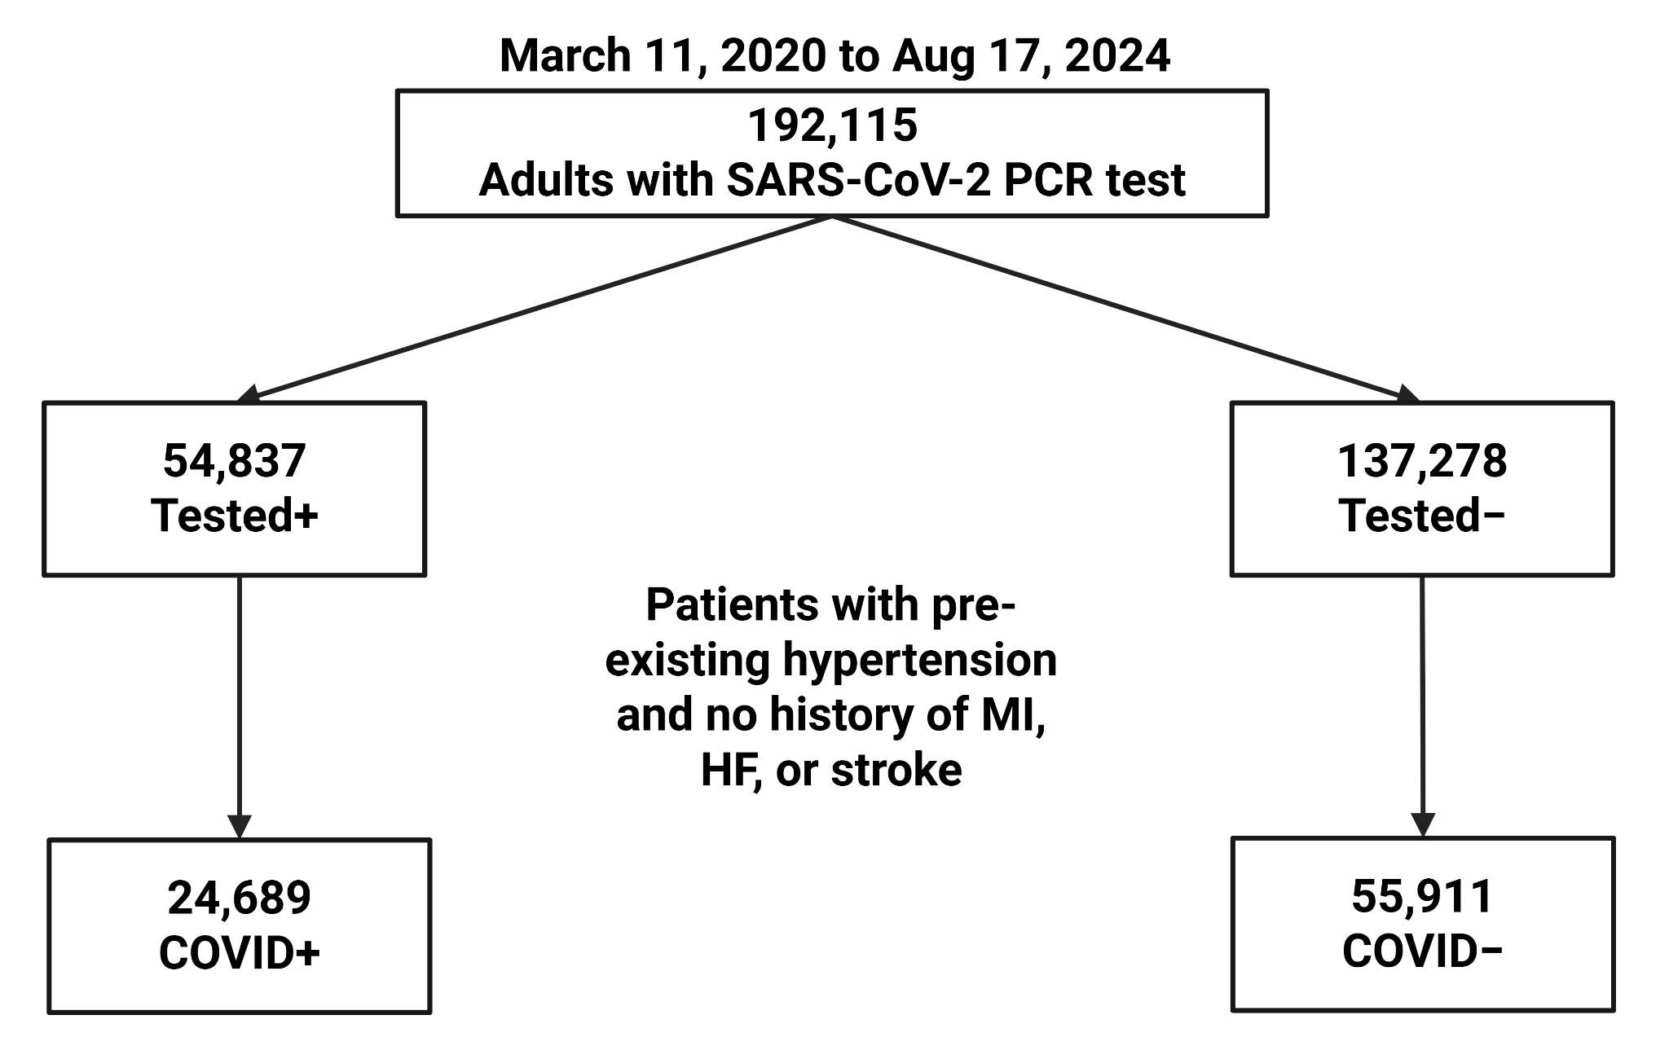
Figure A. Patient selection flowchart not excluding patients who experienced outcomes or were lost to follow-up within 30 days of index date. PCR, polymerase chain reaction. MI, myocardial infarction. HF, heart failure.

Table A. Characteristics of patients with pre-existing hypertension but no history of myocardial infarction, heart failure, or stroke with and without COVID-19 (no 30-day exclusions applied). SD, standard deviation. SMD, standardized mean difference. COPD, chronic obstructive pulmonary disease.
 | COVID+ (n=24689) | COVID– (n=55911) | p-value | SMD
Follow Up Time (Months), mean ± SD | 22.17 ± 14.89 | 26.05 ± 15.05 | <0.005 | 0.26
Age at Index Date (Years), mean ± SD | 56.30 ± 17.05 | 54.71 ± 15.70 | <0.005 | 0.097
Female, n (%) | 15470 (62.66%) | 34507 (61.72%) | 0.011 | 0.019
Race and Ethnicity, n (%)
Non-Hispanic White | 2331 (9.44%) | 5770 (10.32%) | <0.005 | 0.029
Black | 8799 (35.64%) | 19187 (34.32%) | <0.005 | 0.028
Asian | 1128 (4.57%) | 2269 (4.06%) | <0.005 | 0.025
Other Race | 12431 (50.35%) | 28685 (51.30%) | 0.013 | 0.019
Hispanic | 10336 (41.86%) | 22926 (41.00%) | 0.023 | 0.017
Blood Pressure (mm Hg), mean ± SD
Systolic Blood Pressure | 133.08 ± 13.91 | 133.92 ± 14.25 | <0.005 | 0.060
Diastolic Blood Pressure | 78.61 ± 8.48 | 80.05 ± 8.25 | <0.005 | 0.17
Stage of Hypertension, n (%)
No Blood Pressure Measurements Available | 5163 (20.91%) | 12298 (22.00%) | <0.005 | 0.026
Normal | 2409 (9.76%) | 3972 (7.10%) | <0.005 | 0.096
Elevated | 4218 (17.08%) | 8635 (15.44%) | <0.005 | 0.044
Stage 1 Hypertension | 7206 (29.19%) | 17303 (30.95%) | <0.005 | 0.038
Stage 2 Hypertension | 5693 (23.06%) | 13703 (24.51%) | <0.005 | 0.034
Definition of Hypertension Met, n (%)
Blood Pressure Measurements | 17117 (69.33%) | 39641 (70.90%) | <0.005 | 0.034
Antihypertensive Use | 15115 (61.22%) | 30998 (55.44%) | <0.005 | 0.12
ICD-10 Code | 17397 (70.46%) | 35020 (62.64%) | <0.005 | 0.17
Pre-Existing Comorbidities, n (%)
Coronary Artery Disease | 2491 (10.09%) | 3439 (6.15%) | <0.005 | 0.14
Type-2 Diabetes | 8676 (35.14%) | 14965 (26.77%) | <0.005 | 0.18
COPD | 1159 (4.69%) | 1256 (2.25%) | <0.005 | 0.13
Asthma | 5485 (22.22%) | 9466 (16.93%) | <0.005 | 0.13
Chronic Kidney Disease | 4225 (17.11%) | 5320 (9.52%) | <0.005 | 0.23
Liver Disease | 2324 (9.41%) | 4119 (7.37%) | <0.005 | 0.074
Obesity | 14212 (57.56%) | 29775 (53.25%) | <0.005 | 0.087
Tobacco Use | 8395 (34.00%) | 19529 (34.93%) | 0.011 | 0.019
Insurance, n (%)
Medicaid | 8316 (33.68%) | 20163 (36.06%) | <0.005 | 0.050
Medicare | 5306 (21.49%) | 9796 (17.52%) | <0.005 | 0.10
Private | 9206 (37.29%) | 22232 (39.76%) | <0.005 | 0.051
Uninsured | 1861 (7.54%) | 3720 (6.65%) | <0.005 | 0.034
Income Group, n (%)
Lower Third (≤$42,639/year) | 9934 (40.24%) | 22766 (40.72%) | 0.20 | 0.0098
Middle Third ($42,834/year–$61,272/year) | 7250 (29.37%) | 15845 (28.34%) | <0.005 | 0.023
Top Third (≥$61,414/year) | 7505 (30.40%) | 17300 (30.94%) | 0.13 | 0.012
Unmet Social Needs, n (%)
At Least One Unmet Social Need | 2163 (8.76%) | 4322 (7.73%) | <0.005 | 0.037
No Unmet Social Needs | 6345 (25.70%) | 13633 (24.38%) | <0.005 | 0.03
Status Unknown | 16181 (65.54%) | 37956 (67.89%) | <0.005 | 0.05
Hospitalized Due to COVID-19, n (%) | 8123 (32.90%) | 0 (0.00%) | <0.005 | 0.99
Vaccinated for SARS-CoV-2, n (%) | 9211 (37.31%) | 16789 (30.03%) | <0.005 | 0.15
Outcomes, n (%)
All-Cause Mortality | 1377 (5.58%) | 644 (1.15%) | <0.005 | 0.25
Myocardial Infarction | 515 (2.09%) | 936 (1.67%) | <0.005 | 0.03
Heart Failure | 1290 (5.22%) | 2177 (3.89%) | <0.005 | 0.064
Ischemic or Hemorrhagic Stroke | 511 (2.07%) | 966 (1.73%) | <0.005 | 0.025
Major Adverse Cardiovascular Events | 3124 (12.65%) | 3916 (7.00%) | <0.005 | 0.19

Table B. Cox proportional (all-cause mortality and major adverse cardiovascular events) and Fine-Gray subdistribution (myocardial infarction, heart failure, and ischemic or hemorrhagic stroke) adjusted hazard ratios (HR) for different outcomes grouped by COVID-19 status (COVID+ hospitalized and COVID+ non-hospitalized vs. COVID–) (no 30-day exclusions applied). Multivariate model for mortality could not converge due to very high COVID+ hospitalized hazard ratio (HR). Multivariate regression and inverse probability weighting both adjusted for baseline age, sex, race, ethnicity, comorbidities, stage of hypertension, insurance status, tertile of Zone Improvement Plan median income, presence of unmet social needs, and SARS-CoV-2 vaccination status. HR, hazard ratio. CI, confidence interval.
 | Multivariate Regression
Outcome | COVID+ Hospitalized vs COVID– |  | COVID+ Non-Hospitalized vs COVID–
Outcome | Adjusted HR [95% CI] | p-value | Adjusted HR [95% CI] | p-value
Myocardial Infarction | 1.41 [1.23, 1.62] | <0.005 | 1.06 [0.91, 1.22] | 0.48
Heart Failure | 1.56 [1.43, 1.71] | <0.005 | 1.11 [1.01, 1.22] | 0.025
Ischemic or Hemorrhagic Stroke | 1.39 [1.21, 1.60] | <0.005 | 1.06 [0.92, 1.23] | 0.41
Major Adverse Cardiovascular Events | 2.45 [2.31, 2.59] | <0.005 | 1.16 [1.08, 1.24] | <0.005
 | Inverse Probability Weighting-Adjusted
Outcome | COVID+ Hospitalized vs COVID– |  | COVID+ Non-Hospitalized vs COVID–
Outcome | HR [95% CI] | p-value | HR [95% CI] | p-value
All-Cause Mortality | 6.49 [5.80, 7.26] | <0.005 | 1.72 [1.46, 2.02] | <0.005
Myocardial Infarction | 1.55 [1.30, 1.85] | <0.005 | 1.08 [0.92, 1.26] | 0.37
Heart Failure | 1.70 [1.53, 1.90] | <0.005 | 1.11 [1.00, 1.23] | 0.041
Ischemic or Hemorrhagic Stroke | 1.37 [1.15, 1.64] | <0.005 | 1.00 [0.86, 1.17] | 0.96
Major Adverse Cardiovascular Events | 2.42 [2.26, 2.61] | <0.005 | 1.18 [1.09, 1.27] | <0.005

