SUPPLEMENTARY MATERIAL
1. Definitions
Complete remission (CR): Bone marrow blasts < 5%; absence of blasts with Auer rods; absence of extramedullary disease; absolute neutrophil count > 1.0 × 10⁹/L (1000/μL); platelet count > 80 × 10⁹/L (80 000/μL); independence of red cell transfusions.
Continuous CR (CCR): All patients with continuous CR who died after day 42 were considered for the evaluation of treatment-related mortality. Patients, who died due to procedure-related complications of HSCT like veno-occlusive-disease were classified as HSCT-related deaths.
Non-responders: All patients with a survival of at least 42 days without achieving CR until end of intensive chemotherapy were defined as non-responders. All patients with non-response were evaluated and defined as disease-related (non-response or subsequent progression), bleeding, infectious complications during chemotherapy or procedure-related complications of HSCT like veno-occlusive-disease.
Patients with relapse were analyzed in separate groups for infectious deaths, deaths due to bleeding, HSCT-related mortality and disease-related mortality.
Patients with other causes of death such as accidents, unknown reasons or reasons of deaths that were not determinable or inclusive for one category due to simultaneous medical problems were classified as “others”.
Risk stratification: In AML-BFM 87 risk classification was based on morphology and described two risk groups. The low-risk group included French-American-British (FAB) types with granulocytic differentiation and specific additional features: FAB M1 with Auer rods, FAB M2 with WBC <20,000 /microliter, FAB M3 (all patients) and FAB M4 with eosinophils.²⁵ In AML-BFM 93 response evaluation has been included additionally to the morphological parameters (blast cell reduction in bone marrow on day 15). The standard-risk group included: FAB M1/M2 with Auer rods, FAB M4eo (if these patients presented with ≥5% blasts in the bone marrow on day 15, they were shifted to the high-risk group) and FAB M3 (all patients regardless of the blast count on day 15). High-risk group patients have been defined as all others.²⁵ In AML-BFM 98 patients from study 93 who were stratified to high-risk on the basis of morphologic findings but had favorable karyotypes were included in the standard risk group.¹¹ In AML-BFM 2004 risk classification was based on morphology, cytogenetics, molecular genetics, and response to treatment: As before standard risk indicates FAB M1/2 with Auer rods, FAB M4 with atypical eosinophils (M4Eo), FAB M3 and/or favorable cytogenetics, such as t(8;21) and/or AML1-ETO, t(15;17), and/or PML-RARA and inv(16) or t(16;16) and/or CBFB/MYH1, if there was no persistence of BM blasts (≥5%) on day 15 or FLT3-ITD positivity (FAB M3 excluded). All others were classified as high-risk patients.²⁶ From 2011 until 2012 patients have been stratified only to the standard risk arm with FAB M4 with atypical eosinophils (M4Eo), FAB M3 and/or favorable cytogenetics, such as t(8;21) and/or AML1-ETO, t(15;17), and/or PML-RARA and inv(16) or t(16;16) and/or CBFB/MYH1, with no persistence of BM blasts (≥5%) on day 15 or FLT3-ITD positivity (FAB M3 excluded).

2. Recommendations for supportive care in AML-BFM 98 and AML-BFM 04
In AML-BFM 98 recommendations included trimethoprim-sulfamethoxazole prophylaxis for Pneumocystis carinii and the administration of nonabsorbable antibiotics (colistin) and antimycotics (amphotericin B). Systemic antifungal prophylaxis was not recommended, but the administration of penicillin after courses with high-dose cytarabine. As compared to AML-BFM 98, antibiotic prophylaxis with nonabsorbable agents or penicillin were not further recommended in AML-BFM 04. In contrast, chemoprophylaxis was recommended with fluconazole, and voriconazole depending on the local conditions of the clinics. The empiric antibiotic therapy during fever in aplasia did not change remarkably. Compared to AML-BFM 98, AML-BFM 04 included detailed recommendations on empirical antifungal treatment with use of intravenous liposomal amphotericin B, and voriconazole, fluconazole, itraconazole or caspofungin as alternative. However, in both studies, supportive care was administered according to the discretion of the treating physician and institutional standards, and therefore were not standardized.

SUPPLEMENTARY TABLES
Table 1 Cumulative Incidences of relapse and non-response from 1987 – 2012
 | CI (%) | SE | p |  | CI (%) | SE | p |  | p
Period | relapse |  |  |  | non-response |  |  |  | relapse and non-response
1987-1992 | 31.9 | 2.7 | 0.17 | 0.52 | 16.3 | 2.2 | 0.08 | 0.025 | 0.11 | 0.022
1993-1998 | 28.2 | 2 | 0.17 | 0.52 | 10.5 | 1.3
1999-2004 | 34.6 | 2.1 | 0.17 |  | 9.3 | 1.3 | 0.08 |  | 0.11
2005-2010 | 33.1 | 2.2 | 0.17 |  | 9.9 | 1.4
2011-2012* | 25.1 | 3.9 | 0.17 |  | 12.3 | 2.8
Abbreviations: CI, cumulative incidence. SE, standard error.
Table 2 Patients with allogeneic hematopoietic stem cell transplantation from 1987 – 2010
Period | n | % of all patients |  | P | % of all patients |  |  | % of all patients
Period | n | no | yes | P | 1 HSCT | 2 HSCTs | >2 HSCTs | in first CR
1987-1992 | 295 | 84.1 | 15.9 | <0.001 | 14.2 | 1.4 | 0.3 | 6.1
1993-1998 | 533 | 71.7 | 28.3 | <0.001 | 26.8 | 1.5 | 0 | 9.8
1999-2004 | 497 | 59.8 | 40.2 | <0.001 | 35.0 | 4.8 | 0.4 | 13.9
2005-2010 | 477 | 59.1 | 40.9 | <0.001 | 35.2 | 5.0 | 0.6 | 9.0
Abbreviations: CR, complete remission; HSCT, hematopoietic stem cell transplantation.

Table 3 Patients with relapse or non-response with allogeneic hematopoietic stem cell transplantation from 1987-2010
Period | n | % of all patients after relapse |  | % of all patients with non-response
Period | n | No | Yes | No | Yes
1987-1992 | 145 | 78.4 | 21.6 | 81.2 | 18.8
1993-1998 | 215 | 54.7 | 45.3 | 64.3 | 35.7
1999-2004 | 218 | 41.3 | 58.7 | 39.1 | 60.9
2005-2010 | 203 | 25.2 | 74.8 | 14.9 | 85.1

Table 4 Characteristics of patients treated with identical chemotherapy in study AML-BFM 98 and AML-BFM 04
 | AML-BFM 98 |  | AML-BFM 04
 | [n] | [%] | [n] | [%]
Total | 255 | 100 | 128 | 100
Male | 135 | 53 | 68 | 53
Female | 120 | 47 | 60 | 47
Risk group HR | 255 | 100 | 128 | 100
Normal karyotype | 60 | 24 | 32 | 25
BM Day 15≥5% | 54 | 21 | 24 | 19
Abbreviations: HR, high risk; BM, bone marrow

SUPPLEMENTARY FIGURES

Figure 1 Age
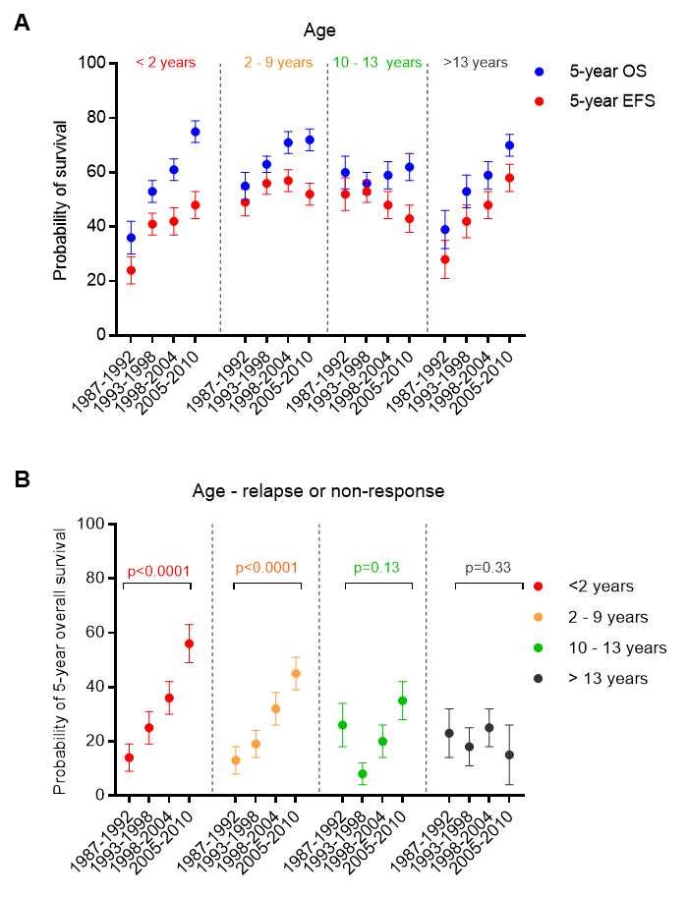
(A) Development of survival per 6-year periods in 4 different age groups. Data shown as probability of EFS and OS ±SE. <2 years: n=70 [1987-1992]; n=126 [1993-1998]; n=123 [1999-2004]; n=111 [2005-2010]. 2 - 9 years: n=119 [1987-1992]; n=199 [1993-1998]; n=162 [1999-2004]; n=147 [2005-2010]. 10 - 13 years: n=63 [1987-1992]; n=134 [1993-1998]; n=117 [1999-2004]; n=96 [2005-2010]. >13 years: n=43 [1987-1992]; n=74 [1993-1998]; n=95 [1999-2004]; n=123 [2005-2010]. (B) Analysis of 5-year OS ±SE after relapse or non-response in 4 different age groups. <2 years: n=42 [1987-1992]; n=62 [1993-1998]; n=60 [1999-2004]; n=50 [2005-2010]. 2 - 9 years: n=54 [1987-1992]; n=76 [1993-1998]; n=63 [1999-2004]; n=64 [2005-2010]. 10 - 13 years: n=27 [1987-1992]; n=44 [1993-1998]; n=52 [1999-2004]; n=47 [2005-2010]. >13 years: n=22 [1987-1992]; n=33 [1993-1998]; n=43 [1999-2004]; n=42 [2005-2010]. (A and B) Kaplan-Meier curves of EFS and OS of distinct subgroups were compared using the log rank test, shown as p-value.

Figure 2 Supportive Care
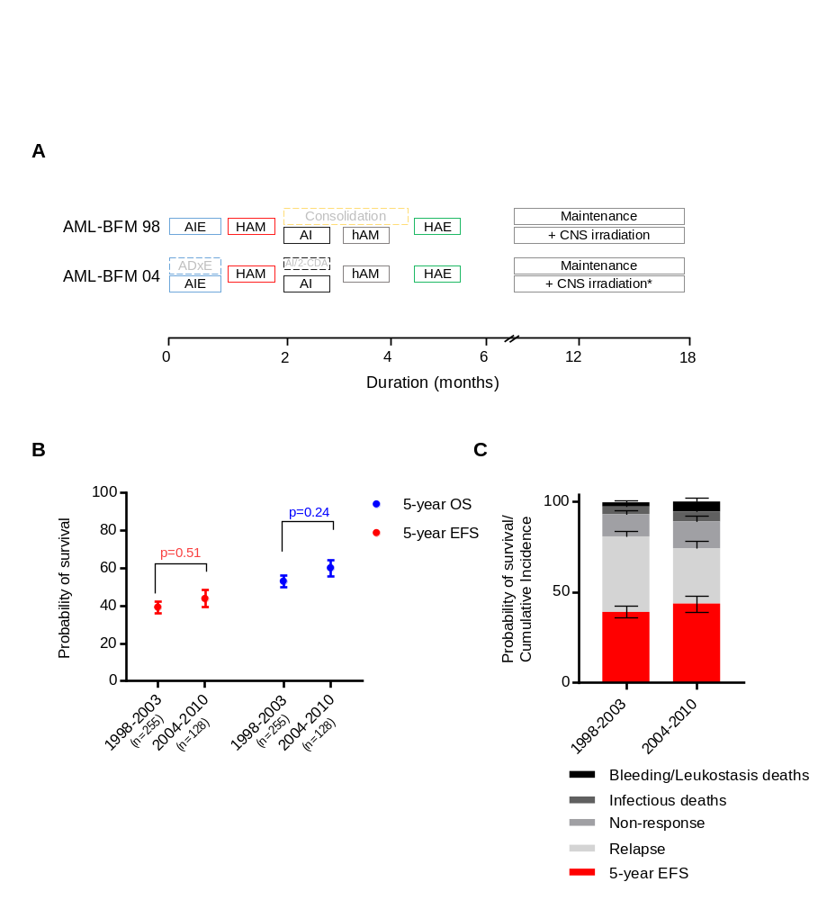
(A) Protocol flow chart for pediatric patients with AML treated with identical chemotherapy from 1998 until 2010 over two study trial periods. Patients were treated in one high-risk treatment arm of the AML-BFM 98 and AML-BFM 04 trials equally consisting of AIE, HAM, AI, haM, HAE and maintenance therapy excluding patients with HSCT (n=383). *CNS irradiation was stopped in May 2009. (B) Analysis of EFS and OS of comparable patients treated with identical chemotherapy in two time periods. Data shown as probability of EFS and OS ±SE. EFS and OS curves of distinct subgroups were compared using the log rank test, shown as p-value. (C) Overview of events (infectious deaths, bleeding- or leukostasis-related deaths, non-response, relapse, others) in two time periods. Data shown as probability of EFS ±SE and cumulative incidences of events ±SE. Gray’s method was used to compare cumulative incidences. Kaplan-Meier curves of EFS were compared using the log rank test, shown as p-value.

