Supplemental Materials
This section include methods for the EORTC QLQ-C30, EORTC QLQ-MY20, EQ-5D-5L, and patient-reported convenience and satisfaction questionnaires; a table for treatment differences over time in QLQ-C30 and QLQ-MY20; and figures for LS means and treatment differences over time for various PRO subscales.
Supplemental Methods
EORTC QLQ-C30, EORTC QLQ-MY20, and EQ-5D-5L
The EORTC QLQ-C30 includes an overall global health status (GHS)/QOL domain, five functional scales, and nine symptom subscales [1] (fatigue, nausea/vomiting, pain, dyspnea, insomnia, appetite loss, constipation, diarrhea, and financial difficulties). All transformed scale scores range from 0 to 100, with higher scores indicating high HRQOL, high level of function, or high level of symptomatology/problems, respectively. The EORTC QLQ-MY20 contains three multi-item scales (disease symptoms, side effects of treatment, and future perspective scales) and one single-item scale (body image) [2, 3]. All transformed scale scores range from 0 to 100 with higher scores indicating worse symptoms (disease symptoms and side effects of treatment scales) or better support/functioning (body and future perspective scales). The EQ-5D-5L is a self-administered questionnaire to assess generic health outcomes, and consists of five dimensions: mobility, self-care, pain, usual activities, and anxiety/depression [4]. Responses to these five dimensions are combined into a single index value that describes the health state of the patient, using the English value set that ranges from −0.285 (worse than death) to 1 (full health) [5]. All PROs were collected electronically via tablet.
Patient-reported convenience and satisfaction
Patient-reported convenience and satisfaction with regard to the carfilzomib dosing schedule were measured with two single-item 5 point Likert-scales:

Instructions: We want to ask you a couple of questions about the convenience of the
carfilzomib dosing schedule you are receiving in this clinical trial. For each question please
provide one response.

I find the carfilzomib dosing schedule
(1) Very Inconvenient (2) Inconvenient (3) Neutral (4) Convenient (5) Very Convenient

How satisfied or dissatisfied are you with the carfilzomib dosing schedule
(1) Very Dissatisfied (2) Dissatisfied (3) Neutral (4) Satisfied (5) Very Satisfied

High scores indicated a high level of convenience/satisfaction with the carfilzomib dosing
schedule. These items were analyzed as categorical variables, and were also collapsed into two
categories for the purposes of some analyses. To assess convenience, items were collapsed into categories of Convenient (5 = Very convenient, 4 = Convenient, 3 = Neutral) and Inconvenient (2 = Inconvenient, 1 = Very inconvenient). To assess satisfaction, items were collapsed into categories of Satisfied (5 = Very satisfied, 4 = Satisfied, or 3 = Neutral) and Dissatisfied (2 = Dissatisfied, 1 = Very dissatisfied). Sensitivity analyses treated the “neutral” category as inconvenient or dissatisfied.

Supplemental Table 1 (online only). Treatment differences over time (treatment-by-time interaction) in QLQ-C30 and QLQ-MY20 subscales
EORTC QLQ-C30 Physical Functioningª
 | LS Means
Visit | Once-weekly Kd70 mg/m²  (N = 231) | Twice-weekly Kd27 mg/m²  (N = 232) | Difference: Once weekly−twice weekly (SE) | DF | 95% CI | p value
Cycle 1, day 1 | 72.00 | 72.00 | - | - | - | -
Cycle 3, day 1 | 75.17 | 72.31 | 2.86 (1.23) | 1679 | 0.45, 5.28 | 0.020
Cycle 5, day 1 | 75.00 | 71.83 | 3.18 (1.15) | 1413 | 0.92, 5.43 | 0.006
Cycle 7, day 1 | 74.84 | 71.34 | 3.50 (1.19) | 626 | 1.16, 5.84 | 0.003
Cycle 9, day 1 | 74.67 | 70.86 | 3.81 (1.35) | 274 | 1.16, 6.46 | 0.005
Cycle 11, day 1 | 74.51 | 70.38 | 4.13 (1.58) | 176 | 1.01, 7.25 | 0.010
Cycle 13, day 1 | 74.34 | 69.89 | 4.45 (1.87) | 143 | 0.76, 8.13 | 0.018
Cycle 15, day 1 | 74.18 | 69.41 | 4.76 (2.18) | 130 | 0.45, 9.08 | 0.031
Treatment-by-time Interaction p value: 0.410
EORTC QLQ-C30 Role Functioning^{b}
 | LS Means
Visit | Once-weekly Kd70 mg/m²  (N = 231) | Twice-weekly Kd27 mg/m²  (N = 232) | Difference:  Once weekly−twice weekly (SE) | DF | 95% CI | p value
Cycle 1, day 1 | 70.48 | 70.48 | - | - | - | -
Cycle 3, day 1 | 74.95 | 71.03 | 3.92 (1.88) | 1813 | 0.23, 7.61 | 0.037
Cycle 5, day 1 | 74.43 | 70.47 | 3.96 (1.72) | 1283 | 0.60, 7.33 | 0.021
Cycle 7, day 1 | 73.92 | 69.91 | 4.01 (1.74) | 661 | 0.58, 7.43 | 0.022
Cycle 9, day 1 | 73.40 | 69.35 | 4.05 (1.96) | 318 | 0.20, 7.90 | 0.039
Cycle 11, day 1 | 72.89 | 68.79 | 4.10 (2.30) | 207 | -0.44, 8.64 | 0.076
Cycle 13, day 1 | 72.37 | 68.23 | 4.14 (2.73) | 168 | -1.25, 9.53 | 0.131
Cycle 15, day 1 | 71.85 | 67.66 | 4.19 (3.21) | 153 | -2.15, 10.53 | 0.194
Treatment-by-time Interaction p value: 0.939
EORTC QLQ-C30 Fatigue^{c}
LS Means
Visit | Once-weekly Kd70 mg/m²  (N = 231) | Twice-weekly Kd27 mg/m²  (N = 232) | Difference:  Once weekly−twice weekly (SE) | DF | 95% CI | p value
Cycle 1, day 1 | 35.26 | 35.26 | - | - | - | -
Cycle 3, day 1 | 32.81 | 37.01 | -4.20 (1.54) | 1801 | -7.21, -1.19 | 0.006
Cycle 5, day 1 | 33.11 | 37.43 | -4.32 (1.41) | 1367 | -7.10, -1.55 | 0.002
Cycle 7, day 1 | 33.40 | 37.85 | -4.45 (1.46) | 644 | -7.31, -1.58 | 0.002
Cycle 9, day 1 | 33.70 | 38.27 | -4.57 (1.65) | 319 | -7.83, -1.32 | 0.006
Cycle 11, day 1 | 34.00 | 38.70 | -4.70 (1.96) | 221 | -8.55, -0.84 | 0.017
Cycle 13, day 1 | 34.30 | 39.12 | -4.82 (2.33) | 188 | -9.41, -0.23 | 0.040
Cycle 15, day 1 | 34.60 | 39.54 | -4.94 (2.74) | 176 | -10.34, 0.45 | 0.072
Treatment-by-time Interaction p value: 0.801
EORTC QLQ-MY20 Disease Symptoms^{d}
LS Means
Visit | Once-weekly Kd70 mg/m²  (N = 231) | Twice-weekly Kd27 mg/m²  (N = 232) | Difference:  Once weekly−twice weekly (SE) | DF | 95% CI | p value
Cycle 1, day 1 | 24.51 | 24.51 | - | - | - | -
Cycle 3, day 1 | 17.41 | 21.19 | -3.78 (1.12) | 1695 | -5.98, -1.59 | <0.001
Cycle 5, day 1 | 17.69 | 21.60 | -3.91 (1.06) | 1345 | -5.99, -1.83 | <0.001
Cycle 7, day 1 | 17.97 | 22.01 | -4.04 (1.13) | 556 | -6.26, -1.82 | <0.001
Cycle 9, day 1 | 18.25 | 22.42 | -4.17 (1.31) | 269 | -6.74, -1.59 | 0.002
Cycle 11, day 1 | 18.54 | 22.83 | -4.29 (1.56) | 189 | -7.37, -1.21 | 0.007
Cycle 13, day 1 | 18.82 | 23.24 | -4.42 (1.86) | 161 | -8.09, -0.76 | 0.018
Cycle 15, day 1 | 19.10 | 23.65 | -4.55 (2.18) | 150 | -8.85, -0.25 | 0.038
Treatment-by-time Interaction p value: 0.735
ITT population consists of 240 once-weekly Kd 20/70 mg/m² patients and 238 twice-weekly Kd 20/27 mg/m² patients.
Visits up to cycle 21, day 1 were included in the analysis, though visits beyond cycle 9, day 1 had over 40% missing completion.
CI confidence interval, DF degrees of freedom, EORTC QLQ-C30 European Organization for Research and Treatment of Cancer Quality of Life Questionnaire Core Module, EORTC QLQ-MY20 European Organization for Research and Treatment of Cancer Quality of Life Questionnaire for Multiple Myeloma, ITT intent-to-treat, Kd27 mg/m² carfilzomib at 20/27 mg/m² plus dexamethasone, Kd70 mg/m² carfilzomib 20/70 mg/m² plus dexamethasone, LS least squares, SE standard error.

ªMinimal important difference (MID) = 6; ^{b}MID = 7; ^{c}MID = 6; ^{d}MID = 9.

Supplemental Figures.
Supplemental Fig. 1 (online only) EORTC QLQ-C30 GHS/QOL least squares means and treatment differences over time based on a mixed model for repeated measures with treatment-by-time interaction
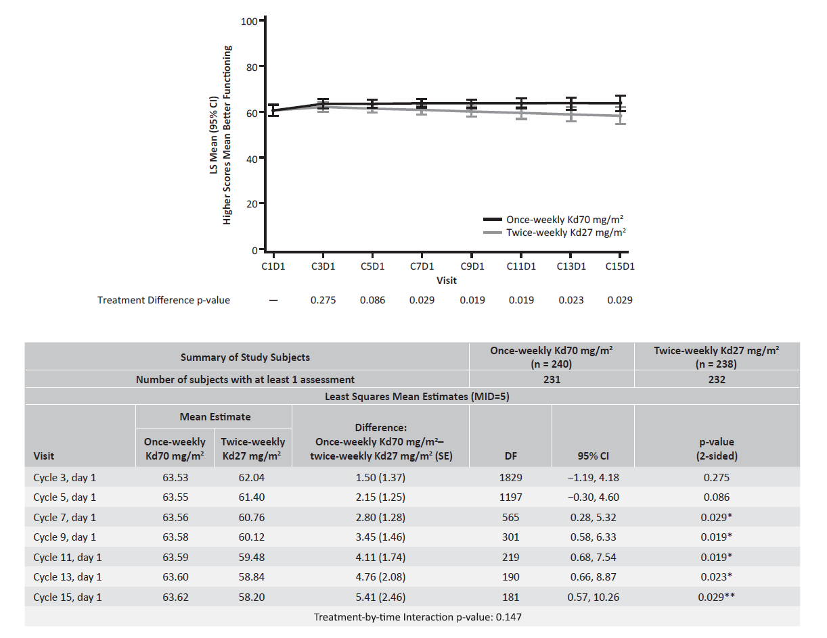
Visits up to cycle 21 day 1 were included in the analysis, though visits beyond cycle 9, day 1 had over 40% missing completion.
CI confidence interval, DF degrees of freedom, EORTC QLQ-C30 European Organization for Research and Treatment of Cancer Quality of Life Questionnaire Core Module, Kd27 mg/m² carfilzomib at 20/27 mg/m² plus dexamethasone, Kd70 mg/m² carfilzomib at 20/70 mg/m² plus dexamethasone, MID minimally important difference, SE standard error.
*Two-sided p value <0.05. **Two-sided p value <0.05 and clinically significant.
Supplemental Fig. 2 (online only) EQ-5D-5L index least squares means and treatment differences over time based on a mixed model for repeated measures with treatment-by-time interaction
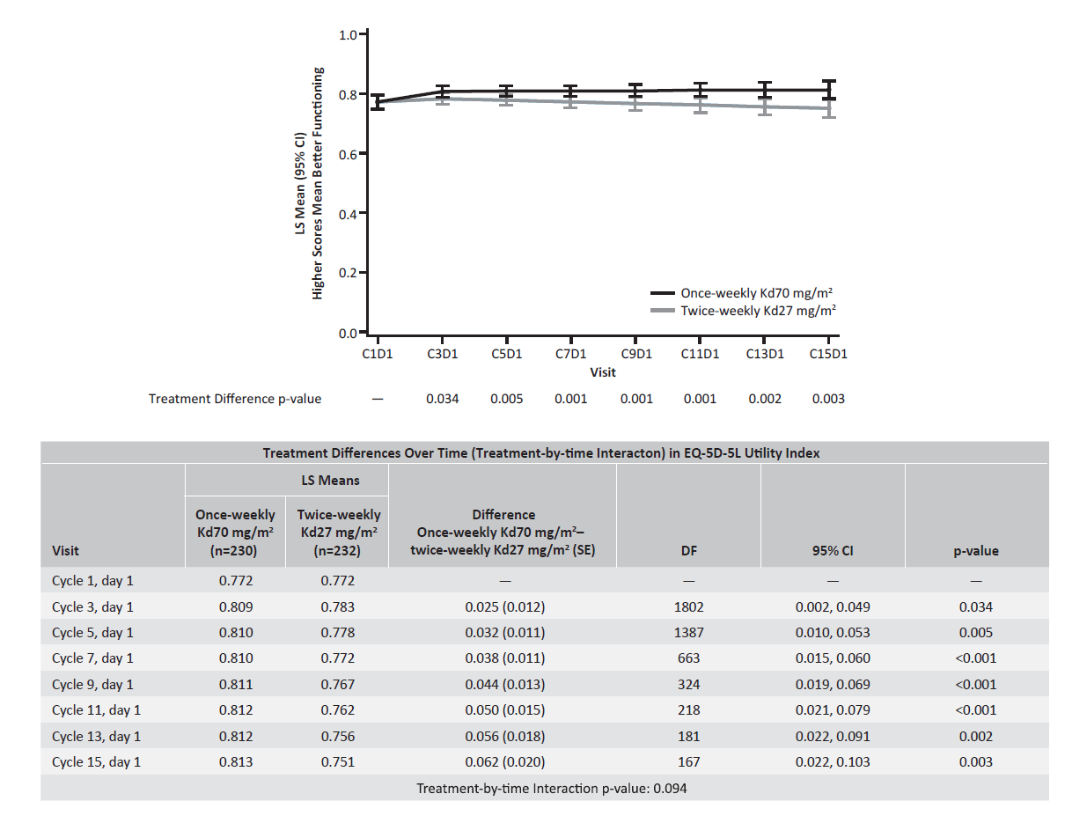
ITT population consists of 240 once-weekly Kd70 mg/m² patients and 238 twice-weekly Kd27 mg/m² patients.
Visits up to cycle 21, day 1 were included in the analysis, though visits beyond cycle 9, day 1 had over 40% missing completion.
CI confidence interval, DF degrees of freedom, EQ-5D-5L European Quality of Life–5 Dimensions–5 Levels, ITT intent-to-treat, Kd27 mg/m² carfilzomib at 20/27 mg/m² plus dexamethasone, Kd70 mg/m² carfilzomib at 20/70 mg/m² plus dexamethasone, LS least squares, SE, standard error.
Supplemental Fig. 3 (online only) Least squares means (95% confidence interval) over time based on a mixed model for repeated measures with treatment-by-time interaction. a Physical functioning. b Role functioning. c Fatigue. d Disease symptoms
A
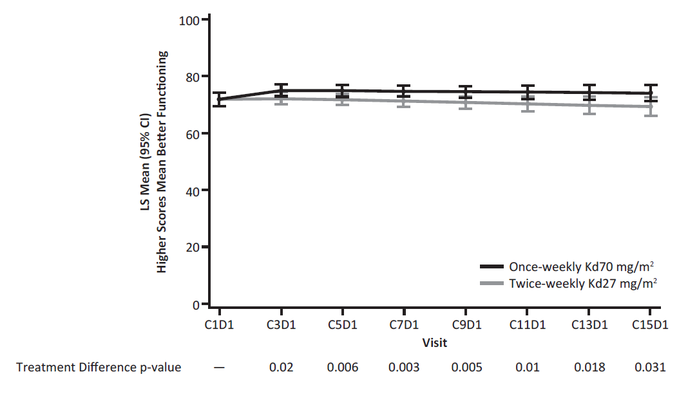
B
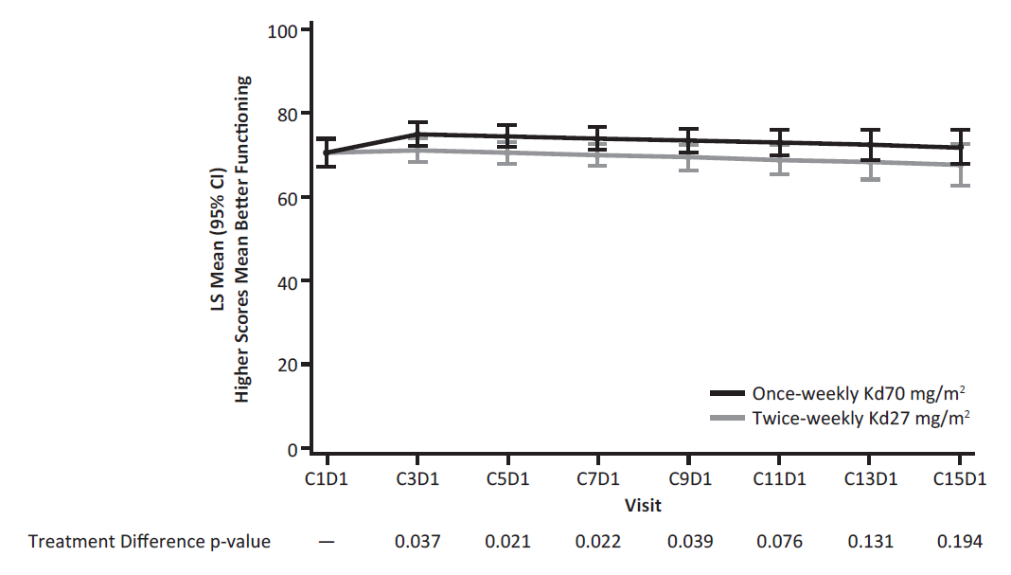

C
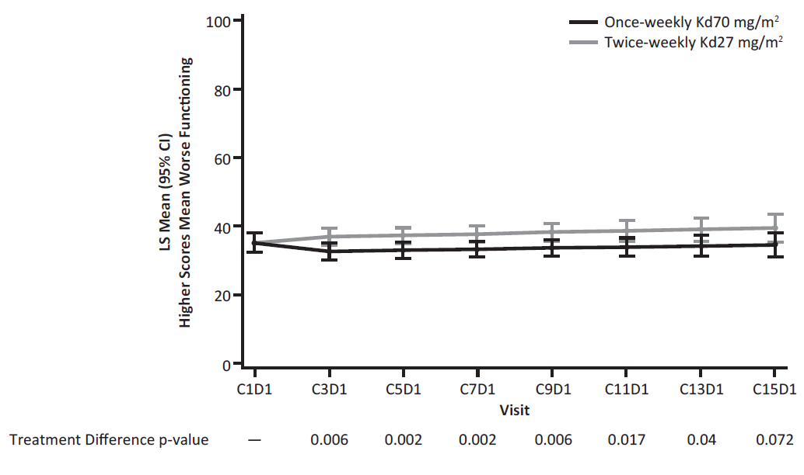
D
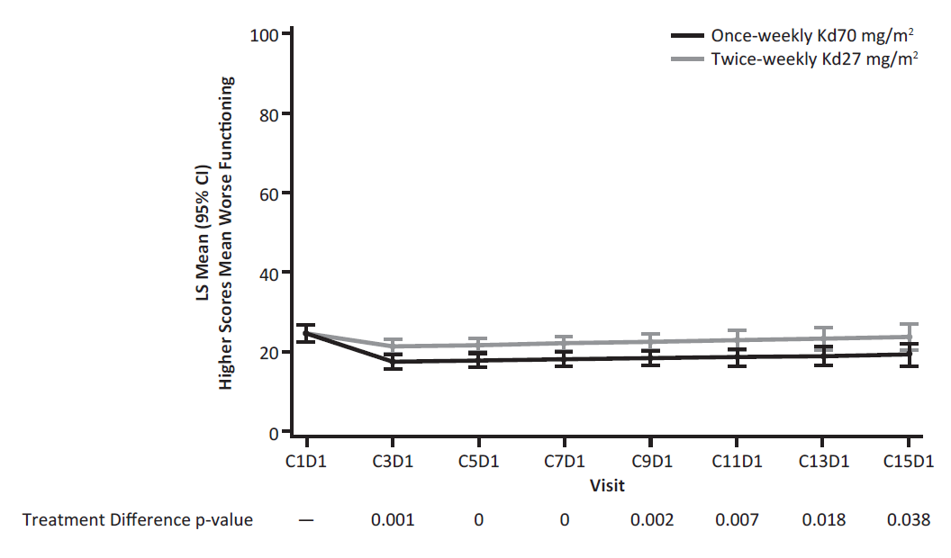

SUPPLEMENTAL REFERENCES
1. Aaronson NK, Ahmedzai S, Bergman B, Bullinger M, Cull A, Duez NJ et al. The European Organization for Research and Treatment of Cancer QLQ-C30: a quality-of-life instrument for use in international clinical trials in onocology. J Natl Cancer Inst 1993; 85: 365–376.
2. Stead ML, Brown JM, Velikova G, Kaasa S, Wisløff F, Child JA et al. Development of an EORTC questionnaire module to be used in health-related quality-of-life assessment for patients with multiple myeloma. European Organization for Research and Treatment of Cancer Study Group on Quality of Life. Br J Haematol 1999; 104: 605–611.
3. Cocks K, Cohen D, Wisløff F, Sezer O, Lee S, Hippe E et al. An international field study of the reliability and validity of a disease-specific questionnaire module (the QLQ-MY20) in assessing the quality of life of patients with multiple myeloma. Eur J Cancer 2007; 43: 1670–1678.
4. Herdman M, Gudex C, Lloyd A, Janssen M, Kind P, Parkin D et al. Development and preliminary testing of the new five-level version of EQ-5D (EQ-5D-5L). Qual Life Res 2011; 20: 1727–1736.
5. Devlin NJ, Shah KK, Feng Y, Mulhern B, Van Hout B. Valuing health-related quality of life: an EQ-5D-5L value set for England. Health Econ 2018; 27: 7–22.

