Supplementary information to:
Standardized next-generation sequencing of immunoglobulin and T-cell receptor gene recombinations for MRD marker identification in acute lymphoblastic leukemia; a EuroClonality-NGS validation study
Monika Brüggemann^{1*}, Michaela Kotrová^{1,2*,} Henrik Knecht¹, Jack Bartram³, Myriam Boudjogrha⁴, Vojtech Bystry⁵, Grazia Fazio⁶, Eva Froňková², Mathieu Giraud⁷, Andrea Grioni⁶, Jeremy Hancock⁸, Dietrich Herrmann¹, Cristina Jiménez⁹, Adam Krejci⁵, John Moppett¹⁰, Tomas Reigl⁵, Mikael Salson⁷, Blanca Scheijen¹¹, Martin Schwarz¹, Simona Songia⁶, Michael Svaton², Jacques JM van Dongen¹², Patrick Villarese¹³, Stephanie Wakeman⁸, Gary Wright³, Giovanni Cazzaniga⁶, Frédéric Davi⁴, Ramón García-Sanz⁹, David Gonzalez¹⁴, Patricia JTA Groenen¹¹, Michael Hummel¹⁵, Elizabeth A. Macintyre¹³, Kostas Stamatopoulos¹⁶, Christiane Pott¹, Jan Trka², Nikos Darzentas^{1,5}, Anton W. Langerak¹⁷, on behalf of the EuroClonality-NGS working group

Standard operating procedures for IG/TR NGS based marker identification

All standard operating procedures (the version used in this manuscript, as well as the most actual version) are available via the EuroClonality website at www.euroclonality.org/protocols.

Single-centre validation of IonTorrent as alternative sequencing platforms for EuroClonality IG/TR NGS assays for ALL marker identification.

Reproducibility of the assay was tested on Ion Torrent platform, using the 1st round PCR products of all 8 sequencing libraries created for 10 ALL patients and both positive (cPTC) and negative (aqua) control. Products from the 1st round of PCR except the purified TRB products, were diluted 1:50 unless amplicons were very weak. Primers containing unique sequencing indexes for each reaction tube and Ion Torrent adaptors were used for the 2nd round of PCR. Concentration of the final products was measured using Qubit dsDNA HS Assay Kit and products were pooled into 8 genewise tubes in equimolar ratios before being purified by gelextraction. Purified products were merged in equimolar ratios into one final pool with the final concentration of 90pM and the library was amplified using the Ion OneTouch 2 System. Sequencing was performed on Ion Torrent PGM sequencer with the Ion 318 TM Chip Kit v2 and Ion PGM HiQ Sequencing Kit resulting with 4,547,434 identified reads. Analysis of identified sequences was performed using the ARResT/Interrogate software and further checked with Vidjil software to allow for manual clustering of smaller clones that were the result of homopolymer errors during sequencing. These errors comprise only a minority of analysed reads (median of 2,4% from all analysed reads per target) and the majority of reads allows to identify a marker clonal IG/TR sequence without manual clustering.

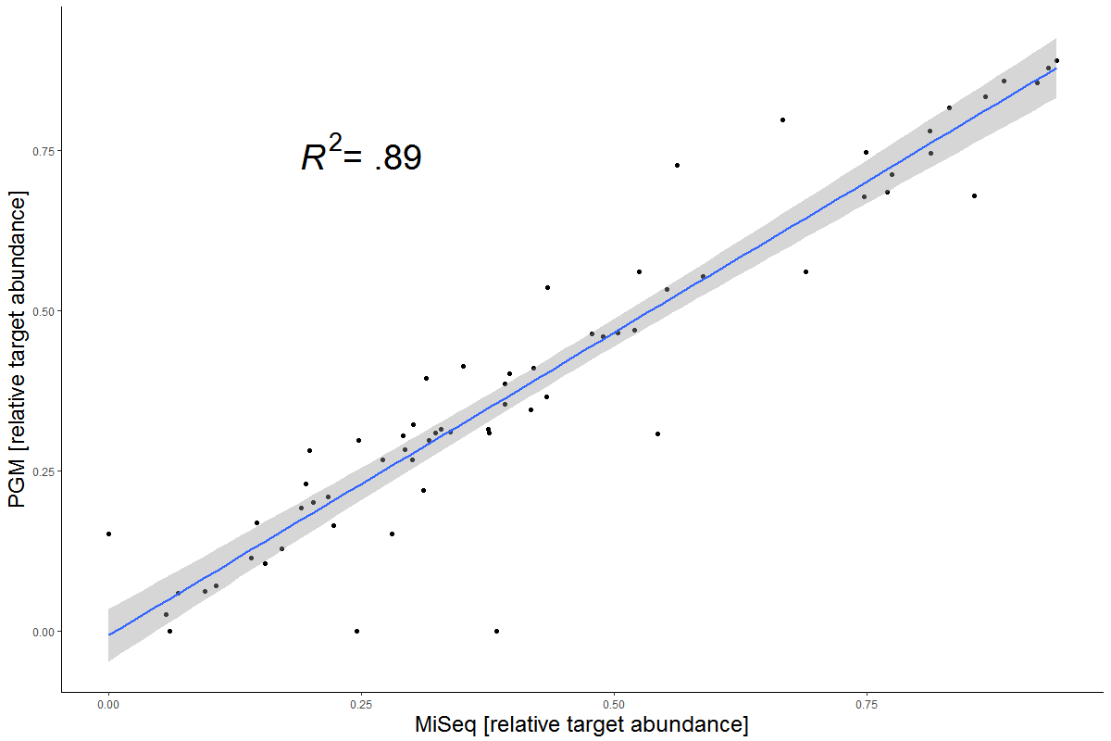
Identified clonal IG/TR sequences were compared to the results of MiSeq data analysis on the basis of their relative abundance based on the number of representing reads. Comparison of the two systems showed that both systems can be used for marker identification with high reproducibility (supp.figure)
Supplemental figure. Comparison of relative marker abundances as calculated from both systems. Linear regression model shows reliable correlation of independent results.

Out of the 65 markers passing the threshold of 5% reads in the tube during data analysis 4 markers would be identified by screening using Illumina MiSeq sequencer that were below the threshold in the data from Ion Torrent. Another marker was only found in the Ion Torrent data above the 5% threshold. The abundance of these markers was commonly around the cut-off threshold and comparable to the polyclonal background and spike-in control.

Table: Primers for the 2nd PCR containing Ion Torrent adaptors and barcodes. Those were used with the concentration 0,2µM.
Oligo Name | Oligo Sequence (5' to 3')
trP1MKIE | CCTCTCTATGGGCAGTCGGTGATTAATACGACTCACTATAGGG
AMID1 | CCATCTCATCCCTGCGTGTCTCCGACTCAGCTAAGGTAACGATGTAAAACGACGGCCAG
AMID2 | CCATCTCATCCCTGCGTGTCTCCGACTCAGTAAGGAGAACGATGTAAAACGACGGCCAG
AMID3 | CCATCTCATCCCTGCGTGTCTCCGACTCAGAAGAGGATTCGATGTAAAACGACGGCCAG
AMID4 | CCATCTCATCCCTGCGTGTCTCCGACTCAGTACCAAGATCGATGTAAAACGACGGCCAG
AMID5 | CCATCTCATCCCTGCGTGTCTCCGACTCAGCAGAAGGAACGATGTAAAACGACGGCCAG
AMID6 | CCATCTCATCCCTGCGTGTCTCCGACTCAGCAGAAGGAACGATGTAAAACGACGGCCAG
AMID7 | CCATCTCATCCCTGCGTGTCTCCGACTCAGTTCGTGATTCGATGTAAAACGACGGCCAG
AMID8 | CCATCTCATCCCTGCGTGTCTCCGACTCAGTTCCGATAACGATGTAAAACGACGGCCAG
AMID9 | CCATCTCATCCCTGCGTGTCTCCGACTCAGTGAGCGGAACGATGTAAAACGACGGCCAG
AMID10 | CCATCTCATCCCTGCGTGTCTCCGACTCAGCTGACCGAACGATGTAAAACGACGGCCAG
AMID11 | CCATCTCATCCCTGCGTGTCTCCGACTCAGTCCTCGAATCGATGTAAAACGACGGCCAG
AMID12 | CCATCTCATCCCTGCGTGTCTCCGACTCAGTAGGTGGTTCGATGTAAAACGACGGCCAG
AMID13 | CCATCTCATCCCTGCGTGTCTCCGACTCAGTCTAACGGACGATGTAAAACGACGGCCAG
AMID14 | CCATCTCATCCCTGCGTGTCTCCGACTCAGTTGGAGTGTCGATGTAAAACGACGGCCAG
AMID15 | CCATCTCATCCCTGCGTGTCTCCGACTCAGTCTAGAGGTCGATGTAAAACGACGGCCAG
AMID16 | CCATCTCATCCCTGCGTGTCTCCGACTCAGTCTGGATGACGATGTAAAACGACGGCCAG
AMID17 | CCATCTCATCCCTGCGTGTCTCCGACTCAGTCTATTCGTCGATGTAAAACGACGGCCAG
AMID18 | CCATCTCATCCCTGCGTGTCTCCGACTCAGAGGCAATTGCGATGTAAAACGACGGCCAG
AMID19 | CCATCTCATCCCTGCGTGTCTCCGACTCAGTTAGTCGGACGATGTAAAACGACGGCCAG
AMID20 | CCATCTCATCCCTGCGTGTCTCCGACTCAGCAGATCCATCGATGTAAAACGACGGCCAG
AMID21 | CCATCTCATCCCTGCGTGTCTCCGACTCAGTCGCAATTACGATGTAAAACGACGGCCAG
AMID22 | CCATCTCATCCCTGCGTGTCTCCGACTCAGTTCGAGACGCGATGTAAAACGACGGCCAG
AMID23 | CCATCTCATCCCTGCGTGTCTCCGACTCAGTGCCACGAACGATGTAAAACGACGGCCAG
AMID24 | CCATCTCATCCCTGCGTGTCTCCGACTCAGAACCTCATTCGATGTAAAACGACGGCCAG
AMID25 | CCATCTCATCCCTGCGTGTCTCCGACTCAGCCTGAGATACGATGTAAAACGACGGCCAG
AMID26 | CCATCTCATCCCTGCGTGTCTCCGACTCAGTTACAACCTCGATGTAAAACGACGGCCAG
AMID27 | CCATCTCATCCCTGCGTGTCTCCGACTCAGAACCATCCGCGATGTAAAACGACGGCCAG
AMID28 | CCATCTCATCCCTGCGTGTCTCCGACTCAGATCCGGAATCGATGTAAAACGACGGCCAG
AMID29 | CCATCTCATCCCTGCGTGTCTCCGACTCAGTCGACCACTCGATGTAAAACGACGGCCAG
AMID30 | CCATCTCATCCCTGCGTGTCTCCGACTCAGCGAGGTTATCGATGTAAAACGACGGCCAG
AMID31 | CCATCTCATCCCTGCGTGTCTCCGACTCAGTCCAAGCTGCGATGTAAAACGACGGCCAG
AMID32 | CCATCTCATCCCTGCGTGTCTCCGACTCAGTCTTACACACGATGTAAAACGACGGCCAG
AMID33 | CCATCTCATCCCTGCGTGTCTCCGACTCAGTTCTCATTGAACGATGTAAAACGACGGCCAG
AMID34 | CCATCTCATCCCTGCGTGTCTCCGACTCAGTCGCATCGTTCGATGTAAAACGACGGCCAG
AMID35 | CCATCTCATCCCTGCGTGTCTCCGACTCAGTAAGCCATTGTCGATGTAAAACGACGGCCAG
AMID36 | CCATCTCATCCCTGCGTGTCTCCGACTCAGAAGGAATCGTCGATGTAAAACGACGGCCAG
AMID37 | CCATCTCATCCCTGCGTGTCTCCGACTCAGCTTGAGAATGTCGATGTAAAACGACGGCCAG
AMID38 | CCATCTCATCCCTGCGTGTCTCCGACTCAGTGGAGGACGGACGATGTAAAACGACGGCCAG
AMID39 | CCATCTCATCCCTGCGTGTCTCCGACTCAGTAACAATCGGCGATGTAAAACGACGGCCAG
AMID40 | CCATCTCATCCCTGCGTGTCTCCGACTCAGCTGACATAATCGATGTAAAACGACGGCCAG
AMID41 | CCATCTCATCCCTGCGTGTCTCCGACTCAGTTCCACTTCGCGATGTAAAACGACGGCCAG
AMID42 | CCATCTCATCCCTGCGTGTCTCCGACTCAGAGCACGAATCGATGTAAAACGACGGCCAG
AMID43 | CCATCTCATCCCTGCGTGTCTCCGACTCAGCTTGACACCGCGATGTAAAACGACGGCCAG
AMID44 | CCATCTCATCCCTGCGTGTCTCCGACTCAGTTGGAGGCCAGCGATGTAAAACGACGGCCAG
AMID45 | CCATCTCATCCCTGCGTGTCTCCGACTCAGTGGAGCTTCCTCGATGTAAAACGACGGCCAG
AMID46 | CCATCTCATCCCTGCGTGTCTCCGACTCAGTCAGTCCGAACGATGTAAAACGACGGCCAG
AMID47 | CCATCTCATCCCTGCGTGTCTCCGACTCAGTAAGGCAACCACGATGTAAAACGACGGCCAG
AMID48 | CCATCTCATCCCTGCGTGTCTCCGACTCAGTTCTAAGAGACGATGTAAAACGACGGCCAG
AMID49 | CCATCTCATCCCTGCGTGTCTCCGACTCAGTCCTAACATAACGATGTAAAACGACGGCCAG
AMID50 | CCATCTCATCCCTGCGTGTCTCCGACTCAGCGGACAATGGCGATGTAAAACGACGGCCAG
AMID51 | CCATCTCATCCCTGCGTGTCTCCGACTCAGTTGAGCCTATTCGATGTAAAACGACGGCCAG
AMID52 | CCATCTCATCCCTGCGTGTCTCCGACTCAGCCGCATGGAACGATGTAAAACGACGGCCAG
AMID53 | CCATCTCATCCCTGCGTGTCTCCGACTCAGCTGGCAATCCTCGATGTAAAACGACGGCCAG
AMID54 | CCATCTCATCCCTGCGTGTCTCCGACTCAGCCGGAGAATCGCGATGTAAAACGACGGCCAG
AMID55 | CCATCTCATCCCTGCGTGTCTCCGACTCAGTCCACCTCCTCGATGTAAAACGACGGCCAG
AMID56 | CCATCTCATCCCTGCGTGTCTCCGACTCAGCAGCATTAATTCGATGTAAAACGACGGCCAG
AMID57 | CCATCTCATCCCTGCGTGTCTCCGACTCAGTCTGGCAACGGCGATGTAAAACGACGGCCAG
AMID58 | CCATCTCATCCCTGCGTGTCTCCGACTCAGTCCTAGAACACGATGTAAAACGACGGCCAG
AMID59 | CCATCTCATCCCTGCGTGTCTCCGACTCAGTCCTTGATGTTCGATGTAAAACGACGGCCAG
AMID60 | CCATCTCATCCCTGCGTGTCTCCGACTCAGTCTAGCTCTTCGATGTAAAACGACGGCCAG
AMID61 | CCATCTCATCCCTGCGTGTCTCCGACTCAGTCACTCGGATCGATGTAAAACGACGGCCAG
AMID62 | CCATCTCATCCCTGCGTGTCTCCGACTCAGTTCCTGCTTCACGATGTAAAACGACGGCCAG
AMID63 | CCATCTCATCCCTGCGTGTCTCCGACTCAGCCTTAGAGTTCGATGTAAAACGACGGCCAG
AMID64 | CCATCTCATCCCTGCGTGTCTCCGACTCAGCTGAGTTCCGACGATGTAAAACGACGGCCAG
AMID65 | CCATCTCATCCCTGCGTGTCTCCGACTCAGTCCTGGCACATCGATGTAAAACGACGGCCAG
AMID66 | CCATCTCATCCCTGCGTGTCTCCGACTCAGCCGCAATCATCGATGTAAAACGACGGCCAG
AMID67 | CCATCTCATCCCTGCGTGTCTCCGACTCAGTTCCTACCAGTCGATGTAAAACGACGGCCAG
AMID68 | CCATCTCATCCCTGCGTGTCTCCGACTCAGTCAAGAAGTTCGATGTAAAACGACGGCCAG
AMID69 | CCATCTCATCCCTGCGTGTCTCCGACTCAGTTCAATTGGCGATGTAAAACGACGGCCAG
AMID70 | CCATCTCATCCCTGCGTGTCTCCGACTCAGCCTACTGGTCGATGTAAAACGACGGCCAG
AMID71 | CCATCTCATCCCTGCGTGTCTCCGACTCAGTGAGGCTCCGACGATGTAAAACGACGGCCAG
AMID72 | CCATCTCATCCCTGCGTGTCTCCGACTCAGCGAAGGCCACACGATGTAAAACGACGGCCAG
AMID73 | CCATCTCATCCCTGCGTGTCTCCGACTCAGTCTGCCTGTCGATGTAAAACGACGGCCAG
AMID74 | CCATCTCATCCCTGCGTGTCTCCGACTCAGCGATCGGTTCGATGTAAAACGACGGCCAG
AMID75 | CCATCTCATCCCTGCGTGTCTCCGACTCAGTCAGGAATACGATGTAAAACGACGGCCAG
AMID76 | CCATCTCATCCCTGCGTGTCTCCGACTCAGCGGAAGAACCTCGATGTAAAACGACGGCCAG
AMID77 | CCATCTCATCCCTGCGTGTCTCCGACTCAGCGAAGCGATTCGATGTAAAACGACGGCCAG
AMID78 | CCATCTCATCCCTGCGTGTCTCCGACTCAGCAGCCAATTCTCGATGTAAAACGACGGCCAG
AMID79 | CCATCTCATCCCTGCGTGTCTCCGACTCAGCCTGGTTGTCGATGTAAAACGACGGCCAG
AMID80 | CCATCTCATCCCTGCGTGTCTCCGACTCAGTCGAAGGCAGGCGATGTAAAACGACGGCCAG
AMID81 | CCATCTCATCCCTGCGTGTCTCCGACTCAGCCTGCCATTCGCGATGTAAAACGACGGCCAG
AMID82 | CCATCTCATCCCTGCGTGTCTCCGACTCAGTTGGCATCTCGATGTAAAACGACGGCCAG
AMID83 | CCATCTCATCCCTGCGTGTCTCCGACTCAGCTAGGACATTCGATGTAAAACGACGGCCAG
AMID84 | CCATCTCATCCCTGCGTGTCTCCGACTCAGCTTCCATAACGATGTAAAACGACGGCCAG
AMID85 | CCATCTCATCCCTGCGTGTCTCCGACTCAGCCAGCCTCAACGATGTAAAACGACGGCCAG
AMID86 | CCATCTCATCCCTGCGTGTCTCCGACTCAGCTTGGTTATTCGATGTAAAACGACGGCCAG
AMID87 | CCATCTCATCCCTGCGTGTCTCCGACTCAGTTGGCTGGACGATGTAAAACGACGGCCAG
AMID88 | CCATCTCATCCCTGCGTGTCTCCGACTCAGCCGAACACTTCGATGTAAAACGACGGCCAG
AMID89 | CCATCTCATCCCTGCGTGTCTCCGACTCAGTCCTGAATCTCGATGTAAAACGACGGCCAG
AMID90 | CCATCTCATCCCTGCGTGTCTCCGACTCAGCTAACCACGGCGATGTAAAACGACGGCCAG
AMID91 | CCATCTCATCCCTGCGTGTCTCCGACTCAGCGGAAGGATGCGATGTAAAACGACGGCCAG
AMID92 | CCATCTCATCCCTGCGTGTCTCCGACTCAGCTAGGAACCGCGATGTAAAACGACGGCCAG
AMID93 | CCATCTCATCCCTGCGTGTCTCCGACTCAGCTTGTCCAATCGATGTAAAACGACGGCCAG
AMID94 | CCATCTCATCCCTGCGTGTCTCCGACTCAGTCCGACAAGCGATGTAAAACGACGGCCAG
AMID95 | CCATCTCATCCCTGCGTGTCTCCGACTCAGCGGACAGATCGATGTAAAACGACGGCCAG
AMID96 | CCATCTCATCCCTGCGTGTCTCCGACTCAGTTAAGCGGTCGATGTAAAACGACGGCCAG

Optimization of PCR conditions and library purification methods - Removal of polyclonal DNA from reaction mix

DNA of 4 samples with B- and 4 samples with T-cell aplasia after anti-B-/anti-T-cell targeted treatment was used for library preparation. In all these cases aplasia was confirmed by flow cytometry. The two samples with B-cell aplasia were chronic lymphocytic leukemia samples after Rituximab (anti-CD20) treatment and the two samples with T-cell aplasia were T-cell prolymphocytic leukemia samples after Alemtuzumab (anti-CD52) treatment. Spike-in DNA was added to each sample, but no polyclonal DNA was used.
The following figure shows the sequencing libraries after the 2nd PCR and the gel extraction. Negative control (aqua) and polyclonal DNA (BC) were used as negative and positive control, respectively. No excessive primer-dimer formation was observed in any of the PCR tubes.
