Supplementary information
The supplementary information includes five supplementary tables and one supplementary figure.
Table S1. Adverse events not considered in the manuscript that occurred prior to cut-off but were reported after the data
analysis snapshot
AE | Age, years  (gender) | Onset  (study day) | End  (study day) | Grade | SAE | Relationship to obinutuzumab/  chemotherapy | Outcome
Hepatitis E | 58 (F) | 570 | 1024 | 3 | Y | Related to obinutuzumab and chemotherapy | Resolved
Neutropenia | 66 (M) | 113 | NA | 2 | N | Related to chemotherapy | Ongoing
Myelosuppression | 61 (M) | 181 | 203 | 3 | N | Related to chemotherapy | Resolved
Headache | 41 (M) | NA | 755 | 3 | Y | Not related | Resolved with sequelae
Fatigue* | 58 (F) | 161 | NA | 1 | N | Related to obinutuzumab and chemotherapy | Ongoing
Neuropathy* | 58 (F) | 245 | 480 | 1 | N | Related to obinutuzumab and chemotherapy | Resolved
Febrile neutropenia | 50 (M) | 99 | 99 | 3 | Y | Related to obinutuzumab and chemotherapy | Resolved
*AEs occurred in the same patient. AE, adverse event; F, female; M, male; N, no; NA, not available; SAE, serious adverse event; Y, yes.

Table S2. Change in final response assessment*
 | Age, years (gender) | Primary analysis snapshot | Updated to
Response | 58 (M) | CR | CRi
*After the data analysis snapshot was taken, one response was changed from CR to CRi by a site on the database that remained open to continue collecting information until the final analysis.
CR, complete response; CRi, complete response with incomplete marrow recovery; M, male.

Table S3. Summary of infusion-related reactions (safety population)
N (%) of patients reporting IRRs
(N = 140)
Any IRR | 97 (69.3)
Grade ≥3 IRRs | 27 (19.3)
Serious IRRs | 13 (9.3)
IRRs leading to treatment discontinuation | 1 (<1.0)
IRRs (reported by ≥2% patients, any grade by preferred term)
Pyrexia | 27 (19.3)
Nausea | 21 (15.0)
Chills | 11 (7.9)
Vomiting | 10 (7.1)
Dyspnea | 10 (7.1)
Rash | 9 (6.4)
Hypertension | 8 (5.7)
Hyperhidrosis | 7 (5.0)
Chest discomfort | 7 (5.0)
Hyperthermia | 7 (5.0)
Hypotension | 7 (5.0)
Headache | 6 (4.3)
Thrombocytopenia | 6 (4.3)
Alanine aminotransferase increased | 5 (3.6)
Aspartate aminotransferase increased | 5 (3.6)
Hot flush | 5 (3.6)
Cytokine release syndrome | 4 (2.9)
Tachycardia | 4 (2.9)
Asthenia | 3 (2.1)
Anemia | 3 (2.1)
Neutropenia | 3 (2.1)
Tumor lysis syndrome | 3 (2.1)
IRRs, infusion-related reactions.

Table S4. Listing of grade 5 (fatal) adverse events (safety population)
AE  (preferred term) | Age, years  (gender) | Treatment period (onset of event)* | AESI | AEPI | Relationship to obinutuzumab/  chemotherapy
Unexplained death | 65 (M) | Post (Day 146) | N | N | Not related
Sepsis | 74 (F) | Post (Day 180) | Y | N | Not related
Acute fibrinous organizing pneumonia | 47 (F) | During (Day 105) | N | N | Related to obinutuzumab and chemotherapy
Acute myeloid leukemia | 64 (M) | Post (Day 903) | N | Y | Not related
*Post = post treatment period; during = during treatment period.
AE, adverse event; AEPI, adverse events of particular interest; AESI, adverse event of special interest; F, female; M, male; N, no; Y, yes.

Table S5. Minimal residual disease response in peripheral blood and bone marrow according to IGHV mutation status
n/N (%) | All patients (N = 140)
Peripheral blood
IGHV mutated | N = 37
Number of patients included in analysis | 29
MRD negative | 28/29 (96.6)
MRD positive | 0
MRD unknown | 1/29 (3.4)
IGHV unmutated | N = 77
Number of patients included in analysis | 59
MRD negative | 54/59 (91.5)
MRD positive | 5/59 (8.5)
Bone marrow
IGHV mutated | N = 37
Number of patients included in analysis | 21
MRD negative | 14/21 (66.7)
MRD positive | 7/21 (33.3)
IGHV unmutated | N = 77
Number of patients included in analysis | 43
MRD negative | 31/43 (72.1)
MRD positive | 11/43 (25.6)
MRD unknown | 1 (2.3)
IGHV, immunoglobulin heavy chain variable region; MRD, minimal residual disease.

Fig. S1. Kaplan−Meier plot of progression-free survival according to IGHV mutation status (ITT population)
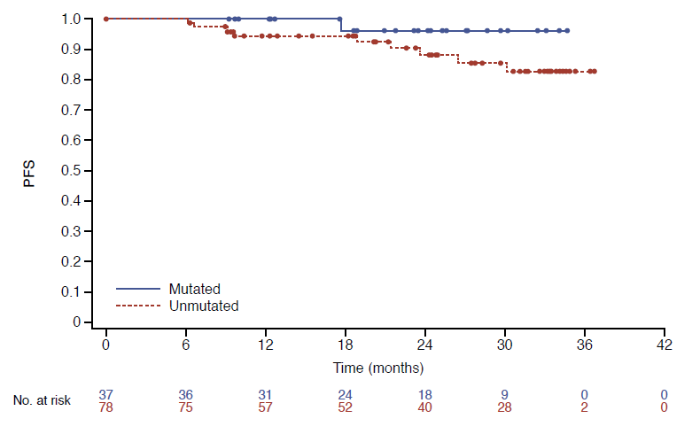
IGHV, immunoglobulin heavy chain variable region; ITT, intent-to-treat; PFS, progression-free survival.

