SUPPLEMENTARY INFORMATION
Aberrant RAG-mediated recombination contributes to multiple structural rearrangements in lymphoid blast crisis of chronic myeloid leukemia

Supplementary Materials and Methods

RNAseq gene expression analysis
Sequencing was performed on an Illumina HiSeq2500 or NextSeq 500 using the Illumina TruSeq stranded total RNA (non-polyA captured) protocol for 100bp or 150bp paired end sequencing as previously described(1). Strand-specific read counts under the iGenomes/UCSC hg19 gene models were quantified using STAR(2). Expression analysis and visualization was carried out in R (v3.5.2), using Bioconductor (v3.4) packages limma(3, 4) and edgeR(4, 5) and annotated using the Bioconductor Homo.sapiens library. Expression was normalized using the TMM method(6). Heteroscedasticity was allowed for using voom(7), quantification of differentially expressed genes between groups using TREAT(8). Table of genes expression, in lcpm (Supplementary Table 5), was printed prior to removing genes with <1 counts per million in at least one group (diagnosis, MBC or LBC). Multidimensional scaling (MDS) and mean-difference (MD) plots were made using limma(3). Heatmaps were created using Heatmap3(9), with hierarchical clustering performed via Ward’s linkage method and utilizing a Euclidean distance metric. Gene ontology annotation was performed using GOPanther(10). Gene expression was plotted with boxplots, with differences of statistical significance calculated with a student’s t test and p-value indicated *<0.05, **<0.01, ***<0.001, ****<0.0001. Expression analysis was performed for the patients tested at CP diagnosis and compared with those who transformed to BC during therapy. Samples were excluded from the expression analysis, differing from our previous report(1) for the following reasons: ‘14_LBC’ was the only patient with T-cell leukemia; ‘4_LBC’ was found to be heavily treated with chemotherapy at the time of sample collection and the disease burden was low and not representative of the BC clone; ‘28_diagnosis’ was found to have a low tumor burden at diagnosis; patients 1, 2 and 38 were diagnosed in BC; and the diagnosis and BC samples for patient 23 were excluded since the sample type was bone marrow, whereas expression analysis was uniformly assessed using peripheral blood for all other samples.

Bioinformatic identification of RAG-mediated genomic deletions from WES data
Patient samples were divided into 5 groups with roughly similar number of samples in each group: 3 diagnosis groups corresponding to subsequent outcome, MMR (n=9), MBC (n=9) or LBC (n=6); and 2 BC groups, MBC (n=11) and LBC (n=8). One LBC sample was excluded as the quality of the data was found to be suboptimal for this analysis (patient 16). To identify candidate structural variants from WES, we used Manta v1.2.1(11) with the following options; --bam \ –exome \ --generateEvidenceBam \ --outputContig. We then filtered the CandidateSV.vcf output using bcftools(12) to select for genomic deletions with nucleotide insertions (2-25 nucleotides in length), and a minimum PAIR_COUNT of 2. Genomic sequence surrounding breakpoints (+/- 25 nucleotides) were calculated with bedtools getfasta(13), and unsupervised motif enrichment was performed using MEME(14). A summary schematic is provided in Supplementary Figure 3.

Combinatorial method of identification of structural variants
Copy number variation (CNV) analysis was performed as previously described(1). Chimeric transcripts were identified from RNAseq with STAR(2) and aberrant splicing identified by selection of unannotated splice junctions from STAR’s SJ.out.tab file. A summary schematic is provided in Supplementary Figure 1.

Identification of acquired single nucleotide variants and COSMIC mutational signatures
Somatic single nucleotide variants (SNVs) were identified with high confidence using 7 variant callers: Strelka (v1.0.13)(15), MuTect (v1.1.4)(16), Virmid (v1.1.1)(17), Seurat (v2.5)(18), Shimmer (v0.1.1)(19), SomaticSniper (v1.0.3)(20) and Varscan2 (v2.3.5)(21) as described(1). COSMIC mutational signatures(22) were calculated using MuSiCa (mutational signatures in cancer)(23) using 691 somatic SNVs from 31 diagnosis patients, 235 SNVs from 7 LBC patients and 406 SNVs from 11 MBC patients, where matched germline samples were available. Two diagnosis and 2 LBC samples were excluded from the analysis since no germline samples were available to establish the somatic status of SNVs (patients 7 and 10).

Quantitative reverse transcription PCR
RNA extraction and cDNA synthesis was performed as described(24). Quantitative reverse transcription PCR (qRT-PCR) was performed using the following conditions: 5 µL of Power SYBR™ Green PCR Master Mix (Thermo Fisher Scientific), 2.5 µL of AccuGene water, 250nM of each forward and reverse PCR primers and 2 µL of cDNA template. qRT-PCR was performed on a ViiA7 instrument with the following cycling conditions: 50°C 2 min, 95°C 10 min, 95°C 15 s, 60°C 1 min (40 cycles), 95°C 15 s, 60°C 15 s, 95°C 15 s. For each sample, 2 separate RT reactions were performed and each cDNA underwent separate qPCR analysis for each gene of interest (RAG1, RAG2 and DNTT) and reference genes (ELF1 and IPO8). Reference genes were chosen from lists of published reference genes(25, 26) and assessed for consistent expression between CML disease phases using our RNAseq expression data. Serial dilution assays were performed and the average amplification efficiency calculated for each gene. ViiA7 software (Applied Biosystems) assessed CT values and the relative mRNA expression levels were determined using the method of Pfaffl et al.(27). The LBC cell line BV-173 that expresses high levels of RAG1/2 and DNTT was used as the control for each reaction. BCR-ABL1 expression was performed as described(28).

Primer sequences (5’)
RAG1_F:gagggcaaggagagagcaga
RAG1_R:gctgaatttcatctggggca
RAG2_F:ggcaaagattcagagaggcg
RAG2_R:cagtggggcaggatcttttg
DNTT_F:ATTTGGAGTGGGGCTGAAGA
DNTT_R:CATCCGGAAGAAATGCCCAG
ELF1_F:AGTTCACTGGATGTTGCTGAAGAA
ELF1_R:CAATTGTTTCATCCCCGTCAT
IPO8_F:gaagcagatgaagccacaca
IPO8_R:atggatcttcttgccacagc

Data Sharing Statement
The sequence data have been deposited at the European Genome-phenome Archive, which is hosted by the European Bioinformatics Institute, under accession #EGAS00001003071.

Supplementary Figures
Supplementary Figure 1. Bioinformatics pipeline. Bioinformatic analyses included fusion detection (STAR and Manta), gene expression analysis (EdgeR, Limma), and copy number variation analysis (developed in-house(1)). Unsupervised motif detection of sequences surrounding breakpoints was performed with MEME. High confidence single nucleotide variants (SNV’s) were unanimously detected by 7 different SNV callers and COSMIC(22) mutational signatures were quantified using MuSiCa(23).

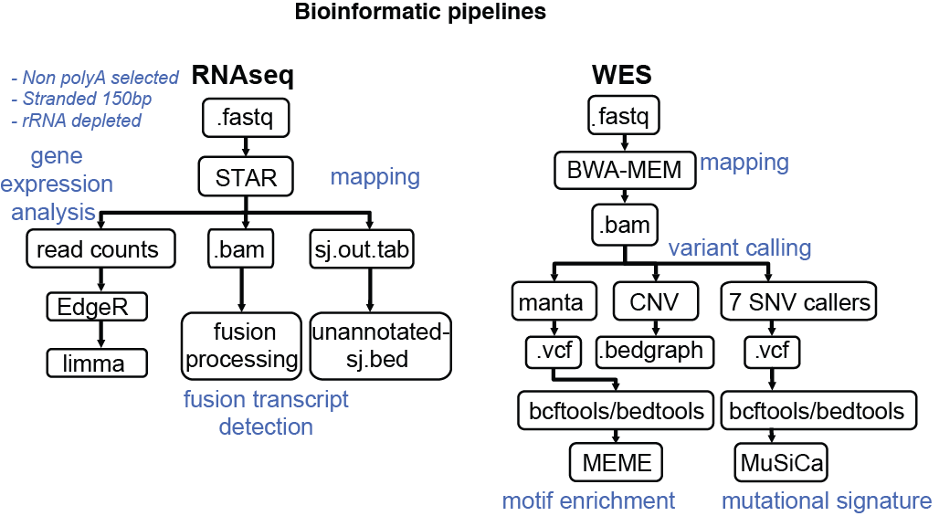

Supplementary Figure 2. CML disease phase is characterized by global differential gene expression. Heatmap of top 1000 genes that were differently expressed between LBC and MBC groups (P<0.001). Hierarchical clustering of 70 patient samples separated LBC patient samples (red) from diagnosis/CP (green) and MBC (blue).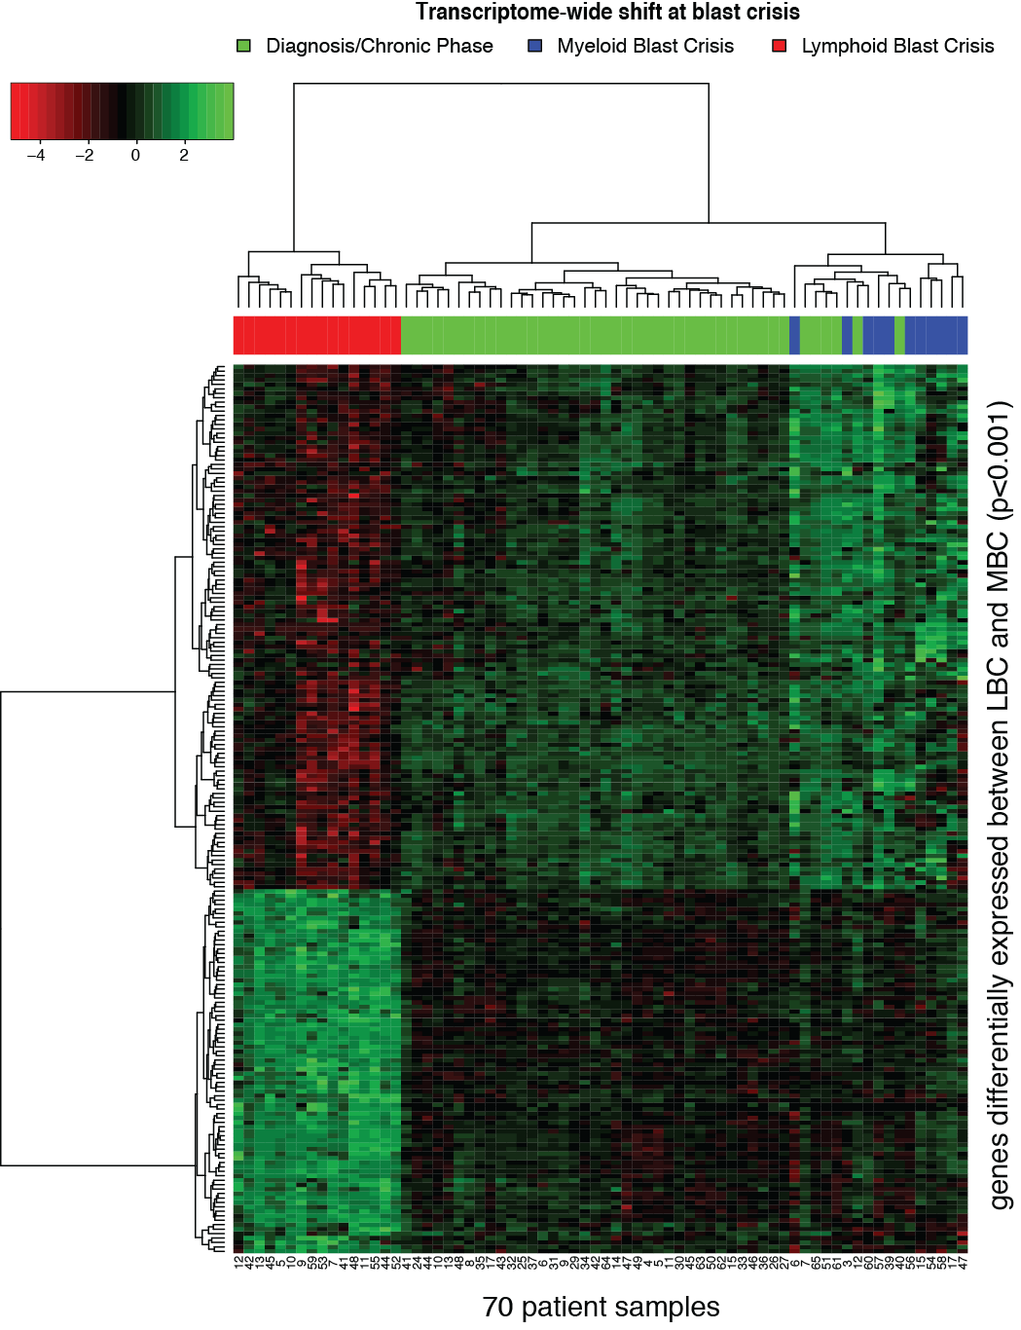
Supplementary Figure 3. Bioinformatic pipeline for identification of genomic deletions with the RAG signature. WES results from CML samples were divided into groups corresponding to diagnosis in CP (Dx/CP) and blast crisis (BC) and further subdivided into subsequent outcome; major molecular response (MMR), myeloid blast crisis (MBC) or lymphoid blast crisis (LBC). Manta(11) was used to identify genomic deletions and filter for those with nucleotide insertions (2 to 25 nucleotides in length). The genomic sequence surrounding breakpoints (+/- 25 nucleotides) was then investigated for motif enrichment (MEME(14)).

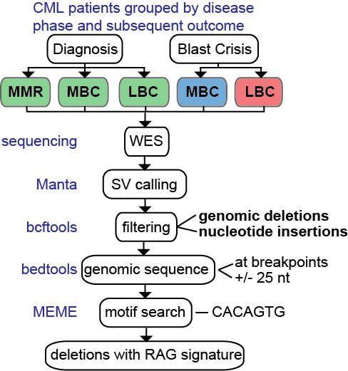

Supplementary Figure 4. Identification of genomic deletions with nucleotide insertions show antigen receptor rearrangement at LBC. Bioinformatically identified genomic deletions with RAG signature (deletions with nucleotide insertions, represented by blue bars) were visualized using Integrative Genomics Viewer (IGV)(29), at IMGT (international ImMunoGeneTics information system(30)) defined regions. The majority of RAG-mediated deletions were in LBC.
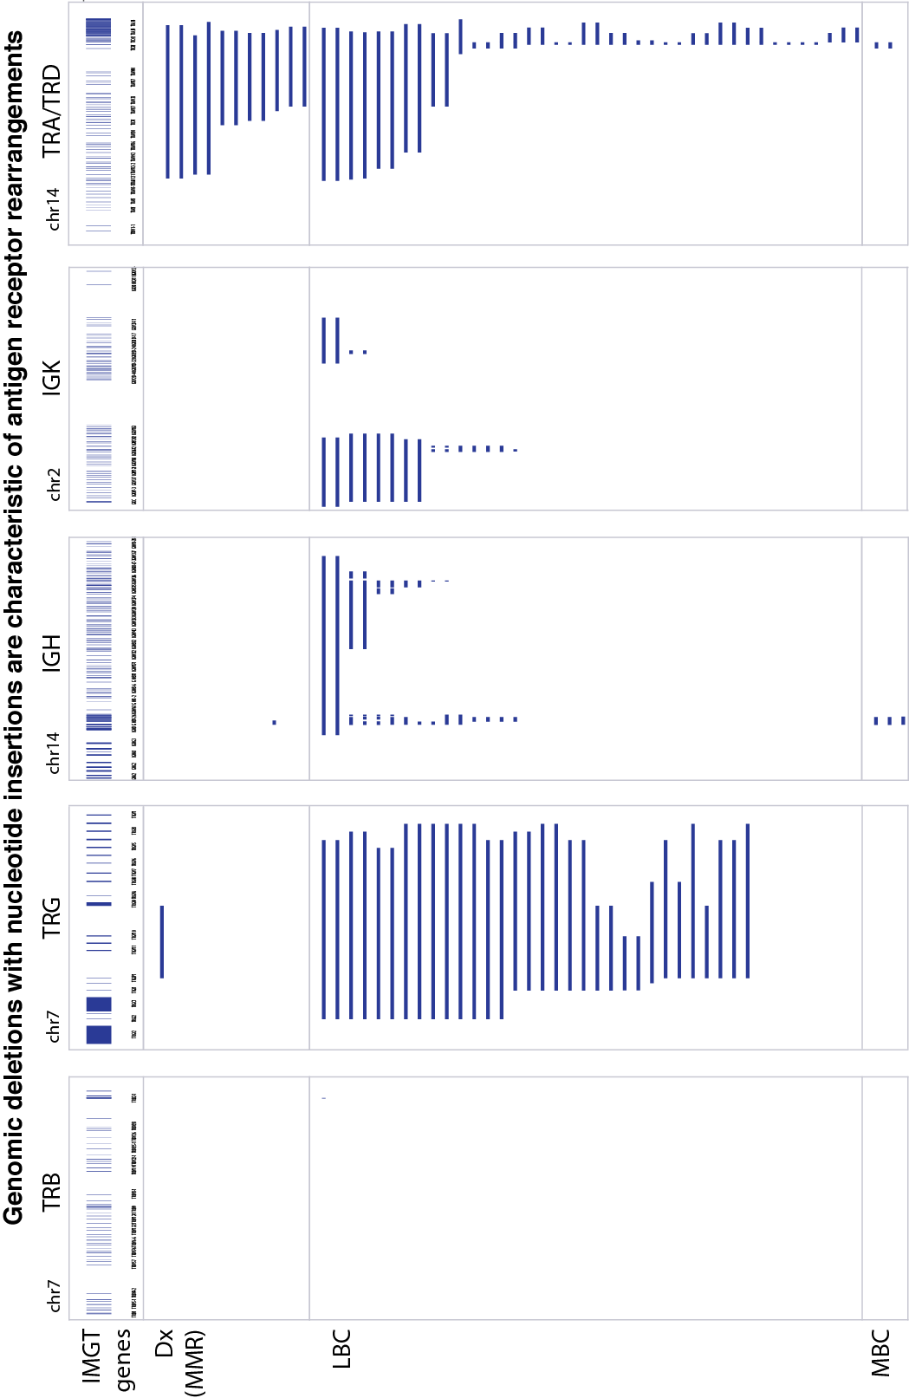

Supplementary Figure 5. Copy number loss at antigen receptor loci was observed in patients at LBC. Copy number variation (CNV) analysis from WES shows promiscuous V(D)J recombination, seen as copy number loss (descending red bars) at antigen receptor loci including immunoglobulin and T-cell receptor (TCR) loci. Typical examples of patients at LBC and MBC are shown, with corresponding diagnosis/CP sample shown for LBC patients.

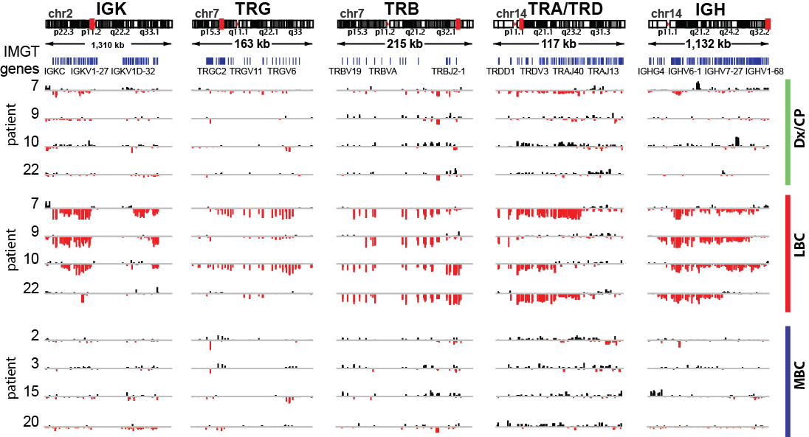

Supplementary Figure 6. RAG is constitutively up-regulated by reinforced regulatory activation. Boxplots showing expression of key V(D)J recombination inhibitors (top) and activators (bottom), in 43 patients at diagnosis (green), 11 in MBC (blue) and 16 in LBC (red). Statistical difference between the means of LBC and diagnosis/CP groups were calculated with a student’s t test and P value indicated with * (p<0.05), ** (p<0.01), *** (p<0.001), **** (p<0.0001). The box of the boxplots corresponds to the 25th to 75th percentile (interquartile range); the thick horizontal line indicates the median; and the vertical line includes data within 1.5× the interquartile range.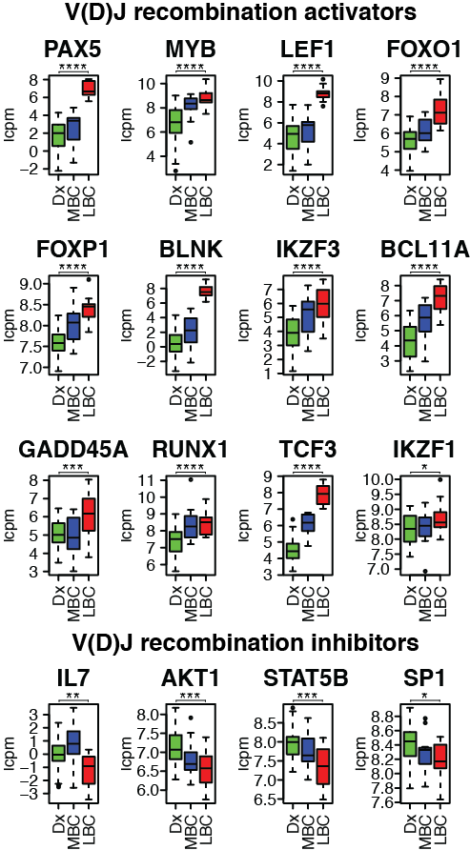

Supplementary Figure 7. The contribution of COSMIC mutational signature in CML patients at diagnosis/CP, MBC or LBC, measured using MuSiCa(23).

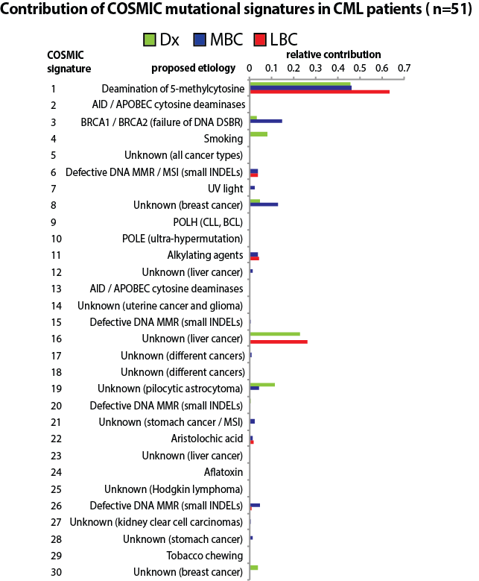

Supplementary Tables
Supplementary Table S1. CML patient samples and sequencing.

Supplementary Table S2. Bioinformatic identification of genomic deletions with non-template nucleotide insertions at breakpoints and enrichment of the ‘CACAGTG’ motif. Including the gene name/s at the deletion (column A), the disease phase when the deletion was acquired and subsequent outcome (column B), the patient ID (column C), the chromosome, start, end and strand of the deletion (columns D-G), the first (start) or second (end) breakpoint of the deletion (column H), the sequence at the DNA break with the motif consensus highlighted (columns I-K) and the non-template nucleotide insertions at the break (column L, blue).

Supplementary Table S3. Structural variants outside the Philadelphia chromosome and immunoglobulin/TCR regions identified in CML patients from combined RNAseq and WES analysis. Including the patient ID (column A), the gene name/s at the DNA breaks (column B), BC phenotype (column C), chromosome coordinates of the first and second breaks (column D-E), sequence at the breakpoint containing the RAG RSS-like motif for the first break (‘|’ indicates the breakpoint) (column F-H), the non-template nucleotide insertion (column I), sequence at the breakpoint containing the MEME identified RAG RSS motif for the second break (column J-L), RAG1/2 and DNTT expression (lcpm) (column M-O), where moderate to high gene expression is highlighted in green.

Supplementary Table S4. Structural variants associated with the Philadelphia chromosome. Including the patient ID (column A), the gene names/s associated with DNA breaks (column B), the chromosome location of the breaks (columns C-D), sequence at the breakpoint containing the MEME identified RAG RSS-like motif at the first break if present (columns E-G), the non-template nucleotide insertion if present (column H), sequence at the breakpoint containing the MEME identified RAG RSS-like motif at the second break if present (columns I-K), RAG1 expression, where high gene expression is highlighted in green.

Supplemental Table S5. Global gene expression (lcpm) for 70 patient samples.

Supplementary Reference List
1. Branford S, Wang P, Yeung DT, Thomson D, Purins A, Wadham C, et al. Integrative genomic analysis reveals cancer-associated mutations at diagnosis of CML in patients with high-risk disease. Blood. 2018;132(9):948-61.
2. Dobin A, Davis CA, Schlesinger F, Drenkow J, Zaleski C, Jha S, et al. STAR: ultrafast universal RNA-seq aligner. Bioinformatics. 2013;29(1):15-21.
3. Ritchie ME, Phipson B, Wu D, Hu Y, Law CW, Shi W, et al. limma powers differential expression analyses for RNA-sequencing and microarray studies. Nucleic acids research. 2015;43(7):e47.
4. Law CW, Alhamdoosh M, Su S, Dong X, Tian L, Smyth GK, et al. RNA-seq analysis is easy as 1-2-3 with limma, Glimma and edgeR. F1000Research. 2016;5.
5. Robinson MD, McCarthy DJ, Smyth GK. edgeR: a Bioconductor package for differential expression analysis of digital gene expression data. Bioinformatics. 2010;26(1):139-40.
6. Robinson MD, Oshlack A. A scaling normalization method for differential expression analysis of RNA-seq data. Genome biology. 2010;11(3):R25.
7. Law CW, Chen Y, Shi W, Smyth GK. voom: Precision weights unlock linear model analysis tools for RNA-seq read counts. Genome biology. 2014;15(2):R29.
8. McCarthy DJ, Smyth GK. Testing significance relative to a fold-change threshold is a TREAT. Bioinformatics. 2009;25(6):765-71.
9. Zhao S, Guo Y, Sheng Q, Shyr Y. Advanced heat map and clustering analysis using heatmap3. BioMed research international. 2014;2014:986048.
10. Mi H, Muruganujan A, Ebert D, Huang X, Thomas PD. PANTHER version 14: more genomes, a new PANTHER GO-slim and improvements in enrichment analysis tools. Nucleic acids research. 2019;47(D1):D419-D26.
11. Chen X, Schulz-Trieglaff O, Shaw R, Barnes B, Schlesinger F, Kallberg M, et al. Manta: rapid detection of structural variants and indels for germline and cancer sequencing applications. Bioinformatics. 2016;32(8):1220-2.
12. Narasimhan V, Danecek P, Scally A, Xue Y, Tyler-Smith C, Durbin R. BCFtools/RoH: a hidden Markov model approach for detecting autozygosity from next-generation sequencing data. Bioinformatics. 2016;32(11):1749-51.
13. Quinlan AR, Hall IM. BEDTools: a flexible suite of utilities for comparing genomic features. Bioinformatics. 2010;26(6):841-2.
14. Bailey TL, Boden M, Buske FA, Frith M, Grant CE, Clementi L, et al. MEME SUITE: tools for motif discovery and searching. Nucleic acids research. 2009;37(Web Server issue):W202-8.
15. Saunders CT, Wong WS, Swamy S, Becq J, Murray LJ, Cheetham RK. Strelka: accurate somatic small-variant calling from sequenced tumor-normal sample pairs. Bioinformatics. 2012;28(14):1811-7.
16. do Valle IF, Giampieri E, Simonetti G, Padella A, Manfrini M, Ferrari A, et al. Optimized pipeline of MuTect and GATK tools to improve the detection of somatic single nucleotide polymorphisms in whole-exome sequencing data. BMC bioinformatics. 2016;17(Suppl 12):341.
17. Kim S, Jeong K, Bhutani K, Lee J, Patel A, Scott E, et al. Virmid: accurate detection of somatic mutations with sample impurity inference. Genome biology. 2013;14(8):R90.
18. Christoforides A, Carpten JD, Weiss GJ, Demeure MJ, Von Hoff DD, Craig DW. Identification of somatic mutations in cancer through Bayesian-based analysis of sequenced genome pairs. BMC genomics. 2013;14:302.
19. Hansen NF, Gartner JJ, Mei L, Samuels Y, Mullikin JC. Shimmer: detection of genetic alterations in tumors using next-generation sequence data. Bioinformatics. 2013;29(12):1498-503.
20. Larson DE, Harris CC, Chen K, Koboldt DC, Abbott TE, Dooling DJ, et al. SomaticSniper: identification of somatic point mutations in whole genome sequencing data. Bioinformatics. 2012;28(3):311-7.
21. Koboldt DC, Chen K, Wylie T, Larson DE, McLellan MD, Mardis ER, et al. VarScan: variant detection in massively parallel sequencing of individual and pooled samples. Bioinformatics. 2009;25(17):2283-5.
22. Alexandrov LB, Nik-Zainal S, Wedge DC, Aparicio SA, Behjati S, Biankin AV, et al. Signatures of mutational processes in human cancer. Nature. 2013;500(7463):415-21.
23. Diaz-Gay M, Vila-Casadesus M, Franch-Exposito S, Hernandez-Illan E, Lozano JJ, Castellvi-Bel S. Mutational Signatures in Cancer (MuSiCa): a web application to implement mutational signatures analysis in cancer samples. BMC bioinformatics. 2018;19(1):224.
24. Branford S, Hughes T. Diagnosis and monitoring of chronic myeloid leukemia by qualitative and quantitative RT-PCR. Methods in molecular medicine. 2006;125:69-92.
25. Hoang VLT, Tom LN, Quek XC, Tan JM, Payne EJ, Lin LL, et al. RNA-seq reveals more consistent reference genes for gene expression studies in human non-melanoma skin cancers. PeerJ. 2017;5:e3631.
26. Chim SSC, Wong KKW, Chung CYL, Lam SKW, Kwok JSL, Lai CY, et al. Systematic Selection of Reference Genes for the Normalization of Circulating RNA Transcripts in Pregnant Women Based on RNA-Seq Data. International journal of molecular sciences. 2017;18(8).
27. Pfaffl MW. A new mathematical model for relative quantification in real-time RT-PCR. Nucleic acids research. 2001;29(9):e45.
28. Branford S, Hughes TP, Rudzki Z. Monitoring chronic myeloid leukaemia therapy by real-time quantitative PCR in blood is a reliable alternative to bone marrow cytogenetics. British journal of haematology. 1999;107(3):587-99.
29. Robinson JT, Thorvaldsdottir H, Winckler W, Guttman M, Lander ES, Getz G, et al. Integrative genomics viewer. Nature biotechnology. 2011;29(1):24-6.
30. Lefranc MP. IMGT, the International ImMunoGeneTics Information System. Cold Spring Harbor protocols. 2011;2011(6):595-603.

