SUPPLEMENTARY CONTENT
Supplemental Tables
Supplemental Table 1. Treatment exposure

Treatment exposure | Safety Population  (N = 112)
Treatment exposure | Pomalidomide  (n = 112) | Low-Dose Dexamethasone  (n = 112) | Daratumumab  (n = 112)
Treatment duration, median (range), months | 14.6 (0.3-28.1) | 13.2 (0.3-28.3) | 14.4 (0.3-29.0)
Treatment cycles, median (range), n | 16.0 (1.0-30.0) | 15.0 (1.0-30.0) | 15.0 (1.0-31.0)
Cumulative dose, median (range), mg | 1079 (32.0-2443.0) | 1250 (40.0-4640.0) | 29,136.5 (56.0-73,418.0)
Relative dose intensity, median (range) | 0.9 (0.3-1.3) | 0.8 (0.3-1.0) | 1.0 (0.0-1.3)
Supplemental Table 2. Response (mIMWG criteria) by number of prior lines of therapy, lenalidomide treatment failure status, last prior lenalidomide dose, prior proteasome inhibitor exposure, and cytogenetic risk status

Response, n (%) | ITT Population
Response, n (%) | 1 Prior Line of Therapy  (N = 70) | 2 Prior Lines of Therapy  (N = 42) | LEN Relapsed  (n = 28) | LEN Refractory  (n = 84) | Last Prior LEN Dose  ≤ 10 mg  (n = 54) | Last Prior LEN Dose  > 10 mg  (n = 57) | Prior PI Exposure  (n = 89) | SR CAsª  (n = 73) | HR CAsª  (n = 20)
CBR^{b} | 60 (85.7) | 36 (85.7) | 25 (89.3) | 71 (84.5) | 48 (88.9) | 47 (82.5) | 78 (87.6) | 63 (86.3) | 15 (75.0)
ORR^{c} | 55 (78.6) | 32 (76.2) | 23 (82.1) | 64 (76.2) | 46 (85.2) | 40 (70.2) | 70 (78.7) | 58 (79.5) | 11 (55.0)
CR | 23 (32.9) | 4 (9.5) | 11 (39.3) | 16 (19.0) | 19 (35.2) | 7 (12.3) | 21 (23.6) | 18 (24.7) | 2 (10.0)
VGPR | 18 (25.7) | 12 (28.6) | 6 (21.4) | 24 (28.6) | 15 (27.8) | 15 (26.3) | 26 (29.2) | 21 (28.8) | 3 (15.0)
PR | 14 (20.0) | 16 (38.1) | 6 (21.4) | 24 (28.6) | 12 (22.2) | 18 (31.6) | 23 (25.8) | 19 (26.0) | 6 (30.0)
MR | 5 (7.1) | 4 (9.5) | 2 (7.1) | 7 (8.3) | 2 (3.7) | 7 (12.3) | 8 (9.0) | 5 (6.8) | 4 (20.0)
SD | 4 (5.7) | 4 (9.5) | 1 (3.6) | 7 (8.3) | 3 (5.6) | 5 (8.8) | 8 (9.0) | 5 (6.8) | 3 (15.0)
PD | 5 (7.1) | 0 | 1 (3.6) | 4 (4.8) | 3 (5.6) | 2 (3.5) | 2 (2.2) | 3 (4.1) | 2 (10.0)
NE | 1 (1.4) | 1 (2.4) | 1 (3.6) | 1 (1.2) | 0 | 2 (3.5) | 0 | 1 (1.4) | 0
Missing | 0 | 1 (2.4) | 0 | 1 (1.2) | 0 | 1 (1.8) | 1 (1.1) | 1 (1.4) | 0
CA; cytogenetic abnormality; CBR, clinical benefit response; CR, complete response; HR, high-risk; ITT, intention-to-treat; LEN, lenalidomide; mIMWG, modified International Myeloma Working Group; MR, minimal response; NE, not evaluable; ORR, overall response rate; PD, progressive disease; PI, proteasome inhibitor; PR, partial response; SD, stable disease; SR, standard-risk; and VGPR, very good partial response.
ª HR was defined as presence of del(17p), t(4;14), and/or t(14;16). SR was defined as absence of all these abnormalities. ^{b} CBR is defined as response ≥ MR. ^{c} ORR is defined as response ≥ PR.

Supplemental Figures
Supplemental Fig. 1. Progression-free survival by number of prior lines of therapy. Median PFS was not reached in either subgroup.
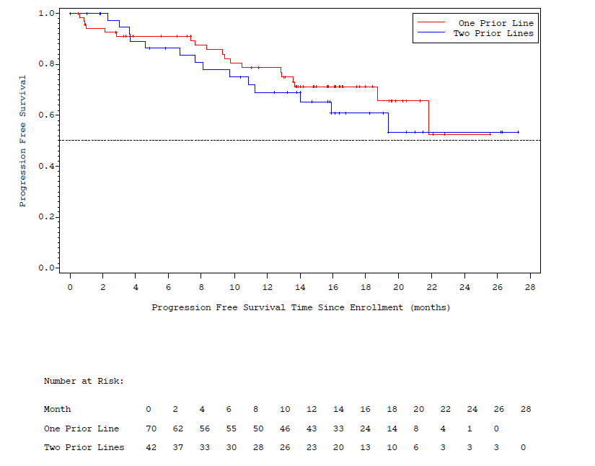
Supplemental Fig. 2. Progression-free survival in patients with prior lenalidomide and proteasome inhibitor exposure. Median PFS was not reached in this subgroup.
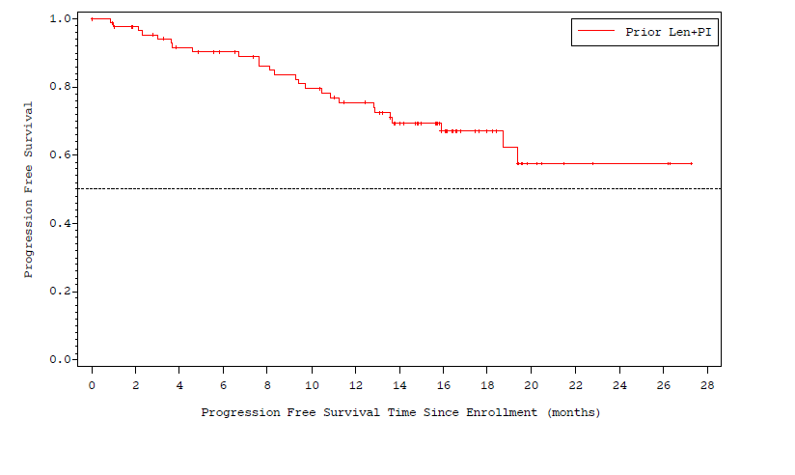

Supplemental Fig. 3. Progression-free survival by cytogenetic risk status. Median PFS was 10.8 months in patients with high-risk cytogenetic abnormalities and not reached in patients with standard-risk cytogenetics.
