Supplemental Information

Supplemental Materials and Methods
Quantitative real-time PCR
mRNA expression levels were quantified using TaqMan gene expression assays for HSPA6, HSPA1 and 18S genes (Thermofisher Scientific, Waltham, MA, USA) on a 7900HT Fast Real‐Time PCR System (Applied Biosystems, Thermofisher Scientific, Waltham, MA, USA).

Lentiviral transfection of inducible short hairpin RNA (shRNA) targeting HSF1/Hsf1 and HSPA6 and HSPA1A promoter-based reporters
Doxycycline-inducible shRNA of scramble control sequence (shC) and of human HSF1 or murine Hsf1 (shHSF1) in well-validated Tet-pLKO-puro vector generated by Dmitri Wiederschain (Plasmid #21915, Addgene) were co-transfected with an equimolar mix of transfer vector psPAX2 and packaging plasmid pMD2.G (Addgene) using jetPrime transfection reagent according to the manufacturer’s instructions (Polyplus, Illkirch, France) into log-phase HEK293T cells. The scramble sequence is: 5’-CCTAAGGTTAAGTCGCCCTCG-3’; the HSF1/Hsf1-targeted sequences are as folowings: 5’-GCAGGTTGTTCATAGTCAGAA-3’ for murine Hsf1; 5’-
GCAGGTTGTTCATAGTCAGAA-3’for human HSF1. Lentiviral supernatants were harvested 60 hr after transfection by centrifugation (800 x g, 10 min) at room temperature. The supernatant was then filtered through 0.45 mm surfactant-free cellulose acetate membranes. The virus stock was used immediately to infect MOLM-13 and Ba/F3 FLT3-ITD with D835Y cells. Exponentially growing cells were resuspended at a concentration of 0.5 x 10⁶ cells per mL of virus stock, transferred to 12-well tissue plates and cultured overnight. MOLM-13 and Ba/F3 FLT3-ITD with D835Y cells were then centrifuged for 90 min at 1,600 x g in room temperature, and washed with growth medium, being returned to the tissue culture incubator. After two doubling times, infected cells were subjected to selection with 0.5 mg/mL puromycin (Invitrogen, San Diego, CA, USA). Generated knockdown cells were assessed by immunoblot using HSF1 antibody 48 h after the exposure to 0.5 µg/mL doxycycline. For HSPA6 and HSPA1A promoter-based reporter assay was generated, in a similar way, OCI-AML3 cells were infected with lentiviral constructs encoding a GFP-luciferase fusion protein driven by promoter elements from either the HSPA1A or HSPA6 genes³³ . Cells in culture media were heated at 42 ̊C for one hour then back to 37 ̊C, and cells with highly induced GFP expression at 18 h after heat shock were sorted by FACS.

Supplemental Table
Case# | status | Age | Sex | Source | Blast% | Chromosome | gene mutations
1 | relapse/refractory | 63 | M | PB | 63 | N.A. | FLT3-ITD+D835, IDH1, DNMT3a
2 | Newly Dx | 52 | M | PB | 90 | 46,XY [20] | KIT
3 | Newly Dx | 69 | M | BM | 51 | 46,XY,r(7)(p11.2q11.2)[20] | TP53, DNMT3a
4 | Newly Dx | 27 | F | PB | 51 | 46,XX[20] | ALXL-1, MLL
5 | relapse/refractory | 48 | M | PB | 70 | 46,XY,t(4;6)(q21;p25),inv(13)(q12q32)[10], 46,idem,t(5;11)(q13;q21)[4] | FLT3-ITD, NPM1
6 | Newly Dx | 77 | M | PB | 91 | 46,XY,t(2;11)(p23;q13)[17] | IDH2
7 | relapse/refractory | 69 | M | BM | 74 | 46,XY,der(3)t(3;14)(p13;q32)inv(3)(q21q26.2),der(14)t(3;14)[18] | FLT3-ITD
8 | relapse | 25 | M | PB | 84 | t(8;21)(q22;q22) | FLT3-ITD
9 | relapse/refractory | 57 | M | PB | 78 | 45,XY,-7[10]/45,sl,del(6)(q13q23),del(11)(p14)[4]/45,sdl,del(17)(p11.2),  add(22)(q13)[3]/45,XY,-7[cp3] | NRAS
10 | AML/MDS | 68 | F | PB | 86 | 46, XX [20] | FLT3-ITD, NPM1
11 | Newly Dx | 43 | M | PB | 86 | 45,X,-Y,inv(16)(p13q22)[20] | no mutations
12 | relapse/refractory | 46 | F | PB | 91 | 46, XX [20] | FLT3-ITD
13 | relapse | 29 | F | PB | 97 | 45,X,-X,+1,del(1)(p22),-10,-15,-18,+2mar[1]/46,XX,t(4;5)(q31.3;p15.3)[1]/46,XX[18] | FLT3-ITD, WT1
14 | relapse/refractory | 80 | M | PB | 92 | N.A. | FLT3 D835, TP53 R248Q, IDH1, DNMT3a
15 | AML/MDS | 71 | F | PB | 57 | 46,XX,add(1)(p13),-6,r(12)(p11.2q13),der(14)ins(14;3)(q32;?)  add(14)(q32),+mar[8] | no mutations
16 | relapse | 24 | M | PB | 97 | 47,idem,+8[19] | FLT3 D835
17 | relapse/refractory | 33 | M | PB | 84 | 46,XY[20] | IDH2
18 | Newly Dx | 73 | F | PB | 81 | 46,XX[20] | NPM1, TET2
19 | relapse/refractory | 58 | M | PB | 52 | N.A. | NRAS
20 | Newly Dx | 82 | M | BM | 85 | 46,XY,del(5)(q31q35),del(6)(q13q23),add(11)(q23),del(16)(q11.2),add(21)(p13)[7]/  46,XY,idem,del(2)(p13)[3]/46,idem,t(2;8)(p25;q12),del(20)(q11.2q13.1)[2]/  45~47,idem,del(20)(q11.2q13.1),+1-3mar[cp6]/46,XY[2] | TP53 R282Q
Table S1. Clinical information for primary AML samples used in the study.
Supplemental Figures
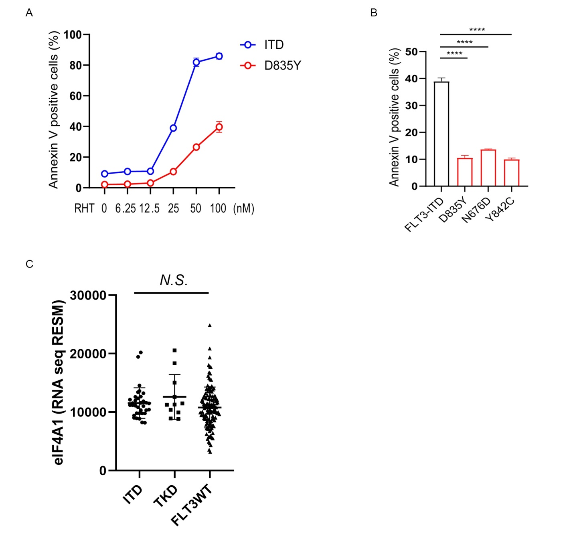
Figure S1. Reduced apoptosis induction by RHT in Ba/F3 cells with FLT3 TKD mutations compared with those with FLT3-ITD.
(A) Ba/F3 cells with FLT3-ITD or TKD-D835Y mutation were treated with RHT with indicated concentrations for 72 h. Annexin V positive cells were measured by flow-cytometry. (B) Ba/F3 cells with FLT3-ITD, TKD-D835Y, -N676D or -Y842C mutations were treated with RHT with 25 nM of RHT for 72 h. Annexin V positive cells were measured by flow-cytometry. One-way ANOVA with Dunnett’s test was used for statistical comparison (****: P < 0.0001). (C) Comparison of eIF4A1 gene expression levels in FLT3-ITD, TKD and wild-type AML samples in TCGA dataset. N.S., not significant.

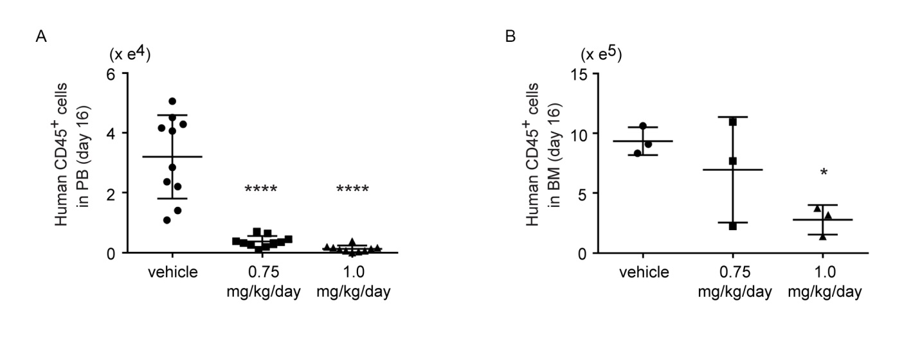
Figure S2. Reduced leukemia burden in in vivo FLT3-ITD AML model.
(A) Human CD45+ blasts percentages in PB samples (N = 10 each) collected from NSG mice engrafted with MOLM-13 cells at day 16. (B) Human CD45+ blasts percentages in BM samples (N = 3) collected from NSG mice engrafted with MOLM-13 cells at day 16. One-way ANOVA with multiple comparison: * P < 0.05, ** P < 0.01, %mean in untreated vs 1.0 mg/kg; 45.49% vs 4.12%, P = 0.00012.

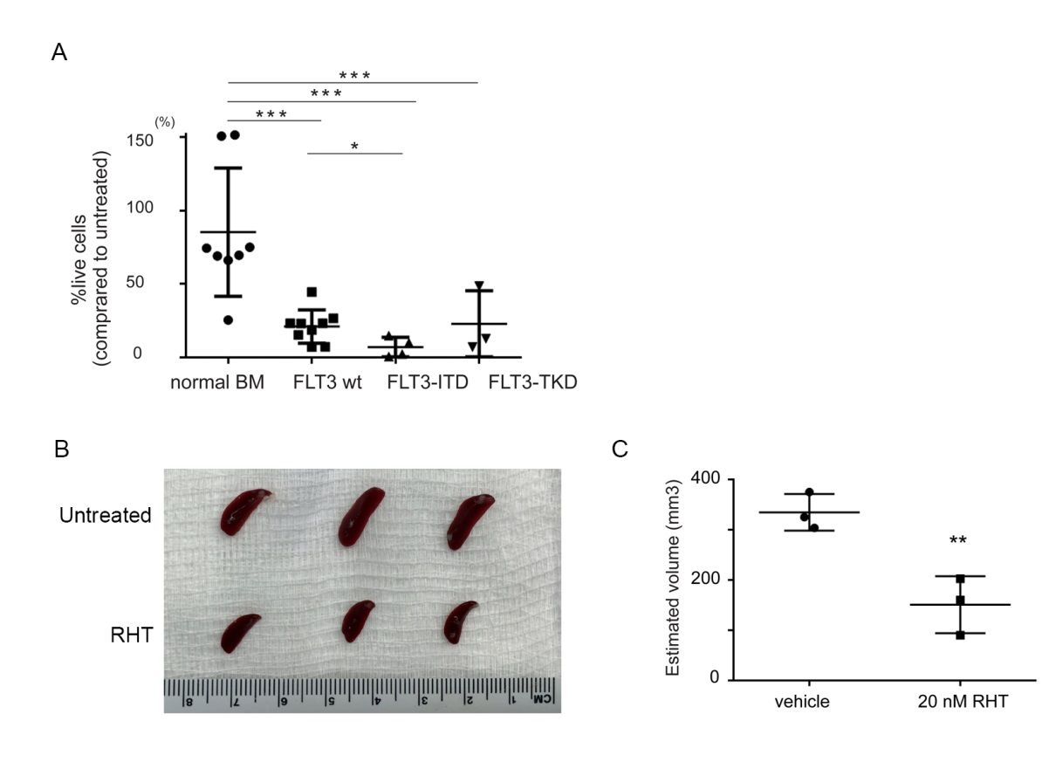
Figure S3. Targeting eIF4A functionally inhibits AML-initiating cells.
(A) %Live cell number of CD34+CD38- primary AML and normal BM cells after treatment with 50 nM RHT for 72 h. The results of %live cell number of CD34+CD38- primary AML shown in Figure 4A was trichotomized according to FLT3 gene mutations (wt; wild type, ITD and TKD). (B) (C) Pictures (B) and estimated sizes (C) of spleens collected from the mice at day 16 after secondary transplantation of PDX AML cells after ex vivo treatment of 20 nM RHT for 24 h (n = 3 for each treatment group). Mean spleen size: 334.6 mm³ in control, 150.8 mm³ in RHT group, unpaired t test, P = 0.0092).

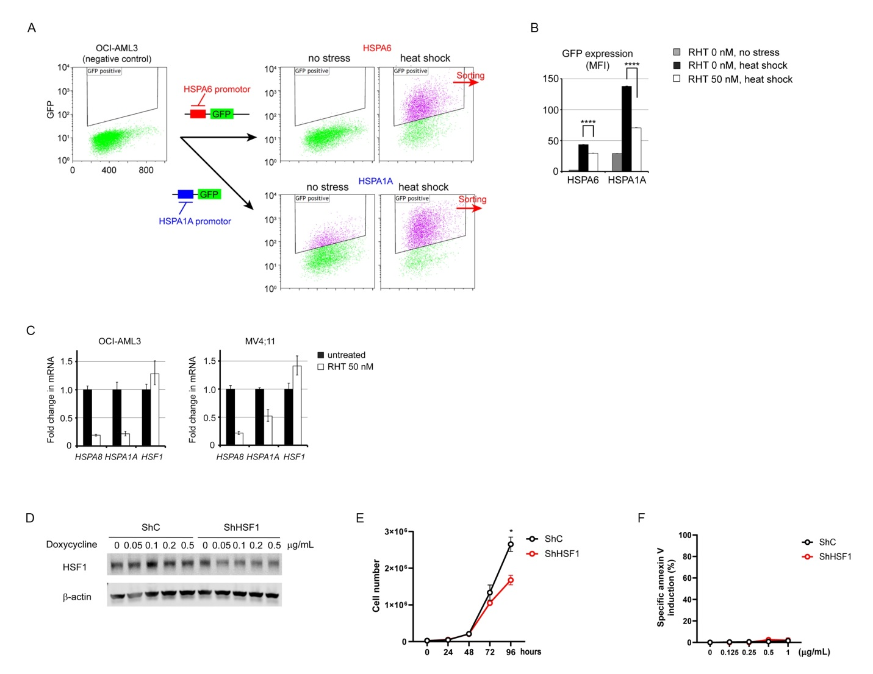
Figure S4. Inhibition of HSF1 transcriptional activity via eIF4A potentiates FLT3 inhibitors in FLT3-mutant AML cells.
(A) Generation of HSF1-reporter lines (see also Materials and Methods). (B) Mean fluorescent intensity of GFP in OCI-AML3 cells treated with or without RHT treatment (50 nM for 10 h) after or without heat shock (42 ̊C for 1 hour). GFP intensity was measured by flow cytometry after additional 17-hour incubation. (C) mRNA levels of HSPA8, HSPA1A and HSF1 in untreated and RHT-treated OCI-AML3 and MV4;11 cells. Cells were treated with 50 nM of RHT for 24 h. (D) Immunoblot for HSF1 and β-actin in Ba/F3 cells which overexpress FLT3 proteins with double mutations of ITD and D835Y (Ba/F3 ITD-D835Y) and are transfected with tet-inducible shRNA against HSF1 (ShHSF1) gene or control shRNA (ShC). Ba/F3 ITD-D835Y cells were treated with doxycycline with indicated concentrations for 48 h. β-actin was used for loading control. (E) Live cell numbers in Ba/F3 ITD-D835Y ShC / ShHSF1 cells treated with 0.5 µg/mL doxycycline for indicated durations. Live cell numbers were counted by trypan-blue dye exclusion method. Live cell numbers were counted by trypan-blue dye exclusion method. (F) Percent of drug-specific apoptosis in Ba/F3 ITD-D835Y ShC / ShHSF1 cells treated with doxycycline at indicated concentrations. One-way ANOVA with Dunnett's test was used for statistical comparison (* P: < 0.05).

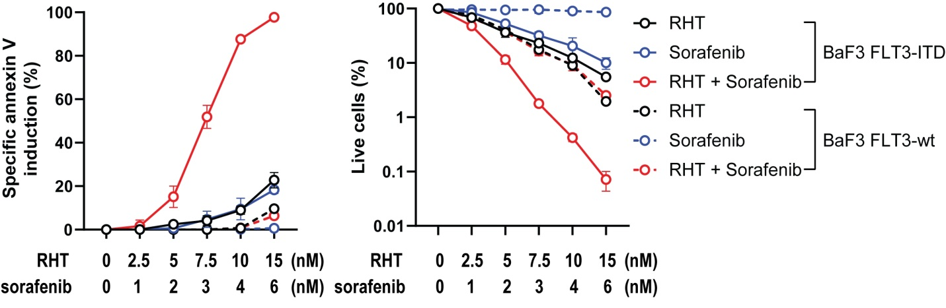
Figure S5. Combination treatment of sorafenib and RHT exerts FLT3-ITD dependent synergistic anti-leukemia effects in Ba/F3 cells.
FLT3-ITD or wild-type FLT3 overexpressing Ba/F3 cells were treated with RHT and sorafenib at indicated concentrations. Annexin V-positive cells (left) and annexin V-negative and DAPI-negative live cell numbers (right) were counted by flow cytometry. Data represent mean ± SD.

