Supplementary Figure 1
Legend : A. Royston and Parmar adjusted* hazard ratio for overall survival in HMA vs. IC for each month from diagnosis – in patients < 75y (*Adjusted for performance status > 1, white blood cell count at diagnosis > 30 giga per liter, cytogenetic risk and secondary vs de novo AML). B. Royston and Parmar adjusted* hazard ratio for overall survival in HMA vs. IC for each month from diagnosis – in patients ≥ 75y (*Adjusted for performance status > 1, white blood cell count at diagnosis > 30 giga per liter, cytogenetic risk and secondary vs de novo AML). C. Royston and Parmar adjusted* hazard ratio for relapse-free survival in HMAs vs. IC for each month from CR/CRi – in patients < 75y (*Adjusted for performance status > 1, white blood cell count at diagnosis > 30 giga per liter, cytogenetic risk, secondary vs. de novo AML, NPM1 and FLT3-ITD mutations). D. Royston and Parmar adjusted* hazard ratio for relapse-free survival in HMAs vs. IC for each month from CR/CRi – in patients ≥ 75y (*Adjusted for performance status > 1, white blood cell count at diagnosis > 30 giga per liter, cytogenetic risk, secondary vs. de novo AML, NPM1 and FLT3-ITD mutation

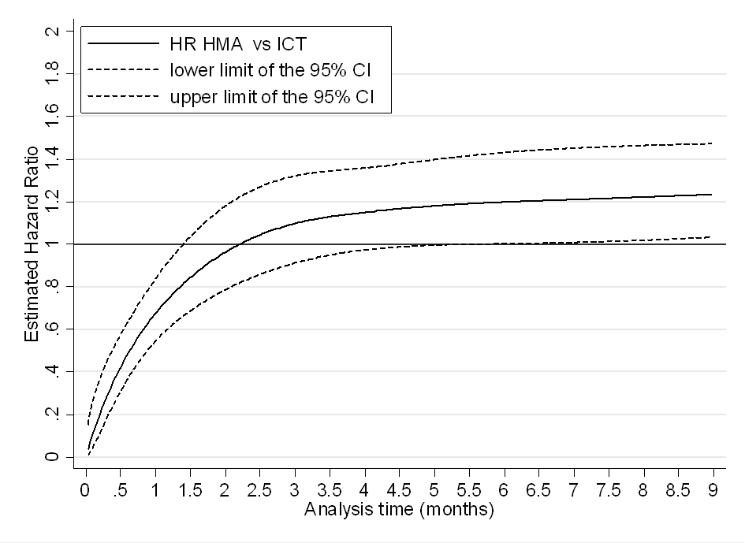
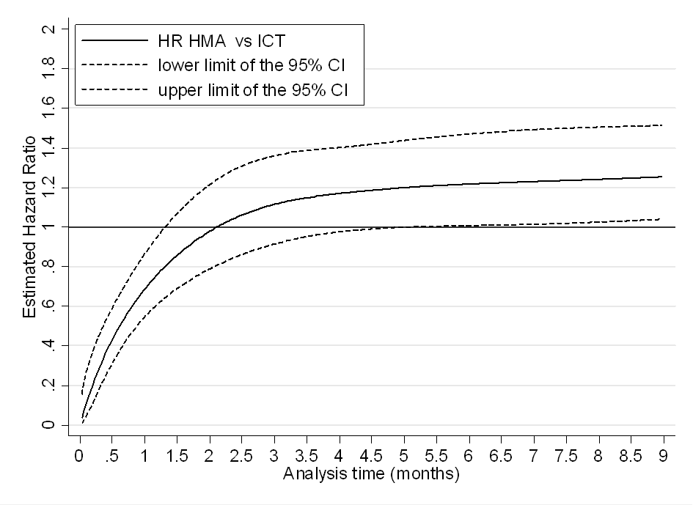
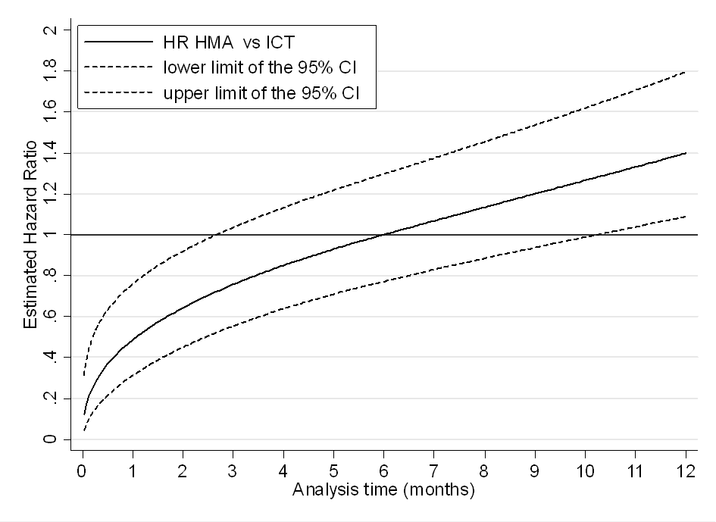
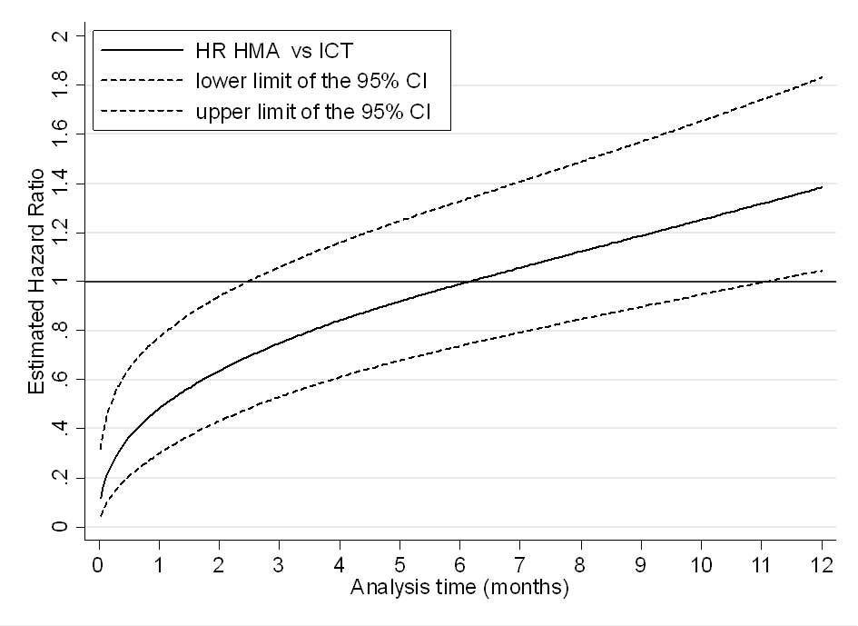
A
B
C
D

