Supplementary Table 1.

Selection of inclusion criteria in MAJESTEC-1
Measurable disease (M-protein level >1.0 g/dl/urine M-protein level >200 mg/24h or FLC >10 mg/dl and abnormal FLC ratio)
Platelets ≥75 x 10⁹/l for pat. in whom <50% of bone marrow nucleated cells are plasma cells; otherwise platelet count ≥50 x 10⁹/l
Absolute neutrophil count (ANC) ≥1.0 x 10⁹/l
Creatinine clearance ≥40 ml/min/1.73m²
no allogeneic transplantation
no known active CNS involvement
no plasma cell leukemia

Supplementary Figure 1. PFS in different cytogenetic risk profiles

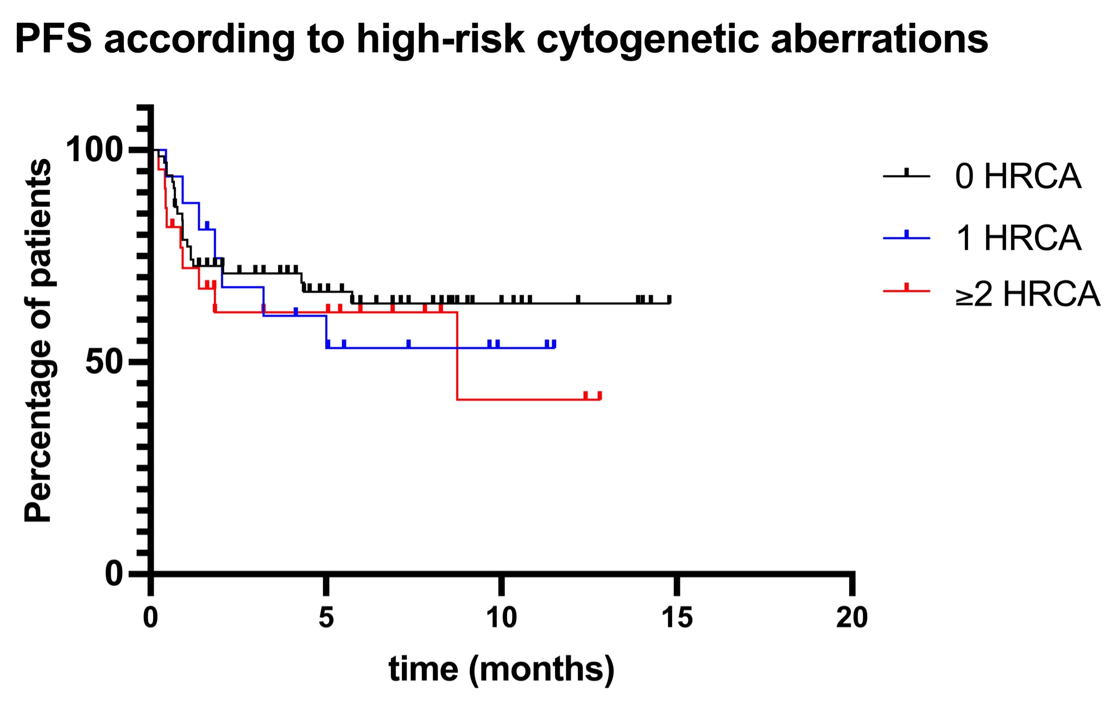
PFS in patients with 0, 1 or ≥2 high-risk cytogenetic aberrations (HRCA) is shown. Patients with 1 HRCA had either del(17p), t(4;14), or t(14;16). In patients with 2 HRCA, two aberrations were present, including del(17p), t(4;14), t(14;16) and gain/amp1q.

