Supplemental Materials – Online Only
Supplemental Tables
Table S1. Options for salvage chemotherapy
Regimen | Dose
LoDAC | - Cytarabine 20 mg was administered twice daily by SC or IV injection for 10 days
MEC induction chemotherapy | - Mitoxantrone 6 mg/m² per day was administered by IV for 5 days (Days 1 through 5)  - Etoposide 100 mg/m² per day was administered by IV for 5 days (Days 1 through 5)  - Cytarabine 1000 mg/m² per day was administered by IV for 5 days (Days 1 through 5)
FLAG induction chemotherapy | - G-CSF 300 μg/m² per day was administered by SC/IV for 5 days (Days 1 through 5)  - Additional G-CSF by SC/IV was recommended 7 days after completing chemotherapy until ANC >0.5 x 10⁹/L  - Fludarabine 30 mg/m² per day was administered by IV for 5 days (Days 2 through 6)  - Cytarabine 2000 mg/m² per day was administered by IV for 5 days (Days 2 through 6)
Supplemental Table S1 available online only.
Abbreviations: ANC, absolute neutrophil count; FLAG, fludarabine, high-dose cytarabine, and granulocyte colony-stimulating factor; G-CSF, granulocyte colony-stimulating factor; IV, intravenous; LoDAC, low-dose cytarabine; MEC, mitoxantrone, etoposide, and intermediate-dose cytarabine; SC, subcutaneous.

Table S2. Response definitions
Response | Definition
Complete remission (CR) | Patients with bone marrow regenerating normal hematopoietic cells and achieving a morphologic leukemia-free state and an ANC ≥1 x 10⁹/L and platelet count ≥100 x 10⁹/L and normal marrow differential with <5% blasts, and RBC and platelet transfusion independent (defined as 1 week without RBC transfusion and 1 week without platelet transfusion).  There should be no evidence of extramedullary leukemia.
Complete remission with incomplete platelet recovery (CRp) | Patients fulfilling all criteria for CR except for platelet recovery (platelet count ≥100 x 10⁹/L).
Complete remission with incomplete hematologic recovery (CRi) | Patients fulfilling all criteria for CR except for hematological recovery (ANC ≥1 x 10⁹/L) with residual neutropenia and complete platelet recovery (platelet count ≥100 x 10⁹/L).  RBC and platelet transfusion independence is not required.
Composite complete remission (CRc) | Defined as the remission rate of all CR, CRp, and CRi.
Partial remission (PR) | Patients with bone marrow regenerating normal hematopoietic cells with evidence of peripheral recovery with no (or only a few regenerating) circulating blasts and with a decrease of at least 50% in the percentage of blasts in the bone marrow aspirate with the total marrow blasts between 5% and 25%. A value of less or equal than 5% blasts is also considered a PR if Auer rods are present. There should be no evidence of extramedullary leukemia.
Complete remission  with partial hematologic recovery (CRh) | Patients with postbaseline marrow blasts <5%, partial hematologic recovery ANC ≥0.5 x 10⁹/L and platelets ≥50 x 10⁹/L, no evidence of extramedullary leukemia, and cannot be classified as CR. The blast counts in peripheral blood must be ≤2%.
Relapse | Relapse after CR, CRp, or CRi is defined as a reappearance of leukemic blasts in the peripheral blood or ≥5% blasts in the bone marrow aspirate not attributable to any other cause or reappearance or new appearance of extramedullary leukemia.  Relapse after PR is similarly defined with reappearance of significant numbers of peripheral blasts and an increase in the percentage of blasts in the bone marrow aspirate to >25% not attributable to any other cause or reappearance or new appearance of extramedullary leukemia.
Best response | Best response is defined as the best measured response to treatment for all visits (in the order of CR, CRp, CRi, PR, NR, and NE) post-treatment. Subjects with best responses of CR, CRp, CRi, or PR will be considered responders. Subjects who do not achieve at least a best response of PR will be considered nonresponders
Supplemental Table S2 available online only.
Abbreviations: ANC, absolute neutrophil count; CR, complete remission; CRc, composite complete remission; CRh, complete remission with partial hematologic recovery; CRi, complete remission with incomplete hematologic recovery; CRp, complete remission with incomplete platelet recovery; NE, not estimable; NR, no response; PR, partial response; RBC, red blood cell.

Table S3. Pharmacokinetic assessment schedule for patients receiving gilteritinib
 | Cycle 1 |  |  | Subsequent Cycles
Activity | Day 1 | Day 8 ± 1 | Day 15 ± 1 | Day 1 ± 2
Whole blood samples for plasma pharmacokinetics | X^{a,b} | X* | X^{a,b} | Xª
Supplemental Table S3 available online only.
ªPharmacokinetic samples for gilteritinib were collected on Cycle 1 Day 1 predose, Cycle 1 Day 8 predose, and at Cycle 1 Day 15, and Day 1 predose of each subsequent cycle (within 1 hour before drug administration).
^{b}For patients randomized to gilteritinib arm at a pharmacokinetic cohort site, pharmacokinetic samples were also collected at 0.5, 1, 2, 3, 4, 6, 10, 24 hours postdose on Cycle 1 Day 1 and Cycle 1 Day 15. Pharmacokinetic sample collection at 24 hours postdose was to be obtained prior to gilteritinib administration on Cycle 1 Day 2 and Cycle 1 Day 16.

Table S4. Best overall response prior to transplantation
Response Parameter, n (%) | Gilteritinib  (n=116) | Salvage Chemotherapy  (n=118)
Complete remission | 15 (12.9) | 12 (10.2)
Complete remission with incomplete platelet recovery | 13 (11.2) | 1 (0.8)
Complete remission with incomplete hematologic recovery | 27 (23.3) | 11 (9.3)
Partial remission | 21 (18.1) | 6 (5.1)
No response | 30 (25.9) | 42 (35.6)
Not evaluable | 10 (8.6) | 46 (39.0)
Composite complete remissionª | 55 (47.4) | 24 (20.3)
Overall response^{b} | 76 (65.5) | 30 (25.4)
Complete remission and complete remission with partial hematologic recovery | 28 (24.1) | 16 (13.6)
Supplemental Table S4 available online only.
ªDefined as the sum of patients who achieved complete remission, complete remission with incomplete platelet recovery, and complete remission with incomplete hematologic recovery.
^{b}Defined as the sum of patients who achieved composite complete remission and partial remission.

Table S5. Summary of adverse events adjusted by patient-year (safety population)
Adverse Event | Gilteritinib  (PY=46.4)  E (E/PY) | Salvage Chemotherapy  (PY=10.0)  E (E/PY)
Treatment-emergent adverse event | 7115 (153.34) | 3886 (388.60)
Serious | 287 (6.19) | 124 (12.40)
Grade 3 or higher | 2709 (58.38) | 1683 (168.30)
Leading to study drug reduction | 37 (0.80) | 1 (0.10)
Leading to study drug interruption | 98 (2.11) | 10 (1.00)
Leading to withdrawal of treatment | 18 (0.39) | 10 (1.00)
Leading to death | 31 (0.67) | 15 (1.50)
Treatment-related adverse eventª | 4251 (91.62) | 2563 (256.30)
Serious | 135 (2.91) | 66 (6.60)
Grade 3 or higher | 1848 (39.83) | 1215 (121.50)
Leading to study drug reduction | 29 (0.63) | 1 (0.10)
Leading to study drug interruption | 65 (1.40) | 8 (0.80)
Leading to withdrawal of treatment | 12 (0.26) | 6 (0.60)
Leading to death | 14 (0.30) | 7 (0.70)
Supplemental Table S5 available online only.
ªAssessed as possible or probable relationship to study drug by the investigator, or records where the relationship is missing.
Abbreviations: E, event; PY, patient-year.

Table S6. Signs and symptoms potentially indicating differentiation syndrome
Adverse Event, n (%) | Gilteritinib  (n=113) | Salvage Chemotherapy  (n=104)
Differentiation syndromeª | 81 (71.7) | 81 (77.9)
Pyrexia | 42 (37.2) | 38 (36.5)
Febrile neutropenia | 25 (22.1) | 30 (28.8)
Pneumonia | 24 (21.2) | 26 (25.0)
Weight increased | 17 (15.0) | 1 (1.0)
Cough | 9 (8.0) | 8 (7.7)
Edema peripheral | 7 (6.2) | 3 (2.9)
Dyspnea | 2 (1.8) | 4 (3.8)
Hypotension | 2 (1.8) | 4 (3.8)
Acute respiratory failure | 0 (0.0) | 5 (4.8)
Blood creatinine increased | 4 (3.5) | 2 (1.9)
Pleural effusion | 2 (1.8) | 1 (1.0)
Respiratory failure | 1 (0.9) | 2 (1.9)
Pulmonary edema | 0 (0.0) | 2 (1.9)
Renal failure | 2 (1.8) | 1 (1.0)
Acute kidney injury | 0 (0.0) | 2 (1.9)
Fluid overload | 1 (0.9) | 0 (0.0)
Fluid retention | 0 (0.0) | 1 (1.0)
Lower respiratory tract infection | 0 (0.0) | 1 (1.0)
Renal injury | 0 (0.0) | 1 (1.0)
Renal impairment | 2 (1.8) | 0 (0.0)
Acute lung injury | 0 (0.0) | 1 (1.0)
Multiple organ dysfunction syndrome | 0 (0.0) | 1 (1.0)
Differentiation syndrome | 1 (0.9) | 0 (0.0)
Supplemental Table S6 available online only.
ªPotential instances of differentiation syndrome, shown in this row as an adverse event of special interest category and not by Preferred Term Code, were reported based on the occurrence of select adverse events and are summarized for adverse events that occurred within the first 90 days of treatment. All other rows represent adverse events by Preferred Term Code.

Table S7. Gilteritinib pharmacokinetic parameters on Day 1 in the pharmacokinetic cohort
Value | AUC₂₄  (h*ng/mL) | AUC_{last}  (h*ng/mL) | C_{max}  (ng/mL) | t_{1/2}  (h) | t_{max}  (h)
n | 21 | 21 | 21 | 15 | 21
Mean | 3230 | 3230 | 206 | 25.2 | NA
SD | 1970 | 1960 | 112 | 7.49 | NA
%CV | 60.8 | 60.7 | 54.3 | 29.7 | NA
Min | 1220 | 1210 | 65.4 | 16.3 | 2.00
Median | 2900 | 2900 | 182 | 24.4 | 4.00
Max | 9460 | 9460 | 523 | 45.3 | 24.1
GM | 2790 | 2790 | 180 | 24.3 | NA
Geo %CV | 58.7 | 58.6 | 57.5 | 27.8 | NA
Supplemental Table S7 available online only.
Abbreviations: AUC₂₄, area under the plasma concentration-time curve from time zero to 24; AUC_{last}, area under the plasma concentration-time curve from time zero to the last measurable concentration; C_{max}, maximum concentration; CV, coefficient of variation; Geo, geometric; GM, geometric mean; NA, not applicable; SD, standard deviation; t_{1/2}, elimination half-life; t_{max}, time of the maximum concentration.

Table S8. Gilteritinib pharmacokinetic parameters on Day 15 in the pharmacokinetic cohort
Value | AUC_{last}  (h*ng/mL) | AUC_{tau}  (h*ng/mL) | CL/F  (L/h) | C_{max}  (ng/mL) | C_{trough}  (ng/mL) | PTR | R_{ac}  (AUC) | R_{ac}  (C_{max}) | t_{max}  (h)
n | 16 | 16 | 16 | 16 | 15 | 16 | 16 | 16 | 16
Mean | 10100 | 10000 | 16.6 | 536 | 323 | 1.75 | 3.87 | 3.04 | NA
SD | 6700 | 6670 | 8.93 | 323 | 222 | 0.342 | 2.29 | 1.14 | NA
%CV | 66.7 | 66.4 | 53.7 | 60.2 | 68.8 | 19.6 | 59.1 | 37.5 | NA
Min | 3540 | 3550 | 4.34 | 171 | 121 | 1.32 | 1.58 | 1.76 | 1.00
Median | 8940 | 8940 | 13.4 | 505 | 247 | 1.69 | 2.81 | 2.68 | 3.85
Max | 27600 | 27600 | 33.8 | 1420 | 923 | 2.47 | 8.34 | 5.24 | 24.3
GM | 8410 | 8420 | 14.3 | 457 | 269 | 1.72 | 3.37 | 2.86 | NA
Geo %CV | 66.1 | 65.8 | 65.8 | 63.8 | 67.0 | 19.5 | 55.9 | 36.7 | NA
Supplemental Table S8 available online only.
Abbreviations: AUC_{last}, area under the plasma concentration-time curve from time zero to the last measurable concentration; AUC_{tau}, area under the plasma concentration-time curve over the dosing interval; CL/F, oral clearance; C_{max}, maximum concentration; C_{trough}, trough concentration; CV, coefficient of variation; Geo, geometric; GM, geometric mean; NA, not applicable; PTR, peak-trough ratio; R_{ac}, accumulation ratio; SD, standard deviation; t_{max}, time of the maximum concentration.

Supplemental Figure Legends – Online Only
Figure S1. Study design. AML, acute myeloid leukemia; FLAG, fludarabine, high-dose cytarabine, and granulocyte colony-stimulating factor; FLT3, FMS-like tyrosine kinase 3; MEC, mitoxantrone, etoposide, and intermediate-dose cytarabine; NR, no response; PD, progressive disease; PK, pharmacokinetic.
Figure S2. Mean plasma concentration profile of gilteritinib in the pharmacokinetic cohort. Mean gilteritinib plasma concentration over time on (A) Day 1 and (B) Day 15 in Chinese patients in the pharmacokinetic cohort.

Supplemental Figures
Figure S1. Study design.
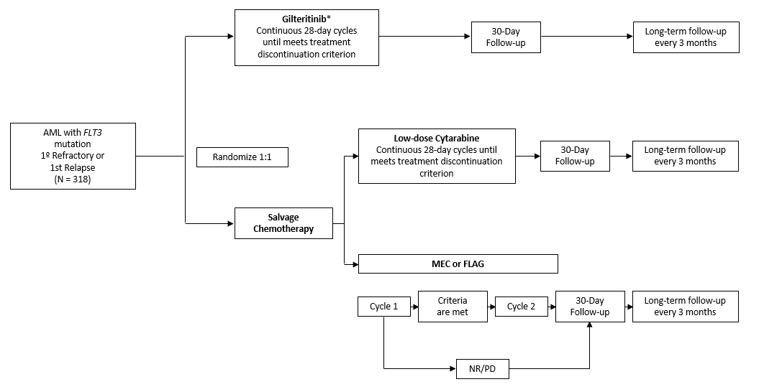
Supplemental Figure S1 available online only.
*Among 318 patients, approximately 20 Chinese patients randomized to gilteritinib will be allocated to the PK cohort.
Abbreviations: 1º, primary; AML, acute myeloid leukemia; FLAG, fludarabine, high-dose cytarabine, and granulocyte colony-stimulating factor; FLT3, FMS-like tyrosine kinase 3; MEC, mitoxantrone, etoposide, and intermediate-dose cytarabine; NR, no response; PD, progressive disease; PK, pharmacokinetic.

Figure S2. Mean plasma concentration profile of gilteritinib in the pharmacokinetic cohort.
- Day 1
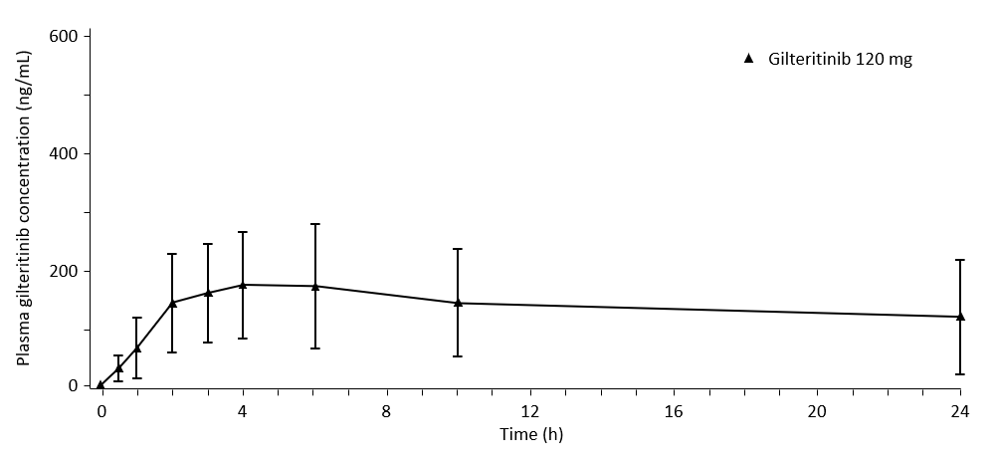
- Day 15
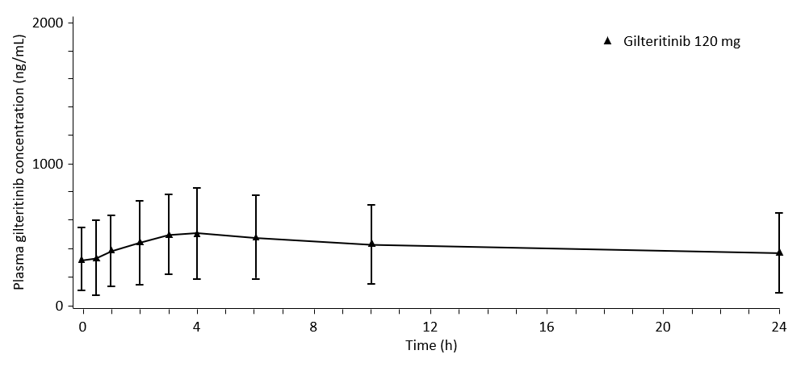
Mean and standard deviations are displayed.
Supplemental Figure S2 available online only.

