SUPPLEMENTARY MATERIAL
Watt-scale super-octave mid-infrared intrapulse difference frequency generation
Christian Gaida^{†1}, Martin Gebhardt^{1,2}, Tobias Heuermann^{1,2}, Fabian Stutzki^{1,3}, Cesar Jauregui¹, Jose Antonio-Lopez⁴, Axel Schülzgen⁴, Rodrigo Amezcua-Correa⁴, Andreas Tünnermann^{1,2,3}, Ioachim Pupeza⁵, Jens Limpert^{1,2,3}
¹Institute of Applied Physics, Abbe Center of Photonics, Friedrich-Schiller-Universität Jena, Albert-Einstein-Str. 15, 07745 Jena, Germany;
²Helmholtz-Institute Jena, Fröbelstieg 3, 07743 Jena, Germany;
³Fraunhofer Institute for Applied Optics and Precision Engineering, Albert-Einstein-Str. 7, 07745 Jena, Germany;
⁴CREOL, College of Optics and Photonics, University of Central Florida, Orlando, Florida 32816, USA; ⁵Max-Planck-Institute of Quantum Optics, Hans-Kopfermann-Str. 1, 85748 Garching, Germany
†Correspondence: C Gaida, Email: christian.gaida@uni-jena.de

GaSe dispersion properties
The dispersion of GaSe in the wavelength region of interest was estimated by the extended Sellmeier Equation with the coefficients shown in table S1 for the extraordinary and ordinary crystal axis¹ :

$$n^{2}=A+\frac{B}{λ^{2}}+\frac{C}{λ^{4}}+\frac{D}{λ^{6}}+\frac{E}{1-F/{λ^{2}}}$$

 | A | B | C | D | E | F
n_{o} | 7.443 | 0.405 | 0.0186 | 0.0061 | 3.1485 | 2194
n_{e} | 5.76 | 0.3879 | -0.2288 | 0.1223 | 1.855 | 1780
Table S1. Sellmeier coefficients of GaSe ¹ for ordinary (n_{o}) and extraordinary (n_{e}) crystal axis.

Estimation of mid-IR power
Schematic setup of the DFG is shown in Fig. 3a of the manuscript. The generated mid-IR radiation passes several optical elements before it is measured by a thermal power meter (power P_{M}) and spectrally characterized by a Fourier-transform interferometer (spectral power distribution S_{M}). The corrected spectral power distribution after the GaSe crystal is estimated as follows:
$$S(λ)=\frac{S_{M}(λ)}{R_{ZnSe}(λ)∙(1-R_{ZnSe}\left(λ\right))²∙R_{Gold}^{2}∙T_{longpass}(λ)}$$
The generated mid-IR after the uncoated GaSe crystal is reflected by 1 gold parabola, 1 uncoated ZnSe-wedge and 1 gold mirror and passes through 1 uncoated ZnSe-window and 1 longpass filter. The gold parabola and gold mirror have a reflectivity R_{Gold}<97% in the mid-IR, each. The ZnSe-wedge reflection has been characterized at 2 µm wavelength and near 0 degree angle of incidence revealing a reflectivity of R_{ZnSe}=17.6%. According to the dispersion of ZnSe ², the Fresnel reflectivity decreases slightly with wavelength (see Fig. S1a) and matches the measured reflectivity at 2 µm very well. This also allows for an accurate estimation of the uncoated ZnSe-window transmission. Together with the transmission properties of the used longpass filter (see Fig. S1b)³, the measured spectral power distribution can be corrected accordingly. For wavelengths longer than 15 µm a transmission of >65% was assumed. The power P_{M}, which was measured with a thermal power meter after all elements, is related to the measured spectrum S_{M}. Thus, the total mid-IR average power after the GaSe crystal can be determined:
$$P=P_{M}\frac{S(λ)}{S_{M}(λ)}$$

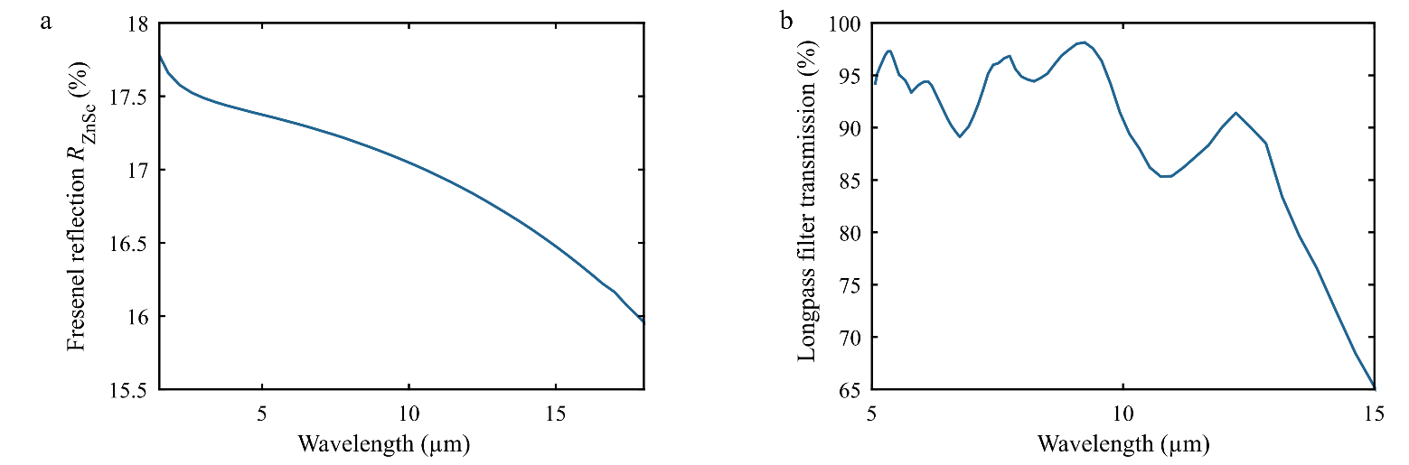
Figure S1. Wavelength-dependent reflection and transmission properties. a Fresnel reflection of ZnSe at normal angle of incidence. b Transmission of longpass filter to block the pump light at 2 µm wavelength ³.

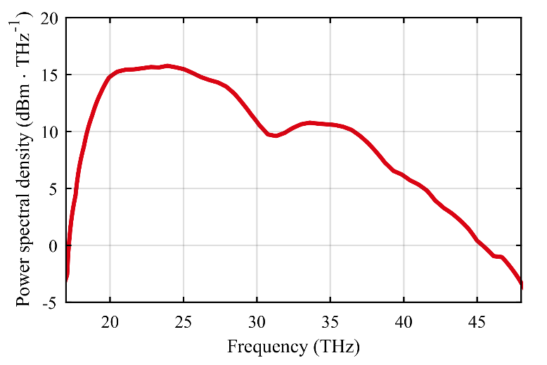

Figure S2. High-power mid-IR spectrum generated by intrapulse difference frequency generation, pumped at 2 µm wavelength resulting in a total mid-IR power of 450 mW.
Brightness estimation
The power spectral density (PSD) is used to calculate the power (ΔP) within a 0.1% interval of optical frequency f (Δf):

$$∆P\left(f\right)=PSD\left(f\right)∙∆f$$

From this we can determine the photon flux ($Φ$) within this optical frequency interval (Planck constant h):

$$Φ(f)=\frac{∆P}{h∙f}$$

The brightness B can then be estimated as:

$$B\left(f\right)=\frac{Φ\left(f\right)}{π∙w_{0}^{2}∙Ω\left(f\right)}$$

Due to the spatial coherence of the DFG process we assume a diffraction-limited mid-IR beam that emerges from the focus (radius w₀) in the crystal. Thus, the beam divergence in terms of solid angle Ω is given by (speed of light c):

$$Ω(f)=\frac{c²}{π∙w_{0}^{2}∙f²}$$

Therefore, the calculation of the brightness can be simplified to⁴:

$$B\left(f\right)=\frac{Φ\left(f\right)}{c^{2}}f^{2}$$

References
1 EKSMA. Infrared nonlinear crystals. http://eksmaoptics.com; 2017.
2 Marple DTF. Refractive Index of ZnSe, ZnTe, and CdTe. Journal of Applied Physics 1964; 35: 539-542.
3 Edmund Opitcs. Longpass-Edge Filters, 4.5µm cut on filter. http://www.edmundoptics.com; 2017.
4 Shukla P, Lawrence J, Zhang Y. Understanding laser beam brightness: A review and new prospective in material processing. Optics & Laser Technology 2015; 75: 40-51.

