Supplementary Information for

Ultrathin monolithic 3D printed optical coherence tomography endoscopy for preclinical and clinical use

Jiawen Li^{1,2*}, Simon Thiele³, Bryden C. Quirk^{1,2}, Rodney W. Kirk^{1,2}, Johan W. Verjans^{1,4,5}, Emma Akers⁴, Christina Bursill^{1,4}, Stephen J. Nicholls⁶, Alois M. Herkommer³,
Harald Giessen⁷, Robert A. McLaughlin^{1,2}

Affiliations
¹Australian Research Council Centre of Excellence for Nanoscale BioPhotonics, Adelaide Medical School, University of Adelaide, Adelaide, SA, 5005, Australia
²Institute for Photonics and Advanced Sensing, The University of Adelaide, Adelaide, SA, 5005, Australia
³Institute of Applied Optics (ITO) and Research Center SCoPE, University of Stuttgart, 70569 Stuttgart, Germany.
⁴South Australian Health and Medical Research Institute (SAHMRI), Adelaide, SA, 5000, Australia
⁵Royal Adelaide Hospital, Adelaide, SA, 5000, Australia
⁶Monash Cardiovascular Research Centre, Monash University, Melbourne, VIC, 3168, Australia
⁷4th Physics Institute and Research Center SCoPE, University of Stuttgart, 70569 Stuttgart, Germany
* Correspondence: jiawen.li01@adelaide.edu.au

File name: Supplementary Information Description.
File name: Supplementary Movie 1 Description: 3D reconstruction movie of an atherosclerotic mouse aorta as described in Figure 5.
File name: Supplementary Movie 2 Description: 3D reconstruction movie of an atherosclerotic mouse aorta as described in Figure 6.

1. Experimental setup for beam profiling in water
Supplementary Figure 1. Experimental setup for beam profiling in water. a Entire setup with probe. b Zoomed red dashed box region in a. During beam profiling, the ultrathin probe was mounted onto a 3D printed probe holder to ensure that the optical beam from the probe was incident normal to the lens unit (LP2-1:1.9-TEL-30-16, DataRay Inc., USA) and the CMOS chip of the beam profiler (WinCamD-XHR-1310, DataRay Inc., USA). The beam profiler camera has a pixel size of 3.2 μm x 3.2 μm and a lens-unit magnification of 1.9x. The beam profiler was moved axially by a linear translation stage (M2DU-50, DataRay Inc., USA) to step through the beam waist.

2. Comparing the beam profiles of this monolithic aberration-corrected probe with our previous work Ref 28
Supplementary Figure 2. Beam profiles of this monolithic aberration-corrected probe and of our previous work (Ref 28 in the main text). The lateral resolution of this aberration-corrected probe is 12 µm, compared to 23 µm in Ref 28. In addition, astigmatism is much more obvious with Ref 28 design. Note that the size of micro-optics in the Ref 28 is almost 300 µm, more than twice of that presented in this work.
3. Sensitivity measurement of the OCT system combined with the 3D printed probe
The sensitivity of the system when using the probe is measured to be at least 98.4 dB.
The sensitivity was determined for the water-immersed intravascular probe by measuring the signal-to-noise ratio (SNR) of a reflection from an interface of fused-silica (n=1.447) and water, resulting in a −27.5 dB Fresnel reflection (see Supplementary Figure 3 for the setup). During measurement, a double-pass attenuation of -25.9 dB was applied to avoid this reflection from silica-water interface to saturate the OCT spectrometer.

Supplementary Figure 3. Setup for sensitivity measurement

The solid line below shows the averaged A-scan signal obtained when the water/silica interface (Peak 1) was at a distance of approximately 500 μm in water from the catheter sheath (Peak 0). Note that the Peak 2 was generated by the back interface of the fused-silica sample (silica/air interface). The SNR at Peak 1 was approximately 45 dB. The sensitivity of the combined OCT system and 3D printed probe was calculated to be 98.4 dB.

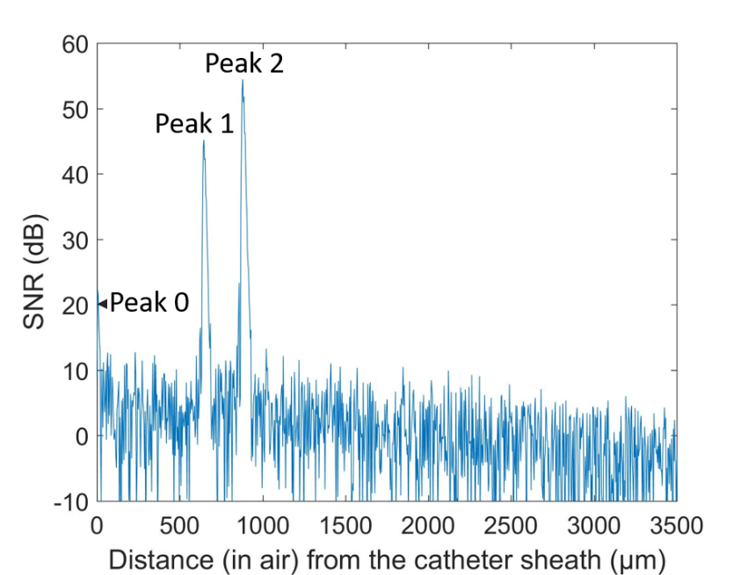
Supplementary Figure 4. SNR of the water-silica interface measured by the ultrathin 3D printed probe being immersed in water and a double-pass attenuation of -25.9 dB being applied

