Supplementary Information for Advanced liquid crystal devices for augmented reality and virtual reality displays: Principles and Applications
Kun Yin, En-Lin Hsiang, Junyu Zou, Yannanqi Li, Zhiyong Yang, Qian Yang, Po-Cheng Lai, Chih-Lung Lin, and Shin-Tson Wu*
College of Optics and Photonics, University of Central Florida, Orlando, FL 32816, USA
*Corresponding author: swu@creol.ucf.edu
_____________________________________________________________________________
S1 PVG calculation parameters
To display full-color images, it is feasible to stack R/G/B PVGs as the in- and out-couplers on one waveguide. However, it is indispensable to ensure the period-matching for all gratings to avoid the crosstalk issue. In this circumstance, the effective FoV significantly shrinks since each color possesses a different FoV. Figure S1 depicts the FoV distribution of RGB light by assigning the matched period to all PVGs. The specific parameters are listed in Table S1.
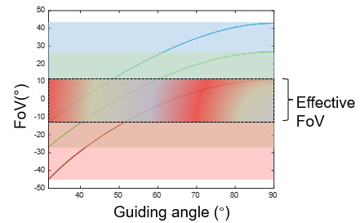
Fig. S1 PVG FoV simulation results. Plot of FoV distribution of RGB light. All RGB PVGs are assigned to the same horizontal period.
Table S1: The parameters used in PVG calculations
Blue wavelength (nm) | Green wavelength (nm) | Red wavelength (nm) | n_{g} | Critical angle (º) | Maximum guiding angle (º) | Grating period (nm)
450 | 535 | 630 | 1.9 | 31.7 | 90 | 368.96

