Supporting Information
for
“Dielectric Mie Voids: Confining Light in Air”

Mario Hentschel^{1,*}, Kirill Koshelev², Florian Sterl¹, Steffen Both¹, Julian Karst¹, Lida Shamsafar¹, Thomas Weiss^{1,3}, Yuri Kivshar^{2,*}, and Harald Giessen^{1,*}

¹4th Physics Institute and Research Center SCoPE, University of Stuttgart, Pfaffenwaldring 57, 70569 Stuttgart, Germany
²Nonlinear Physics Centre, Research School of Physics, Australian National University, Canberra ACT 2601, Australia
³Institute of Physics, University of Graz, and NAWI Graz, Universitätsplatz 5, 8010 Graz, Austria

*m.hentschel@physik.uni-stuttgart.de, yuri.kivshar@anu.edu.au, giessen@physik.uni-stuttgart.de

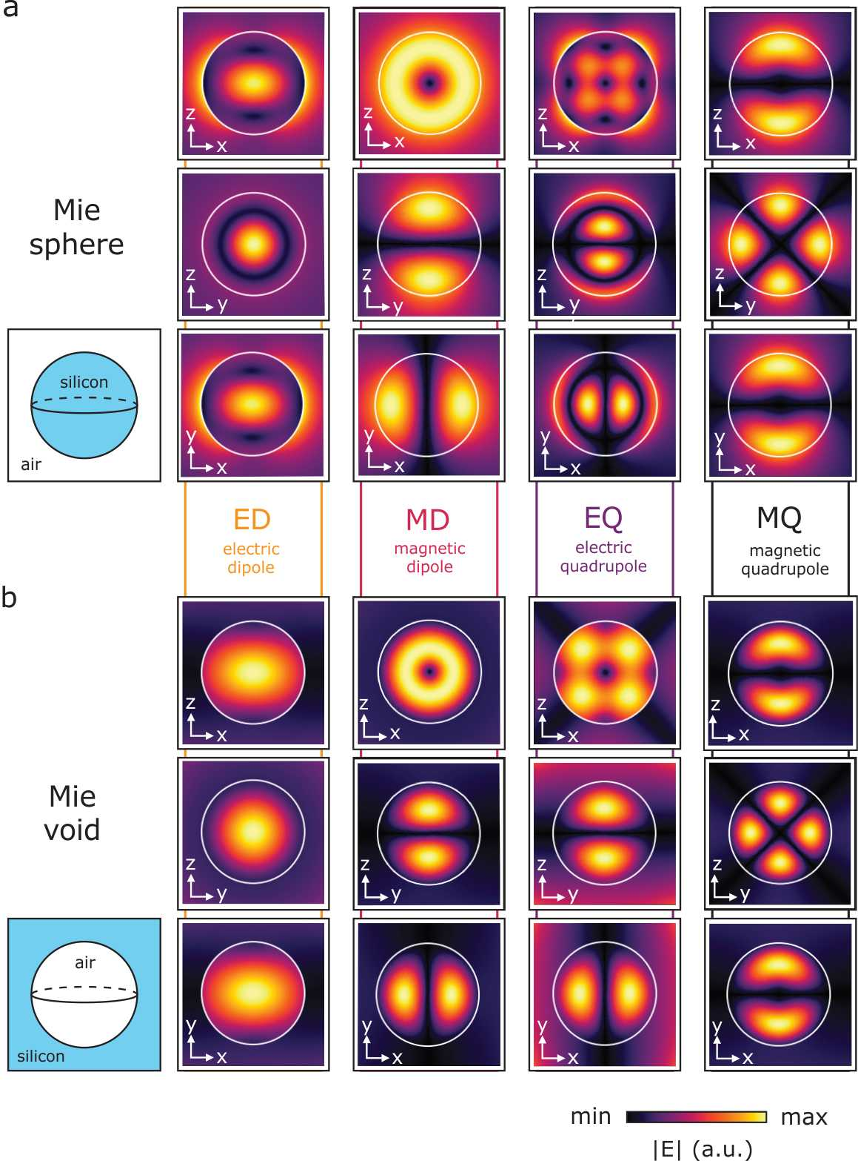
Figure S1: Electric field profiles for the eigenmodes of (a) a silicon sphere in air and (b) a spherical air void in silicon environment. The fields are for four fundamental modes, electric and magnetic dipole, and electric and magnetic quadrupole. The field cross-sections are plotted in the main X-Z, Y-Z, and X-Y planes for the sphere centered in the origin of the reference frame. Each of the selected modes is degenerate with respect to the azimuthal index m, so the field profiles are shown only for the modes that can be excited with a linearly X-polarized plane wave propagating along the Z direction similar to conditions of excitation in the experiment (Fig. 3 of the main text). The selected modes correspond to the azimuthal index m = -1 for magnetic modes and m = 1 for electric modes. The refractive index of silicon in simulations is 3.7, the extinction coefficient is zero.

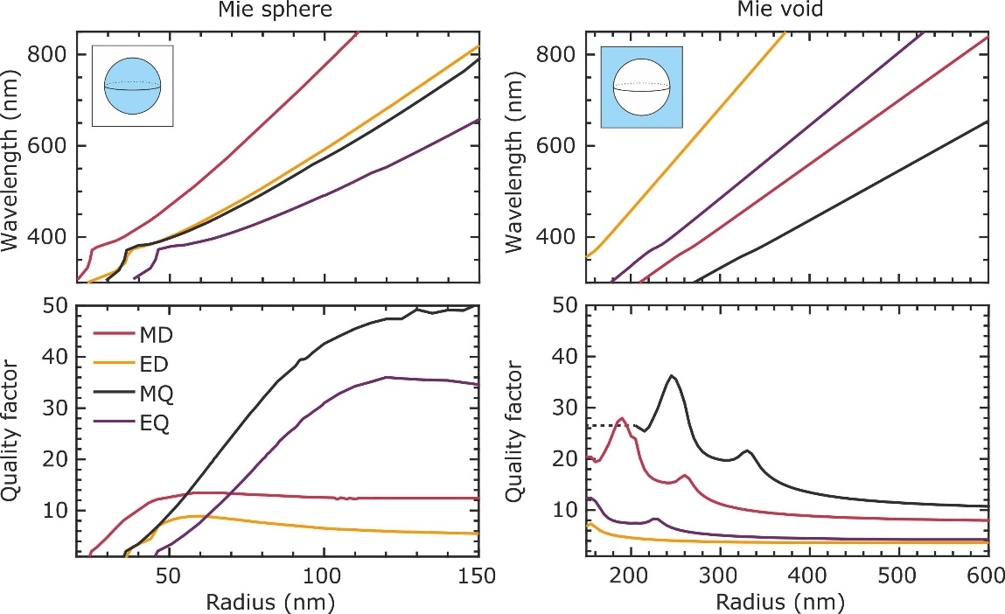

Figure S2: Calculated dependence of the resonant wavelength and mode quality factor on the sphere radius for a silicon sphere in air (left panels) and a spherical air void in silicon environment (right panels). The refractive index and extinction coefficients of silicon are taken from Fig.2c in the main text (top panel). The calculations are done for four fundamental modes, electric and magnetic dipole, and electric and magnetic quadrupole. The dashed line in lower right panel shows the extrapolation of quality factor to the size range where the dispersion of material is unavailable (wavelength range below 290 nm). The sharp peaks of the quality factor for Mie voids for sphere radius below 350 nm can be explained by increase of the extinction coefficient and refractive index, which leads to increased Fresnel reflection coefficient from the air-silicon interface.
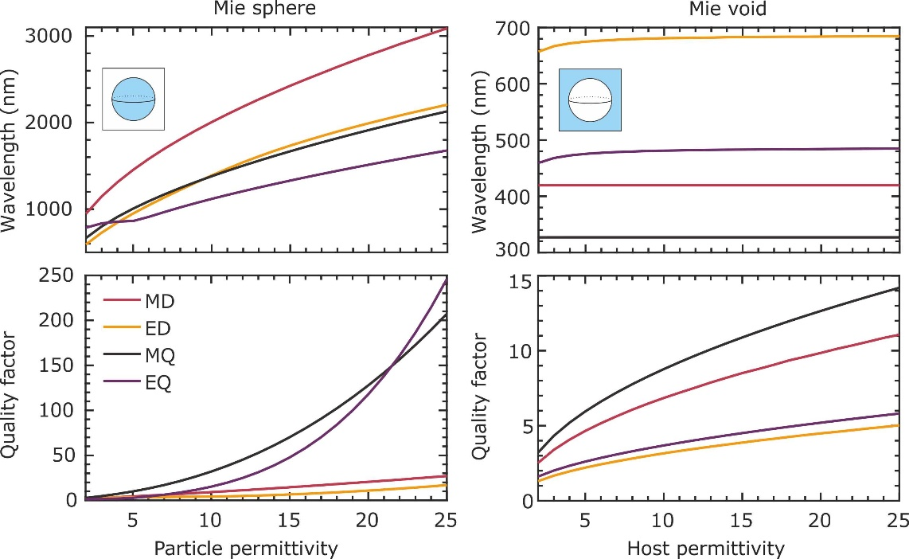

Figure S3: Calculated dependence of the resonant wavelength and mode quality factor on the material permittivity for a dielectric sphere in air (left panels) and a spherical air void in dielectric environment (right panels). The dielectric material is lossless. The calculations are done for four fundamental modes, electric and magnetic dipole, and electric and magnetic quadrupole. While the modes of the dielectric sphere show strong dispersion for varying permittivity values of the dielectric, the resonant wavelength of modes of a Mie void is robust to the change of host permittivity as the modes are confined in air. The quality factors of the modes for the dielectric sphere exhibit an extremely strong dependence on the permittivity and increase significantly for increasing permittivity. A similar behaviour is observed for the void, yet, the overall change is weaker. Again, the difference can be explained by the confinement in the dielectric vs. confinement in air.
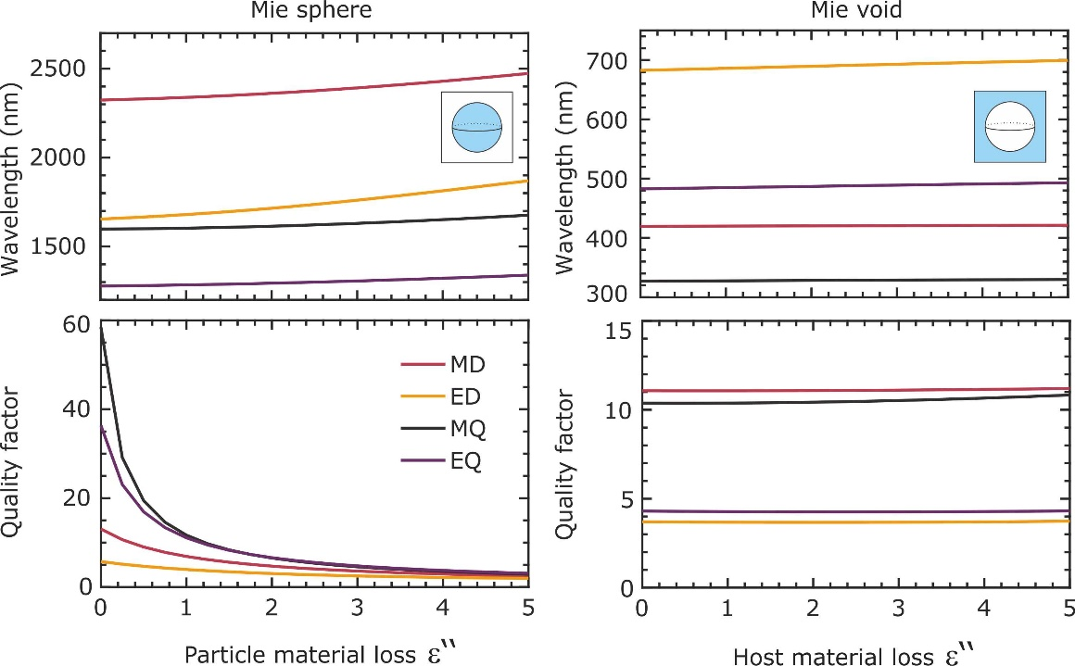

Figure S4: Calculated dependence of the resonant wavelength and mode quality factor on material losses for a dielectric sphere in air (left panels) and a spherical air void in dielectric environment (right panels). The real part of the dielectric’s permittivity is 13.69. The calculations are done for four fundamental modes, electric and magnetic dipole, and electric and magnetic quadrupole. The resonant wavelength of the modes for the dielectric sphere exhibit a slow increase with increasing loss while the quality factor drops extremely fast with increasing loss. Both phenomena are explained by the confinement of the mode to the lossy dielectric material and thus are subject to strong damping. The resonant wavelength of modes of a Mie void is robust to the increase of losses, while their quality factor grows slowly with increase of material absorption. Due to the confinement of the mode to air the losses of the host material do not damp the mode. The slight increase in the quality factor can be explained by an increased reflection at the air/silicon interface with increasing loss and thus by a stronger confinement.
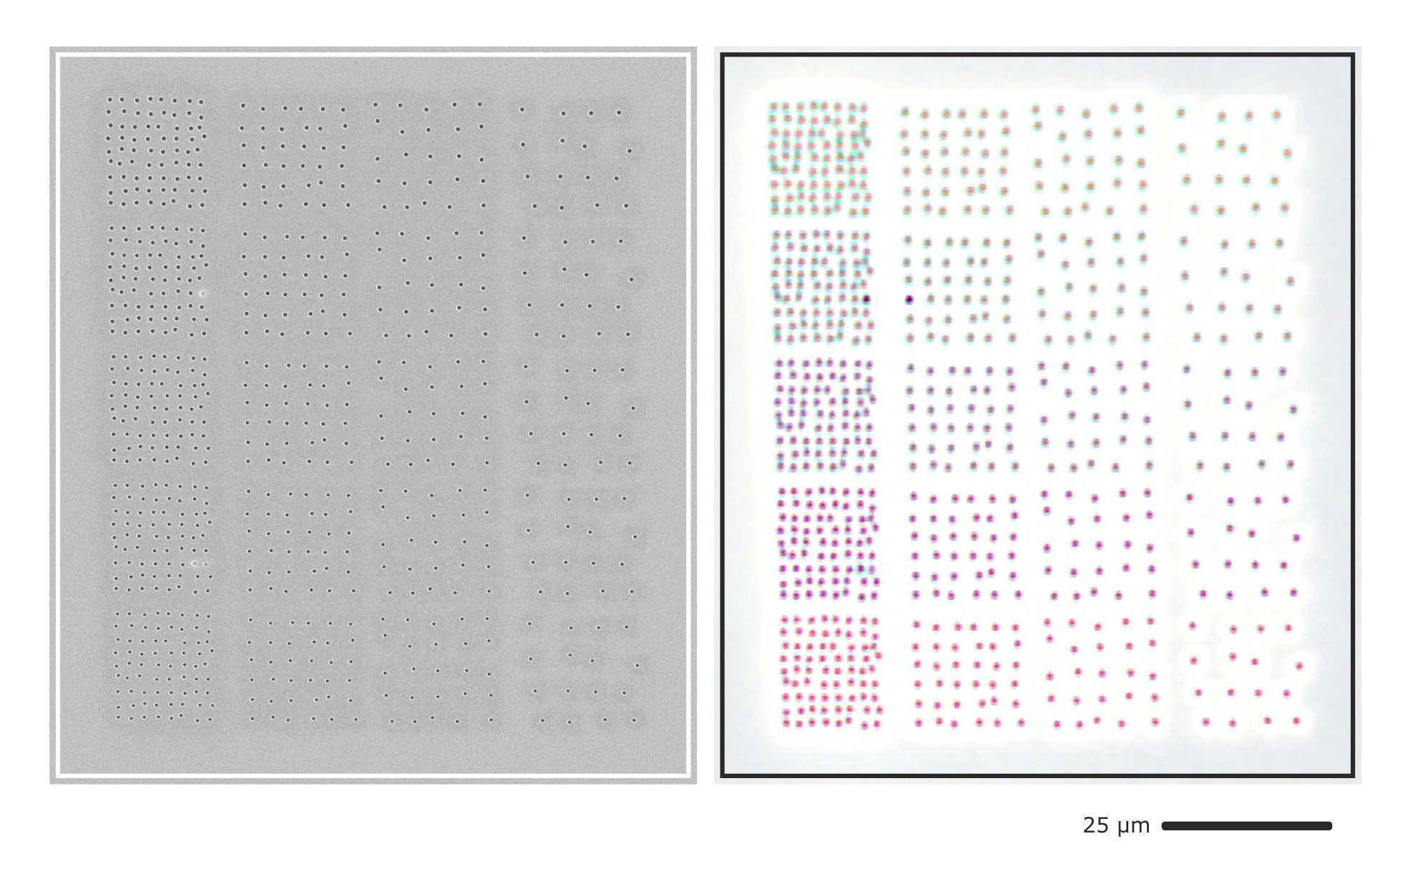
Figure S5: Disordered gratings of periods 2 µm, 3 µm, 4 µm, and 5 µm with varying particle diameter (bottom to top). All rows show distinctively different colours that remain unchanged with increasing periodicity, showing that the colour impression is indeed caused by localized modes. Also note the structuring defects in the second and fourth row, first column, which can be clearly identified in the colour impression, also pointing to localized modes of each particle.

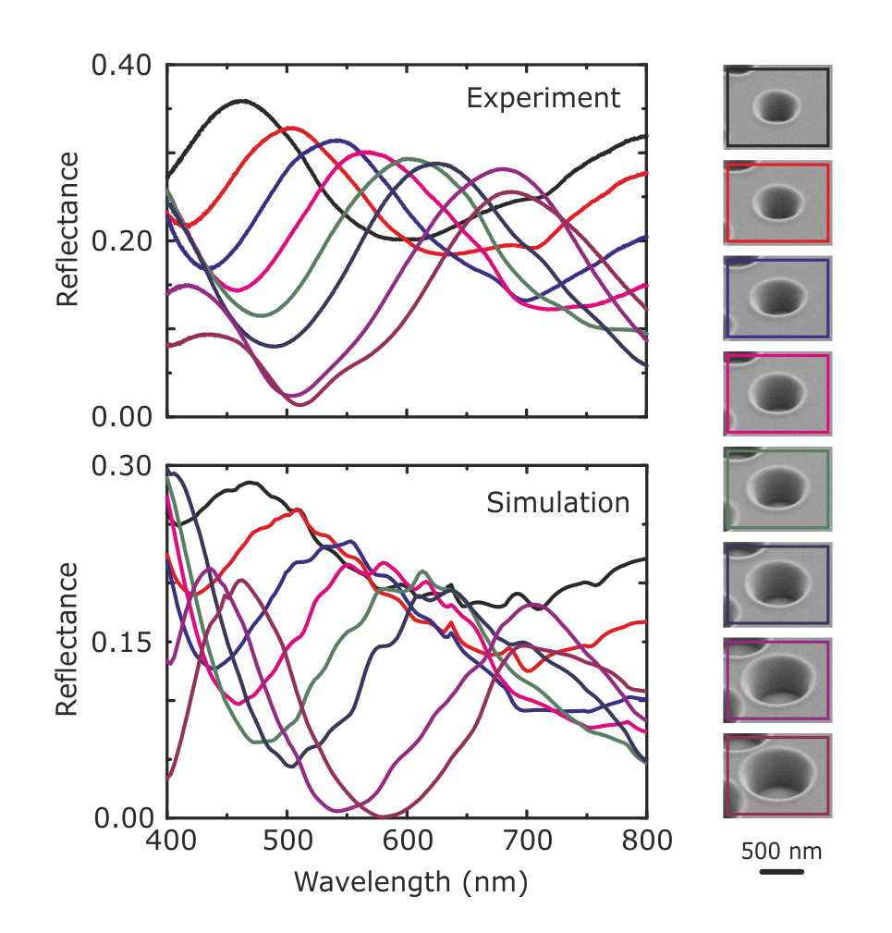
Figure S6: Experimental and simulated reflectance spectra as well as SEM images of the structures shown in Figure 3 in the main text (without vertical displacement). The experimentally determined geometrical parameters are as follows: (upper radius (nm), lower radius (nm), depth (nm)): (225, 135, 400), (255, 145, 400), (290, 160, 400), (305, 185, 410), (330, 200, 420), (340, 225, 440), (390, 265, 470), (405, 290, 500). These values are also used for the simulation. Periodicity is 900 nm in both directions.

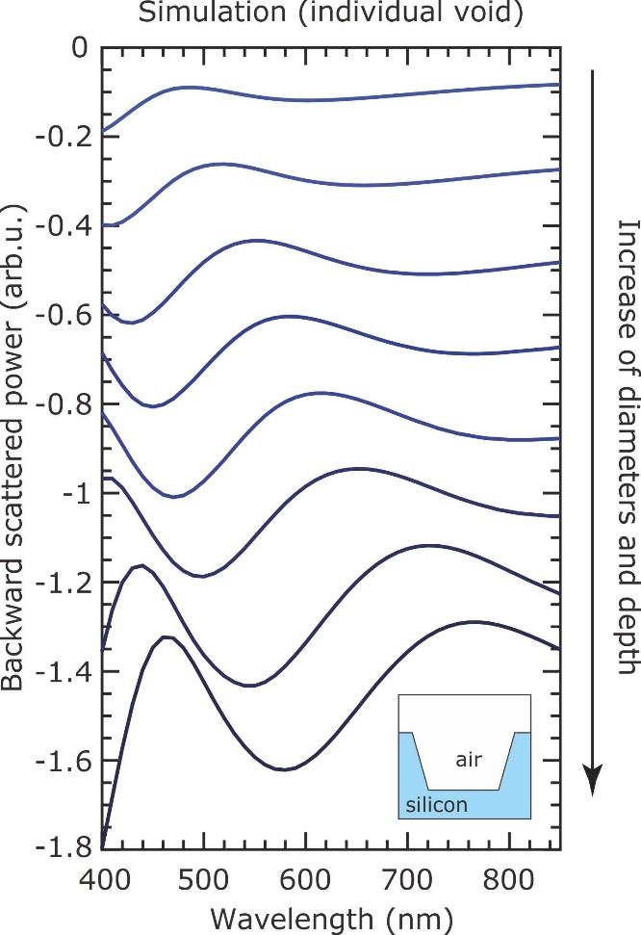

Figure S7: Simulated spectra of backward-scattered power from a single air void in silicon substrate for different diameters and depths. The geometry of the void and the range of size parameters are the same as in Fig. 3c of the main text. The resulting power is calculated as the difference between the backward-scattered power from the silicon substrate with a void and a bare silicon substrate. The refractive index and extinction coefficients of silicon are taken from the data shown in Fig. 2c of the main text (top panel). The spectra are shifted vertically relatively by 0.17 units. We observe excellent agreement with the measurement and finite-element-based array simulations shown in Fig. 3b. This behaviour underpins the localized nature of the observed modes and the minute to vanishing contribution from array or grating effects.

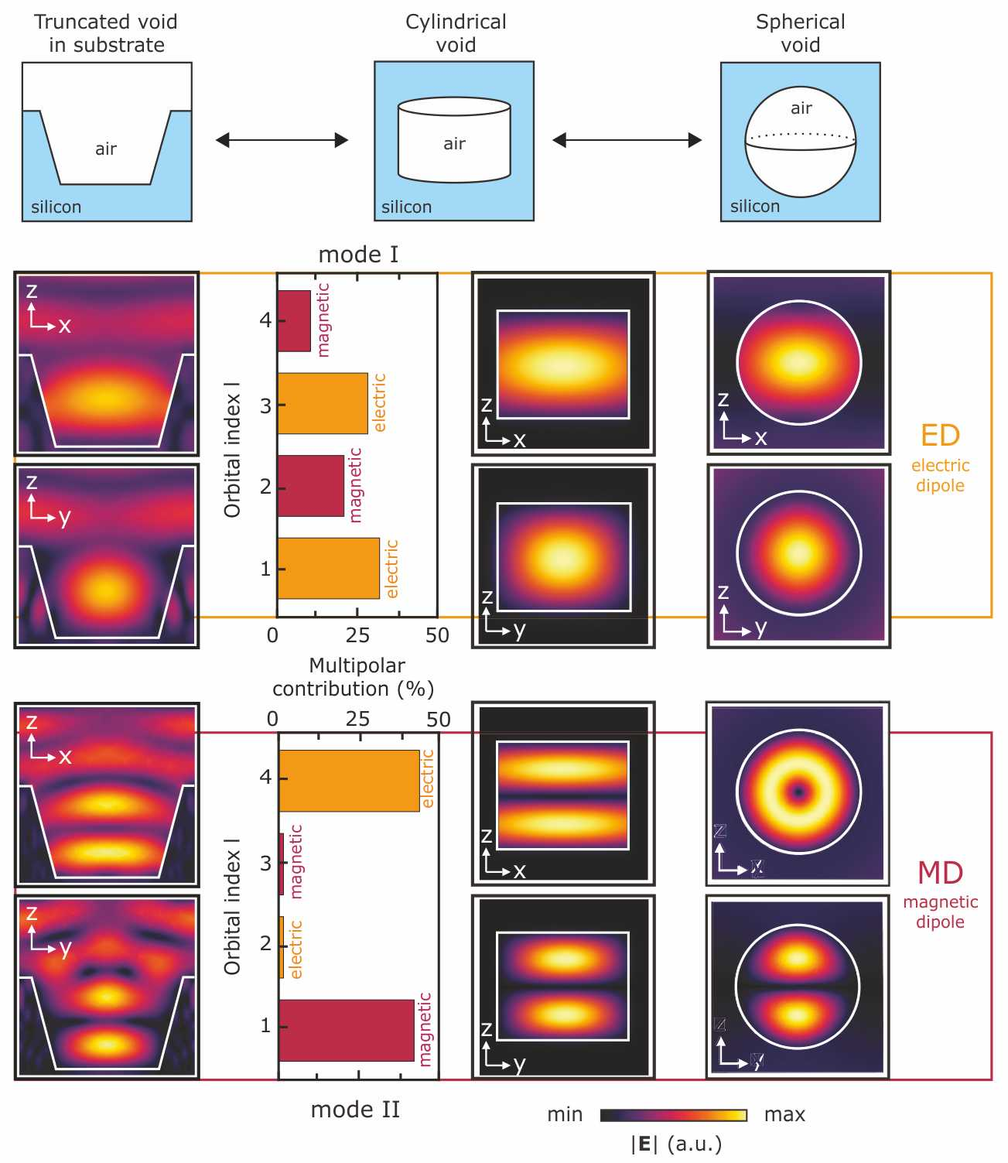
Figure S8: Connection between modes I and II of a cylindrical void in substrate and modes of a spherical Mie void. Comparison of the electric field profiles in Z-X and Z-Y planes for ED and MD modes of a spherical air void in homogeneous silicon environment (right) with the modes I and II, respectively, for a cylindrical air void in homogeneous silicon environment (central), and a truncated cylindrical air void in a silicon substrate (left). The field profiles for the central and right columns are from the eigenmode simulations, and for the left column are from the scattering simulations for periodic structures as in Fig. 3c of the main text. The inset on the top shows the geometry of the corresponding column. Overall, we observe a very good agreement between the mode profiles for cylindrical-shaped geometries (left and central) obtained from the full-wave reflection simulation and the eigenmode analysis. Moreover, in comparing these modal profiles to the analytical modes obtained from Mie’s theory on the right, we can identify the key properties of the electric and magnetic dipolar modes in the simulated ones. This is particularly clear for the electric dipolar mode, for which we observe excellent match. To further quantify this, the insets on the left show the relative multipolar contribution of the first four fundamental multipolar channels with the orbital indices from 1 to 4 to the radiated field of modes I and II for the cylindrical air void in homogeneous silicon environment. The comparison of the field profiles and multipolar decomposition results show that mode I is dominated by the electric dipolar radiation and mode II is dominated by the magnetic dipolar radiation with a contribution from other channels.

 | 1 | 2 | 3 | 4 | 5 | 6 | 7 | 8 | 9 | 10 | 11 | 12 | 13 | 14 | 15 | 16 | 17 | 18 | 19 | 20 | 21 | 22 | 23 | 24 | 25 | 26 | 27 | 28 | 29 | 30 | 31 | 32 | 33 | 34 | 35 | 36
36 | 337 | 360 | 383 | 406 | 429 | 465 | 500 | 536 | 571 | 607 | 621 | 635 | 649 | 663 | 677 | 698 | 719 | 740 | 761 | 782 | 800 | 818 | 837 | 855 | 873 | 891 | 909 | 927 | 945 | 963 | 982 | 1000 | 1018 | 1036 | 1054 | 1072
35 | 328 | 350 | 373 | 395 | 418 | 452 | 487 | 521 | 556 | 590 | 604 | 618 | 631 | 645 | 659 | 679 | 700 | 720 | 741 | 761 | 779 | 796 | 814 | 832 | 849 | 867 | 885 | 902 | 920 | 937 | 955 | 973 | 990 | 1008 | 1026 | 1043
34 | 319 | 341 | 363 | 384 | 406 | 440 | 473 | 507 | 540 | 574 | 587 | 601 | 614 | 627 | 641 | 660 | 680 | 700 | 720 | 740 | 757 | 774 | 791 | 809 | 826 | 843 | 860 | 877 | 894 | 911 | 929 | 946 | 963 | 980 | 997 | 1014
33 | 310 | 331 | 352 | 373 | 394 | 427 | 460 | 492 | 525 | 558 | 571 | 583 | 596 | 609 | 622 | 642 | 661 | 680 | 699 | 719 | 735 | 752 | 769 | 785 | 802 | 819 | 835 | 852 | 869 | 885 | 902 | 919 | 935 | 952 | 969 | 985
32 | 301 | 321 | 342 | 363 | 383 | 414 | 446 | 478 | 510 | 541 | 554 | 566 | 579 | 591 | 604 | 623 | 641 | 660 | 679 | 698 | 714 | 730 | 746 | 762 | 778 | 795 | 811 | 827 | 843 | 859 | 875 | 892 | 908 | 924 | 940 | 956
31 | 292 | 312 | 332 | 352 | 371 | 402 | 433 | 463 | 494 | 525 | 537 | 549 | 561 | 574 | 586 | 604 | 622 | 640 | 658 | 676 | 692 | 708 | 724 | 739 | 755 | 771 | 786 | 802 | 818 | 833 | 849 | 865 | 880 | 896 | 912 | 927
30 | 282 | 302 | 321 | 341 | 360 | 389 | 419 | 449 | 479 | 508 | 520 | 532 | 544 | 556 | 567 | 585 | 603 | 620 | 638 | 655 | 671 | 686 | 701 | 716 | 731 | 746 | 762 | 777 | 792 | 807 | 822 | 838 | 853 | 868 | 883 | 898
29 | 273 | 292 | 311 | 330 | 348 | 377 | 406 | 434 | 463 | 492 | 503 | 515 | 526 | 538 | 549 | 566 | 583 | 600 | 617 | 634 | 649 | 664 | 678 | 693 | 708 | 722 | 737 | 752 | 767 | 781 | 796 | 811 | 825 | 840 | 855 | 869
28 | 264 | 282 | 300 | 319 | 336 | 364 | 392 | 420 | 448 | 476 | 487 | 498 | 509 | 520 | 531 | 547 | 564 | 580 | 597 | 613 | 627 | 641 | 656 | 670 | 684 | 698 | 713 | 727 | 741 | 755 | 769 | 784 | 798 | 812 | 826 | 840
27 | 255 | 273 | 290 | 308 | 325 | 352 | 379 | 405 | 432 | 459 | 470 | 481 | 491 | 502 | 512 | 528 | 544 | 560 | 576 | 592 | 606 | 619 | 633 | 647 | 661 | 674 | 688 | 702 | 715 | 729 | 743 | 757 | 770 | 784 | 798 | 811
26 | 246 | 263 | 280 | 297 | 313 | 339 | 365 | 391 | 417 | 443 | 453 | 463 | 474 | 484 | 494 | 509 | 525 | 540 | 555 | 571 | 584 | 597 | 610 | 624 | 637 | 650 | 663 | 677 | 690 | 703 | 716 | 730 | 743 | 756 | 769 | 782
25 | 237 | 253 | 269 | 286 | 302 | 327 | 352 | 376 | 401 | 426 | 436 | 446 | 456 | 466 | 476 | 491 | 505 | 520 | 535 | 550 | 562 | 575 | 588 | 601 | 613 | 626 | 639 | 652 | 664 | 677 | 690 | 703 | 715 | 728 | 741 | 753
24 | 228 | 243 | 259 | 275 | 290 | 314 | 338 | 362 | 386 | 410 | 420 | 429 | 439 | 448 | 458 | 472 | 486 | 500 | 514 | 529 | 541 | 553 | 565 | 578 | 590 | 602 | 614 | 627 | 639 | 651 | 663 | 676 | 688 | 700 | 712 | 725
23 | 219 | 234 | 249 | 264 | 278 | 301 | 324 | 348 | 371 | 394 | 403 | 412 | 421 | 430 | 439 | 453 | 467 | 480 | 494 | 507 | 519 | 531 | 543 | 554 | 566 | 578 | 590 | 601 | 613 | 625 | 637 | 648 | 660 | 672 | 684 | 696
22 | 210 | 224 | 238 | 253 | 267 | 289 | 311 | 333 | 355 | 377 | 386 | 395 | 403 | 412 | 421 | 434 | 447 | 460 | 473 | 486 | 497 | 509 | 520 | 531 | 543 | 554 | 565 | 576 | 588 | 599 | 610 | 621 | 633 | 644 | 655 | 667
21 | 200 | 214 | 228 | 242 | 255 | 276 | 297 | 319 | 340 | 361 | 369 | 378 | 386 | 394 | 403 | 415 | 428 | 440 | 453 | 465 | 476 | 487 | 497 | 508 | 519 | 530 | 541 | 551 | 562 | 573 | 584 | 594 | 605 | 616 | 627 | 638
20 | 191 | 204 | 218 | 231 | 244 | 264 | 284 | 304 | 324 | 344 | 352 | 360 | 368 | 376 | 384 | 396 | 408 | 420 | 432 | 444 | 454 | 465 | 475 | 485 | 495 | 506 | 516 | 526 | 537 | 547 | 557 | 567 | 578 | 588 | 598 | 609
19 | 182 | 195 | 207 | 220 | 232 | 251 | 270 | 290 | 309 | 328 | 336 | 343 | 351 | 358 | 366 | 377 | 389 | 400 | 411 | 423 | 433 | 442 | 452 | 462 | 472 | 482 | 491 | 501 | 511 | 521 | 531 | 540 | 550 | 560 | 570 | 580
18 | 173 | 185 | 197 | 209 | 220 | 239 | 257 | 275 | 293 | 312 | 319 | 326 | 333 | 341 | 348 | 359 | 369 | 380 | 391 | 402 | 411 | 420 | 430 | 439 | 448 | 458 | 467 | 476 | 485 | 495 | 504 | 513 | 523 | 532 | 541 | 551
17 | 164 | 175 | 186 | 198 | 209 | 226 | 243 | 261 | 278 | 295 | 302 | 309 | 316 | 323 | 329 | 340 | 350 | 360 | 370 | 381 | 389 | 398 | 407 | 416 | 425 | 433 | 442 | 451 | 460 | 469 | 478 | 486 | 495 | 504 | 513 | 522
16 | 155 | 165 | 176 | 187 | 197 | 214 | 230 | 246 | 262 | 279 | 285 | 292 | 298 | 305 | 311 | 321 | 330 | 340 | 350 | 359 | 368 | 376 | 384 | 393 | 401 | 409 | 418 | 426 | 434 | 443 | 451 | 459 | 468 | 476 | 484 | 493
15 | 146 | 156 | 166 | 176 | 186 | 201 | 216 | 232 | 247 | 262 | 268 | 275 | 281 | 287 | 293 | 302 | 311 | 320 | 329 | 338 | 346 | 354 | 362 | 370 | 377 | 385 | 393 | 401 | 409 | 417 | 424 | 432 | 440 | 448 | 456 | 464
14 | 137 | 146 | 155 | 165 | 174 | 188 | 203 | 217 | 232 | 246 | 252 | 257 | 263 | 269 | 275 | 283 | 292 | 300 | 309 | 317 | 324 | 332 | 339 | 347 | 354 | 361 | 369 | 376 | 383 | 391 | 398 | 405 | 413 | 420 | 427 | 435
13 | 128 | 136 | 145 | 154 | 162 | 176 | 189 | 203 | 216 | 230 | 235 | 240 | 246 | 251 | 256 | 264 | 272 | 280 | 288 | 296 | 303 | 310 | 317 | 323 | 330 | 337 | 344 | 351 | 358 | 365 | 371 | 378 | 385 | 392 | 399 | 406
12 | 118 | 127 | 135 | 143 | 151 | 163 | 176 | 188 | 201 | 213 | 218 | 223 | 228 | 233 | 238 | 245 | 253 | 260 | 267 | 275 | 281 | 288 | 294 | 300 | 307 | 313 | 319 | 326 | 332 | 339 | 345 | 351 | 358 | 364 | 370 | 377
11 | 109 | 117 | 124 | 132 | 139 | 151 | 162 | 174 | 185 | 197 | 201 | 206 | 210 | 215 | 220 | 226 | 233 | 240 | 247 | 254 | 260 | 265 | 271 | 277 | 283 | 289 | 295 | 301 | 307 | 312 | 318 | 324 | 330 | 336 | 342 | 348
10 | 100 | 107 | 114 | 121 | 128 | 138 | 149 | 159 | 170 | 180 | 185 | 189 | 193 | 197 | 201 | 208 | 214 | 220 | 226 | 233 | 238 | 243 | 249 | 254 | 259 | 265 | 270 | 276 | 281 | 286 | 292 | 297 | 303 | 308 | 313 | 319
9 | 91 | 97 | 104 | 110 | 116 | 126 | 135 | 145 | 154 | 164 | 168 | 172 | 175 | 179 | 183 | 189 | 194 | 200 | 206 | 211 | 216 | 221 | 226 | 231 | 236 | 241 | 246 | 251 | 256 | 260 | 265 | 270 | 275 | 280 | 285 | 290
8 | 82 | 88 | 93 | 99 | 104 | 113 | 122 | 130 | 139 | 148 | 151 | 154 | 158 | 161 | 165 | 170 | 175 | 180 | 185 | 190 | 195 | 199 | 203 | 208 | 212 | 217 | 221 | 226 | 230 | 234 | 239 | 243 | 248 | 252 | 256 | 261
7 | 73 | 78 | 83 | 88 | 93 | 100 | 108 | 116 | 124 | 131 | 134 | 137 | 140 | 143 | 146 | 151 | 156 | 160 | 165 | 169 | 173 | 177 | 181 | 185 | 189 | 193 | 197 | 200 | 204 | 208 | 212 | 216 | 220 | 224 | 228 | 232
6 | 64 | 68 | 73 | 77 | 81 | 88 | 95 | 101 | 108 | 115 | 117 | 120 | 123 | 125 | 128 | 132 | 136 | 140 | 144 | 148 | 151 | 155 | 158 | 162 | 165 | 169 | 172 | 175 | 179 | 182 | 186 | 189 | 193 | 196 | 199 | 203
5 | 55 | 58 | 62 | 66 | 70 | 75 | 81 | 87 | 93 | 98 | 101 | 103 | 105 | 108 | 110 | 113 | 117 | 120 | 123 | 127 | 130 | 133 | 136 | 139 | 142 | 144 | 147 | 150 | 153 | 156 | 159 | 162 | 165 | 168 | 171 | 174
4 | 46 | 49 | 52 | 55 | 58 | 63 | 68 | 72 | 77 | 82 | 84 | 86 | 88 | 90 | 92 | 94 | 97 | 100 | 103 | 106 | 108 | 111 | 113 | 116 | 118 | 120 | 123 | 125 | 128 | 130 | 133 | 135 | 138 | 140 | 142 | 145
3 | 36 | 39 | 41 | 44 | 46 | 50 | 54 | 58 | 62 | 66 | 67 | 69 | 70 | 72 | 73 | 75 | 78 | 80 | 82 | 85 | 87 | 88 | 90 | 92 | 94 | 96 | 98 | 100 | 102 | 104 | 106 | 108 | 110 | 112 | 114 | 116
2 | 27 | 29 | 31 | 33 | 35 | 38 | 41 | 43 | 46 | 49 | 50 | 51 | 53 | 54 | 55 | 57 | 58 | 60 | 62 | 63 | 65 | 66 | 68 | 69 | 71 | 72 | 74 | 75 | 77 | 78 | 80 | 81 | 83 | 84 | 85 | 87
1 | 18 | 19 | 21 | 22 | 23 | 25 | 27 | 29 | 31 | 33 | 34 | 34 | 35 | 36 | 37 | 38 | 39 | 40 | 41 | 42 | 43 | 44 | 45 | 46 | 47 | 48 | 49 | 50 | 51 | 52 | 53 | 54 | 55 | 56 | 57 | 58
Table ST1: Experimental values for the depth in nanometers for the size and depth sweep shown in Figure 4. These values have been used for the simulations shown in the same figure. The patterning parameters have been adapted as follows: Singly-charged gold ions at a beam current of ~350 pA and a 30 µm beam-forming aperture are used. The step size is 10 nm, circles are exposed in circular outward mode. The base dose value is 1 nC/µm². The dose sweep is linear in 36 steps from a dose factor of 0.1 to 1.85 with constant increment of 0.05. 30 depth have been determined from SEM inspection, the other depth have been extrapolated from these measurements assuming that the depth is linear with dose.
 | 1 | 2 | 3 | 4 | 5 | 6 | 7 | 8 | 9 | 10 | 11 | 12 | 13 | 14 | 15 | 16 | 17 | 18 | 19 | 20 | 21 | 22 | 23 | 24 | 25 | 26 | 27 | 28 | 29 | 30 | 31 | 32 | 33 | 34 | 35 | 36
36 | 400 | 410 | 420 | 430 | 440 | 450 | 460 | 470 | 480 | 490 | 500 | 510 | 520 | 530 | 540 | 550 | 560 | 570 | 580 | 590 | 600 | 610 | 620 | 630 | 640 | 650 | 660 | 670 | 680 | 690 | 700 | 710 | 720 | 730 | 740 | 750
35 | 399 | 409 | 419 | 429 | 439 | 449 | 459 | 469 | 479 | 489 | 499 | 509 | 519 | 529 | 539 | 549 | 559 | 569 | 579 | 589 | 599 | 609 | 619 | 629 | 639 | 649 | 659 | 669 | 679 | 689 | 699 | 709 | 719 | 729 | 739 | 749
34 | 398 | 408 | 418 | 428 | 438 | 448 | 458 | 468 | 478 | 488 | 498 | 508 | 518 | 528 | 538 | 548 | 558 | 568 | 578 | 588 | 598 | 608 | 618 | 628 | 638 | 648 | 658 | 668 | 678 | 688 | 698 | 708 | 718 | 728 | 738 | 748
33 | 396 | 406 | 416 | 426 | 436 | 446 | 456 | 466 | 476 | 486 | 496 | 506 | 516 | 526 | 536 | 546 | 556 | 566 | 576 | 586 | 596 | 606 | 616 | 626 | 636 | 646 | 656 | 666 | 676 | 686 | 696 | 706 | 716 | 726 | 736 | 746
32 | 395 | 405 | 415 | 425 | 435 | 445 | 455 | 465 | 475 | 485 | 495 | 505 | 515 | 525 | 535 | 545 | 555 | 565 | 575 | 585 | 595 | 605 | 615 | 625 | 635 | 645 | 655 | 665 | 675 | 685 | 695 | 705 | 715 | 725 | 735 | 745
31 | 394 | 404 | 414 | 424 | 434 | 444 | 454 | 464 | 474 | 484 | 494 | 504 | 514 | 524 | 534 | 544 | 554 | 564 | 574 | 584 | 594 | 604 | 614 | 624 | 634 | 644 | 654 | 664 | 674 | 684 | 694 | 704 | 714 | 724 | 734 | 744
30 | 393 | 403 | 413 | 423 | 433 | 443 | 453 | 463 | 473 | 483 | 493 | 503 | 513 | 523 | 533 | 543 | 553 | 563 | 573 | 583 | 593 | 603 | 613 | 623 | 633 | 643 | 653 | 663 | 673 | 683 | 693 | 703 | 713 | 723 | 733 | 743
29 | 392 | 402 | 412 | 422 | 432 | 442 | 452 | 462 | 472 | 482 | 492 | 502 | 512 | 522 | 532 | 542 | 552 | 562 | 572 | 582 | 592 | 602 | 612 | 622 | 632 | 642 | 652 | 662 | 672 | 682 | 692 | 702 | 712 | 722 | 732 | 742
28 | 391 | 401 | 411 | 421 | 431 | 441 | 451 | 461 | 471 | 481 | 491 | 501 | 511 | 521 | 531 | 541 | 551 | 561 | 571 | 581 | 591 | 601 | 611 | 621 | 631 | 641 | 651 | 661 | 671 | 681 | 691 | 701 | 711 | 721 | 731 | 741
27 | 389 | 399 | 409 | 419 | 429 | 439 | 449 | 459 | 469 | 479 | 489 | 499 | 509 | 519 | 529 | 539 | 549 | 559 | 569 | 579 | 589 | 599 | 609 | 619 | 629 | 639 | 649 | 659 | 669 | 679 | 689 | 699 | 709 | 719 | 729 | 739
26 | 388 | 398 | 408 | 418 | 428 | 438 | 448 | 458 | 468 | 478 | 488 | 498 | 508 | 518 | 528 | 538 | 548 | 558 | 568 | 578 | 588 | 598 | 608 | 618 | 628 | 638 | 648 | 658 | 668 | 678 | 688 | 698 | 708 | 718 | 728 | 738
25 | 387 | 397 | 407 | 417 | 427 | 437 | 447 | 457 | 467 | 477 | 487 | 497 | 507 | 517 | 527 | 537 | 547 | 557 | 567 | 577 | 587 | 597 | 607 | 617 | 627 | 637 | 647 | 657 | 667 | 677 | 687 | 697 | 707 | 717 | 727 | 737
24 | 386 | 396 | 406 | 416 | 426 | 436 | 446 | 456 | 466 | 476 | 486 | 496 | 506 | 516 | 526 | 536 | 546 | 556 | 566 | 576 | 586 | 596 | 606 | 616 | 626 | 636 | 646 | 656 | 666 | 676 | 686 | 696 | 706 | 716 | 726 | 736
23 | 385 | 395 | 405 | 415 | 425 | 435 | 445 | 455 | 465 | 475 | 485 | 495 | 505 | 515 | 525 | 535 | 545 | 555 | 565 | 575 | 585 | 595 | 605 | 615 | 625 | 635 | 645 | 655 | 665 | 675 | 685 | 695 | 705 | 715 | 725 | 735
22 | 384 | 394 | 404 | 414 | 424 | 434 | 444 | 454 | 464 | 474 | 484 | 494 | 504 | 514 | 524 | 534 | 544 | 554 | 564 | 574 | 584 | 594 | 604 | 614 | 624 | 634 | 644 | 654 | 664 | 674 | 684 | 694 | 704 | 714 | 724 | 734
21 | 381 | 391 | 401 | 411 | 421 | 431 | 441 | 451 | 461 | 471 | 481 | 491 | 501 | 511 | 521 | 531 | 541 | 551 | 561 | 571 | 581 | 591 | 601 | 611 | 621 | 631 | 641 | 651 | 661 | 671 | 681 | 691 | 701 | 711 | 721 | 731
20 | 382 | 392 | 402 | 412 | 422 | 432 | 442 | 452 | 462 | 472 | 482 | 492 | 502 | 512 | 522 | 532 | 542 | 552 | 562 | 572 | 582 | 592 | 602 | 612 | 622 | 632 | 642 | 652 | 662 | 672 | 682 | 692 | 702 | 712 | 722 | 732
19 | 381 | 391 | 401 | 411 | 421 | 431 | 441 | 451 | 461 | 471 | 481 | 491 | 501 | 511 | 521 | 531 | 541 | 551 | 561 | 571 | 581 | 591 | 601 | 611 | 621 | 631 | 641 | 651 | 661 | 671 | 681 | 691 | 701 | 711 | 721 | 731
18 | 380 | 390 | 400 | 410 | 420 | 430 | 440 | 450 | 460 | 470 | 480 | 490 | 500 | 510 | 520 | 530 | 540 | 550 | 560 | 570 | 580 | 590 | 600 | 610 | 620 | 630 | 640 | 650 | 660 | 670 | 680 | 690 | 700 | 710 | 720 | 730
17 | 377 | 387 | 397 | 407 | 417 | 427 | 437 | 447 | 457 | 467 | 477 | 487 | 497 | 507 | 517 | 527 | 537 | 547 | 557 | 567 | 577 | 587 | 597 | 607 | 617 | 627 | 637 | 647 | 657 | 667 | 677 | 687 | 697 | 707 | 717 | 727
16 | 374 | 384 | 394 | 404 | 414 | 424 | 434 | 444 | 454 | 464 | 474 | 484 | 494 | 504 | 514 | 524 | 534 | 544 | 554 | 564 | 574 | 584 | 594 | 604 | 614 | 624 | 634 | 644 | 654 | 664 | 674 | 684 | 694 | 704 | 714 | 724
15 | 371 | 381 | 391 | 401 | 411 | 421 | 431 | 441 | 451 | 461 | 471 | 481 | 491 | 501 | 511 | 521 | 531 | 541 | 551 | 561 | 571 | 581 | 591 | 601 | 611 | 621 | 631 | 641 | 651 | 661 | 671 | 681 | 691 | 701 | 711 | 721
14 | 368 | 378 | 388 | 398 | 408 | 418 | 428 | 438 | 448 | 458 | 468 | 478 | 488 | 498 | 508 | 518 | 528 | 538 | 548 | 558 | 568 | 578 | 588 | 598 | 608 | 618 | 628 | 638 | 648 | 658 | 668 | 678 | 688 | 698 | 708 | 718
13 | 365 | 375 | 385 | 395 | 405 | 415 | 425 | 435 | 445 | 455 | 465 | 475 | 485 | 495 | 505 | 515 | 525 | 535 | 545 | 555 | 565 | 575 | 585 | 595 | 605 | 615 | 625 | 635 | 645 | 655 | 665 | 675 | 685 | 695 | 705 | 715
12 | 362 | 372 | 382 | 392 | 402 | 412 | 422 | 432 | 442 | 452 | 462 | 472 | 482 | 492 | 502 | 512 | 522 | 532 | 542 | 552 | 562 | 572 | 582 | 592 | 602 | 612 | 622 | 632 | 642 | 652 | 662 | 672 | 682 | 692 | 702 | 712
11 | 359 | 369 | 379 | 389 | 399 | 409 | 419 | 429 | 439 | 449 | 459 | 469 | 479 | 489 | 499 | 509 | 519 | 529 | 539 | 549 | 559 | 569 | 579 | 589 | 599 | 609 | 619 | 629 | 639 | 649 | 659 | 669 | 679 | 689 | 699 | 709
10 | 356 | 366 | 376 | 386 | 396 | 406 | 416 | 426 | 436 | 446 | 456 | 466 | 476 | 486 | 496 | 506 | 516 | 526 | 536 | 546 | 556 | 566 | 576 | 586 | 596 | 606 | 616 | 626 | 636 | 646 | 656 | 666 | 676 | 686 | 696 | 706
9 | 354 | 364 | 374 | 384 | 394 | 404 | 414 | 424 | 434 | 444 | 454 | 464 | 474 | 484 | 494 | 504 | 514 | 524 | 534 | 544 | 554 | 564 | 574 | 584 | 594 | 604 | 614 | 624 | 634 | 644 | 654 | 664 | 674 | 684 | 694 | 704
8 | 351 | 361 | 371 | 381 | 391 | 401 | 411 | 421 | 431 | 441 | 451 | 461 | 471 | 481 | 491 | 501 | 511 | 521 | 531 | 541 | 551 | 561 | 571 | 581 | 591 | 601 | 611 | 621 | 631 | 641 | 651 | 661 | 671 | 681 | 691 | 701
7 | 348 | 358 | 368 | 378 | 388 | 398 | 408 | 418 | 428 | 438 | 448 | 458 | 468 | 478 | 488 | 498 | 508 | 518 | 528 | 538 | 548 | 558 | 568 | 578 | 588 | 598 | 608 | 618 | 628 | 638 | 648 | 658 | 668 | 678 | 688 | 698
6 | 345 | 355 | 365 | 375 | 385 | 395 | 405 | 415 | 425 | 435 | 445 | 455 | 465 | 475 | 485 | 495 | 505 | 515 | 525 | 535 | 545 | 555 | 565 | 575 | 585 | 595 | 605 | 615 | 625 | 635 | 645 | 655 | 665 | 675 | 685 | 695
5 | 342 | 352 | 362 | 372 | 382 | 392 | 402 | 412 | 422 | 432 | 442 | 452 | 462 | 472 | 482 | 492 | 502 | 512 | 522 | 532 | 542 | 552 | 562 | 572 | 582 | 592 | 602 | 612 | 622 | 632 | 642 | 652 | 662 | 672 | 682 | 692
4 | 339 | 349 | 359 | 369 | 379 | 389 | 399 | 409 | 419 | 429 | 439 | 449 | 459 | 469 | 479 | 489 | 499 | 509 | 519 | 529 | 539 | 549 | 559 | 569 | 579 | 589 | 599 | 609 | 619 | 629 | 639 | 649 | 659 | 669 | 679 | 689
3 | 336 | 346 | 356 | 366 | 376 | 386 | 396 | 406 | 416 | 426 | 436 | 446 | 456 | 466 | 476 | 486 | 496 | 506 | 516 | 526 | 536 | 546 | 556 | 566 | 576 | 586 | 596 | 606 | 616 | 626 | 636 | 646 | 656 | 666 | 676 | 686
2 | 333 | 343 | 353 | 363 | 373 | 383 | 393 | 403 | 413 | 423 | 433 | 443 | 453 | 463 | 473 | 483 | 493 | 503 | 513 | 523 | 533 | 543 | 553 | 563 | 573 | 583 | 593 | 603 | 613 | 623 | 633 | 643 | 653 | 663 | 673 | 683
1 | 330 | 340 | 350 | 360 | 370 | 380 | 390 | 400 | 410 | 420 | 430 | 440 | 450 | 460 | 470 | 480 | 490 | 500 | 510 | 520 | 530 | 540 | 550 | 560 | 570 | 580 | 590 | 600 | 610 | 620 | 630 | 640 | 650 | 660 | 670 | 680
Table ST2: Experimental values for the diameter in nanometers for the size and depth sweep shown in Figure 4. These values have been used for the simulations shown in the same figure. The design parameters in the GDSII file are diameters from 150 nm to 500 nm in steps of 10 nm. 30 diameters have been determined from SEM inspection, the other have been extrapolated from these measurements assuming that the diameters increases linearly with the depth (or dose).

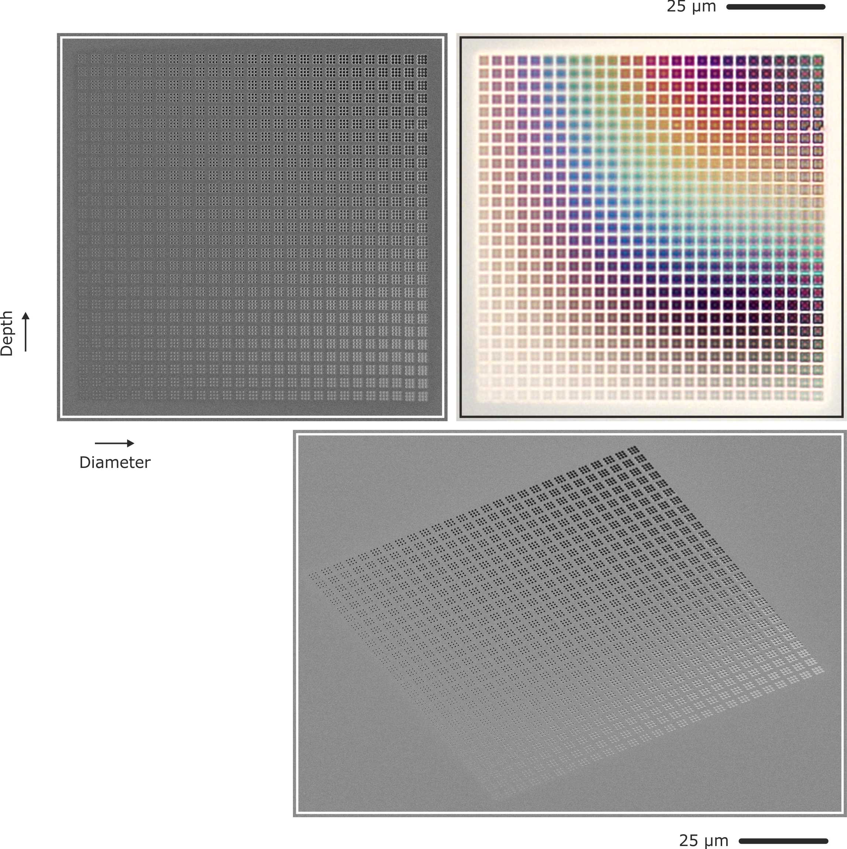

Figure S9: SEM and optical microscope images of a diameter and depth sweep. The normal and tilted view SEM images show the increasing hole diameter in horizontal and the increasing depth in vertical direction. Periodicity is fixed at 900nm in both directions. Each variation contains 3x3 holes, the spacing is 3600 nm. The optical microscope image illustrates the distinct colour appearance of the individual 3x3 arrays as well as the excellent tuneability of the colour. Please note that apart from “colours” also whitish and blackish appearance can be created.

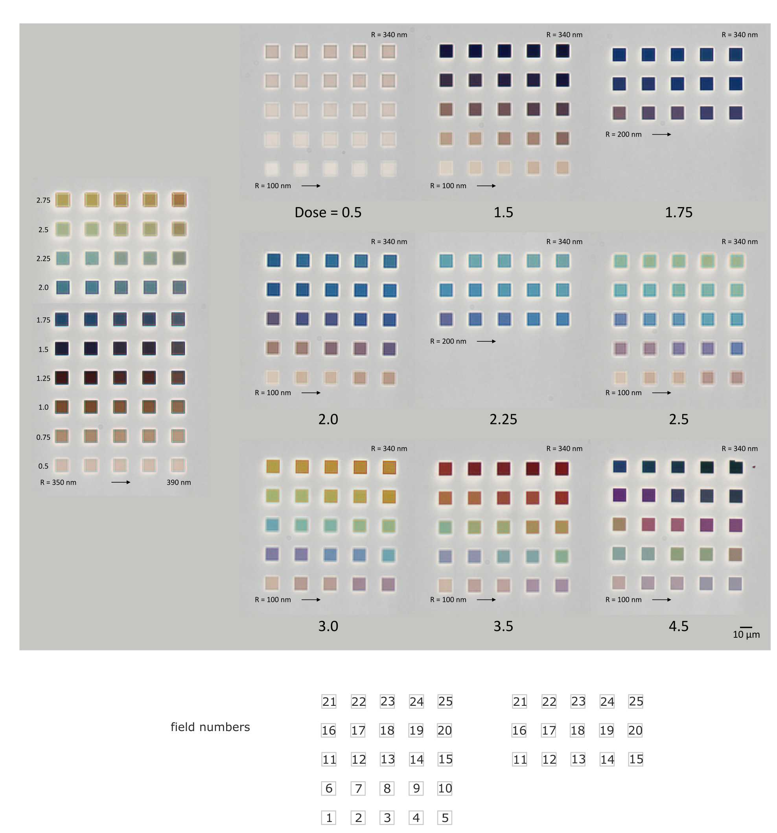

Figure S10: Colour catalogue: Composed optical microscope image of the parameter space in use. All parameters given in the figure are the design values used for the structuring. The resulting experimentally obtained parameters for diameter and depth can be found in the Table ST3.

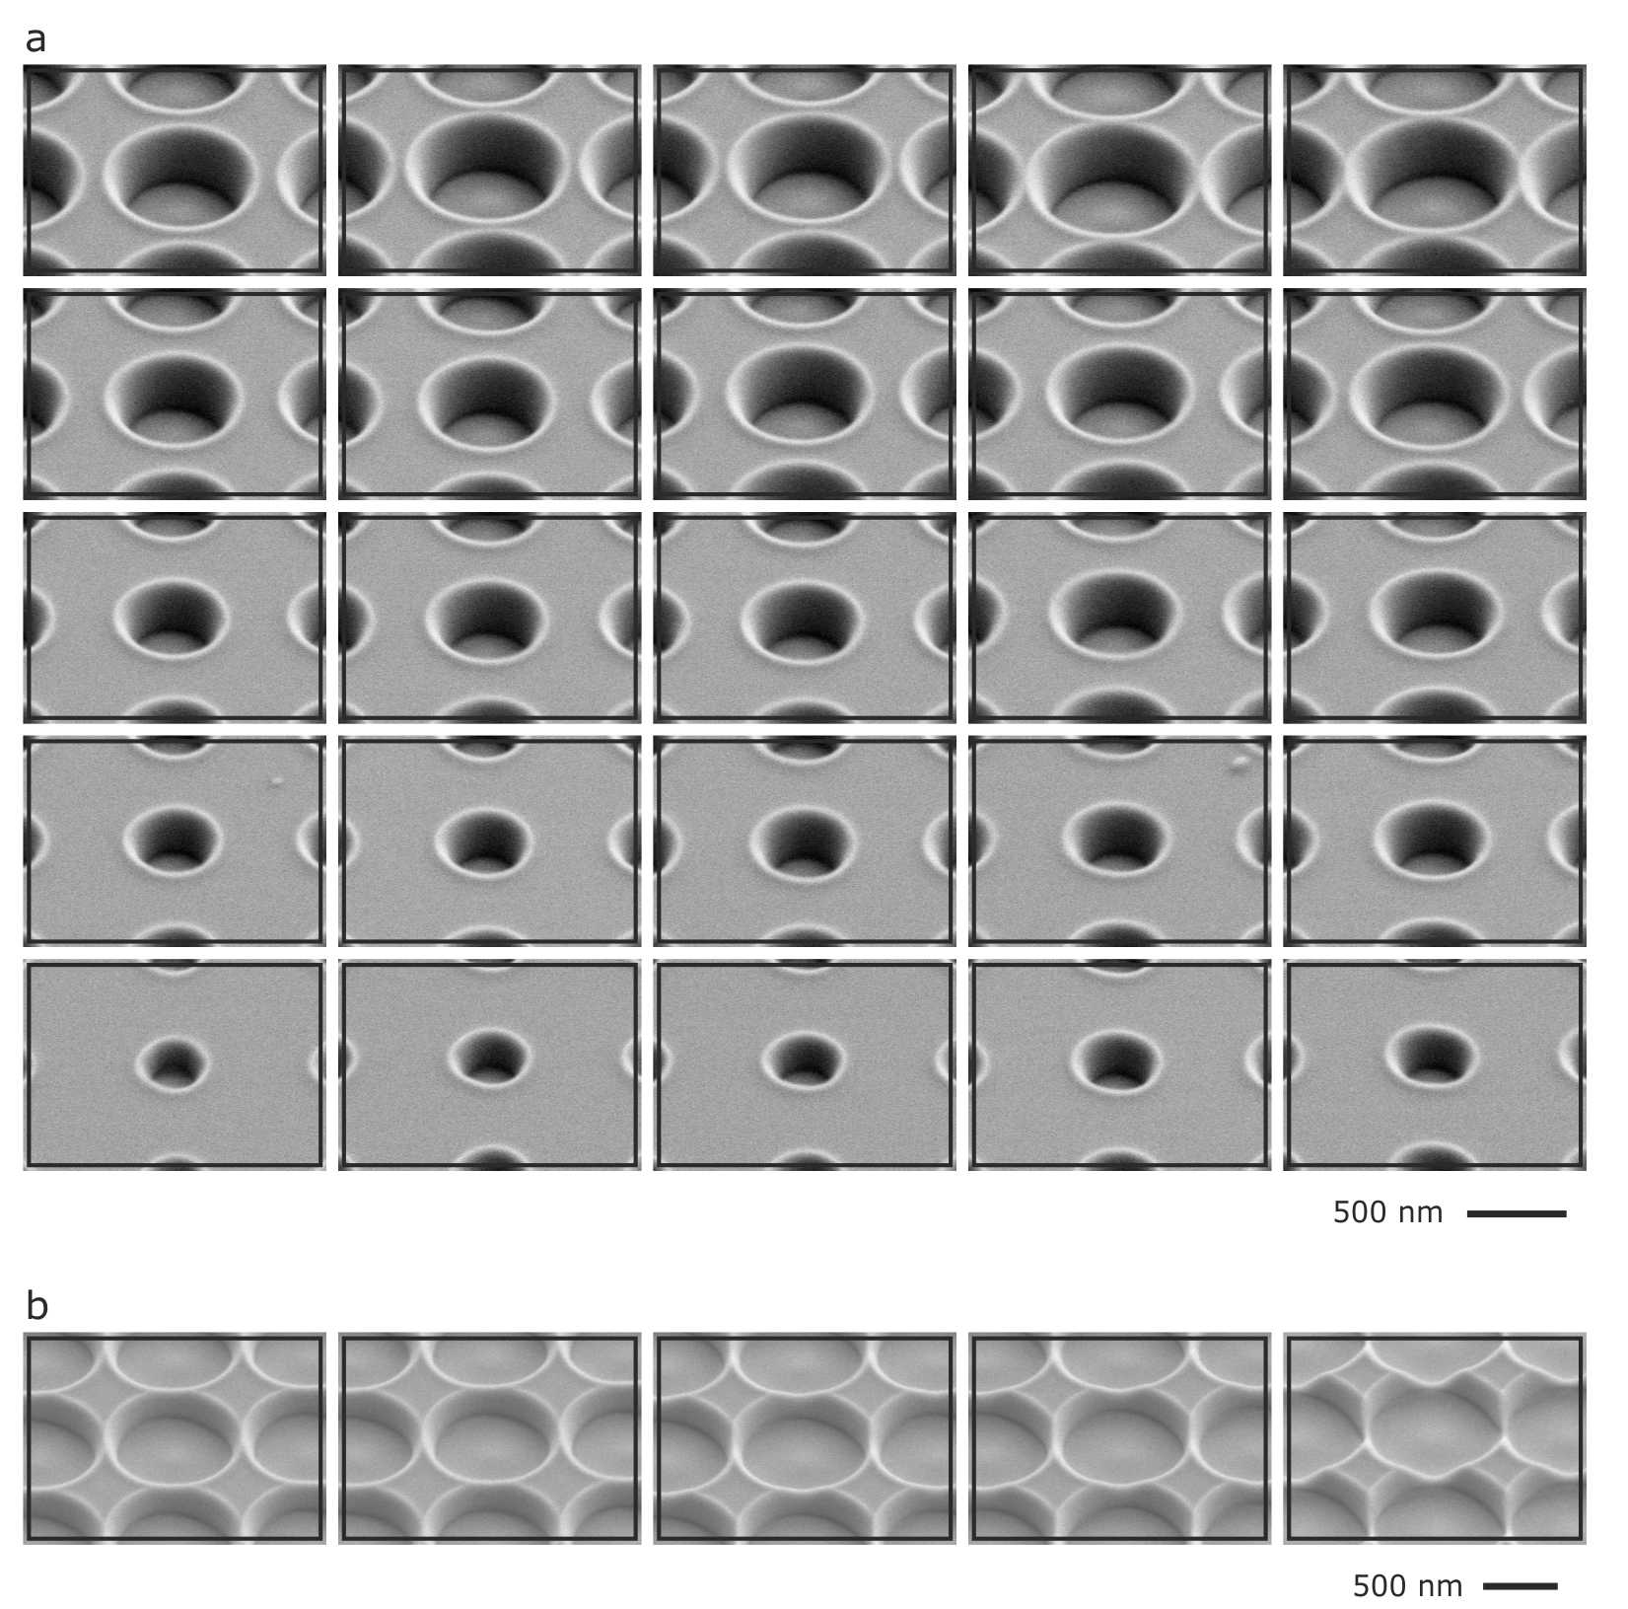
Figure S11: SEM images illustrating the size variation of the colour catalogue shown in Figure S10. Panel a depicts the sizes of the 5x5 arrays (full and reduced one), panel b depicts the 5x10 array on the left side of Figure S10. Exact parameters are given in Table ST3.

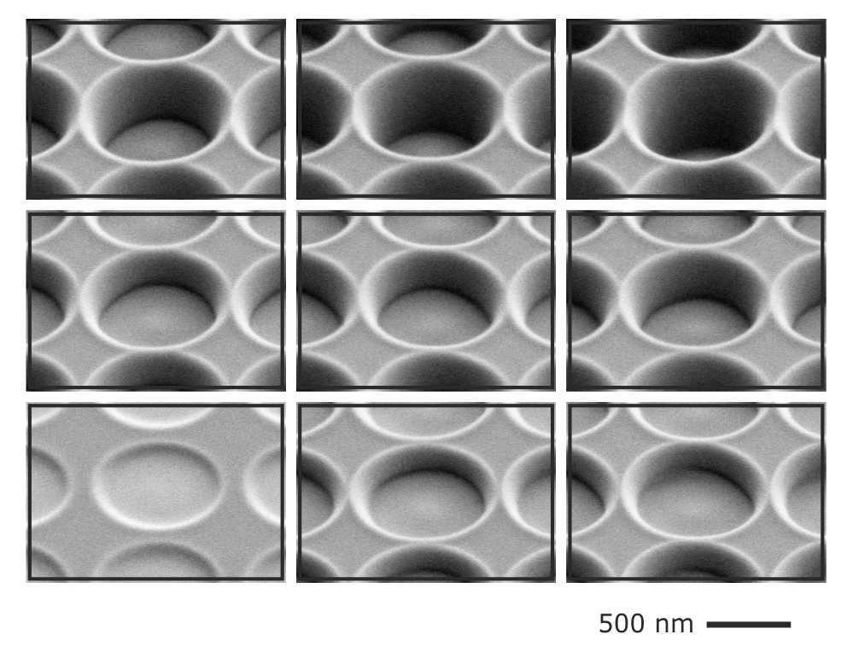
Figure S12: SEM images illustrating the depth variation of the colour catalogue shown in Figure S10. The resulting depth depends mainly on the deposited dose, that is, the number of ions. However, there is also slight dependence on the diameter, larger circles tend to be slightly deeper at the same dose value as smaller ones. For intermediate diameters around 600 nm the dose values result in depth as follows: Dose 0.5: 60 nm; Dose 1.50: 170 nm; Dose 1.75: 200 nm; Dose 2.25: 260 nm; Dose 2.50: 290 nm; Dose 3.00: 345 nm; 3.50: 400 nm; Dose 4.50: 515 nm. For the size sweep we observe depth within +/- 10% around these values.

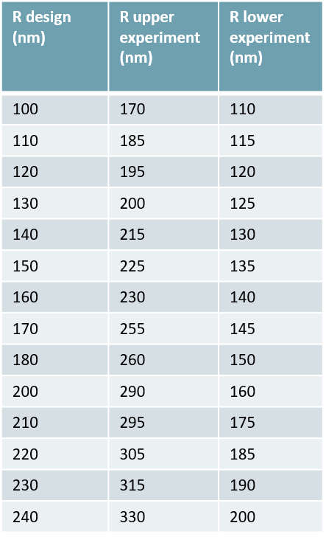
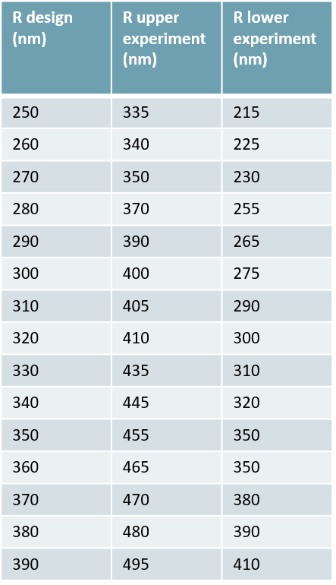

Table ST3: Experimental values for the upper and lower diameter of the cylindrical voids, nomenclature as in Figure S10.

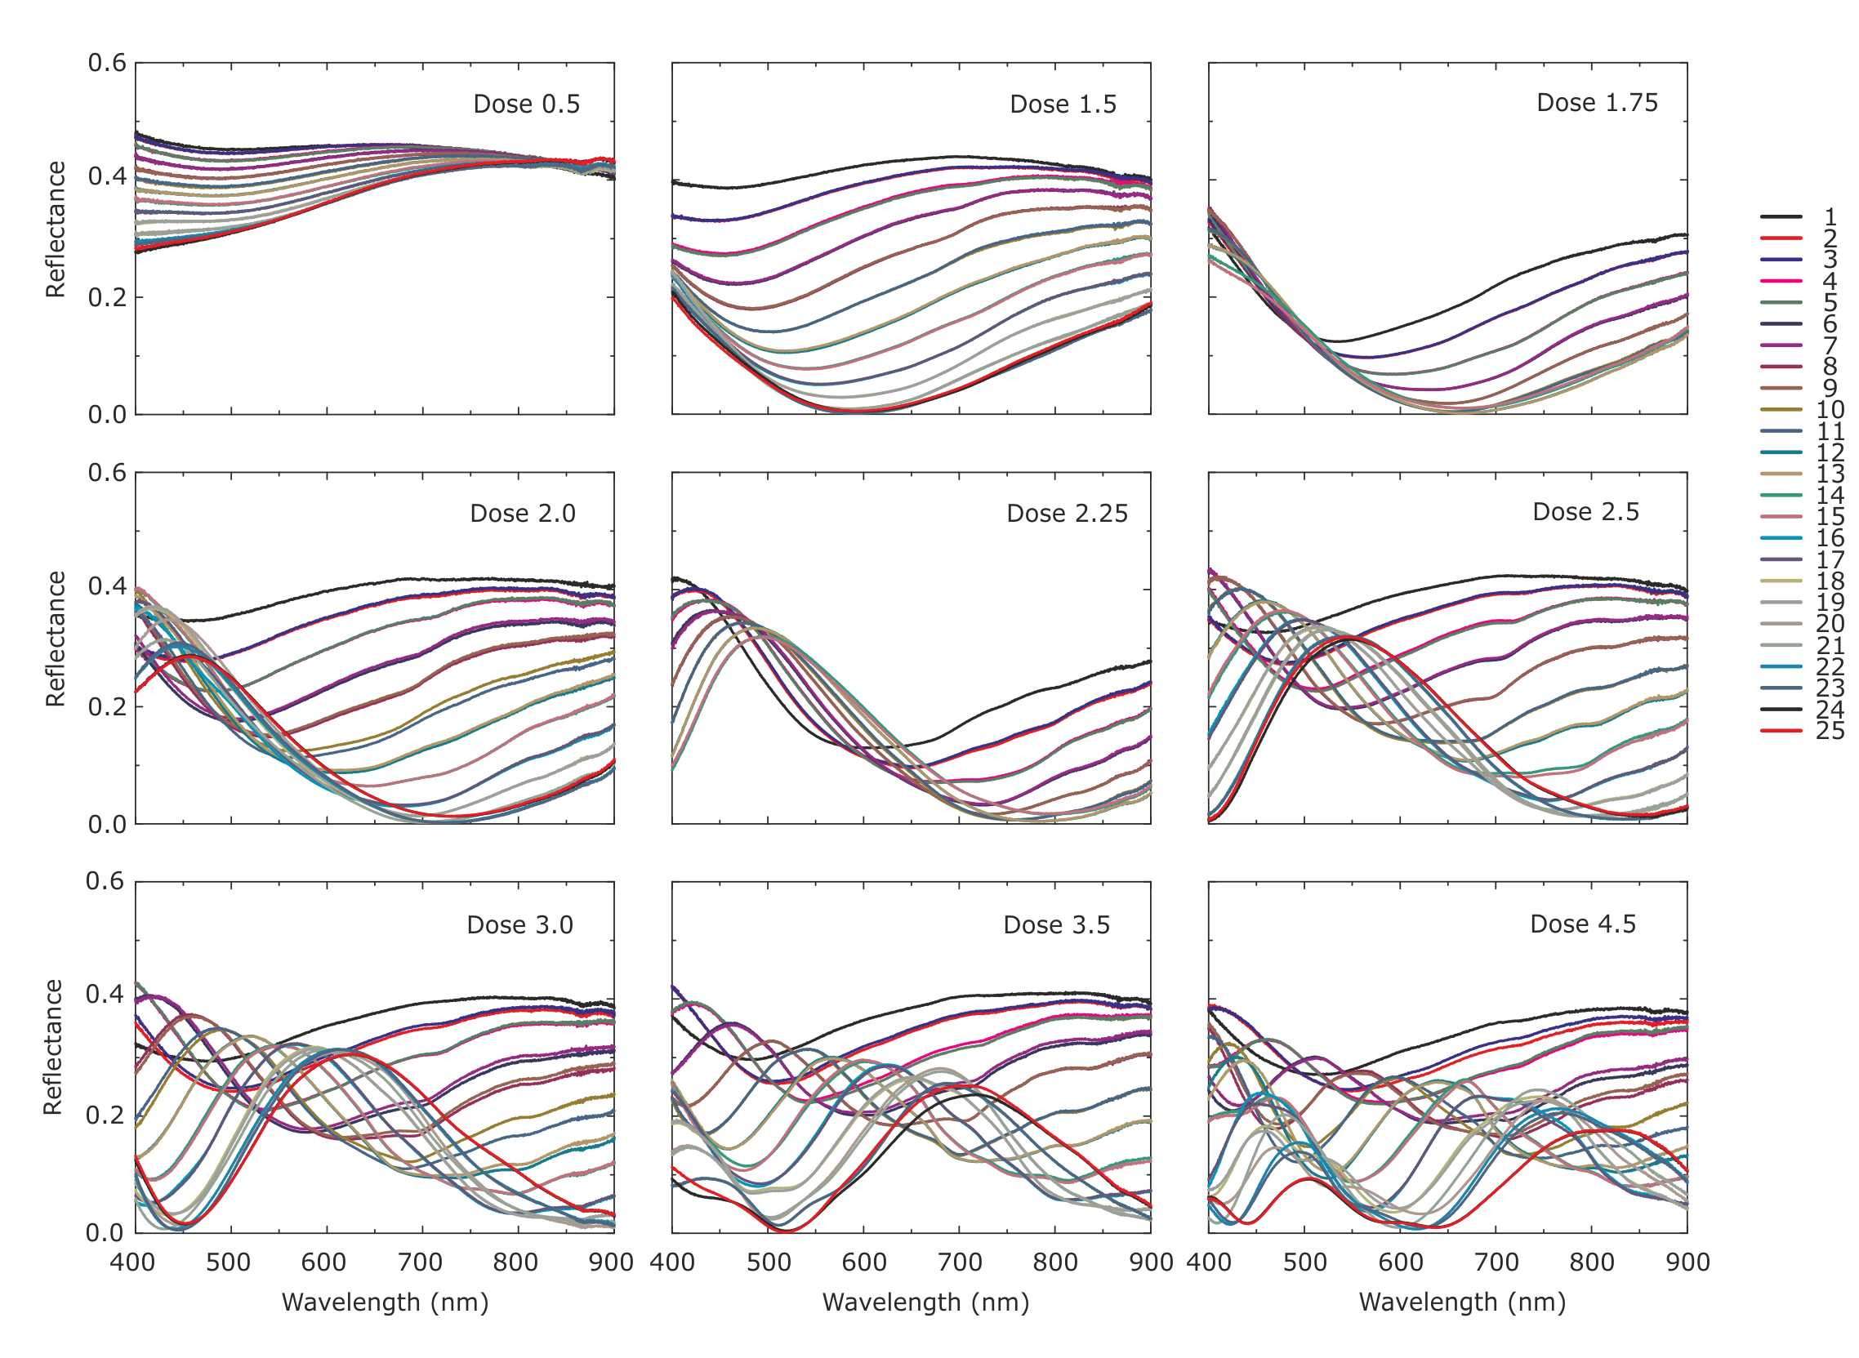
Figure S13: Unpolarised reflection spectra of the structures shown in Figure S10 with the parameter given in Table ST3. Please note, that except for dose values 1.75 and 2.25, all graphs contain 25 spectra corresponding to the 25 different diameters. For dose factors 1.75 and 2.25 the 15 largest diameters have been structured. For the experimental dimensions and the arrangement please refer to Figure S10 and table ST3. Please also note that two structures each are very similar in the experimentally realized dimensions and the spectra are thus also very similar and do partially overlap.

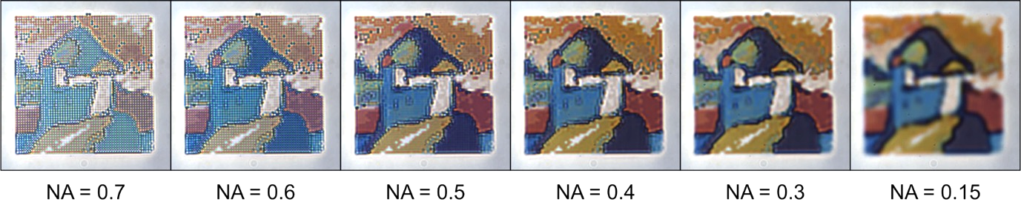

Figure S14: Images of a section of the colour printed “Improvisation No. 9” for varying numerical aperture (NA) of the microscope objective. The most straightforward and intuitive experimental method to study the angle dependence is imaging based: Utilizing a k-space microscopy setup, we can vary the NA with which we image a structure. A larger NA implies a larger spread of incident and out going angles (which will also result in a better spatial resolution). We imaged the section of the colour printed version of “Improvisation No. 9” shown in Figure 5 of the main manuscript with varying NA. One can observe two main feature: The colour impression changes only slightly, underpinning the resonant localized nature of the modes. Additionally, one can clearly observe a larger spatial resolution of the image, which is the main reason for the slight fading of the colour.

λ (nm) n k
230 1.52474 3.62384
232 1.64355 3.49551
234 1.69363 3.43674
236 1.70027 3.4252
238 1.68955 3.43865
240 1.68209 3.45175
242 1.67916 3.46
244 1.68311 3.51011
246 1.68258 3.56351
248 1.68432 3.62043
250 1.69492 3.6803
252 1.71159 3.74609
254 1.73575 3.82204
256 1.74741 3.90751
258 1.77825 3.99607
260 1.80576 4.09502
262 1.8474 4.20295
264 1.90089 4.31412
266 1.96679 4.44308
268 2.04371 4.58143
270 2.15406 4.72433
272 2.29679 4.86819
274 2.46614 4.99711
276 2.65159 5.1122
278 2.87105 5.20665
280 3.09979 5.27456
282 3.33034 5.32035
284 3.60146 5.35364
286 3.89557 5.35113
288 4.20301 5.28144
290 4.49059 5.12703
292 4.72925 4.91355
294 4.88765 4.68184
296 4.98159 4.46423
298 5.03318 4.26642
300 5.06448 4.09359
302 5.07841 3.94523
304 5.07994 3.82129
306 5.07719 3.71398
308 5.07367 3.621
310 5.07674 3.53956
312 5.07416 3.46823
314 5.08066 3.40653
316 5.08703 3.35155
318 5.09131 3.30462
320 5.10631 3.25722
322 5.11214 3.2194
324 5.12355 3.18084
326 5.14194 3.14341
328 5.16594 3.10927
330 5.18356 3.07678
332 5.19874 3.04667
334 5.22578 3.01594
336 5.25029 2.99213
338 5.2743 2.96867
340 5.30124 2.94738
342 5.33389 2.93184
344 5.36549 2.91917
346 5.4015 2.91026
348 5.44479 2.90417
350 5.49781 2.90401
352 5.56231 2.90892
354 5.64408 2.91877
356 5.75222 2.9246
358 5.886 2.92787
360 6.05492 2.90309
362 6.25366 2.82993
364 6.46277 2.70096
366 6.65189 2.51186
368 6.79771 2.26735
370 6.88427 1.99102
372 6.90837 1.70132
374 6.8659 1.43182
376 6.77072 1.19176
λ (nm) n k
378 6.65163 0.99827
380 6.5202 0.84581
382 6.37989 0.71943
384 6.25958 0.62819
386 6.15173 0.55649
388 6.04901 0.4978
390 5.95257 0.44777
392 5.86415 0.40687
394 5.7879 0.37281
396 5.71087 0.34173
398 5.63775 0.31526
400 5.57228 0.29177
402 5.50921 0.27116
404 5.4497 0.25434
406 5.39534 0.23907
408 5.34126 0.22436
410 5.29125 0.21202
412 5.2446 0.20015
414 5.20121 0.18973
416 5.15893 0.18035
418 5.11706 0.17127
420 5.08015 0.16301
422 5.04452 0.15631
424 5.00875 0.14914
426 4.97646 0.14318
428 4.9444 0.13711
430 4.91572 0.13137
432 4.88744 0.12617
434 4.86016 0.12158
436 4.83602 0.11709
438 4.81035 0.11366
440 4.78542 0.10863
442 4.76109 0.10565
444 4.73756 0.10179
446 4.71354 0.09847
448 4.69082 0.09521
450 4.66869 0.0912
452 4.64783 0.08856
454 4.62756 0.08587
456 4.60791 0.08338
458 4.58882 0.08106
460 4.57017 0.07889
462 4.5518 0.07687
464 4.53401 0.07483
466 4.5171 0.07242
468 4.50091 0.06989
470 4.48517 0.06764
472 4.4697 0.06604
474 4.45451 0.06462
476 4.43941 0.06307
478 4.42453 0.06146
480 4.4101 0.05991
482 4.39632 0.05849
484 4.38282 0.05711
486 4.36911 0.05568
488 4.35554 0.05423
490 4.34269 0.05284
492 4.33105 0.05156
494 4.31996 0.05035
496 4.30906 0.04918
498 4.29825 0.04806
500 4.28735 0.04701
502 4.27614 0.04606
504 4.26513 0.0451
506 4.25485 0.04395
508 4.24511 0.04272
510 4.23558 0.04162
512 4.22603 0.04083
514 4.21654 0.04011
516 4.20697 0.03935
518 4.19746 0.03855
520 4.1882 0.03773
522 4.17938 0.03691
524 4.17082 0.03612
λ (nm) n k
526 4.16244 0.03545
528 4.15426 0.03486
530 4.1464 0.03429
532 4.13902 0.03373
534 4.13158 0.03311
536 4.12329 0.03223
538 4.11469 0.03127
540 4.10671 0.03052
542 4.10013 0.03024
544 4.09394 0.03005
546 4.08745 0.02973
548 4.08076 0.02929
550 4.07408 0.0288
552 4.06752 0.02825
554 4.06097 0.02768
556 4.05433 0.02709
558 4.04767 0.02649
560 4.04108 0.02586
562 4.03461 0.02517
564 4.02839 0.02462
566 4.02283 0.02453
568 4.01761 0.02465
570 4.01224 0.02462
572 4.00628 0.02408
574 4.00022 0.02347
576 3.99426 0.0231
578 3.98848 0.02288
580 3.98293 0.02261
582 3.97772 0.02217
584 3.97275 0.02179
586 3.96801 0.02175
588 3.96342 0.02187
590 3.95888 0.02183
592 3.95428 0.02137
594 3.94968 0.02079
596 3.94507 0.02019
598 3.94047 0.01965
600 3.93589 0.01926
602 3.93134 0.01913
604 3.92684 0.0191
606 3.92239 0.01911
608 3.91799 0.01909
610 3.91362 0.01893
612 3.90927 0.01851
614 3.90497 0.01804
616 3.90075 0.01768
618 3.89664 0.01741
620 3.89276 0.01715
622 3.88921 0.01687
624 3.8858 0.01659
626 3.88243 0.01624
628 3.8791 0.01591
630 3.8759 0.0157
632 3.87293 0.01574
634 3.8698 0.0158
636 3.866 0.01563
638 3.86183 0.01533
640 3.85774 0.01508
642 3.85408 0.015
644 3.85067 0.01493
646 3.84764 0.01472
648 3.8448 0.01442
650 3.84184 0.01417
652 3.83846 0.01403
654 3.83515 0.01393
656 3.83244 0.01384
658 3.82999 0.01373
660 3.82719 0.01354
662 3.82349 0.01319
664 3.81983 0.01288
666 3.8172 0.01282
668 3.81506 0.01289
670 3.81249 0.01282
672 3.80867 0.01238
λ (nm) n k
674 3.8048 0.01198
676 3.80183 0.0121
678 3.79947 0.01247
680 3.7972 0.01264
682 3.79469 0.01222
684 3.79216 0.01173
686 3.78967 0.0116
688 3.7872 0.01164
690 3.7847 0.01149
692 3.78214 0.01083
694 3.77951 0.01023
696 3.77666 0.01022
698 3.77378 0.01058
700 3.77117 0.01094
702 3.76913 0.01105
704 3.76713 0.01103
706 3.76455 0.01083
708 3.76176 0.0105
710 3.75938 0.01012
712 3.75799 0.00975
714 3.75665 0.00946
716 3.75456 0.00943
718 3.75196 0.00957
720 3.74931 0.00969
722 3.74687 0.00964
724 3.7445 0.00966
726 3.74205 0.01017
728 3.73975 0.01077
730 3.73801 0.01083
732 3.73728 0.00971
734 3.73658 0.0085
736 3.73493 0.00822
738 3.73265 0.00852
740 3.73027 0.00879
742 3.72816 0.00863
744 3.72604 0.00832
746 3.72362 0.00777
748 3.72125 0.0072
750 3.71959 0.00694
752 3.71931 0.00734
754 3.719 0.00785
756 3.71731 0.00814
758 3.71466 0.00819
760 3.71168 0.00804
762 3.70867 0.00767
764 3.70618 0.00717
766 3.70556 0.0065
768 3.70583 0.00589
770 3.70539 0.00568
772 3.70282 0.00627
774 3.69987 0.00694
776 3.69763 0.00704
778 3.69593 0.00675
780 3.6944 0.0063
782 3.69291 0.00579
784 3.69138 0.00545
786 3.68954 0.00562
788 3.68759 0.00619
790 3.68577 0.00703
792 3.68431 0.00814
794 3.68317 0.0089
796 3.68278 0.00832
798 3.68262 0.00691
800 3.68182 0.00548
802 3.67956 0.00461
804 3.6771 0.00421
806 3.6755 0.00481
808 3.6744 0.00594
810 3.67314 0.00688
812 3.67123 0.00704
814 3.66933 0.00683
816 3.66799 0.00615
818 3.66696 0.00528
820 3.66573 0.00468
λ (nm) n k
822 3.66386 0.00474
824 3.66227 0.005
826 3.6622 0.00526
828 3.66276 0.00543
830 3.66229 0.00548
832 3.65927 0.0053
834 3.65637 0.005
836 3.65476 0.00464
838 3.65559 0.00423
840 3.66003 0.00382

Table ST4: Dielectric data used in Figure 2 in the main text. Taken from http://www.sspectra.com/sopra.html

