Inductively Coupled, mm-Sized, Single Channel Optical Neuro-Stimulator with Intensity Enhancer

Wasif Khan¹, Yaoyao Jia², Fatma Madi³, Arthur Weber³, Maysam Ghovanloo² and Wen Li¹
¹Department of Electrical and Computer Engineering, Michigan State University, East Lansing, USA
²School of Electrical and Computer Engineering, Georgia Institute of Technology, Atlanta, USA
³Department of Physiology, Michigan State University, East Lansing, USA

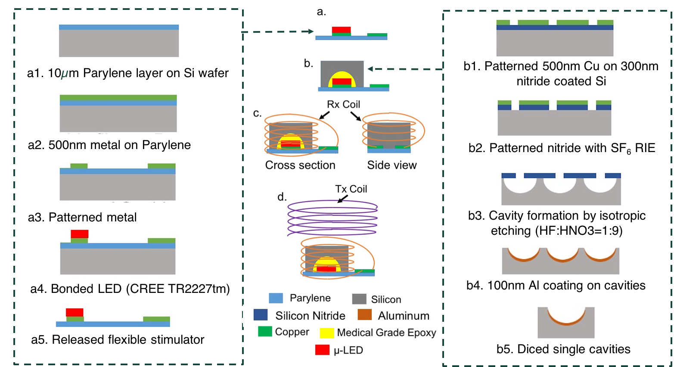

S1. Simplified fabrication and integration process flow

Supplementary Table S1. Comparison of our work and neurostimulators reported by other groups
Work | Architecture | Substrate | Weight  (mg) | Dimensions (mm) | Frequency | channels | Available intensity (mW/mm²)
Kim et al ¹ | Discrete device | Flexible/rigid PCB | 700 | 14x12.5x3 | 910MHz | 4 | 17.7
Montgomery et al ²² | Discrete device | Rigid PCB | 20-50 | 2x2x2 | 1.6 GHz | 1 | 25.8
Shin et. al. ³⁷ | Discrete device | Flexible PCB | 30 | 10mm  diameter, thickness<1.3mm | 13.6 MHz | 1,2 | 100
Aldaoud et al ⁴⁵ | Discrete Device | Rigid PCB | 1000 | 5x2.5x2.5 | 20, 13.4/15.6 MHz | 1,2,16 | _
Park et al.⁴⁶ | Discrete device | Rigid PCB | 70 | 2.4x3.5x8.5 | 1.6-2.5 GHz | 4 | _
Park et al ³⁸ | Discrete device | Stretchable Polymer | 16 | 3.8x6x0.7 | 2.0-2.5 GHz | 1 | 10
Lee et al ⁴⁷ | LSI | Stacked rigid PCB | 1600 | 12x7x11 | 2.4GHz | 1 | 27
This work | Discrete Device | Flexible PCB | 20 | 2.8x4.2x2.1 | <100 MHz | 1 | 5.8

