Supplementary Information
Microneedle-based skin patch for blood-free rapid diagnostic testing
Xue Jiang¹ and Peter B. Lillehoj^{1, 2}*
¹Department of Mechanical Engineering, Rice University, Houston, TX 77005, USA.
²Department of Bioengineering, Rice University, Houston, TX 77030, USA.

*Corresponding Author: Peter B. Lillehoj; Tel: 713-348-7344; E-mail: lillehoj@rice.edu

Figure S1: Microneedle mechanical testing. Compression force vs. displacement curves for the 4 × 4 microneedle array. The solid line represents the mean values ± standard deviation (shaded region) obtained from four different microneedle arrays.

Figure S2: Microneedle integrity following skin insertion. Optical micrographs of the microneedle array before (a) and after (b) insertion in porcine skin. Scale bar, 1 mm.

Figure S3: Sensitivity of the PfHRP2 assay with and without gold enhancement. (a) Test results of interstitial fluid containing increasing concentrations of PfHRP2 without gold enhancement treatment. (b) Test results of interstitial fluid containing increasing concentrations of PfHRP2 with gold enhancement treatment.

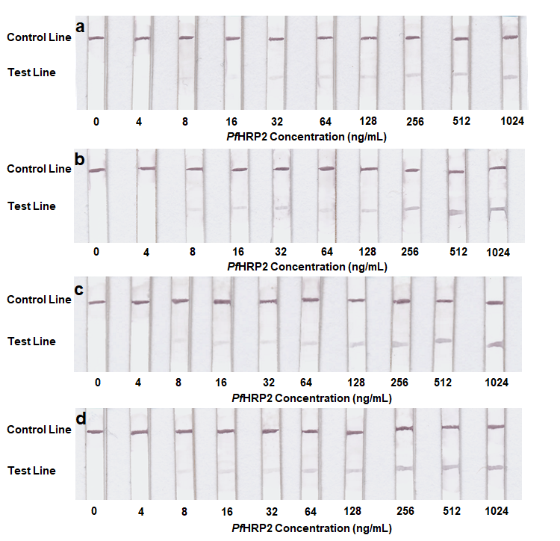
Figure S4: Sensitivity of the PfHRP2 assay with varying sample volumes. Test results of (a) 2 μL, (b) 5 μL, (c) 10 μL and (d) 15 μL of interstitial fluid containing increasing concentrations of PfHRP2 with gold enhancement treatment.

Figure S5: Optical characterization of AuNP-IgG conjugates with and without gold enhancement. (a) Absorbance spectra of AuNP-IgG conjugates with and without gold enhancement treatment. (b) Optical transmittance spectra of unmodified nitrocellulose paper (blank) and nitrocellulose paper containing AuNP-IgG conjugates with and without gold enhancement treatment.

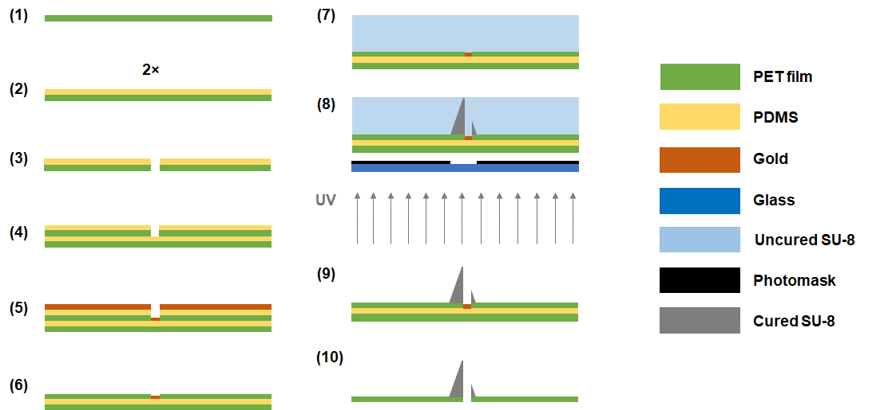
Figure S6: Microneedle array fabrication process. Schematic illustration of the fabrication process for generating hollow SU-8 microneedle arrays.

