SUPPLEMENTARY INFORMATION: Sensitive capacitive pressure sensors based on graphene membrane arrays

Makars Šiškins¹, Martin Lee¹, Dominique Wehenkel², Richard van Rijn², Tijmen W. de Jong¹, Johannes R. Renshof¹, Berend C. Hopman¹, Willemijn S. J. M. Peters¹, Dejan Davidovikj¹, Herre S. J. van der Zant¹, Peter G. Steeneken^{1, 3}
¹⁾ Kavli Institute of Nanoscience, Delft University of Technology, Lorentzweg 1, 2628 CJ, Delft, The Netherlands
²⁾ Applied Nanolayers B.V., Feldmannweg 17, 2628 CT, Delft, The Netherlands
³⁾ Department of Precision and Microsystems Engineering, Delft University of Technology, Mekelweg 2, 2628 CD, Delft, The Netherlands

Correspondence: Makars Šiškins (m.siskins-1@tudelft.nl), Peter G. Steeneken (p.g.steeneken@tudelft.nl)

(Dated: 30 September 2020)

Contents

Fig. S1: Detailed characterization of annealed double-layer graphene in a region where PMMA residues were observed 2

Fig. S2: Capacitance response of a DLG sample to pressure step-changes after thermal annealing. 3

Fig. S3: Simulated capacitance-pressure curves of the graphene pressure sensor with a different number of layers and pre-tension. 3

Fig. S4: Simulated capacitance-pressure curves of the graphene pressure sensor with a different diameter of drums and pre-tension. 4

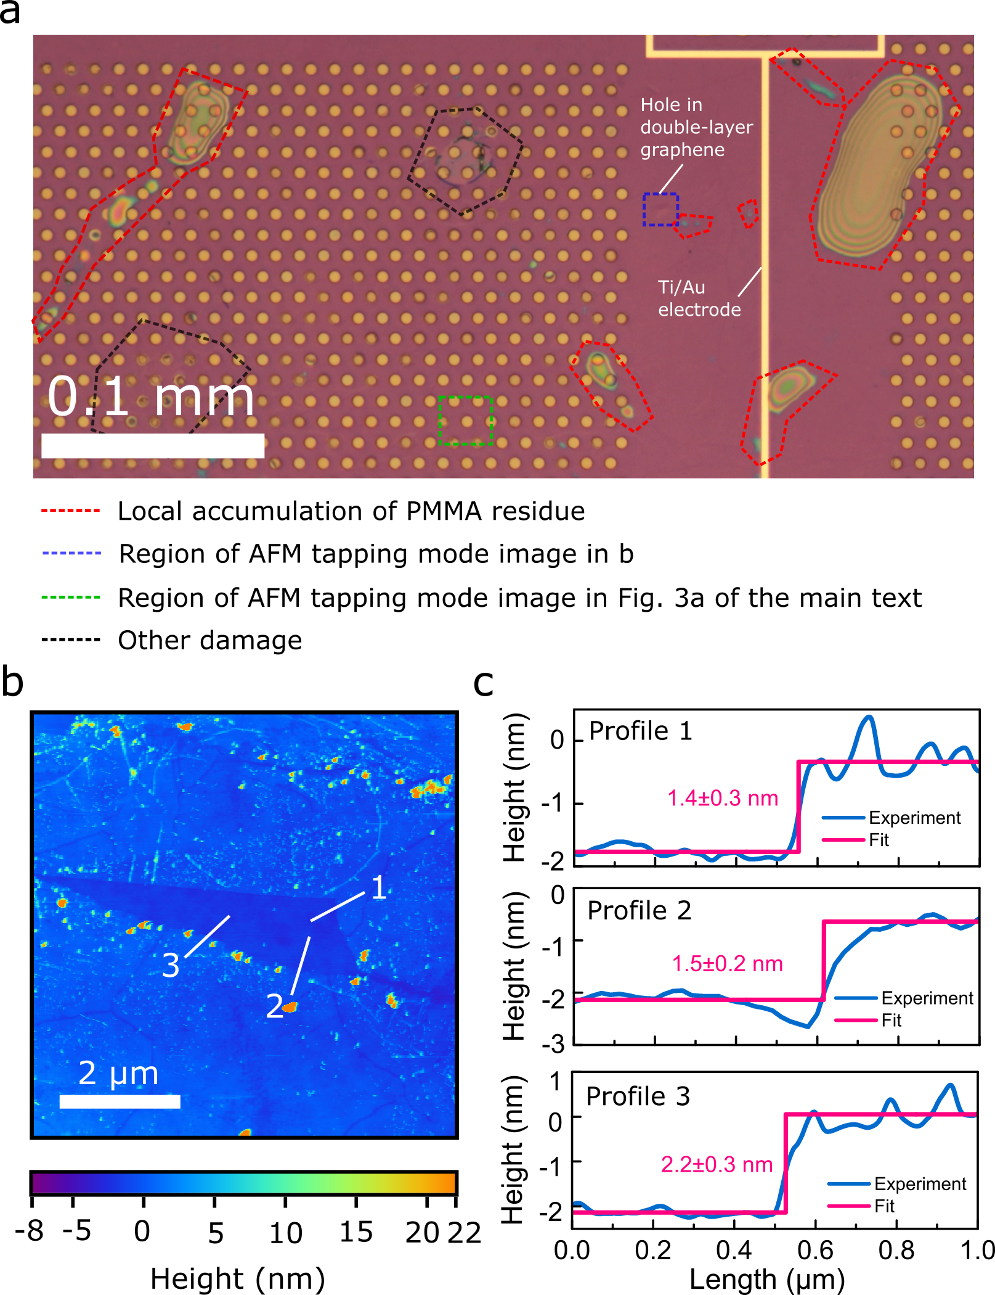

FIG. S1. Detailed characterization of annealed double-layer graphene in a region where PMMA residues were observed. (a) Optical image of a thermally annealed graphene sample with a $285$ nm thickness of SiO₂, results of which are also presented in Fig. 3 of the main text. (b) Tapping mode AFM image of the area indicated with a dashed blue line in (a). Numbered white lines indicate corresponding height profiles in (c). The extracted thickness of DLG is indicated for each case.

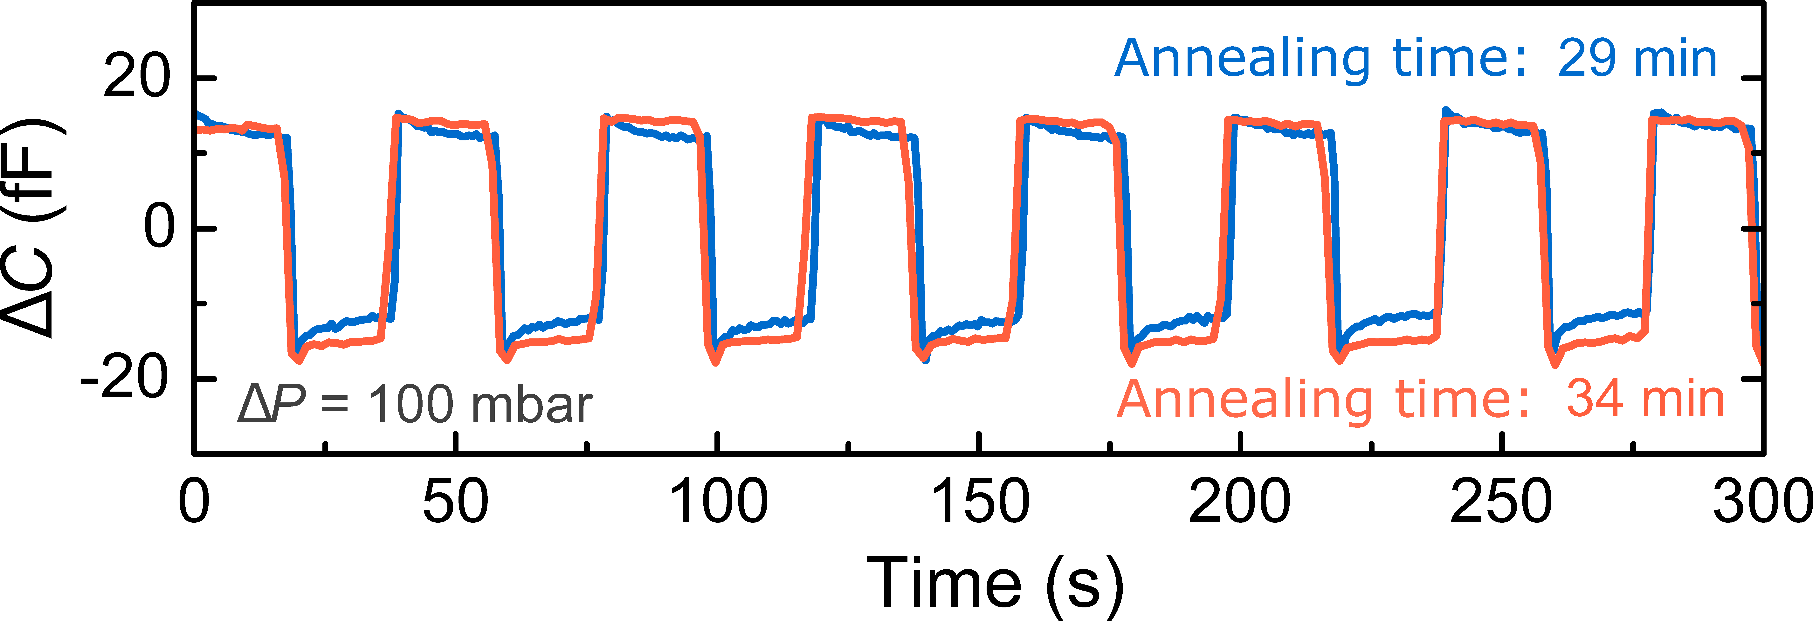

FIG. S2. Capacitance response of a DLG sample to pressure step-changes after thermal annealing. Coloured lines - change in capacitance of a single chip as a function of measurement time in response to $ΔP$, annealed for a time indicated in the legend.

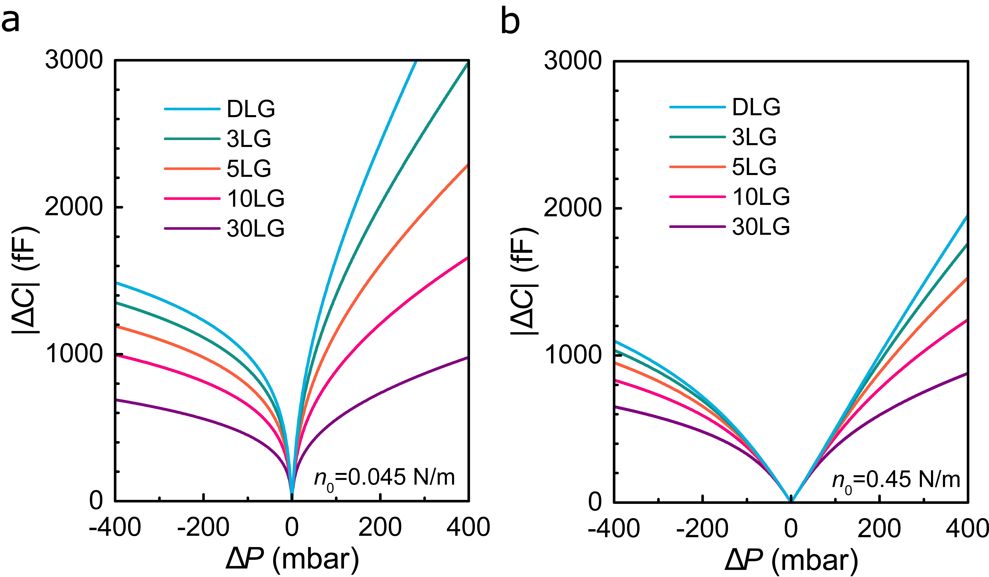

FIG. S3. Simulated capacitance-pressure curves of the graphene pressure sensor with a different number of layers and pre-tension of (a) 0.045 N/m and (b) 0.45 N/m.

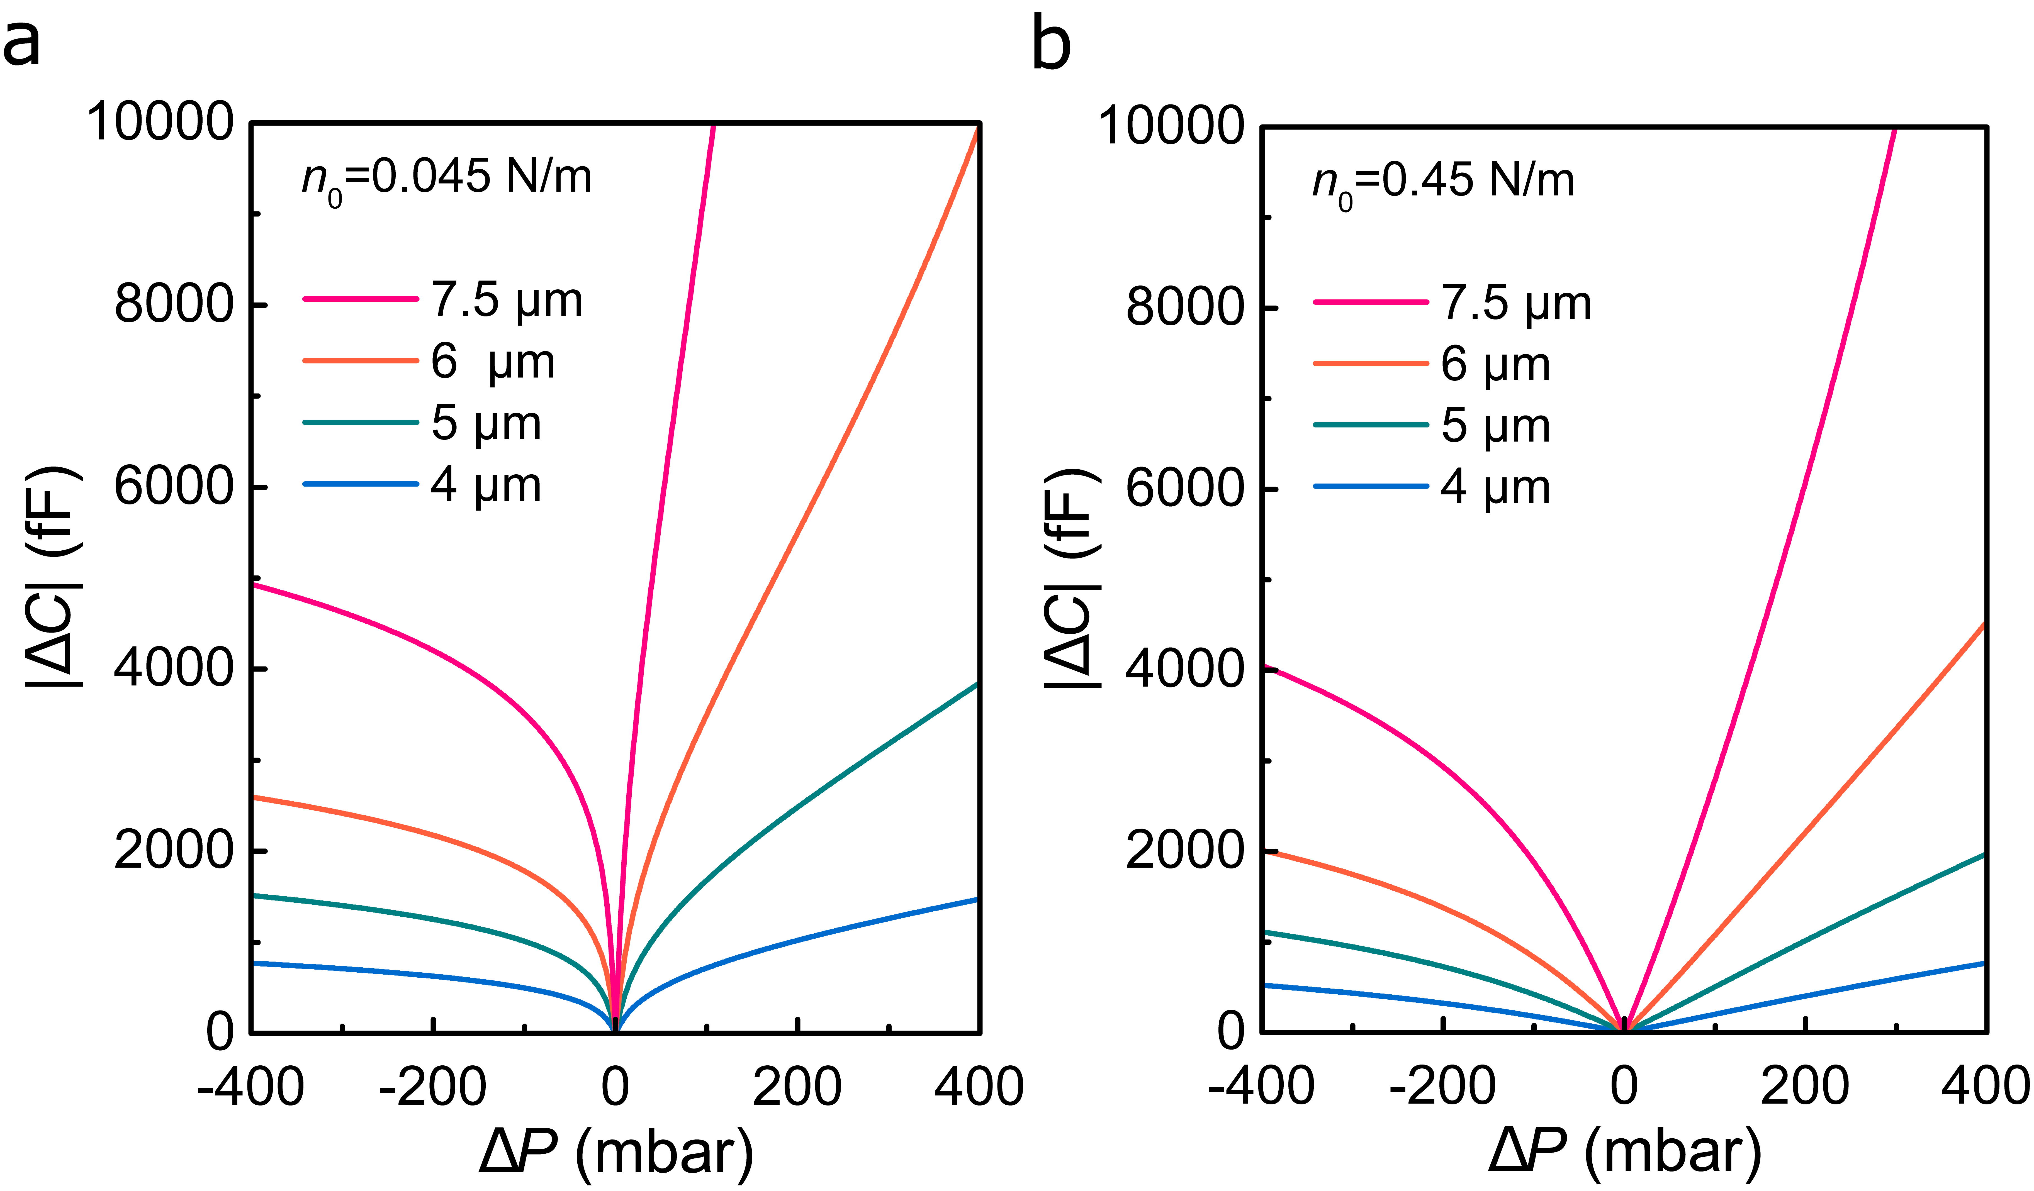

FIG. S4. Simulated capacitance-pressure curves of the graphene pressure sensor with a different diameter of drums and pre-tension of (a) 0.045 N/m and (b) 0.45 N/m.

