Investigation of cell mechanics using single-beam acoustic tweezer as a versatile tool for diagnosis and treatment of highly invasive breast cancer cell lines: an in vitro study

Hae Gyun Lim¹, Hsiao-Chuan Liu², Chi Woo Yoon², Hayong Jung², Min Gon Kim², Changhan Yoon³, Hyung Ham Kim^{1*}, and K. Kirk Shung²

¹Department of Creative IT Engineering, Pohang University of Science and Technology, Pohang 37673, Republic of Korea
²NIH Resource Center for Medical Ultrasonic Transducer Technology and Department of Biomedical Engineering, University of Southern California, Los Angeles, California, 90089, USA
³Department of Biomedical Engineering, Inje University, Gimhae, Gyeongnam, 50834, Republic of Korea

*Correspondence should be addressed to H.H.K. (david.kim@postech.ac.kr)
Department of Creative IT Engineering, Pohang University of Science and Technology
77 Cheongam-ro, Nam-gu, C5 building #209
Pohang, Gyeongbuk, 37673, Republic of Korea
Phone: +82-54-279-8864
Supplementary Materials

Supplementary Figure 1. Cell viability test of MDA-MB-231, MCF-7, and SKBR-3 cells. a fluorescence images for MDA-MB-231, MCF-7, and SKBR-3 cells for before SBAT (negative control), after SBAT (experimental group), and 0.1% bleach test (positive control). Scale bars indicate 10 μm. b Normalized fluorescence intensity of cells before and after SBAT. Error bars indicate standard deviations. Sample number for each cell was 20.

Supplementary Figure 2. Acoustic pressure field of the ultrasonic transducers measured by a needle hydrophone. a One-dimensional lateral intensity of spatial peak temporal average (I_{SPTA}) was measured. The -3 dB lateral beam width was measured to be 32 μm. b 2D acoustic pressure field was measured after a 50 MHz transducer was excited with the input parameters of V_{pp}= 25 V, cycle numbers of 10, and pulse repetition frequency of 1 kHz.

Supplementary Table 1. Normalized deformability and measured Young’s modulus of cell-mimicking spheres (0.1, 0.3, 0.6, 0.9, and 1.2%) and cancer cells (MDA-MB-231, MCF-7, and SKBR-3).

Supplementary Video Captions

Supplementary Video 1. Cell trapping and deformation after the application of the SBAT. When the acoustic tweezer was turned on, a MDA-MB-231 was manipulated and trapped into the trapping zone. The cell boundary was deformed with input peak to peak voltage from 0 ~ 20 V, cycle numbers of 500, and pulse repetition frequency of 1 kHz. Total duration: 30 seconds.

Supplementary Video 2. Killing of a highly invasive cancer cell by ultrasound. A MDA-MB-231 was killed by a strong acoustic pressure. When input peak to peak voltage reached 69.5 V, a black circular mark was generated on the surface of the petri dish, and the cell was killed simultaneously. In this video, input voltage was rapidly increased from 0 to 69.5 Vpp in a one-step, then gradually increased up to 79.0 V_{pp} with cycle numbers of 500 and pulse repetition frequency of 1 kHz. Total duration: 8 seconds.

Supplementary Figure 1.
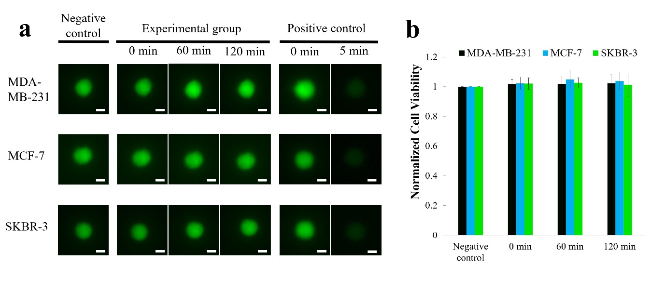

Supplementary Figure 2.
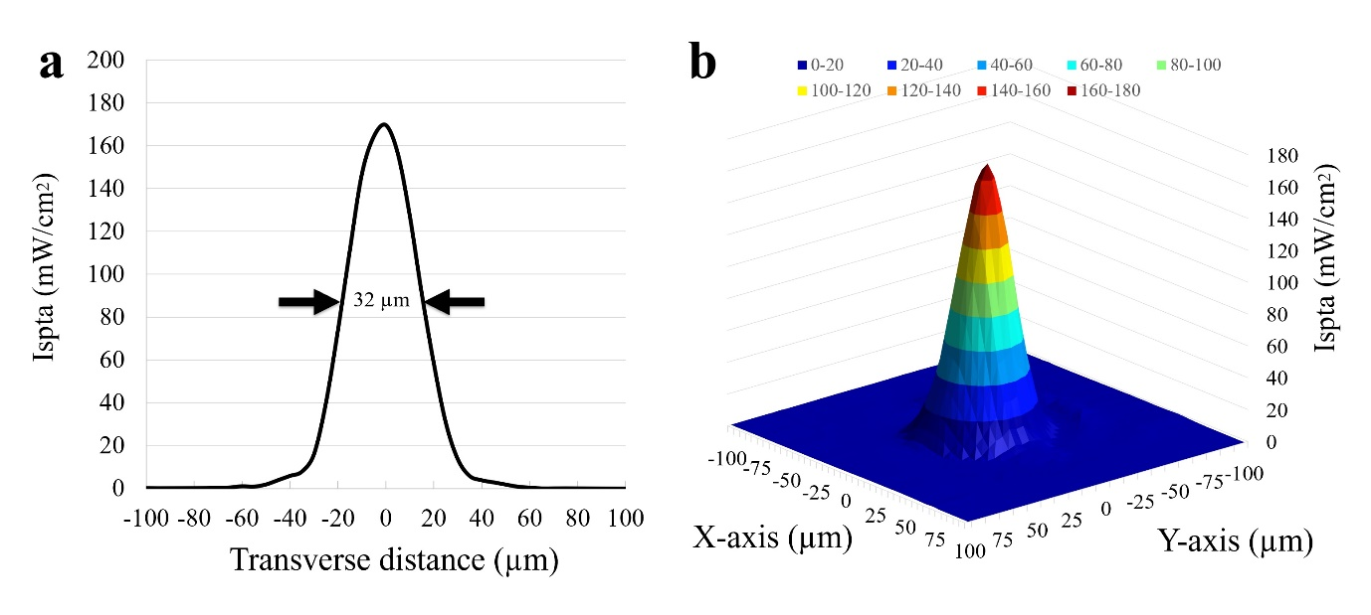

Supplementary Table 1.
 |  | Normalized deformability |  |  |  |  | Young’s modulus
Acoustic pressure (Mpa) |  | 0.23 | 0.43 | 0.63 | 0.82 | 1.00 | Young’s modulus
Cell-mimicking sphere | 0.1% | 1.211 ± 0.047 | 1.312 ± 0.055 | X | X | X | 0.214 ± 0.082
Cell-mimicking sphere | 0.3% | 1.061 ± 0.034 | 1.102 ± 0.069 | 1.123 ± 0.074 | 1.154 ± 0.086 | 1.173 ± 0.098 | 1.603 ± 0.242
Cell-mimicking sphere | 0.6% | 1.048 ± 0.021 | 1.067 ± 0.022 | 1.068 ± 0.033 | 1.077 ± 0.038 | 1.084 ± 0.049 | 2.995 ± 0.573
Cell-mimicking sphere | 0.9% | 1.021 ± 0.006 | 1.024 ± 0.008 | 1.026 ± 0.011 | 1.043 ± 0.015 | 1.045 ± 0.014 | 6.401 ± 1.089
Cell-mimicking sphere | 1.2% | 1.012 ± 0.017 | 1.015 ± 0.019 | 1.017 ± 0.023 | 1.018 ± 0.023 | 1.018 ± 0.023 | 9.235 ± 1.634
Cell | MDA-MB-231 | 1.025 ± 0.055 | 1.085 ± 0.055 | 1.130 ± 0.057 | 1.173 ± 0.069 | 1.194 ± 0.066 | 1.527 ± 0.310
Cell | MCF-7 | 1.015 ± 0.012 | 1.041 ± 0.026 | 1.061 ± 0.044 | 1.084 ± 0.060 | 1.090 ± 0.059 | 2.650 ± 0.680
Cell | SKBR-3 | 1.015 ± 0.019 | 1.033 ± 0.022 | 1.055 ± 0.031 | 1.071 ± 0.043 | 1.088 ± 0.055 | 2.772 ± 0.782

