SUPPLEMENTARY INFORMATION
Avoiding transduction-induced heating in suspended microchannel resonators using piezoelectricity
Damien Maillard
¹Advanced NEMS Laboratory, Institute of Mechanical Engineering, École Polytechnique Fédérale de Lausanne (EPFL), 1015 Lausanne, Switzerland
damien.maillard@epfl.ch

Annalisa De Pastina
¹Advanced NEMS Laboratory, Institute of Mechanical Engineering, École Polytechnique Fédérale de Lausanne (EPFL), 1015 Lausanne, Switzerland
²Center for Research on Adaptive Nanostructures and Nanodevices (CRANN), Trinity College Dublin (TCD), Dublin 2, Ireland
depastia@tcd.ie

Amir Musa Abazari
³Department of Mechanical Engineering, Faculty of Engineering, Urmia University, Urmia, Iran
am.abazari@urmia.ac.ir

Luis Guillermo Villanueva
¹Advanced NEMS Laboratory, Institute of Mechanical Engineering, École Polytechnique Fédérale de Lausanne (EPFL), 1015 Lausanne, Switzerland
guillermo.villanueva@epfl.ch
0041 21 693 11 87

- FEM simulations
In order to perform FEM simulations as realistic as possible, we choose to create a model with the actual dimensions of the SMR. We cut through the middle of an SMR with Focused Ion Beam technology, and then proceeded to observe the cross-section at the SEM. Fig. S1 depicts a view of the SMR with the dimensions needed to build the model. For each particular feature, we increased the magnification to make a measurement as precise as possible.

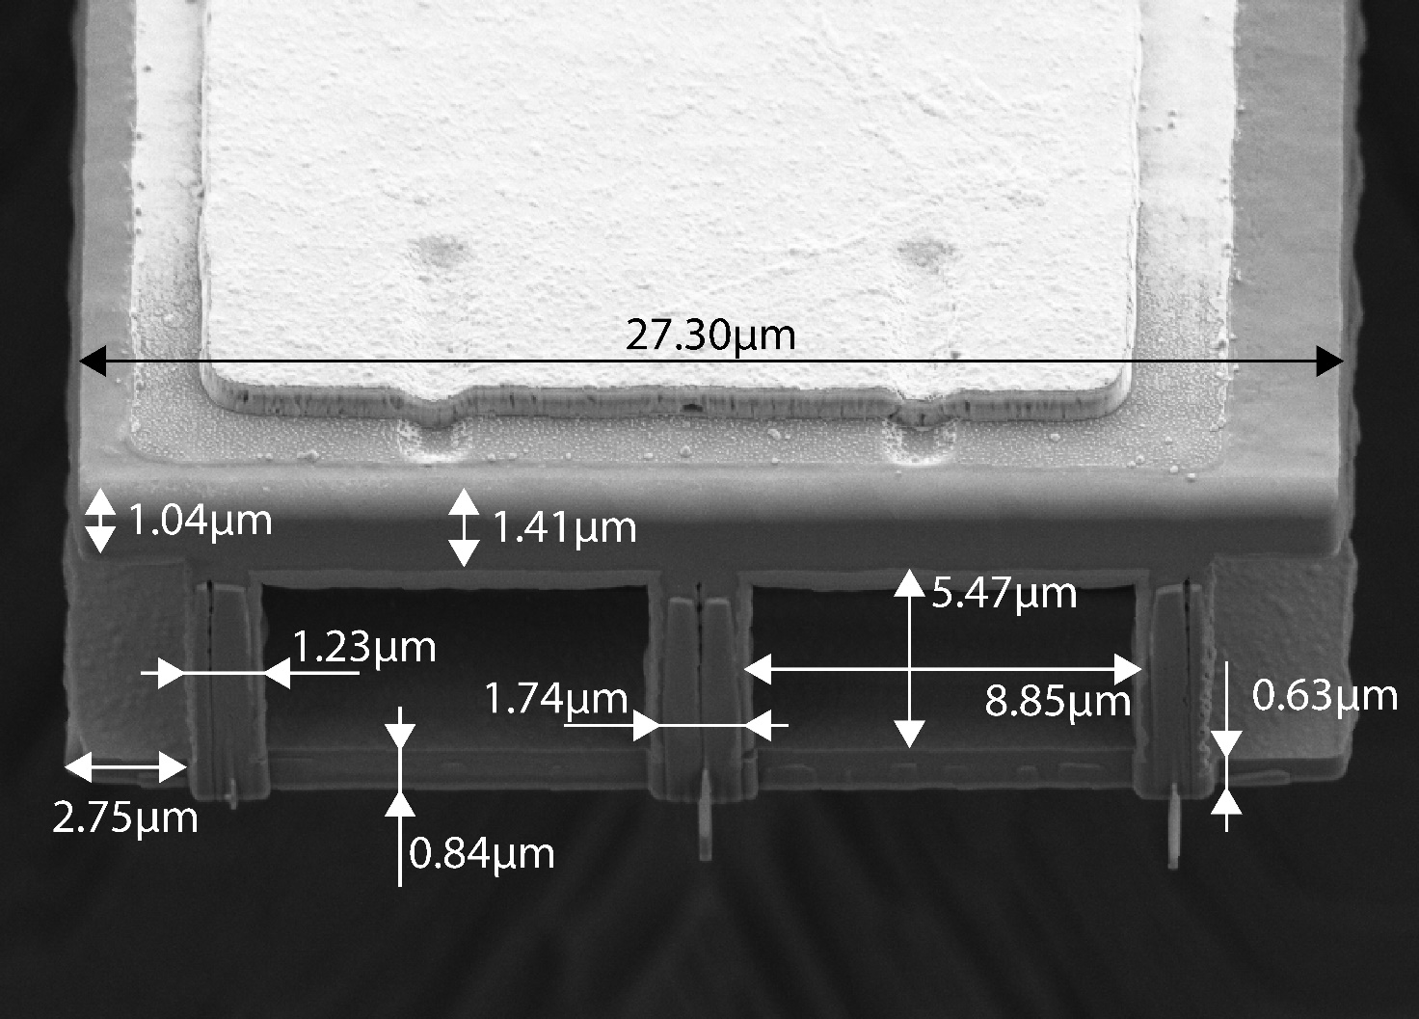
Fig. S1: SEM cross-section view of an SMR after cut with FIB. The image is taken on the device while tilted 45°.
Our model consists of a time-dependent simulation of the evolution of the average temperature of the cantilever (silicon nitride beam and water flowing) when the free end of the cantilever is subject to a heat source. Observing the behavior of the temperature over time for different flow rates allows to extract the $τ$ of the transition to the stationary state.
In a second step, the temperature results are used in a modal analysis to compute the changes in resonance frequency. After doing this, we can refine the value of the absorbed power and match exactly the frequency jumps we observed experimentally. This power is around 30μW (about 5% of the incident light).

- Thermal time constant
To extract the time constants of the transition between the two states of resonance frequency when the laser is switched on, we fit the measurement to an exponential decay function, as shown in Fig. S2 for the 250-µm-long SMR.

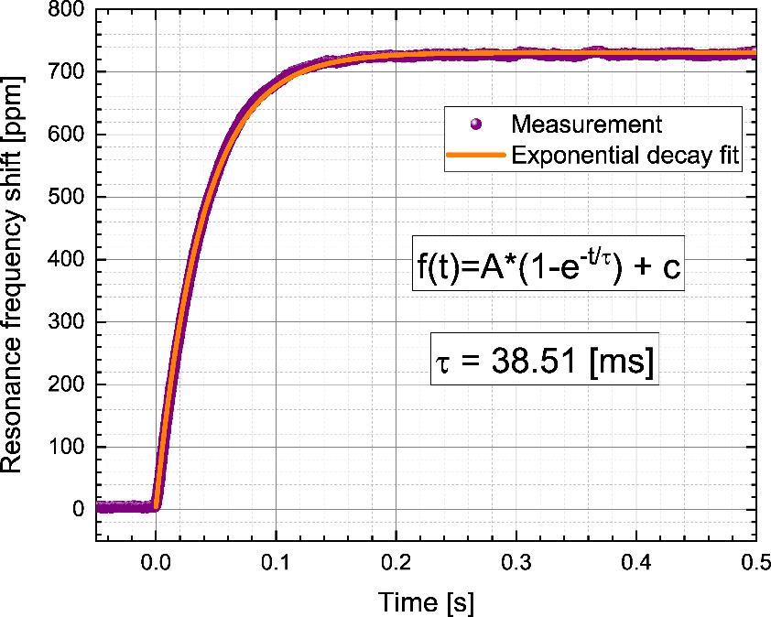
Fig. S2: Resonance frequency transition when the laser is switched on. We notice that the data is closely fitted by an exponential decay function, which allows to extract the time constant of the transition.

